Network Services Design
Susanne Lefvert
Futures Laboratory
Argonne National Laboratory
9700 S. Cass Ave.
Argonne, IL 60439

Introduction
This document describes ongoing and planned work to support network services in the Access Grid Toolkit.

Requirements
In order to decide requirements for network services, different types of services are identified and described as follows.

- Transcoders
  - For example a 8kHz <-> 16 kHz audio transcoder.
  - Has stream input and output.
  - Registers with venues/venue servers.
  - Should not be visible in venue clients.
  - A venue connects to a transcoder when capability mismatch occurs.
  - Can be described by one general SOAP interface.
  - May need user input to function properly.

- General Services
  - For example a Multicast Monitor.
  - Input does not have to be streams.
  - Registers with venues/venue servers.
  - Have different SOAP interfaces.
  - Should be visible in venue clients.
  - Needs a customized client to communicate with the service.
  - May contribute information to determine capabilities.

Design
Since the requirements differ depending on the network service type, I have divided the design section into two parts; one for transcoders and the other for general services.

Design to Support Transcoders.

The class diagram in Figure 1 shows new classes that will be added to support network services. The NetworkServicesManager contains a list of AGNetworkServiceDescriptions, describing available services, and a NetworkServiceMatcher, to use for service selection when capability mismatch occurs in the venue. The Venue class will get new methods to support registration of network services, and the VenueClient is provided with richer capabilities.

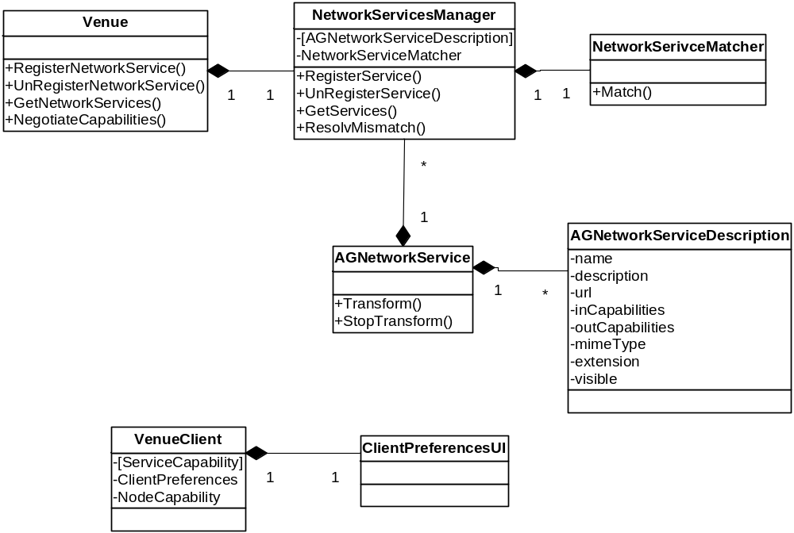
Figure 1 Class Diagram

A network service would register with the venue or a venue server in a similar manner to how the bridge server works, see diagram in Figure 2. To notify the venue client of the new service, an ADD_SERVICE event is distributed to all participants of the venue.

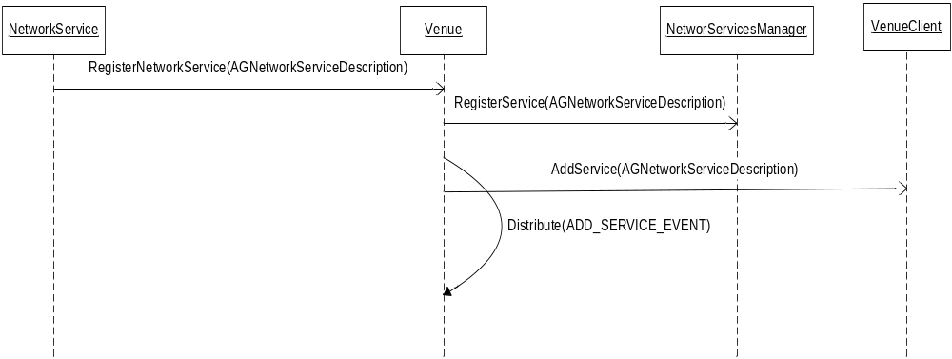
Figure 2 Sequence Diagram - Register Network Service

The sequence diagram in Figure 3 shows the flows of actions that occur when a node enters a venue with capabilities that do not match all streams available. For instance, this could be a node that is only able to receive 8kHz audio while streams in the venue are of 16kHz. The network service would then be an audio transcoder (8kHz -> 16 kHz). When a node enters the venue, the internal NegotiateCapability() call will notice a mismatch in capabilities and call the NetworkServiceManager.ResolveMismatch() method with all the streams that do not match and the capabilities of the node. The NetworkServiceMatcher will select a chain of network services that can be used to resolve the mismatch based on streams, capabilities, and available network services. The mismatched streams are then sent to the NetworkService.Transform() method to produce new streams for the venue.
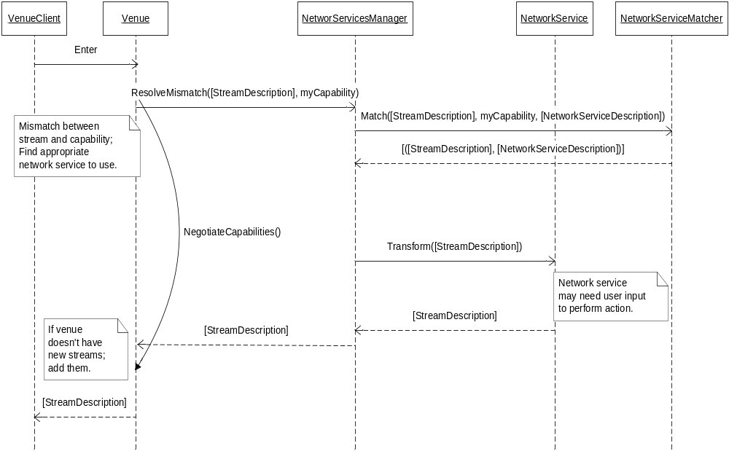
Figure 3 Sequence Diagram - Enter Venue

Design to Support General Services
General services do not necessarily operate on streams and should not be a result of service matching. Instead, these services may present nodes and the venue with useful information that may change the environment and capabilities that are providing the base for matching. Each general service would instead have a unique soap interface and a client that knows how to communicate with the service via the interface. Classes relevant for general services are shown in Figure 3.

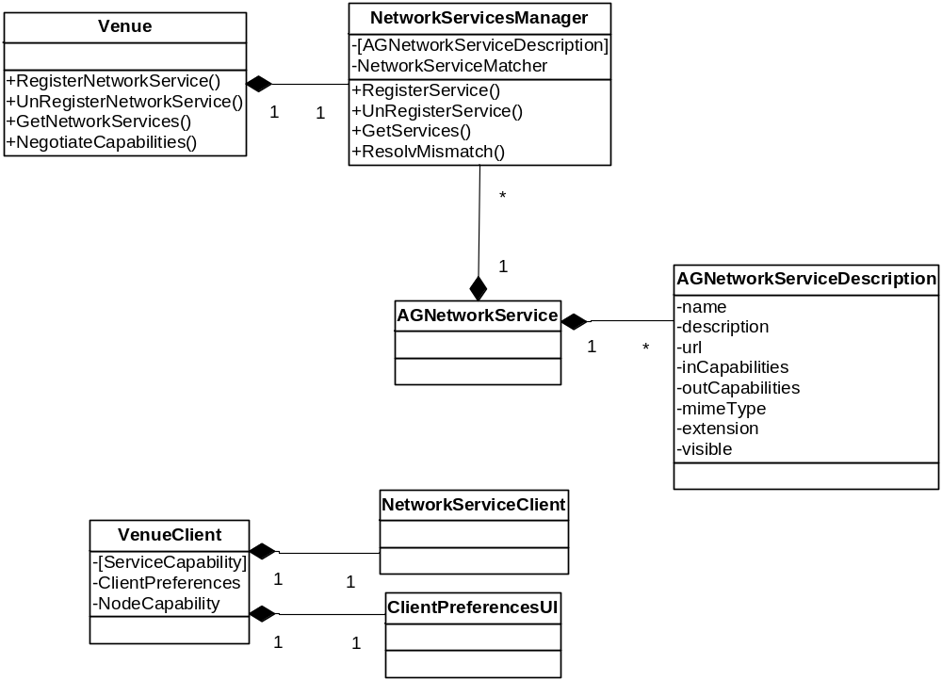
Figure 4 General Services

A general service would still register with the venue, just like transcoders would shown in Figure2. When registering, an AddService event would be distributed to all participants of the venue and the service would show up under the Service heading in the venue client. When you right click the new service and select open, a custom client, installed for this specific service, would open. To register the service client, agpm.py is used to associate the client with the service mime type.

Implementation
This section includes changes made to the toolkit to support the design described in last section as well as examples of how a transcoder and a general service would be implemented.

Modifications to Existing Classes

Types.Capability
To maintain interoperability, a new parameter is added to the capability class where a richer capability description will get stored.

class Capability:

PRODUCER = "producer"
CONSUMER = "consumer"

AUDIO = "audio"
VIDEO = "video"
TEXT = "text"

def __init__( self, role=None, type=None ):
self.role = role
self.type = type
self.parms = dict()
self.xml = ''

Descriptions.CreateCapability()

def CreateCapability(capabilityStruct):
# Old capability
cap = Capability(capabilityStruct.role,capabilityStruct.type)

# Add new capability as xml document.
if hasattr(capabilityStruct, 'xml') and capabilityStruct.xml:
cap.xml = capabilityStruct.xml

Node Services
Node services need to include richer capabilities and will use the new ServiceCapability class to achieve this. The new Capability.xml parameter is used to store the new xml document.

from AccessGrid.ServiceCapability import ServiceCapability

oldCap1 = Capability( Capability.PRODUCER, Capability.AUDIO )
oldCap2 = Capability( Capability.CONSUMER, Capability.AUDIO )

# Create new capabilities to include in old capability format
config = {ServiceCapability.DEVICE_SAMPLE_RATE:'8000', ServiceCapability.ENCODING_NAME:'gsm'}

nsc1 = ServiceCapability('GSM Audio Service', oldCap1.role, oldCap1.type, config)
oldCap1.xml = nsc1.ToXML()

nsc2 = ServiceCapability('GSM Audio Service', oldCap2.role, oldCap2.type, config)
nsc2.SetConfigOption(ServiceCapability.DEVICE_SAMPLE_RATE, '8000')
nsc2.SetConfigOption(ServiceCapability.ENCODING_NAME, 'gsm')
oldCap2.xml = nsc2.ToXML()

self.capabilities = [oldCap1, oldCap2]

Venue

__init__()

from AccessGrid.Descriptions import CreateAGNetworkServiceDescription
from AccessGrid.ServiceCapability import ServiceCapability
from AccessGrid.NetworkServicesManager import NetworkServicesManager

class Venue(AuthorizationMixIn):
def __init__(self, server, name, description, dataStoreLocation,
oid=None):
self.networkServicesManager = NetworkServicesManager()

RegisterNetworkService()

def RegisterNetworkService(self, networkServiceDescription):
nsd = CreateAGNetworkServiceDescription(networkServiceDescription)
try:
self.networkServicesManager.RegisterService(nsd)
self.server.eventService.Distribute( self.uniqueId,
Event( Event.ADD_SERVICE,
self.uniqueId,
nsd ) )

except:
log.exception('Venue.RegisterNetworkService: Failed')
raise Exception, 'Venue.RegisterNetworkService: Failed'

NegotiateCapabilities()

Add matching of new richer capabilities if they exist. When mismatch occurs, call the NetworkService manager for resolution.

# add user as producer of new stream
if not matchesExistingStream:

capability = Capability( clientCapability.role,
clientCapability.type )
capability.parms = clientCapability.parms

# Add new capability as xml document.
if hasattr(clientCapability, 'xml') and clientCapability.xml:
n = ServiceCapability.CreateServiceCapability(clientCapability.xml)
capability.xml = n.ToXML()

clientConsumerCapTypes = []
newCapabilities = []
mismatchedStreams = []

for capability in clientProfile.capabilities:
if capability.role == Capability.CONSUMER:
clientConsumerCapTypes.append( capability.type )

# Store new capabilities to check with new streams
if hasattr(capability, 'xml') and capability.xml:
newCapabilities.append(capability)

for stream in self.streamList.GetStreams():
if stream.capability.type in clientConsumerCapTypes:
streamDescriptions.append( stream )

# Additional Check!
# Find mismatches in new capabilities. The streams might already
# be added to the streamDescriptions list, so remove them from the list
# and send them to the network service manager for resolution.

for s in self.streamList.GetStreams():
match = 0

# If stream has new capability
if hasattr(s.capability, 'xml') and s.capability.xml:

# Check for matches for new consumer capabilities
sCap=ServiceCapability.CreateServiceCapability(s.capability.xml)
for c in newCapabilities:
cCap = ServiceCapability.CreateServiceCapability(c.xml)

if sCap.Matches(cCap):
match = 1

if not match:
# Append to the list of mismatched streams.
mismatchedStreams.append(s)

# The stream does not match so remove it from
# the list of stream descriptions.
for stream in streamDescriptions:
if s.id == stream.id:
streamDescriptions.remove(stream)

# Use network services to resolve mismatches.
if len(mismatchedStreams)>0:
matchingStreams = self.networkServicesManager.ResolveMismatch(mismatchedStreams,
clientProfile.capabilities)

# Add new streams that got created by
# network services during matching.
streamIds = map(lambda x: x.id,self.streamList.GetStreams())

for s in matchingStreams:
c = ServiceCapability.CreateServiceCapability(s.capability.xml)

if not self.streamList.FindStreamByDescription(s):
# Make new stream available for other clients.
self.streamList.AddStream(s)

# Return new streams to the client.
streamDescriptions.extend(matchingStreams)

VenueClientUI

AddService()
Only show network services that have the visible flag set. For example, we might not want to show a transcoder in the UI.

def AddService(self, serviceDescription):
if isinstance(serviceDescription, AGNetworkServiceDescription):
# Only show visible network services
if not serviceDescription.visible:
return

ContentListPanel.OnRightClick()

elif isinstance(item, AGNetworkServiceDescription):
menu = self.BuildNetworkServiceMenu(event, item)
self.PopupMenu(menu, wxPoint(self.x, self.y))

ContentListPanel.BuildNetworkServiceMenu()
Only add Open and Properties options to menu.

def BuildNetworkServiceMenu(self, event, item):
ext = item.name.split('.')[-1]
commands = self.parent.GetCommands(item)

menu = wxMenu()

# - Open
id = wxNewId()

menu.Append(id, "Open", "Open this service.")

if commands != None and commands.has_key('Open'):
EVT_MENU(self, id, lambda event,
cmd=commands['Open'], itm=item:
self.parent.StartCmd(itm, verb='Open'))
else:
EVT_MENU(self, id, lambda event,
itm=item: self.FindUnregistered(itm))
# - type-specific commands
if commands != None:
for key in commands.keys():
if key != 'Open':
id = wxNewId()
menu.Append(id, string.capwords(key))
EVT_MENU(self, id, lambda event,
verb=key, itm=item:
self.parent.StartCmd(itm, verb=verb))
menu.AppendSeparator()

# - Properties
id = wxNewId()
menu.Append(id, "Properties", "View the details of this service.")
EVT_MENU(self, id, lambda event, item=item:
self.LookAtProperties(item))

return menu

ContentListPanel.LookAtProperties()

elif isinstance(desc, AGNetworkServiceDescription):
serviceView = ServicePropertiesDialog(self, -1, "Service Properties")
serviceView.SetDescription(desc)
serviceView.ShowModal()
serviceView.Destroy()

VenueClientController

StartCmd()
Start a network service client in the same way as a shared application client.

else:
# Get the app dir and go there
if (isinstance(objDesc, ApplicationDescription) or
isinstance(objDesc, AGNetworkServiceDescription)):

GetCommands()
elif isinstance(objDesc, AGNetworkServiceDescription):
commandList = dict()
commandList.update(self.userAppDatabase.GetCommands(objDesc.mimeType))
commandList.update(self.systemAppDatabase.GetCommands(objDesc.mimeType))

Open Issues
- How should I store new capabilities in node service svc file? Do we have to modify the file by hand or could we automatically write the xml document to the svc file. Currently, I am calling CreateSVCFile() to push new soap capabilities into the file.

- How can a network service, involved in matching, communicate with a participant? For example, if we have a video selector and we want the participant to select which streams to receive.
  - Events?
  - Through venue client soap interface. Firewall issues?

- Should I use AGNetworkServiceDescription class, or have a more general name for it, like ServiceDescription. Maybe other services will be using the same mechanism? Should general services apply to all services, not just network services?

- How can information retrieved from general services be used in capability negotiation?

- Is it right to use agpm.py to install service clients?
  - Should I use .app extension to a service client? Or svc? Or something else?
  - Should extension be application/servicename or maybe service/servicename?

Example Implementation of a Transcoder
Currently, this is just a fake transcoder that really does not do anything but receive a stream description with sample rate set to 16kHz and returns a description set to 8 kHz.

from AccessGrid.AGNetworkService import AGNetworkService, AGNetworkServiceI
from AccessGrid.ServiceCapability import ServiceCapability
from AccessGrid.Descriptions import StreamDescription
from AccessGrid.Platform.ProcessManager import ProcessManager
from AccessGrid.NetworkLocation import MulticastNetworkLocation

import os

class AudioTranscoder(AGNetworkService):
"""
Network service that starts tcoder, a simple audio
transcoder for pcmu, gsm, lpc, and dvi formats.
"""

def __init__(self, name):
AGNetworkService.__init__(self, name, 'Audio Transcoder', '1.0',
'application/x-ag-audio-transcoder',
'audiotranscoder')
self.processManager = ProcessManager()

# Create in and out capabilities.
config = {ServiceCapability.ENCODING_NAME: 'pcm',
ServiceCapability.DEVICE_SAMPLE_RATE:'8000'}
n1 = ServiceCapability(name, 'consumer', 'audio', config)

config = {ServiceCapability.ENCODING_NAME: 'gsm',
ServiceCapability.DEVICE_SAMPLE_RATE:'8000'}
n2 = ServiceCapability(name, 'producer', 'audio', config)

self.inCapabilities = [n1.ToXML()]
self.outCapabilities = [n2.ToXML()]

# Create soap interface
soapInterface = AGNetworkServiceI(self)

# Start the service.
self.Start(soapInterface)

def StopTransform(self):
'''
Shutdown all tcoder processes.
'''
self.processManager.TerminateAllProcesses()

StopTransform.soap_export_as = "StopTransform"

def Transform(self, streamList):
'''
Start transform of given streams.
'''
descList = []

for streamDesc in streamList:
fromAddr = streamDesc.location.host
fromPort = streamDesc.location.port

# Create new stream description
newCapability = streamDesc.capability
newCapability.xml = self.outCapabilities[0]

# Location should be decided in a better way, possibly through
# the venue interface. For now, just use multicast address
# and port 8866.
location = MulticastNetworkLocation(fromAddr, 8866, 127)
newDesc = StreamDescription("pcm - gsm transcoder",
location,
newCapability)
toAddr = location.host
toPort = location.port

# Create command to execute
executable = os.path.join('.', 'tcoder')

options = []
options.append("-m ")
options.append("%s/%d"%(fromAddr, fromPort))
options.append("-u ")
options.append("%s/%d"%(toAddr, toPort))

descList.append(newDesc)

# Execute command - Start transcoding
print "START TRANSFORM exec = ", executable, "options = ", options
self.processManager.StartProcess(executable, options)

return descList

Transform.soap_export_as = "Transform"

if __name__ == "__main__":
# Create the network service.
fat = AudioTranscoder('Audio Transcoder')

# Register with venues if url is not given via command line.
if not fat.app.GetOption('venueUrl') or fat.app.GetOption('venueServerUrl'):
fat.RegisterWithVenues(['https://localhost:8000/Venues/default'])

# Start signal loop to make it possible to exit cleanly
fat.StartSignalLoop()

# Stop audio transcoder
fat.StopTransform()

Example Implementation for a General Services
This example shows a simple service that has one SOAP method, GetConfiguration(), that returns 1. The client connects to the service and shows a simple window with a button displaying the received configuration value.

FakeMonitor.py

from AccessGrid.AGNetworkService import AGNetworkService, AGNetworkServiceI
from AccessGrid.ServiceCapability import ServiceCapability
from AccessGrid.hosting.SOAPInterface import SOAPInterface, SOAPIWrapper
from AccessGrid.Toolkit import CmdlineApplication
from AccessGrid.GUID import GUID
from AccessGrid.hosting.SOAPInterface import SOAPIWrapper
from AccessGrid.Descriptions import CreateStreamDescription

import copy

class FakeMonitor(AGNetworkService):
def __init__(self, name):
AGNetworkService.__init__(self, name, 'Multicast monitor', '1.0',
'application/x-ag-fake-monitor', 'fakemonitor')

# Create in and out capabilities.
config = {ServiceCapability.DEVICE_SAMPLE_RATE:'8000', ServiceCapability.ENCODING_NAME:'H.261'}
n1 = ServiceCapability(name, 'consumer', 'audio', config)

self.inCapabilities = [n1.ToXML()]
self.outCapabilities = None

soapInterface = FakeMonitorI(self)

# Start the service.
self.Start(soapInterface)

def GetConfiguration(self):
return 1
GetConfiguration.soap_export_as = "GetConfiguration"

class FakeMonitorI(SOAPInterface):
def __init__(self, impl):
SOAPInterface.__init__(self, impl)

def _authorize(self, *args, **kw):
return 1

def GetConfiguration(self):
return self.impl.GetConfiguration()

class FakeMonitorIW(SOAPIWrapper):
'''
This interface is used for monitor clients.
'''

def __init__(self, url, faultHandler = None):
SOAPIWrapper.__init__(self, url, faultHandler)

def GetConfiguration(self):
return self.proxy.GetConfiguration()

if __name__ == "__main__":
import sys

# Create the network service.
fat = FakeMonitor('Fake Monitor Service')

# Register with venues if url is not given via command line.
if not fat.app.GetOption('venueUrl') or fat.app.GetOption('venueServerUrl'):
fat.RegisterWithVenues(['https://localhost:8000/Venues/default'])

# Start signal loop to make it possible to exit cleanly
fat.StartSignalLoop()

FakeMonitorClient.py

from FakeMonitor import FakeMonitorIW
from wxPython.wx import *
from AccessGrid import icons
import os

class FakeMonitorClient(wxApp):
def __init__(self, url, app):
wxApp.__init__(self, False)
app.Initialize('FakeMonitorClient')
fms = FakeMonitorIW(url)
confVal = fms.GetConfiguration()
wxInitAllImageHandlers()
self.mainSizer = None
self.frame = wxFrame(None, -1, "Shared Question Tool")
self.frame.SetIcon(icons.getAGIconIcon())
self.button = wxButton(self.frame, -1, str(confVal))
self.SetTopWindow(self.frame)
self.topPanel = wxPanel(self.frame, -1)

self.__Layout()
self.frame.Show(1)
self.MainLoop()

def OnInit(self):
return 1

def __Layout(self):
sizer = wxBoxSizer(wxVERTICAL)
sizer.Add((10,10))
sizer.Add(self.button, 0, wxEXPAND|wxALL, 10)
self.topPanel.SetSizer(sizer)
sizer.Fit(self.topPanel)

self.mainSizer = wxBoxSizer(wxVERTICAL)
self.mainSizer.Add(self.topPanel, 0, wxEXPAND)

self.frame.SetSizer(self.mainSizer)
self.mainSizer.Fit(self.frame)
self.frame.SetAutoLayout(1)

if __name__ == "__main__":
import sys
from AccessGrid.Toolkit import WXGUIApplication

app = WXGUIApplication().instance()

i = 0
for arg in sys.argv:
i = i + 1
if arg == '--s':
app.AddCmdLineOption('--s')
url = sys.argv[i]

fClient = FakeMonitorClient(url, app)

FakeMonitor.app

[application]
name = Fake Monitor
mimetype = application/x-ag-fake-monitor
extension = fakemonitor
files = FakeMonitor.py FakeMonitorClient.py
startable = 0

[commands]
Open = %(python)s FakeMonitorClient.py --s %(serviceUrl)s

