Data Service Design
Futures Laboratory
Argonne National Laboratory
9700 S. Cass Ave.
Argonne, IL 60439
4/23/2003

1 Introduction
The DataService class is used to create remote data storage locations accessible for venues. It allows data storage to be located on a machine other than where the venue server is running and venue managers can make use of distributed resources for data storage.

2 Design
The DataService exposes a SOAP interface used by the venue server to create remote DataStores.

2.1 Methods
RegisterVenue creates a DataStore object with privateId as unique identifier recognized in the venue. It uses this private id together with the venue cannelId to send events on the venue event service, located at eventServiceLocation, when data is uploaded, downloaded, or deleted. If the venue has called this method before, data left from last session is recognized and reloaded.

UnRegisterVenue shuts down the DataStore for a venue registered with channelId. Data is not destroyed when you call UnRegisterVenue, but remain on the file system. The data gets loaded as RegisterVenue is called again when a venue with this channelId is restarted.

url RegisterVenue(privateId, eventServiceLocation, channelId)
void UnRegisterVenue(channelId)

2.2 Abstractions

2.2.1 Class Diagram
Figure 1 shows a diagram over the data storage system. The venue server calls the DataService SOAP interface whenever a new venue is created or shut down. The DataService has a GSIHTTPTransferServer that is the data transfer engine for data uploads and downloads shared among created DataStores. Each DataStore has a DataDescriptionContainer that keeps track of data descriptions representing data present in the file system. When data is changed, the DataDescriptionContainer sends an event via the EventClient that is registered on the venue event channel. The Venue uses the DataStore SOAP interface to get DataDescriptions from the DataStore,

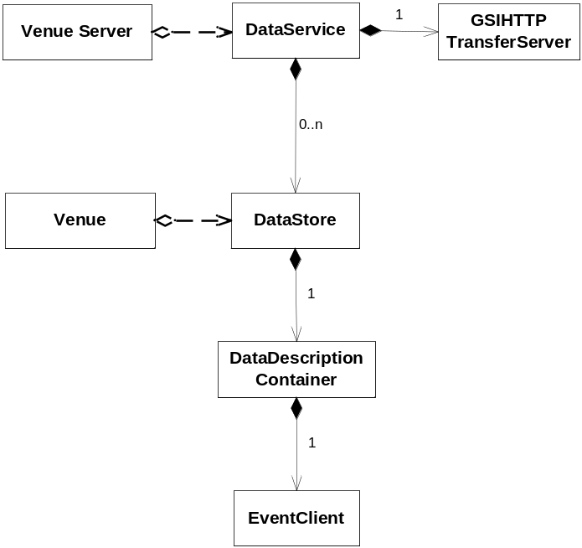
Figure 1 Class Diagram

2.2.2 Sequence Diagrams
Before register a venue with the DataService the venue have to assign a private id for the DataStore to be created. This is done by adding a net service, see Figure 2. In order for the DataStore to be able to send events it also needs to know where the event service is located and what channel id to use for events, done by the GetEventLocation call. After gathering this information, the venue server calls RegisterVenue on the DataService.

The RegisterVenue call creates a DataStore and an EventClient, and then calls the SetEventClient and SetTransferEngine methods on the created DataStore. Finally the RegisterVenue call returns the url of the new DataStore and the venue data store can be set with this url as parameter enabling the venue to communicate with the DataStore SOAP interface.
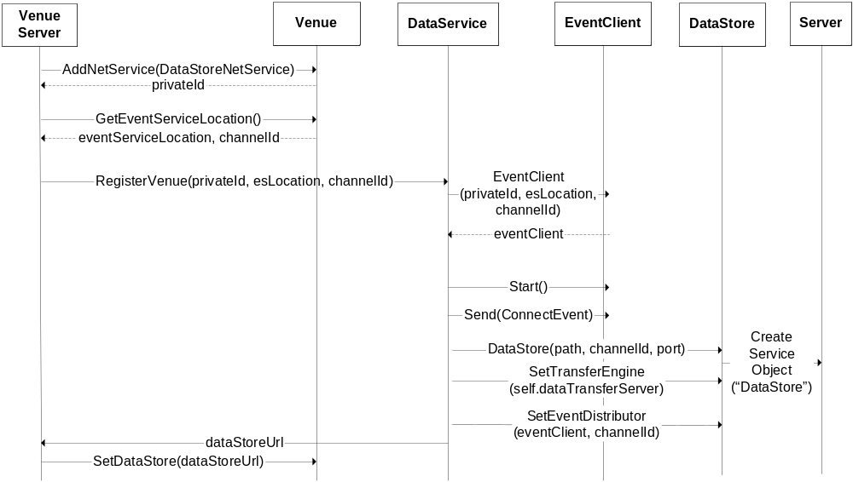
Figure 2 Sequence Diagram for RegisterVenue

Figure 3 shows the flow of actions made when we call the UnRegisterVenue method on the DataService. It shuts down the DataStore, which stops the eventclient and the SOAP server, and the DataDescriptions are saved for correct data persistence.

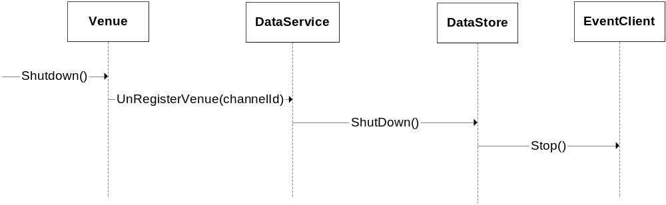
Figure 3 Sequence Diagram for UnRegisterVenue

Notes
A method should be added to the DataService SOAP interface that removes a Datastore and its files permanently from the file system. This method would be called when a venue is removed from the venue server.

