Node Management Architecture
Version 2.0

The Futures Laboratory
Mathematics and Computer Science Division
Argonne National Laboratory

Introduction
Each Access Grid Node is made up of hardware and software resources that provide capabilities to the users. The goal of Access Grid Nodes is to provide shared capabilities among a group of co-located collaborators. These capabilities extend each individual user’s capabilities in a manner that supports cooperative work. Additionally, AGNs are designed to provide mechanisms for sharing the context of the local collaboration with other groups using AGNs. To do this distributed group collaboration, AGNs provides multiple simultaneous camera views, an echo-cancelled audio environment, a large format display, user management mechanisms and support for collaborative applications.

An Access Grid Node typically comprises multiple machines each assigned a particular task, working together to provide the infrastructure of a group space for collaboration in a venue. Each machine in the node delivers a stream or streams to the venue. Streams are coordinated on a machine by a single process, a Node Daemon. Node Management knows the Node Daemons, thus tying the disparate parts into a manageable whole. Node Management has a network interface, making it accessible by different clients: local or remote, text or graphical.

This document lists the requirements for Node Management, and then defines an architecture that satisfies these requirements.

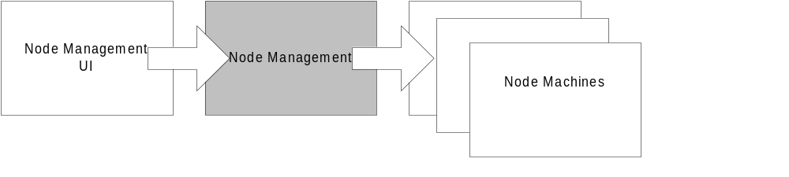

Requirements

Node Management configures a Node and its Services
Node management will provide a simple interface for controlling the configuration of a node, including maintenance of the authorization policy, window layout, which services are installed, and how services are configured.

Node Management is network accessible
Node management functionality will be accessible through a well-defined network interface. This will enable development of varied clients, whether text- or GUI-based, local or remote.

Architecture
The architecture is discussed in terms of data elements and operations.

Resources

Identification
The Identification names and describes the Node for external parties.

Authorization Policy
The Authorization Policy is used to determine whether a user may associate with the node, and what operations that user may perform on the node.

Users
This is a list of the users currently associated with the node.

Node Services
A Node Service provides a capability to a Node. Node Services must be configurable in Node Management. Therefore, Node Management must maintain a list of Node Services currently in the Node, and must know their locations to be able to communicate with them.

Examples of a Node Service are the Audio Service or Video Service.

Operations

Login
A user associates with the node by logging in. If the user provides appropriate credentials, Node Management adds the user to its list of users.

Modify the Authorization Policy
Authorized users can modify the Authorization Policy.

Add or Remove Node Services
Authorized users can modify the node capabilities by adding or removing Node Services. Newly added services should not start automatically. Services that are removed will (of course) be stopped.

Query Node Services
These operations provide info about Node Services configured on a Node.

Query Node Service Configuration
These operations allow authorized users to query the configuration of Node Services.

Configure Node Service
Authorized users can configure the Node Services. This could include changing the location to which it delivers its stream, or lower-level configuration such as device parameters.

Start or Stop Node Service
These operations allow users to Start and Stop Node Services.

Discovery of Capabilities
Discovery reveals the resources available on a Node, which may consist of multiple machines. These resources can then be used to configure new Services on the node.

