Virtual Venue Client 2.0 User Manual

Access Grid Toolkit Documentation

The Futures Laboratory
5/28/2003

Contents

1.0 Introduction 4
Background 4
Overview 5
2.0 Actions 6
2.1 Start Venue Client 6
Set up Certificate 6
Running the Program 9
Create Your Profile 9
2.2 Connecting to a Venue 9
Specify Venue Address 9
Create Grid Proxy Certificate 10
2.3 Viewing a Profile 10
2.4 Changing Your Profile 11
2.5 Writing Text Message 11
2.6 My Venues 11
2.6.1 Adding a Venue to My Venues 12
2.6.2 Removing Venue from My Venues 12
2.6.3 Rename Venue in My Venues 12
2.7 Navigating 12
2.8 Sharing Data 13
2.8.1 Adding Venue Data 14
2.8.2 Adding Personal Data 14
2.8.3 Deleting Data 14
2.8.4 Opening Data 14
2.8.5 Viewing Data Properties 14
2.9 Sharing Applications 14
2.9.1 Joining Application 14
2.9.2 Deleting Application 14
2.10 Sharing Services 15
2.10.1 Adding Service 15
2.10.2 Opening Service 15
2.10.3 Deleting Service 15
2.11 Managing Certificates 15
2.11.1 View Trusted CA Certificate 15
2.11.2 View Identity Certificates 16
2.12 Managing Your Node 17
2.12.1 Start Service Manager 17
2.12.2 Start Node Service 17
2.12.3 Open Node Management 17
2.12.4 Adding a Service Manager 18
2.12.5 Removing a Service Manager 18
2.12.6 Adding a Service 18
2.12.7 Enabling or Disabling a Service 19
2.12.8 Removing a Service 19
2.12.9 Change Service Configuration 19
3.0 About Certificates 20
3.1 What Is a Certificate? 20
3.2 Why use Certificates? 20
3.3 Distinguished Name 20
3.4 Grid Proxy 20

1.0 Introduction

Background
The Access Grid is an Internet-based model for video conferencing that focuses on group-to-group communication, using an ensemble of resources including multimedia large-format displays, presentation and interactive environments, and interfaces to Grid middleware and visualization environments. For instance, the Access Grid is used for large-scale distributed meetings, collaborative work sessions, seminars, lectures, tutorials, and training. Even though the Access Grid is concentrated on group interactions, it also provides an access point for individual desktop users, permitting one-to-many or one-to-one communication.

The virtual meeting space, where people come together to collaborate in the Access Grid, is called a Virtual Venue. If authorized, the Venue provides users with all the necessary information needed to communicate with each other, including audio and video streams, user capabilities, data, services, applications, and connections to other venues.
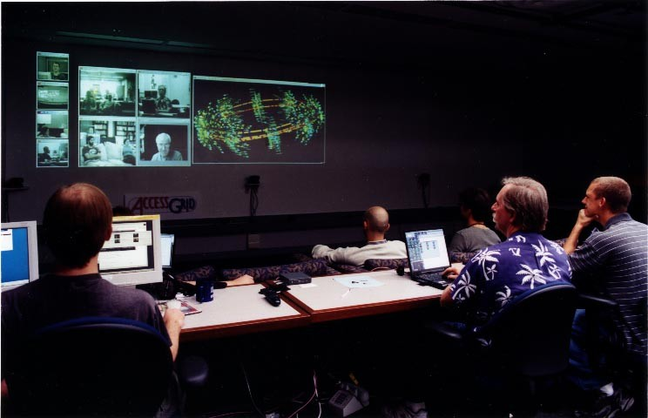
Figure 1 A node at Argonne National Laboratory
Users connect to a Virtual Venue from their particular environment, identified as a node, which contains collaborative resources needed to provide high-quality user experiences. Access Grid users are given the ability to configure nodes according to their own preference. Examples of node configurations are a desktop using a Quick Camera or an entire room with several microphones, cameras, and advanced display environments. Figure 1 shows one of several nodes available at Argonne National Laboratory.

Figure 1 A node at Argonne National Laboratory

Overview
The Venue Client, in Figure 2, is used to connect and participate in an Access Grid Virtual Venue. It displays the contents of the Virtual Venue, connections to other venues, and an interface to configure your node arrangement. The description below explains the different components that represent the Venue Client.

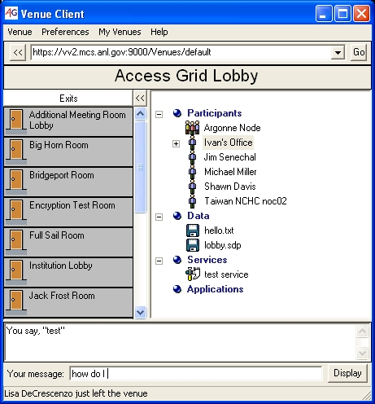

Figure 2 Venue Client
The Address Bar is used to connect to a venue. You are allowed to enter two different types of addresses in the address bar, either the default venue on a venue server (https://host:port/Venues/default) or the actual address of a specific venue (https://host:port/Venues/unique id). For instance, you can in Figure 2 see the Venue Client connected to default venue on a venue server running on host “vv2.mcs.anl.gov” using port 9000. After writing the address in the address bar, click the “Go” button to connect to the venue.

The Title Bar includes the name of the venue you are currently connected to.

The Contents Panel displays participants of the venue, present data, applications, and services available to share. Users can join the venue either as a single participant or as a node. A node is a group of people taking part in the venue together in which all of the participants are sharing the same collaborative capabilities, for example, watching the venue projected on a white screen with cameras placed strategically around the room.

The Exits Panel shows other venues linked to this venue, connected through exits, enabling users to travel through the venue space. Next to the door icon you can see the name of the connected venue. The venue description is displayed as a tool tip that shows up if the mouse is held over the exit.

All venue participants and nodes will receive the text available in the Text Field.
You can write a short message in the Message Field and display the text by clicking on the “Display” button.

2.0 Actions
This section describes how to use the Venue Client. The discussion begins with basics such as setting up certificates and gradually covers such complex issues as managing a node.

2.1 Start Venue Client

Set up Certificate
To connect to a venue you have to have a valid grid identity certificate (for more information about certificates, see Section 3.1). You have to request and configure your certificate only once; the same certificate can then be used for all future Access Grid interactions. Also, you are allowed to user the same certificate on several machines; so if you already have a certificate, you can simply move your certificate files over to the right directory on the other machine (for Windows: C:\Documents and Settings\<your user name>\Application Data\globus\ and for Linux: /home/<your user name>/.globus).

For Windows users:
Go to “Get a Certificate” in the “Windows Globus” start menu. A window will appear prompting you for necessary information to create your certificate and the distinguished name you will be associated with (for more information about distinguished names read Section 3.3). Take care to remember the password you select because you will be using this in the future. After you are done, a file called usercert.pem is created at the specified location. Send this file to leggett@mcs.anl.gov who will provide you with a user certificate. This can take some time depending on how many requests are being processed at the moment; please be patient.

When your request has been approved, you will receive an email containing your certificate files. Place them in C:\Documents and Settings\<your user name>\Application Data\globus\ together with usercert.pem, as instructed in the email. To keep your identity private, make sure the certificate files are readable only by you. After receiving all your certificate files, you are ready to configure your certificate settings by selecting “Globus Configuration” from the “Windows Globus” start menu. The window in Figure 3 is displayed, click “Next”.

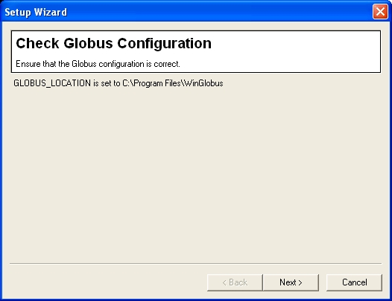
Figure 3 Configure your certificate settings

A new window, shown in Figure 4, will now open. Make sure you see four OK’s to the right of the certificate files. If any of the files is missing, you will have to use the “Browse…” button to find where the file is located. After this is done, click “Next.”

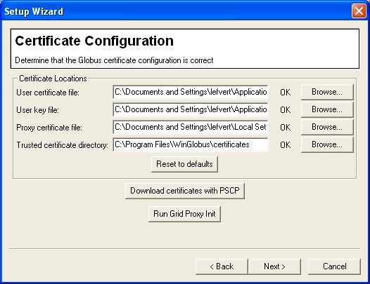
Four OK’s indicates your certificate is installed properly
Figure 4 Checking your certificate locations

Finally, the window in Figure 5 will appear. Click “Finish,” and your certificate should be configured.

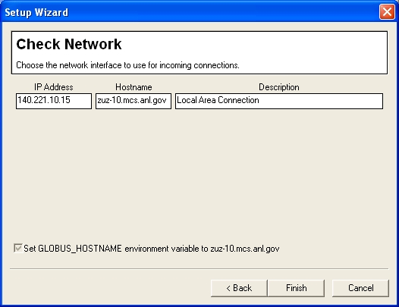
Figure 5 Configure your certificate settings

For Linux users:
An easy way to determine whether you have a certificate is to run grid-proxy-init on the command line. If it returns “user certificate not found,” you need to request a certificate. Or, if you know you have a certificate, you can simply move your certificate files to /home/<your user name>/.globus. To request a certificate, run grid-cert-request on the command line. Enter a pass phrase when prompted; remember the password, since you will be using this in the future. A file, usercert_request.pem, is created. Copy or attach this file to an email, and send it to leggett@mcs.anl.gov, who will provide you with a user certificate. This can take some time depending on how many requests are being processed at the moment. Please be patient.

When your request has been approved, you will receive an email containing your certificate files. Place them in /home/lefvert/.globus/ as instructed in the email. To keep your identity private, make sure the certificate files are readable only by you.

Useful Linux commands:
grid-cert-request – Request a certificate.
grid-cert-info – View information about your certificate.
grid-proxy-info – View information about your proxy.
grid-proxy-init – Create your proxy
grid-proxy-destroy – Destroy your proxy.

Note: Use the –help flag for different command options.

Running the Program
For Windows users:
Go to the Start menu and select “All Programs-Access Grid Toolkit-Venue Client,” or click on the desktop shortcut.

For Linux users:
Run VenueClient on the command line.

Create Your Profile
If this is the first time you are using the Venue Client, a profile dialog will appear, and you should enter your information, which will be used to represent you in venues (see Figure 6). You are required at least to fill in your name, but it is helpful if you enter as much information as possible. Keep in mind that you can change the profile at any time (see “Changing your Profile,” Section 2.4). When you are present in a venue, your profile information will be made available for every participant in that venue (read “View Profile,” Section 2.3)

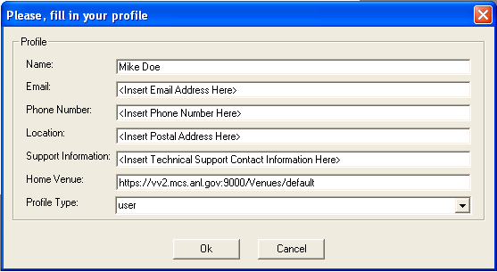
Information on how to contact the responsible person for this node. For example, support@mcs.anl.gov
This address will show up in the Address Bar every time you start the Venue Client
Figure 6 Profile Dialog

2.2 Connecting to a Venue

Specify Venue Address
Enter the venue address in the Address Bar, and then click “Go” to enter the venue. Apart from venue addresses (https://<host>:<port>/<unique id>) you can enter the address of the default venue on a venue server (https://<host>:<port>/Venues/default), as shown in Figure 7.

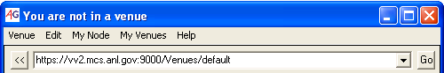

Figure 7 Using the Address Bar to connect to a venue

Create Grid Proxy Certificate
In order to successfully connect to the venue server, you have to have a valid grid proxy certificate (for more information, read Section 3.1). If such a certificate is missing, the dialog in Figure 8 will enable you to create a proxy. Fill in the password you chose when you initially requested your certificate in the “Passphrase” field. The “Proxy lifetime (hours)” field indicates how long this proxy certificate will be valid; the default value is 8 hours, but you may change this number. When the proxy life time expires, you will be prompted for your password again. After specifying the validity of the proxy, click “Ok.”

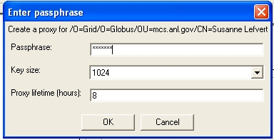
Figure 8 Creating a grid proxy

Figure Create your proxy certiicate

2.3 Viewing a Profile
Right click on the participant or node you want to see profile information about, and select “View Profile…”, as shown in Figure 9.

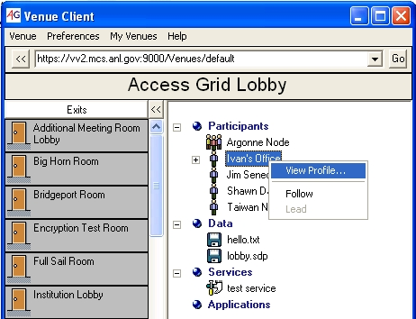
Figure 9 View Profile

2.4 Changing Your Profile
From the menu, choose “Preferences-Edit Profile…” as shown in Figure 10. When the Profile Dialog appears, edit the appropriate fields, and then click “Ok.”

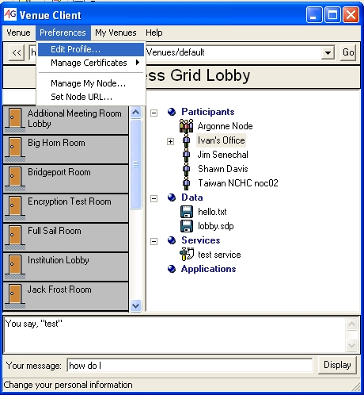
Figure 10 Edit your profile from the menu

2.5 Writing Text Message
Enter text in the Message Field, and click “Display.” The text will show up in the Text Field for all participants in the venue; see Figure 11.

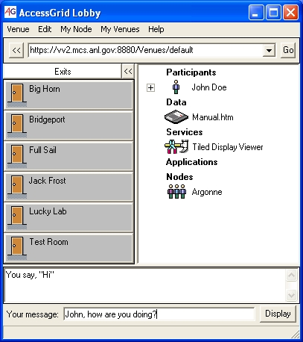
Figure 11 Text chat

2.6 My Venues
In the “My Venues” menu option, you can add a list of venue names that, when clicked on, fills in the Address Bar with correct venue address. This functionality is available to avoid you having to remember and type long addresses for venues you are visiting frequently, much like the “bookmark” feature in most Web browsers.

2.6.1 Adding a Venue to My Venues
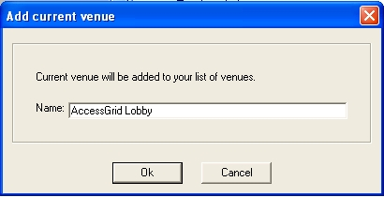
First, go to the menu and click on “My Venues-Add Current Venue.” The dialog in Figure 12 opens with the current venue’s name filled in automatically. You can change the name to whatever you want and then click “Ok.” The name will be added to the list found under the “My Venues” menu option. When you select a name in the list, the address will be filled in to the address bar, and you can connect to it as usual by clicking the “Go” button in the address bar.

Figure 2. Associate a venue address with a name
Figure 12 Associate a venue address with a name

2.6.2 Removing Venue from My Venues

Go to “My Venues - Edit” in the menu bar, and right click the venue you want to delete. Select “Remove Venue” and then “Ok.”

2.6.3 Rename Venue in My Venues
Go to “My Venues - Edit” in the menu bar, and right click the venue you want to rename. Select “Rename,” fill in the new name, then press “Ok.”

2.7 Navigating
To the left side of the Venue Client is the Exits Panel, containing a list of names of other venues. If you place the mouse over one of the exits, the description of the venue shows up as a tool tip. You can see the description of the Test Room in Figure 13. If you click the left mouse button on one of the exits, you will leave the venue you are currently connected to and enter the other venue.

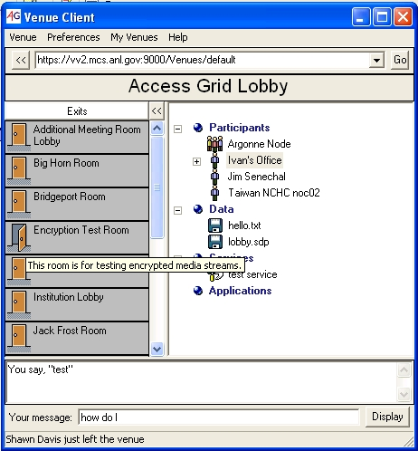
Figure 13 Navigating

2.8 Sharing Data
The Venue Client allows you to share data among users of the venue. Files can either belong to the venue or be user specific. The user may carry around personal data when walking between venues. Files belonging to a participant or node will therefore stay in the venue for as long as its owner is present. Venue data, however, always stays in the venue until deleted. Personal user data is placed under the participant or node that owns the file, while venue data is found under the “Data” heading in the Contents Panel. “VenueClient.py”, in Figure 14, is one example of a personal file belonging to “Ivan’s Office”, and “hallo.txt” is owned by the venue.

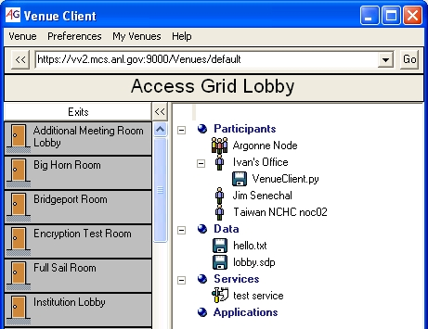

Figure 14 Venue and personal data as displayed in the Venue Client

2.8.1 Adding Venue Data
Right click on the “Data” heading, and choose the option “Add….” Or, from the menu, go to “Venue-Add Data….” A file browse dialog will show up from which you can pick the file you wish to add to the venue. Then press the “Ok” button.

2.8.2 Adding Personal Data
Right click on your profile under the “Participant” heading, and choose the option “Add Personal Data”. A file browse dialog will show up from which you can pick the file you wish to add to your personal files. Click the “Ok” button. Observe that personal data will be shown under your profile and not under the “Data” heading, illustrated in Figure 14.

2.8.3 Deleting Data
Right click on the data item, personal or venue specific, and choose “Delete.” A dialog will ask whether you really want to remove the selected data. Click “Ok” to confirm.

2.8.4 Opening Data
Right click on the data item and choose “Open….” If the file type is associated with an application, the data will be opened directly using that program. Otherwise you will be prompted for a program to associate with and handle the file.

2.8.5 Viewing Data Properties
Right click on the data item, and choose “Properties….” A dialog will be opened showing the file name, the distinguished name of its owner, and file size.

2.9 Sharing Applications

2.9.1 Joining Application
To join an application, right click on the application you wish to use, and select “Join.”

2.9.2 Deleting Application
To delete an application, right click on the application you wish to remove, and select “Delete.” A dialog will appear to check that you really want to delete the service. Click “Ok” to confirm.

2.10 Sharing Services

2.10.1 Adding Service
Before adding a service to the venue, you need to know the address where the service is located and what MIME type to associate with the service. The MIME type helps the Venue Client to identify what type of service is being added and how to handle it. When you have gathered this information, right click on the “Service” heading and click “Add…,” or from the main menu choose “Venue-Add Service….” In the dialog, enter name, URL address, MIME type, and the description you want to associate with the service. Then click “Ok.”

2.10.2 Opening Service
To open a service, right click on the service you wish to use, and select “Open.”

2.10.3 Deleting Service
To delete a service, right click on the service you wish to remove, and select “Delete.” A dialog will appear to check that you really want to delete the service. Click “Ok” to confirm.

2.10.4 Viewing Service Properties
To view service properties, right click on the service item and choose “Properties….” A dialog will be opened showing the name, URL address, MIME type, and the description associate with the selected service.

2.11 Managing Certificates

2.11.1 View Trusted CA Certificate
The certificates used by all participants in the venue are issued from a trusted certificate authority. To find out what certificates are being accepted by your Venue Client, select from the main menu, “Preferences-Manage Certificates-View Trusted CA Certificates….” The dialog in Figure 15 will appear. If you select one of the certificate authorities shown in the list you can see its information displayed below.

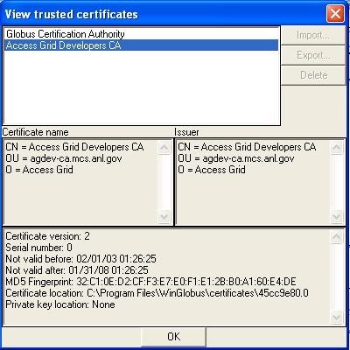
Figure 15 Authorities currently trusted by this Venue Client

2.11.2 View Identity Certificates
If you want to know details about the certificates you are using, go to “Preferences-Manage Certificates-View Identity Certificates…” in the main menu. The dialog in Figure 16 will then show you a list of all your certificates. If you select an identity from the list, its information will be displayed below.

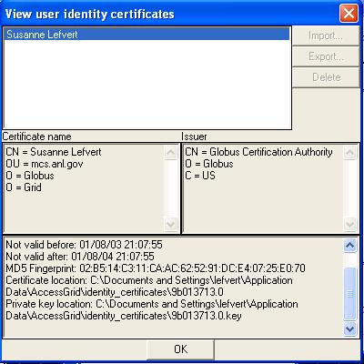
Figure 16 Your certificates

2.12 Managing Your Node
A node consists of a node service, one or more service managers, and one or more services. One example of a node configuration, pictured in Figure 17, uses three machines; one for video creation, one for video display and one responsible for audio. The services, in this case, are used to produce and receive audio and video. Each machine runs a service manager communicating with services on that specific machine. The service managers are controlled by the node service, which can run on any machine. Default services used by the Venue Client are VIC for video and RAT for audio.

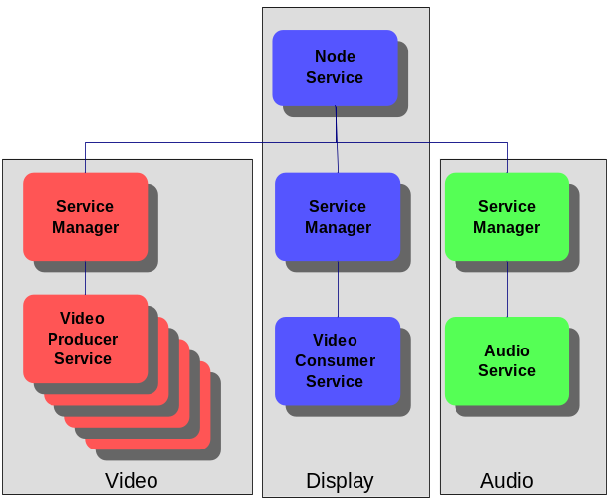
Figure 17 Example of an Access Grid node layout

2.12.1 Start Service Manager
If you want to start a service manager, run AGServiceManager.py.

2.12.2 Start Node Service
If you want to start a node service, run AGNodeService.py.

2.12.3 Open Node Management
The Venue Client allows you to set up and configure the resources available in your node layout. Go to the main menu and click on “My Node-Manage…”; and the Node Management Window will open. To the left side of the window you can see a list of Service Managers. A Service Manager is responsible for managing different services present in your specific node. In Figure 18, the Service Manager is running on “zuz-10.mcs.anl.gov” using port 12000. To the right side of the Node Management window, you can see a list of services corresponding to the selected item in the Service Manager list. The selected Service Manager is controlling one audio service responsible for sending and receiving voice communication.

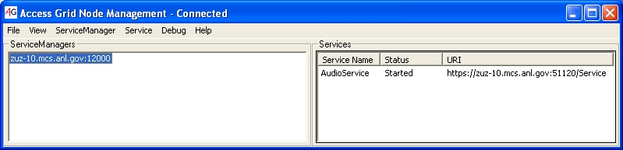
Figure 18 Node Management

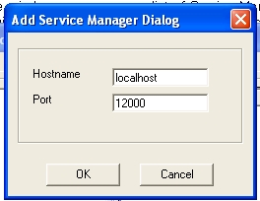
2.12.4 Adding a Service Manager
If you want to add a new Service Manager, go to the main menu and select “ServiceManager-Add…,” or right click on the Service Manager and select “Add…”. Enter the computer in which the service manager is running and the port it is using. When you are finished, click “Ok.” If the service manager is located on your local computer, it is sufficient to enter localhost as “Hostname”; see Figure 19.

Figure19 Add Service Manager
Figure 3. Add Service Manager

2.12.5 Removing a Service Manager
Select the Service Manager to remove, then click “ServiceManager-Remove” in the main menu, or right click the Service Manager and select “Remove.” The Service Manager should disappear from the list.

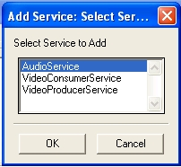
2.12.6 Adding a Service
Select the Service Manager you wish to add a service to, select from the menu “Service-Add…” or right click on a Service Manager and click “Add….” A window containing a list of all available services will be displayed. Select the service to add; then click “Ok.” In Figure 20 you can see three existing services to use for voice and video communication available for Service Manager zuz-10.mcs.anl.gov:12000.

Figure 4. Add Service
Figure 20 Adding a Service

2.12.7 Enabling or Disabling a Service
Select the service you wish to start or stop from the list of services. Go to the main menu and select “Services-Enable” or “Services-Disable,” or right click on the service and select “Enable” or “Disable.” You should now see the status field for the service you selected change accordingly in the list.

2.12.8 Removing a Service
Select the service you wish to delete from the list of services, and choose from the main menu “Service-Remove” or right click the service and select “Remove.”

2.12.9 Change Service Configuration
Select the service you want to change, and choose from the main menu “Service-Configure….”

2.12.10 Attach to Node
You can connect to a node service running on any machine by selecting from the main menu “File-Attach to Node”. Give the host and port information where the node service is running.

2.12.11 Loading a Configuration
An existing Service Manager configuration can be loaded with all services added automatically. From the main menu select “File-Load Configuration…”, and select the desired configuration from the list of names. Then click “Ok.”

2.12.12 Saving a Configuration
If you know you will use your Service Manager configuration several times, it is a good idea to store the configuration. You can then simply load the configuration when you want to use it, instead of adding the same services all over again. In the main menu, go to “File-Save Configuration…,” specify the name you want the configuration to be associated with, then click “Ok”.

3.0 About Certificates

3.1 What Is a Certificate?
Every user and service in the Access Grid is required to have a valid identity certificate issued by a trusted certificate authority. Certificates are a form of electronic identification that is superior to the well-known and widely used password strategy. This form of authentication aims to reduce the many problems seen with passwords, such as poorly chosen, forgotten, or insecurely stored passwords, in order to enable a reliable environment for collaboration. The certificate authority is responsible for giving you a certificate; thus make sure you really are who you say you are.

3.2 Why use Certificates?
A certificate is basically used to assure your security when connected to the Access Grid. The following are examples of security provided in the certificate mechanism:

1. Deal with authentication during log in procedures to identify who you are.
2. Authorize what resources people are allowed and have permission to access.
3. Preserve confidentiality by just showing given individuals’ resources and information they are supposed to see, secure transactions, and so forth.
4. Take care of users’ integrity; for example, back up resources when something unexpected happens.

For more information about security through certificates, read http://www.globus.org/security/.

3.3 Distinguished Name
A distinguished name (DN) is a globally unique identifier that represents the user as an individual. In the Access Grid, DNs are constructed from entity name and domain information. The following is an example of a distinguished name "/O=Grid/O=Globus/OU=mcs.anl.gov/CN=John Doe.” On Windows you can find your distinguished name in the usercert.pem file, created when you requested your certificate, found in C:\Documents and Settings\<your user name>\Application Data\globus\usercert.pem. Linux users can run grid-cert-info –subject.

3.4 Grid Proxy
You are not actually using your certificate for authentication. Rather you have to create a grid proxy certificate, which is used for authentication without requiring you to enter your pass phrase. Once you have initiated the proxy with your password you will not have to enter it again until the proxy is invalid. However, longer validity means less security.

