Venue Client Design 2.0
Futures Laboratory
Argonne National Laboratory
9700 S. Cass Ave.
Argonne, IL 60439

1.0 Introduction
The Venue Client is an Access Grid user’s interface to Virtual Venues, allowing users to enter Venues and interact with their contents. Support to share data, services, and applications as well as exchanging text-based messages with other participants in the Virtual Venue is provided by the interface. The software also gives users the ability to manage AccessGrid node resources providing collaborative capabilities such as microphones, cameras, etc. Additionally, by including a navigation interface for the Virtual Venue space, the Venue Client enables users to travel from one Venue to another.

 | Requirement |  | Description
Maintain coherence with the Venue |  | Preserves contents and state of the Venue to display for users
Shared data support |  | Allows Venue participants to add, delete, open, and save shared data.
Shared services support |  | Presents an interface to add and use shared services
Shared application support |  | Provides an interface for associating data types with applications. Dereferences the data type/application associations to launch the appropriate application. Saves data type/application associations in user configuration
Text communication |  | Gives the ability to display short text messages visible for Venue participants
User Representation |  | Associate AccessGrid users with profile information.
Navigation interface |  | Connects Venues in the Venue space, allowing users to move between Venues
Follow/Lead |  | Permits users to follow/lead each other through the Venue space

2.0 Design

The Venue Client is made up of two high-level pieces, Node Management software and Venue Client software. The node management software enables users to utilize resources they have to collaborate with other users. For more information about the node management software, see the AG NodeManagement Design 2.0 document. It is possible to have Venue Client software that is independent of node management software, but in this case the user has very limited capabilities for collaboration. It is more often the case that users run the entire Venue Client software suite – thus creating a full personal AG node – then use the ability of the node management software to remotely manage a node.

2.1 Technology Decisions
The Venue Client will be implemented in python with user interface components developed using wxPython. In order to communicate with the Virtual Venues, and Node Services, SOAP technology will be used to enable developers to build independent clients, using their technology of choice.

2.2 Abstractions

2.2.1 Venue Client Software Overview
As mentioned, the VenueClient is an AccessGrid user’s interface to a Venue responsible for communicating VenueState to the user via the VenueClientUI, see figure 2.1. Both VenueClient and VenueClientUI call the Venue SOAP interface methods according to user actions, resulting in changes in the venue state. When the venue state is modified, the EventClient is notified and distributes correct events to the VenueClient event methods. The VenueClientUI overrides the event methods from the VenueClient to perform appropriate user interface updates.

SOMETHING ABOUT NODE SERVICE

By inheriting from ServiceBase, the VenueClient can create a service using the Server class and export methods, consequently be used as a SOAP interface, allowing distributed VenueClients to communicate with each other.

Each VenueClient is represented in the AccessGrid with a ClientProfile that keeps information about the user. For more detailed information read section 2.3 to 2.10.

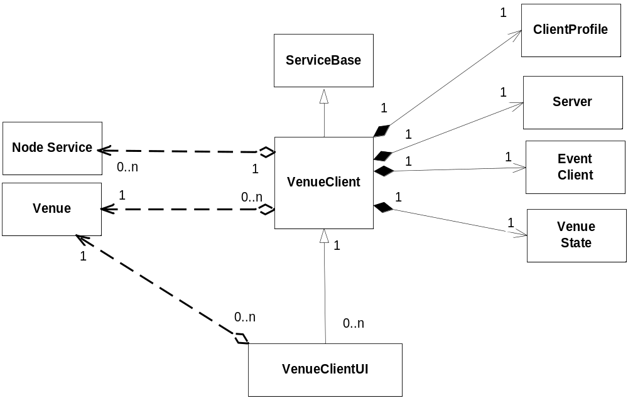

Figure 2.1 Venue Client Class Diagram

2.2.2 Venue Client User Interface Classes Overview

The VenueClientUI includes all graphical user interface components for the Venue Client, illustrated in figure 2.2.

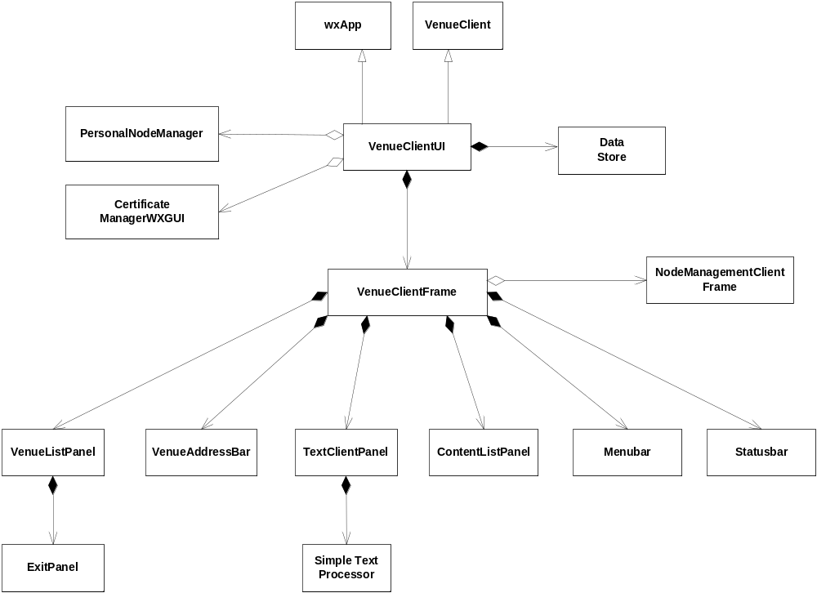

Figure 2.2 Venue Client User Interface Class Diagram

2.2.3 Descriptions Overview
Objects are sent between components as different descriptions, all inherits from the base class ObjectDescription, see figure 2.3.

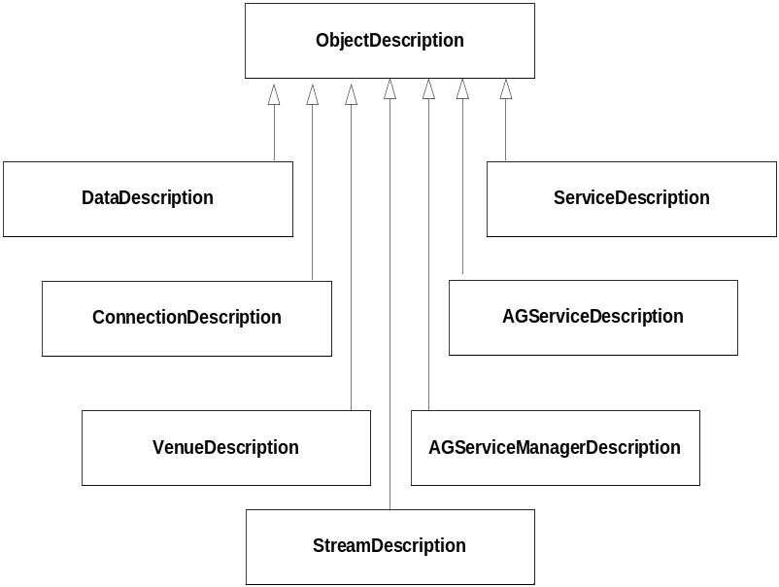

Figure 2.3 Class Diagram for Descriptions

2.3 Coherence
The VenueClient class represents an interface for the Venue it is connected to and is responsible for presenting the contents of that specific Venue. State information includes the name, description, url, and unique id of the Venue, current participants, connections to other Venues, event location, text location, and applications, and is encapsulated in the VenueState object, see figure 2.1. When the state of the Venue changes, for instance when a new participant joins the Venue, an event is distributed through the EventClient. By registering callback methods to the EventClient, the VenueClient handles events and updates the VenueState object accordingly.

Interactions with users are made via the VenueClientUI class, which inherits the VenueClient and overrides the event callback methods to trigger appropriate user interface updates whenever an event occurs. Following sequence diagram, Figure 2.4, shows one example of how calls propagate in order to change and maintain Venue state and finally update the user interface, in this particular case a new participant enters a Venue.

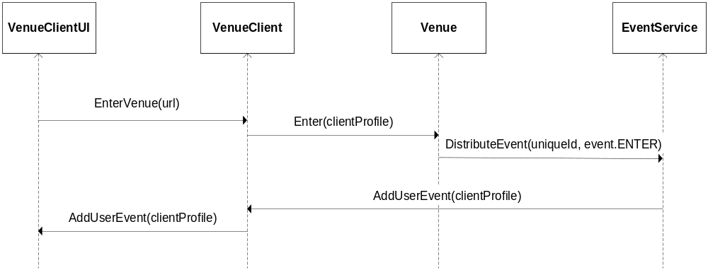

Figure 2.4 Sequence diagram – New user enters Venue

2.4 Shared Data Support
Data is represented in the Venue in two different ways; either belonging to the Venue or owned by a participant or node in the Venue. Venue data will stay in the Venue until removed while personal data will be carried around by the user who owns it, only present when the user is connected to the Venue. However, both types of data can be accessed in the same way when in the Venue, available actions includes add, delete, open,
and save data as well as viewing data properties. Data is represented by DataDescriptions, distinguished by their type parameter. Personal data has type set to the owner’s public id while the value for Venue data equals none, see section 3.0 about Spcifications.

2.4.1 Shared Venue Data
Shared data is stored in the DataStore owned by the Venue, explained in DataStore Design Document. The sequence diagram for adding Venue data is illustrated below in figure 2.5.

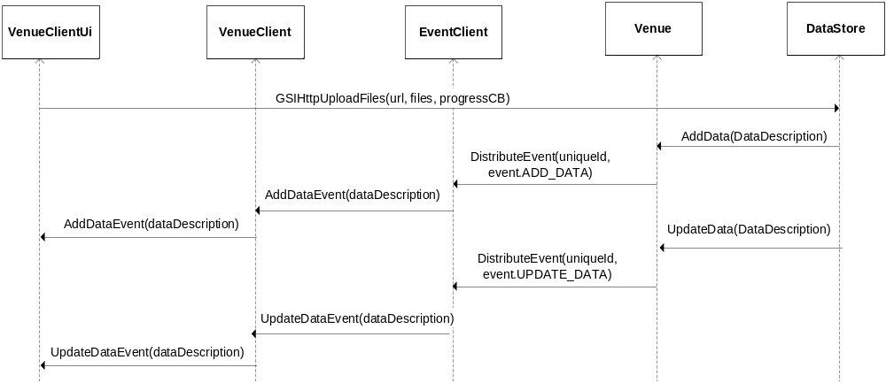
Figure 2.5 Sequence diagram – Add Venue Data

2.4.2 Shared Personal Data
Each VenueClient has a DataStore for personal data storage. DataDescriptions are stored in the Venue in the exact same way as Venue specific data, and the Venue is accountable for distributing correct events to the clients. When receiving data events, the VenueClient and VenueClientUI can, by examining the type parameter in the obtained DataDescription, update the user interface appropriately. Figure 2.6 demonstrates the sequence of actions performed for adding personal data.

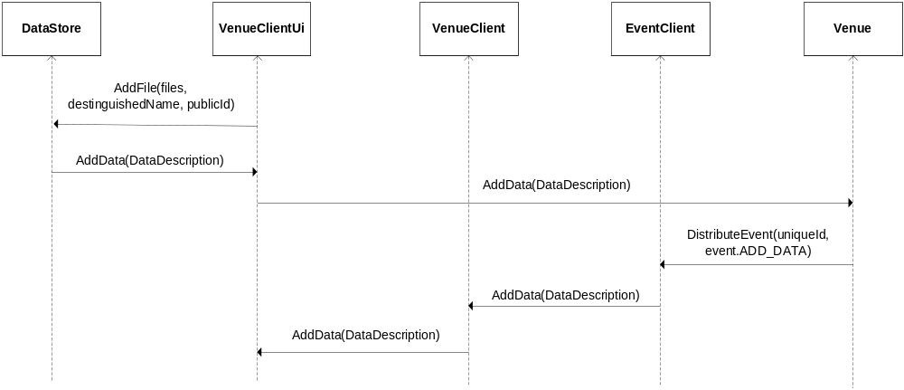

Figure 2.6 Sequence Diagram – Add personal data

2.5 Shared Services Support

NEEDS TO BE SPECIFIED

2.4 Shared Application Support
The Venue client supports integration of shared applications for collaboration within a Venue. This support consists of the following functionality:

Provide interface for adding applications to the Venue
This interface will be very simple, requiring only an application name, description of the application, and a mimetype.

Provide interface for user to associate mimetypes with applications
This interface should be similar to that in a web browser. The user should be able to specify, for each mimetype, one shared application and one non-shared application.

Launch the appropriate application for a given mimetype
When a user chooses to join a shared application session in a Venue, the client will examine the mimetype associated with the session, dereference the mimetype to the application specified by the user, and start the application. If the user has not specified an application for the mimetype, the Venue client will prompt the user to specify one, launching the application when the association has been successfully completed.

The Venue client will start the application with the following command-line:

[python] executable[.py] <appObjectUrl> <profileFile>

The executable may be a python script, in which case it will be executed as an argument to python. appObjectUrl is the URL to the application object web service; profileFile is the path to a file containing the user’s profile.

Interactions between the application component and the application object are outlined in the sequence diagram below.

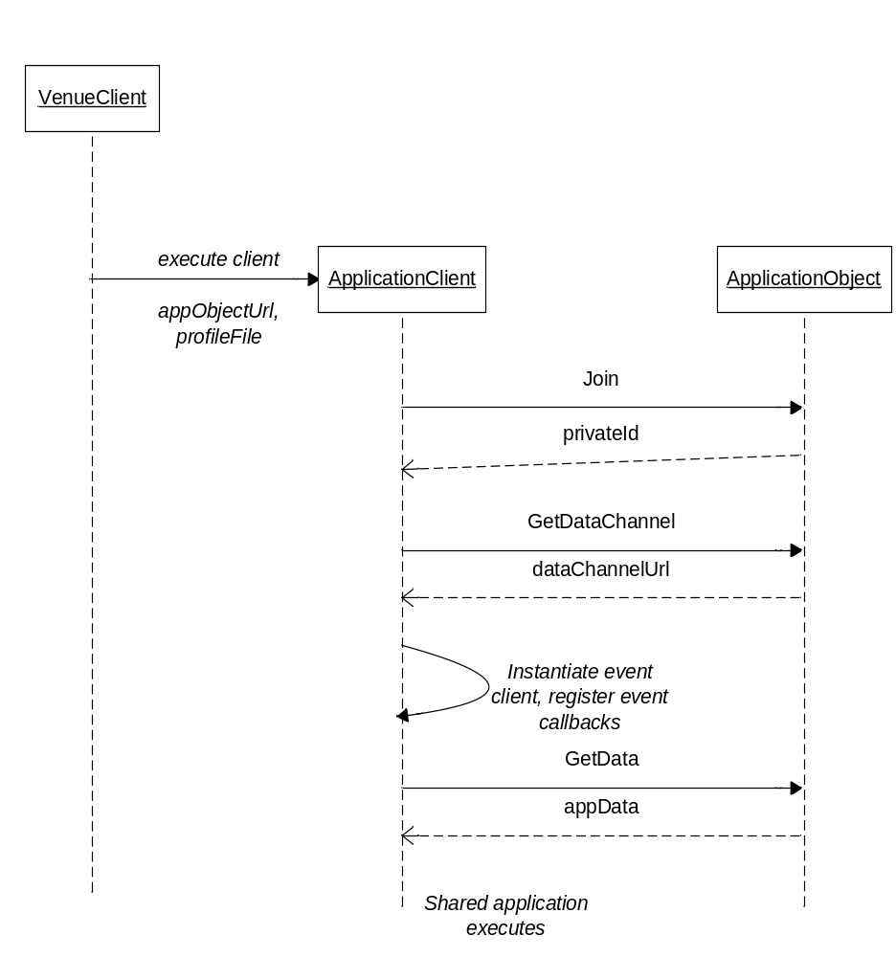

Figure 2.7 Sequence diagram – Shared applications

2.5 Text Communication
Users of the Venue are given the ability to display text messages, visible for all participants of the Virtual Venue, by using the SimpleTextProcessor, as illustrated in figure 2.2.

Figure 2.5 shows how calls are made between two users in the Venue. Initially, the user creates a SimpleTextProcessor and a ConnectEvent is sent to notify that the new user has entered the text communication channel, now able to distribute and react on TextEvents. After creating the processor, the first user decides to write a text message, and sends a TextEvent. The second user’s ProcessNetwork thread hears the call and outputs the text by using the callback sent to the SimpleTextProcessor during creation by the VenueClientUI.

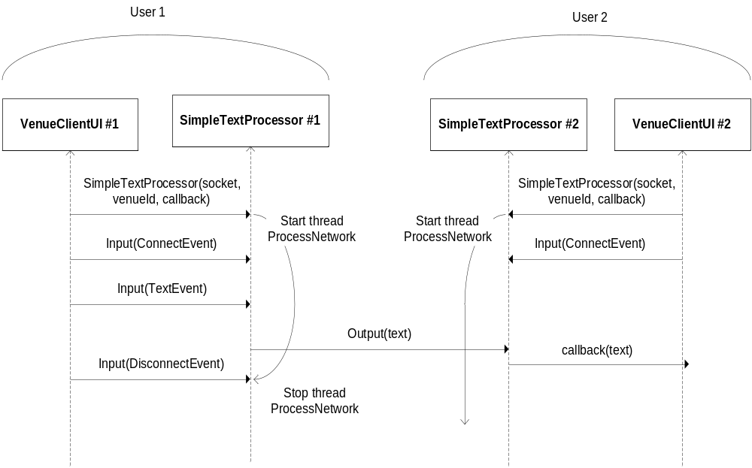
Figure 2.5 Sequence diagram – Text communication

2.6 User Representation
In order to represent users throughout the AccessGrid, each VenueClient includes a ClientProfile object. The ClientProfile information is sent to the Venue when a user first enters, as illustrated in figure 2.4, and is thereby included in the VenueState. By doing so, the client profile information is made public to each participant in the Venue. The client profile is distinguished using its public id, more information about Specifications is found in section 3.0.

2.7 Navigation Interface
Each Venue is associated with a url address, specifying where the Venue is located, allowing Venue Clients to connect and communicate with the Venue using its SOAP interface.

When a Venue is created, the option to set connections to other Venues is made available. The connected Venues are contained in the VenueState object in VenueClient as a list of ConnectionDescriptions that includes name, id, description, and a url address, see section 3.0 about Specifications. This architecture makes it possible for Venue creators to build their own Venue space, and for users to traverse between connected Venues in this space using the Venue Client.

2.8 Follow/Lead
A Venue client is represented in a Venue by its ClientProfile. Each Venue client runs a SOAP Server, the URL of which is contained in its ClientProfile object. One user can, then, select a second user in the Venue and make calls to its SOAP server. Calls to arrange follow/lead relationships between clients are made via this SOAP interface.

When a client enters a Venue, it messages its followers to enter the same Venue over the SOAP interface. A follower only responds to requests made by its registered leader.

Interactions between Venue clients during follow/lead are outlined in the following sequence diagrams.

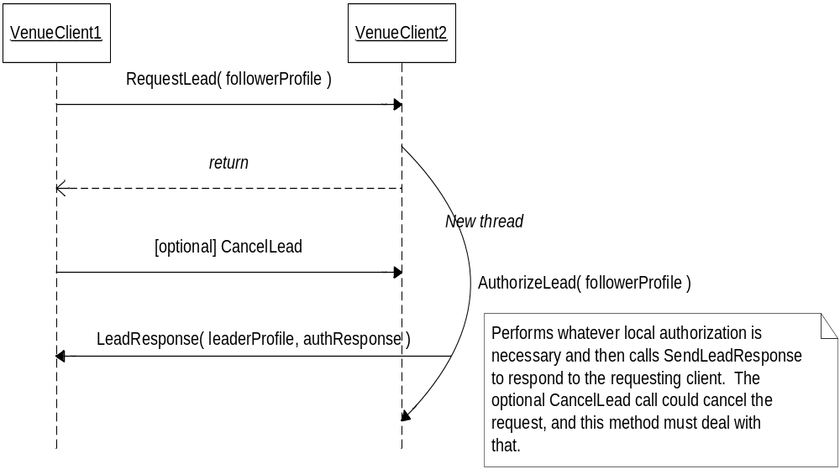Figure 2.8.1 Sequence diagram - Follow

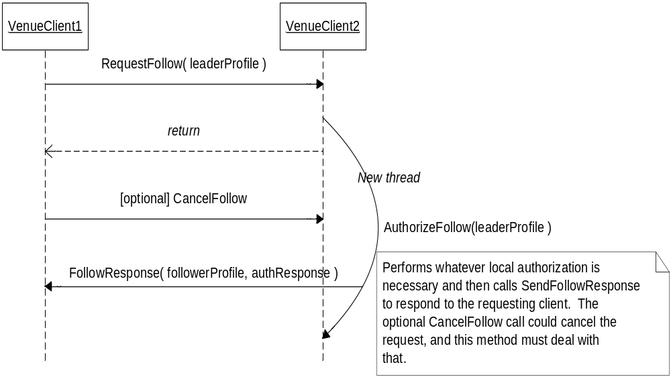
Figure 2.8.2 Sequence diagram - Lead

3.0 Specifications

Venue Client
Attribute | Descriptions
pendingLeader : ClientProfile | Profile of user who’s been requested to lead this node, but hasn’t confirmed
leaderProfile : ClientProfile | Profile of user leading this client
pendingFollowers : ClientProfile [] | List of profiles of users who’ve been requested to follow this client, but haven’t confirmed
followerProfiles : ClientProfile [] | List of profiles of users who are following this client
appAssociations : dict() | Dictionary of mimetype/executable associations  key is mimetype, value is executable name

Method Signature | Description
Methods to maintain coherence with the Venue
EnterVenue(self, URL) | Puts the client into the Venue located at specified URL
ExitVenue(self) | Removes the client from the Venue
AddUserEvent(self, data) | Responds to ENTER events
RemoveUserEvent(self, data) | Responds to EXIT events
ModifyUserEvent(self, data) | Responds to MODIFY_USER events
AddDataEvent(self, data) | Responds to ADD_DATA events
UpdateDataEvent(self, data) | Responds to UPDATA_DATA events
RemoveDataEvent(self, data) | Responds to REMOVE_DATA events
AddServiceEvent(self, data) | Responds to ADD_SERVICE events
RemoveServiceEvent(self, data) | Responds to REMOVE_SERVICE events
AddApplicationEvent(self, data) | Responds to ADD_APPLICATION events
RemoveApplicationEvent(self, data) | Responds to REMOVE_APPLICATION events
AddConnectionEvent(self, data) | Responds to ADD_CONNECTION events
RemoveConnectionEvent(self, data) | Responds to REMOVE_CONNECTION events
SetConnectionsEvent(self, data) | Responds to SET_CONNECTIONS events
Method to support Follow and Lead
CreateVenueClientWebService(self) | Creates SOAP server
Methods to support Follow
Follow(self, leaderProfile) | Encapsulates the call to tell another client to lead this client
RequestLead ( self, followerProfile ) | RequestLead accepts requests from other clients who wish to be lead
AuthorizeLead ( self, clientProfile ) | Authorize requests to lead this client. Subclasses should override this method to perform their specific authorization, calling SendLeadResponse thereafter.
SendLeadResponse( self, clientProfile, response ) | SendLeadResponse responds to requests to lead other Venue clients.
LeadResponse ( self, leaderProfile, isAuthorized ) | LeadResponse is called by other Venue clients to respond to lead requests sent by this client. A UI client would override this method to give the user visual feedback to the Lead request.
Methods to support Lead
Lead(self, followerProfile) | Encapsulates the call to tell another client to follow this client
RequestFollow ( self, leaderProfile ) | RequestFollow accepts requests for other clients to lead this client
AuthorizeFollow ( self, leaderProfile ) | Authorize requests to lead this client. Subclasses should override this method to perform their specific authorization, calling SendFollowResponse thereafter.
SendFollowResponse( self, leaderProfile,response ) | This method responds to requests to be led by other Venue clients.
FollowResponse ( self, followerProfile, isAuthorized ) | FollowResponse is called by other Venue clients to respond to follow requests sent by this client. A UI client would override this method to give the user visual feedback to the Follow request.
Methods to support Shared Applications
AddAppAssociation(mimeType, executable)
RemoveAppAssociation(mimeType)
GetAppAssociation(mimeType) : executable

VenueState
Attribute | Description
uniqueId : int
name: string | Name of the Venue
description : string | Description of the Venue
uri : string | Location to where Venue SOAP calls should be made
eventLocation : string | Host and port where the EventService can be found
textLocation : string | Host and port where the TextService can be found
connections: dict() | Venues this Venue is connected to, key is url and value is ConnectionDescriptions
users : dict() | Users in the Venue, key is public id and value is ClientDescriptions
nodes : dict() | Nodes in the Venue, key is public id and value is ClientDescriptions
data : dict() | Data in the Venue, both personal and Venue. Key is name and value is DataDescriptions
clients : dict() | ?
Applications : dict() | Applications in the Venue.

ClientProfile
Attribute | Description
techSupportInformation : string | ????
profileType : string | A user can either be of type ‘NODE’ or ‘USER’
email : string | Users email address
name : string | Users name
phoneNumber : string | Users phone number
icon : IconType | Users icon
VenueClientURL : string | Url pointing to where the client’s web service is located
[key] publicId : string | The public id is a client’s unique id
privateId : string | ????
distinguishedName : string | Destinguished name associated with globus grid proxy
capabilities : Capability [ ] | List of user capabilities
homeVenue: string | The Venue url that will act as the default Venue url
location : string | Where is the users physical location
defaultProfile : dict() | Configuration values of initial client profile

Method signature | Description
ClientProfile(self, fileName = None) | Creates a client profile, if fileName is None this is the default profile
Load(self, fileName) | Load this ClientDescription with information from a profile saved with path fileName
CheckProfile(self) | Check to see if this profile contains correct information
Save(self, fileName) | Save this profile into a configuration file at location filename
IsDefault(self) | Check to see if this client profile has been changed based on the default profile

ObjectDescription
Attribute | Description
name : string | The name of the object
description : string | Description of the object
[key] url : string | Address where the object is located
Id : float | Unique id

DataDescription
Attribute | Description
name : string | File name, parameter inherited from ObjectDescription
description : string | Description of the data, parameter inherited from ObjectDescription
[key] uri : string | Address where the data is located, parameter inherited from ObjectDescription
id : float | Unique id, Inherited from ObjectDescription
type : string | Used to distinguish between different data. Includes owners public id, else None if the data belongs to a Venue
owner : string | Distinguished name of the user who created the DataDescription.
size : int | Size of data
checksum : float ????? | Checksum for data

ConnectionDescription
Attribute | Description
name : string | The name of the connected Venue, parameter inherited from ObjectDescription
description : string | Description of the Venue, parameter inherited from ObjectDescription
[key] url : string | Address where the data is located, parameter inherited from ObjectDescription
Id : float | Unique id, Inherited from ObjectDescription

Event
Attribute | Description
eventType : string | Specifies the type of the event, available events includes;  ENTER, EXIT, ADD_USER, MODIFY_USER, ADD_DATA, MODIFY_DATA, REMOVE_DATA, ADD_SERVICE, REMOVE_SERVICE, ADD_APPLICATION, REMOVE_APPLICATION, ADD_CONNECTION, REMOVE_CONNECTION, SET_CONNECTIONS, UPDATE_VENUE_STATE
venueId : string | Contains information of what venue this event belongs to
data : string | Data being sent with the event

Method signature | Description
Event(self, eventType, venueId, data) | Creates an event

4.0 Notes
Consideration should be taken to move non user interface code from the VenueClientUI to the VenueClient in order to separate user interface from implementation, examples of components that might belong in VenueClient are the personal DataStore, the SimpleTextProcessor, and PersonalNodeManager, see figure 2.2.

