Node Setup Wizard Design
Futures Laboratory
Argonne National Laboratory
9700 S. Cass Ave.
Argonne, IL 60439
4/23/2003

Introduction
The node setup wizard guides users through the steps necessary for setting up and testing a room-based Access Grid node. The wizard creates a configuration file that can be loaded from the Node Management Tool and the user can optionally decide to always load the created configuration as default when opening the Venue Client in personal node mode.

Design
The user interface is developed in wxPython. All interactions with the AGNodeService, AGServiceManagers, and AGServices SOAP interfaces are done via the NodeInterface class to separate UI components from node components.

Class Diagram
The NodeSetupWizard is the main class including all the wizard pages. Each wizard page inherits the TitledPage class which is a template for how to display page titles and a possible wizard image. To separate user interface code, the wizard pages use a NodeInterface object that has an AGNodeService instance. The NodeInterface uses the AGNodeService to communicate with AGServiceManagers and AGServices SOAP interface but SOAP calls are also made directly from the NodeInterface, see Figure 1.
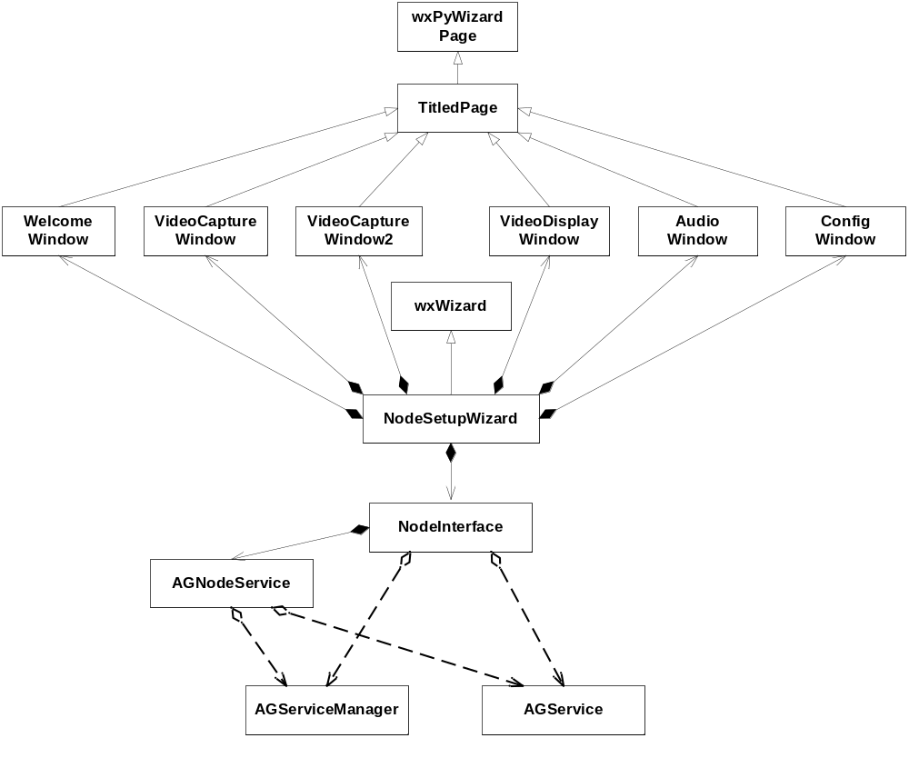
Figure 1 Class Diagram

Sequence Diagrams
Figure 2 illustrates the flow of actions between classes when a user runs the node setup wizard. When the user clicks ‘Next’ in the VideoCaptureWindow, VideoDisplayWindow, or AudioWindow their validate methods are called to check if an AGServiceManager is running on the machine and port specified. The VideoCaptureWindow also checks which video capture cards are installed on the video machine and displays them in VideoCaptureWindow2. The ConfigWindow summarizes the node configuration entered by the user. When the user clicks ‘Finish’, the NodeInterface adds all AGServiceManagers and their AGServices to the AGNodeService. Finally, AGNodeService.StoreConfiguration is called to save the configuration and make it available to load from the Node Management Tool. If the user toggles the default option box, AGNodeService.SetDefaultConfiguration is called to allow this configuration to be loaded when starting the VenueClient in personal node mode (default configuration).

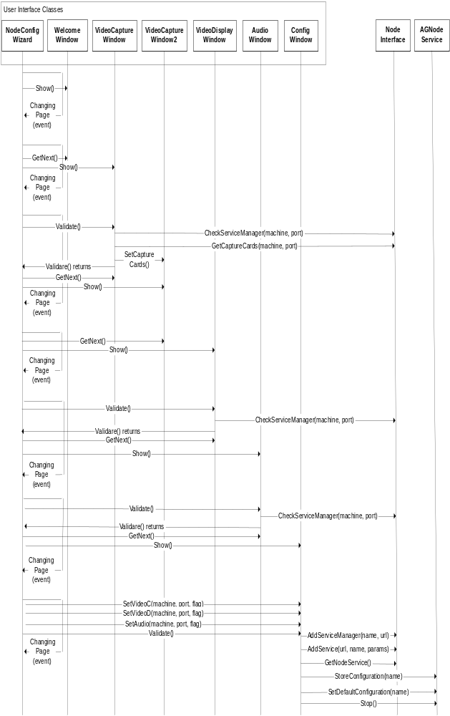
Figure 2 Node Setup Wizard Sequence Diagram
Methods included in the NodeInterface are illustrated in Figure 3. Examples of classes that make the calls are shown on the left hand side for the figure. One method worth mentioning is the AddService call. The service configuration is not known when the AGNodeService.AddService call is made so we need to request the created configuration from the AGService SOAP method after the service is added to set right camera ports and executable path.
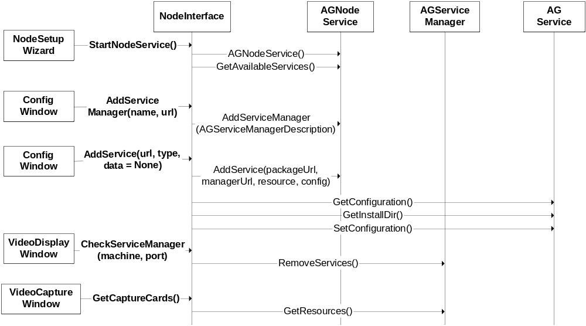
Figure 3 NodeInterface Sequence Diagram

