Certificate Request Tool Design
Futures Laboratory
Argonne National Laboratory
9700 S. Cass Ave.
Argonne, IL 60439
4/23/2003

Introduction
The certificate request tool helps users to request identity, service, and host certificates.

Design
The certificate request tool is a user interface that has a certificate request client (CRSClient) and a CertificateRepository. The user interface is developed in wxPython and uses the CRSClient to request a certificate and the CertificateRepository for certificate storage.

Class Diagram
The CertificateRequestTool is a wizard with six pages, see Figure 1. It helps the user to request identity, service, or a host certificate. The CertificateStatusDialog is used to show currently requested but not received certificates and allows the user to check their status and install requested certificates.

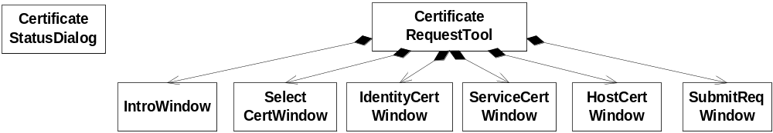
Figure 1 Class Diagram

Sequence Diagrams
Each wizard page has a Validate method that is called by the CertificateRequestTool when the user clicks the ‘Next’ button. When the user clicks ‘Next’ on the last page, SubmitReqWindow, the CertificateRepository creates the request and the CRSClient submits the request, see sequence diagram in Figure 2. The certificate request is stored in the CertificateRepository together with the request id to indicate that the certificate is requested but not yet received.
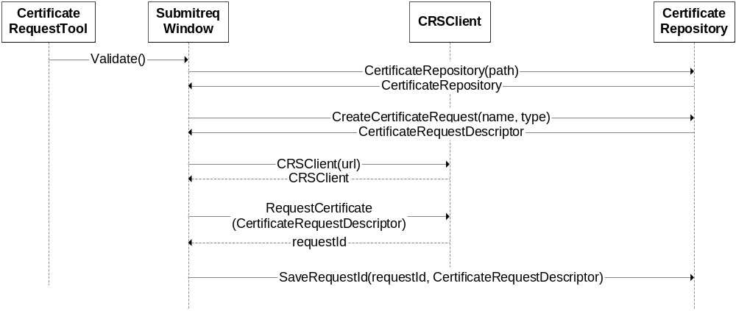
Figure 2 Submit Certificate Request Sequence Diagram

If the user has pending requests (the request and the request id is present in the CertificateRepository), the CertificateStatusDialog is opened. It shows the user which certificates are already requested but not yet received. The CertificateStatusDialog checks the CertificateRepostitory for requested certificates, see Figure 3. It receives a dictionary with requestId’s and requests and displays the certificate information for the user with status ‘Not Approved’. If the user clicks ‘Ok’, the CertificateStatusDialog then tries to retrieve the certificate from the CRSClient. If the certificate is ready, the status of that certificate is set to ‘Installed’ and the certificate is saved into the CertificateRepository, and the request id is removed to show that the certificate is present.

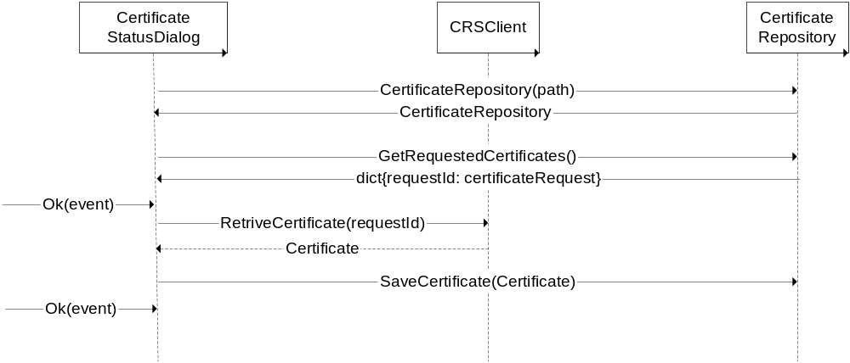
Figure 3 Certificate Status Dialog Sequence Diagram

