Venue Management Design 2.0
Futures Laboratory
Argonne National Laboratory
9700 S. Cass Ave.
Argonne, IL 60439
4/23/2003

1 Introduction
The Venue Management is an administrative tool used to create and maintain venues located on a server. It includes information about present venues on the server, their storage location, authorized administrators, and the type of encryption used for media communication.

2 Design
The Venue Management is made up of graphical user interface components listening to user actions. Based on received user events, Venue Management calls correct venue and venue server SOAP interface methods.

2.1 Technology Decisions
The Venue Management will be implemented in python with user interface components developed using wxPython. In order to communicate with venues and the venue server, SOAP technology will be used.

2.2 Abstractions
This section gives an overview of the Venue Management classes and provides sequence diagrams to clarify main actions used to communicate with a venue server. Finally, a summary of descriptions used to encapsulate and send data between server and Venue Management is illustrated.

2.2.1 Venue Management Software Overview
The class diagram in Figure 1 shows an overview of the Venue Management application. The VenueManagementClient class inherits wxApp and starts the wxPython main user interface thread. It also includes a wxFrame containing all user interface classes such as the menu bar, status bar, address bar, and VenueManagementTabs. The contents of the server are displayed as two different tabs, one showing venues located on the server, the VenuesPanel, and the other for presenting configuration information, the ConfigurationPanel. The WXGUIApplication is used for certificate management and are separate from the main wxFrame. If the user is missing a proxy certificate this dialog will make sure one is created before the wxFrame is displayed. One could argue that classes could be combined, but current class separation allows for extensibility in case additional pieces needs to be incorporated into the Venue Management software or decisions are made to change the appearance of the user interface.

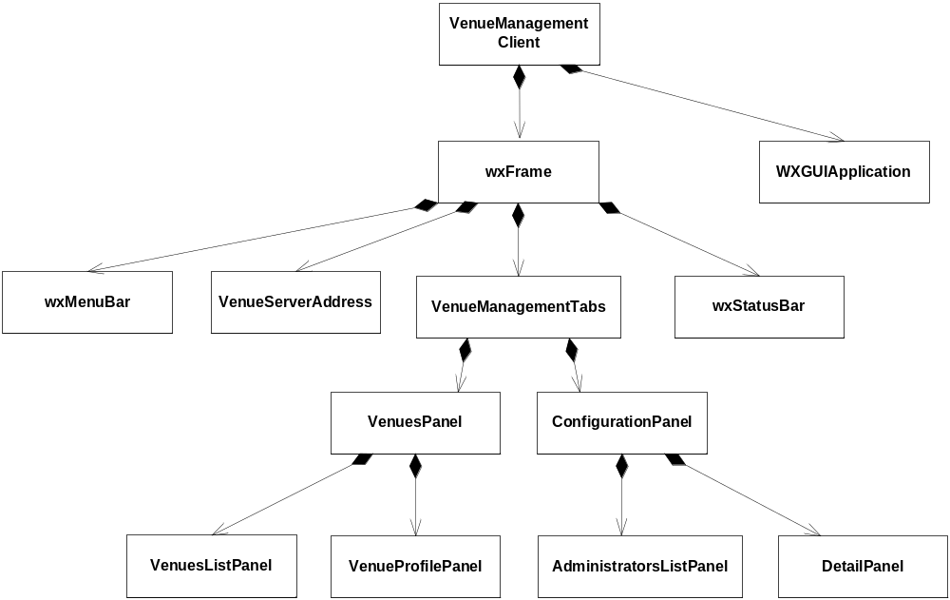
Figure 1 Class diagram (see Section 3.1 for UML details)

2.2.2 Dialogs
Dialogs used to create and modify venues and administrators as well as changing storage location and multicast options are illustrated in Figure 2. AddVenueFrame and ModifyVenueFrame are opened when a user wants to create or modify a venue. The dialogs are identical, except from frame title, and are therefore inheriting VenueParamFrame that includes code for user interface components. If the dialogs are to be changed this only needs to be done in the VenueParamFrame and the sub classed dialogs will consequently have the same appearance. Same concept is used for creating and modifying administrators, the AddAdministratorFrame and ModifyAdministratorFrame both inherit the AdministratorParamFrame. If the user decides to change data storage location for venues located on the server, the EditPathDialog will appear. The MulticastDialog is used to change the custom range multicast address option for the server.

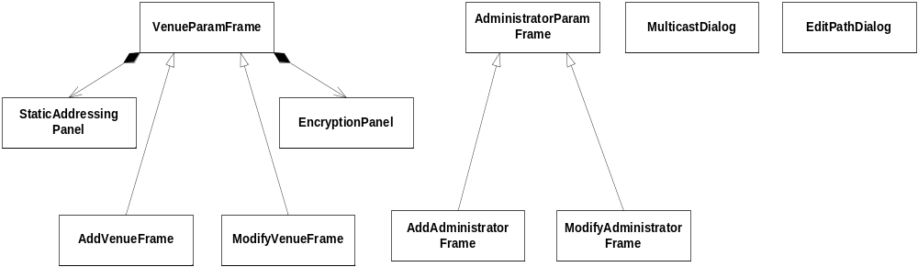
Figure 2 Dialogs used in Venue Management (see Section 3.1 for UML details)

2.2.3 Sequence Diagrams
Following sequence diagrams illustrates the communication flow within the Venue Management software for adding and modifying a venue. You can also see necessary calls made to venue and venue server SOAP interface to execute the action triggered by the user. (Note: This code is too messy and work is in progress to change the design.)
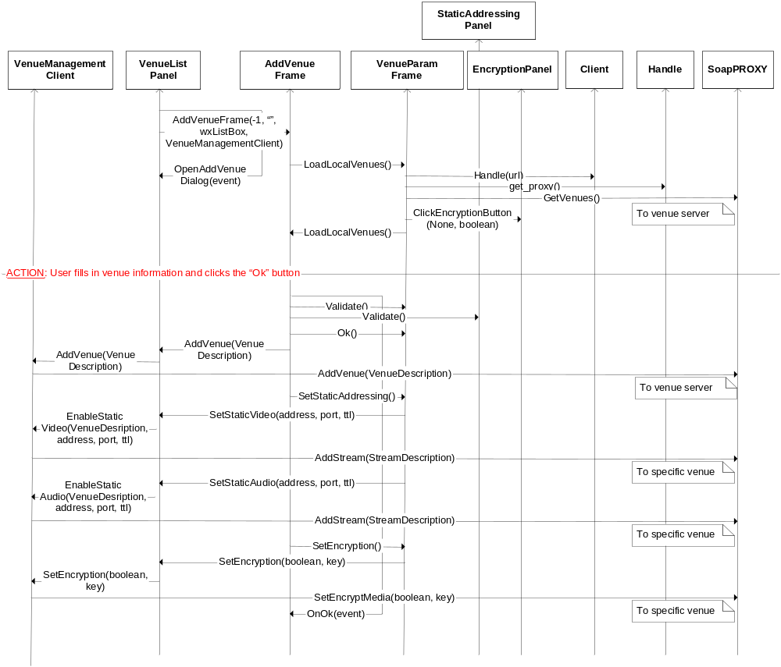
Figure 3 Add a new venue to the venue server

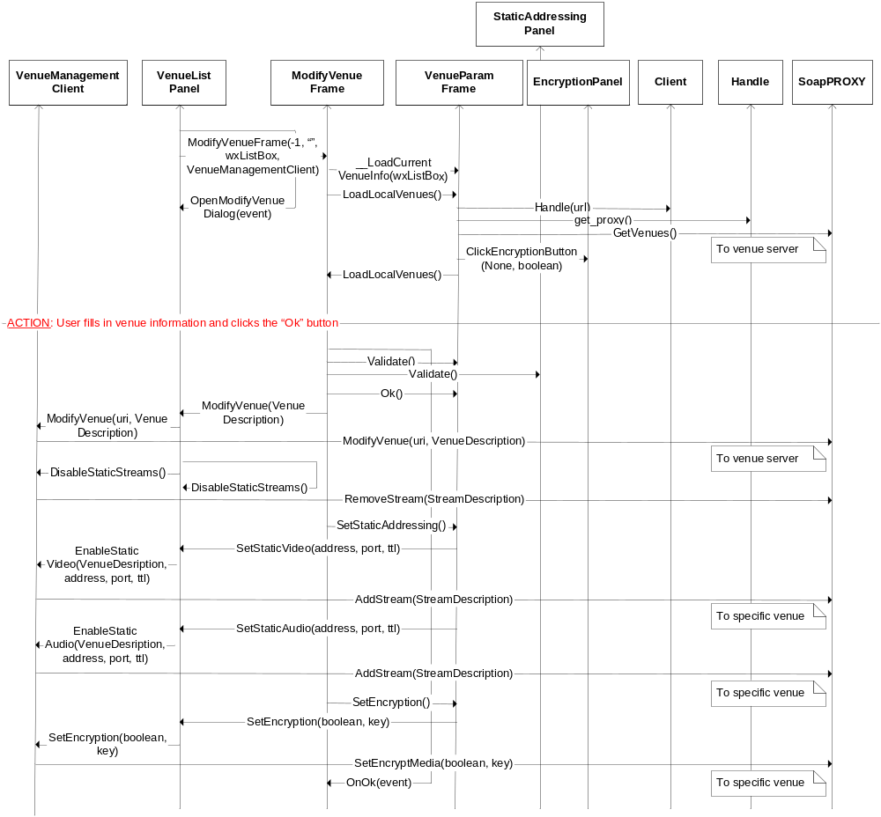
Figure 4 Modify a venue currently located on the server

2.2.4 Descriptions Overview
Different descriptions are used to encapsulate data communicated with venues and the venue SOAP methods. Each description is derived from the ObjectDescription class, illustrated in Figure 2.3.

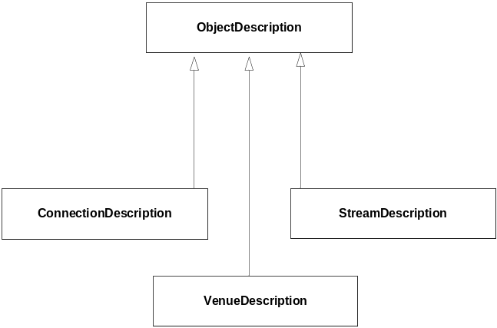
Figure 5 Class diagram for descriptions used to communicate with venues and the venue server (see Section 3.1 for UML details)

3 Notes
The Venue Management implementation of add and modify venue, see Section 2.2.3, needs to be cleaned up and restructured. The venue server interface, used by the code, changed from the initial specification and that resulted in some temporary solutions in Venue Management. The code should be improved to enhance readability.

3.1 UML
Figure 4.1 describes UML symbols used for class diagrams in this document.

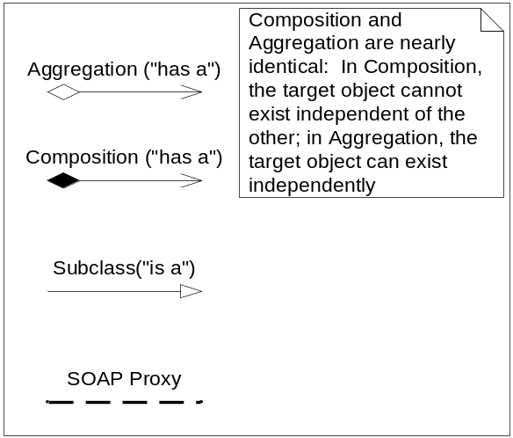
Figure 6 UML symbols

