Bridge Server Design
The Futures Laboratory
Mathematics and Computer Science Division
Argonne National Laboratory

October 2003

Introduction
This document describes a means by which Virtual Venues can enable clients without multicast connectivity to interact with other multicast-connected venue participants. The solution involves a bridge server which interacts with particular venues to discover their media streams and create bridges from multicast to unicast. The unicast transport information is included in the network locations specified for the venue. When a client enters the venue, each applicable stream is described, with available transports. The client selects from among these and configures media tools accordingly.

Motivation
The AccessGrid relies heavily on working multicast for transmitting audio and video among participants. This reliance suffers from two factors:
- Not all sites have multicast available
- Multicast is not sufficiently reliable

To this end, we define a mechanism by which clients can use an alternate transport—in this case, unicast—when multicast is not available.

Requirements
Create unicast bridges for streams in a venue
Add/Remove unicast bridges as streams are added/removed in the venue
The Bridge Server must be able to bridge new streams as they are added to the venue, and should stop bridges when the corresponding stream is removed.
Represent bridges coherently in venue
The venue should remove bridge info from the venue if a bridge becomes unavailable
Allow the bridge server to reside on a separate machine
Bridging a large amount of multicast traffic could overload the venue server, so the bridge server should be able to reside on a machine distinct from that on which the venue server is running.
In the future, this will enable users in a venue (or network service providers) to provide bridges for a venue.

Assumptions

Bridging is not targeted at restoring full connectivity to the users in a multicast group
This is not being considered because it requires knowledge about the connectivity of the individuals in the multicast group.

Design Overview
A BridgeServer will be employed to run bridges and make them available within venues. Given a set of venues, the bridge server will, for each venue:
- register with the venue
- attach an event client to the venue event service
- begin sending heartbeats to the venue (1)
- query the streams in the venue
- for each stream (2)
  - start a multicast bridge
  - add the bridged address/port to the stream
- listen for AddStream/RemoveStream events, and add/remove streams appropriately (3)
If the venue doesn’t receive heartbeats from the NetService, it removes the associated bridge addresses from its streams.
When a client enters the venue, it receives a list of the stream descriptions in the venue. These include the bridged addresses, which include information about the bridge provider, from among which the client can select.

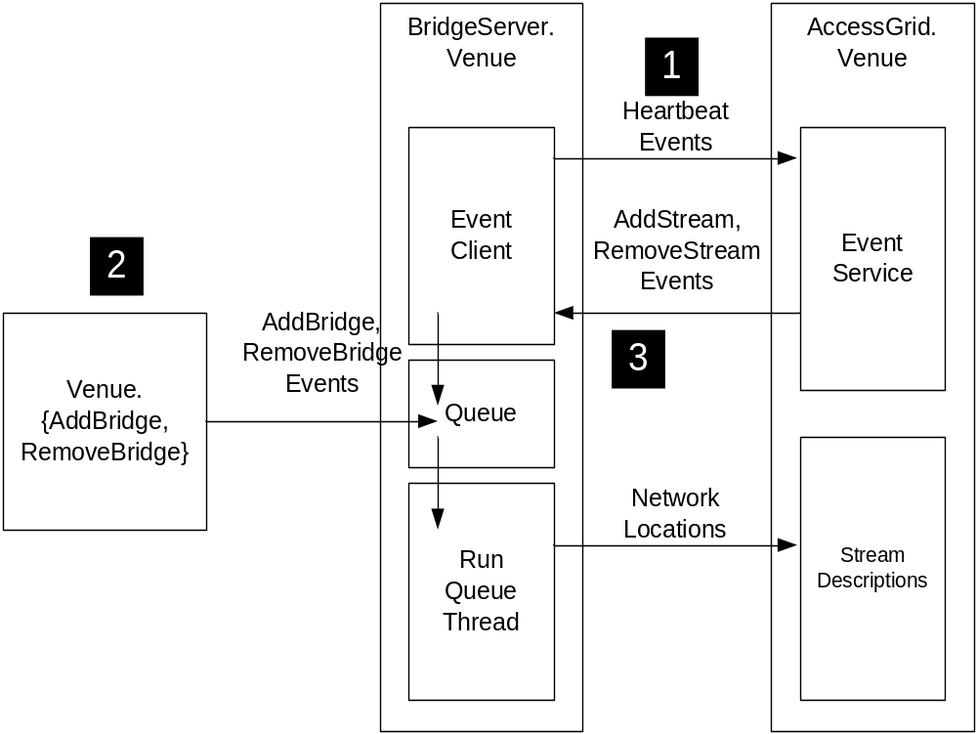
Figure 1 Overview of BridgeServer operation

Decomposition

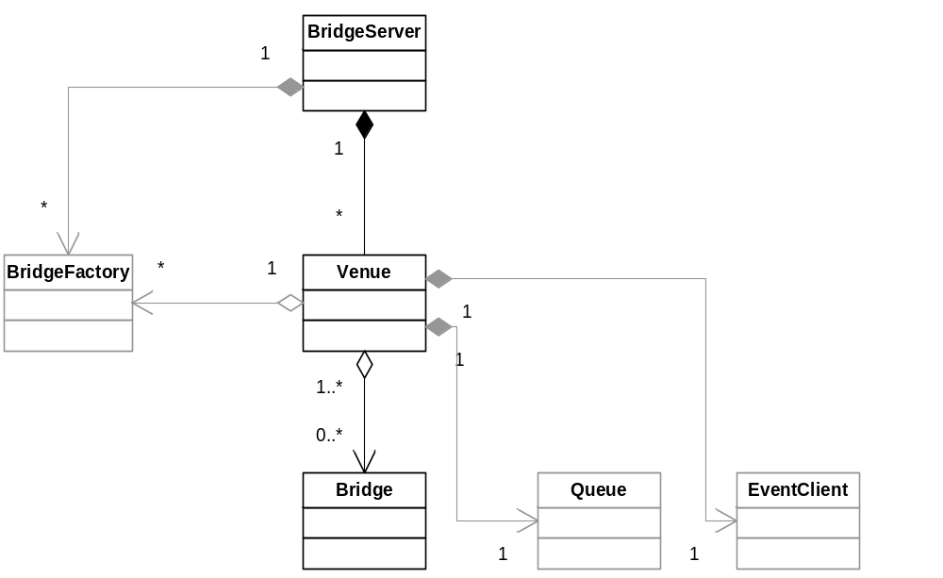
Figure 2 Class Diagram

Overview
The BridgeServer is decomposed as shown in Figure 1, with the secondary parts grayed out.
A BridgeServer keeps a list of Venues that it is bridging. A Venue has a Bridge for each stream it is bridging. A Venue also has an EventClient, for sending heartbeats to the Venue event service, and for receiving events regarding stream changes in the venue. Each Venue also has a Queue, for starting and stopping bridges at startup and in response to events.
Bridges are created by a BridgeFactory.
The individual components are described in more detail below.

BridgeServer.BridgeServer
The Bridge Server is simply a container for Venue objects. It includes methods for adding and removing venues to the list of Venues being bridged, and for shutting down the BridgeServer.

Attributes
providerProfile : ProviderProfile
bridgeFactory : BridgeFactory
privateId : string
venues : dict [key=venueUrl ; value = Venue]
running : int [0:1]

Methods
__init__(providerProfile, bridgeFactory, privateId, debug=0) : BridgeServer
__setLogger() : None
AddVenue( venueUrl ) : None
RemoveVenue( venueUrl ) : None
RemoveVenues() : None
GetVenues() : list of Venues
Shutdown() : None
IsRunning() : int [0:1]

BridgeServer.BridgeFactory
The BridgeFactory is a generator of Bridge objects. The BridgeFactory is used to encapsulate knowledge about the bridging software being used, away from the rest of the hierarchy of the BridgeServer. It maintains knowledge about Bridges currently in use, so it can reuse an existing Bridge if a second request is made for the same multicast address/port.

Attributes
qbexec : string
bridges : dict [key=addr + str(port) ; value = Bridge]

Methods
__init__(qbexec) : BridgeFactory
CreateBridge(id,maddr,mport,mttl,uaddr,uport) : Bridge
Create a Bridge for the specified multicast group, using the specified unicast address/port. If a Bridge already exists for the multicast group, return it instead of creating one.
DestroyBridge(Bridge) : None
Remove a reference to this Bridge. If the reference count is zero, delete the Bridge.

BridgeServer.BridgeFactory.Bridge
A Bridge receives multicast traffic and republishes it on a unicast address/port. Clients connect to the unicast address/port to receive the data.

Attributes
qbexec : string
id : string
maddr : string
mport : int
mttl : int
uaddr : string
uport : int
processManager : ProcessManager

Method
__init__(qbexec, id, maddr, mport, mttl, uaddr, uport) : Bridge
Start() : None
Stop() : None

BridgeServer.Venue
This class represents a venue for the purposes of the BridgeServer. It calls the BridgeFactory to create Bridges for venue streams, listens for addition and removal of streams and adds/removes bridges accordingly. It spawns two threads: one to send heartbeats to the venue, and the other to process events placed in its Queue. The event client used by a venue also requires a thread.
The Queue is used to isolate the starting and stopping of bridge processes to a single thread, since difficulties arise when one thread tries to kill processes started by a second thread.

Attributes
venueUrl : string
providerProfile : ProviderProfile
bridgeFactory : BridgeFactory
privateId : string
venueProxy : SOAPProxy
bridges : dict [key = bridgeId; value = Bridge]
queue : Queue()
running : int [0:1]
sendHeartbeats : int [0:1]
channelId : string
eventServiceLocation : tuple (event service location, channelId)
eventClient : EventClient

Methods
__init__(venueUrl, providerProfile, bridgeFactory, id) : Venue
ConnectEventClient() : None
EventReceivedCB(event) : None
AddBridges() : None
RemoveBridges() : None
AddBridge(StreamDescription) : None
RemoveBridge( bridgeId ) : None
__AddBridge(self, streamDesc)
__RemoveBridge(self, id):
RunQueueThread() : None
HeartbeatThread() : None
Shutdown() : None

AccessGrid.Venue.Venue
The Venue maintains a list of stream descriptions. StreamDescriptions are being extended to include a list of network locations. The Venue exposes interfaces for adding and removing network locations in streams.
Additions to Venue class:

Attributes
netServices : dict [key = privateId; value = tuple (NetService, lastHeartbeatSecs) ]

Methods
AddNetworkLocationToStream( privateId, streamId, NetworkLocation ) : int networkLocationId
RemoveNetworkLocationFromStream( streamId, NetworkLocation ) : None
RemoveNetworkLocationsByPrivateId(privateId) : None
GetEventServiceLocation() : tuple (event service location, channelId)

AddNetService(clientType, privateId=str(GUID())) : string privateId
Adds a NetService of the specified type. If the type is not known, an exception is raised.
RemoveNetService(privateId): None

Modifications to Venue class:
- channelAuthCallback accepts EventService connections from NetService clients
- ClientHeartbeat handles heartbeat events from NetService clients
- CleanupClients modified to remove NetServices with expired heartbeat

AccessGrid.VenueClient.VenueClient
The venue client receives a list of stream descriptions when a venue is entered. The StreamDescription class has been modified to include a list of network locations. The lis includes the multicast address and unicast addresses for bridges that are present in the venue. Each network location includes information about the provider of the bridge.
The venue client presents options for selecting one of the bridges, modifies the location attribute of the stream descriptions, and sends them to the node service to update the media services.

AccessGrid.Descriptions.StreamDescription
A StreamDescription contains a network location, which includes a multicast address, port, and ttl; the network location remains in the stream description. The StreamDescription has been extended to include a separate list of network locations. Among these will be the multicast network location and any additional unicast network locations added to represent bridges. Each network location includes an attribute to identify the provider (by name and location).

Additions to StreamDescription:

Attributes
networkLocations : list

Methods
AddNetworkLocation(NetworkLocation) : int networkLocationId
Note: This method sets the id in the networkLocation passed in
RemoveNetworkLocation(networkLocationId) : None

AccessGrid.NetworkLocation.NetworkLocation
Addition to NetworkLocation:

Attributes
id : string
privateId : string
profile : ProviderProfile

AccessGrid.NetworkLocation.ProviderProfile
The ProviderProfile class is new in the NetworkLocation module. It describes the provider of a particular network location. It is a nearly trivial class, and it is compatible with the ClientProfile class so that a ClientProfile could be substituted for a ProviderProfile.

Attributes
name : string
location : string

Methods
__init__(name,location) : ProviderProfile

AccessGrid.NetService.NetService

Attributes
venue : string
privateId : string
type : string
connObj : EventServiceAsynch.ConnectionHandler

Methods
SetConnection(EventServiceAsynch.ConnectionHandler) : None
Stop() : None

AccessGrid.NetService.BridgeNetService

Methods
Stop() : None
Removes network locations associated with the given privateId from streams in the venue

Functionality

BridgeServer.Venue

Handle AddStream event
Processes must be stopped in the same thread that created them; therefore, all starting and stopping of bridges is done in the queue processing thread. To add a bridge, an AddBridge event is put in the queue.
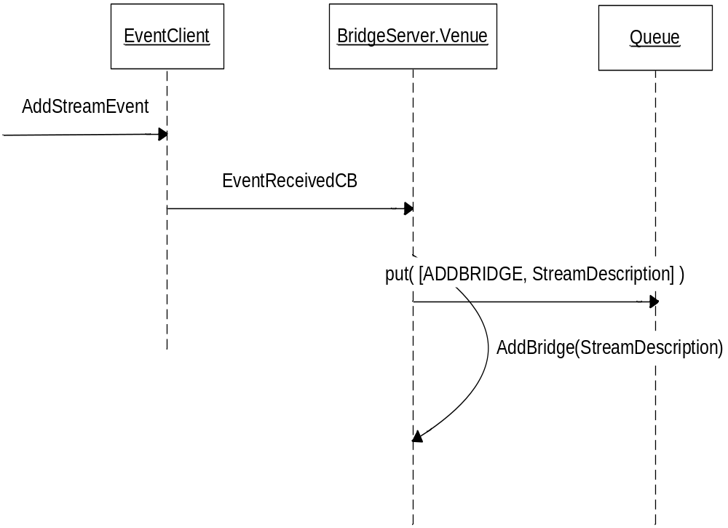
Figure 3 Sequence Diagram for handling of add stream events

Handle RemoveStream event
Processes must be stopped in the same thread that created them; therefore, all starting and stopping of bridges is done in the queue processing thread. To remove a bridge, a RemoveBridge event is put in the queue.
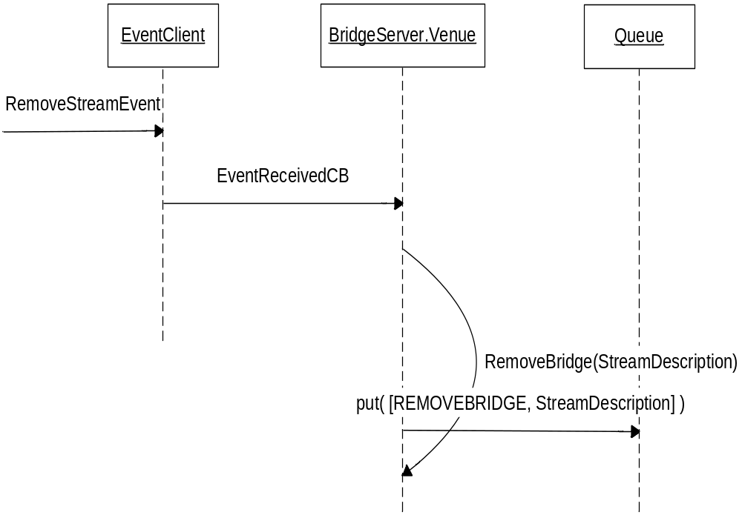
Figure 4 Sequence Diagram for handling of remove stream events

Add Bridge
When an AddBridge event is gotten from the Queue, the __AddBridge method is called. The operation of this method is described in the figure below.
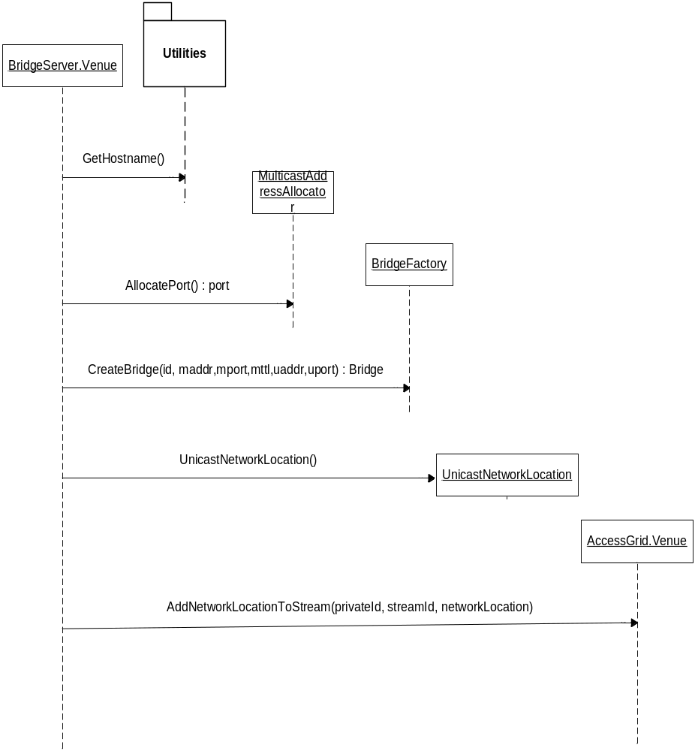

Remove Bridge
When a RemoveBridge event is gotten from the Queue, the Venue.__RemoveBridge method is called. This method:
- calls BridgeFactory.DestroyBridge, which will destroy the bridge if there are no other references to it.
- removes the bridge from the list of Bridges kept by the Venue

AccessGrid.Venue.Venue

Heartbeat from BS lost, associated transports removed, client notified
If the Venue does not receive a heartbeat from the BridgeServer within the critical period, network locations registered by the BridgeServer are removed. Thereafter, a ModifyStream event is distributed to clients of the event channel. It’s the clients responsibility to handle the event appropriately; in the case of the venue client, the option for selecting unicast will be disabled if no unicast network locations exist in the stream descriptions.

BridgeServer-Venue/VenueServer data flow
The data exchanged between the BridgeServer and a Venue consist of the following:
- string data (ids, etc.)
- NetworkLocation objects
- Python tuples (return from Venue.GetEventServiceLocation)
- StreamDescription lists
The data exchanged between the BridgeServer and a VenueServer consist of the following:
- VenueDescription lists (return from VenueServer.GetVenues)

Deployment
The BridgeServer must be pointed at a venue or venues at startup. To this end, the BridgeServer will include options for specifying venues to bridge in the following ways:
- a single venue url
- a list of venue urls in a file
- a single venue server url (all venues on that server will be bridged)
- a list of venue server urls in a file (all venues on all servers will be bridged)
The BridgeServer will also include options for specifying the name and location of the provider of the bridge; this will allow users to select the site to which they wish to bridge on a name/geographic basis. These options are specified in a configuration file; the format of the configuration file is as follows:

[BridgeServer]
# the “id” field is assigned by the system
id = <unique id of this bridge server>
name = <name of your institution>
location = <location of your institution>
qbexec = /usr/bin/QuickBridge
# ONE of the following mutually exclusive options can be specified
venue = <URL of venue to bridge>
venueFile = <file containing URLs of venues to bridge>
venueServer = <URL of venue server to bridge>
venueServerFile = <file containing URLs of venue servers to bridge>

Format of BridgeServer configuration file

Notes
Modification of QuickBridge code
Normally, QuickBridge will abort if it detects multicast traffic from a known unicast peer. If multiple users are connected to a bridge when this occurs for one user, all users will lose their bridge. That’s okay for the user who has regained multicast, but not for the remaining users. QuickBridge has, therefore, been modified to just disconnect the offending user.

