**First Simulation Workshop on**

**ASPEN and CFD (Ansys) for**

**Chemical Engineering Students & Scholars**

**ACCESS - 2018**

**4 – 15, June 2018**

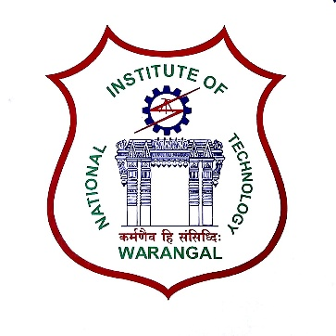

**Coordinators**

**Dr. V. Ramsagar**

**Dr. P. V. Suresh**

**Dr. T. Sunil Kumar**

**Dr. A. Sarath Babu**

[~~https://sites.google.com/view/imtme2018~~](https://sites.google.com/view/imtme2018)

**Organized by**

**Department of Chemical Engineering**

**National Institute of Technology**

**Warangal – 506 004, India**

**ABOUT THE PROGRAM**

This workshop is mainly aimed at providing rich hands-on experience to the participants on the use of process and flow simulation software - **ASPEN PLUS** and **Ansys CFD** in addressing Chemical Engineering problems. The lecture sessions are carefully designed to provide the required theoretical background. The laboratory exercises include problems drawn from almost all the core areas of Chemical Engineering. Real life examples from industry will be demonstrated as case studies.

The workshop includes 40 hours of classroom lectures and 30 hours of laboratory practice and is **offered for two credits.** The participants are evaluated on a continuous basis and their performance will be graded. A certificate indicating the credits and the grade obtained will be issued.

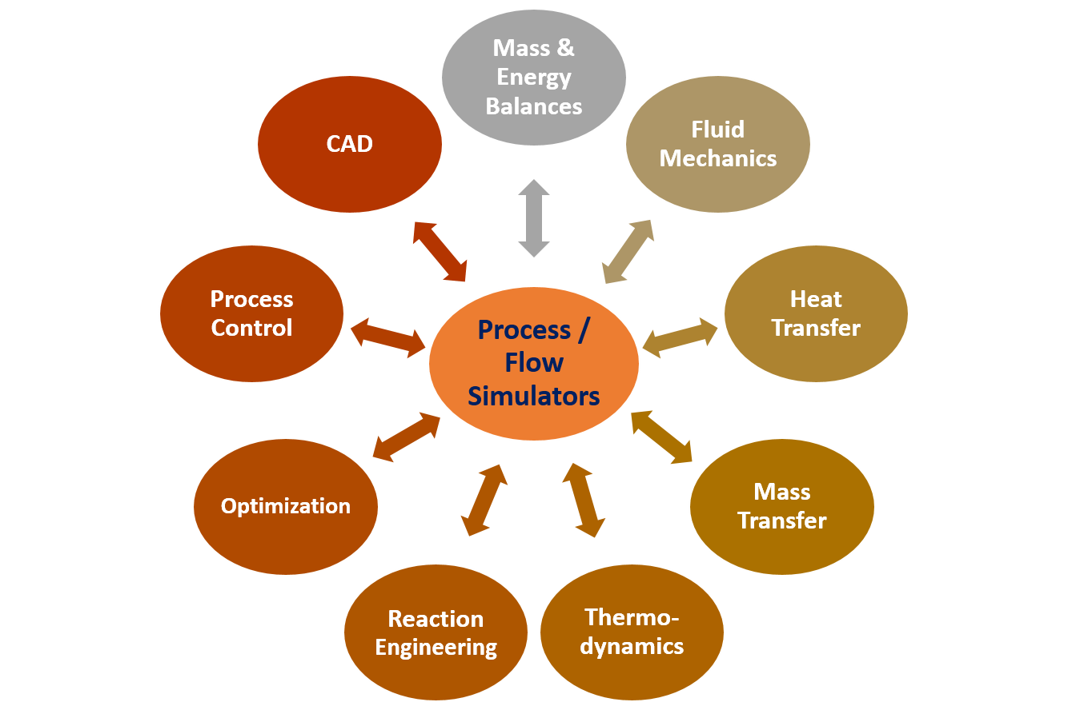

**COURSE CONTENTS:**

* Introduction to Process & Flow Simulation and their Pre-requisites
* Modeling Methodology
* Numerical schemes
* Examples of application through case studies
* Bench marking, Analysis, Optimization and Validation

**RESOURCE PERSONS**

Experienced faculty members of Chemical Engineering Department, NIT, Warangal will be delivering the lectures and conducting the laboratory sessions.

**REGISTRATION**

* **Who Can Apply:**

This program is open to the Undergraduate students, Postgraduate students and Research scholars of Chemical Engineering. Undergraduate students need to have completed at least III year to be eligible.

* **How to Apply:**

Eligible candidates may apply online through  
[~~https://sites.google.com/view/imtme20188~~ on or before 08-05-2018](https://sites.google.com/view/imtme20188%20on%20or%20before%2008-05-2018).

* **Confirmation of Participation:**

On being short listed, the applicant will be intimated. Students with good academic background will be preferred. The shortlisting will be made based on merit and first come first serve basis. **The short listed students are required to make the fee payment within the prescribed date.**

After payment of registration fee, participants will be sent confirmation through Email. Participants need **NOT** send a hard-copy of the registration form.

* **Registration Fee:**

Course Fee: **Rs. 4,000/-**

Boarding & Lodging Fee: **Rs. 2,500/-**

The course fee includes kit, course material and mid-session tea/snacks. Participants who can make their own arrangements for boarding and lodging need to pay ONLY the course fee.

* **Payment Details:**

|  |  |
| --- | --- |
| ~~Account Name~~ | ~~TEQIP III Funds~~ |
| ~~Account Number~~ | ~~37583198741~~ |
| Bank | State Bank of India |
| Branch | NIT Warangal |
| Branch Code | 20149 |
| IFSC code | SBIN0020149 |

**The number of participants is limited to 60. *Candidates are advised to register early to avoid disappointment.***

**ABOUT THE INSTITUTE**

National Institute of Technology, Warangal (NITW) formerly known as Regional Engineering College, Warangal (RECW) is the first among seventeen RECs set up in 1959. Over the years, the Institute has established itself as a premier Institution in imparting technical education of a very high standard, leading to the B.Tech degrees at under graduate level with various branches of engineering, M.Tech degrees at post graduate level and Ph.D. programmes in various specializations of Science and Engineering streams.

**ABOUT WARANGAL**

Warangal is the second largest city of the new  
state of Telangana. It is situated at a distance of  
140 km from the state capital Hyderabad  
(Nearest Airport). It is well connected by Rail  
(Kazipet Junction is two km away and Warangal Station is 12 km away) and by Road (NH 202).Warangal is renowned for its rich historical and cultural heritage. It was the seat of erstwhile 5th Kakatiya dynasty. It is a place of tourist attraction with a number of historical monuments like Thousand Pillars Temple, Warangal Fort, Bhadrakali & Ramappa Temples and Laknavaram Lake.

**ABOUT THE DEPARTMENT**

The Department of Chemical Engineering was established in the year 1964 and celebrated Golden Jubilee in the year 2014. The Department offers B.Tech in Chemical Engineering, M.Tech in Chemical Engineering & Process Control specializations and Ph.D programs. Currently, the Department has 14 faculty members with research expertise in a variety of areas. The Department of Chemical Engineering has rich experience in using both flow and process simulators.

The Department conducted a number of training programs both for faculty and students on flow and process simulation and is well known across the country for its expertise in this area.

**IMPORTANT DATES**

* **Last date for online submission of the Registration forms: 8th May 2018**
* **Last date for Payment of requisite fees (after shortlisting): 15th May 2018**
* **Intimation of Confirmation: 22nd May 2018**

**ADDRESS FOR COMMUNICATION:**

**Coordinators – ACCESS-2018**

Dept. of Chemical Engineering

National Institute of Technology

Warangal – 506 004, India

Ph: 8332969402, 8332969406

**Email:** [access.nitw@gmail.com](mailto:access.nitw@gmail.com)