


+91 8001670158
+91 8588800695




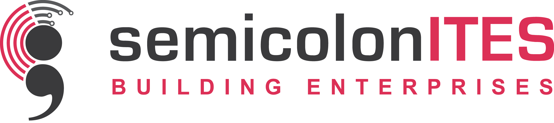
Meeting Resolution
Meeting No: 01
This meeting is conducted for the purpose of opening a Bank Account for transactional convenience of our Partnership Firm. As we have discussed and decided to open a Current Account in the name & style of “M/s. SEMICOLON ITES” with Indian Bank, Galsi Branch, Galsi.
And the said Bank Account to be operated by the joint signature of the following Partner. Specimen Signature of Signatory Authorities shall be as hereunder :
Sl.No. | Name of Member | Designation | Signature
1. | DEBAYAN SEN | PARTNER
2. | RAJARSHI BASU | PARTNER
3. | NANDA PAL | PARTNER

We are all agreed with the decision as above mentioned and giving consent by putting our signature as hereunder.
Quorum of the meeting is maintained and the meeting is ended with vote of thanks.
Signature of Partners
Sl.No. | Name of Member | Designation | Signature
1. | DEBAYAN SEN | PARTNER
2. | SOUMYAJEET BANDYOPADHYAY | PARTNER
3. | RAJARSHI BASU | PARTNER
4. | ANANYA DUTTA | PARTNER
5. | RIBHU RAY | PARTNER
6. | NANDA PAL | PARTNER

Purpose: Opening of Bank Account

Date: 16/01/2018
Place: Office Premises

www.semicolonites.com
business@semicolonites.com
19 JN DAS Path Sail-co-opt
City center, Durgapur-713216

