CS-340 7-2 Project Two README
Author: Ahmad Mansour

Required Functionality
This project implements a complete interactive dashboard for Grazioso Salvare, an organization that identifies search-and-rescue training candidates. The dashboard connects to a MongoDB database containing Austin Animal Center outcomes and allows users to filter dogs based on specific rescue type requirements. When a filter is applied, the dashboard updates three components simultaneously:
- The interactive data table
- A breed distribution pie chart
- A geolocation map centered on Austin, Texas
The four available filters—Water Rescue, Mountain or Wilderness Rescue, Disaster or Individual Tracking, and Reset (All Records)—retrieve appropriate data using MongoDB queries based on breed, age, and sex criteria defined by the Dashboard Specifications Document.

Tools Used and Rationale
• MongoDB – Stores animal records as flexible documents and supports rich querying for rescue-type logic.
• AnimalShelter Python CRUD Class – Provides structured Create, Read, Update, and Delete operations used by the dashboard.
• Dash / JupyterDash – Framework for building the interactive user interface and linking components via callbacks.
• Dash DataTable – Displays dynamic data with filtering, sorting, pagination, and row selection.
• Plotly Express – Renders the breed distribution pie chart.
• dash_leaflet – Displays geographic markers for selected animals.

Steps to Reproduce the Project
1. Install required Python libraries: dash, jupyter_dash, dash_leaflet, plotly, pandas, numpy, pymongo.
2. Import the Austin Animal Center outcomes dataset into MongoDB:
- Database: aac
- Collection: animals
3. Ensure MongoDB authentication is enabled and create a user such as:
Username: aacuser, Password: SNHU1234
4. Place animal_shelter.py and ProjectTwoDashboard.ipynb in the project directory.
5. Open ProjectTwoDashboard.ipynb and run all cells.
6. Launch the dashboard using external mode: app.run_server(mode='external').
7. Use the radio filters to verify the dashboard updates the table, chart, and map.

Challenges and How They Were Overcome
A key challenge was ensuring the dashboard rendered correctly within Codio. Initially, the application could not load using default settings. Adding JupyterDash.infer_jupyter_proxy_config() and running the server in external mode resolved the connection issues.
Another challenge was ensuring all components—data table, chart, and map—updated in sync. Using the table’s derived_virtual_data ensured consistency, and callbacks were structured to respond to filter changes and row selection.

Screenshots

Screenshot 1 – Reset (All Records)
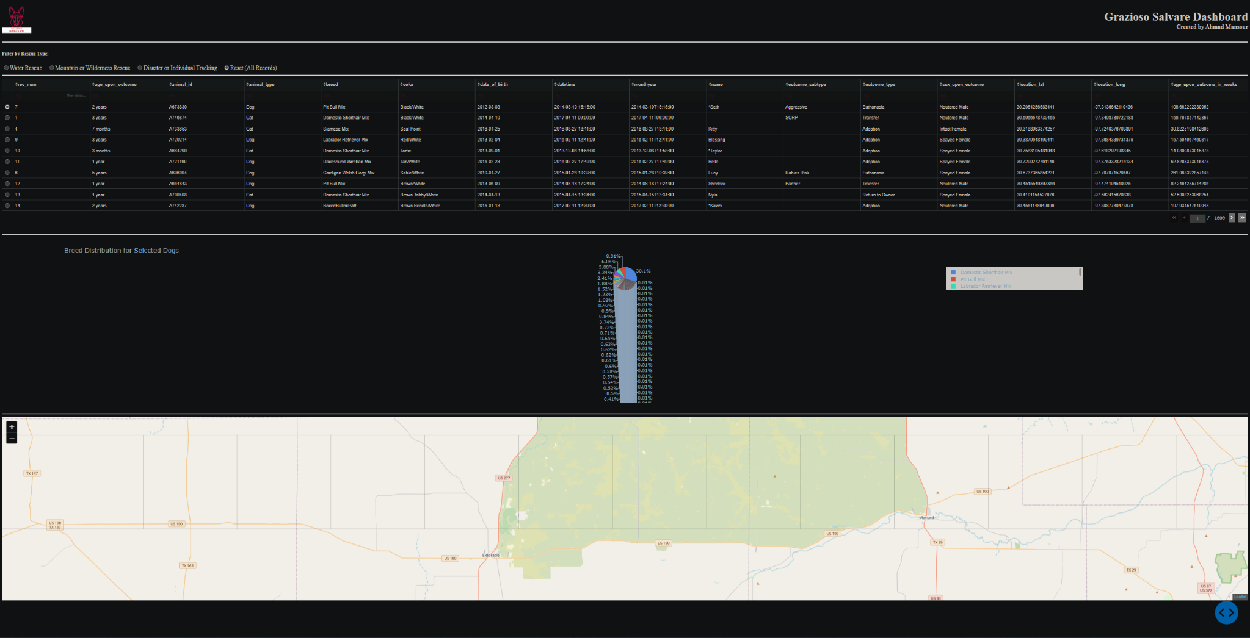

Screenshot 2 – Water Rescue
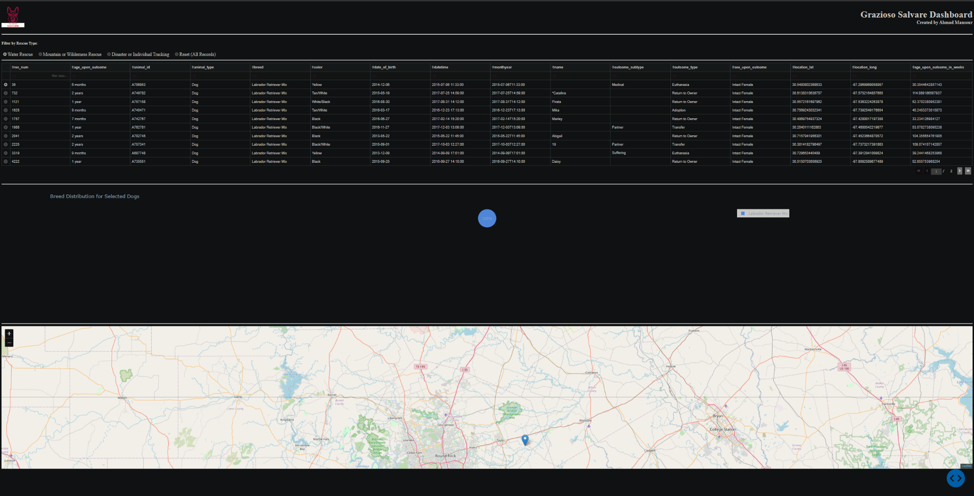

Screenshot 3 – Mountain or Wilderness Rescue
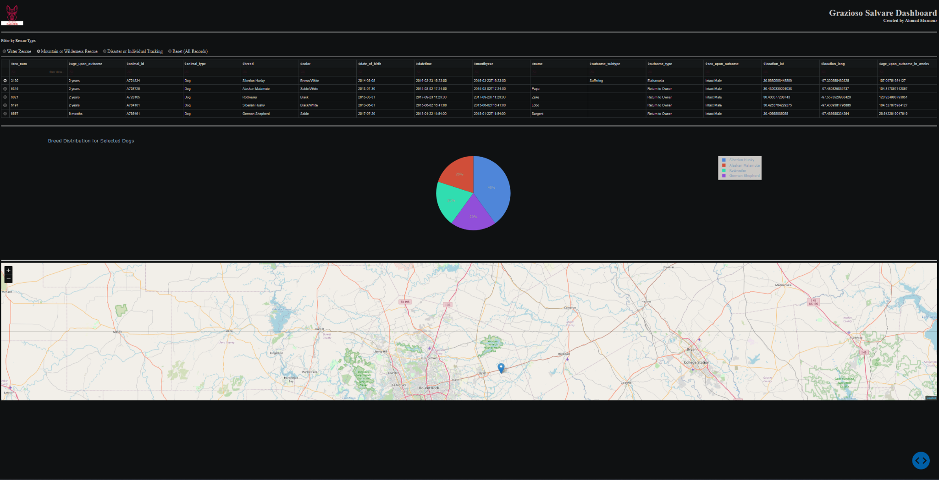

Screenshot 4 – Disaster or Individual Tracking
