Sample Quarto Document

# Sample Quarto Document

This is a sample document that demonstrates the power of Quarto integration in this documentation system.

## Features Demonstrated

### 1. Rich Text Formatting

You can use **bold text**, *italic text*, and code snippets in your content.

### 2. Code Blocks

def hello_world():  
 print("Hello, World!")  
 return True  
  
# This code will be syntax highlighted  
result = hello_world()

### 3. Tables

| Feature | Description | Status |
| --- | --- | --- |
| Export to DOCX | Generate Word documents | ✅ |
| Export to PPTX | Generate PowerPoint presentations | ✅ |
| Mermaid Diagrams | Create flowcharts and diagrams | ✅ |
| Math Equations | LaTeX math rendering | ✅ |

### 4. Lists

**Ordered Lists:** 1. First item 2. Second item 3. Third item

**Unordered Lists:** - Bullet point one - Bullet point two - Nested bullet - Another nested bullet

### 5. Diagrams

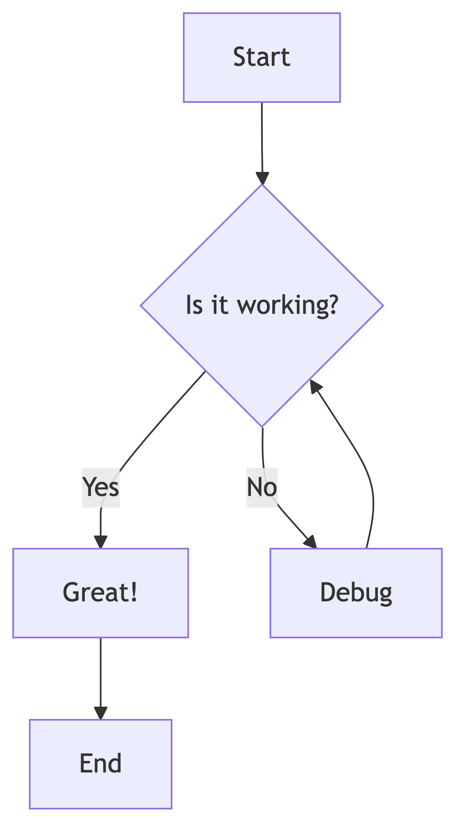

### 6. Math Equations

You can include inline math like $E=mc^{2}$ or display math:

$$\int_{−∞}^{∞}{e^{−x^{2}}}dx=\sqrt{π}$$

### 7. Blockquotes

This is a blockquote. It can be used to highlight important information or quotes from other sources.

### 8. Links and References

* [Hugo Documentation](https://gohugo.io/documentation/)
* [Quarto Documentation](https://quarto.org/docs/)
* [Mermaid Documentation](https://mermaid.js.org/)

## Export Options

This document can be exported to: - **DOCX**: Click the DOCX button above to download a Word document - **PPTX**: Click the PPTX button above to download a PowerPoint presentation - **Print**: Click the Print button for a clean, formatted print version

## Conclusion

This documentation system combines the best of both worlds: - Hugo’s fast static site generation - Quarto’s powerful document processing and export capabilities

Start creating your own documentation by replacing this sample content with your own files!