This document will setup a default ASP.Net MVC project(Visual Studio 2015) to make use of a captcha on the account registration form.

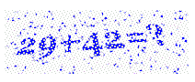

Let’s create the project. In Visual Studio, goto the File menu and New Project. We want to select the “ASP.NET Web Application (Visual Basic)”.

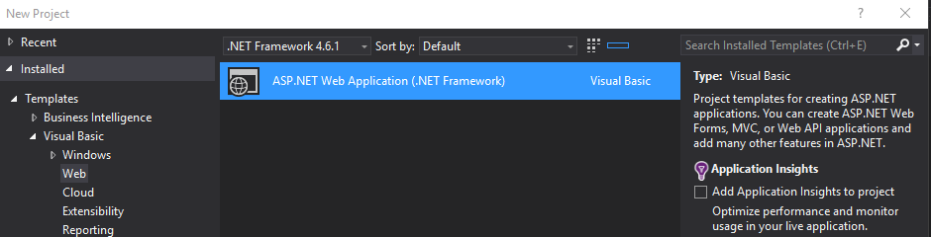

Then choose the MVC type: 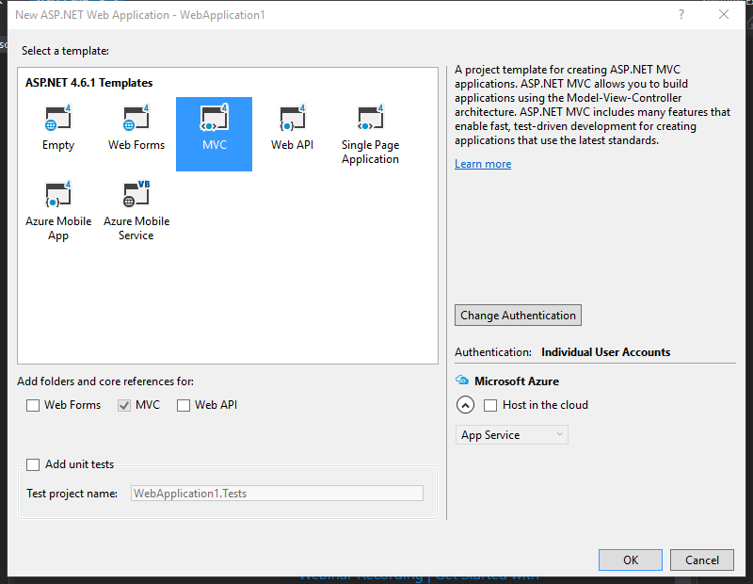

Wait for your studio to create all the files and settle down. You should see something like this when it is ready.

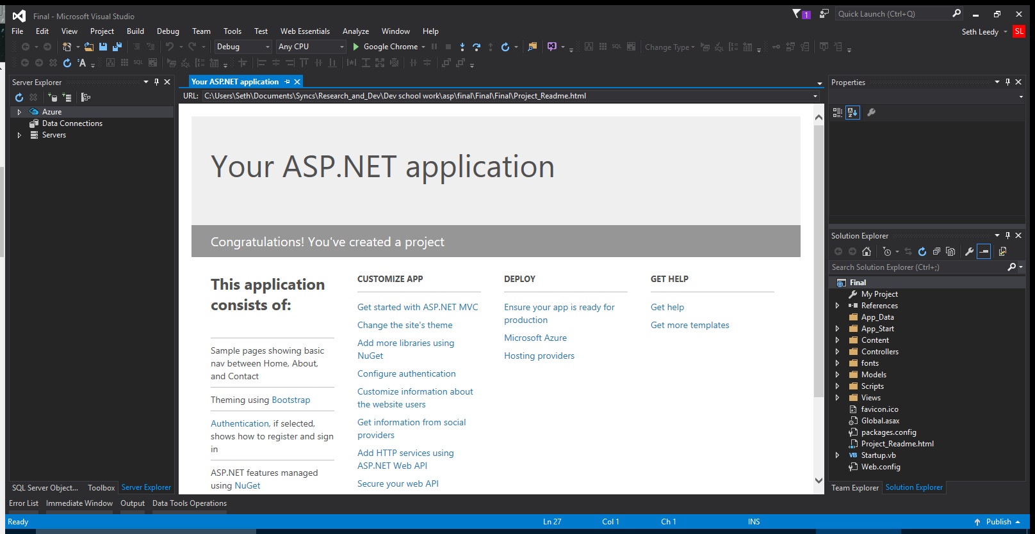

Good, now let’s modify this project. We need to add a NuGet package called “CaptchaMvc.Mvc4”.

Note:

* Latest version as of now is 1.5.0.
* I could have used “CaptchaMvc.Mvc5”. Welcome to try.

The NuGet packages are found in the Tools menu.

When searching via the GUI interface, make sure the Package source is set to “All”. When found, checkmark the project on the right and click the Install button.

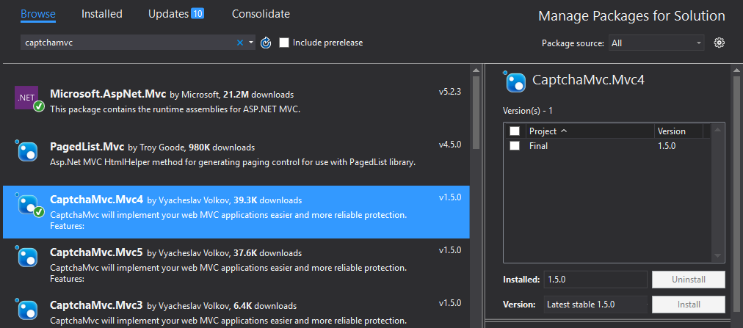

Alternatively, you can open the NuGet console and execute “Install-Package CaptchaMvc.Mvc4”.

With this installed we can make use of it within the project.

To modify the Registration page we need to open up the controller AccountController.vb(under Controllers).

We are first going to append to the Imports at the top of the file. We are importing the captcha code space for use.

Add:

“Imports System.Web.Mvc”

“Imports CaptchaMvc.HtmlHelpers”

Now open the second “Register” entry in the file, “Public Async Function Register(model As RegisterViewModel) As Task(Of ActionResult)“.

This is the function where the form submission is checked for validity. We are going to insert the following code at the top under the If statement. It’s going to check if the captcha is good to go.

“

' Code for validating the CAPTCHA  
 If Not Me.IsCaptchaValid("Captcha is not valid") Then   
 ' Return RedirectToAction("ThankYouPage", "Register")  
 'Else  
 ViewBag.ErrMessage = "Error: captcha is not valid."  
 Return View(model)  
 End If

“

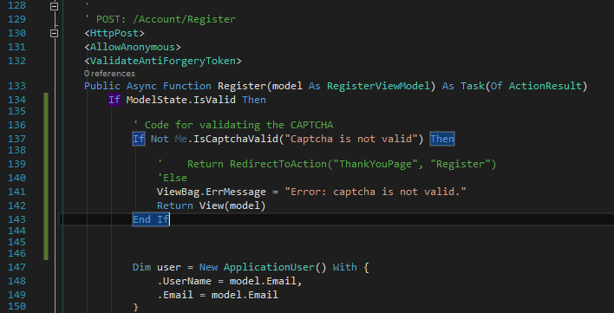

With that, the controller is done.

Now let’s modify the the View code of the form in “Register.vbhtml”. It’s located in the folder Views->Account.

This file is pretty straight forward in the HTML area. We will be adding some and moving the submit button, but first let’s add the requisite headers for the captcha.

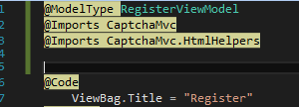

Looking at the form page in the browser, you can see what we are aiming for:

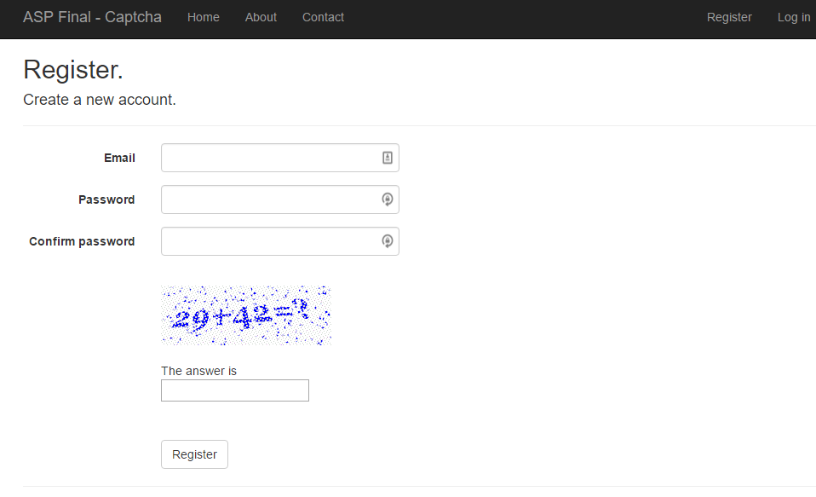

So let’s move the <div> code containing the Register button to the bottom of the <text></text> container. Then just above it, put in this code for the captcha:

“

<div class="form-group">  
 <div class="col-md-offset-2 col-md-10">  
 @Html.MathCaptcha()   
 <br />  
 <p Class="Error">@ViewBag.ErrMessage </p>   
 </div>  
 </div>

“

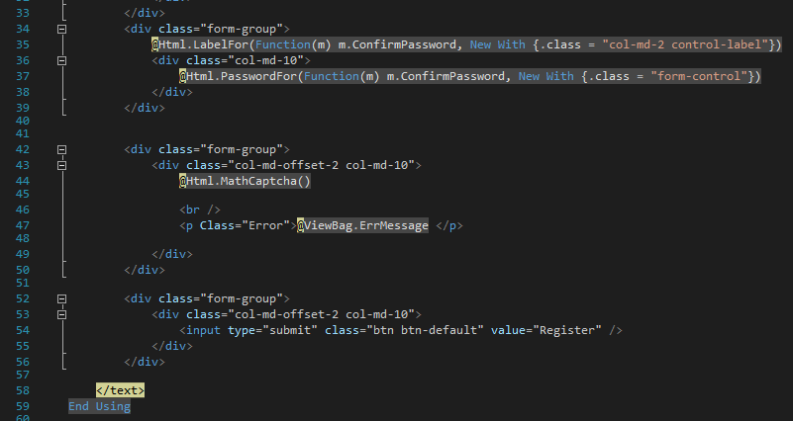

That concludes the View file.

Go ahead and give it a try. On the registration page, fill in the email and password first, then test the captcha with an incorrect number. It will notify you of it being incorrect after clicking “Register”. Should work if the answer is correct.

P.S.

The captcha is all numbers here, but the original document I followed allowed letters as well, if the captcha was called with “@Html.captcha(4)” instead of “@Html.MathCaptch()”. The number argument in .captcha is how many characters to print out.

Original source: <http://www.infinetsoft.com/Post/How-to-implement-captcha-in-asp-net-mvc/2452>