pandoc -f markdown -t html ./2021-03-01-eclipse-che.md | pandoc -f html -t docx -o eclipse-che.docx

Introduction to Eclipse Che介绍
- A centralized developer environment running on Kubernetes or OpenShift.-在Kubernetes或OpenShift上运行的集中式开发人员环境。
- A multicontainer workspace for each developer with the ability to replicate with a single click using Eclipse Che factories.-每个开发人员的多容器工作区，能够使用Eclipse Che工厂单击一次进行复制。
- Pre-built stacks with the ability to create custom stacks for any language or runtime.-预先构建的堆栈，能够为任何语言或运行时创建自定义堆栈。
- An enterprise integration that uses Keycloak for Active Directory (AD) database and Lightweight Directory Access Protocol (LDAP) related actions.-使用Keycloak进行Active Directory（AD）数据库和轻型目录访问协议（LDAP）相关操作的企业集成。
- Browser-based IDEs; integration with Che-Theia or any other web IDE, such as Jupyter.-基于浏览器的IDE； 与Che-Theia或任何其他Web IDE（如Jupyter）集成。
- Support of tooling protocols, such as the Language Server Protocol or Debug Adapter Protocol.-支持工具协议，例如语言服务器协议或调试适配器协议。
- A plug-in mechanism compatible with Visual Studio Code extensions.-与Visual Studio Code扩展兼容的插件机制。
- A software development kit (SDK) for creating custom cloud developer platforms.-用于创建自定义云开发人员平台的软件开发套件（SDK）。

Getting started with Che入门

What is Eclipse Che 什么是Eclipse Che。
Eclipse Che is a Kubernetes-native IDE and developer collaboration platform.
Eclipse Che是Kubernetes的本地IDE和开发人员协作平台。
As an open-source project, the core goals of Eclipse Che are to:
作为一个开源项目，Eclipse Che的核心目标是：
- Accelerate project and developer onboarding: As a zero-install development environment that runs in your browser, Eclipse Che makes it easy for anyone to join your team and contribute to a project.
- 加快项目和开发人员的使用速度：作为在您的浏览器中运行的零安装开发环境，Eclipse Che使任何人都可以轻松加入您的团队并为项目做出贡献。
- Remove inconsistency between developer environments: No more: “But it works on my machine.” Your code works exactly the same way in everyone’s environment.
- 消除开发人员环境之间的不一致：不再：“但是它可以在我的机器上工作。” 您的代码在每个人的环境中的工作方式都完全相同。
- Provide built-in security and enterprise readiness: As Eclipse Che becomes a viable replacement for VDI solutions, it must be secure and it must support enterprise requirements, such as role-based access control and the ability to remove all source code from developer machines.
- 提供内置的安全性和企业就绪性：随着Eclipse Che成为VDI解决方案的可行替代品，它必须安全并且必须支持企业要求，例如基于角色的访问控制和删除所有源代码的能力 从开发人员机器。
To achieve those core goals, Eclipse Che provides:
为了实现这些核心目标，Eclipse Che提供了：
- Workspaces: Container-based developer workspaces providing all the tools and dependencies needed to code, build, test, run, and debug applications.
- 工作空间：基于容器的开发人员工作空间，提供了编码，构建，测试，运行和调试应用程序所需的所有工具和依赖项。
- Browser-based IDEs: Bundled browser-based IDEs with language tools, debuggers, terminal, VCS integration, and much more.
- 基于浏览器的IDE：具有语言工具，调试器，终端，VCS集成等等的基于浏览器的捆绑IDE。
- Extensible platform: Bring your own IDE. Define, configure, and extend the tools that you need for your application by using plug-ins, which are compatible with Visual Studio Code extensions.
- 可扩展的平台：带上自己的IDE。 通过使用与Visual Studio Code扩展兼容的插件，定义，配置和扩展应用程序所需的工具。
- Enterprise Integration: Multiuser capabilities, including Keycloak for authentication and integration with LDAP or AD.
- 企业集成：多用户功能，包括用于身份验证和与LDAP或AD集成的Keycloak。

Workspace model 工作空间模型
Che defines the workspace to be the project code files and all the dependencies necessary to edit, build, run, and debug them. Che treats the IDE and the development runtime as dependencies of the workspace. These items are embedded and always included with the workspace. This differentiates Che from classical workspace definitions, which may include the project code, but require the developer to bind their IDE to their workstation and use it to provide a runtime locally.
Che将工作空间定义为项目代码文件以及编辑，构建，运行和调试它们所需的所有依赖项。 Che将IDE和开发运行时视为工作空间的依赖项。 这些项目是嵌入式的，并且始终包含在工作空间中。 这将Che与经典工作区定义（可能包括项目代码）区分开来，但要求开发人员将其IDE绑定到其工作站并使用它在本地提供运行时。
Workspaces are isolated from one another and are responsible for managing the lifecycle of their components.
工作区彼此隔离，并负责管理其组件的生命周期。
Developers using Eclipse Che use their containers directly in their developer workspaces. Che workspaces are Kubernetes or OpenShift pods, which allow to replicate the application runtimes (and its microservices) used in production and provide a “dev mode” layer on top of those, adding intelligent code completion and IDE tools.
使用Eclipse Che的开发人员直接在其开发人员工作区中使用其容器。 ** Che工作区是Kubernetes或OpenShift Pod，它们可以复制生产中使用的应用程序运行时（及其微服务）**，并在它们之上提供“开发模式”层，从而添加智能代码完成和IDE工具。

Browser-based IDEs 基于浏览器的IDE
Eclipse Che provides browser-based IDEs for its workspaces. The default IDE is built on Theia, and it has the following capabilities:
Eclipse Che为其工作区提供了基于浏览器的IDE。 默认的IDE建立在[Theia]（https://github.com/theia-ide/theia）上，它具有以下功能：
- Monaco-based editor: A fast and responsive editor, CodeLens
- 基于Monaco的编辑器：**快速响应的编辑器CodeLens
- Language Server Protocol: Language tools
- 语言服务器协议：语言工具
- Debug Adapter Protocol: Debugger tools
- 调试适配器协议：调试器工具
- Command palette: Do everything from your keyboard
- 命令面板：通过键盘进行所有操作
- Task support: Tasks from Visual Studio Code are extended and support Che commands
- 任务支持： Visual Studio Code中的任务得到扩展并支持Che命令
- Embedded preview: Preview your application directly from the IDE, including Markdown preview
- 嵌入式预览：直接从IDE预览您的应用程序，包括Markdown预览
- Customizable layout: Adapt the layout using drag and drop
- 可自定义的布局：通过拖放调整布局
- And more: Outline view, search, Git
- 更多：大纲视图，搜索，Git

Different IDEs for different use cases 针对不同用例的不同IDE
In Eclipse Che, the IDE is completely decoupled, so that it is possible to plug a different IDE into Che workspaces:
在Eclipse Che中，IDE是完全分离的，因此可以将其他IDE插入Che工作区：
- It can be based on Eclipse Theia (as it is a framework to build a web IDE), such as Sirius:
- 它可以基于Eclipse Theia（因为它是构建Web IDE的框架），例如Sirius：
- It can be a completely different solution, such as Jupyter or Eclipse Dirigible:
- 它可以是完全不同的解决方案，例如Jupyter或Eclipse Dirigible：
For situations in which the default IDE does not cover the use cases of the users or to use a dedicated tool instead of an IDE.
对于默认IDE无法覆盖用户使用情况或使用专用工具代替IDE的情况。

Extensible platform 可扩展平台
Eclipse Che is a great platform to build cloud-native tools, and it provides a strong extensibility model with an enjoyable developer experience for contributors.
Eclipse Che是构建云原生工具的绝佳平台，它提供了强大的可扩展性模型，并为贡献者提供了令人愉悦的开发人员经验。
Eclipse Che is extensible in different ways:
Eclipse Che可以通过多种方式扩展：
- Plug-ins to add capabilities to the IDE. Che-Theia plug-ins rely on APIs compatible with Visual Studio Code. Plug-ins are isolated and provide their own dependencies packaged in containers.
- 插件，以向IDE添加功能。 Che-Theia插件依赖与Visual Studio Code兼容的API。 插件是隔离的，并提供打包在容器中的自己的依赖项。
- Stacks to create pre-configured Che workspaces with a dedicated set of tools.
- 堆栈，可使用一组专用工具创建预配置的Che工作区。
- Alternative IDEs to provide specialized tools within Eclipse Che. Build your own, based on Eclipse Theia, or pick existing ones like Jupyter.
- 替代IDE ，可在Eclipse Che中提供专用工具。 基于Eclipse Theia构建自己的数据库，或选择现有的Jupyter数据库。
- Marketplace (soon) to easily distribute tools and custom IDEs, which can be tried online, to users and communities.
- 市场（很快），可以轻松地向用户和社区分发工具和自定义IDE，可以在线尝试这些工具和自定义IDE。
Eclipse Che uses Che-Theia as its default browser-based IDE. Che-Theia provides a framework to build web IDEs. It is built in TypeScript and gives contributors a programming model that is flexible, relies on state-of-the-art tooling protocols, and makes it faster to build new tools.
Eclipse Che使用Che-Theia作为其默认的基于浏览器的IDE。 Che-Theia提供了构建Web IDE的框架。 它内置于TypeScript中，并为贡献者提供了一个灵活的编程模型，该模型依赖于最新的工具协议，并且可以更快地构建新工具。
In Eclipse Che, the dependencies needed for the tools running in the user’s workspace are available when needed. This means that a Che-Theia plug-in provides its dependencies, its back-end services (which could be running in a sidecar container connected to the user’s workspace), and the IDE UI extension. Che packages all these elements together, so that the user does not have to configure different tools together.
在Eclipse Che中，需要时可以使用在用户工作空间中运行的工具所需的依赖项。 这意味着Che-Theia插件提供了它的依赖关系，它的后端服务（可以在连接到用户工作区的Sidecar容器中运行）以及IDE UI扩展。 Che将所有这些元素打包在一起，因此用户不必一起配置不同的工具。

Visual Studio Code extension compatibility Visual Studio Code扩展兼容性
Eclipse Che rationalizes the effort for a contributor who wants to build a plug-in and distribute it to different developer communities and tools. For that purpose, Eclipse Che features a plug-in API compatible with extension points from Visual Studio Code. As a result, it is easy to bring an existing plug-in from Visual Studio Code into Eclipse Che. The main difference is in the way the plug-ins are packaged. On Eclipse Che, plug-ins are delivered with their own dependencies in their own container.
Eclipse Che使想要构建插件并将其分发给不同的开发人员社区和工具的贡献者合理化了工作。 为此，Eclipse Che具有与Visual Studio Code的扩展点兼容的插件API。 结果，很容易将现有的插件从Visual Studio Code引入Eclipse Che。 主要区别在于插件的打包方式。 在Eclipse Che上，插件在其自己的容器中以其自身的依赖项进行交付。

Enterprise integration 企业整合
- Eclipse Che includes Keycloak to handle authentication and security. It allows integration with any single sign-on (SSO), and with Active Directory or LDAP.
- Eclipse Che包含[Keycloak]（https://www.keycloak.org/），用于处理身份验证和安全性。 它允许与任何单点登录（SSO）以及Active Directory或LDAP集成。
- Every Eclipse Che user gets a centralized developer workspace that can be easily defined, administered, and managed.
- 每个Eclipse Che用户都会获得一个集中的开发人员工作区，该工作区可以轻松定义，管理和管理。
- As a Kubernetes-native application, Eclipse Che provides state-of-the-art monitoring and tracing capabilities, integrating with Prometheus and Grafana.
- 作为Kubernetes原生应用程序，Eclipse Che提供了最先进的监视和跟踪功能，并与[Prometheus]（https://prometheus.io/）和[Grafana]（https://grafana.com/）集成在一起 ）。

Additional resources 其他资源

Che architecture overview
Che体系结构概述
Eclipse Che components are:
Eclipse的组成部分是：
- A central workspace controller: an always running service that manages users workspaces through the Kubernetes API.
- 中央工作区控制器：始终运行的服务，通过Kubernetes API管理用户工作区。
- Users workspaces: container-based IDEs that the controller stops when the user stops coding.
- 用户工作空间：当用户停止编码时，控制器将停止的基于容器的IDE。
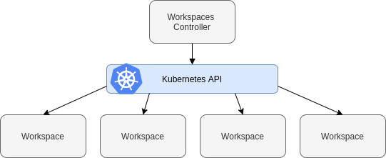
che high level
Figure 1. High-level Che architecture
图1.高级Che架构
When Che is installed on a Kubernetes or OpenShift cluster, the workspace controller is the only component that is deployed. A Che workspace is created immediately after a user requests it.
当Che安装在Kubernetes或OpenShift集群上时，工作区控制器是唯一部署的组件。 用户请求后，将立即创建Che工作区。

Understanding Che workspaces architecture 了解Che工作区架构

Che workspace controller
Che工作区控制器
The workspaces controller manages the container-based development environments: Che workspaces. Following deployment scenarios are available:
工作区控制器管理基于容器的开发环境：Che工作区。 提供以下部署方案：
- Single-user: The deployment contains no authentication service. Development environments are not secured. This configuration requires fewer resources. It is more adapted for local installations.
- 单用户：部署不包含身份验证服务。 开发环境不安全。 此配置需要较少的资源。 它更适合本地安装。
- Multi-user: This is a multi-tenant configuration. Development environments are secured, and this configuration requires more resources. Appropriate for cloud installations.
- 多用户：这是一个多租户配置。 开发环境受到保护，并且此配置需要更多资源。 适用于云安装。
The following diagram shows the different services that are a part of the Che workspaces controller. Note that Keycloak and PostgreSQL are only needed in the multi-user configuration.
下图显示了作为Che工作区控制器一部分的各种服务。 请注意，仅在多用户配置中才需要Keycloak和PostgreSQL。
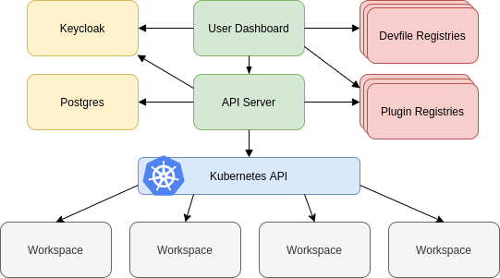
che workspaces controllers
Figure 1. Che workspaces controller
图1. Che工作区控制器
Additional resources 其他资源
- Authenticating users 用户认证

Che server 服务器
The Che server is the central service of the workspaces controller. It is a Java web service that exposes an HTTP REST API to manage Che workspaces and, in multi-user mode, Che users.
Source code | Eclipse Che GitHub
Container image | eclipse/che-server
Additional resources 其他资源
Advanced configuration options for the Che server component Che服务器组件的高级配置选项

Che user dashboard Che用户仪表板
The user dashboard is the landing page of Eclipse Che. It is an Angular front-end application. Che users create, start, and manage Che workspaces from their browsers through the user dashboard.
用户仪表板是Eclipse Che的登录页面。 它是一个Angular前端应用程序。 Che用户通过他们的浏览器通过用户仪表板创建，启动和管理Che工作区。
Source code | Che Dashboard
Container image | eclipse/che-server

Che Devfile registry Che Devfile 注册表
The Che devfile registry is a service that provides a list of Che stacks to create ready-to-use workspaces. This list of stacks is used in the Dashboard → Create Workspace window. The devfile registry runs in a container and can be deployed wherever the user dashboard can connect.
Che devfile注册表是一项提供Che堆栈列表以创建即用型工作区的服务。 该堆栈列表在“仪表板”→“创建工作区”窗口中使用。 devfile注册表在容器中运行，并且可以部署在用户仪表板可以连接的任何位置。
For more information about devfile registry customization, see the Customizing devfile registry section.
有关devfile注册表自定义的更多信息，请参见“自定义devfile注册表”部分。
Source code | Che Devfile registry
Container image | quay.io/eclipse/che-devfile-registry

Che plug-in registry Che插件注册表
The Che plug-in registry is a service that provides the list of plug-ins and editors for the Che workspaces. A devfile only references a plug-in that is published in a Che plug-in registry. It runs in a container and can be deployed wherever Che server connects.
Che插件注册表是一项提供Che工作区的插件和编辑器列表的服务。 devfile仅引用在Che插件注册表中发布的插件。 它在容器中运行，并且可以在Che服务器连接的任何地方进行部署。
Source code | Che plug-in registry
Container image | quay.io/eclipse/che-plugin-registry
Additional resources
- Customizing the registries 定制注册表

Che and PostgreSQL Che和PostgreSQL
The PostgreSQL database is a prerequisite to configure Che in multi-user mode. The Che administrator can choose to connect Che to an existing PostgreSQL instance or let the Che deployment start a new dedicated PostgreSQL instance.
PostgreSQL数据库是在多用户模式下配置Che的先决条件。 Che管理员可以选择将Che连接到现有PostgreSQL实例，或让Che部署启动新的专用PostgreSQL实例。
The Che server uses the database to persist user configurations (workspaces metadata, Git credentials). Keycloak uses the database as its back end to persist user information.
Che服务器使用数据库来保留用户配置（工作区元数据，Git凭据）。 Keycloak使用数据库作为其后端来保留用户信息。
Source code | Che Postgres
Container image | quay.io/eclipse/che-postgres

Che and Keycloak
Keycloak is a prerequisite to configure Che in multi-user mode. The Che administrator can choose to connect Che to an existing Keycloak instance or let the Che deployment start a new dedicated Keycloak instance.
Keycloak是在多用户模式下配置Che的先决条件。 Che管理员可以选择将Che连接到现有的Keycloak实例，或让Che部署启动新的专用Keycloak实例。
The Che server uses Keycloak as an OpenID Connect (OIDC) provider to authenticate Che users and secure access to Che resources.
Che服务器使用Keycloak作为OpenID Connect（OIDC）提供程序来验证Che用户并保护对Che资源的访问。
Source code | Che Keycloak
Container image | quay.io/eclipse/che-keycloak

Understanding Che workspaces architecture 了解Che工作区架构

Che workspaces architecture Che工作区架构
A Che deployment on the cluster consists of the Che server component, a database for storing user profile and preferences, and a number of additional deployments hosting workspaces. The Che server orchestrates the creation of workspaces, which consist of a deployment containing the workspace containers and enabled plug-ins, plus related components, such as:
群集上的Che部署由Che服务器组件，用于存储用户配置文件和首选项的数据库以及托管工作空间的许多其他部署组成。 Che服务器协调工作空间的创建，该工作空间由一个包含工作空间容器和已启用插件的部署以及相关组件组成，例如：
- ConfigMaps
- services
- endpoints
- ingresses/routes
- secrets
- PVs
The Che workspace is a web application. It is composed of microservices running in containers that provide all the services of a modern IDE such as an editor, language auto-completion, and debugging tools. The IDE services are deployed with the development tools, packaged in containers and user runtime applications, which are defined as Kubernetes resources.
Che工作区是一个Web应用程序。 它由运行在容器中的微服务组成，这些容器提供现代IDE的所有服务，例如编辑器，语言自动完成和调试工具。 IDE服务与开发工具一起部署，打包在容器和用户运行时应用程序中，这些工具定义为Kubernetes资源。
The source code of the projects of a Che workspace is persisted in a Kubernetes or OpenShift PersistentVolume. Microservices run in containers that have read-write access to the source code (IDE services, development tools), and runtime applications have read-write access to this shared directory.
Che工作区项目的源代码保存在Kubernetes或OpenShift PersistentVolume中。 微服务运行在对源代码（IDE服务，开发工具）具有读写访问权限的容器中，而运行时应用程序对此共享目录具有读写访问权限。
The following diagram shows the detailed components of a Che workspace.
下图显示了Che工作区的详细组件。
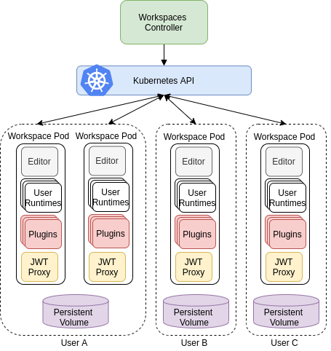
che workspaces
Figure 1. Che workspace components
图1. Che工作区组件
In the diagram, there are three running workspaces: two belonging to User A and one to User C. A fourth workspace is getting provisioned where the plug-in broker is verifying and completing the workspace configuration.
在该图中，有三个正在运行的工作空间：两个属于** User A ，一个属于 User C **。 在插件代理验证并完成工作空间配置的地方准备了第四个工作空间。
Use the devfile format to specify the tools and runtime applications of a Che workspace.
使用devfile格式指定Che工作区的工具和运行时应用程序。

Che workspace components Che工作区组件
This section describes the components of a Che workspace.
本节描述Che工作区的组件。

Che Plugin plug-ins Che Plugin插件
Che Plugin plug-ins are special services that extend Che workspace capabilities. Che Plugin plug-ins are packaged as containers. Packaging plug-ins into a container has the following benefits:
- It isolates the plug-ins from the main IDE, therefore limiting the resources that a plug-in has access to.
- It uses the consolidated standard of container registries to publish and distribute plug-ins (as with any container image).
The containers that plug-ins are packaged into run as sidecars of the Che workspace editor and augment its capabilities.
Visual Studio Code extensions packaged in containers are Che plug-ins for the Che-Theia editor.
Multiple Che plug-ins can run in the same container (for better resource use), or a Che Plugin can run in its dedicated container (for better isolation).
“ Che插件”插件是扩展Che工作区功能的特殊服务。 “ Che插件”插件被打包为容器。 将插件打包到容器中具有以下好处：
-它将插件与主IDE隔离开，从而限制了插件可以访问的资源。 -它使用容器注册表的统一标准来发布和分发插件（与任何容器映像一样）。
插件容器被打包成Che工作区编辑器的边车运行，并增强了其功能。
打包在容器中的Visual Studio Code扩展是Che-Theia编辑器的Che插件。
多个Che插件可以在同一个容器中运行（以更好地利用资源），或者Che插件可以在其专用容器中运行（以更好地隔离）。

Che Editor plug-in “ Che Editor”插件
A Che Editor plug-in is a Che workspace plug-in. It defines the web application that is used as an editor in a workspace. The default Che workspace editor is Che-Theia. It is a web-based source-code editor similar to Visual Studio Code (VS Code). It has a plug-in system that supports VS Code extensions.
“ Che编辑器”插件是Che工作区插件。 它定义了用作工作空间中的编辑器的Web应用程序。 默认的Che工作区编辑器是[Che-Theia]（https://github.com/eclipse/che-theia）。 它是基于Web的源代码编辑器，类似于[Visual Studio Code]（https://code.visualstudio.com/）（VS Code）。 它具有一个支持VS Code扩展的插件系统。
Source code | Che-Theia
Container image | eclipse/che-theia
Endpoints | theia, webviews, theia-dev, theia-redirect-1, theia-redirect-2, theia-redirect-3
Additional resources
- Che-Theia
- Eclipse Theia open-source project
- Visual Studio Code

Che user runtimes Che用户运行时
Use any non-terminating user container as a user runtime. An application that can be defined as a container image or as a set of Kubernetes or OpenShift resources can be included in a Che workspace. This makes it easy to test applications in the Che workspace.
To test an application in the Che workspace, include the application YAML definition used in stage or production in the workspace specification. It is a 12-factor app dev/prod parity.
Examples of user runtimes are Node.js, SpringBoot or MongoDB, and MySQL.
使用任何非终止用户容器作为用户运行时。 可以定义为容器映像或Kubernetes或OpenShift资源集的应用程序可以包含在Che工作区中。 这使得在Che工作区中轻松测试应用程序变得容易。
要在Che工作区中测试应用程序，请将阶段或生产中使用的应用程序YAML定义包括在工作区规范中。 这是一个由12个因素组成的应用开发/产品奇偶校验。
用户运行时的示例为Node.js，SpringBoot或MongoDB，以及MySQL。

Che workspace JWT proxy Che工作区JWT代理
The JWT proxy is responsible for securing the communication of the Che workspace services. The Che workspace JWT proxy is included in a Che workspace only if the Che server is configured in multi-user mode.
An HTTP proxy is used to sign outgoing requests from a workspace service to the Che server and to authenticate incoming requests from the IDE client running on a browser.
JWT代理负责保护Che工作区服务的通信安全。 仅当在多用户模式下配置Che服务器时，Che工作区JWT代理才包括在Che工作区中。
HTTP代理用于将来自工作空间服务的传出请求签名到Che服务器，并验证来自运行在浏览器上的IDE客户端的传入请求。
Source code | JWT proxy
Container image | eclipse/che-jwtproxy

Che plug-ins broker
Plug-in brokers are special services that, given a plug-in meta.yaml file:
- Gather all the information to provide a plug-in definition that the Che server knows.
- Perform preparation actions in the workspace namespace (download, unpack files, process configuration).
- 插件代理是特殊的服务，通过提供插件meta.yaml文件：
- -收集所有信息以提供Che服务器知道的插件定义。 -在工作空间名称空间中执行准备操作（下载，解压缩文件，过程配置）。
The main goal of the plug-in broker is to decouple the Che plug-ins definitions from the actual plug-ins that Che can support. With brokers, Che can support different plug-ins without updating the Che server.
The Che server starts the plug-in broker. The plug-in broker runs in the same Kubernetes namespace or OpenShift project as the workspace. It has access to the plug-ins and project persistent volumes.
A plug-ins broker is defined as a container image (for example, eclipse/che-plugin-broker). The plug-in type determines the type of the broker that is started. Two types of plug-ins are supported: Che Plugin and Che Editor.
插件代理的主要目标是使Che插件定义与Che可以支持的实际插件脱钩。 使用代理，Che可以支持不同的插件，而无需更新Che服务器。
Che服务器启动插件代理。 插件代理与工作空间在相同的Kubernetes命名空间或OpenShift项目中运行。 它可以访问插件和项目持久卷。
插件代理定义为容器映像（例如，“ eclipse / che-plugin-broker”）。 插件类型确定启动的代理的类型。 支持两种类型的插件：“ Che插件”和“ Che编辑器”。
Source code | Che Plug-in broker
Container image | quay.io/eclipse/che-plugin-artifacts-broker eclipse/che-plugin-metadata-broker

Che workspace creation flow

che workspace creation flow
The following is a Che workspace creation flow:
以下是Che工作区的创建流程：
- A user starts a Che workspace defined by:
  - An editor (the default is Che-Theia)
  - A list of plug-ins (for example, Java and Kubernetes or OpenShift tools)
  - A list of runtime applications
  - 用户启动由以下项定义的Che工作区：
  - -编辑器（默认为Che-Theia） -插件列表（例如Java和Kubernetes或OpenShift工具） -运行时应用程序列表
- Che server retrieves the editor and plug-in metadata from the plug-in registry.
- Che服务器从插件注册表中检索编辑器和插件元数据。
- For every plug-in type, Che server starts a specific plug-in broker.
- 对于每种插件类型，Che服务器都会启动一个特定的插件代理。
- The Che plug-ins broker transforms the plug-in metadata into a Che Plugin definition. It executes the following steps:
  - Downloads a plug-in and extracts its content.
  - Processes the plug-in meta.yaml file and sends it back to Che server in the format of a Che Plugin.
  - Che插件代理将插件元数据转换为Che Plugin定义。 它执行以下步骤：
  - 1.下载一个插件并提取其内容。 2.处理插件“ meta.yaml”文件，并将其以Che插件的格式发送回Che服务器。
- Che server starts the editor and the plug-in sidecars.
- Che服务器启动编辑器和插件Sidecar。
- The editor loads the plug-ins from the plug-in persistent volume.
- 编辑器从插件持久卷中加载插件。

Eclipse Che hosted by Red Hat
This section describes procedures to get started with Eclipse Che hosted by Red Hat - https://workspaces.openshift.com
本节介绍了由Red Hat托管的Eclipse Che入门的过程-[https://workspaces.openshift.com]（https://workspaces.openshift.com/）

About Eclipse Che hosted by Red Hat 关于Red Hat托管的Eclipse Che
Eclipse Che hosted by Red Hat is an open-source product based on Eclipse Che that is running on OpenShift Dedicated. The new service is part of the Developer Sandbox for Red Hat OpenShift offering, and is using CodeReady Workspaces, which is built upon Eclipse Che and is optimized for Red Hat OpenShift and Red Hat Linux.
由Red Hat托管的Eclipse Che是基于[Eclipse Che]（https://www.eclipse.org/che/）的开源产品，它在[OpenShift Dedicated]（https://www.openshift.com）上运行 / products / dedicated /）。 这项新服务是[Red Hat OpenShift开发人员沙箱]（https://developers.redhat.com/developer-sandbox）产品的一部分，并且正在使用[CodeReady工作区]（https://developers.redhat.com/ 产品/代码就绪工作区），它是基于Eclipse Che构建的，并且针对Red Hat OpenShift和Red Hat Linux进行了优化。

Differences between Eclipse Che and CodeReady Workspaces Eclipse Che和CodeReady工作区之间的区别
Red Hat CodeReady Workspaces is the product that is built from the Eclipse Che project. The product is normally two versions behind the project. Red Hat also provides licensing, packaging, and support, so CodeReady Workspaces is considered a more stable product than the upstream Eclipse Che project. More details about the difference between Eclipse Che and Red Hat CodeReady Workspaces can be found on the official documentation.
红帽CodeReady工作区是从Eclipse Che项目构建的产品。 该产品通常是项目背后的两个版本。 红帽还提供许可，打包和支持，因此CodeReady Workspaces被认为比上游Eclipse Che项目更稳定。 可以在官方网站上找到有关Eclipse Che和Red Hat CodeReady Workspaces之间差异的更多详细信息。
There is complete feature parity between the Eclipse Che and Red Hat CodeReady Workspaces - all the product’s functionality is available in the project and vice versa. However, not all the upstream plugins are available in the CodeReady Workspaces. In order to use an unsupported plugin inside the CodeReady Workspaces, one needs to explicitly refer to the raw meta.yaml of the plugin from the devfile. The procedure is described in the Adding a VS Code extension using the workspace configuration section.
更多操作Eclipse Che和Red Hat CodeReady Workspaces之间具有完全相同的功能-项目中所有产品的功能都可用，反之亦然。 但是，并非所有上游插件在CodeReady工作区中都可用。 为了在CodeReady工作区中使用不受支持的插件，需要从devfile中显式引用该插件的原始“ meta.yaml”。 [使用工作空间配置添加VS Code扩展名]（https://www.eclipse.org/che/docs/che-7/end-user-guide/adding-a-vs-code- 扩展到工作区/＃使用工作区配置_che添加vs代码扩展）部分。

Terms of service 服务
Eclipse Che hosted by Red Hat has the following usage limits and terms of service:
- Storage: 10 GB
- RAM: 7 GB
- Concurrent workspaces: 1
- Number of workspaces: Unlimited
- Number of projects per workspace: Unlimited
- Usage time limit: 14 days
- 由Red Hat托管的Eclipse Che具有以下使用限制和服务条款：
- -储存空间：10 GB -RAM：7 GB -并发工作空间：1 -工作区数量：无限制 -每个工作区的项目数量：无限制 -使用期限：14天
- The account will be active for 14 days. At the end of the active period, the access will be revoked and all the data will be deleted. All existing workspaces will be lost. In order to start using Eclipse Che hosted by Red Hat again, a user must re-register.
- 该帐户将启用14天。 有效期结束时，访问将被撤消，所有数据将被删除。 所有现有的工作区将丢失。 为了再次使用Red Hat托管的Eclipse Che，用户必须重新注册。
- Maximum time for a running workspace: 8 hours
- 运行的工作空间的最长时间：8小时
- Eclipse Che hosted by Red Hat automatically stops workspaces that run more than 8 hours regardless of activity.
- 由Red Hat托管的Eclipse Che会自动停止运行超过8小时的工作空间，而不管其活动如何。
- Workspace idling time: 30 minutes
- 工作区空转时间：30分钟
- If there are no interactions with the IDE, the workspace will be stopped after 30 minutes.
- 如果没有与IDE进行交互，则30分钟后工作空间将停止。

Registering to Eclipse Che hosted by Red Hat 注册到Red Hat托管的Eclipse Che
This section describes how to register to Eclipse Che hosted by Red Hat.
本节描述如何注册到Red Hat托管的Eclipse Che。
Procedure
- Navigate to Developer Sandbox for Red Hat OpenShift.
- Register with an existing OpenShift Online, Red Hat Developer Program, or Red Hat Customer Portal account, or create a new Red Hat account.
- Verify the phone number
- 程序
- 1.导航到[Red Hat OpenShift开发人员沙箱]（https://developers.redhat.com/developer-sandbox）。 2.向现有的OpenShift Online，Red Hat Developer Program或Red Hat Customer Portal帐户注册，或创建一个新的Red Hat帐户。 3.验证电话号码
A valid phone number is required for reducing the creation of fraudulent accounts on the Developer Sandbox for Red Hat OpenShift. Red Hat will not use this information for any other reason, and you will never receive a phone call from Red Hat or any third-party as a result of trying the sandbox.
需要有效的电话号码，以减少在Red Hat OpenShift的开发人员沙箱上创建欺诈性帐户的情况。 红帽不会出于任何其他原因使用此信息，并且由于尝试使用沙箱，您将永远不会收到来自红帽或任何第三方的电话。
- Once the account is provisioned, Eclipse Che hosted by Red Hat will be ready for use from both Developer Sandbox and https://workspaces.openshift.com pages.
- 设置帐户后，由Red Hat托管的Eclipse Che将可以在Developer Sandbox和https://workspaces.openshift.com页面上使用。

Creating a workspace from the user dashboard 从用户仪表板创建工作空间
This section describes how to create a workspace from the user dashboard in Eclipse Che hosted by Red Hat.
本部分描述了如何在Red Hat托管的Eclipse Che中从用户仪表板创建工作区。
Prerequisites
- Existing Eclipse Che hosted by Red Hat account. See Registering to Eclipse Che hosted by Red Hat.
Procedure
- Navigate to the link:https://workspaces.openshift.com.
- Once login, the redirect to the user dashboard will happen.
- Click the Add Workspace button and create a “Custom Workspace” using Devfile, or choose the “Get Started” tab, and pick one of the existing samples.
- 先决条件
- -由Red Hat帐户托管的现有Eclipse Che。 请参阅[注册到Red Hat托管的Eclipse Che]（https://www.eclipse.org/che/docs/che-7/hosted-che/hosted-che/#registering-to-hosted-che_che）。
- 程序
- 1.导航到链接：https：//workspaces.openshift.com。 2.登录后，将重定向到用户仪表板。 3.单击“添加工作区”按钮，并使用Devfile创建“自定义工作区”，或选择“入门”选项卡，然后选择一个现有示例。
Additional resources
- For more details, see Developer workspaces.

Creating a workspace from a template on the official Eclipse Che website 通过Eclipse Che官方网站上的模板创建工作区
This section describes how to create a workspace from a predefined template.
Various programming languages and frameworks are supported.
Prerequisites
- Existing Eclipse Che hosted by Red Hat account. See Registering to Eclipse Che hosted by Red Hat.
- 本节介绍如何通过预定义的[模板]（https://www.eclipse.org/che/getting-started/cloud/）创建工作区。
- 支持各种编程语言和框架。
- 先决条件
- -由Red Hat帐户托管的现有Eclipse Che。 请参阅[注册到Red Hat托管的Eclipse Che]（https://www.eclipse.org/che/docs/che-7/hosted-che/hosted-che/#registering-to-hosted-che_che）。
Procedure
- Navigate to the templates registry.
- Choose the required type of a workspace.
- Click the Launch Workspace button.
The workspace is created and displayed in the Eclipse Che hosted by Red hat.
The workspace is created and displayed in the Eclipse Che hosted by Red hat.
程序
1.导航到[模板注册表]（https://www.eclipse.org/che/getting-started/cloud/）。 2.选择所需的工作区类型。 3.单击“启动工作区”按钮。
工作空间已创建并显示在Red hat托管的Eclipse Che中。
工作空间已创建并显示在Red hat托管的Eclipse Che中。
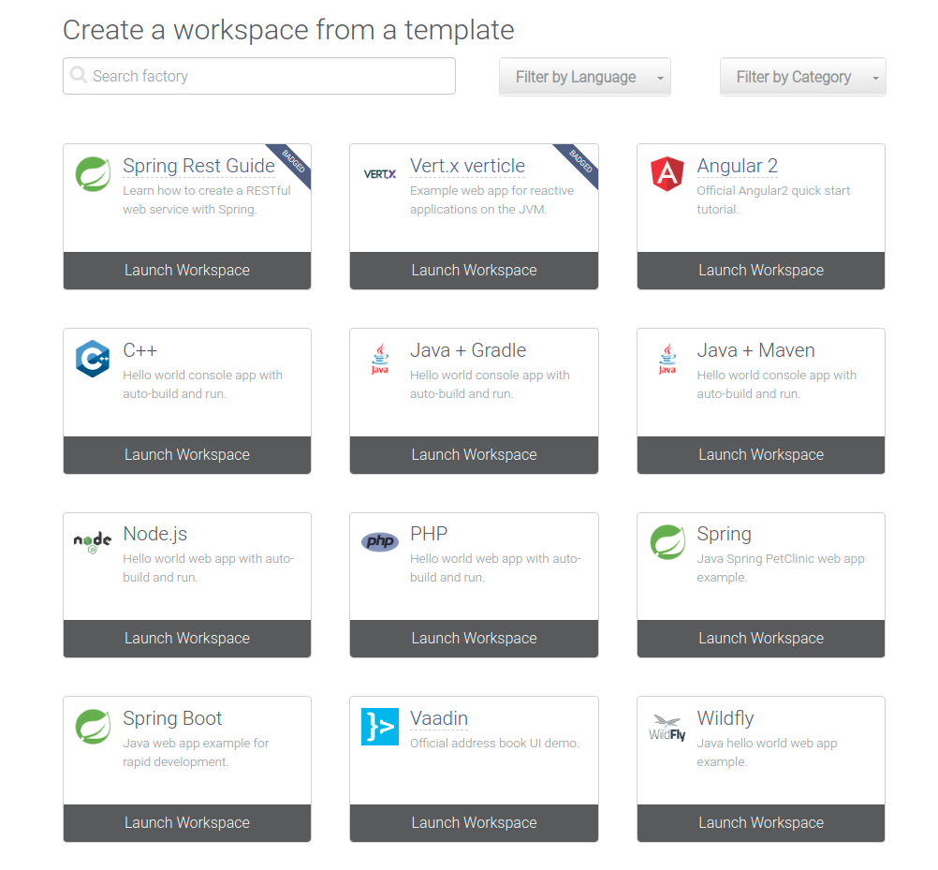
getting started devfile

Contributing to GitHub projects from Eclipse Che hosted by Red Hat 由Red Hat主持的Eclipse Che贡献给GitHub项目
This section describes how to contribute to GitHub projects from Eclipse Che hosted by Red Hat.
Prerequisites
- A workspace running in Eclipse Che hosted by Red Hat, including a project imported from GitHub.
- The SSH Plug-in is available in the workspace.
Procedure
- Generate an SSH key pair with the SSH Plug-in.
- Upload the public key to the GitHub account. For details, see the Adding a new SSH key to your GitHub account procedure.
- 本节描述了如何通过Red Hat托管的Eclipse Che为GitHub项目做出贡献。
- 先决条件
- -在Red Hat托管的Eclipse Che中运行的工作区，包括从GitHub导入的项目。 -[SSH插件]（https://github.com/eclipse/che-theia/tree/master/plugins/ssh-plugin）在工作区中可用。
- 程序
- 1.使用[SSH插件]（https://github.com/eclipse/che-theia/tree/master/plugins/ssh-plugin）生成SSH密钥对。 2.将公钥上传到GitHub帐户。 有关详细信息，请参见[向GitHub帐户添加新的SSH密钥]（https://help.github.com/en/articles/adding-a-new-ssh-key-to-your-github-account）过程 。

Frequently Asked Questions (FAQs) and Troubleshooting 常见问题解答（FAQ）和故障排除

FAQs
Eclipse Che hosted by Red Hat is part of the Developer Sandbox for Red Hat OpenShift offering. The common FAQs are available on the Developer Sandbox for Red Hat OpenShift website.
由Red Hat托管的Eclipse Che是[Red Hat OpenShift开发人员沙箱]（https://developers.redhat.com/developer-sandbox）产品的一部分。 常见的常见问题解答可在[Red Hat OpenShift的开发人员沙箱]（https://developers.redhat.com/developer-sandbox#assembly-field-sections-57861）网站上找到。

Troubleshooting 故障排除
Unexpected error during login
If an unexpected error during login happens the workaround is refreshing the page:
We are sorry... Unexpected error when authenticating with identity provider
To authenticate to https://workspaces.openshift.com, one needs to allow cookies from the static.developers.redhat.com. In case these cookies are blocked (by a browser extension like Privacy Badger), authentication will fail.
登录期间发生意外错误
如果登录期间发生意外错误，则解决方法将刷新页面：
很抱歉...向身份提供者进行身份验证时发生意外错误
为了对[https://workspaces.openshift.com]（https://workspaces.openshift.com/）进行身份验证，需要允许来自“ static.developers.redhat.com”中的cookie。 如果这些Cookie被阻止（例如[Privacy Badger]（https://www.eff.org/privacybadger）这样的浏览器扩展），则身份验证将失败。
Telemetry
Telemetry is enabled in Eclipse Che hosted by Red Hat, so Woopra / Segment tracking scripts must be explicitly allowed in case being blocked by a browser extension:
- https://api.segment.io/v1/t
- https://static.woopra.com/js/w.js
In case, the browser is running in the incognito mode the third-party cookies must be explicitly unblocked:
遥测
在Red Hat托管的Eclipse Che中启用了遥测，因此必须明确允许Woopra / Segment跟踪脚本，以防被浏览器扩展阻止：
-https://api.segment.io/v1/t -https://static.woopra.com/js/w.js
如果浏览器以隐身模式运行，则必须明确取消阻止第三方Cookie：
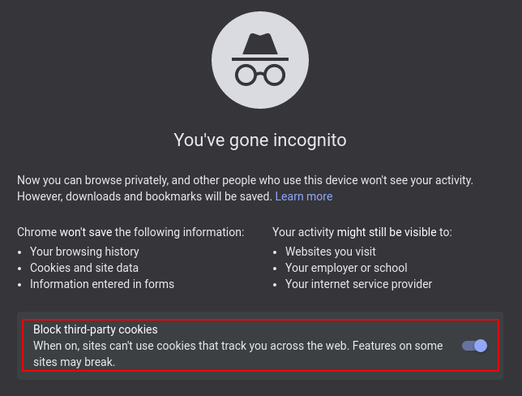
unblock third party cookies
Otherwise, the workspace startup will fail.
否则，工作空间启动将失败。
Additional resources
- For general end-user guidance, see Developer workspaces.

End-user-guide 最终用户向导

Navigating Che
This chapter describes available methods to navigate Eclipse Che.
- Navigating Che using the Dashboard
- Importing certificates to browsers
- Accessing Che from OpenShift Developer Perspective
本章描述了导航Eclipse Che的可用方法。
-[使用仪表板导航Che]（https://www.eclipse.org/che/docs/che-7/end-user-guide/navigating-che-using-the-dashboard/） -[将证书导入浏览器]（https://www.eclipse.org/che/docs/che-7/end-user-guide/importing-certificates-to-browsers/） -[从OpenShift开发人员角度访问Che]（

Che-Theia IDE basics Che-Divine已经具备基础知识
This section describes basics workflows and commands for Che-Theia: the native integrated development environment for Eclipse Che.
- Defining custom commands for Che-Theia
- Version Control
- Che-Theia Troubleshooting
- Differences in how Che-Theia Webview works on a single-host mode comparing to a multi-host mode
本节描述Che-Theia的基本工作流程和命令：Eclipse Che的本机集成开发环境。
-[为Che-Theia定义自定义命令]（https://www.eclipse.org/che/docs/che-7/end-user-guide/defining-custom-commands-for-che-theia/） -[版本控制]（https://www.eclipse.org/che/docs/che-7/end-user-guide/version-control/） -[Che-Theia故障排除]（https://www.eclipse.org/che/docs/che-7/end-user-guide/che-theia-troubleshooting/） -[与多主机模式相比，Che-Theia Webview在单主机模式下的工作方式差异] [

Using Developer workspaces 开发人员工作区
Contents
- Using a badge to link to workspaces
- Including the developer workspace badge in a README
Eclipse Che provides developer workspaces with everything needed to a code, build, test, run, and debug applications. To allow that, the developer workspaces provide four main components:
- The source code of a project.
- A web-based integrated development environment (IDE).
- Tool dependencies, needed by developers to work on a project.
- Application runtime: a replica of the environment where the application runs in production.
- Eclipse Che为开发人员工作区提供了编写，构建，测试，运行和调试应用程序所需的一切。 为此，开发人员工作区提供了四个主要组件：
- 1.项目的源代码。 2.基于Web的集成开发环境（IDE）。 3.开发人员在项目上需要的工具依赖项。 4.应用程序运行时：应用程序在生产环境中运行的环境的副本。
Pods manage each component of a Che workspace. Therefore, everything running in a Che workspace is running inside containers. This makes a Che workspace highly portable.
The embedded browser-based IDE is the point of access for everything running in a Che workspace. This makes a Che workspace easy to share.
Pod管理Che工作区的每个组件。 因此，在Che工作区中运行的所有内容都在容器内部运行。 这使得Che工作区具有高度的可移植性。
基于嵌入式浏览器的IDE是Che工作区中运行的所有内容的访问点。 这使得Che工作区易于共享。
By default, it is possible to run only one workspace at a time. To increase the number of concurrent workspaces a user can run, update the CheCluster:$ oc patch checluster eclipse-che -n eclipse-che --type=merge \ -p '{ "spec": { "server": { "customCheProperties": { "CHE_LIMITS_USER_WORKSPACES_RUN_COUNT": "-1" } } } }'For additional information, see: Users workspace limits.
默认情况下，一次只能运行一个工作空间。 要增加用户可以运行的并发工作空间的数量，请更新CheCluster：
$ oc patch checluster eclipse-che -n eclipse-che --type=merge \
-p '{ "spec": { "server": { "customCheProperties": { "CHE_LIMITS_USER_WORKSPACES_RUN_COUNT": "-1" } } } }'
有关更多信息，请参见：用户工作空间限制。
Features | Traditional IDE workspaces | Eclipse Che workspaces
Configuration and installation required | Yes. | No.
Embedded tools | Partial. IDE plug-ins need configuration. Dependencies need installation and configuration. Example: JDK, Maven, Node. | Yes. Plug-ins provide their dependencies.
Application runtime provided | No. Developers have to manage that separately. | Yes. Application runtime is replicated in the workspace.
Shareable | No. Or not easily | Yes. Developer workspaces are shareable with a URL.
Capable of being versioned | No | Yes. Devfiles exist with project source code.
Accessible from anywhere | No. Installation is needed. | Yes. Only requires a browser.
To start a Che workspace, following options are available:
- Configuring a Che 7.26 workspace
- Configuring a workspace using a devfile
Use the Dashboard to discover Che 7.26:
- Creating a workspace from code sample
- Creating a workspace by importing the source code of a project
Use a devfile as the preferred way to start a Che 7.26 workspace:
- Configuring a workspace using a devfile
- Importing Kubernetes applications into a workspace
要启动Che工作区，可以使用以下选项：
-[配置Che 7.26工作区]（https://www.eclipse.org/che/docs/che-7/end-user-guide/configuring-a-workspace-with-dashboard/） -[使用devfile配置工作区]（https://www.eclipse.org/che/docs/che-7/end-user-guide/configuring-a-workspace-using-a-devfile/）
使用仪表板发现Che 7.26：
-[通过代码示例创建工作区]（https://www.eclipse.org/che/docs/che-7/end-user-guide/creating-a-workspace-from-code-sample/） -[通过导入项目的源代码创建工作区]（https://www.eclipse.org/che/docs/che-7/end-user-guide/creating-a-workspace-by-importing-the -项目的源代码/）
使用devfile作为启动Che 7.26工作区的首选方法：
-[使用devfile配置工作区]（https://www.eclipse.org/che/docs/che-7/end-user-guide/configuring-a-workspace-using-a-devfile/） -[将Kubernetes应用程序导入到工作区中] [
Use the browser-based IDE as the preferred way to interact with a Che 7.26 workspace. For an alternative way to interact with a Che 7.26 workspace, see: Remotely accessing workspaces.
Using a badge to link to workspaces
It is common for code repositories to display badges in their README files that describe various aspects of the project, such as its test coverage, latest build status, link to documentation, and other things. For example, the Che GitHub README has the following badges:
使用基于浏览器的IDE作为与Che 7.26工作区进行交互的首选方式。 有关与Che 7.26工作空间进行交互的另一种方法，请参阅：[远程访问工作空间]（https://www.eclipse.org/che/docs/che-7/end-user-guide/remotely-accessing-workspaces/ ）。
使用徽章链接到工作区
代码存储库通常在其“ README”文件中显示标志，以描述项目的各个方面，例如测试范围，最新的构建状态，文档链接等。 例如，Che GitHubREADME具有以下标志：
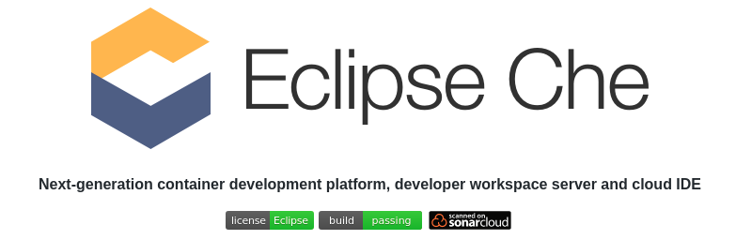
To make the process of using Che easier, the following badge is available:
Use this badge and link it to a Che instance to quickly open a developer workspace.
为了简化使用Che的过程，提供了以下标志：！[Factory标志]（2021-03-01-eclipse-che.assets / contribute.svg）
使用此徽章并将其链接到Che实例，以快速打开开发人员工作区。

Including the developer workspace badge in a README 在自述文件中包含开发人员工作区标志
Procedure
Add a link to your repository in the project README file. Using che.openshift.io as an example Che host, and a GitHub repository:
程序
在项目“ README”文件中添加指向您的存储库的链接。 使用[che.openshift.io]（https://che.openshift.io/）作为示例Che主机和GitHub存储库：
[![Contribute](https://www.eclipse.org/che/contribute.svg)](https://che.openshift.io/#https://github.com/org/repository)
The snippet above creates a badge that opens a developer workspace of the repository at https://github.com/org/repository in che.openshift.io. To open a workspace in your Che installation, substitute your URL and repository:
上面的代码段创建了一个徽章，用于打开[che.openshift.io]（https://che.openshift.io/）中位于https://github.com/org/repository的存储库的开发人员工作区。 要在Che安装中打开工作区，请替换URL和存储库：
[![Contribute](https://www.eclipse.org/che/contribute.svg)](https://your-che-host.com/#https://your-repository-url)

Creating a workspace from code sample 从代码示例创建工作区

Contents
- Creating a workspace from Get Started view of user dashboard
- Creating a custom workspace from a template
This section explains how to create a workspace from code sample or devfile template.
- Creating a workspace from sample using the Get Started view.
- Creating a custom workspace using templates on Custom Workspace view.
For more information about devfiles, see Configuring a workspace using a devfile.
本节说明如何从代码示例或devfile模板创建工作区。
1.使用[入门视图]（https://www.eclipse.org/che/docs/che-7/end-user-guide/creating-a-workspace-from-code-sample从示例创建工作区 /＃从用户仪表板_che的开始视图创建工作区）。 2.使用[自定义工作区视图]上的模板创建自定义工作区（https://www.eclipse.org/che/docs/che-7/end-user-guide/creating-a-workspace-from-code-sample /＃create-a-custom-workspace-from-a-template_che）。
有关devfile的更多信息，请参阅[使用devfile配置工作区]（https://www.eclipse.org/che/docs/che-7/end-user-guide/configuring-a-workspace-using-a- devfile /）。

Creating a workspace from Get Started view of user dashboard 从用户仪表板的“入门”视图创建工作区
This section describes how to create a workspace from the user dashboard with a code sample.
Prerequisites
- A running instance of Eclipse Che. To install an instance of Eclipse Che, see Installing Che.
- 本节介绍如何使用代码示例从用户仪表板创建工作区。
- 先决条件
- -Eclipse Che的运行实例。 要安装Eclipse Che的实例，请参阅[Installing Che]（https://www.eclipse.org/che/docs/che-7/installation-guide/installing-che/）。
Procedure
- Navigate to the Che Dashboard. See Navigating Che using the Dashboard.
- In the left navigation panel, go to Get Started.
- Click the Get Started tab.
- In the gallery, there is list of samples that may be used to build and run projects.
- 程序
- 1.导航到Che仪表板。 请参阅[使用仪表板导航Che]（https://www.eclipse.org/che/docs/che-7/end-user-guide/navigating-che-using-the-dashboard/）。 2.在左侧导航面板中，转到“入门”。 3.单击“入门”选项卡。 4.在库中，有可用于构建和运行项目的示例列表。
- 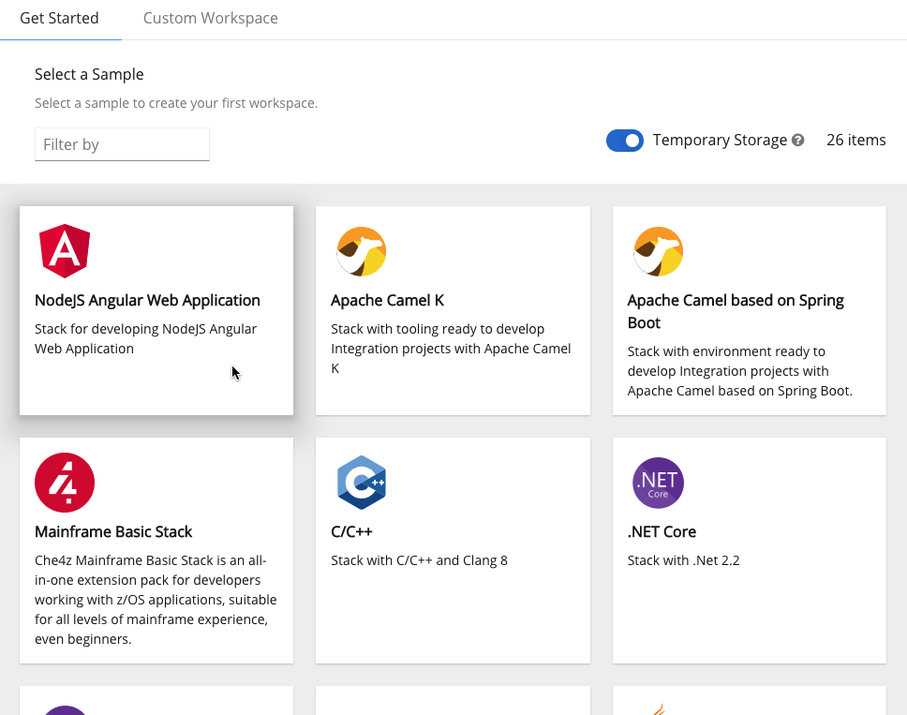
- Select a sample from the gallery
- Start the workspace: click the chosen stack card.
- 启动工作空间：单击所选的堆栈卡。
- 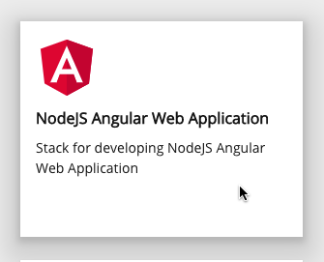
- Create and Open
New workspace nameWorkspace name can be auto-generated based on the underlying devfile of the stack. Generated names always consist of the devfile metadata.generateName property as the prefix and four random characters.
新的工作空间名称可以根据堆栈的基础devfile自动生成工作空间名称。 生成的名称始终由devfile的metadata.generateName属性作为前缀和四个随机字符组成。

Creating a custom workspace from a template 从模板创建自定义工作区
This section describes how to create a custom workspace from a template.
Prerequisites
- A running instance of Eclipse Che. To install an instance of Eclipse Che, see Installing Che.
- 本节介绍如何从模板创建自定义工作区。
- 先决条件
- -Eclipse Che的运行实例。 要安装Eclipse Che的实例，请参阅[Installing Che]（https://www.eclipse.org/che/docs/che-7/installation-guide/installing-che/）。
Procedure
- Navigate to the Che Dashboard. See Navigating Che using the Dashboard.
- In the left navigation panel, go to Get Started.
- Click the Custom Workspace tab.
- Define a Name for the workspace.
- 程序
- 1.导航到Che仪表板。 请参阅[使用仪表板导航Che]（https://www.eclipse.org/che/docs/che-7/end-user-guide/navigating-che-using-the-dashboard/）。 2.在左侧导航面板中，转到“入门”。 3.单击“自定义工作区”选项卡。 4.为工作区定义一个“名称”。
- New workspace nameWorkspace name can be auto-generated based on the underlying devfile of the stack. Generated names always consist of the devfile metadata.generateName property as the prefix and four random characters.
- 更多操作新工作空间名称可以根据堆栈的基础devfile自动生成工作空间名称。 生成的名称始终由devfile的metadata.generateName属性作为前缀和四个随机字符组成。
- In the Devfile section, select the devfile template that will be used to build and run projects.
- 在“ Devfile”部分中，选择将用于构建和运行项目的devfile模板。
- 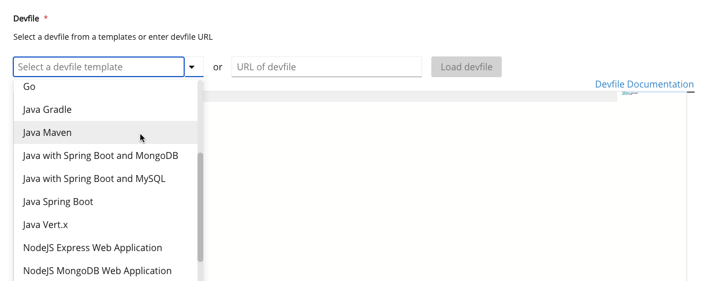
- Select a devfile from the list
- Start the workspace: click the Create & Open button at the bottom of the form:
- 启动工作空间：单击表单底部的“创建并打开”按钮：

Creating a workspace from remote devfile 从远程devfile创建工作区

Contents
- Creating a workspace from the default branch of a Git repository
- Creating a workspace from a feature branch of a Git repository
- Creating a workspace from a publicly accessible standalone devfile using HTTP
- Overriding devfile values using factory parameters
- Allowing users to define workspace deployment labels and annotations
For quick and easy Che workspace creation, use a factory link.
为了快速轻松地创建Che工作区，请使用工厂链接。

Creating a workspace from the default branch of a Git repository 从Git存储库的默认分支创建工作区
It is possible to create a Che workspace by pointing to a devfile that is stored in a Git source repository. The Che instance then uses the discovered devfile.yaml file to build a workspace using the factory URL. There are two forms for factory URL, short one is /#$URL and long that supports additional configuration parameters `/f?url=$URL`.
可以通过指向存储在Git源存储库中的devfile来创建Che工作区。 然后，Che实例使用发现的[devfile.yaml]（https://github.com/eclipse/che/blob/master/devfile.yaml）文件使用工厂URL来构建工作区。 工厂URL有两种形式，一种是/＃$ URL，另一种是支持其他配置参数/ f？url = $ URL。
Prerequisites
- A running instance of Eclipse Che. To install an instance of Eclipse Che, see Installing Che.
- The devfile.yaml or .devfile.yaml file is located in the root folder of a Git repository that is available over HTTPS. See Configuring a workspace using a devfile for detailed information about creating and using devfiles.
- 先决条件
- -Eclipse Che的运行实例。 要安装Eclipse Che的实例，请参阅[Installing Che]（https://www.eclipse.org/che/docs/che-7/installation-guide/installing-che/）。 -devfile.yaml或.devfile.yaml文件位于可通过HTTPS访问的Git存储库的根文件夹中。 有关详细信息，请参见[使用devfile配置工作区]（https://www.eclipse.org/che/docs/che-7/end-user-guide/configuring-a-workspace-using-a-devfile/）。 有关创建和使用devfile的信息。
Procedure
Run the workspace by opening the following URL: https://che-host:che-port/#https://*<GitRepository>*
程序
通过打开以下URL运行工作空间：https：// che-host：che-port /＃https：// * <GitRepository> *
Example
示例
https://che.openshift.io/#https://github.com/eclipse/che

Creating a workspace from a feature branch of a Git repository 从Git存储库的功能分支创建工作区
A Che workspace can be created by pointing to devfile that is stored in a Git source repository on a feature branch of the user’s choice. The Che instance then uses the discovered devfile to build a workspace.
可以通过指向存储在用户选择的功能分支上的Git源存储库中的devfile来创建Che工作区。 然后，Che实例使用发现的devfile构建工作空间。
Prerequisites
- A running instance of Eclipse Che. To install an instance of Eclipse Che, see Installing Che.
- The devfile.yaml or .devfile.yaml file is located in the root folder of a Git repository, on a specific branch of the user’s choice that is accessible over HTTPS. See Configuring a workspace using a devfile for detailed information about creating and using devfiles.
- 先决条件
- -Eclipse Che的运行实例。 要安装Eclipse Che的实例，请参阅[Installing Che]（https://www.eclipse.org/che/docs/che-7/installation-guide/installing-che/）。 -devfile.yaml或.devfile.yaml`文件位于Git信息库的根文件夹中，位于用户选择的特定分支上，可以通过HTTPS进行访问。 有关详细信息，请参见[使用devfile配置工作区]（https://www.eclipse.org/che/docs/che-7/end-user-guide/configuring-a-workspace-using-a-devfile/）。 有关创建和使用devfile的信息。
Procedure
Execute the workspace by opening the following URL: https://che-host:che-port/#*<GitHubBranch>*
程序
通过打开以下URL执行工作区：https：// che-host：che-port /＃* <GitHubBranch> *
Example
Use following URL format to open an experimental quarkus-quickstarts branch hosted on che.openshift.io.
https://che.openshift.io/#https://github.com/maxandersen/quarkus-quickstarts/tree/che
例子
使用以下URL格式打开在[che.openshift.io]（https://che.openshift.io/）上托管的实验性[quarkus-quickstarts]（https://github.com/quarkusio/quarkus-quickstarts）分支。

Creating a workspace from a publicly accessible standalone devfile using HTTP 使用HTTP从可公开访问的独立dev文件创建工作区
A workspace can be created using a devfile, the URL of which is pointing to the raw content of the devfile. The Che instance then uses the discovered devfile to build a workspace.
可以使用devfile创建工作空间，该devfile的URL指向devfile的原始内容。 然后，Che实例使用发现的devfile构建工作空间。
Prerequisites
- A running instance of Eclipse Che. To install an instance of Eclipse Che, see Installing Che.
- The publicly-accessible standalone devfile.yaml file. See Configuring a workspace using a devfile for detailed information about creating and using devfiles.
- 先决条件
- -Eclipse Che的运行实例。 要安装Eclipse Che的实例，请参阅[Installing Che]（https://www.eclipse.org/che/docs/che-7/installation-guide/installing-che/）。 -可公开访问的独立devfile.yaml文件。 有关详细信息，请参见[使用devfile配置工作区]（https://www.eclipse.org/che/docs/che-7/end-user-guide/configuring-a-workspace-using-a-devfile/）。 有关创建和使用devfile的信息。
Procedure
- Execute the workspace by opening the following URL: https://che-host:che-port/#https://*<yourhosturl>*/devfile.yaml
程序
1.通过打开以下URL执行工作区：https：// che-host：che-port /＃https：// * <yourhosturl> * / devfile.yaml
Example 例子
https://che.openshift.io/#https://gist.githubusercontent.com/themr0c/ef8e59a162748a8be07e900b6401e6a8/raw/8802c20743cde712bbc822521463359a60d1f7a9/devfile.yaml

Overriding devfile values using factory parameters 使用工厂参数覆盖devfile值
Values in the following sections of a remote devfile can be overridden using specially constructed additional factory parameters:
- apiVersion
- metadata
- projects
- attributes
- 可以使用特制的其他工厂参数来覆盖远程devfile的以下部分中的值：
- -apiVersion -metadata -项目 -属性
Prerequisites
- A running instance of Eclipse Che. To install an instance of Eclipse Che, see Installing Che.
- A publicly accessible standalone devfile.yaml file. See Configuring a workspace using a devfile for detailed information about creating and using devfiles.
- 先决条件
- -Eclipse Che的运行实例。 要安装Eclipse Che的实例，请参阅[Installing Che]（https://www.eclipse.org/che/docs/che-7/installation-guide/installing-che/）。 -可公开访问的独立devfile.yaml文件。 有关详细信息，请参见[使用devfile配置工作区]（https://www.eclipse.org/che/docs/che-7/end-user-guide/configuring-a-workspace-using-a-devfile/）。 有关创建和使用devfile的信息。
Procedure
- Open the workspace by navigating to the following URL: https://che-host:che-port/f?url=https://*<hostURL>*/devfile.yaml&override.*<parameter.path>*=*<value>*
- 程序
- 1.通过导航到以下URL打开工作区：https：// che-host：che-port / f？url = https：// * <hostURL> * / devfile.yaml＆override。* <parameter.path> * = * <值> *
Example of overriding the generateName property
Consider the following initial devfile:
覆盖generateName属性的示例
考虑以下初始devfile：
---
apiVersion: 1.0.0
metadata:
generateName: golang-
projects:
...
To add or override generateName value, use the following factory URL:
要添加或覆盖“ generateName”值，请使用以下工厂网址：
https://che.openshift.io/f?url=https://gist.githubusercontent.com/themr0c/ef8e59a162748a8be07e900b6401e6a8/raw/8802c20743cde712bbc822521463359a60d1f7a9/devfile.yaml&override.metadata.generateName=myprefix
The resulting workspace has the following devfile model:
产生的工作空间具有以下devfile模型：
---
apiVersion: 1.0.0
metadata:
generateName: myprefix
projects:
...
Example of overriding project source branch property
Consider the following initial devfile:
覆盖项目源分支属性的示例
考虑以下初始devfile：
---
apiVersion: 1.0.0
metadata:
generateName: java-mysql-
projects:
- name: web-java-spring-petclinic
source:
type: git
location: "https://github.com/spring-projects/spring-petclinic.git"
...
To add or override source branch value, use the following factory URL:
要添加或覆盖源“分支”值，请使用以下工厂网址：
https://che.openshift.io/f?url=https://gist.githubusercontent.com/themr0c/ef8e59a162748a8be07e900b6401e6a8/raw/8802c20743cde712bbc822521463359a60d1f7a9/devfile.yaml&override.projects.web-java-spring-petclinic.source.branch=1.0.x
The resulting workspace has the following devfile model:
产生的工作空间具有以下devfile模型：
apiVersion: 1.0.0
metadata:
generateName: java-mysql-
projects:
- name: web-java-spring-petclinic
source:
type: git
location: "https://github.com/spring-projects/spring-petclinic.git"
branch: 1.0.x
...
Example of overriding or creating an attribute value
Consider the following initial devfile:
覆盖或创建属性值的示例
考虑以下初始devfile：
---
apiVersion: 1.0.0
metadata:
generateName: golang-
attributes:
persistVolumes: false
projects:
...
To add or override persistVolumes attribute value, use the following factory URL:
要添加或覆盖“ persistVolumes”属性值，请使用以下工厂网址：
https://che.openshift.io/f?url=https://gist.githubusercontent.com/themr0c/ef8e59a162748a8be07e900b6401e6a8/raw/8802c20743cde712bbc822521463359a60d1f7a9/devfile.yaml&override.attributes.persistVolumes=true
The resulting workspace has the following devfile model:
产生的工作空间具有以下devfile模型：
---
apiVersion: 1.0.0
metadata:
generateName: golang-
attributes:
persistVolumes: true
projects:
...
When overriding attributes, everything that follows the attributes keyword is interpreted as an attribute name, so a user can use dot-separated names:
当覆盖属性时，关键字attributes后面的所有内容都被解释为属性名称，因此用户可以使用点分隔的名称：
https://che.openshift.io/f?url=https://gist.githubusercontent.com/themr0c/ef8e59a162748a8be07e900b6401e6a8/raw/8802c20743cde712bbc822521463359a60d1f7a9/devfile.yaml&override.attributes.dot.name.format.attribute=true
The resulting workspace has the following devfile model:
产生的工作空间具有以下devfile模型：
---
apiVersion: 1.0.0
metadata:
generateName: golang-
attributes:
dot.name.format.attribute: true
projects:
...

Allowing users to define workspace deployment labels and annotations 允许用户定义工作区部署标签和注释
This section describes how to customize workspace deployment labels and annotation using factory parameters.
本节描述如何使用工厂参数来自定义工作区部署标签和注释。
Prerequisites
- A running instance of Eclipse Che. To install an instance of Eclipse Che, see Installing Che.
- A publicly accessible standalone devfile.yaml file. See Configuring a workspace using a devfile for detailed information about creating and using devfiles.
- 先决条件
- -Eclipse Che的运行实例。 要安装Eclipse Che的实例，请参阅[Installing Che]（https://www.eclipse.org/che/docs/che-7/installation-guide/installing-che/）。 -可公开访问的独立devfile.yaml文件。 有关详细信息，请参见[使用devfile配置工作区]（https://www.eclipse.org/che/docs/che-7/end-user-guide/configuring-a-workspace-using-a-devfile/）。 有关创建和使用devfile的信息。
Procedure
- Open the workspace by navigating to the following URL: https://che-host:che-port/f?url=https://*<hostURL>*/devfile.yaml&workspaceDeploymentLabels=*<url_encoded_comma_separated_key_values>*&workspaceDeploymentAnnotations=*<url_encoded_comma_separated_key_values override>*
- 程序
- 1.通过导航到以下URL打开工作区：https：// che-host：che-port / f？url = https：// * <hostURL> * / devfile.yaml＆workspaceDeploymentLabels = * <url_encoded_comma_separated_key_values> *＆workspaceDeploymentAnnotations = * <url_encoded_comma_separated_key_values覆盖> *
Example of overriding the deployment labels
Consider the following labels to add:
覆盖“部署标签”的示例
考虑添加以下标签：
ike.target=preference-v1
ike.session=test
To add or override labels, use the following factory URL:
要添加或覆盖标签，请使用以下工厂网址：
https://che.openshift.io/f?url=https://gist.githubusercontent.com/themr0c/ef8e59a162748a8be07e900b6401e6a8/raw/8802c20743cde712bbc822521463359a60d1f7a9/devfile.yaml&workspaceDeploymentLabels=ike.target%3Dpreference-v1%2Cike.session%3Dtest
The resulting workspace has the following deployment labels:
产生的工作空间具有以下部署标签：
---
apiVersion: apps/v1
kind: Deployment
metadata:
annotations:
deployment.kubernetes.io/revision: "1"
creationTimestamp: "2020-10-27T14:03:26Z"
generation: 1
labels:
che.component.name: che-docs-dev
che.original_name: che-docs-dev
che.workspace_id: workspacegln2g1shejjufpkd
ike.session: test
ike.target: preference-v1
name: workspacegln2g1shejjufpkd.che-docs-dev
namespace: opentlc-mgr-che
resourceVersion: "107516"
spec:
...
Example of overriding the deployment annotations
Consider the following annotations to add:
覆盖“部署注释”的示例
考虑添加以下注释：
ike.A1=preference-v1
ike.A=test
To add or override annotations, use the following factory URL:
要添加或覆盖注释，请使用以下工厂URL：
https://che.openshift.io/f?url=https://gist.githubusercontent.com/themr0c/ef8e59a162748a8be07e900b6401e6a8/raw/8802c20743cde712bbc822521463359a60d1f7a9/devfile.yaml&workspaceDeploymentAnnotations=ike.A1%3Dpreference-v1%2Cike.A%3Dtest
The resulting workspace has the following deployment annotations:
产生的工作空间具有以下部署注释：
---
apiVersion: apps/v1
kind: Deployment
metadata:
annotations:
deployment.kubernetes.io/revision: "1"
ike.A: test
ike.A1: preference-v1
creationTimestamp: "2020-10-28T09:58:52Z"
generation: 1
labels:
che.component.name: che-docs-dev
che.original_name: che-docs-dev
che.workspace_id: workspacexrtf710v64rl5ouz
name: workspacexrtf710v64rl5ouz.che-docs-dev
namespace: opentlc-mgr-che
resourceVersion: "213191"
...
Additional resources 额外资源
- Configuring a workspace using a devfile

Creating a workspace using chectl and a local devfile 使用chectl和本地devfile创建工作区
A Che workspace can be created by pointing the chectl tool to a locally stored devfile. The Che instance then uses the discovered devfile to build a workspace.
可以通过将“ chectl”工具指向本地存储的devfile来创建Che工作区。 然后，Che实例使用发现的devfile构建工作空间。
Prerequisites
- A running instance of Eclipse Che. To install an instance of Eclipse Che, see Installing Che.
- The Che CLI management tool. See Using the chectl management tool.
- The devfile is available on the local filesystem in the current working directory. See Configuring a workspace using a devfile for detailed information about creating and using devfiles.
- You are logged in to Eclipse Che. See How to login into Che using chectl
- 先决条件
- -Eclipse Che的运行实例。 要安装Eclipse Che的实例，请参阅[Installing Che]（https://www.eclipse.org/che/docs/che-7/installation-guide/installing-che/）。 -Che CLI管理工具。 请参阅[使用chectl管理工具]（https://www.eclipse.org/che/docs/che-7/installation-guide/using-the-chectl-management-tool/）。 -devfile在当前工作目录中的本地文件系统上可用。 有关详细信息，请参见[使用devfile配置工作区]（https://www.eclipse.org/che/docs/che-7/end-user-guide/configuring-a-workspace-using-a-devfile/）。 有关创建和使用devfile的信息。 -您已登录Eclipse Che。 请参阅[如何使用chectl登录到Che]
Example
Download the devfile.yaml file from the GitHub repository to the current working directory.
例子
从[GitHub存储库]（https://github.com/eclipse/che/blob/master/devfile.yaml）下载devfile.yaml文件到当前工作目录。
Procedure
- Run a workspace from a devfile using the workspace:create parameter with the chectl tool as follows:
- 程序
- 1.使用带有chectl工具的workspace：create参数从devfile运行一个工作空间，如下所示：
$ chectl workspace:create --name=<WORKSPACE_NAME> \
--devfile=devfile.yaml --start \
-n eclipse-che
The workspace name to create.

If --devfile flag is omitted, the chectl looks for devfile.yaml or devfile.yml files in the current directory to create a workspace from.

Creating a workspace by importing the source code of a project 通过导入项目的源代码创建工作区

Contents
- Select a sample from the Dashboard, then change the devfile to include your project
- Importing from the Dashboard into an existing workspace
- Editing the commands after importing a project
- Importing to a running workspace using the Git: Clone command
- Importing to a running workspace with git clone in a terminal
This section describes how to create a new workspace for editing an existing codebase.
本节介绍如何创建新的工作区来编辑现有代码库。
Prerequisites
- A running instance of Che. To install an instance of Che, see Installing Che.
- An existing workspace with plug-ins related to your development environment defined on this instance of Eclipse Che Configuring a Che 7.26 workspace.
- 先决条件
- -Che的运行实例。 要安装Che的实例，请参阅[安装Che]（https://www.eclipse.org/che/docs/che-7/installation-guide/installing-che/）。 -在此Eclipse Che实例上定义了具有与开发环境相关的插件的现有工作区[配置Che 7.26工作区]（https://www.eclipse.org/che/docs/che-7/end-user- 指南/配置带仪表板的工作区/）。
A user can progress with two methods that have to be applied before starting a workspace:
- Select a sample from the Dashboard, then change the devfile to include your project
- Configuring a workspace using a devfile
- 用户可以在开始工作区之前**使用必须应用的两种方法进行处理：
- -[从仪表板中选择一个示例，然后更改devfile以包含您的项目]（https://www.eclipse.org/che/docs/che-7/end-user-guide/creating-a-workspace-by 导入项目的源代码/从dashboard_che创建＃自定义工作区） -[使用devfile配置工作区]（
To create a new workspace for editing an existing codebase, use one of the following methods after the workspace has been started:
- Import from the Dashboard into an existing workspace
- Import to a running workspace using the git clone command
- Import to a running workspace using git clone in a terminal
- 要创建用于编辑现有代码库的新工作空间，请在工作空间启动后**使用以下方法之一：
- -[从仪表板导入现有工作区]（https://www.eclipse.org/che/docs/che-7/end-user-guide/creating-a-workspace-by-importing- 项目的源代码/＃从仪表板导入到现有的工作区_che中） -[使用git clone命令导入正在运行的工作空间]（https://www.eclipse.org/che/docs/che-7/end-user-guide/creating-a-workspace-by-importing- 项目的源代码/使用git-lone-command_che导入运行的工作区） -[在终端中使用git clone导入正在运行的工作空间]（

Select a sample from the Dashboard, then change the devfile to include your project 从仪表板中选择一个示例，然后更改devfile以包括您的项目
- In the left navigation panel, go to Get Started.
- Click the Custom Workspace tab if it’s not already selected.
- In the Devfile section, select the devfile template that will be used to build and run projects.
- -在左侧导航面板中，转到“入门”。 -如果尚未选中“自定义工作区”标签，请点击该标签。 -在“ Devfile”部分中，选择将用于构建和运行项目的devfile模板。
- 
- Select a devfile from the list
- In the Devfile editor, update projects section:
- 在** Devfile编辑器**中，更新`projects’部分：
- 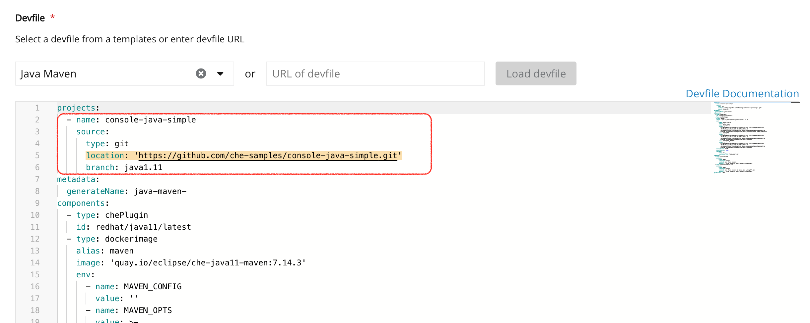
- img
- Example: add a projectTo add a project into the workspace, add or edit the following section:projects: - name: che source: type: git location: 'https://github.com/eclipse/che.git'![copy icon](https://www.eclipse.org/che/docs/_/img/octicons-16.svg#view-clippy)See the Devfile reference.
- 示例：添加一个项目 要将项目添加到工作区中，请添加或编辑以↑部分：
- To open the workspace, click the Create & Open button.
- 要打开工作区，请单击“创建并打开”按钮。

Importing from the Dashboard into an existing workspace 从仪表板导入现有工作区
- From the Dashboard, select Workspaces.
- Select your workspace by selecting its name. This will link you to the workspace’s Overview tab.
- Open Devfile tab where you can enter your own YAML configuration.
- Add the project.
- -从“控制台”中选择“工作区”。 -通过选择工作区的名称来选择工作区。 这会将您链接到工作区的“概述”标签。 -打开“ Devfile”标签，您可以在其中输入自己的YAML配置。 -添加项目。
Example: add a projectTo add a project into the workspace, add or edit the following section:projects: - name: che source: type: git location: 'https://github.com/eclipse/che.git'![copy icon](https://www.eclipse.org/che/docs/_/img/octicons-16.svg#view-clippy)See the Devfile reference.
示例：添加项目要将项目添加到工作区中，请添加或编辑以上内容

Editing the commands after importing a project 导入项目后编辑命令
After you have a project in your workspace, you can add commands to it. Adding commands to your projects allows you to run, debug, or launch your application in a browser.
工作区中有项目后，可以向其中添加命令。 在项目中添加命令可以使您在浏览器中运行，调试或启动应用程序。
To add commands to the project:
- Open the workspace configuration in the Dashboard, then select the Devfile tab.
- Modify the commands field.
- Open the workspace.
- To run a command, select Terminal > Run Task from the main menu.
- 要将命令添加到项目中：
- 1.在“仪表板”中打开工作区配置，然后选择“ Devfile”选项卡。 2.修改命令字段。 3.打开工作区。 4.要运行命令，请从主菜单中选择“终端”>“运行任务”。
- 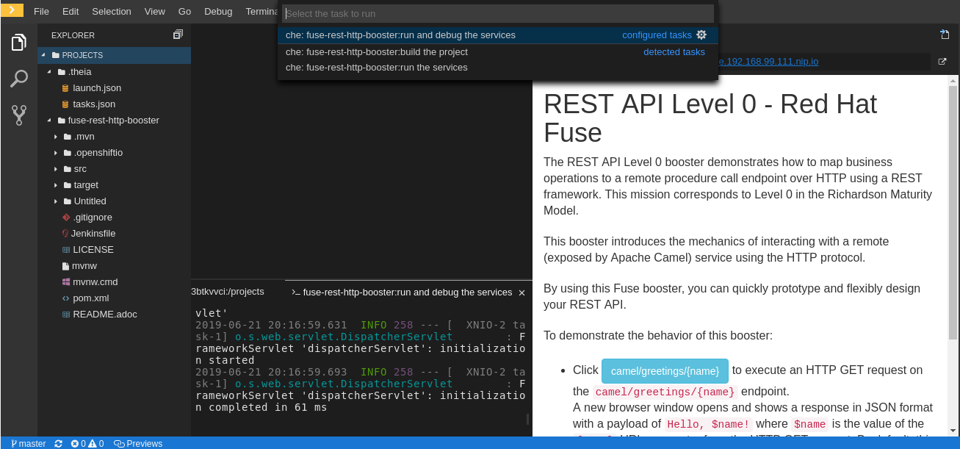
- Run task
- To configure commands, select Terminal > Configure Tasks from the main menu.
- 要配置命令，请从主菜单中选择** Terminal （终端）> Configure Tasks（配置任务）**。
- 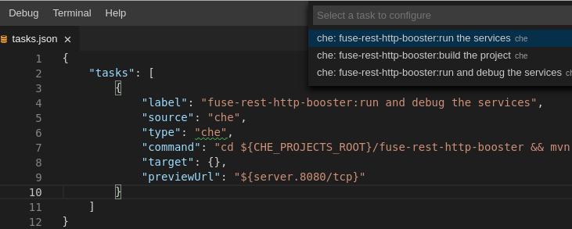
- Configure tasks

Importing to a running workspace using the Git: Clone command 使用 Git：Clone 命令导入到正在运行的工作空间
To import to a running workspace using the Git: Clone command:
- Start a workspace, then use the Git: Clone command from the command palette or the Welcome screen to import a project to a running workspace.
- 要使用** Git：Clone **命令导入到正在运行的工作空间：
- 1.启动工作区，然后使用命令面板或“欢迎”屏幕中的“ Git：克隆”命令将项目导入到正在运行的工作区中。
- 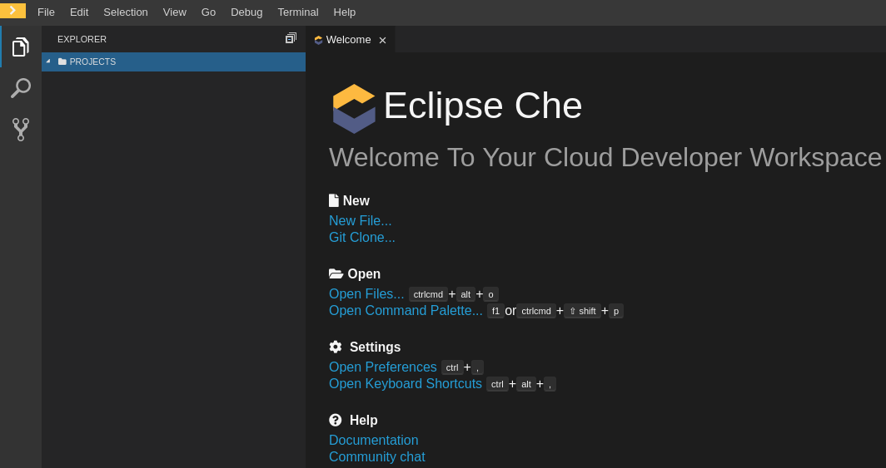
- Welcome screen
- Open the command palette using F1 or CTRL-SHIFT-P, or from the link in the Welcome screen.
- 使用“ F1”或“ CTRL-SHIFT-P”或从“欢迎”屏幕中的链接打开命令面板。
- 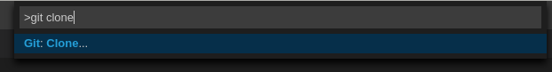
- Invoke git clone command
- Enter the path to the project that is about to be cloned.
- 输入将要克隆的项目的路径。
- 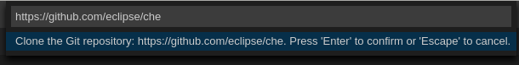
- Configure git clone command

Importing to a running workspace with git clone in a terminal 在终端中使用git clone导入到正在运行的工作空间
In addition to the approaches above, you can also start a workspace, open a Terminal, and type git clone to pull code.
除了上述方法之外，您还可以启动工作空间，打开** Terminal **，然后键入git clone来提取代码。
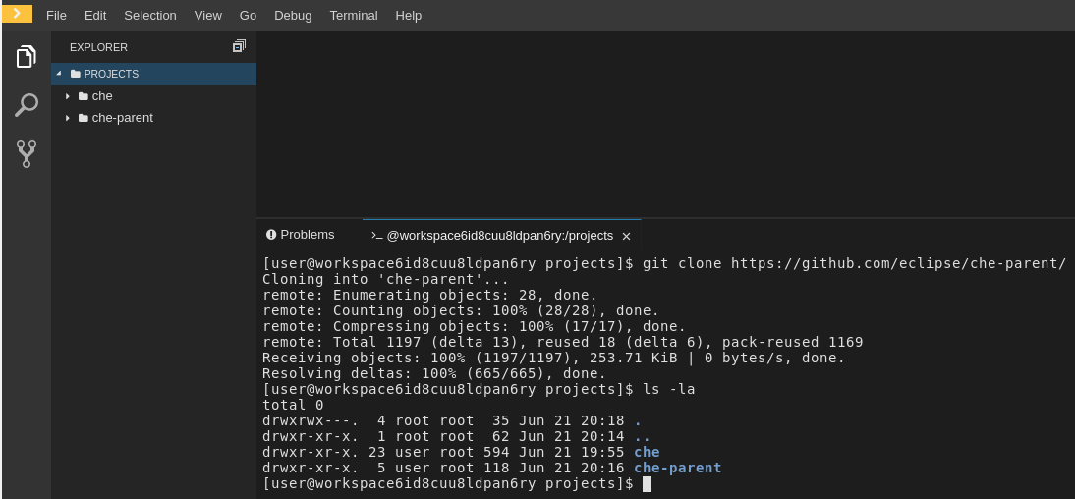
Run git clone in a terminal
Importing or deleting workspace projects in the terminal does not update the workspace configuration, and the change is not reflected in the Project and Devfile tabs in the dashboard.Similarly, when you add a project using the Dashboard, then delete it with rm -fr myproject, it may still appear in the Projects or Devfile tab.
在终端中导入或删除工作空间项目不会更新工作空间配置，并且更改不会反映在仪表板的项目''和开发文件’’选项卡中。类似地，当您使用添加项目时 仪表板，然后用rm -fr myproject删除它，它可能仍会出现在** Projects 或 Devfile **选项卡中。

Configuring a Che 7.26 workspace 配置Che 7.26工作区

Contents
- Changing the configuration of an existing workspace
- Adding projects to your workspace
- Configuring the workspace tools
- Adding plug-ins
- Defining the workspace editor
- -[更改现有工作区的配置]（https://www.eclipse.org/che/docs/che-7/end-user-guide/configuring-a-workspace-with-dashboard/#changing-the- 现有工作区的配置） -[将项目添加到您的工作区]（https://www.eclipse.org/che/docs/che-7/end-user-guide/configuring-a-workspace-with-dashboard/#adding-projects-to- your-workspace_che） -[配置工作区工具]（https://www.eclipse.org/che/docs/che-7/end-user-guide/configuring-a-workspace-with-dashboard/#configuring-the-workspace-and -adding-tooling_che） -[添加插件]（https://www.eclipse.org/che/docs/che-7/end-user-guide/configuring-a-workspace-with-dashboard/#adding-plug-ins_che） -[定义工作区编辑器]（https://www.eclipse.org/che/docs/che-7/end-user-guide/configuring-a-workspace-with-dashboard/#defining-the-workspace-editor_che ）

Changing the configuration of an existing workspace 更改现有工作空间的配置
This section describes how to change the configuration of an existing workspace from the user Dashboard.
本节介绍如何从用户仪表板更改现有工作区的配置。
Prerequisites
- A running instance of Che. To install an instance of Che, see Installing Che.
- An existing workspace defined on this instance of Che.
- 先决条件
- -Che的运行实例。 要安装Che的实例，请参阅[安装Che]（https://www.eclipse.org/che/docs/che-7/installation-guide/installing-che/）。 -在该Che实例上定义的现有工作区。
Procedure
- Navigate to the Che Dashboard. See Navigating Che using the Dashboard.
- In the left navigation panel, go to Workspaces.
- Click the name of a workspace to navigate to the configuration overview page.
- Click the Overview tab and execute following actions:
  - Change the Workspace name.
  - Select Storage Type.
  - Review Kubernetes namespace.
- From the Devfile tab, edit YAML configuration of the workspace. See Configuring a workspace using a devfile.
- 程序
- 1.导航到Che仪表板。 请参阅[使用仪表板导航Che]（https://www.eclipse.org/che/docs/che-7/end-user-guide/navigating-che-using-the-dashboard/）。 2.在左侧导航面板中，转到“工作区”。 3.单击工作区的名称以导航到配置概述页面。 4.单击“概述”选项卡，然后执行以下操作： -更改“工作区名称”。 -选择“存储类型”。 -查看** Kubernetes命名空间**。 5.从“ Devfile”选项卡中，编辑工作区的YAML配置。 请参阅[使用devfile配置工作区]（https://www.eclipse.org/che/docs/che-7/end-user-guide/configuring-a-workspace-using-a-devfile/）。

Adding projects to your workspace 将项目添加到您的工作区
Prerequisites
- A running instance of Che. To install an instance of Che, see Installing Che.
- An existing workspace defined on this instance of Che.
- 先决条件
- -Che的运行实例。 要安装Che的实例，请参阅[安装Che]（https://www.eclipse.org/che/docs/che-7/installation-guide/installing-che/）。 -在该Che实例上定义的现有工作区。
Procedure
To add a project to your workspace:
- Navigate to the Workspaces page and click the workspace, which is about to be updated.
- Open the Devfile tab.
- In the Devfile editor, add a projects section with desired project.
- 程序
- 要将项目添加到您的工作区，请执行以下操作：
- 1.导航到“工作区”页面，然后单击将要更新的工作区。 2.打开“ Devfile”选项卡。 3.在** Devfile编辑器**中，添加带有所需项目的`projects’部分。
- 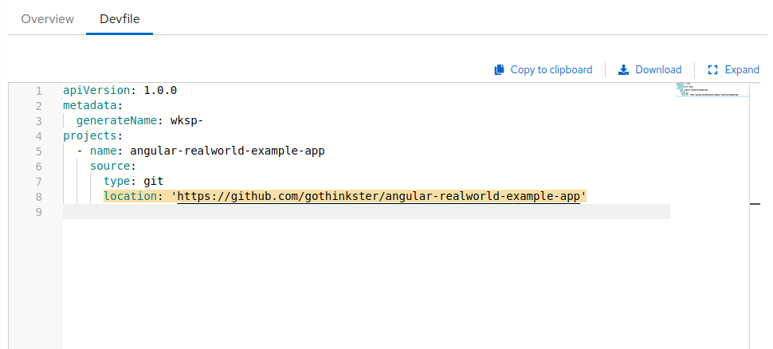
- Once the project is added, click the Save button to save this workspace configuration.
- For demonstration example, see below:
- Example - Adding a .git project into a workspace using a devfile
- In the following instance, the project che acts as the example of a user’s project. A user specifies this project using the name attribute of a devfile. The location attribute defines the source repository represented by an URL to a Git repository or ZIP archive.
- To add a project into the workspace, add or edit the following section:
- 添加项目后，单击“保存”按钮以保存此工作区配置。
- 有关演示示例，请参见下文：
- 示例-使用devfile将.git项目添加到工作区中
- 在以下情况下，项目“ che”充当用户项目的示例。 用户使用devfile的name属性指定该项目。 “ location”属性定义了由Git存储库或ZIP存档的URL表示的源存储库。
- 要将项目添加到工作区中，请添加或编辑以下部分：
- projects:
- name: <che>
source:
type: git
location: 'https://github.com/<github-organization>/<che>.git'
- For additional information, see the Devfile reference section.
- 有关更多信息，请参见[Devfile参考]（https://www.eclipse.org/che/docs/che-7/end-user-guide/configuring-a-workspace-using-a-devfile/#devfile- reference_che）部分。

Configuring the workspace tools 配置工作区工具

Adding plug-ins 添加插件
Prerequisites
- A running instance of Che. To install an instance of Che, see Installing Che.
- An existing workspace defined on this instance of Che.
- 先决条件
- -Che的运行实例。 要安装Che的实例，请参阅[安装Che]（https://www.eclipse.org/che/docs/che-7/installation-guide/installing-che/）。 -在该Che实例上定义的现有工作区。
Procedure
To add plug-ins to your workspace:
- Click the Devfile tab.
- Add the desired chePlugin component and click the Save button.
- 程序
- 要将插件添加到您的工作空间，请执行以下操作：
- 1.单击** Devfile **选项卡。 2.添加所需的“ chePlugin”组件，然后单击“保存”按钮。
- To see a list of available plugins, activate the completion feature by pressing Ctrl+Space.
- 要查看可用插件的列表，请按Ctrl + Space激活完成功能。
- 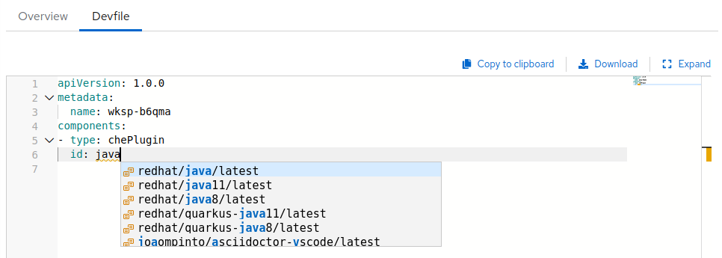
- workspace add plugin

Defining the workspace editor 定义工作区编辑器
Prerequisites
- A running instance of Che. To install an instance of Che, see Installing Che.
- An existing workspace defined on this instance of Che.
- 先决条件
- -Che的运行实例。 要安装Che的实例，请参阅[安装Che]（https://www.eclipse.org/che/docs/che-7/installation-guide/installing-che/）。 -在该Che实例上定义的现有工作区。
Procedure
To define the editor to use with the workspace:
- Click the Devfile tab.
- Add the desired cheEditor component and click the Save button.
- 程序
- 定义要与工作空间一起使用的编辑器：
- 1.单击** Devfile **选项卡。 2.添加所需的“ cheEditor”组件，然后单击“保存”按钮。
- To see a list of available plugins, activate the completion feature by pressing Ctrl+Space. The recommended editor for Che 7.26 is Che-Theia.
- 要查看可用插件的列表，请按Ctrl + Space激活完成功能。 Che 7.26的推荐编辑器是Che-Theia。
- 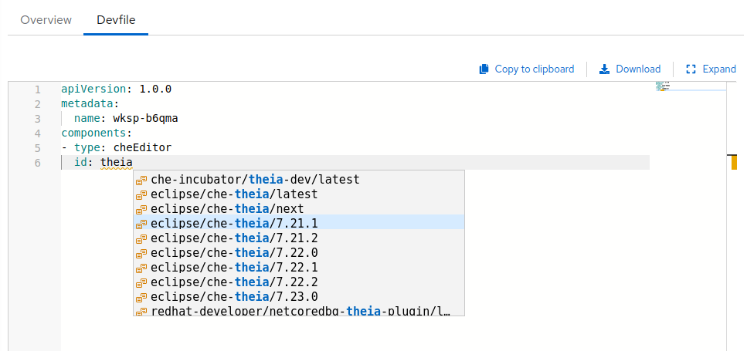
- workspace add editor
Additional resources
- Configuring a workspace using a devfile

Configuring a workspace using a devfile

Contents
- What is a devfile
- A minimal devfile
- Generating workspace names
- Writing a devfile for a project
- Preparing a minimal devfile
- Specifying multiple projects in a devfile
- Devfile reference
- Adding projects to a devfile
- Adding components to a devfile
- Adding commands to a devfile
- Devfile attributes
- Objects supported in Eclipse Che 7.26
To quickly and easily configure a Che workspace, use a devfile. For an introduction to devfiles and instructions for their use, see the instructions in this section.

What is a devfile
A devfile is a file that describes and define a development environment:
- The source code.
- The development components, such as browser IDE tools and application runtimes.
- A list of pre-defined commands.
- Projects to clone.
A devfiles is a YAML file that Che consumes and transforms into a cloud workspace composed of multiple containers. It is possible to store a devfile remotely or locally, in any number of ways, such as:
- In a git repository, in the root folder, or on a feature branch.
- On a publicly accessible web server, accessible through HTTP.
- Locally as a file, and deployed using chectl.
- In a collection of devfiles, known as a devfile registry.
When creating a workspace, Che uses that definition to initiate everything and run all the containers for the required tools and application runtimes. Che also mounts file-system volumes to make source code available to the workspace.
Devfiles can be versioned with the project source code. When there is a need for a workspace to fix an old maintenance branch, the project devfile provides a definition of the workspace with the tools and the exact dependencies to start working on the old branch. Use it to instantiate workspaces on demand.
Che maintains the devfile up-to-date with the tools used in the workspace:
- Elements of the project, such as the path, git location, or branch.
- Commands to perform daily tasks such as build, run, test, and debug.
- The runtime environment with its container images needed for the application to run.
- Che-Theia plug-ins with tools, IDE features, and helpers that a developer would use in the workspace, for example, Git, Java support, SonarLint, and Pull Request.

A minimal devfile
The following is the minimum content required in a devfile:
- apiVersion
- metadata name
apiVersion: 1.0.0
metadata:
name: che-in-che-out
For a complete devfile example, see Eclipse Che in Che devfile.yaml.
A choice of use of the parameter generateName or name is optional, but only one of these parameters has to be chosen by a user and defined. When both attributes are specified, generateName is ignored. See Generating workspace names.metadata: generatedName:![copy icon](https://www.eclipse.org/che/docs/_/img/octicons-16.svg#view-clippy)ormetadata: name:![copy icon](https://www.eclipse.org/che/docs/_/img/octicons-16.svg#view-clippy)

Generating workspace names
To specify a prefix for automatically generated workspace names, set the generateName parameter in the devfile:
apiVersion: 1.0.0
metadata:
generateName: che-
The workspace name will be in the <generateName>YYYYY format (for example, che-2y7kp). Y is random [a-z0-9] character.
The following naming rules apply when creating workspaces:
- When name is defined, it is used as the workspace name: <name>
- When only generateName is defined, it is used as the base of the generated name: <generateName>YYYYY
For workspaces created using a factory, defining name or generateName has the same effect. The defined value is used as the name prefix: <name>YYYYY or <generateName>YYYYY. When both generateName and name are defined, generateName takes precedence.

Writing a devfile for a project
This section describes how to create a minimal devfile for your project and how to include more than one projects in a devfile.

Preparing a minimal devfile
A minimal devfile sufficient to run a workspace consists of the following parts:
- Specification version
- Name
Example of a minimal devfile with no project
apiVersion: 1.0.0
metadata:
name: minimal-workspace
Without any further configuration, a workspace with the default editor is launched along with its default plug-ins, which are configured on the Che Server. Che-Theia is configured as the default editor along with the Che Machine Exec plug-in. When launching a workspace within a Git repository using a factory, the project from the given repository and branch is be created by default. The project name then matches the repository name.
Add the following parts for a more functional workspace:
- List of components: Development components and user runtimes
- List of projects: Source code repositories
- List of commands: Actions to manage the workspace components, such as running the development tools, starting the runtime environments, and others
Example of a minimal devfile with a project
apiVersion: 1.0.0
metadata:
name: petclinic-dev-environment
projects:
- name: petclinic
source:
type: git
location: 'https://github.com/spring-projects/spring-petclinic.git'
components:
- type: chePlugin
id: redhat/java/latest

Specifying multiple projects in a devfile
A single devfile can define multiple projects, which are cloned to the desired destination. These projects are created inside a user’s workspace after the workspace is started.
For each project, specify the following:
- The type of the source repository - this can be .git or .zip. For additional information, see the Devfile reference section.
- The location of the source repository - an URL to a Git repository or ZIP archive.
- Optionally, the directory to which the project is cloned. If none is specified, the default directory is used, which is a directory that matches the project name or project Git repository.
Example of a devfile with two projects
In the following example, the projects frontend and backend act as examples of a user’s projects. Each project is located in a separate repository.
- The backend project has a specific requirement to be cloned into the src/github.com/*<github-organization>*/*<backend>*/ directory under the source root, implicitly defined by the Che runtime.
- The frontend project will be cloned into the *<frontend/>* directory under the source root.
apiVersion: 1.0.0
metadata:
name: example-devfile
projects:
- name: <frontend>
source:
type: git
location: https://github.com/<github-organization>/<frontend>.git
- name: <backend>
clonePath: src/github.com/<github-organization>/<backend>
source:
type: git
location: https://github.com/<github-organization>/<backend>.git
Additional resources
For a detailed explanation of all devfile component assignments and possible values, see:
- Specification repository
- Detailed json-schema documentation
These sample devfiles are a good source of inspiration:
- Sample devfiles for Eclipse Che workspaces used by default in the user interface.
- Sample devfiles for Eclipse Che workspaces from Red Hat Developer program.

Devfile reference
This section contains devfile reference and instructions on how to use the various elements that devfiles consist of.

Adding projects to a devfile
A devfile is designed to contain one or more projects. A workspace is created to develop those projects. Projects are added in the projects section of devfiles.
Each project in a single devfile must have:
- Unique name
- Source specified
Project source consists of two mandatory values: type and location.
- type
- The kind of project-source provider.
- location
- The URL of project source.
Che supports the following project types:
- git
- Projects with sources in Git. The location points to a clone link.
- github
- Same as git but for projects hosted on GitHub only. Use git for projects that do not use GitHub-specific features.
- zip
- Projects with sources in a ZIP archive. Location points to a ZIP file.

Project-source type: git
source:
type: git
location: https://github.com/eclipse/che.git
startPoint: master
tag: 7.2.0
commitId: 36fe587
branch: 7.20.x
sparseCheckoutDir: core
startPoint: The general value for tag, commitId, and branch. The startPoint, tag, commitId, and branch parameters are mutually exclusive. When more than one is supplied, the following order is used: startPoint, tag, commitId, branch.
sparseCheckoutDir: The template for the sparse checkout Git feature. This is useful when only a part of a project, typically a single directory, is needed.
Example 1. sparseCheckoutDir parameter settings
- Set to /my-module/ to create only the root my-module directory (and its content).
- Omit the leading slash (my-module/) to create all my-module directories that exist in the project. Including, for example, /addons/my-module/.
- The trailing slash indicates that only directories with the given name (including their content) are created.
- Use wildcards to specify more than one directory name. For example, setting module-* checks out all directories of the given project that start with module-.
For more information, see Sparse checkout in Git documentation.

Project-source type: zip
source:
type: zip
location: http://host.net/path/project-src.zip

Project clone-path parameter: clonePath
The clonePath parameter specifies the path into which the project is to be cloned. The path must be relative to the /projects/ directory, and it cannot leave the /projects/ directory. The default value is the project name.
Example devfile with projects
apiVersion: 1.0.0
metadata:
name: my-project-dev
projects:
- name: my-project-resourse
clonePath: resources/my-project
source:
type: zip
location: http://host.net/path/project-res.zip
- name: my-project
source:
type: git
location: https://github.com/my-org/project.git
branch: develop

Adding components to a devfile
Each component in a single devfile must have a unique name.

Component type: cheEditor
Describes the editor used in the workspace by defining its id. A devfile can only contain one component of the cheEditor type.
components:
- alias: theia-editor
type: cheEditor
id: eclipse/che-theia/next
When cheEditor is missing, a default editor is provided along with its default plug-ins. The default plug-ins are also provided for an explicitly defined editor with the same id as the default one (even if it is a different version). Che-Theia is configured as default editor along with the Che Machine Exec plug-in.
To specify that a workspace requires no editor, use the editorFree:true attribute in the devfile attributes.

Component type: chePlugin
Describes plug-ins in a workspace by defining their id. It is allowed to have several chePlugin components.
components:
- alias: exec-plugin
type: chePlugin
id: eclipse/che-machine-exec-plugin/0.0.1
Both types above use an ID, which is slash-separated publisher, name and version of plug-in from the Che Plug-in registry.
List of available Eclipse{nbsp}Che plug-ins and more information about registry can be found in the Eclipse{nbsp}Che plug-in registry GitHub repository.

Specifying an alternative component registry
To specify an alternative registry for the cheEditor and chePlugin component types, use the registryUrl parameter:
components:
- alias: exec-plugin
type: chePlugin
registryUrl: https://my-customregistry.com
id: eclipse/che-machine-exec-plugin/0.0.1

Specifying a component by linking to its descriptor
An alternative way of specifying cheEditor or chePlugin, rather than a use of the editor or plug-in id (and optionally an alternative registry), is to provide a direct link to the component descriptor (typically named meta.yaml) by using the reference field:
components:
- alias: exec-plugin
type: chePlugin
reference: https://raw.githubusercontent.com.../plugin/1.0.1/meta.yaml
It is impossible to mix the id and reference fields in a single component definition; they are mutually exclusive.

Tuning chePlugin component configuration
A chePlugin component may need to be precisely tuned, and in such case, component preferences can be used. The example shows how to configure JVM using plug-in preferences.
id: redhat/java/0.38.0
type: chePlugin
preferences:
java.jdt.ls.vmargs: '-noverify -Xmx1G -XX:+UseG1GC -XX:+UseStringDeduplication'
Preferences may also be specified as an array:
id: redhat/java/0.38.0
type: chePlugin
preferences:
go.lintFlags: ["--enable-all", "--new"]

Component type: kubernetes
A complex component type that allows to apply configuration from a list of Kubernetes components.
The content can be provided through the reference attribute, which points to the file with the component content.
components:
- alias: mysql
type: kubernetes
reference: petclinic.yaml
selector:
app.kubernetes.io/name: mysql
app.kubernetes.io/component: database
app.kubernetes.io/part-of: petclinic
Alternatively, to post a devfile with such components to REST API, the contents of the Kubernetes List object can be embedded into the devfile using the referenceContent field:
components:
- alias: mysql
type: kubernetes
reference: petclinic.yaml
referenceContent: |
kind: List
items:
-
apiVersion: v1
kind: Pod
metadata:
name: ws
spec:
containers:
... etc

Overriding container entrypoints
As with the understood by Kubernetes or OpenShift).
There can be more containers in the list (contained in Pods or Pod templates of deployments). To select which containers to apply the entrypoint changes to.
The entrypoints can be defined as follows:
components:
- alias: appDeployment
type: kubernetes
reference: app-deployment.yaml
entrypoints:
- parentName: mysqlServer
command: ['sleep']
args: ['infinity']
- parentSelector:
app: prometheus
args: ['-f', '/opt/app/prometheus-config.yaml']
The entrypoints list contains constraints for picking the containers along with the command and args parameters to apply to them. In the example above, the constraint is parentName: mysqlServer, which will cause the command to be applied to all containers defined in any parent object called mysqlServer. The parent object is assumed to be a top level object in the list defined in the referenced file, which is app-deployment.yaml in the example above.
Other types of constraints (and their combinations) are possible:
- containerName
- the name of the container
- parentName
- the name of the parent object that (indirectly) contains the containers to override
- parentSelector
- the set of labels the parent object needs to have
A combination of these constraints can be used to precisely locate the containers inside the referenced Kubernetes List.

Overriding container environment variables
To provision or override entrypoints in a Kubernetes or OpenShift component, configure it in the following way:
components:
- alias: appDeployment
type: kubernetes
reference: app-deployment.yaml
env:
- name: ENV_VAR
value: value
This is useful for temporary content or without access to editing the referenced content. The specified environment variables are provisioned into each init container and containers inside all Pods and Deployments.

Specifying mount-source option
To specify a project sources directory mount into container(s), use the mountSources parameter:
components:
- alias: appDeployment
type: kubernetes
reference: app-deployment.yaml
mountSources: true
If enabled, project sources mounts will be applied to every container of the given component. This parameter is also applicable for chePlugin type components.

Component type: dockerimage
A component type that allows to define a container image-based configuration of a container in a workspace. The dockerimage type of component brings in custom tools into the workspace. The component is identified by its image.
components:
- alias: maven
type: dockerimage
image: quay.io/eclipse/che-java11-maven:nightly
volumes:
- name: mavenrepo
containerPath: /root/.m2
env:
- name: ENV_VAR
value: value
endpoints:
- name: maven-server
port: 3101
attributes:
protocol: http
secure: 'true'
public: 'true'
discoverable: 'false'
memoryLimit: 1536M
memoryRequest: 256M
command: ['tail']
args: ['-f', '/dev/null']
Example of a minimal dockerimage component
apiVersion: 1.0.0
metadata:
name: MyDevfile
components:
- type: dockerimage
image: golang
memoryLimit: 512Mi
command: ['sleep', 'infinity']
It specifies the type of the component, dockerimage and the image attribute names the image to be used for the component using the usual Docker naming conventions, that is, the above type attribute is equal to docker.io/library/golang:latest.
A dockerimage component has many features that enable augmenting the image with additional resources and information needed for meaningful integration of the tool provided by the image with Eclipse Che.

Mounting project sources
For the dockerimage component to have access to the project sources, you must set the mountSources attribute to true.
apiVersion: 1.0.0
metadata:
name: MyDevfile
components:
- type: dockerimage
image: golang
memoryLimit: 512Mi
command: ['sleep', 'infinity']
The sources is mounted on a location stored in the CHE_PROJECTS_ROOT environment variable that is made available in the running container of the image. This location defaults to /projects.

Container Entrypoint
The command attribute of the dockerimage along with other arguments, is used to modify the entrypoint command of the container created from the image. In Eclipse Che the container is needed to run indefinitely so that you can connect to it and execute arbitrary commands in it at any time. Because the availability of the sleep command and the support for the infinity argument for it is different and depends on the base image used in the particular images, Che cannot insert this behavior automatically on its own. However, you can take advantage of this feature to, for example, start necessary servers with modified configurations, and so on.

Persistent Storage
Components of any type can specify the custom volumes to be mounted on specific locations within the image. Note that the volume names are shared across all components and therefore this mechanism can also be used to share file systems between components.
Example specifying volumes for dockerimage type:
apiVersion: 1.0.0
metadata:
name: MyDevfile
components:
- type: dockerimage
image: golang
memoryLimit: 512Mi
mountSources: true
command: ['sleep', 'infinity']
volumes:
- name: cache
containerPath: /.cache
Example specifying volumes for cheEditor/chePlugin type:
apiVersion: 1.0.0
metadata:
name: MyDevfile
components:
- type: cheEditor
alias: theia-editor
id: eclipse/che-theia/next
env:
- name: HOME
value: $(CHE_PROJECTS_ROOT)
volumes:
- name: cache
containerPath: /.cache
Example specifying volumes for kubernetes/openshift type:
apiVersion: 1.0.0
metadata:
name: MyDevfile
components:
- type: openshift
alias: mongo
reference: mongo-db.yaml
volumes:
- name: mongo-persistent-storage
containerPath: /data/db

Specifying container memory limit for components
To specify a container(s) memory limit for dockerimage, chePlugin or cheEditor, use the memoryLimit parameter:
components:
- alias: exec-plugin
type: chePlugin
id: eclipse/che-machine-exec-plugin/0.0.1
memoryLimit: 1Gi
- alias: maven
type: dockerimage
image: quay.io/eclipse/che-java11-maven:nightly
memoryLimit: 512M
This limit will be applied to every container of the given component.
For the cheEditor and chePlugin component types, RAM limits can be described in the plug-in descriptor file, typically named meta.yaml.
If none of them are specified, system-wide defaults will be applied (see description of CHE_WORKSPACE_SIDECAR_DEFAULT__MEMORY__LIMIT__MB system property).

Specifying container memory request for components
To specify a container(s) memory request for dockerimage, chePlugin or cheEditor, use the memoryRequest parameter:
components:
- alias: exec-plugin
type: chePlugin
id: eclipse/che-machine-exec-plugin/0.0.1
memoryLimit: 1Gi
memoryRequest: 512M
- alias: maven
type: dockerimage
image: quay.io/eclipse/che-java11-maven:nightly
memoryLimit: 512M
memoryRequest: 256M
This limit will be applied to every container of the given component.
For the cheEditor and chePlugin component types, RAM requests can be described in the plug-in descriptor file, typically named meta.yaml.
If none of them are specified, system-wide defaults are applied (see description of CHE_WORKSPACE_SIDECAR_DEFAULT__MEMORY__REQUEST__MB system property).

Specifying container CPU limit for components
To specify a container(s) CPU limit for chePlugin, cheEditor or dockerimage use the cpuLimit parameter:
components:
- alias: exec-plugin
type: chePlugin
id: eclipse/che-machine-exec-plugin/0.0.1
cpuLimit: 1.5
- alias: maven
type: dockerimage
image: quay.io/eclipse/che-java11-maven:nightly
cpuLimit: 750m
This limit will be applied to every container of the given component.
For the cheEditor and chePlugin component types, CPU limits can be described in the plug-in descriptor file, typically named meta.yaml.
If none of them are specified, system-wide defaults are applied (see description of CHE_WORKSPACE_SIDECAR_DEFAULT__CPU__LIMIT__CORES system property).

Specifying container CPU request for components
To specify a container(s) CPU request for chePlugin, cheEditor or dockerimage use the cpuRequest parameter:
components:
- alias: exec-plugin
type: chePlugin
id: eclipse/che-machine-exec-plugin/0.0.1
cpuLimit: 1.5
cpuRequest: 0.225
- alias: maven
type: dockerimage
image: quay.io/eclipse/che-java11-maven:nightly
cpuLimit: 750m
cpuRequest: 450m
This limit will be applied to every container of the given component.
For the cheEditor and chePlugin component types, CPU requests can be described in the plug-in descriptor file, typically named meta.yaml.
If none of them are specified, system-wide defaults are applied (see description of CHE_WORKSPACE_SIDECAR_DEFAULT__CPU__REQUEST__CORES system property).

Environment variables
Eclipse Che allows you to configure Docker containers by modifying the environment variables available in component’s configuration. Environment variables are supported by the following component types: dockerimage, chePlugin, cheEditor, kubernetes, openshift. In case component has multiple containers, environment variables will be provisioned to each container.
apiVersion: 1.0.0
metadata:
name: MyDevfile
components:
- type: dockerimage
image: golang
memoryLimit: 512Mi
mountSources: true
command: ['sleep', 'infinity']
env:
- name: GOPATH
value: $(CHE_PROJECTS_ROOT)/go
- type: cheEditor
alias: theia-editor
id: eclipse/che-theia/next
memoryLimit: 2Gi
env:
- name: HOME
value: $(CHE_PROJECTS_ROOT)
The variable expansion works between the environment variables, and it uses the Kubernetes convention for the variable references.The predefined variables are available for use in custom definitions.
The following environment variables are pre-set by the Che server:
- CHE_PROJECTS_ROOT: The location of the projects directory (note that if the component does not mount the sources, the projects will not be accessible).
- CHE_WORKSPACE_LOGS_ROOT__DIR: The location of the logs common to all the components. If the component chooses to put logs into this directory, the log files are accessible from all other components.
- CHE_API_INTERNAL: The URL to the Che server API endpoint used for communication with the Che server.
- CHE_WORKSPACE_ID: The ID of the current workspace.
- CHE_WORKSPACE_NAME: The name of the current workspace.
- CHE_WORKSPACE_NAMESPACE: The Che namespace of the current workspace. This environment variable is the name of the user or organization that the workspace belongs to. Note that this is different from the Kubernetes namespace or OpenShift project to which the workspace is deployed.
- CHE_MACHINE_TOKEN: The token used to authenticate the request against the Che server.
- CHE_MACHINE_AUTH_SIGNATURE__PUBLIC__KEY: The public key used to secure the communication with the Che server.
- CHE_MACHINE_AUTH_SIGNATURE__ALGORITHM: The encryption algorithm used in the secured communication with the Che server.
A devfiles may only need the CHE_PROJECTS_ROOT environment variable to locate the cloned projects in the component’s container. More advanced devfiles might use the CHE_WORKSPACE_LOGS_ROOT__DIR environment variable to read the logs (for example as part of a devfile command). The environment variables used to securely access the Che server are, for the most part, out of scope for devfiles and are present only for advanced use cases that are handled by the Che plug-ins.

Endpoints
Components of any type can specify the endpoints that the Docker image exposes. These endpoints can be made accessible to the users if the Che cluster is running using a Kubernetes ingress or an OpenShift route and to the other components within the workspace. You can create an endpoint for your application or database, if your application or database server is listening on a port and you need to be able to directly interact with it yourself or you allow other components to interact with it.
Endpoints have several properties as shown in the following example:
apiVersion: 1.0.0
metadata:
name: MyDevfile
projects:
- name: my-go-project
clonePath: go/src/github.com/acme/my-go-project
source:
type: git
location: https://github.com/acme/my-go-project.git
components:
- type: dockerimage
image: golang
memoryLimit: 512Mi
mountSources: true
command: ['sleep', 'infinity']
env:
- name: GOPATH
value: $(CHE_PROJECTS_ROOT)/go
- name: GOCACHE
value: /tmp/go-cache
endpoints:
- name: web
port: 8080
attributes:
discoverable: false
public: true
protocol: http
- type: dockerimage
image: postgres
memoryLimit: 512Mi
env:
- name: POSTGRES_USER
value: user
- name: POSTGRES_PASSWORD
value: password
- name: POSTGRES_DB
value: database
endpoints:
- name: postgres
port: 5432
attributes:
discoverable: true
public: false
Here, there are two Docker images, each defining a single endpoint. Endpoint is an accessible port that can be made accessible inside the workspace or also publicly (example, from the UI). Each endpoint has a name and port, which is the port on which certain server running inside the container is listening. The following are a few attributes that you can set on the endpoint:
- discoverable: If an endpoint is discoverable, it means that it can be accessed using its name as the host name within the workspace containers (in the Kubernetes or OpenShift terminology, a service is created for it with the provided name). 55
- public: The endpoint will be accessible outside of the workspace, too (such endpoint can be accessed from the Che user interface). Such endpoints are publicized always on port 80 or 443 (depending on whether tls is enabled in Che).
- protocol: For public endpoints the protocol is a hint to the UI on how to construct the URL for the endpoint access. Typical values are http, https, ws, wss.
- secure: A boolean value (defaulting to false) specifying whether the endpoint is put behind a JWT proxy requiring a JWT workspace token to grant access. The JWT proxy is deployed in the same Pod as the server and assumes the server listens solely on the local loop-back interface, such as 127.0.0.1.
- Listening on any other interface than the local loop-back poses a security risk because such server is accessible without the JWT authentication within the cluster network on the corresponding IP addresses.
- path: The path portion of the URL to the endpoint. This defaults to /, meaning that the endpoint is assumed to be accessible at the web root of the server defined by the component.
- unsecuredPaths: A comma-separated list of endpoint paths that are to stay unsecured even if the secure attribute is set to true.
- cookiesAuthEnabled: When set to true (the default is false), the JWT workspace token is automatically fetched and included in a workspace-specific cookie to allow requests to pass through the JWT proxy.
- This setting potentially allows a CSRF attack when used in conjunction with a server using POST requests.
When starting a new server within a component, Che detects this automatically, and the UI offers to automatically expose this port as a public port. This is useful for debugging a web application, for example. It is impossible to do this for servers that start automatically with the container (for example, a database server). For such components, specify the endpoints explicitly.
Example specifying endpoints for kubernetes/openshift and chePlugin/cheEditor types:
apiVersion: 1.0.0
metadata:
name: MyDevfile
components:
- type: cheEditor
alias: theia-editor
id: eclipse/che-theia/next
endpoints:
- name: 'theia-extra-endpoint'
port: 8880
attributes:
discoverable: true
public: true
- type: chePlugin
id: redhat/php/latest
memoryLimit: 1Gi
endpoints:
- name: 'php-endpoint'
port: 7777
- type: chePlugin
alias: theia-editor
id: eclipse/che-theia/next
endpoints:
- name: 'theia-extra-endpoint'
port: 8880
attributes:
discoverable: true
public: true
- type: openshift
alias: webapp
reference: webapp.yaml
endpoints:
- name: 'web'
port: 8080
attributes:
discoverable: false
public: true
protocol: http
- type: openshift
alias: mongo
reference: mongo-db.yaml
endpoints:
- name: 'mongo-db'
port: 27017
attributes:
discoverable: true
public: false

Kubernetes or OpenShift resources
To describe complex deployments, include references to Kubernetes or OpenShift resource lists in the devfile. The Kubernetes or OpenShift resource lists become a part of the workspace.
Che merges all resources from the Kubernetes or OpenShift resource lists into a single deployment.Be careful when designing such lists to avoid name conflicts and other problems.

Platform | Supported resources
Kubernetes | deployments, pods, services, persistent volume claims, secrets, ConfigMaps
OpenShift | deployments, pods, services, persistent volume claims, secrets, ConfigMaps, Routes
apiVersion: 1.0.0
metadata:
name: MyDevfile
projects:
- name: my-go-project
clonePath: go/src/github.com/acme/my-go-project
source:
type: git
location: https://github.com/acme/my-go-project.git
components:
- type: kubernetes
reference: ../relative/path/postgres.yaml
The preceding component references a file that is relative to the location of the devfile itself. Meaning, this devfile is only loadable by a Che factory to which you supply the location of the devfile and therefore it is able to figure out the location of the referenced Kubernetes or OpenShift resource list.
The following is an example of the postgres.yaml file.
apiVersion: v1
kind: List
items:
-
apiVersion: v1
kind: Deployment
metadata:
name: postgres
labels:
app: postgres
spec:
template:
metadata:
name: postgres
app:
name: postgres
spec:
containers:
- image: postgres
name: postgres
ports:
- name: postgres
containerPort: 5432
volumeMounts:
- name: pg-storage
mountPath: /var/lib/postgresql/data
volumes:
- name: pg-storage
persistentVolumeClaim:
claimName: pg-storage
-
apiVersion: v1
kind: Service
metadata:
name: postgres
labels:
app: postgres
name: postgres
spec:
ports:
- port: 5432
targetPort: 5432
selector:
app: postgres
-
apiVersion: v1
kind: PersistentVolumeClaim
metadata:
name: pg-storage
labels:
app: postgres
spec:
accessModes:
- ReadWriteOnce
resources:
requests:
storage: 1Gi
For a basic example of a devfile with an associated Kubernetes or OpenShift list, see web-nodejs-with-db-sample on redhat-developer GitHub.
If you use generic or large resource lists from which you will only need a subset of resources, you can select particular resources from the list using a selector (which, as the usual Kubernetes or OpenShift selectors, works on the labels of the resources in the list).
apiVersion: 1.0.0
metadata:
name: MyDevfile
projects:
- name: my-go-project
clonePath: go/src/github.com/acme/my-go-project
source:
type: git
location: https://github.com/acme/my-go-project.git
components:
- type: kubernetes
reference: ../relative/path/postgres.yaml
selector:
app: postgres
Additionally, it is also possible to modify the entrypoints (command and arguments) of the containers present in the resource list.

Adding commands to a devfile
A devfile allows to specify commands to be available for execution in a workspace. Every command can contain a subset of actions, which are related to a specific component in whose container it will be executed.
commands:
- name: build
actions:
- type: exec
component: mysql
command: mvn clean
workdir: /projects/spring-petclinic
You can use commands to automate the workspace. You can define commands for building and testing your code, or cleaning the database.
The following are two kinds of commands:
- Che specific commands: You have full control over what component executes the command.
- Editor specific commands: You can use the editor-specific command definitions (example: tasks.json and launch.json in Che-Theia, which is equivalent to how these files work in VS Code).

Che-specific commands
Each Che-specific command features:
- An actions attribute that specifies a command to execute.
- A component attribute that specifies the container in which to execute the command.
The commands are run using the default shell in the container.
apiVersion: 1.0.0
metadata:
name: MyDevfile
projects:
- name: my-go-project
clonePath: go/src/github.com/acme/my-go-project
source:
type: git
location: https://github.com/acme/my-go-project.git
components:
- type: dockerimage
image: golang
alias: go-cli
memoryLimit: 512Mi
mountSources: true
command: ['sleep', 'infinity']
env:
- name: GOPATH
value: $(CHE_PROJECTS_ROOT)/go
- name: GOCACHE
value: /tmp/go-cache
commands:
- name: compile and run
actions:
- type: exec
component: go-cli
command: “go get -d && go run main.go”
workdir: “${CHE_PROJECTS_ROOT}/src/github.com/acme/my-go-project”
If a component to be used in a command must have an alias. This alias is used to reference the component in the command definition. Example: alias: go-cli in the component definition and component: go-cli in the command definition. This ensures that Eclipse Che can find the correct container to run the command in.A command can have only one action.

Editor-specific commands
If the editor in the workspace supports it, the devfile can specify additional configuration in the editor-specific format. This is dependent on the integration code present in the workspace editor itself and so is not a generic mechanism. However, the default Che-Theia editor within Eclipse Che is equipped to understand the tasks.json and launch.json files provided in the devfile.
apiVersion: 1.0.0
metadata:
name: MyDevfile
projects:
- name: my-go-project
clonePath: go/src/github.com/acme/my-go-project
source:
type: git
location: https://github.com/acme/my-go-project.git
commands:
- name: tasks
actions:
- type: vscode-task
referenceContent: >
{
"version": "2.0.0",
"tasks": [
{
"label": "create test file",
"type": "shell",
"command": "touch ${workspaceFolder}/test.file"
}
]
}
This example shows association of a tasks.json file with a devfile. Notice the vscode-task type that instructs the Che-Theia editor to interpret this command as a tasks definition and referenceContent attribute that contains the contents of the file itself. You can also save this file separately from the devfile and use reference attribute to specify a relative or absolute URL to it.
In addition to the vscode-task commands, the Che-Theia editor understands vscode-launch type using which you can specify the launch configurations.

Command preview URL
It is possible to specify a preview URL for commands that expose web UI. This URL is offered for opening when the command is executed.
commands:
- name: tasks
previewUrl:
port: 8080
path: /myweb
actions:
- type: exec
component: go-cli
command: "go run webserver.go"
workdir: ${CHE_PROJECTS_ROOT}/webserver
TCP port where the application listens. Mandatory parameter.
The path part of the URL to the UI. Optional parameter. The default is root (/).
The example above opens http://__<server-domain>__/myweb, where *<server-domain>* is the URL to the dynamically created Kubernetes Ingress or OpenShift Route.

Setting the default way of opening preview URLs
By default, a notification that asks the user about the URL opening preference is displayed.
To specify the preferred way of previewing a service URL:
- Open Che preferences in File → Settings → Open Preferences and find che.task.preview.notifications in the Che section.
- Choose from the list of possible values:
  - on — enables a notification for asking the user about the URL opening preferences
  - alwaysPreview — the preview URL opens automatically in the Preview panel as soon as a task is running
  - alwaysGoTo — the preview URL opens automatically in a separate browser tab as soon as a task is running
  - off — disables opening the preview URL (automatically and with a notification)

Devfile attributes
Devfile attributes can be used to configure various features.

Attribute: editorFree
When an editor is not specified in a devfile, a default is provided. When no editor is needed, use the editorFree attribute. The default value of false means that the devfile requests the provisioning of the default editor.
Example of a devfile without an editor
apiVersion: 1.0.0
metadata:
name: petclinic-dev-environment
components:
- alias: myApp
type: kubernetes
reference: my-app.yaml
attributes:
editorFree: true

Attribute: persistVolumes (ephemeral mode)
By default, volumes and PVCs specified in a devfile are bound to a host folder to persist data even after a container restart. To disable data persistence to make the workspace faster, such as when the volume back end is slow, modify the persistVolumes attribute in the devfile. The default value is true. Set to false to use emptyDir for configured volumes and PVC.
Example of a devfile with ephemeral mode enabled
apiVersion: 1.0.0
metadata:
name: petclinic-dev-environment
projects:
- name: petclinic
source:
type: git
location: 'https://github.com/che-samples/web-java-spring-petclinic.git'
attributes:
persistVolumes: false

Attribute: asyncPersist (asynchronous storage)
When persistVolumes is set to false (see above), the additional attribute asyncPersist can be set to true to enable asynchronous storage. See Configuring storage types for more details.
Example of a devfile with asynchronous storage enabled
apiVersion: 1.0.0
metadata:
name: petclinic-dev-environment
projects:
- name: petclinic
source:
type: git
location: 'https://github.com/che-samples/web-java-spring-petclinic.git'
attributes:
persistVolumes: false
asyncPersist: true

Attribute: mergePlugins
This property can be set to manually control how plugins are included in the workspace. When the property mergePlugins is set to true, Che will attempt to avoid running multiple instances of the same container by combining plugins. The default value when this property is not included in a devfile is governed by the Che configuration property che.workspace.plugin_broker.default_merge_plugins; adding the mergePlugins: false attribute to a devfile will disable plugin merging for that workspace.
Example of a devfile with plugin merging disabled
apiVersion: 1.0.0
metadata:
name: petclinic-dev-environment
projects:
- name: petclinic
source:
type: git
location: 'https://github.com/che-samples/web-java-spring-petclinic.git'
attributes:
mergePlugins: false

Objects supported in Eclipse Che 7.26
The following table lists the objects that are partially supported in Eclipse Che 7.26:
Object | API | Kubernetes Infra | OpenShift Infra | Notes
Pod | Kubernetes | Yes | Yes | -
Deployment | Kubernetes | Yes | Yes | -
ConfigMap | Kubernetes | Yes | Yes | -
PVC | Kubernetes | Yes | Yes | -
Secret | Kubernetes | Yes | Yes | -
Service | Kubernetes | Yes | Yes | -
Ingress | Kubernetes | Yes | No | Minishift allows you to create Ingress and it works when the host is specified (OpenShift creates a route for it). But, the loadBalancer IP is not provisioned. To add Ingress support for the OpenShift infrastructure node, generate routes based on the provided Ingress.
Route | OpenShift | No | Yes | The OpenShift recipe must be made compatible with the Kubernetes Infrastructure: OpenShift routes replaced on Ingresses.
Template | OpenShift | Yes | Yes | The Kubernetes API does not support templates. A workspace with a template in the recipe starts successfully and the default parameters are resolved.
Additional resources
- Devfile specifications

The end

