|  |  |  |  |  |  |  |  |  |  |  |
| --- | --- | --- | --- | --- | --- | --- | --- | --- | --- | --- |
| 7.2 kHz | 0 | 1 | 1 | 0 | 1 | 0 | 0­S |  |  |  |
| 6.0 kHz | 1S | 0 | 1 | 1 | 0 | 0 | 1 | 1 | 0 | 0S |
| 4.8 kHz | 0 | 0 | 1 | 1 | 0 | 1 | 0 | 0S |  |  |

|  |  |  |  |  |  |  |
| --- | --- | --- | --- | --- | --- | --- |
|  |  | Samples | | | | |
|  |  | 0 | 1 | 2-61 | 62 | 63 |
| Bit Pattern | 0 0 0 | 128 | 127 | … | 126 | 128 |
| … | … | … | … | … | … |
| 0 1 0 | 128 | 126 | … | 127 | 128 |
| 0 1 1 | 128 | 127 | … | 125 | 128 |
| 1 0 0 | 128 | 126 | … | 127 | 128 |

PORT C

DAC

64 Samples @ 40 kHz

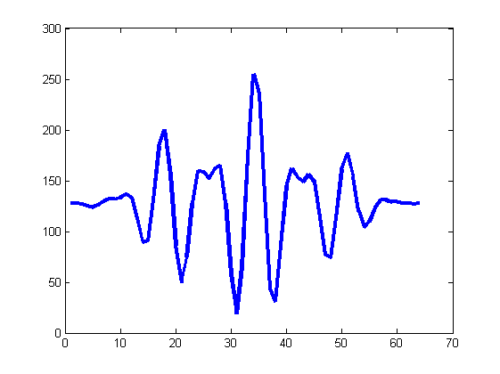

Advances every 1.6ms

ISR @ 40 kHz

Frequency Table

Serial

Scheduler