**Workshop Steps**

**Step #1:** Installing Python

<https://www.python.org/ftp/python/2.7.13/python-2.7.13.msi>

**Step #2:** Installing Flask

* After install python, now we need to add Python’s directory to “Windows Environment Variable” as a path.

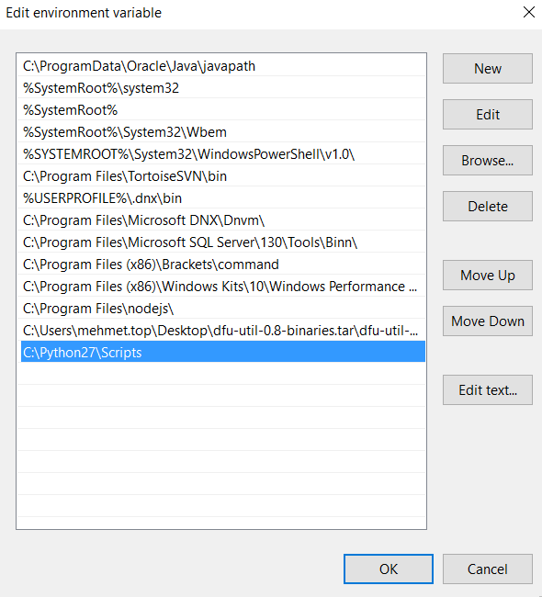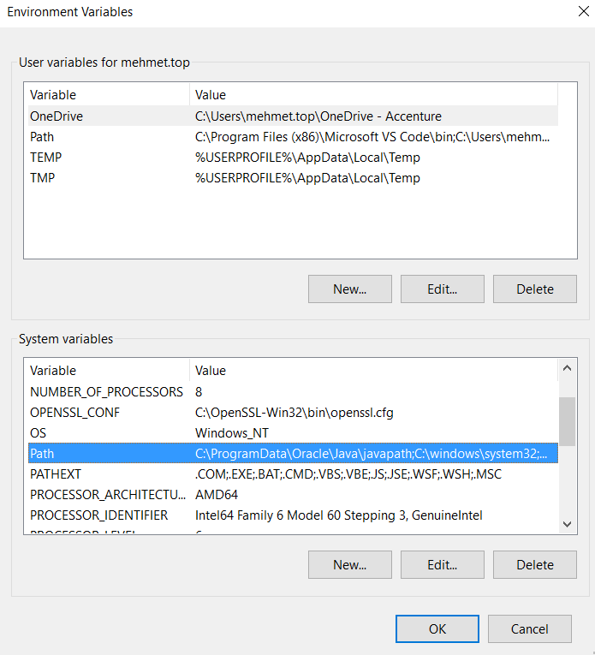

* Open Windows Command Prompt

>> pip install Flask

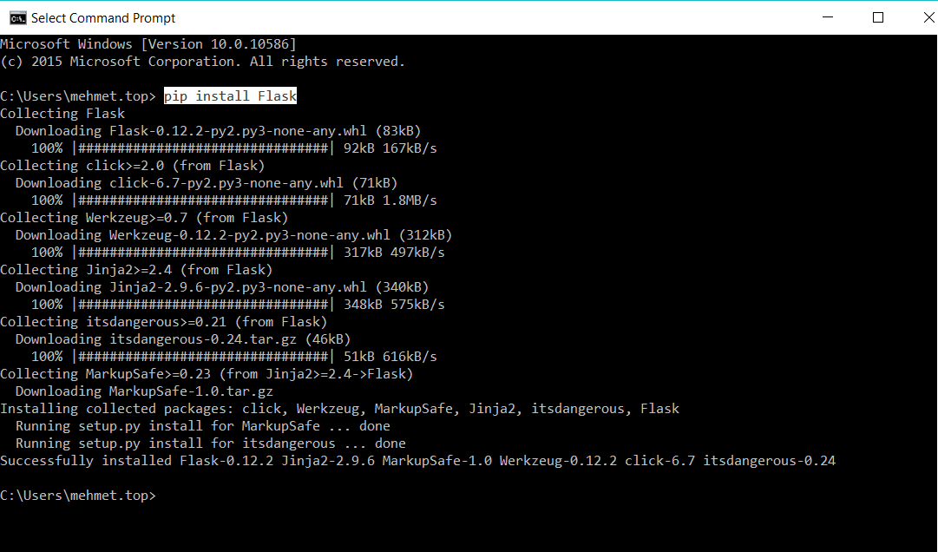

**Step #3 :** Installing PyScripter

<https://sourceforge.net/projects/pyscripter/files/latest/download>

*\*\*\*If you try install PyScripter without Python, you will get below error*

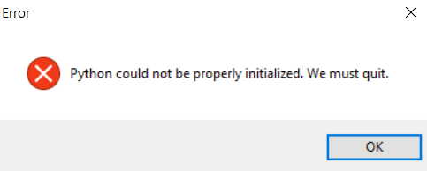

**Step #4:** Check if everything is okey.

* Open PyScripter and run below application sample

