# Title: Limits to bioinvasions in the Bering Sea: Predicting suitable conditions from regional ocean models

**Running title:** Limits to bioinvasions in the Bering Sea

# Authors: A. Droghini1, A. S. Fischbach2, J. Watson3, J. P. Reimer1

**Affiliations:** 1. Alaska Center for Conservation Science, University of Alaska Anchorage, 2400 W Campus Drive, Anchorage, AK 99508. 2. U.S. Geological Service, Alaska Science Center, 4210 University Drive, Anchorage, AK 99508. 3. NOAA Alaska Fisheries Science Center, Auke Bay Laboratories, Ted Stevens Marine Research Institute, 17109 Pt. Lena Loop Rd., Juneau, AK 99801

**Corresponding author:** J. P. Reimer, tel: 907-786-6349, email: [jpreimer@alaska.edu](mailto:jpreimer@alaska.edu)

# Abstract

Cold water temperatures and minimal vessel traffic are expected to limit biological introductions to polar ecosystems; however, to date, these expectations have not been comprehensively evaluated for a large marine ecosystem. We evaluated whether suitable conditions exist in the Bering Sea for the survival and reproduction of 42 and 25 non-indigenous species (NIS), respectively. We compared species-specific temperature and salinity thresholds to conditions projected by three regional ocean models during two study periods: recent (2003-2012) and mid-century (2030-2039). In addition, we explored patterns of vessel traffic and connectivity among Bering Sea ports and international and regional ports from which NIS may be transported. We found that the southeastern Bering Sea was highly suitable for the year-round survival of ~80% NIS assessed, but that cold water may currently limit NIS survival in areas with seasonal sea ice (i.e. north of 58°N). Although we found suitable reproductive conditions for many taxa, short summers may limit those that require temperatures above 10ºC for reproduction. Predicted ocean warming is expected to expand suitable conditions northward, largely favoring taxa that already have the ability to survive year-round within the study area. Traffic patterns apparent from ballast water discharge data and fishing vessel records reveal a network of coastwise and transoceanic traffic centered on Dutch Harbor, with connectivity throughout the Bering Sea. Areas predicted to support the highest number of NIS were also the most likely points of human-mediated introductions. Our findings provide an important foundation for risk assessments of NIS in a commercially important Arctic system and can inform research on climate change and bioinvasions in other high-latitude marine systems.

**Key words:** Arctic, climate change, physiological thresholds, habitat suitability, biological invasion, non-native species, North Pacific, Alaska, risk assessment

**Paper type:** Primary research

# Introduction

Warming ocean temperatures and marine transport are fueling the rapid range expansion of non-indigenous species (NIS) in marine ecosystems worldwide (Seebens et al., 2017), These species are of concern to managers and scientists alike because of their potential to impact native biodiversity, commercial fisheries, and subsistence resources. It is therefore important to understand what factors determine invasion success and which areas are most at-risk of receiving and supporting NIS (Carlton, 1996; Ruiz, Fofonoff, Carlton, Wonham, & Hines, 2000; Zenni & Nuñez, 2013). Because NIS are transported to new regions primarily through vessels (Molnar, Gamboa, Revenga, & Spalding, 2008; Ruiz, Carlton, Grosholz, & Hines, 1997), ports that receive high levels of vessel traffic are typically more vulnerable biological introductions (Seebens, Gastner, & Blasius, 2013; Lord, Calini, & Whitlatch, 2015, but see Verling et al. 2005;). This relationship is especially true for saline ports at mid-latitudes because water temperatures and salinity levels are well within the physiological thresholds of most marine species. However, temperature and salinity become increasingly limiting for NIS as the difference between environmental conditions at the port of origin and port of arrival increase (Herborg, Jerde, Lodge, Ruiz, & MacIsaac, 2007; Iacarella, Dick, Alexander, & Ricciardi, 2015), which results in biogeographic differences in the distribution of NIS globally.

Compared to most marine ecosystems, Arctic marine ecosystems receive relatively little vessel traffic and have cold water temperatures nearly year-round. Collectively, these factors have been proposed to explain the low rates of NIS introductions to the Arctic (de Rivera, Steves, Fofonoff, Hines, & Ruiz, 2011; Ruiz & Hewitt, 2009). Although vessel traffic is lower in Arctic systems than elsewhere (McGee, Piorkowski, & Ruiz, 2006; Ruiz & Hewitt, 2009), NIS are nevertheless being transported from temperate to Arctic systems via biofouling and ballast water, and are surviving the voyage (Chan, Briski, Bailey, & MacIsaac, 2014; Chan, MacIsaac, & Bailey, 2016; Ware et al., 2016). Modeling studies suggest that temperature and salinity conditions in Arctic systems are currently suitable for the survival of at least some NIS (de Rivera et al., 2011; Goldsmit et al., 2018; Ware et al., 2016). Moreover, the spatial extent of these suitable conditions is expected to increase over the next century as oceans respond to climate change (de Rivera et al., 2011; Ware et al., 2016, 2014). In fact, Arctic systems are already experiencing rapid oceanographic and ecological changes as a result of climate change (e.g. Grebmeier, 2012). Warming water temperatures have facilitated recent range expansions of NIS in the North Atlantic (Alvsvåg, Agnalt, & Jørstad, 2009; Fossheim et al., 2015; Reid et al., 2007) and reduced sea ice has allowed for increased vessel traffic (Eguíluz, Fernández-Gracia, Irigoien, & Duarte, 2016; Miller & Ruiz, 2014). The current low number of NIS reported from Arctic systems might no longer hold as conditions increase the number and diversity of NIS being transported and capable of surviving (Miller & Ruiz, 2014).

In this paper, we explore whether suitable conditions currently exist for the survival and establishment of NIS in the Bering Sea, and whether climate change will facilitate NIS survival and establishment. To do so, we compare physiological thresholds of NIS with modeled temperature and salinity values for the Bering Sea under recent (2003-2012) and mid-century (2030-2039) conditions. We also quantify vessel traffic and ballast water discharge for U.S. ports in the Bering Sea to explore the intersection between areas of high traffic and NIS suitability. Since relatively few NIS have been documented in the Bering Sea (Reimer et al. 2017), we predicted that survival and establishment of NIS would be limited under current conditions. Given projections for increased sea temperatures and receding sea ice, we predicted that ocean conditions would become more suitable by mid-century, which would be reflected in an increase in the overall number of NIS capable of surviving and reproducing in the Bering Sea. For NIS already capable of surviving or establishing in the Bering Sea, we predicted increased survival and reproductive duration.

# Materials and methods

## Study area

The Bering Sea is a transition between subarctic and arctic marine systems that lies between the temperate North Pacific Ocean and the Arctic waters of the Chukchi Sea (Figure 1). Spanning 15 degrees of latitude from 51°N to 66°N, it is characterized by a strong latitudinal gradient in water temperature and sea ice formation (Stabeno, Schumacher, & Ohtani, 1999). Sea ice forms seasonally in the north, while the southern Bering Sea remains ice-free most years (Grebmeier, Cooper, Feder, & Sirenko, 2006). The southeastern Bering Sea in particular is of particular ecological and economic importance. Its extensive continental shelf has some of the highest levels of marine productivity in the world. It also supports a USD $1 billion commercial fishing industry (NMFS, 2017) and is a hub for international and regional vessel traffic (McGee et al., 2006).

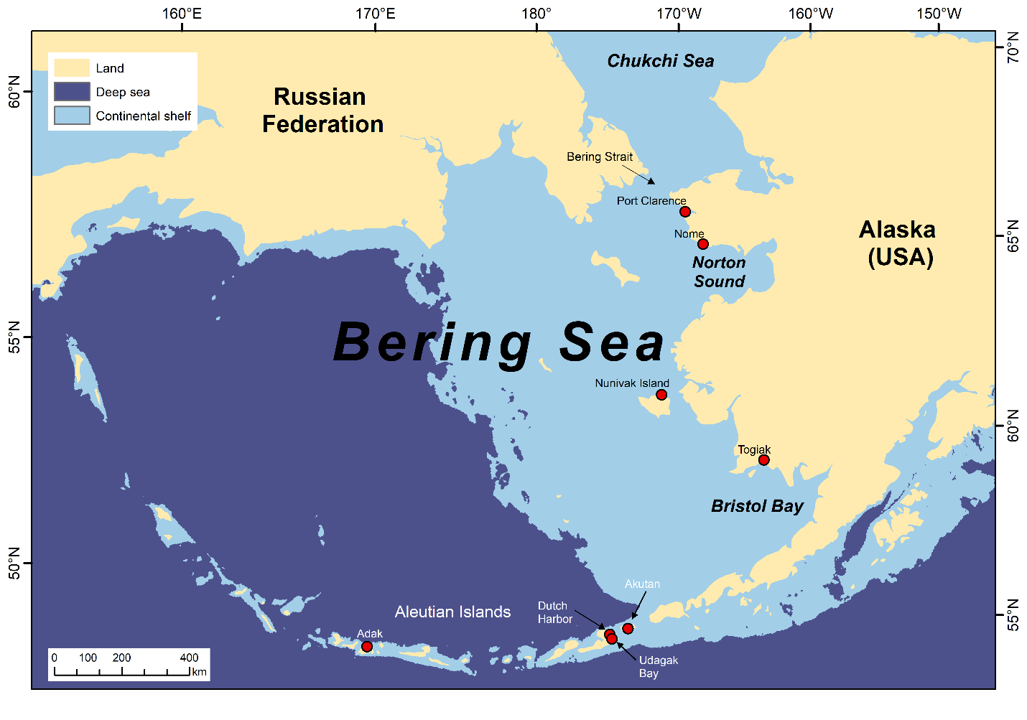

**Figure 1.** Map of the Eastern Bering Sea Marine Ecoregion, which extends from the Aleutian Islands in the south to the Bering Strait in the north and from the Russian Federation to the U.S. state of Alaska. The continental shelf designates waters where total water depth is less than 200 m. U.S. ports in the Bering Sea are designated as red circles.

Like many high-latitude systems, there are few NIS that are known from the Bering Sea. Four NIS have been reported to date (Fofonoff, Ruiz, Steves, Simkanin, & Carlton, 2018): the American shad (*Alosa sapidissima* Wilson, 1811), the Atlantic salmon (*Salmo salar* Linnaeus, 1758), the Japanese skeleton shrimp (*Caprella mutica* Schurin, 1935), and the soft-shell clam (*Mya arenaria* Linnaeus, 1758; see Powers et al. (2006) for the history of *M. arenaria* in the Bering Sea). Of these, only the Japanese skeleton shrimpand the soft-shell clamhave established self-sustaining populations (Ashton, Riedlecker, & Ruiz, 2008).

## Modeling suitable conditions

We evaluated whether conditions in the Bering Sea were suitable for the survival and establishment of NIS by comparing regional ocean models to taxon-specific physiological threshold. “Suitable conditions” were defined as a function of temperature, salinity, and water depth. While other environmental factors are important in determining survival and reproduction, detailed habitat requirements are unknown for many of the taxa we considered and unavailable for most of the Bering Sea. In contrast, temperature and salinity thresholds were available for many of the taxa we considered and downscaled climate models have been built for the Bering Sea for both recent timeframes and future predictions (Hermann et al., 2013, 2016).

## Defining taxa-specific thresholds

We compiled a list of NIS that could feasibly be transported to and survive in the Bering Sea. We began by downloading occurrence records from the National Exotic Marine and Estuarine Species Information System (NEMESIS; Fofonoff et al., 2018) and the Nonindigenous Aquatic Species Database (Fuller & Benson, 2013). From there, we considered only taxa with occurrence records within three marine ecoregions of the Bering Sea (Spalding et al., 2007). The geographic area we considered extended from the Bering Sea south to the Washington-Oregon border in the east Pacific and the Sea of Japan in the west. Beginning with this list of 164 taxa, we searched through peer-reviewed publications, reports, and electronic databases to find taxa-specific temperature (T) and salinity (S) thresholds for survival and reproduction. Because brackish water habitats are limited in the Bering Sea, we excluded taxa that could not survive or reproduce in salinities ≥30 parts per trillion (ppt). Two anadromous NIS that currently occur in the Bering Sea, the Atlantic salmon and the American shad, were only included in the survival component of our analyses.

We prioritized T-S thresholds obtained from experimental studies but used thresholds inferred from geographic distributions if no other data were available. We defined survival thresholds as the broadest T-S range a given taxon can tolerate before exhibiting deleterious effects. Survival thresholds therefore represent the absolute minimum and maximum values reported for that taxon, irrespective of life stage and geography. In contrast, reproductive thresholds represent the narrowest T-S range required for either sexual reproduction (e.g. spawning) or ontogenetic development and growth (e.g. metamorphosis). If multiple thresholds were available, we chose the thresholds associated with the least tolerant life stage.

Our models required information on minimum and maximum thresholds for both temperature and salinity. This information was unavailable for many taxa. However, we retained taxa with incomplete data in the following cases. For taxa that have been observed in temperatures that exceeded the Bering Sea maximum (~17°C), but for which no maximum temperature threshold was reported, we assigned an arbitrary maximum temperature value of +999 to ensure its inclusion in our model analyses. For taxa that had been reported from marine ecoregions whose salinities were comparable to those of the Bering Sea, but for which no salinity thresholds were reported, we set a salinity range to average seawater values (31 to 35 ppt), which would confer salinity survival to 98.8% of the Bering Sea shelf.

The complete list of NIS we considered is included as Supplementary Material. The most common taxonomic groups were Crustacea (*n*=15), Mollusca (*n*=11), and Tunicata (*n*=8). All taxa have been documented to spread via at least one anthropogenic vector (e.g. ballast water, biofouling, intentional introductions; Reimer et al., 2017).

## Defining temperature and salinity of the Bering Sea

We derived T-S values of the Bering Sea from three Regional Ocean Modeling Systems (ROMS) developed by NOAA’s Pacific Marine Environmental Laboratory (PMEL; Hermann et al., 2013, 2016). Each ROMS was generated by downscaling one of three general circulation models (GCMs), which were chosen for their ability to satisfactorily predict observed conditions in the Bering Sea and the northeastern Pacific: 1) CGCM3-t47, 2) ECHO-G, and 3) MIROC3.2. The ROMS provide weekly values of temperature and salinity with a 6-nautical mile (NM) spatial resolution and for 16 vertical depth levels (Hermann et al., 2016). T-S values are available for the entire Bering Sea and for several water depth intervals (roughly every 10 meters (m) up to 300 m). However, given the most NIS inhabit nearshore or otherwise shallow waters (Ruiz, Fofonoff, & Carlton, 2015), we restricted our analyses to the continental shelves i.e. waters with total depths < 200 m and to the first 40 m of the water column. Temperature and salinity change with water depth, but we collapsed the depth dimension for each pixel into a single value by taking the maximum T-S values reported at that location.

We considered two 10-year study periods: recent (2003-2012) and mid-century (2030-2039) to evaluate changes in environmental suitability over time. Opting for a decadal study period (rather than a single year) allows us to incorporate system uncertainty inherent from annual fluctuations in Bering Sea conditions. Projections were based on the A1B emissions scenario from the Intergovernmental Panel on Climate Change (IPCC) Fourth Assessment Report (Nakićenović et al., 2000). Compared to other scenarios, the A1B scenario implies moderate greenhouse forcing mitigation; however, because all scenarios generally track each other in the near-term, results from A1B GCMs do not differ substantially from other emission scenarios over the length of our study period (2003-2039; Nakićenović et al., 2000).

## Analyzing potential for survival and reproduction

We conducted three separate analyses to evaluate whether NIS had suitable conditions in the Bering Sea. Analyses were run separately for each taxon-ROMS-study period combination, but final results were averaged across taxa. Analyses were conducted in R Statistical Software version 3.3.2 (R Core Team, 2018) with support from the following packages: doSNOW (Microsoft Co. & Weston, 2017), dplyr (Wickham, Francois, Henry, & Müller, 2017), ggplot2 (Wickham, 2016), ncdf4 (Pierce, 2017), maptools (R. Bivand & Lewin-Koh, 2017), plyr (Wickham, 2011), rgdal (R. Bivand, Keitt, & Rowlingson, 2018), raster (J. Hijmans, 2017), rasterVis (Perpinan Lamigueiro & Hijmans, 2018), rgeos (R. Bivand & Rundel, 2017), sp (R. S. Bivand, Pebesma, & Gomez-Rubio, 2013; Pebesma & Bivand, 2005), viridis (Garnier, 2016).

1. Year-round survival: for each taxon, we defined a 6 NM pixel as ‘suitable’ if the pixel’s T-S values remained within the taxon’s T-S survival range for all weeks of a given year. Within each 10-year study period, we classified the pixel as ‘suitable year-round’ if it was suitable for at least seven of the 10 years. Across-taxa suitability was determined for each pixel by summing the number of taxa with suitable year-round conditions in that pixel. We examined change in suitable conditions by subtracting the mid-century suitability raster from the recent suitability raster. For a given pixel, a positive value indicates that more taxa are predicted to have suitable conditions by mid-century compared to the recent time period.

2. Weekly survival: for each week, a taxon was considered to have suitable survival conditions if at least one pixel had T-S values that were within the taxon’s T-S survival range. Weekly survival was then calculated as the number of weeks per year with suitable survival conditions, averaged across each 10-year study period. Unlike our year-round survival analysis, where the same pixel had to remain suitable year-round, in this analysis we allowed suitable conditions to shift in pixel-space from one week to the next. We summarized results across taxa by summing mean weekly survival values for each pixel and study period. Pixel values could therefore range from zero to 2,184 (52 weeks × 42 taxa).

3. Weekly reproduction: for each taxon, we defined a pixel as ‘suitable’ if the pixel’s T-S values were within the taxon’s T-S reproduction range for at least one week of a given year. For each year within our 10-year study periods, we calculated the number of consecutive weeks of suitable reproductive conditions, such that pixel values could range from 0 to 52. For our analysis, we used the maximum number of consecutive weeks within each 10-year study period as our metric.

## Vessel traffic

We analyzed current vessel traffic and ballast water discharge in the Bering Sea using two datasets: the National Ballast Information Clearinghouse (NBIC) and NOAA Fisheries Vessel Monitoring Systems (VMS) for Alaska commercial fishing vessels. These data allowed us to quantify the magnitude and spatial patterns of traffic arriving at U.S. ports in the Bering Sea from fishing vessels and from other large commercial vessels (> 24 m). First-order port connections were examined using the circlize package (Gu, Gu, Eils, Schlesner, & Brors, 2014) in R Statistical Software version 3.3.2 (R Core Team, 2018).

NBIC data are publicly available (https://invasions.si.edu/nbic/search.html) reports of vessel landings and their ballast water activities. Most large vessels (> 24 m) are required to report their ballast water exchanges when entering any port in the U.S. (33 CFR §§ 151). Because regulations have changed in the last decade, especially with respect to mandatory reporting by crude oil tankers (D. E. Verna & Harris, 2016), we only considered the three most recent, complete years (2014-2016). We queried Ship Arrival Records and Ballast Tank Records from the NBIC data portal for any vessel arriving in Alaska from 01 January 2014 - 31 December 2016. Ports in Alaska were binned into one of the following regions: Arctic, Bering Sea / Aleutian Islands (BSAI), Gulf of Alaska (GOA), or Southeast Alaska (SEAK). Source ports with fewer than five reported trips were binned in a group labeled “Other”. Records without a port name were removed (*n*=13). While the NBIC provides data on large, commercial vessels, it does not apply to smaller vessels ≤ 24 m long, which includes many fishing vessels. We therefore relied on VMS data (not publicly available) from Alaska to examine patterns of fishing vessel traffic. Current regulations by the National Marine Fisheries Service (NMFS) require VMS on all fishing vessels that target walleye pollock, Pacific cod, Atka mackerel, and crab in the BSAI and the GOA. These locations are transmitted at 30-minute intervals. For temporal consistency with the NBIC data, we examined all trips by vessels with VMS from 2014 – 2016, using methods from (Watson & Haynie, 2016). We analyzed a total of 4,133 trips by 566 vessels during this time. Port connections with fewer than three different vessels were omitted according to confidentiality rules, and discharge reports that did not include valid source locations were omitted from the analyses.

Some U.S. fishing vessels appeared in both the NBIC and the VMS databases, but are not easily queried because ‘Fishing’ is not a vessel type category in the NBIC database. To identify these records, we used their co-occurrence to create a ‘Fishing’ vessel type, thereby removing these vessels from the ‘Other’ category. These vessels were identified by linking NMFS fishing permit and U.S. Coast Guard numbers to the International Maritime Organization (IMO) vessel identifiers in the NBIC data via a NMFS vessel database (st.nmfs.noaa.gov/coast-guard-vessel-search/index).

# Results

We obtained T-S survival thresholds for 42 NIS and reproductive thresholds for 25 NIS. Minimum survival temperatures for the 42 NIS assessed ranged from -2°C to +10°C (see Supplementary Material for taxa-specific thresholds). The median minimum temperature required for survival was 0°C. Thirteen taxa required minimum temperatures ≥1°C for survival. The median minimum temperature required for reproduction was 12°C. Only five taxa were capable of reproducing and developing at temperatures below 10°C.

When averaged across the three ROMS for the recent (2003-2012) study period, minimum water temperatures ranged from -2.6°C to +4.2°C, and maximum water temperatures ranged from +3.8°C to +16.3°C. Mid-century (2030-2039) models predicted minimum water temperatures between -2.5°C and +4.8°C, and maximum temperatures between +5.42°C and +18.6°C (see also Hermann et al., 2016; note that reference acknowledges a ‘cold-bias’ in model results).

## Year-round Survival

For the recent (2003-2012) study period, all models predicted that suitable conditions existed for a median of 10 NIS per pixel (Figure 2). The maximum number of taxa with suitable conditions varied by model. The CGCM3-t47 model predicted suitable conditions for a maximum of 35 taxa, the ECHO-G model predicted suitable conditions for a maximum of 33 taxa, and MIROC3.2 predicted suitable conditions for a maximum of 34 taxa. Across all models, areas that were predicted to support the highest number of NIS were the coastlines of the Aleutian Islands and western Bristol Bay (Figure 2). The minimum number of taxa with suitable conditions predicted by all models was zero. Areas that were inhospitable for all taxa included northern Norton Sound (≥63.7°N) and the northern Gulf of Anadyr (≥65.0°N; Figure 2). The ECHO-G and CGCM3-t47 also predicted a continuous area without any suitable conditions along the coastline of the Yukon-Kuskokwim Delta from Norton Sound south to Kuskokwim Bay.

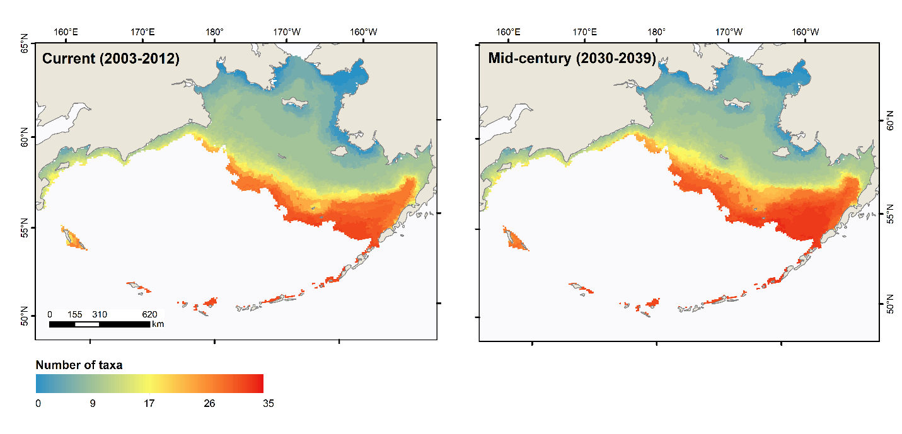

**Figure 2.** Number of non-indigenous taxa predicted to have suitable temperature and salinity conditions for year-round survival in the Bering Sea. The figure represents the average number of taxa predicted by three regional ocean models. Two 10-year study periods were considered: current and mid-century.

Under mid-century (2030-2039) conditions, the CGCM3-t47 and the MIROC3.2 models predicted that the Bering Sea would become more suitable for NIS survival, both in terms of NIS richness and in terms of spatial area. For the MIROC3.2 model, the median number of taxa per pixel increased from 10 taxa per pixel to 11, and from 10 taxa/pixel to 12 for the CGCM3-t47 model. The maximum number of taxa with suitable conditions increased by one for both the MIROC3.2 and the CGCM3-t47 models to a maximum of 35 and 36 NIS, respectively. The ECHO-G model did not predict any change in these values compared to recent predictions.

Averaged across the three models, 5,148 out of 10,224 pixels in our Bering Sea study area are predicted to become suitable for the year-round survival of additional NIS by 2039, whereas less than 6% of our study area (570.3 pixels) is predicted to be suitable for fewer NIS compared to recent conditions. Given that each pixel has an area of 36 NM, these values represent an additional area of ~635,600 sq. km. (185,328 NM) shifting from unsuitable to suitable conditions by 2039, while only ~70,400 sq. km. (20,523 NM) would shift to becoming less suitable over the same time period. Regions between 57°N and 59°N are expected to experience the greatest increases in NIS suitability (Figure 2).

## Weekly Survival

We found a seasonal pattern of survival suitability that was consistent across latitudes and study periods. In the first third of the year (weeks 1 to 17), survival conditions were present only for NIS whose survival thresholds allowed year-round survival (Figure 3). In the second third of the year (weeks 17 to 34), conditions rapidly became suitable for all or nearly all NIS. The number of NIS that could survive gradually declined in the last third of the year (Figure 3).

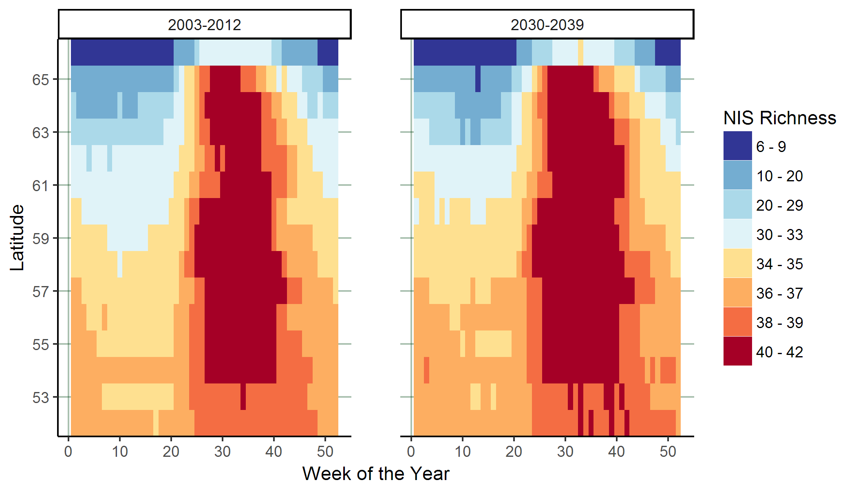

**Figure 3.** Number of non-indigenous taxa with suitable temperature and salinity conditions for survival in the Bering Sea, shown across latitudes and weeks of the year. The figure represents the average number of taxa predicted by three regional ocean models. Two 10-year study periods were considered: current and mid-century. Latitudes at the edge of the study area are minimally represented in the Bering Sea and may not be representative of broader patterns.

This pattern was similar under both recent and mid-century study periods, though mid-century conditions predict a lengthening of the highly suitable, species-rich summer season. The number of consecutive weeks that can support additional taxa increased from a minimum of 11 to 14 weeks. This period of increasing suitability began at the end of April (week 17) and continued until either the beginning of July (week 27; recent study period) or early August (week 30; mid-century). Mid-century models also predicted that conditions in mid- to late winter would be suitable for a larger number of taxa than recent conditions (Figure 3).

The latitudinal gradient we observed in year-round survival was also evident when considering survival on a weekly basis. In general, southern latitudes had conditions to support a greater number of taxa and, for taxa without year-round survival, conditions were suitable for a greater number of weeks than northern latitudes (Figure 3). Pixels between 52°N and 53°N supported the most taxa year-round, equivalent to the minimum number of taxa with year-round survival in the previous section. Pixels between 58°N and 59°N supported slightly fewer taxa year-round but were suitable for all 42 taxa for the longest length of time. This high summertime suitability at these latitudes was consistently predicted for all models and study periods. For the recent study period, the ECHO-G model predicted that conditions would be suitable for all taxa at these latitudes from mid-July to early September (weeks 29 to 36). The CGCM3-t47 and MIROC3.2 models predicted constant survival until week 36 beginning as early as late June (week 26) and early July (week 27), respectively. Under mid-century conditions, the length of time where conditions were suitable for all taxa increased. The MIROC3.2 model predicted that conditions would become suitable one week earlier and persist until the last week of September (week 39), for a total of 14 weeks. In the case of the ECHO-G model, this period of time began two weeks earlier (week 27) but ended at the same time (week 36), and consequently increased in length from eight to 10 weeks. Lastly, the CGCM3-t47 model predicted that suitable conditions would begin at the same time (week 26) but end later in the season (week 39), representing an increase from 11 to 14 weeks.

## Reproduction and establishment

Suitable conditions for reproduction were largely limited to the southern Bering Sea from Bristol Bay to the Aleutian Islands (Figure 4). Areas north of 58°N were unsuitable for the majority of NIS we considered, except for some NIS in limited areas along the coastlines of the southern Seward Peninsula and in Norton Sound (Figure 4). These coastal areas, as well as the Bristol Bay region, are expected to become suitable for an increasing number of NIS by mid-century (Figure 4). The northern Bering Sea is predicted to remain unsuitable for the reproduction of most NIS we considered.

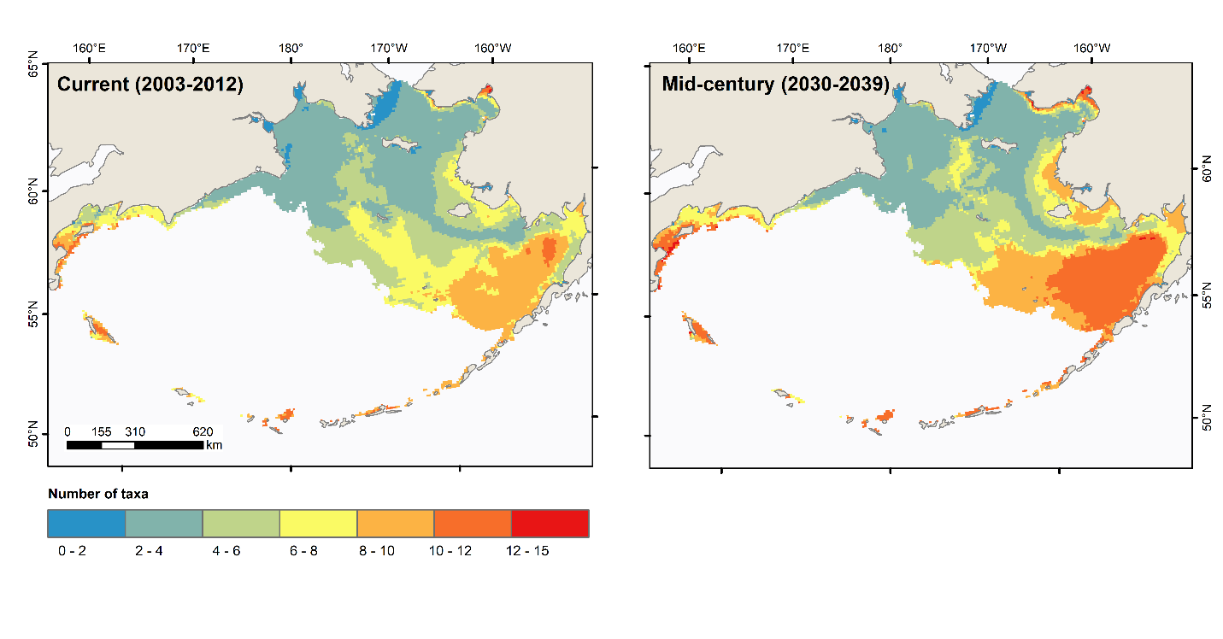

**Figure 4.** Number of non-indigenous taxa predicted to have suitable conditions for growth and reproduction in the Bering Sea for at least one week per year. The figure represents the average number of taxa predicted by three regional ocean models. Two 10-year study periods were considered: current and mid-century.

Taxa with minimum reproductive temperatures of 4°C were predicted to have nearly year-round suitable conditions every year. In contrast, four NIS were predicted to have less than one week of suitable conditions across all three models: the Pacific oyster (*Crassostrea gigas* Thunberg, 1793), *Hediste diadroma* (Sato and Nakashima 2003), the Eastern mudsnail (*Tritia obsoleta* Say, 1822), and the Japanese littleneck (*Venerupis philippinarum* A. Adams and Reeve, 1850). These NIS required minimum temperatures of ≥16°C for reproduction or development, which was outside the range of temperatures predicted for any model-year combination. Mid-century models predicted that conditions would remain unsuitable or highly limited, averaging less than one week per year over the 10-year study period.

Models varied with respect to the number of taxa that were predicted to have at least one week of suitable reproductive conditions. For the recent study period, the median number of taxa per pixel ranged from 2.8 (MIROC3.2) to 5.2 (CGCM3-t47). The maximum number of taxa per pixel ranged from 13.1 (CGCM3-t47) to 13.7 (ECHO-G). For the mid-century study period, both the CGCM3-t47 and MIROC3.2 models predicted increases in the number of taxa for which conditions would be suitable for reproduction. The CGCM3-t47 model predicted that the median would increase from 5.2 to 6.7 taxa per pixel and the maximum would increase from 13.1 to 13.8. Meanwhile, the MIROC3.2 model predicted the median would increase from 2.8 to 3.7 taxa per pixel and the maximum from 13.3 to 16.2. The ECHO-G model also predicted the median would increase by 1.0 taxa per pixel, but predicted a decrease in the maximum number of taxa from 13.7 to 12.5.

## Vessel traffic

From 2014 to 2016, the NBIC data reported a total of 816 arrival records and 15,837 ballast water discharge reports in U.S. Bering Sea ports from trips originating outside of the Bering Sea. Records were distributed across 9 vessel types: Bulker (*N* = 2,755), Container (*N* = 295), General Cargo (*N* = 114), Other (*N* = 396), Passenger (*N* = 774), Refrigerated Cargo (*N* = 418), Roll-on/Roll-off Cargo (*N* = 10), Tanker (*N* = 9,935), and Fishing (*N* = 1,140), with Tankers accounting for more than 90% of the total ballast water volume discharged.

Dutch Harbor received the greatest amount of traffic for both NBIC and VMS reported boats (Figure 5). Nome received the second highest amount of traffic for NBIC reported vessels, and Akutan received the second highest amount of traffic for VMS reported vessels. Arrivals originating from outside of Alaska accounted for 83.3% of NBIC records (Figure 5a). California (*N* = 175), Washington (*N* = 142), and South Korea (*N* = 127) accounted for greater portions of vessel traffic into the Bering Sea than the more proximate Gulf of Alaska ports (*N* = 120). However, from VMS data, which predominantly includes smaller fishing vessels that do not report to the NBIC, an overwhelming majority of trips originated from Gulf of Alaska ports (*N* = 657; Figure 5b).

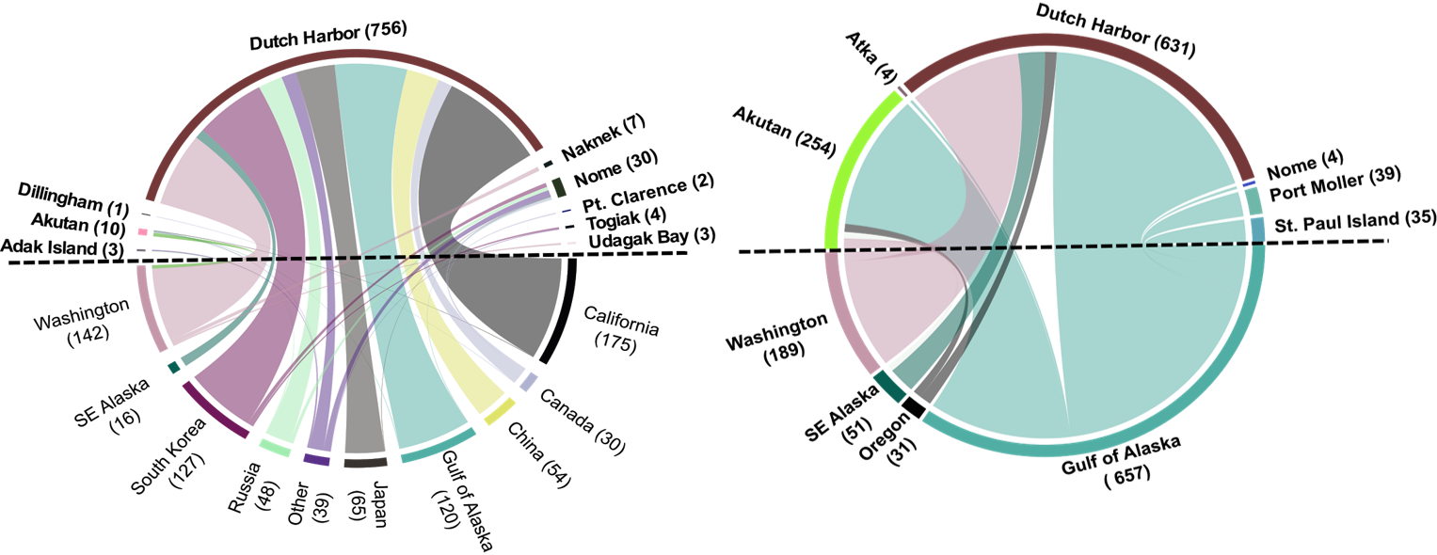

**Figure 5.** Total number of vessel trips to U.S. ports in the Bering Sea over a three-year period (2014-2016). Ports in the Bering Sea are shown above the dashed lines, while ports below the dashed lines indicate the location where vessels originated from. Number in parenthesis represent number of vessel trips to or from each location. The left panel illustrates data from the National Ballast Information Clearinghouse for vessel transits from commercial vessels > 24 m. The panel on the right represents only commercial fishing vessels whose locations are tracked through NOAA Fisheries Vessel Monitoring Systems.

With respect to ballast water discharge, 87.7% of reported discharge occurred in Dutch Harbor, equivalent to 57,736 metric tons (mt). The port of Nome received the second largest discharge volume (7,004 mt). While ports in the eastern Pacific Ocean accounted for more trips, most ballast water released in the Bering Sea originated from Asian ports. South Korea and China each accounted for an order of magnitude more ballast water (18,728 and 17,453 mt, respectively) than the next greatest sources, Japan (7,183 mt), Canada (6,912 mt), and Washington (3,852 mt). Approximately 20% of the 15,837 ballast water exchange records (representing 10.6% of the discharged volume) identified the source of their ballast water using coordinates (typically from offshore waters) instead of port names. Among these non-port ballast water sources, 25% of water originated from locations in the northeast Pacific Ocean (defined here as latitudes > 23.5° N, longitudes between 179.9° W and 110°W) and 15% originated from locations in the northwest Pacific Ocean (defined here as latitudes > 23.5° N, longitudes between 100° E and 180° E). Among these non-port source locations, 75.5% of the coordinates occurred in water depths greater than 200m (i.e., off the continental shelf), where the risk of NIS is likely less.

# Discussion

## Current model predictions

Although the Bering Sea has few reports of NIS to date, our results indicate that recent oceanographic conditions offer potentially suitable conditions for a large number of taxa, both for their survival and reproduction. The southern Bering Sea in particular, which includes the Aleutian Islands chain, the Pribilof Islands, and the northwestern Alaska Peninsula, was highly suitable for both survival and establishment of NIS. Of the 42 taxa assessed, 34 had year-round suitable survival conditions and all taxa had suitable conditions for at least six weeks from early July to mid-August. Conditions in the Bering Sea were predicted to be suitable for the reproduction and growth of 21 of 25 taxa, yet only 14 taxa were predicted to have at least six consecutive weeks of suitable conditions. Since the taxa we assessed have all been observed in marine ecoregions close to the Bering Sea, it is conceivable that these species may frequently be transported to the Bering Sea, and given enough opportunity, may survive and establish populations under current Bering Sea conditions. Moreover, anadromous NIS not included in our reproduction analysis, including two fish species that have already been documented in the Bering Sea, may readily find suitable reproductive habitat in the many rivers and tributaries that feed into the Bering Sea.

We considered potential NIS richness by summing results across all NIS and found a latitudinal gradient in potential NIS richness that was high in the southern Bering Sea and decreased sharply above 58ºN. The 58ºN “threshold boundary” predicted by our models is coincident with the current limit of seasonal sea ice extent in the Bering Sea (Grebmeier, Overland, et al., 2006; Stabeno et al., 2012). Above this “boundary”, all taxa were predicted to have suitable survival conditions in summer but year-round survival was limited to taxa that could tolerate sub-zero water temperatures. While tolerance to sub-zero temperatures was not uncommon, most taxa we considered had minimum temperature thresholds ≥0°C. At least for the time being, biological invasions in Arctic waters may be limited to taxa that are adapted to polar environments or that are tolerant of low temperatures (de Rivera et al., 2011).

Although most taxa we evaluated had at least one week of suitable reproductive conditions, the presence of suitable habitat was more restricted in both space and time. Again, the southern Bering Sea was highly suitable for NIS establishment. Suitable conditions for several taxa were also predicted in Norton Sound (~64°N) (Figure 4). Although Norton Sound freezes annually, its shallow waters create a high-latitude hotspot in the summer (Hermann et al., 2016; Ladd & Overland, 2009). The presence of such hotspots could create a window of opportunity for NIS to establish in arctic waters. At the same, the time available for reproduction and development may be limiting for several NIS. Although we did not collect data on the time needed to complete development, taxa requiring temperatures ≥ 14°C had less than three weeks of suitable reproductive conditions. NIS such as *Botrylloides violaceus* (Oka, 1927) and the European green crab (*Carcinus maenas* Linnaeus, 1758), which are of high concern elsewhere along the eastern Pacific coast, either did not have suitable temperatures or did not have enough time to complete development (de Rivera et al., 2007; Westerman, Whitlatch, Dijkstra, & Harris, 2009), though both are predicted to have suitable conditions for year-round survival across moderately large areas of the shelf. Interestingly, the two NIS that are currently known to be established in the Bering Sea (the Japanese skeleton shrimp and the softshell clam) required the lowest minimum reproductive temperatures (4°C) of all NIS assessed and were the only ones that had suitable reproductive conditions nearly year-round (> 51 consecutive weeks).

## Future model predictions

The Bering Sea is already experiencing significant effects from climate change (Grebmeier, Overland, et al., 2006; Mueter & Litzow, 2008; Stabeno, Bond, & Salo, 2007). Sea ice cover has decreased substantially since the 1950s and surface water temperatures have increased by 0.23°C per decade since then (Mueter & Litzow, 2008). Although the location of the ice boundary naturally shifts from year to year, recent years have experienced several of the lowest sea ice extents on record and substantial decreases in the length of the ice-covered season (Onarheim, Eldevik, Smedsrud, & Stroeve, 2018). Surveys of commercial fish and invertebrate species in this area have already illustrated northward shifts under steadily changing conditions (Barbeaux & Hollowed, 2018; Kotwicki & Lauth, 2013; Mueter & Litzow, 2008), so it is not surprising that potential NIS habitat expansions would follow similar patterns. Our models suggest that warming water temperatures will increase the amount of suitable area for taxa that can already survive in parts of the Bering Sea. This increased area is predicted to present itself as a northward expansion and is in agreement with other NIS modeling studies for Alaska (de Rivera et al., 2011) and elsewhere in the Arctic (Goldsmit et al., 2018; Ware et al., 2016). Our models also predict increases in the length of the reproductive season as a result of warming summer temperatures, potentially allowing NIS to establish sustainable populations in the Bering Sea. Studies in temperate systems have shown that NIS typically respond favorably to warmer spring and summer water temperatures e.g. through earlier recruitment (Stachowicz, Fried, Osman, & Whitlatch, 2002; Valdizan, Beninger, Decottignies, Chantrel, & Cognie, 2011) or positive changes in growth rates (de Rivera et al., 2007), abundance (Saunders & Metaxas, 2007; Witte, Buschbaum, van Beusekom, & Reise, 2010), and fecundity (Dijkstra, Westerman, & Harris, 2017; Valdizan et al., 2011).

Given that cold water temperatures currently seem to limit survival and reproduction in the Bering Sea, warming temperatures might have the greatest implication for taxa that are at the limit of their temperature thresholds, such as the European green crab (de Rivera et al., 2007). Our mid-century models suggest that warming temperatures will cause the southern Bering Sea to shift from marginal to moderately suitable conditions for the European green crab’s growth and reproduction, which would allow this species to move from merely surviving under recent Bering Sea conditions to being able to reproduce and establish a population under mid-century projections (model results for specific species, including the European green crab, can be found at http://beringinvaders.org/).

## Model limitations

The ROMS we used to predict suitable conditions underestimate summer water temperatures near the coast and in shallow waters < 10 m deep. The models’ spatial resolution does not extend to the edge of the coastline and computational limitations required water depths to be set to a minimum of 10 m depth (A. Hermann, pers. comm.). Moreover, while the ROMS include a coarse estimate of freshwater runoff, they do not account for the warming of shallow, coastal waters caused by river discharge. The influence of rivers is likely significant in our study area given the many large rivers that drain into the Bering Sea, notably the Yukon, Kuskokwim, and Nushagak rivers. Measurements from finer scale models have recorded temperatures as high as 19°C near the Yukon River (from MODIS; <https://neo.sci.gsfc.nasa.gov/>), and field measurements at the mouth of the Yukon have been as high as 21°C (T. Jorgenson, pers. comm.). In contrast, maximum temperatures predicted by the ROMS never exceeded 16.3°C. However, while the warming effects of these rivers are not fully captured by the ROMS, they do not last for more than a few weeks. Thus, while we may be underestimating the number of weeks of suitable reproductive conditions, model limitations should not affect the results of our year-round survival analysis.

Our approach, which uses physiological thresholds rather than environmental matching, is especially meaningful in systems such as the Arctic, where environmental conditions fall outside the range of values to which taxa are exposed in their current range. However, we found that there were limited data on physiological thresholds, especially with respect to cold water tolerances and to reproductive and developmental processes. Estimating tolerances for reproduction and development is particularly complex given that organisms have different temperature and time requirements for spawning, brooding, and metamorphosis. Moreover, exposure to temperatures at the tail-end of an organism’s tolerance threshold can increase the time required for development (de Rivera et al., 2007). Additional research is needed to understand taxa’s thermal response curves (Miller, 2016; Monaco & Helmuth, 2011; Sorte, 2014; Westerman et al., 2009) and the potential for rapid evolution (Huang et al., 2017; Ricciardi et al., 2017), which could enable taxa to increase their tolerances to cold water. More comprehensive models can be built for a subset of high-interest NIS that take into account additional habitat requirements such as substrate type, wave exposure, and prey availability.

## Interactions between vessel traffic and predicted NIS habitat

Without a road system to provide access to Alaska’s port communities, vessels of all types form a marine highway system that is traveled by ferries, tugs, barges, and as demonstrated here, fishing vessels. Data from commercial and fishing vessel traffic, and from ballast water discharge, point to the port of Dutch Harbor as the most visited port in the Bering Sea. Traffic to Dutch Harbor was up to two orders of magnitude more than traffic to other ports, and trips ending in Dutch Harbor originated from more than ten countries around the world. Compared to ballast water data, fishing vessel traffic was highly regional, connecting the port of Dutch Harbor to ports of the Pribilof Islands, Bristol Bay, and Akutan. While many of these vessels may not discharge ballast water, they can still transport fouling organisms, which may be a larger contributor of propagules than ballast water (Chan, MacIsaac, Bailey, & Krkošek, 2015).

Dutch Harbor is one of the largest fisheries port in the U.S. and has long been recognized as a potentially important point of entry for non-native species based on patterns of vessel traffic (McGee et al., 2006; Verna, Harris, Holzer, & Minton, 2016). Given Dutch Harbor’s connectivity to other ports, it may also act as a “transport hub” (Floerl, Inglis, Dey, & Smith, 2009) introducing NIS to remote communities across the Bering Sea. The vulnerability of Dutch Harbor to introductions from vessels is particularly salient because of its location. Dutch Harbor is one of the southernmost ports in the Bering Sea and is within the area that is predicted to have highly suitable conditions for NIS survival and establishment (Figure 2; Figure 4).

Although the northern Bering Sea was predicted to have low suitability for NIS, certain areas in the northern Bering Sea, such as the coastlines of Norton Sound, are already predicted to be warm enough to support reproduction and survival (Figure 2; Figure 4). The northern Bering Sea is also experiencing rapid and dramatic changes in ocean climate. Warming temperatures and reductions in sea ice are predicted to increase its vulnerability. Northern ports may experience increases in fishing vessel traffic as range shifts of commercial fish species move northward and fishing fleets follow suit (Fossheim et al., 2015; Pinsky, Worm, Fogarty, Sarmiento, & Levin, 2013). Moreover, increased shipping traffic and oil and gas exploration in the region may lead to the continued development of plans for industrial-scale facilities in northern ports such as Nome, which currently receives little traffic.

It is currently unknown whether vessels arriving to Bering Sea ports are transporting viable non-native organisms, and several factors affect an organism’s survivorship during the voyage from one port to another. Introductions to the Bering Sea may be relatively low due to the long transit times between Bering Sea ports and other regional or international ports. Indeed, a study from the Canadian Arctic found that NIS richness and abundance was inversely related to the length of the voyage, and that ballast water age was the most important predictor of richness and abundance (Chan et al., 2014). Thus, although Dutch Harbor receives high volumes of ballast water, the relatively long residence time of the ballast water discharged in Dutch Harbor may reduce its invasion risk (Verna et al., 2016). In the absence of data on propagule pressure, future analyses of vessel traffic in the context of invasive species transport may benefit from using Automatic Identification System (AIS) data, which are available for a greater portion of vessels traveling through Alaskan waters.

While it has recently been believed that NIS introductions and establishment have been restricted in the Arctic due to cold water temperatures which yield inhospitable environments for many introduced taxa, our results indicate that (1) recent Bering Sea conditions offer potential habitat for a large number of NIS, and for both survival and reproduction life stages; (2) suitable conditions for NIS are projected to expand by mid-century due to warming ocean temperatures; and (3) mechanisms for NIS transport into and throughout the Bering Sea exist and overlap with conditions suitable for NIS survival and reproduction. Our findings suggest that cold water temperatures currently limit establishment of NIS in the northern Bering Sea, but emphasize the susceptibility of the southeastern Bering Sea, which typically remains ice-free year-round and experiences warmer water temperatures. The suitable temperature conditions of the southern Bering Sea are especially concerning given the high vessel traffic in the region, notably to and from the port of Dutch Harbor. As declining sea ice cover makes the Arctic an increasingly popular shortcut between the Pacific and Atlantic, we expect the risk of NIS introductions in the region to increase, as has been observed in other high-latitude systems, with potential implications for native biodiversity, commercial fisheries, and subsistence resources. Given the low number of NIS that currently exist in the region, the Bering Sea would benefit from ongoing monitoring and programs aimed at prevention and early detection.

# Acknowledgements

Funding for this project was made available by the North Pacific Research Board (project #1532) and the Aleutian and Bering Sea Islands Landscape Conservation Cooperative. Tracey Gotthardt and Aaron Poe were involved with spearheading the project. Casey Greenstein, Lindsey Flagstad, Bonnie Bernard, Jaime Weltfelt, and Curtis Whisman contributed to the development of the ranking system and the species status reports. J.W. thanks Jen Karnak of Marine Exchange of Alaska, who assisted with vessel identification. A.F. thanks Rob Bochenek and Dr. William Koeppen of Axiom Data Science for assistance extracting the ROMS data. A.D. thanks Marcus Geist for his GIS wizarding and Dr. Al Hermann for insightful conversations about the ROMS. Additional thanks goes to Dr. Matthew Carlson and Dr. Michael Carey for valuable feedback on this manuscript.

# References

Alvsvåg, J., Agnalt, A. L., & Jørstad, K. E. (2009). Evidence for a permanent establishment of the snow crab (Chionoecetes opilio) in the Barents Sea. *Biological Invasions*, *11*(3), 587–595. doi: 10.1007/s10530-008-9273-7

Ashton, G. V., Riedlecker, E. I., & Ruiz, G. M. (2008). First non-native crustacean established in coastal waters of Alaska. *Aquatic Biology*, *3*(2), 133–137. doi: 10.3354/ab00070

Barbeaux, S. J., & Hollowed, A. B. (2018). Ontogeny matters: Climate variability and effects on fish distribution in the eastern Bering Sea. *Fisheries Oceanography*, *27*(1), 1–15. doi: 10.1111/fog.12229

Bivand, R., Keitt, T., & Rowlingson, R. (2018). *rgdal: Bindings for the “geospatial” data abstraction library. R package version 1.2-20*.

Bivand, R., & Lewin-Koh, N. (2017). *maptools: Tools for reading and handling spatial objects. R package version 0.9-2*.

Bivand, R., & Rundel, C. (2017). *rgeos: Interface to Geometry Engine - Open Source ('GEOS’). R package version 0.3-26*.

Bivand, R. S., Pebesma, E., & Gomez-Rubio, V. (2013). *Applied spatial data analysis with R. Second edition.* New York: Springer.

Carlton, J. T. (1996). Pattern, process, and prediction in marine invasion ecology. *Biological Conservation*, *78*(1–2), 97–106. doi: 10.1016/0006-3207(96)00020-1

Chan, F. T., Briski, E., Bailey, S. A., & MacIsaac, H. J. (2014). Richness–abundance relationships for zooplankton in ballast water: temperate versus Arctic comparisons. *ICES Journal of Marine Science*, *71*(7), 1876–1884. doi: 10.1093/icesjms/fsu020

Chan, F. T., MacIsaac, H. J., & Bailey, S. A. (2016). Survival of ship biofouling assemblages during and after voyages to the Canadian Arctic. *Marine Biology*, *163*(12), 250. doi: 10.1007/s00227-016-3029-1

Chan, F. T., MacIsaac, H. J., Bailey, S. A., & Krkošek, M. (2015). Relative importance of vessel hull fouling and ballast water as transport vectors of nonindigenous species to the Canadian Arctic. *Canadian Journal of Fisheries and Aquatic Sciences*, *72*(8), 1230–1242. doi: 10.1139/cjfas-2014-0473

de Rivera, C. E., Hitchcock, N. G., Teck, S. J., Steves, B. P., Hines, A. H., & Ruiz, G. M. (2007). Larval development rate predicts range expansion of an introduced crab. *Marine Biology*, *150*(6), 1275–1288. doi: 10.1007/s00227-006-0451-9

de Rivera, C. E., Steves, B. P., Fofonoff, P. W., Hines, A. H., & Ruiz, G. M. (2011). Potential for high-latitude marine invasions along western North America. *Diversity and Distributions*, *17*(6), 1198–1209. doi: 10.1111/j.1472-4642.2011.00790.x

Dijkstra, J. A., Westerman, E. L., & Harris, L. G. (2017). Elevated seasonal temperatures eliminate thermal barriers of reproduction of a dominant invasive species: A community state change for northern communities? *Diversity and Distributions*, *23*(10), 1182–1192. doi: 10.1111/ddi.12604

Eguíluz, V. M., Fernández-Gracia, J., Irigoien, X., & Duarte, C. M. (2016). A quantitative assessment of Arctic shipping in 2010-2014. *Scientific Reports*, *6*(March), 3–8. doi: 10.1038/srep30682

Floerl, O., Inglis, G. J., Dey, K., & Smith, A. (2009). The importance of transport hubs in stepping-stone invasions. *Journal of Applied Ecology*, *46*(1), 37–45. doi: 10.1111/j.1365-2664.2008.01540.x

Fofonoff, P. W., Ruiz, G. M., Steves, B., Simkanin, C., & Carlton, J. T. (2018). National Exotic Marine and Estuarine Species Information System (NEMESIS). Retrieved from http://invasions.si.edu/nemesis/

Fossheim, M., Primicerio, R., Johannesen, E., Ingvaldsen, R. B., Aschan, M. M., & Dolgov, A. V. (2015). Recent warming leads to a rapid borealization of fish communities in the Arctic. *Nature Climate Change*, *5*(7), 673–677. doi: 10.1038/nclimate2647

Fuller, P. F., & Benson, A. J. (2013). Nonindigenous Aquatic Species Database (NAS). Retrieved from https://nas.er.usgs.gov/

Garnier, S. (2016). *viridis: Default color maps from “matplotlib”. R package version 0.3.4*.

Goldsmit, J., Archambault, P., Chust, G., Villarino, E., Liu, G., Lukovich, J. V., … Howland, K. L. (2018). Projecting present and future habitat suitability of ship-mediated aquatic invasive species in the Canadian Arctic. *Biological Invasions*, *20*(2), 501–517. doi: 10.1007/s10530-017-1553-7

Grebmeier, J. M. (2012). Shifting patterns of life in the Pacific Arctic and sub-Arctic seas. *Annual Review of Marine Science*, *4*(1), 63–78. doi: 10.1146/annurev-marine-120710-100926

Grebmeier, J. M., Cooper, L. W., Feder, H. M., & Sirenko, B. I. (2006). Ecosystem dynamics of the Pacific-influenced Northern Bering and Chukchi Seas in the Amerasian Arctic. *Progress in Oceanography*, *71*(2–4), 331–361. doi: 10.1016/j.pocean.2006.10.001

Grebmeier, J. M., Overland, J. E., Moore, S. E., Farley, E. V, Carmack, E. C., Cooper, L. W., … McNutt, S. L. (2006). A major ecosystem shift in the Northern Bering Sea. *Science*, *311*, 1461–1464. doi: 10.1126/science.1121365

Gu, Z., Gu, L., Eils, R., Schlesner, M., & Brors, B. (2014). circlize implements and enhances circular visualization in R. *Bioinformatics*, *30*(19), 2811–2812. doi: 10.1093/bioinformatics/btu393

Herborg, L.-M., Jerde, C. L., Lodge, D. M., Ruiz, G. M., & MacIsaac, H. J. (2007). *Predicting invasion risk using measures of introduction effort and environmental niche models*. *17*(3), 663–674.

Hermann, A. J., Gibson, G. A., Bond, N. A., Curchitser, E. N., Hedstrom, K., Cheng, W., … Aydin, K. (2016). Projected future biophysical states of the Bering Sea. *Deep-Sea Research Part II: Topical Studies in Oceanography*, *134*, 30–47. doi: 10.1016/j.dsr2.2015.11.001

Hermann, A. J., Gibson, G. A., Bond, N. A., Curchitser, E. N., Hedstrom, K., Cheng, W., … Cieciel, K. D. (2013). A multivariate analysis of observed and modeled biophysical variability on the Bering Sea shelf: Multidecadal hindcasts (1970-2009) and forecasts (2010-2040). *Deep-Sea Research Part II: Topical Studies in Oceanography*, *94*, 121–139. doi: 10.1016/j.dsr2.2013.04.007

Huang, X., Li, S., Ni, P., Gao, Y., Bei, J., Zhou, Z., & Zhan, A. (2017). Rapid response to changing environments during biological invasions: DNA methylation perspectives. *Molecular Ecology*, *12*(10), 3218–3221. doi: 10.1111/ijlh.12426

Iacarella, J. C., Dick, J. T. A., Alexander, M. E., & Ricciardi, A. (2015). Ecological impacts of invasive alien species along temperature gradients : testing the role of environmental matching. *Ecological Applications*, *25*(3), 706–716. doi: 10.1890/14-0545.1

J. Hijmans, R. (2017). *raster: Geographic data analysis and modeling. R package version 2.6-7*.

Kotwicki, S., & Lauth, R. R. (2013). Detecting temporal trends and environmentally-driven changes in the spatial distribution of bottom fishes and crabs on the eastern Bering Sea shelf. *Deep-Sea Research Part II: Topical Studies in Oceanography*, *94*, 231–243. doi: 10.1016/j.dsr2.2013.03.017

Ladd, C., & Overland, J. E. (2009). *Retrospective analysis of sea surface temperature in the northern Bering and Chukchi seas. NOAA Technical Memorandum OAR PMEL-145*. Seattle, WA.

Lord, J. P., Calini, J. M., & Whitlatch, R. B. (2015). Influence of seawater temperature and shipping on the spread and establishment of marine fouling species. *Marine Biology*, *162*(12), 2481–2492. doi: 10.1007/s00227-015-2737-2

McGee, S., Piorkowski, R., & Ruiz, G. (2006). Analysis of recent vessel arrivals and ballast water discharge in Alaska: Toward assessing ship-mediated invasion risk. *Marine Pollution Bulletin*, *52*(12), 1634–1645. doi: 10.1016/j.marpolbul.2006.06.005

Microsoft Co., & Weston, S. (2017). *doSNOW: Foreach Parallel Adaptor for the “snow” Package. R package version 1.0.16*.

Miller, A. W., & Ruiz, G. M. (2014). Arctic shipping and marine invaders. *Nature Climate Change*, *4*(6), 413–416. doi: 10.1038/nclimate2244

Miller, K. B. (2016). Forecasting at the edge of the niche: Didemnum vexillum in Southeast Alaska. *Marine Biology*, *163*(2), 1–12. doi: 10.1007/s00227-015-2799-1

Molnar, J. L., Gamboa, R. L., Revenga, C., & Spalding, M. D. (2008). Assessing the global threat of invasive species to marine biodiversity. *Frontiers in Ecology and the Environment*, *6*(9), 485–492. doi: 10.1890/070064

Monaco, C. J., & Helmuth, B. (2011). Tipping points, thresholds and the keystone role of physiology in marine climate change research. In *Advances in Marine Biology* (Vol. 60). doi: 10.1016/B978-0-12-385529-9.00003-2

Mueter, F. J., & Litzow, M. A. (2008). Sea ice retreat alters the biogeography of the Bering Sea continental shelf. *Ecological Applications*, *18*(2), 309–320. doi: 10.1890/07-0564.1

Nakićenović, N., Alcamo, J., Davis, G., de Vries, B., Fenhann, J., Gaffin, S., & Gregory, K. (2000). IPCC Special Report on Emissions Scenarios: A special report of Working Group III of the Intergovernmental Panel on Climate Change. In *Emissions Scenarios*. Cambridge, UK: Cambridge University Press.

National Marine Fisheries Service (NMFS). (2017). *Fisheries of the United States, 2016*. Retrieved from https://www.st.nmfs.noaa.gov/commercial-fisheries/ fus/fus16/index

Onarheim, I. H., Eldevik, T., Smedsrud, L. H., & Stroeve, J. C. (2018). Seasonal and regional manifestation of Arctic sea ice loss. *Journal of Climate*, *31*(12), 4917–4932. doi: 10.1175/JCLI-D-17-0427.1

Pebesma, E. J., & Bivand, R. S. (2005). *Classes and methods for spatial data in R. R News 5 (2)*. Retrieved from https://cran.r-project.org/doc/Rnews/

Perpinan Lamigueiro, O., & Hijmans, R. (2018). *rasterVis. R package version 0.45.*

Pierce, D. (2017). *Interface to Unidata netCDF (Version 4 or Earlier) Format Data Files. R package version 1.16.* Retrieved from https://cran.r-project.org/package=ncdf4

Pinsky, M. L., Worm, B., Fogarty, M. J., Sarmiento, J. L., & Levin, S. A. (2013). Marine taxa track local climate velocities. *Science*, *341*(6151), 1239–1242. doi: 10.1126/science.1239352

Powers, S. P., Bishop, M. A., Grabowski, J. H., & Peterson, C. H. (2006). Distribution of the invasive bivalve Mya arenaria L. on intertidal flats of southcentral Alaska. *Journal of Sea Research*, *55*(3), 207–216. doi: 10.1016/J.SEARES.2005.10.004

R Core Team. (2018). *R: A language and environment for statistical computing*. Retrieved from https://www.r-project.org/

Reid, P. C., Johns, D. G., Edwards, M., Starr, M., Poulin, M., & Snoeijs, P. (2007). A biological consequence of reducing Arctic ice cover: Arrival of the Pacific diatom Neodenticula seminae in the North Atlantic for the first time in 800000 years. *Global Change Biology*, *13*(9), 1910–1921. doi: 10.1111/j.1365-2486.2007.01413.x

Reimer, J. P., Droghini, A., Fischbach, A., Watson, J. T., Bernard, B., & Poe, A. (2017). *Assessing the risk of non-native marine species in the Bering Sea*. Retrieved from www.beringinvaders.org

Ricciardi, A., Blackburn, T. M., Carlton, J. T., Dick, J. T. A., Hulme, P. E., Iacarella, J. C., … Aldridge, D. C. (2017). Invasion science: a horizon scan of emerging challenges and opportunities. *Trends in Ecology and Evolution*, *32*(6), 464–474. doi: 10.1016/j.tree.2017.03.007

Ruiz, G. M., Carlton, J. T., Grosholz, E. D., & Hines, A. H. (1997). Global invasions of marine and estuarine habitats by non-indigenous species: Mechanisms, extent, and consequences. *American Zoologist*, *37*(6), 621–632.

Ruiz, G. M., Fofonoff, P. W., & Carlton, J. T. (2015). Invasion history and vector dynamics in coastal marine ecosystems: a North American perspective. *Aquatic Ecosystem Health & Management*, *18*(3), 299–311. doi: 10.1080/14634988.2015.1027534

Ruiz, G. M., Fofonoff, P. W., Carlton, J. T., Wonham, M. J., & Hines, A. H. (2000). Invasion of coastal marine communities in North America: apparent patterns, processes, and biases. *Annual Review of Ecology and Systematics*, *31*(1), 481–531. doi: 10.1146/annurev.ecolsys.31.1.481

Ruiz, G. M., & Hewitt, C. L. (2009). Latitudinal patterns of biological invasions in marine ecosystems: a polar perspective. In I. Krupnik, M. A. Lang, & S. E. Miller (Eds.), *Smithsonian at the Poles: Contributions to International Polar Year Science* (pp. 347–358). doi: 10.5479/si.097884601X.0

Saunders, M., & Metaxas, A. (2007). Temperature explains settlement patterns of the introduced bryozoan Membranipora membranacea in Nova Scotia, Canada. *Marine Ecology Progress Series*, *344*, 95–106. doi: 10.3354/meps06924

Seebens, H., Blackburn, T. M., Dyer, E. E., Genovesi, P., Hulme, P. E., Jeschke, J. M., … Essl, F. (2017). No saturation in the accumulation of alien species worldwide. *Nature Communications*, *8*, 14435. doi: 10.1038/ncomms14435

Seebens, H., Gastner, M. T., & Blasius, B. (2013). The risk of marine bioinvasion caused by global shipping. *Ecology Letters*, *16*(6), 782–790. doi: 10.1111/ele.12111

Sorte, C. J. B. (2014). Synergies between climate change and species invasions: Evidence from marine systems. *Invasive Species and Global Climate Change*, 101–116.

Spalding, M. D., Fox, H. E., Allen, G. R., Davidson, N., Ferdaña, Z. A., Finlayson, M., … Robertson, J. (2007). Marine ecoregions of the world: a bioregionalization of coastal and shelf areas. *BioScience*, *57*(7), 573–583. doi: 10.1641/B570707

Stabeno, P. J., Bond, N. A., & Salo, S. A. (2007). On the recent warming of the southeastern Bering Sea shelf. *Deep-Sea Research Part II: Topical Studies in Oceanography*, *54*(23), 2599–2618. doi: 10.1016/j.dsr2.2007.08.023

Stabeno, P. J., Kachel, N. B., Moore, S. E., Napp, J. M., Sigler, M., Yamaguchi, A., & Zerbini, A. N. (2012). Comparison of warm and cold years on the southeastern Bering Sea shelf and some implications for the ecosystem. *Deep-Sea Research Part II: Topical Studies in Oceanography*, *65*, 31–45. doi: 10.1016/j.dsr2.2012.02.020

Stabeno, P. J., Schumacher, J. D., & Ohtani, K. (1999). The physical oceanography of the Bering Sea: A summary of physical, chemical, and biological characteristics, and a synopsis of research on the Bering Sea. In T. R. Loughlin & K. Ohtani (Eds.), *Dynamics of the Bering Sea* (pp. 1–28). Fairbanks, AK.

Stachowicz, J. J., Fried, H., Osman, R. W., & Whitlatch, R. B. (2002). Biodiversity, invasive resistance, and marine ecosystem function: reconciling pattern and process. *Ecology*, *83*(9), 2575–2590. doi: 10.2307/3071816

Valdizan, A., Beninger, P. G., Decottignies, P., Chantrel, M., & Cognie, B. (2011). Evidence that rising coastal seawater temperatures increase reproductive output of the invasive gastropod Crepidula fornicata. *Marine Ecology Progress Series*, *438*, 153–165. doi: 10.3354/meps09281

Verna, D. E., & Harris, B. P. (2016). Review of ballast water management policy and associated implications for Alaska. *Marine Policy*, *70*, 13–21. doi: 10.1016/j.marpol.2016.04.024

Verna, D., Harris, B., Holzer, K., & Minton, M. (2016). Ballast-borne marine invasive species: exploring the risk to coastal Alaska, USA. *Management of Biological Invasions*, *7*(2), 199–211. doi: 10.3391/mbi.2016.7.2.08

Ware, C., Berge, J., Jelmert, A., Olsen, S. M., Pellissier, L., Wisz, M., … Alsos, I. G. (2016). Biological introduction risks from shipping in a warming Arctic. *Journal of Applied Ecology*, *53*(2), 340–349. doi: 10.1111/1365-2664.12566

Ware, C., Berge, J., Sundet, J. H., Kirkpatrick, J. B., Coutts, A. D. M., Jelmert, A., … Alsos, I. G. (2014). Climate change, non-indigenous species and shipping: assessing the risk of species introduction to a high-Arctic archipelago. *Diversity and Distributions*, *20*(1), 10–19. doi: 10.1111/ddi.12117

Watson, J. T., & Haynie, A. C. (2016). Using vessel monitoring system data to identify and characterize trips made by fishing vessels in the United States North Pacific. *PLoS ONE*, *11*(10), 1–20. doi: 10.1371/journal.pone.0165173

Westerman, E. L., Whitlatch, R., Dijkstra, J. A., & Harris, L. G. (2009). Variation in brooding period masks similarities in response to changing temperatures. *Marine Ecology Progress Series*, *391*, 13–19. doi: 10.3354/meps08107

Wickham, H. (2011). The split-apply-combine strategy for data analysis. *Journal of Statistical Software*, *40*(1), 1–29.

Wickham, H. (2016). *ggplot2: Elegant graphics for data analysis. R package version 2.2.1.* Retrieved from http://ggplot2.tidyverse.org/

Wickham, H., Francois, R., Henry, L., & Müller, K. (2017). *dplyr: A grammar of data manipulation. R package version 0.7.4.* Retrieved from https://cran.r-project.org/package=dplyr

Witte, S., Buschbaum, C., van Beusekom, J. E. E., & Reise, K. (2010). Does climatic warming explain why an introduced barnacle finally takes over after a lag of more than 50 years? *Biological Invasions*, *12*(10), 3579–3589. doi: 10.1007/s10530-010-9752-5

Zenni, R. D., & Nuñez, M. A. (2013). The elephant in the room: The role of failed invasions in understanding invasion biology. *Oikos*, *122*(6), 801–815. doi: 10.1111/j.1600-0706.2012.00254.x

Package citations:

Microsoft Co. and Weston, S. 2017. doSNOW: Foreach Parallel Adaptor for the 'snow' Package. R package version 1.0.16. https://CRAN.R-project.org/package=doSNOW

Bivand, R. and Lewin-Koh, N. 2017. maptools: Tools for reading and handling spatial objects. R package version 0.9-2. [https://CRAN.R-project.org/package=maptools](https://cran.r-project.org/package=maptools)

Bivand, R., Keitt, T. and Rowlingson, R. 2018. rgdal: Bindings for the 'geospatial' data abstraction library. R package version 1.2-20. https://CRAN.R-project.org/package=rgdal

Bivand, R. and Rundel, C. 2017. rgeos: Interface to Geometry Engine - Open Source ('GEOS'). R package version 0.3-26. [https://CRAN.R-project.org/package=rgeos](https://cran.r-project.org/package=rgeos)

Garnier, S. 2016. viridis: Default Color Maps from 'matplotlib'. R package version 0.3.4. [https://CRAN.R-project.org/package=viridis](https://cran.r-project.org/package=viridis)

Hijmans, R.J. 2017. raster: Geographic data analysis and modeling. R package version 2.6-7. [https://CRAN.R-project.org/package=raster](https://cran.r-project.org/package=raster)

Wickham, H., Francois, R., Henry, L. and Müller, K. 2017. dplyr: A Grammar of Data Manipulation. R package version 0.7.4. [https://CRAN.R-project.org/package=dplyr](https://cran.r-project.org/package=dplyr)

Wickham, H.. ggplot2: Elegant Graphics for Data Analysis. Springer-Verlag New York, 2016.

Wickham, H. 2011. The Split-Apply-Combine Strategy for Data Analysis. Journal of Statistical Software, 40(1), 1-29. <http://www.jstatsoft.org/v40/i01/>

Pierce, D. 2017. ncdf4: Interface to Unidata netCDF (Version 4 or Earlier) Format Data Files. R package version 1.16. [https://CRAN.R-project.org/package=ncdf4](https://cran.r-project.org/package=ncdf4)

Pebesma, E.J., R.S. Bivand, 2005. Classes and methods for spatial data in R. R News 5 (2), https://cran.r-project.org/doc/Rnews/.

Perpinan Lamigueiro, O. and Hijmans, R. 2018. rasterVis. R package version 0.45.