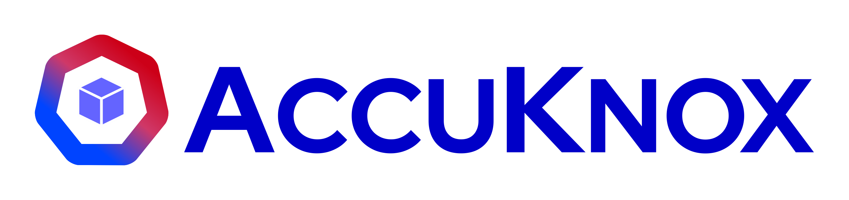

AccuKnox SIEM
SIEM Deployment Proposal
Unified Log Ingestion, Threat Detection & Compliance-Ready Retention
Confidential & Proprietary | AccuKnox

Table of Contents
Executive Summary
Requirements Traceability
AccuKnox SIEM: Solution Overview
Scope of Work: Log Source Mapping
Technical Architecture
Platform Walkthrough
Data Retention & Storage Management
Product Capabilities
Integration & Interoperability Strategy
Phased Deployment Roadmap
Security, Compliance & Auditability
Business Impact
Support & Service-Level Commitment
Proposal Summary
Appendix A: AccuKnox Multi-tenancy & Scalability
Appendix B: Integration Ecosystem
Appendix C: POC Timeline & Checklist
Appendix D: Syslog Integration Approach for Firewalls

Executive Summary
The organization is consolidating log visibility across its cloud, SaaS, endpoint, and network estate into a single SIEM platform, with a one-year retention window and six months of searchable data to meet audit and compliance obligations. This proposal outlines how AccuKnox SIEM meets that requirement for the fifteen log sources identified during discovery.
Scope of this proposal: AccuKnox SIEM covers log ingestion, normalization, correlation, threat detection, dashboards, alerting, and compliance-ready retention and search. Automated remediation (Cloud Detection & Response) is out of scope for this engagement. The organization's requirement, as scoped, is detection and monitoring only. No auto-remediation actions, playbooks, or write-access to the organization's cloud accounts are configured as part of this deployment.

What AccuKnox SIEM delivers
• Unified log ingestion: AWS (CloudTrail, VPC Flow Logs, WAF, Config, Route 53, Network Firewall), GCP audit/activity logs, OCI audit logs, Google Workspace, MongoDB, Slack, Jamf, Cisco Meraki, CrowdStrike FDR, AquaSec, and Palo Alto firewalls, all fifteen sources from discovery.
• Retention that meets the compliance requirement: 1-year log retention with 6 months of searchable, metadata-indexed data, plus on-demand audit log export.
• Threat detection and correlation: out-of-the-box detectors for AWS CloudTrail, GCP, and Kubernetes, custom detectors for the organization's SaaS and endpoint sources, threat intelligence enrichment, and MITRE ATT&CK mapping.
• Purpose-built dashboards and alerting: custom SOC dashboards, saved searches, and notifications to Slack, Jira, ServiceNow, or email.
• Native hand-off to AccuKnox CNAPP: SIEM findings surface in AccuKnox CNAPP's unified asset and findings view for teams already using AccuKnox CSPM/CWPP.

Why AccuKnox
• We meet the ingestion, retention, and detection requirements the organization outlined during discovery, using the same log sources and methods already validated on the AccuKnox platform.
• AccuKnox was founded in partnership with SRI International, the R&D lab behind the computer mouse, the modem, and some of the earliest intrusion detection research, giving the detection engine a strong technical foundation.
• We run a structured, time-boxed POC so the organization can validate ingestion, detection, and retention against its own data before committing to a full rollout.
• Cloud-native ingestion pipelines scale to 100K events/second and 1TB/day per tenant, so the organization's log volumes are handled with headroom.

Requirements Traceability
A quick reference confirming how this proposal addresses each requirement the organization outlined during discovery.
Customer Requirement | How AccuKnox SIEM Meets It
All 15 log sources ingested (AWS x6, GCP, OCI, Google Workspace, MongoDB, Slack, Jamf, Meraki, CrowdStrike FDR, AquaSec, Palo Alto) | Scope of Work table maps every source to a specific ingestion method, see the next section.
1-year log retention | Confirmed platform default for all onboarded sources; see Data Retention & Storage Management.
6 months of searchable data | Metadata-based indexing keeps the most recent 6 months fully searchable; see Data Retention & Storage Management.
Compliance/audit readiness | On-demand and scheduled audit log export (JSON/CSV); see Security, Compliance & Auditability.
Syslog-only firewalls (Meraki, Palo Alto) supported | Syslog-to-JSON middleware VM architecture; see Appendix D.

AccuKnox SIEM: Solution Overview
AccuKnox SIEM is a cloud-native log ingestion, correlation, and threat-detection platform, available as a SaaS deployment at siem.accuknox.com. It is a distinct product from AccuKnox CNAPP, with a native integration between the two: SIEM detections and threat-analysis alerts surface directly inside the CNAPP console, so teams already using AccuKnox for CSPM or CWPP get a single pane of glass for findings.
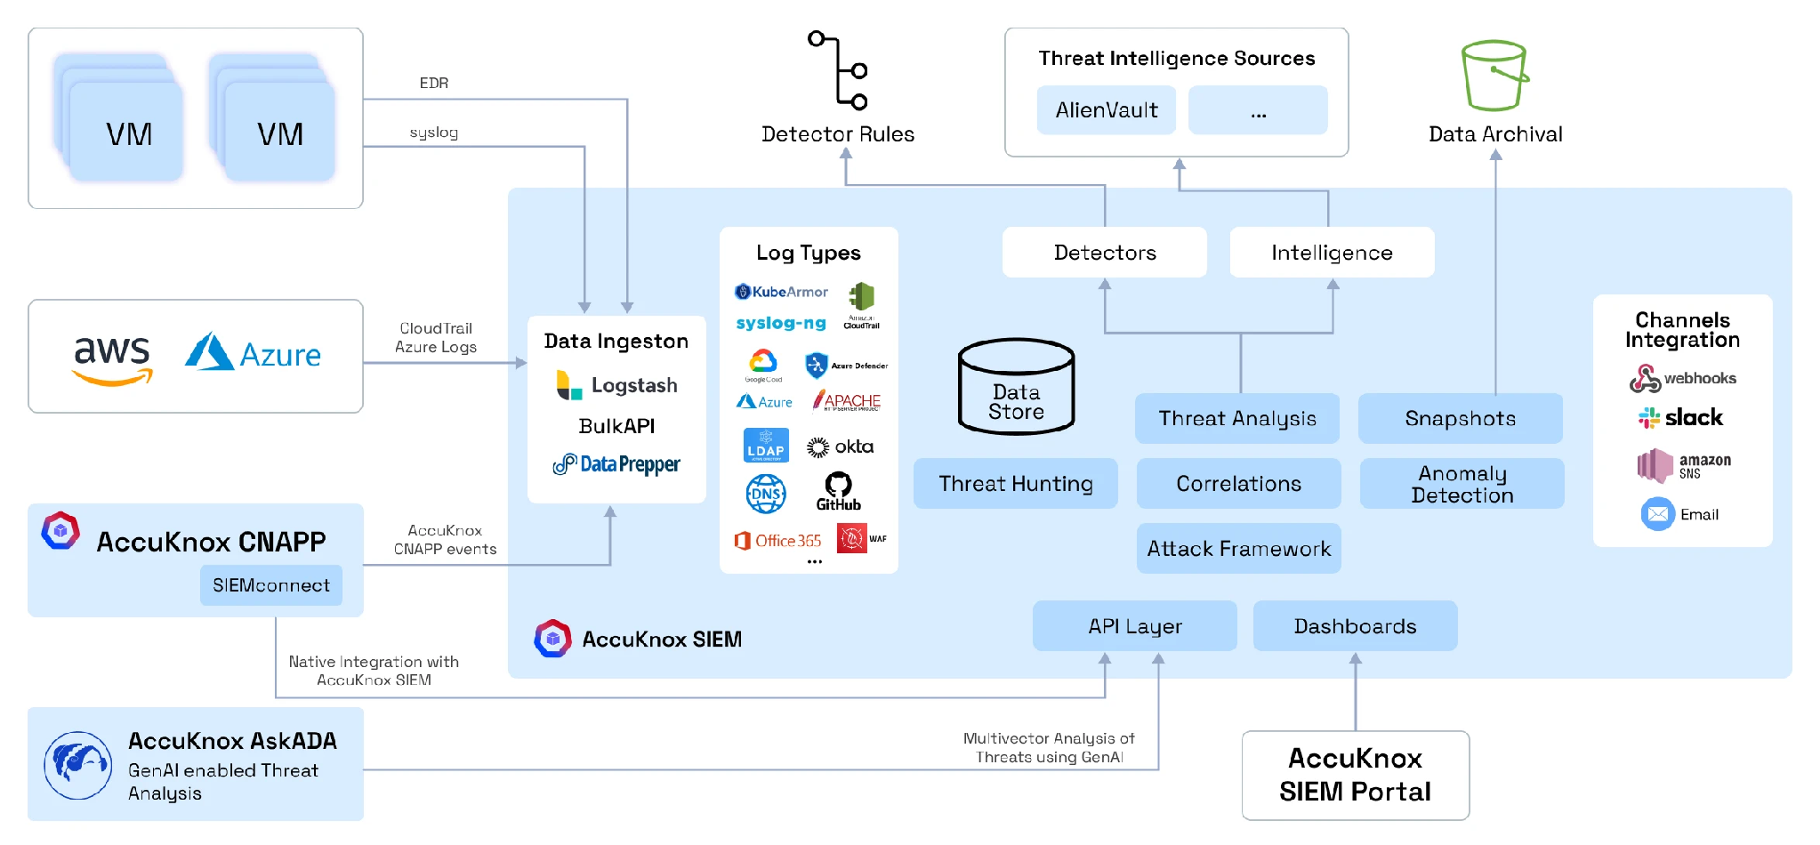
Figure 1. AccuKnox SIEM data flow: sources, ingestion, detection, and downstream channels.

Core capabilities
• Data/log ingestion: LogStash, Bulk API, and Data Prepper connectors covering HTTP, Kafka, OTel, S3, Kinesis, DynamoDB, DocumentDB, and Fluentd inputs, in addition to native cloud log sinks and vendor APIs.
• Extensive integration coverage: cloud platforms, identity providers, SaaS applications, endpoint agents, firewalls (via syslog), and Kubernetes. See the Scope of Work below for the organization's specific set, and Appendix B for the full platform catalog.
• Threat analysis: multivector correlation across cloud, identity, and network events, with anomaly detection and threat hunting built in.
• Threat intelligence enrichment: alerts are enriched against external threat intel sources (including AlienVault) for IP and domain reputation.
• Snapshots: periodic snapshots of indexed data support recoverability and business continuity.
• Native CNAPP integration: SIEM alerts and cloud telemetry feed directly into AccuKnox CNAPP's asset and findings views. CNAPP calls SIEM APIs for CloudTrail and cloud access data, and KubeArmor runtime events flow in as a custom SIEM log type with purpose-built detectors.
• External channel integrations: Slack, webhooks, and Amazon SNS for downstream notification and ticketing workflows.

Ingestion at scale, per tenant
Each tenant's ingestion runs through its own isolated pipeline inside the AccuKnox SIEM Kubernetes cluster. The organization's data would land in its own namespace (for example, tenant.accuknox.com) with a dedicated ingestion pipeline, separate from every other tenant on the platform. Cloud telemetry, endpoint data, and syslog sources all flow through this per-tenant pipeline into the shared storage backend, which is what lets the platform scale to 100K events/second and 1TB/day per tenant without one tenant's volume affecting another's.

AskADA: GenAI-powered SOC copilot
AccuKnox AskADA is a GenAI copilot that runs on top of SIEM and CNAPP data. It performs multivector threat analysis by combining the organization's own findings and telemetry with external threat-intelligence sources, giving the organization's SOC analysts faster triage and analysis across cloud and endpoint assets without manually pivoting between tools.

Platform differentiation
• Custom rules and detectors across syslog, KubeArmor, EDR, CloudTrail, and O365 log types, not just a fixed rule pack.
• MITRE ATT&CK alignment spans Cloud, Container, and Endpoint tactics, not just cloud API calls.
• Low-cost ingestion, storage, and processing architecture, which is what keeps per-GB retention costs down over a 1-year window.
• Correlation and prioritization are built to reduce SOC analyst hours spent triaging noise, not just to generate more alerts.

Scope of Work: Log Source Mapping
The table below maps each of the fifteen log sources identified during discovery to its ingestion method on AccuKnox SIEM. Sources fall into three categories: cloud platforms ingested through each provider's native logging service, SaaS/endpoint tools connected through vendor APIs, and syslog-only firewalls that route through a lightweight middleware VM.
Log Source | Ingestion Method | Notes
AWS CloudTrail | Native, AWS CloudTrail via scoped IAM role | Management and data events; onboarded via the standard AWS CloudFormation onboarding stack.
AWS VPC Flow Logs | Native, CloudWatch Logs / S3 export | Same AWS onboarding stack as CloudTrail; no separate agent.
AWS WAF | Native, S3 / Kinesis Firehose log export | Web ACL logs delivered via existing AWS onboarding.
AWS Config | Native, S3 export of Config snapshots and history | Same AWS onboarding stack.
Route 53 | Native, CloudWatch Logs (query logging) | Same AWS onboarding stack.
AWS Network Firewall | Native, CloudWatch Logs / S3 export | Flow and alert logs; same AWS onboarding stack.
GCP Audit / Activity Logs | Native, Cloud Logging log sink to Pub/Sub | AccuKnox SIEM consumes the sink directly; no forwarder required.
OCI Audit Logs | Native, OCI Logging via Streaming / Object Storage export | Read-only export configuration in the OCI tenancy.
Google Workspace | API, Admin SDK Reports API | Login, admin, and application audit events.
MongoDB (Atlas) | API, Atlas Audit Log / Atlas Administration API | Database and project-level audit events.
Slack | API, Enterprise Grid Audit Logs API | Workspace and admin audit events.
Jamf | API, Jamf Pro API / webhook events | Device management and compliance events.
CrowdStrike FDR | Native, Falcon Data Replicator (S3-based) | AccuKnox SIEM reads directly from the FDR S3 bucket.
AquaSec | API, Aqua Platform API / webhook | Container and workload security events.
Cisco Meraki | Syslog → Syslog VM middleware → AccuKnox SIEM | See Appendix D for the syslog-to-JSON middleware architecture.
Palo Alto Firewall | Syslog → Syslog VM middleware → AccuKnox SIEM | See Appendix D for the syslog-to-JSON middleware architecture.

How cloud-native ingestion works
For AWS, GCP, and OCI, AccuKnox SIEM ingests logs directly through each provider's native logging and monitoring service: CloudTrail for AWS, Cloud Logging log sinks for GCP, and the Logging service for OCI. No forwarders or agents run on the organization's infrastructure for these three platforms. Onboarding follows AccuKnox's standard SIEM onboarding workflow:
• AWS SIEM Onboarding Guide
• GCP SIEM Onboarding Guide
AccuKnox uses one shared cloud-connection workflow for both log ingestion and (where separately licensed) automated response, so the same onboarding steps apply regardless of which capability is enabled. For this engagement, only detection and monitoring are configured. No remediation actions are enabled on the organization's cloud accounts.

Technical Architecture
AccuKnox SIEM ingests events from the organization's cloud accounts, SaaS applications, and network appliances, normalizes them into a common schema, and runs them through detectors, correlation, and threat-intelligence enrichment before surfacing results in dashboards and external channels.
Figure 2. AccuKnox SIEM architecture, as deployed for the organization's scope (log ingestion, detection, dashboards and channels).

Architecture layers
• Sources: AWS, Google Workspace, and the AccuKnox CNAPP events feed connect through their native APIs; VMs, EDR tools, and syslog-only appliances (Cisco Meraki, Palo Alto) forward through syslog.
• Data ingestion: LogStash, Bulk API, and Data Prepper receive and normalize events across all supported log types before they are written to the data store.
• Data store: logs are indexed with enriched metadata (source, timestamp, event type, severity, account, region), which is what makes 6-month search fast without scanning raw log volumes.
• Detectors and intelligence: detection rules and threat-intelligence sources (including AlienVault) run continuously against ingested data, feeding threat analysis, correlations, threat hunting, and the MITRE ATT&CK mapping.
• Dashboards and API layer: the AccuKnox SIEM Portal and API layer expose search, dashboards, and snapshots; AccuKnox AskADA adds GenAI-assisted multivector threat analysis on top of the same data.
• Channels: detections and snapshots can notify out to Slack, webhooks, and Amazon SNS for the organization's SOC workflows.
• Data archival: logs beyond the 6-month searchable window move to archival storage and remain retrievable through the 1-year retention period.

Platform Walkthrough
A look at the two layers the organization's team would work in day to day: the SIEM backend, where logs are stored, queried, and visualized, and the AccuKnox UI, where alerts are triaged.

SIEM backend: log storage and query layer
The SIEM backend is where ingested logs are stored and queried directly. Access is tenant-scoped and authenticated per user.
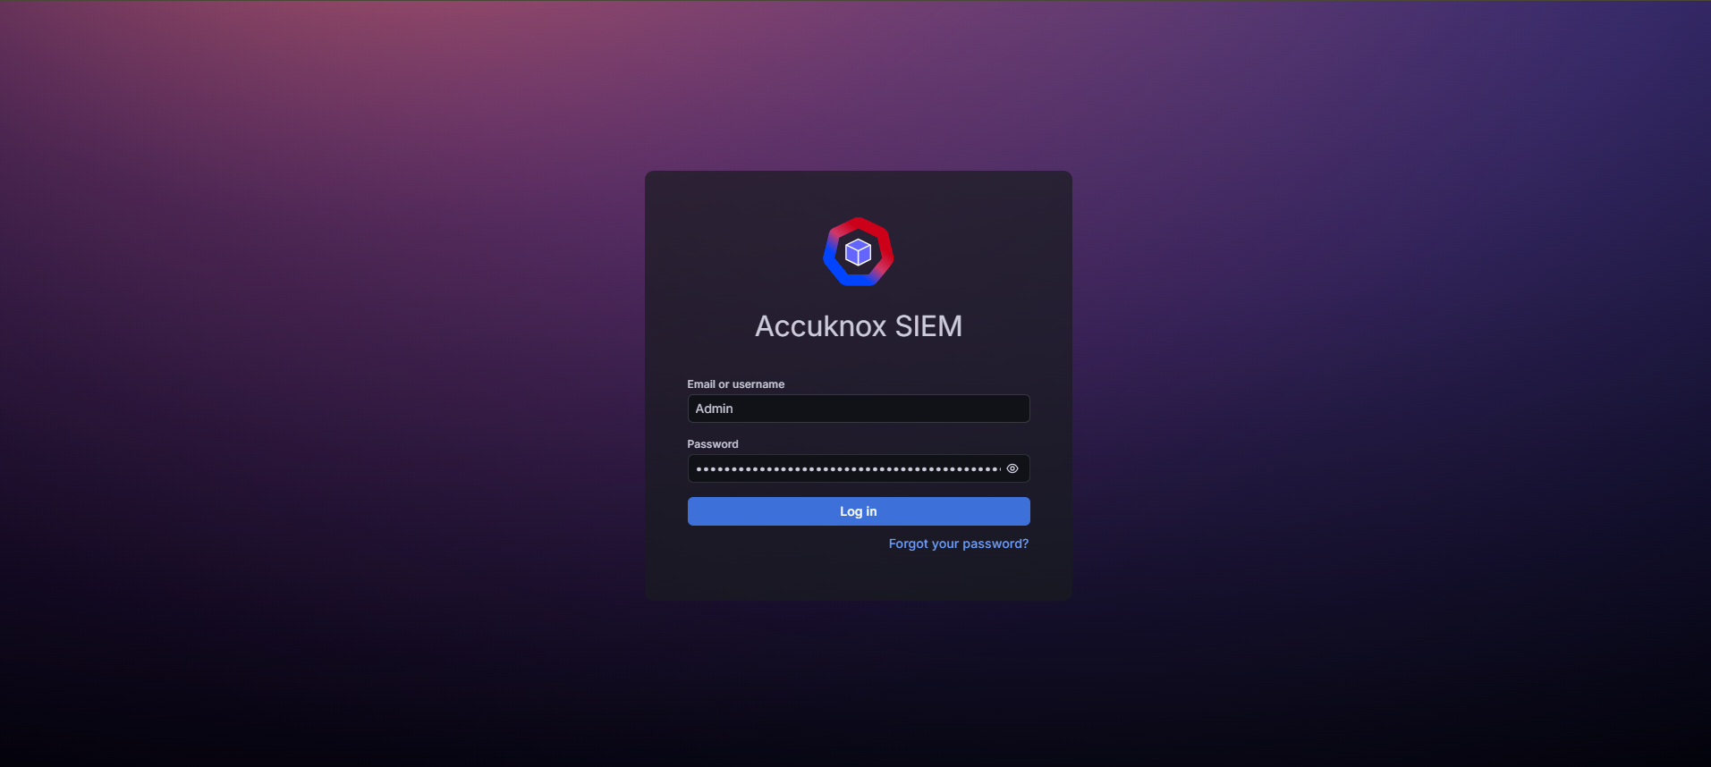
Figure 3. AccuKnox SIEM backend login.
Once logged in, the backend exposes purpose-built dashboards per log source. The example below is an AWS CloudTrail operations dashboard, showing total event volume, error/access-denied counts, unique identities, and activity trends over a selected time window.
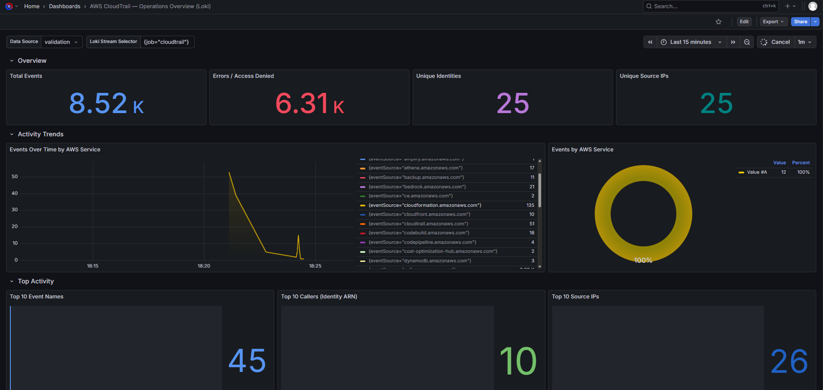
Figure 4. AWS CloudTrail operations dashboard on the AccuKnox SIEM backend.

AccuKnox UI: alerts
Detections surface as alerts in the main AccuKnox UI, where the organization's SOC team would triage them day to day, filterable by module, status, log source, and severity, with saved filters and export.
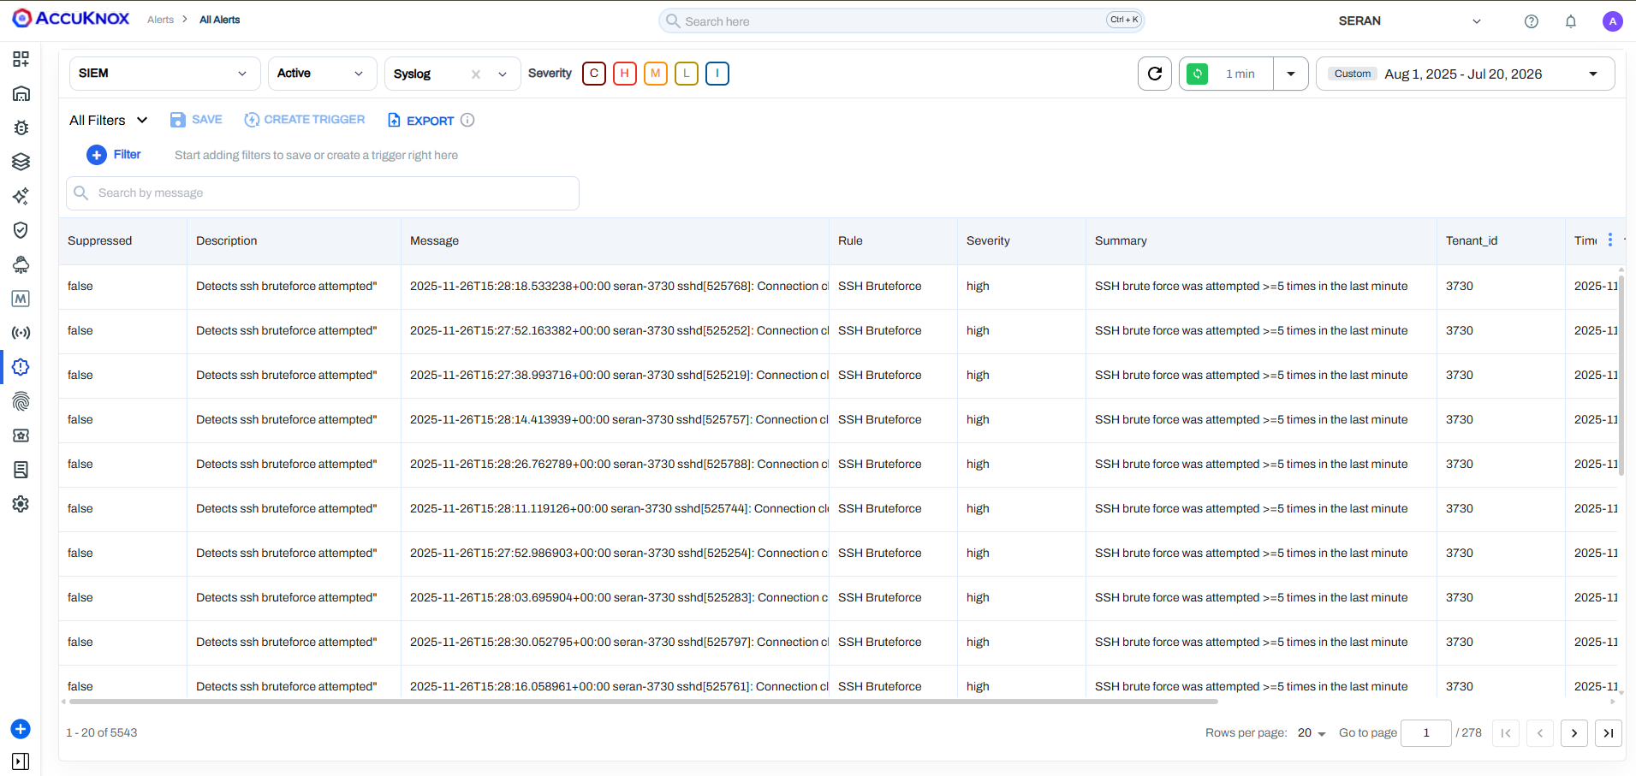
Figure 5. AccuKnox UI, Alerts page: active syslog-sourced alerts filtered by severity.
Each alert opens into full detail, including the raw log payload, for investigation and audit purposes.
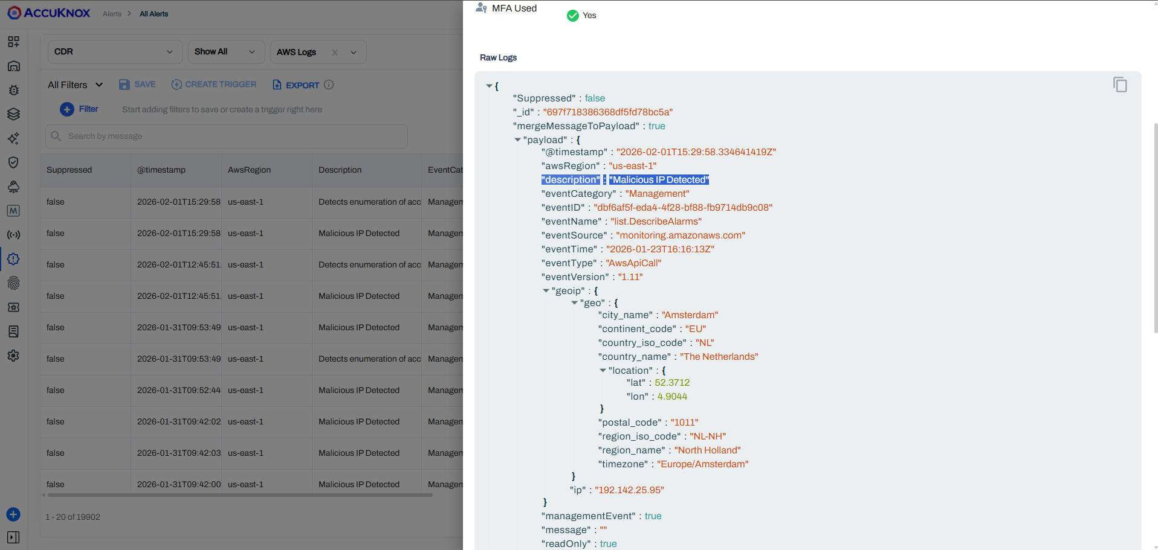
Figure 6. AccuKnox UI, alert detail view with raw log payload.

Data Retention & Storage Management
The organization's stated requirement is 1-year log retention with 6 months of searchable data for compliance and audit purposes. AccuKnox SIEM's storage model is built around exactly this pattern:
• 1-year retention: all ingested logs from every source in the Scope of Work above are retained for a full year.
• 6-month searchable window: the most recent 6 months of data is indexed and fully searchable through metadata-based storage, so investigations and audits query fast without scanning raw log volumes.
• Metadata-based indexing: logs are enriched with source, timestamp, event type, severity, account, and region metadata at ingestion, which is what keeps 6-month search performant.
• Data archival: logs beyond the 6-month searchable window move to cold, S3-compatible archival storage and remain restorable on demand through month 12.
• Ingestion and storage controls: per-tenant ingestion limits and storage quotas are configurable, so upper limits are enforced and costs stay predictable.
• Snapshots and backup: periodic snapshots of indexed data protect against data loss and support recoverability.
• Audit log exports: scheduled or on-demand export of logs in JSON or CSV format for compliance reviews and regulatory submissions.
• Tenant isolation: the organization's log data is isolated from other AccuKnox tenants at the storage layer, with separate index namespaces and separate database collections/tables.

Product Capabilities
Capability | Details
Log Ingestion & Retention | LogStash, Bulk API, Data Prepper (HTTP, Kafka, OTel, S3, Kinesis, DynamoDB, DocumentDB, Fluentd) plus native cloud and vendor-API connectors. 100K events/sec, 1TB/day/tenant, 1-year retention with a 6-month searchable window.
Threat Detection & Rules | Out-of-the-box detectors for AWS CloudTrail, GCP, and Kubernetes, plus custom detectors authored for the organization's CrowdStrike, AquaSec, MongoDB, Google Workspace, Meraki, and Palo Alto sources.
Correlation & Analytics | Multivector correlation, anomaly detection, and threat hunting across cloud, identity, and network sources, with MITRE ATT&CK framework alignment.
Threat Intelligence | Alerts enriched against external threat intelligence sources (including AlienVault) for IP and domain reputation.
Dashboards & Reporting | Custom dashboards, saved searches, metadata-based log storage, and scheduled or on-demand audit log exports.
Alerting & Notifications | Slack, webhook, and Amazon SNS notification channels for the organization's SOC workflows. No automated remediation actions are configured. Alerts are informational and route to the organization's own response process.
Native CNAPP Integration | SIEM alerts and cloud telemetry feed into AccuKnox CNAPP's asset and findings views for teams already using AccuKnox CSPM/CWPP.
RBAC & Multi-tenancy | Multi-tenant architecture with granular role-based access control and SSO/SAML/MFA support; per-tenant custom views and reports.

Integration & Interoperability Strategy
AccuKnox SIEM covers all fifteen of the organization's priority log sources identified during discovery, alongside 70+ additional integrations available on the platform (Appendix B has a snapshot).

1. Cloud platforms, native onboarding
• AWS: CloudTrail, VPC Flow Logs, WAF, Config, Route 53, Network Firewall, onboarded together via the standard CloudFormation onboarding template.
• GCP: audit and activity logs via Cloud Logging log sink.
• OCI: audit logs via the OCI Logging service.

2. SaaS and endpoint, API connectors
• Identity & collaboration: Google Workspace, Slack, Jamf.
• Data & workload: MongoDB Atlas, CrowdStrike FDR, AquaSec.

3. Network appliances, syslog middleware
• Cisco Meraki and Palo Alto firewalls forward Syslog to a dedicated Syslog VM, which converts events to JSON before AccuKnox SIEM ingests them via Bulk API. Full architecture in Appendix D.

4. Notification and ticketing (informational only)
• Slack, webhooks, and Amazon SNS route alerts to the organization's existing SOC workflow. As scoped, these channels are for notification. No automated remediation or write-back actions are configured.

Phased Deployment Roadmap
We recommend a time-boxed, three-phase rollout. Each phase is scoped to minimize risk and validate results before moving to the next.

Phase 1: Log Source Onboarding & Ingestion
• Onboard AWS CloudTrail, VPC Flow Logs, WAF, Config, Route 53, and Network Firewall via the CloudFormation onboarding template.
• Connect GCP audit/activity logs and OCI audit logs through their native log-export services.
• Connect Google Workspace, MongoDB, Slack, Jamf, CrowdStrike FDR, and AquaSec via their respective APIs.
• Deploy the Syslog VM middleware and onboard Cisco Meraki and Palo Alto firewall logs.
• Validate ingestion rates and confirm 1-year retention with the 6-month searchable window is indexing correctly.

Phase 2: Threat Detection & Threat Intelligence
• Enable out-of-the-box detection rules for AWS CloudTrail, GCP, and Kubernetes.
• Author and tune custom detectors for CrowdStrike, AquaSec, MongoDB, Google Workspace, Meraki, and Palo Alto log patterns.
• Enable threat-intelligence enrichment (AlienVault and others) and MITRE ATT&CK mapping.
• Configure anomaly-detection baselines and multivector correlations across identity, cloud, and network sources.
• Push detection alerts into AccuKnox CNAPP for a unified findings view, where applicable.

Phase 3: Dashboards, Alerting & Compliance Reporting
• Build organization-specific dashboards: SOC overview, per-source detections, MITRE heatmap, and compliance widgets.
• Configure alerting to Slack, Jira, ServiceNow, or email with tuned thresholds and de-duplication.
• Enable scheduled audit log exports (JSON/CSV) for compliance reviews and validate retention exports end to end.

Security, Compliance & Auditability
AccuKnox SIEM's retention, search, and export model is built to support standard audit and compliance workflows. The platform's design aligns with:
• ISO/IEC 27001: information security management
• SOC 2: security, availability, and confidentiality trust principles
• PCI DSS: logging and monitoring requirements for cardholder data environments
• GDPR: data protection and audit-trail requirements
• NIST SP 800-207: Zero Trust architecture principles
For the organization's specific compliance program, we recommend confirming applicable frameworks during the POC so dashboards and audit-export formats can be tuned accordingly from day one.

Business Impact
• Tool consolidation: replace fragmented log tooling across AWS, GCP, OCI, SaaS, and network appliances with a single cloud-native SIEM. One platform, one retention policy, one search experience.
• Reduced infrastructure overhead: cloud-native ingestion pipelines scale to 100K events/sec and 1TB/day per tenant without forwarder farms or heavy on-prem infrastructure. The syslog VM is the only piece of infrastructure the organization needs to run.
• Operational efficiency: correlation and MITRE-aligned prioritization reduce alert noise, cutting the time SOC analysts spend triaging low-value alerts.
• Faster investigations: metadata-based indexing keeps 6-month search fast, so audits and incident investigations don't wait on raw log scans.
• Audit and retention cost reduction: 1-year retention with a 6-month searchable window and one-click audit log exports cut audit-preparation time.
• Scalable for growth: per-tenant RBAC, dashboards, and ingestion controls scale cleanly as the organization adds business units, environments, or geographies.

Support & Service-Level Commitment
• 24/7 product support, per the agreed commercial terms.
• A dedicated Technical Account Manager (TAM).
• Quarterly health checks and improvement recommendations.

Proposal Summary
AccuKnox SIEM meets the organization's requirements across all fifteen log sources identified during discovery, with a retention and search model built specifically around the 1-year / 6-month compliance requirement.
• Log ingestion & search: AWS (CloudTrail, VPC, WAF, Config, Route 53, Network Firewall), GCP, OCI, Google Workspace, MongoDB, Slack, Jamf, Cisco Meraki, CrowdStrike FDR, AquaSec, and Palo Alto, ingested at scale (100K events/sec, 1TB/day/tenant).
• Threat detection & MITRE ATT&CK: out-of-the-box AWS CloudTrail detection rules plus custom detectors for the organization's stack, enriched with threat intelligence.
• Retention & search: 1-year retention, 6-month searchable window, metadata-based indexing, and on-demand audit log export.
• Native CNAPP hand-off & multi-tenancy: SIEM alerts feed AccuKnox CNAPP's asset/findings views; per-tenant RBAC and dashboards for the organization's teams and business units.
We would be glad to run a structured POC with the organization to validate ingestion, detection, and retention against real data before a full commercial rollout. See Appendix C for the proposed timeline.

Appendix A: AccuKnox Multi-tenancy & Scalability
AccuKnox is built on a multi-tenant architecture from the ground up, which is what allows the organization's environment to scale horizontally without a dedicated control plane per business unit.

Isolation model
• Hard isolation: a dedicated instance of the app and database per customer. Strong isolation, higher operational cost.
• Soft isolation: customers share a database, but each has its own set of tables, a balance of isolation and cost. This is the default for most deployments.

Layered architecture
• Layer 1: Users, RBAC, and tenants.
• Layer 2: Backend jobs and execution management.
• Layer 3: Data isolation between tenants.
• Layer 4: Custom reporting, dashboards, and layouts per tenant.
A single user can belong to multiple tenants with different permissions in each, useful if, for example, a security team needs read access across two regional business units while engineering teams stay segregated.
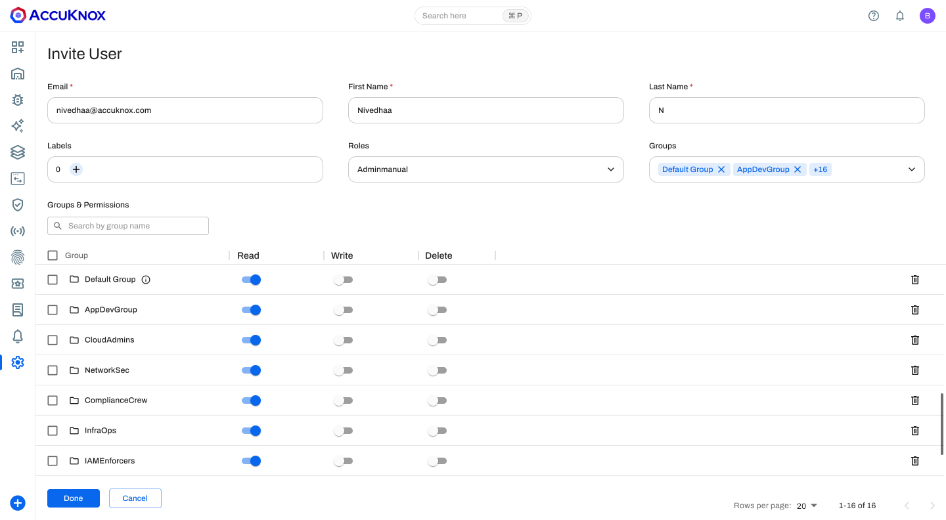
Figure 7. A user can hold different RBAC roles across multiple tenants.
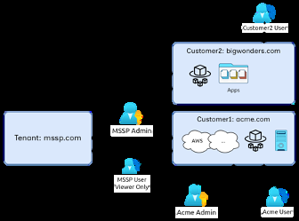
Figure 8. Regional tenant separation with shared or segregated team access.

Resource allocation and the noisy-neighbor problem
AccuKnox uses a hybrid allocation model: customers requiring hard isolation get a dedicated control plane, while multiple small or mid-size tenants share compute through Kubernetes-native soft isolation. To prevent one tenant's workload from starving another's, the classic “noisy neighbor” problem, AccuKnox uses Kueue for cluster-wide job scheduling and isolated, namespace-based replica sets for parser tasks.

Data isolation
Tenant data is isolated at the storage layer without spinning up a separate database instance per customer: each tenant gets its own PostgreSQL tables, and its own MongoDB collections, each with independent access control, which keeps the blast radius contained if one tenant's access is compromised.
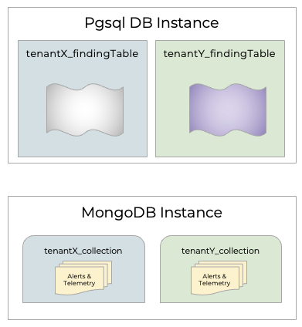
Figure 9. Per-tenant data isolation at the storage layer.

Deployment models
• SaaS
• Customer cloud (AccuKnox control plane deployed in the customer's AWS/Azure/GCP)
• On-premises / air-gapped
The same multi-tenancy architecture applies across all three models, and AccuKnox's control plane is already battle-tested at MSSP scale. One OEM partner alone onboards hundreds of tenants on a shared control plane.

Appendix B: Integration Ecosystem
AccuKnox integrates with 80+ ecosystem tools and frameworks across cloud, SIEM, CI/CD, and container platforms. The organization's committed scope is the fifteen sources in the Scope of Work section; the categories below show the broader AccuKnox SIEM integration catalog available if the organization's needs expand. The latest full list is available at accuknox.com/integrations.

AccuKnox SIEM integration categories
• Identity: AD/LDAP, Okta, Microsoft O365, GitHub, and AccuKnox CNAPP cloud findings.
• Firewalls & network appliances: FortiGate, Palo Alto, and any syslog-capable firewall; routers and managed switches.
• Cloud service providers: AWS CloudTrail, Azure Logs, GCP Logs.
• Endpoints: Syslog, KubeArmor, Microsoft Defender, Microsoft Windows.
• Kubernetes: KubeArmor and Kubernetes API server logs.
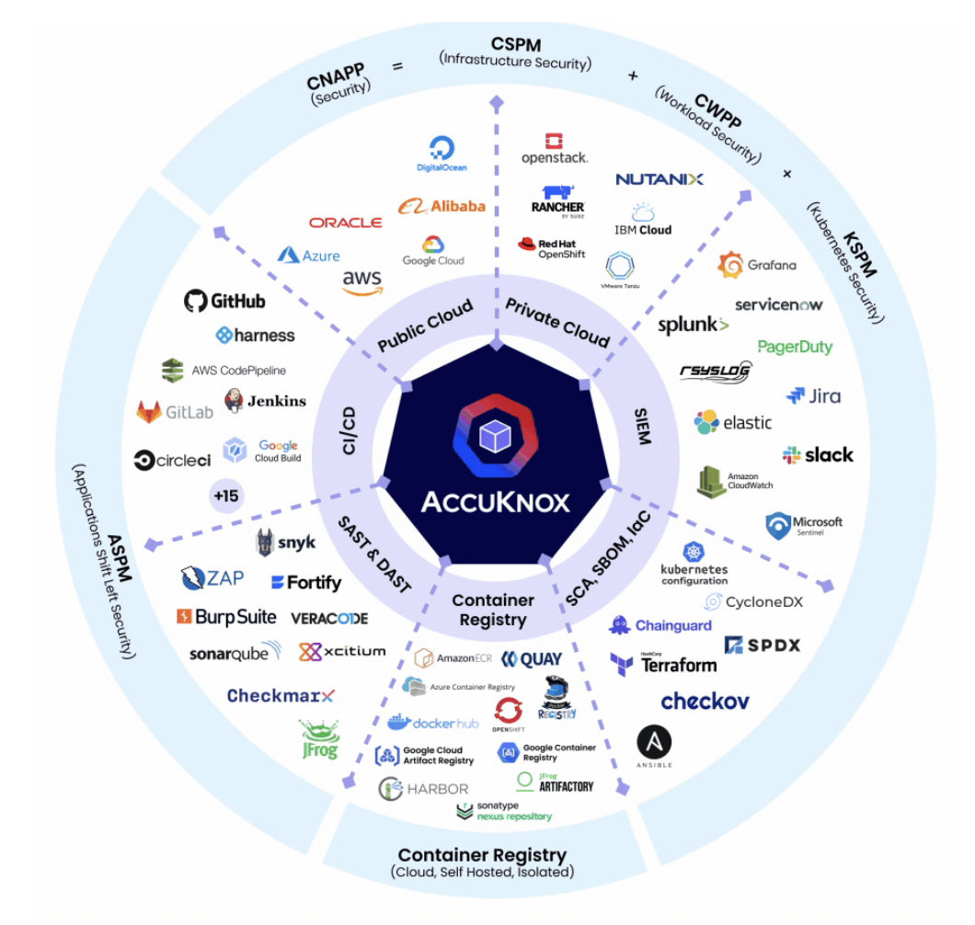
Figure 10. AccuKnox platform integration ecosystem.

Appendix C: POC Timeline & Checklist
The proposed POC validates AccuKnox SIEM against the organization's fifteen log sources and its 1-year / 6-month retention requirement in a structured, milestone-driven approach. SIEM ingestion and detection only, with no automated remediation actions in scope.

Checklist
Checklist Item | Validation Criteria
Log Ingestion | Validate ingestion from AWS, GCP, OCI, all SaaS/API sources, and the Syslog VM middleware for Meraki and Palo Alto.
Threat Detection | Confirm out-of-the-box and custom detectors trigger correctly against sample and live events.
Threat Intelligence | Validate IP/domain reputation enrichment against known indicators.
Dashboards | Build and validate a sample custom dashboard and saved search.
Alerting | Validate notification delivery to Slack, email, and/or Jira.
Retention & Search | Confirm 1-year retention configuration, 6-month searchable window, and audit log export in JSON/CSV.
RBAC & Multi-tenancy | Validate tenant isolation and role-based access for the organization's teams.

Timeline
Phase | Activities | Duration
Phase 1 | Log source onboarding across AWS, GCP, OCI, and SaaS/API sources, plus Syslog VM setup for Meraki and Palo Alto. | 2 business days
Phase 2 | Threat detection and threat-intelligence validation across onboarded sources. | 1 business day
Phase 3 | Dashboards, alerting, and audit log export validation. | 1 business day
Wrap-up | End-to-end validation, fine-tuning, knowledge transfer, and next-steps planning. | 1 business day

Appendix D: Syslog Integration Approach for Firewalls
AccuKnox SIEM does not parse the Syslog protocol directly. For the organization's Palo Alto Firewall and Cisco Meraki sources, both of which emit Syslog, AccuKnox uses a lightweight middleware VM to convert Syslog to JSON before ingestion.

Approach
Source device (Syslog) → Syslog VM (Rsyslog + JSON conversion script) → AccuKnox SIEM (JSON ingestion via Bulk API)

Step by step
• 1. Source configuration: point the Palo Alto Firewall and Cisco Meraki dashboard to forward Syslog to the Syslog VM's IP and port (default UDP/TCP 514).
• 2. Syslog VM setup: deploy an Ubuntu VM in the same network segment or VPC as the source devices, and install Rsyslog to receive messages from both sources.
• 3. JSON conversion: a script on the Syslog VM parses each incoming line and converts it to a JSON object (source IP, timestamp, event type, message body, device name).
• 4. Forward to AccuKnox SIEM: the JSON payload is sent to AccuKnox SIEM's ingestion endpoint via Bulk API or LogStash HTTP output.
• 5. Indexing & detection: AccuKnox SIEM indexes events under the organization's tenant namespace and applies detection rules: port-scan and policy-violation detectors for Palo Alto, client-association and unauthorized-SSID detectors for Meraki.
The Syslog VM is a small piece of onboarding infrastructure that lives in the organization's environment. AccuKnox does not require inbound access to the organization's network to operate it.

