 | How to Generate AccuKnox-Branded  Docs and PPTs with Claude Code

Claude Code can take any Word doc or Google Slides deck and reformat it into AccuKnox branding, correct logo, colors, and layout, in one pass. Works for both docs and PPTs, and you can batch as many files as you want in one go.
Prerequisites
- An active Claude Code subscription. We use one shared account (website@accuknox.com, 30+ users). Claude desktop must be installed, and you work inside the Claude Code window.
- The docs or PPTs you want branded, saved locally on your PC.
- The doc-ppt-template repo cloned locally: https://github.com/accuknox/doc-ppt-template

Steps
1. Clone the doc-ppt-template repo and load it in Claude Code.
2. Attach the docx or PPT you want to rebrand into AccuKnox's branding.
3. Reference the template files using the @ selector. Both live at the root of the doc-ppt-template repo:
- Word doc → WORD_TEMPLATE_ACCUKNOX.docx
- Presentation → PPT Template.pptx (or AccuKnox_Proposal_Template_BLANK.pptx to start a new deck)
4. Set permissions to “Bypass permissions” so Claude works autonomously.
5. Use Sonnet 5 only. Do not use Opus for this task.

Example Prompt
@doc-ppt-template Brand the attached DOCX file with AccuKnox branding, do it well and ensure it looks as per the expected outcome, be strict and use the logo correctly as well.

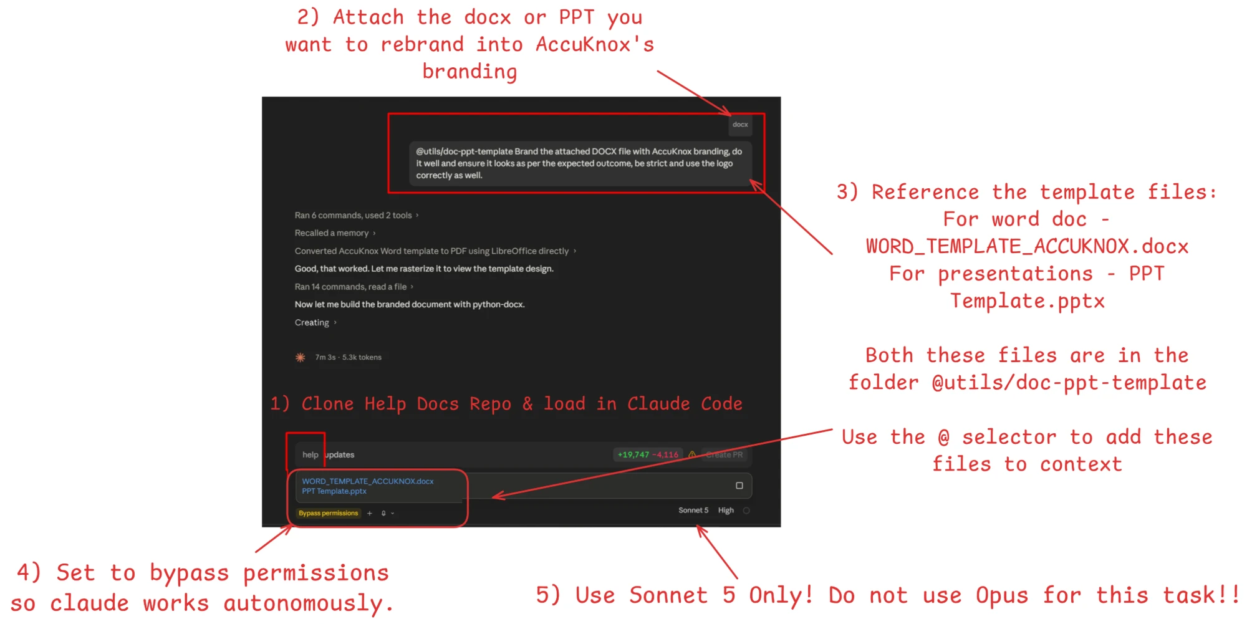
The five steps above, shown inside Claude Code. (Screenshot predates the doc-ppt-template repo split; the @ selector and Bypass Permissions workflow are unchanged.)
Before / After
The same comparison table, before and after AccuKnox branding is applied.
