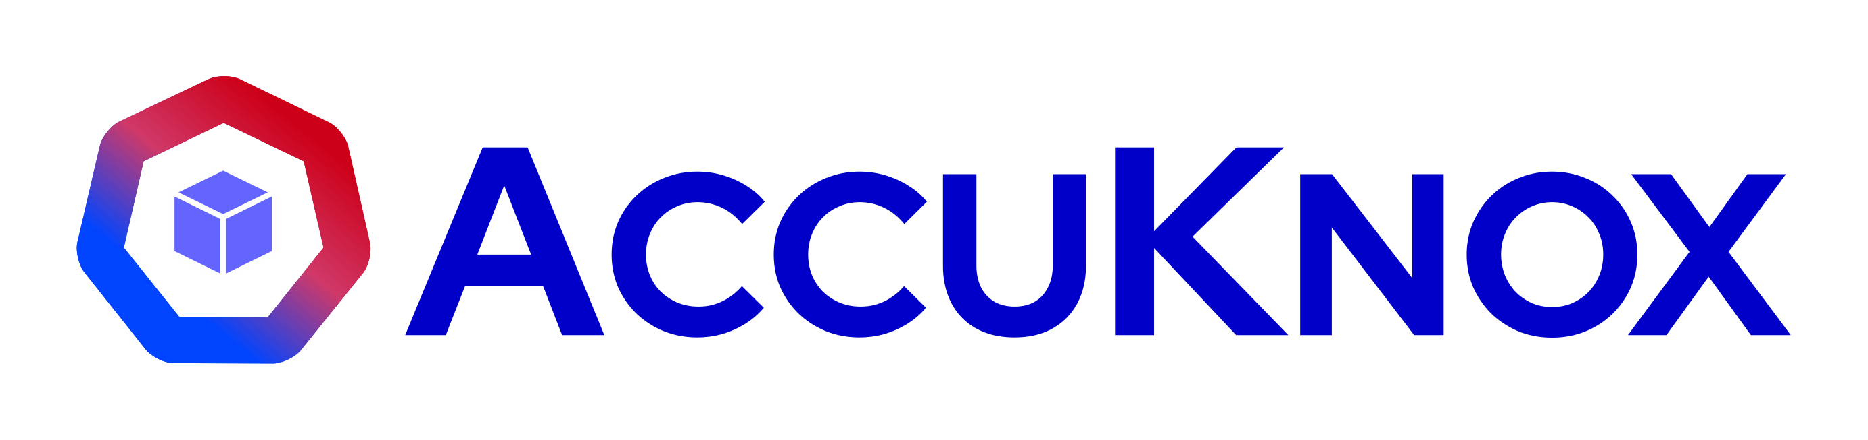
ACCUKNOX BLOG

Executive Order 14409: Why Your AI Agents Are Now a Legal Attack Surface
By Nat Natraj · July 2, 2026 · 7 min read

TL;DR
• On June 2, 2026, President Trump signed Executive Order 14409, “Promoting Advanced Artificial Intelligence Innovation and Security,” giving federal agencies 30 to 60 days to harden systems against AI-enabled attacks and adopt AI-enabled defenses.
• The order explicitly rules out mandatory licensing or preclearance for AI models. It regulates federal agency posture, not AI vendors directly.
• Section 3 creates a voluntary path for the government to benchmark “covered frontier models” for cyber capability and get early access before wider release.
• Section 4 directs the Attorney General to prioritize prosecution of anyone who uses AI, including AI agents, to illegally access data. That is the first time agentic AI shows up by name in federal computer-crime enforcement.
• None of the order’s deadlines bind private companies, but the posture it describes, AI-enabled detection, pre-deployment model testing, and governed agent identity, is what enterprise AI security already needs regardless of who signed what.

On June 2, 2026, President Trump signed Executive Order 14409, “Promoting Advanced Artificial Intelligence Innovation and Security.” Read next to the fact sheet the White House released the same day, the order does two things in one breath: it commits to keeping AI development lightly regulated, and it tells federal agencies to close AI security gaps in 30 to 60 days. Most AI policy debates put those two goals on opposite sides of a table. This order puts them on the same page, and the security half is where the real detail lives, all the way down to a sentence about AI agents that security teams should not skip past.

No license required, still no free pass
The order states plainly that nothing in it authorizes “a mandatory governmental licensing, preclearance, or permitting requirement” for building, publishing, or releasing an AI model. That is a deliberate contrast with pre-market regimes like the EU AI Act, and the fact sheet says so directly, framing the goal as partnering with industry rather than running a top-down compliance regime. But light touch on model development does not mean light touch on security. Everything past that line reads like a checklist for agencies to close gaps fast, not a deregulation memo, and it borrows a private-sector idea agencies rarely move on this quickly: fight AI-scale attacks with AI-scale defense.

Washington wants AI fighting AI
Section 2 gives the Committee on National Security Systems and the Secretary of War 30 days to prioritize cyber defense of national security systems and Department of War networks. CISA gets the same 30 days to issue binding directives that expand federal cybersecurity programs built around AI-enabled defensive tools, and to get those tools to state and local authorities and the critical infrastructure operators the order names directly: rural hospitals, community banks, local utilities. Treasury stands up a voluntary AI cybersecurity clearinghouse with industry to find and patch software vulnerabilities at scale, OMB has 30 days to identify grant funding for AI vulnerability detection, and OPM gets 60 days to widen its cybersecurity hiring pipeline. Put together, the order is describing the same gap that AI detection and response exists to close: most AI incidents trace back to an asset nobody inventoried, not one nobody tried to defend.
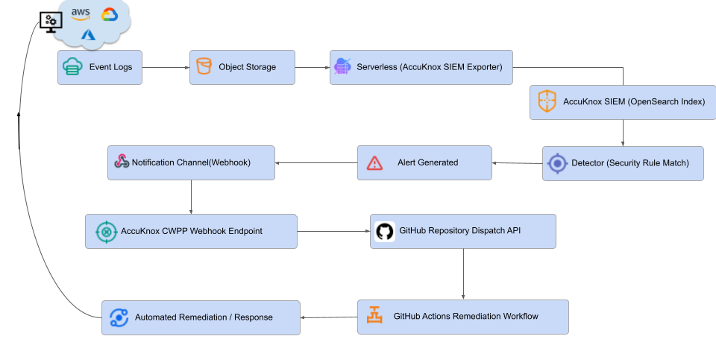
A continuous detect-alert-remediate loop is the commercial version of the AI-enabled defense this order asks agencies to build for themselves.
Watching AI infrastructure continuously, across cloud accounts and on-prem clusters, with alerts routed straight into automated remediation, is the commercial version of what this section asks agencies to build. AI detection and response runs that loop today, for anyone not waiting on a Binding Operational Directive to start.

A benchmark for frontier models, not a gatekeeper
Section 3 asks Treasury, the NSA, and CISA to build a classified process for scoring how much offensive cyber capability an AI model carries, and to use that score to decide when a model counts as a “covered frontier model.” Developers can then choose to give the government up to 30 days of early access to a covered model before wider release. It is opt-in, and the no-licensing line applies here too. The principle underneath it, that a model’s risk should be measured before it ships and again every time it changes, is the same one behind automated red teaming: run adversarial probes for prompt injection, jailbreaks, hallucination, and unsafe code generation before launch, then run them again on every update, so a risk score exists before an incident forces one.
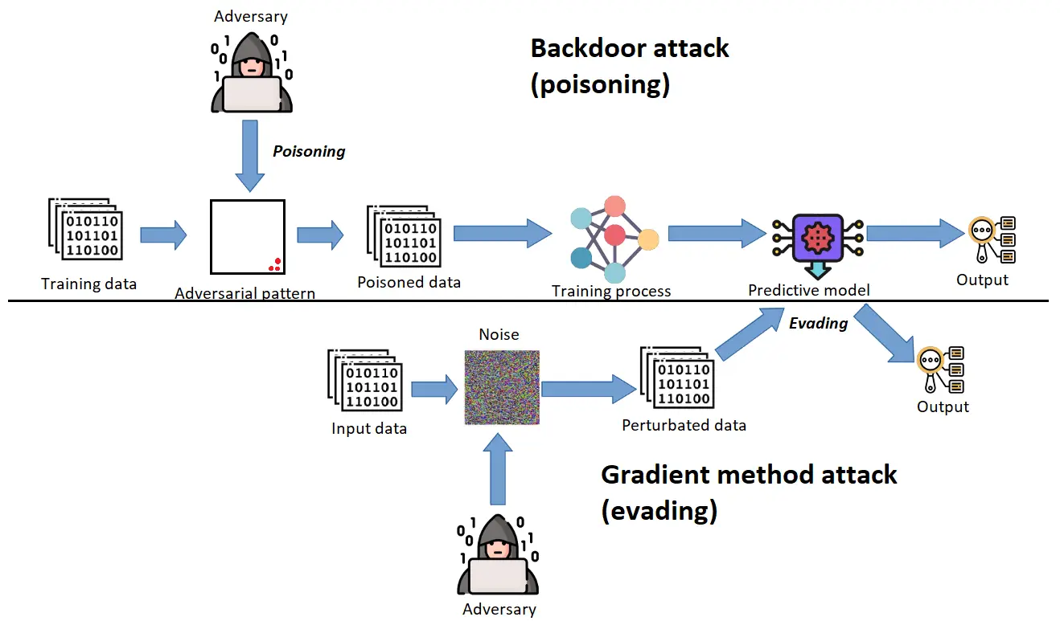
The same attack classes a classified frontier-model benchmark would need to score, poisoning and evasion, are what automated red teaming tests for before a model ever reaches production.

Section 4 puts AI agents in the criminal code
The line worth reading twice is in Section 4. The Attorney General is directed to prioritize enforcement of the federal computer fraud, identity theft, and wire fraud statutes, 18 U.S.C. 1028, 1030, and 1343, against anyone who uses AI to illegally access or damage a computer, and the order spells out that this includes “employing AI agents to unlawfully access data or information that is subsequently used for a criminal or unlawful purpose.” That sentence does not distinguish between an attacker’s own tool and someone else’s agent that got hijacked into doing the same thing. An agent running with a service account that can read more than its task needs, no per-agent identity, and no record of which tool call touched what data is now sitting on top of a fact pattern federal prosecutors are being told to pursue. It does not matter whether the agent misbehaved because it was compromised, over-permissioned, or steered through a poisoned tool description or an indirect prompt injection over MCP. The exposure is identical. Scoped identity per agent, tool allow lists, and an audit trail that shows exactly what an agent did and why are no longer just good architecture. They are what separates a contained incident from a federal case.

What this means if you do not sell to the government
Every deadline in this order binds a federal agency, not a bank, a hospital, or a software vendor. But the posture underneath it travels well beyond government. Assume AI is being used against you as much as for you. Measure a model’s risk before it deploys, not after. Be able to prove what an autonomous agent did, and why, after the fact. That is the same shape as AI security posture management paired with continuous red teaming and a stateful prompt firewall that scores a full conversation instead of one isolated message, deployed on whatever mix of cloud, on-prem, or air-gapped infrastructure the job requires, including the community banks and rural hospitals this order calls out by name. The federal timeline here is 30 to 60 days. Nothing about the risk it describes waits that long for anyone else, and enterprises already running this playbook against the EU AI Act, NIST’s AI RMF, or India’s RBI will recognize the shape of it immediately.

FAQs
What does Executive Order 14409 actually require?
It directs federal agencies, not private companies, to harden national security, defense, and civilian information systems against AI-enabled threats, stand up an AI cybersecurity clearinghouse with industry, and build a framework for assessing high-capability frontier AI models, all within 30 to 60 days of the order.
Does the order regulate AI companies or require a license to build AI models?
No. It states directly that nothing in it creates a mandatory governmental licensing, preclearance, or permitting requirement for developing, publishing, or releasing an AI model, including frontier models.
What is a “covered frontier model”?
A designation the NSA Director sets, in consultation with the National Cyber Director, CISA, and other agencies, for AI models that cross a classified threshold for advanced cyber capability. Developers can voluntarily give the federal government up to 30 days of early access to a covered model before it reaches other partners.
Does the order create new legal exposure around AI agents?
Yes. Section 4 directs the Attorney General to prioritize prosecution, under existing computer fraud, identity theft, and wire fraud statutes, of anyone who uses AI, including AI agents, to illegally access or damage a computer or to steal data for an unlawful purpose.
Do the order’s 30 and 60 day deadlines apply to private companies?
No. Every deadline in the order binds a federal agency or department. Private companies, including the critical infrastructure operators the order names, are not directly bound by these timelines, though the security posture it describes applies well beyond government.
How should enterprises respond even though the order does not bind them?
Treat AI as both an attack surface and a defense tool: inventory every AI asset, red-team models before and after deployment, run a stateful firewall on customer-facing AI, and enforce scoped, auditable identity for every autonomous agent.

Publishing Details
For the marketing and SEO team. Not part of the published post.
SEO title: Executive Order 14409: What It Means for AI Security
Meta description: Executive Order 14409 pushes federal agencies toward AI-driven cyber defense and puts AI agents into criminal law. Here's what it means for AI security teams.
Slug: ai-security-executive-order-14409
URL: https://accuknox.com/blog/ai-security-executive-order-14409
Primary keyword: AI security executive order
Secondary keywords: Executive Order 14409; agentic AI security; covered frontier model; AI cybersecurity clearinghouse; AI executive order 2026
Author: Nat Natraj
Date: July 2, 2026
Cover image prompt (Claude)
A clean, modern editorial illustration for a cybersecurity policy blog. The United States Capitol dome rendered in simplified geometric form, with a network of glowing nodes and connecting lines representing AI agents extending outward from it, one node highlighted in a warning amber tone to suggest a flagged autonomous agent. Deep navy and electric blue palette (#11206D and #003BF6) on a light background, flat vector style, a faint technical grid in the background, generous negative space, no text, no logos, no photorealistic faces. 16:9 aspect ratio.
Cover image prompt (Midjourney)
editorial vector illustration, simplified US Capitol dome, network of glowing AI agent nodes extending outward, one node highlighted amber as flagged, government AI policy, navy and electric blue #11206D #003BF6, flat minimal geometric style, technical grid background, generous negative space, clean professional --ar 16:9 --style raw --v 6 --no text, logos, photorealistic faces

