FOR RBI-REGULATED ENTITIES

Meeting the RBI Guidance on Model Risk Management
A security control map for AI and ML models

This paper takes the Reserve Bank of India's Guidance on Regulatory Principles for Model Risk Management and maps each AI and ML requirement to the security controls AccuKnox provides, and to the duties that stay with the regulated entity.
Applies to commercial and co-operative banks, NBFCs, payments and small finance banks, all-India financial institutions such as NABARD and EXIM Bank, asset reconstruction companies, and credit information companies.

AccuKnox · White Paper · Final · June 2026

Contents
Right-click and choose Update Field, or press Ctrl+A then F9, to build the contents.

1. Executive summary
The Reserve Bank of India has set out how regulated entities must govern the risk of the models they run, including models that use AI and machine learning, in its Guidance on Regulatory Principles for Model Risk Management. It reaches commercial and co-operative banks, NBFCs, payments and small finance banks, all-India institutions, and credit information companies, and is open for comment until 24 July 2026.
Most of the guidance is technology-neutral. The AI and ML chapter is where the bulk of the security work sits, and it is where most institutions have the least in place today.
This paper maps each AI and ML requirement to a control you can deploy and the evidence it produces, and it is honest about the parts that stay with you. AccuKnox is not a governance framework. It supplies the inventory, the validation results, the runtime controls, and the audit trail your Model Risk Management Framework relies on.
At a glance, AccuKnox covers:
• A live inventory of every AI model, dataset, and pipeline, including shadow assets.
• Independent, repeatable validation of model behaviour through automated red teaming.
• Runtime controls for customer-facing and generative models: a stateful prompt firewall, operating-system-level enforcement, and a reachable kill-switch.
• Continuous monitoring that catches drift, behaviour change, and silent provider updates.
• Documented, traceable evidence for your board, your committee, and your auditor.
What stays with you: the framework itself, risk-tier decisions, model soundness and fairness, customer disclosures, and contractual terms.

2. About this paper
This paper concentrates on the AI and ML parts of the RBI guidance, because that is where most of the security work sits, along with the deployment and monitoring duties that go with them. It is written for the security and risk teams who will operate these controls.
One boundary keeps it honest. AccuKnox is a security platform, not a governance framework. It does not replace your Model Risk Management Framework. It produces the inventory, the test results, the runtime controls, and the audit trail that the framework relies on. Where a requirement is yours to own and not ours to solve, this paper says so.

Who this applies to
RBI names eleven categories of regulated entity. In practice it reaches almost everyone the RBI supervises:
• Commercial banks, including foreign banks, and small finance, payments, local area, and regional rural banks
• Urban and rural co-operative banks
• NBFCs across the base, middle, upper, and top layers
• All-India financial institutions: EXIM Bank, NABARD, NaBFID, NHB, and SIDBI
• Asset reconstruction companies and credit information companies
If a model has a material effect on a business decision, RBI expects you to govern it, and that includes models that use AI and ML.

3. Who owns what
Model risk management is shared work. The regulated entity owns the framework and the judgement calls. AccuKnox owns the technical controls and the evidence. Reading the map with that split in mind avoids the common mistake of buying a tool and assuming the obligation is met.
The regulated entity owns | Where AccuKnox helps
Board-approved framework, risk appetite, approval committees | Inventory, validation results, and monitoring reports the board and committee review
The risk-tier decision for each model | Risk signals that inform tiering: exposure, autonomy, customer reach
Conceptual and statistical soundness, fairness statistics | Behavioural and security validation through automated red teaming
Training-data governance and quality | Runtime data protection and behaviour-change signals
Telling users they deal with AI, and human-handoff design | Enforcement: block, kill-switch, and surfacing outputs for human review
Contractual audit rights and the business continuity policy | Audit trail, continuous monitoring, and traceable findings

4. The requirement map
Each item states what RBI asks for, then what AccuKnox delivers against it, then any part that stays with you.

4.1 Governance and accountability
RBI asks for a board-approved framework covering every model, with the board setting risk appetite, a board committee overseeing it, and senior management running it. You stay accountable for every model outcome, in-house or vendor-supplied.
AccuKnox delivers the evidence that framework runs on, not the framework itself: a current inventory of AI assets, validation results from red teaming, and monitoring reports your committee can review.
Stays with you the governance structure, the committees, and the risk appetite.

4.2 A complete inventory of every AI model
RBI asks for an accurate, current inventory of all models, active, inactive, and retired, with upstream and downstream dependencies, and enhanced documentation for AI models so they can be traced and audited.
AccuKnox delivers automatic discovery of your AI estate: models, datasets, compute, and the pipelines that connect them, across cloud and on-prem. It surfaces the shadow models nobody registered, and keeps the inventory current because discovery runs continuously. Findings are tagged to recognised AI risk frameworks for traceability.
Stays with you spreadsheet-style models in the wider definition belong in your GRC register.

4.3 Risk-based model tiering
RBI asks you to classify every model by how material and how complex it is, review the tier at least once a year, and weigh the autonomy and reliance placed on an AI model's output.
AccuKnox delivers the signals that make the tiering decision evidence-based: which models face customers, how exposed they are, what they can reach, and what red teaming found.
Stays with you the tier decision itself.

4.4 Independent validation and structured challenge
RBI asks for independent validation of every model, before and after deployment and on every material change, and structured challenge, red-teaming above all, for anything customer-facing or generative, tested under stressed and adversarial inputs.
AccuKnox delivers automated red teaming against your models for prompt injection, jailbreaks, hallucination, toxic output, and unsafe code, before launch and again on every update, with each run documented as evidence.
Stays with you conceptual and statistical soundness, which is your validation team's work.

4.5 Third-party and hosted models
RBI asks you to stay accountable for a vendor model whatever assurance it carries, validate it yourself, and account for supply-chain risk and provider-driven change. Where a provider discloses little, limit usage.
AccuKnox delivers red teaming against hosted models such as AWS Bedrock, NVIDIA Triton, and vLLM on your terms, and model-artifact scanning for tampering such as pickle-deserialization payloads and poisoned weights. When disclosure is thin, the prompt firewall enforces the usage limits RBI asks for.
Stays with you contractual audit rights and vendor documentation, which you negotiate.

4.6 Explainability and compensating controls
RBI asks you to set explainability thresholds and, where full explainability is not achievable, to apply compensating controls: corroborate output before use, validate more often, monitor continuously, and restrict usage.
AccuKnox delivers exactly that layer. You set the threshold; when a model falls short AccuKnox supplies the controls, response checks that verify output before a customer sees it, scheduled re-tests, continuous monitoring, and hard usage limits at the prompt boundary.

4.7 Hallucination, bias, and consumer protection
RBI asks for control boundaries against hallucination in generative models, identification of bias and discriminatory output, and a flat rule against deploying a model that harms consumers.
AccuKnox delivers hallucination and toxicity measurement during red teaming, and a stateful prompt firewall that inspects responses in production, blocking toxic content, leaked PII, and off-policy answers before the customer sees them.
Stays with you statistical fairness testing on protected groups.

4.8 Deployment controls
RBI asks that deploying a model not introduce vulnerabilities, naming access controls, safeguards against cyber risk, and the risks from external interfaces, APIs, and integration pipelines.
AccuKnox delivers least-privilege enforcement at the operating-system layer, so a model talked into misbehaving still cannot act. A runtime policy blocks an attempt to read a credentials file whatever the prompt says, and API security covers the interface and pipeline risks.

4.9 Customer-facing and generative models
RBI asks for models that interact with customers: defenses against prompt injection and adversarial input, limits on session and context persistence, detection of anomalous usage, a clear disclosure that the user is dealing with AI, and a route to human help.
AccuKnox delivers a stateful prompt firewall that scores the whole conversation, the thing that catches multi-turn jailbreaks a single-prompt filter misses. It blocks injection and adversarial input, caps tokens and context, and AI-DR flags anomalous usage.
Stays with you the AI disclosure and the human-handoff route, which are choices in your application.

4.10 Human oversight
RBI asks for human oversight of AI models, including override, suspension, and kill-switch arrangements, and periodic human review of model-driven decisions.
AccuKnox delivers the enforcement side. Runtime protection is the kill-switch: it blocks or deactivates model behaviour at the operating-system layer, independent of the model's own guardrails, and flagged outputs surface for human review.
Stays with you who reviews, how often, and how reviewers are trained against over-reliance.

4.11 Monitoring, change, and automatic updates
RBI asks for ongoing monitoring of every deployed model, attention to data and concept drift, and tighter controls for models that update automatically.
AccuKnox delivers AI-DR that watches models in production, flags behaviour change after a provider-driven or automatic update, and triggers a fresh red-team run so a quiet update does not bypass validation.
Stays with you statistical drift on your training data, which sits in your MLOps pipeline.

4.12 Business continuity and decommissioning
RBI asks you to plan for model failure with fallback mechanisms, tell stakeholders when a model is retired, and keep decommissioned models in the inventory for at least ten years.
AccuKnox delivers an inventory that tracks active, inactive, and retired AI assets, and runtime enforcement that can act as a fallback by denying unsafe behaviour if a model degrades.
Stays with you the continuity policy and the ten-year retention record.

4.13 Selection, development, and data governance
RBI asks you to define the rationale before building a model, follow a structured development process, govern the data, and make sure models are not overfitted and do not rely on spurious correlations.
AccuKnox delivers a narrower contribution here: scanning model artifacts for tampering. The rest is model-quality work.
Stays with you this work, owned by your data and modelling teams. AccuKnox does not assess overfitting or statistical soundness.

5. Consolidated map
Coverage key. Direct: AccuKnox provides the control. Supports: AccuKnox supplies evidence or signals that feed a process you own. Yours: you own this and AccuKnox does not provide it.
Requirement | AccuKnox capability | Coverage
Board framework, committee oversight, accountability | Reports and evidence for the board and committee | Supports
Inventory of all models and dependencies, AI documentation | Continuous AI asset discovery, dependency view, framework tagging | Direct
Risk-based model tiering | Exposure, autonomy, and customer-reach signals | Supports
Do not deploy models that harm consumers | Output filtering of toxic, PII, and off-policy responses | Supports
Selection, development, data governance, model quality | Artifact scanning only | Yours
Independent validation, before and after, periodic | Automated red teaming, documented and repeatable | Direct
Approval and exception structure | Validation evidence for approval | Supports
Deployment and ongoing monitoring | Continuous runtime and behaviour monitoring (AI-DR) | Direct
Change management and material-change re-validation | Behaviour-change detection, re-run red teaming, findings log | Supports
Business continuity, decommissioning, retention | Inventory of inactive assets, fallback enforcement | Supports
Third-party accountability and independent validation | Red teaming of hosted models, artifact scans | Direct
AI scope, limited-disclosure mitigants, supply chain | Usage limits, artifact scans, provider-update detection | Direct
Explainability thresholds and compensating controls | Monitoring, output corroboration, usage limits | Direct
Hallucination control boundaries | Red teaming and response checks | Direct
Bias and discriminatory output | Toxicity testing and output filtering | Supports
Data risk, data and concept drift | Runtime data protection, behaviour-change signal | Supports
Structured challenge and red-teaming | Automated red teaming | Direct
Controls for automatic updates | Re-validate on update, monitor behaviour change | Direct
Deployment controls: access, cyber, API and pipeline | Runtime and zero-trust enforcement, API security | Direct
Prompt injection, adversarial input, session limits, anomaly detection | Stateful prompt firewall and AI-DR | Direct
AI disclosure and human-handoff option | Application UX | Yours
Human oversight, kill-switch, periodic review | Runtime kill and override, surfaced outputs | Direct

6. Deploying in a regulated environment
Most of the duties above involve sending model inputs and outputs through a control plane. For an RBI-regulated entity, where that control plane runs, and where the data goes, matters as much as the controls themselves.
AccuKnox runs as SaaS or fully on-premises, including air-gapped. In an on-premises deployment the prompt firewall, red teaming, discovery, and runtime enforcement run inside your own environment, so prompts, responses, and model telemetry do not leave the bank's boundary. That keeps the controls compatible with data-localisation expectations and with an internal audit that needs to inspect the system directly.
Findings, alerts, and audit logs export to the SIEM and ticketing tools you already run, so model risk evidence lands in the same place as the rest of your security and audit trail.

7. Where to start
You do not have to do everything at once. A practical order that follows RBI's own risk logic:
1. Discover the inventory. You cannot tier or validate what you cannot see, and shadow models are where the surprises are.
2. Red team the customer-facing and generative models first. RBI singles them out, and they carry the most consumer risk.
3. Put the stateful prompt firewall in front of those endpoints to cover prompt injection, session limits, and harmful output.
4. Turn on runtime enforcement and continuous monitoring so a bypassed guardrail or a silent model update does not become an incident.
Each step produces evidence your Model Risk Management Framework can record, which is what turns a security deployment into a compliance position.

Sources and further reading

The RBI guidance
Reserve Bank of India, Guidance on Regulatory Principles for Model Risk Management, issued 24 June 2026, open for public comment until 24 July 2026.

AccuKnox documentation
AI and ML security onboarding: https://help.accuknox.com/how-to/aiml-overview/
Prompt Firewall: https://help.accuknox.com/use-cases/prompt-firewall-overview/
AI Red Teaming: https://help.accuknox.com/use-cases/red-teaming/
AI Detection and Response (AI-DR): https://help.accuknox.com/use-cases/aidr/
Model artifact scanning (ModelArmor): https://help.accuknox.com/use-cases/modelarmor/

Related reading
AccuKnox for RBI and SEBI compliance: https://accuknox.com/blog/rbi-and-sebi-compliance
The RBI SBOM mandate and banking compliance: https://accuknox.com/blog/rbi-sbom-mandate-banking-compliance-platform
Stateful prompt firewall: a guardrail for AI security: https://accuknox.com/blog/stateful-prompt-firewall-guardrail-for-ai-security

AccuKnox is a zero trust CNAPP that secures cloud, workloads, and AI systems from build to runtime. This paper maps RBI's Model Risk Management guidance to security controls and is provided for information, not as legal or compliance advice.

Appendix A. Screenshots
The diagrams and screenshots below illustrate the controls referenced in this paper. The first four are architecture and flow diagrams; the rest are from the AccuKnox console.
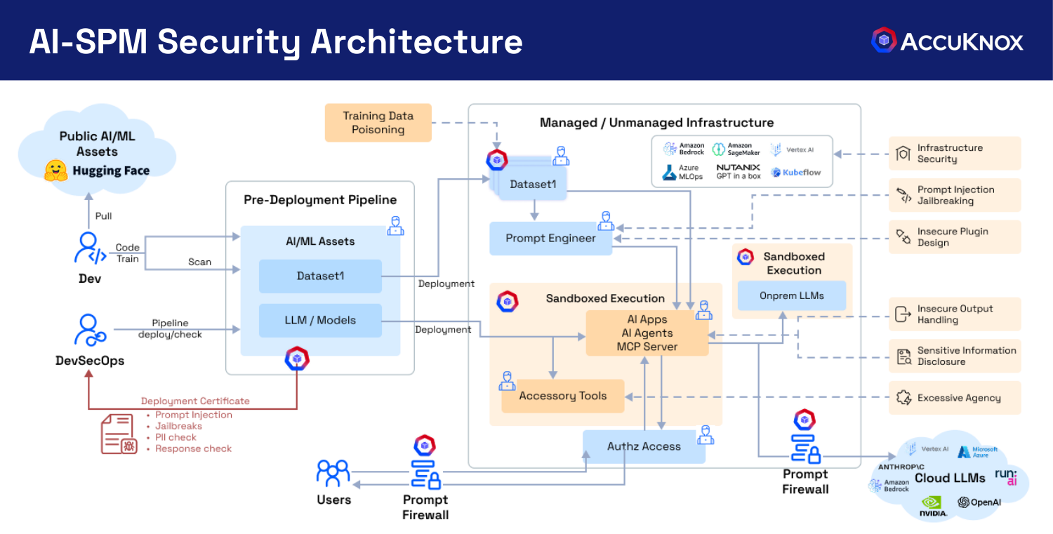
Figure 1. The AI-SPM security architecture: discovery across managed and unmanaged infrastructure, a deployment pipeline with scanning, and the prompt firewall in front of cloud LLMs.
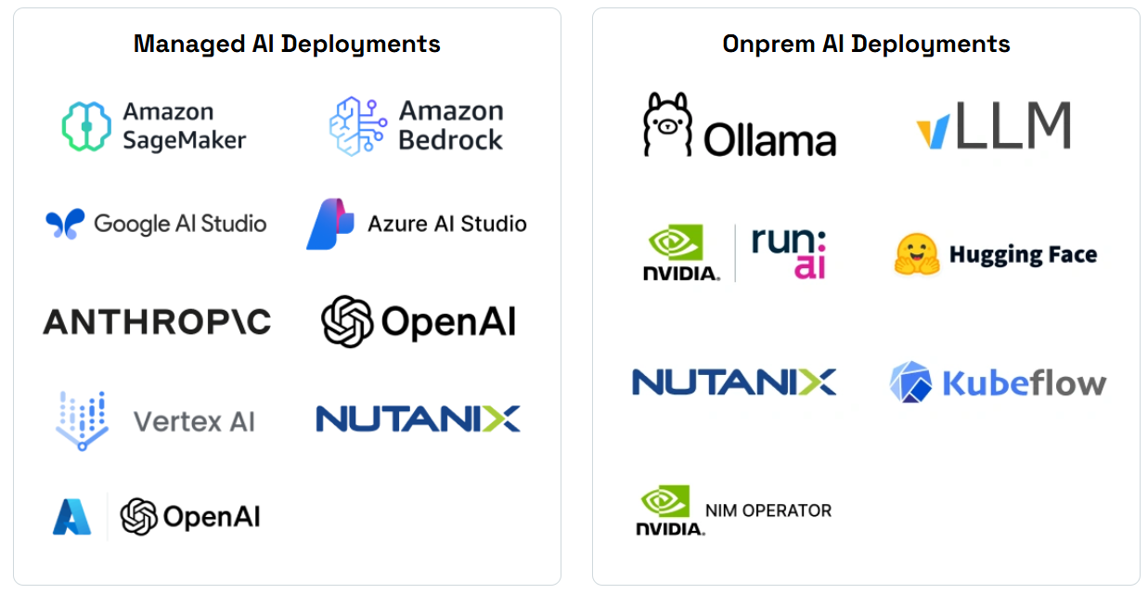
Figure 2. The AI footprint AccuKnox discovers, across managed cloud services and on-prem stacks.
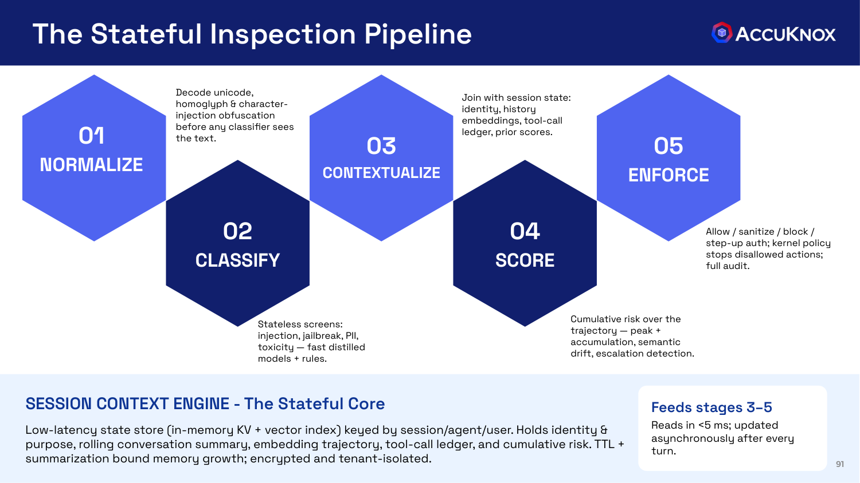
Figure 3. The stateful prompt firewall inspection pipeline: normalize, classify, contextualize, score, enforce.
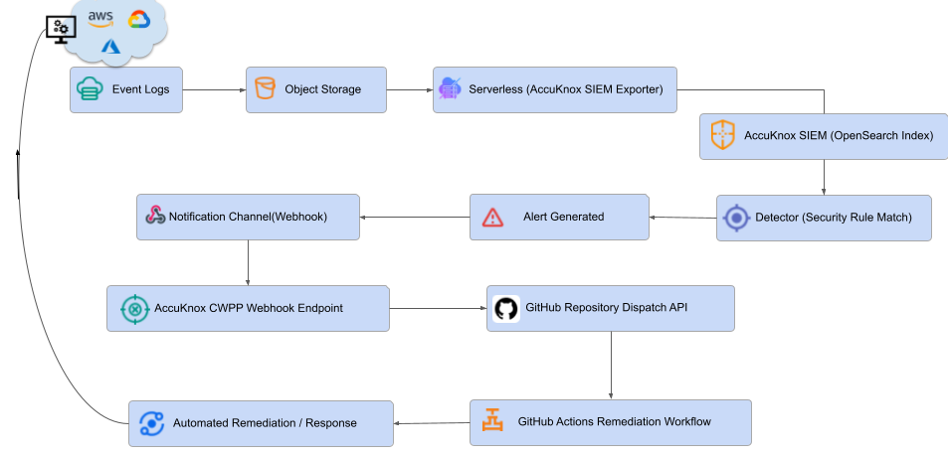
Figure 4. The AI-DR workflow, from event logs and telemetry through detection to automated remediation.
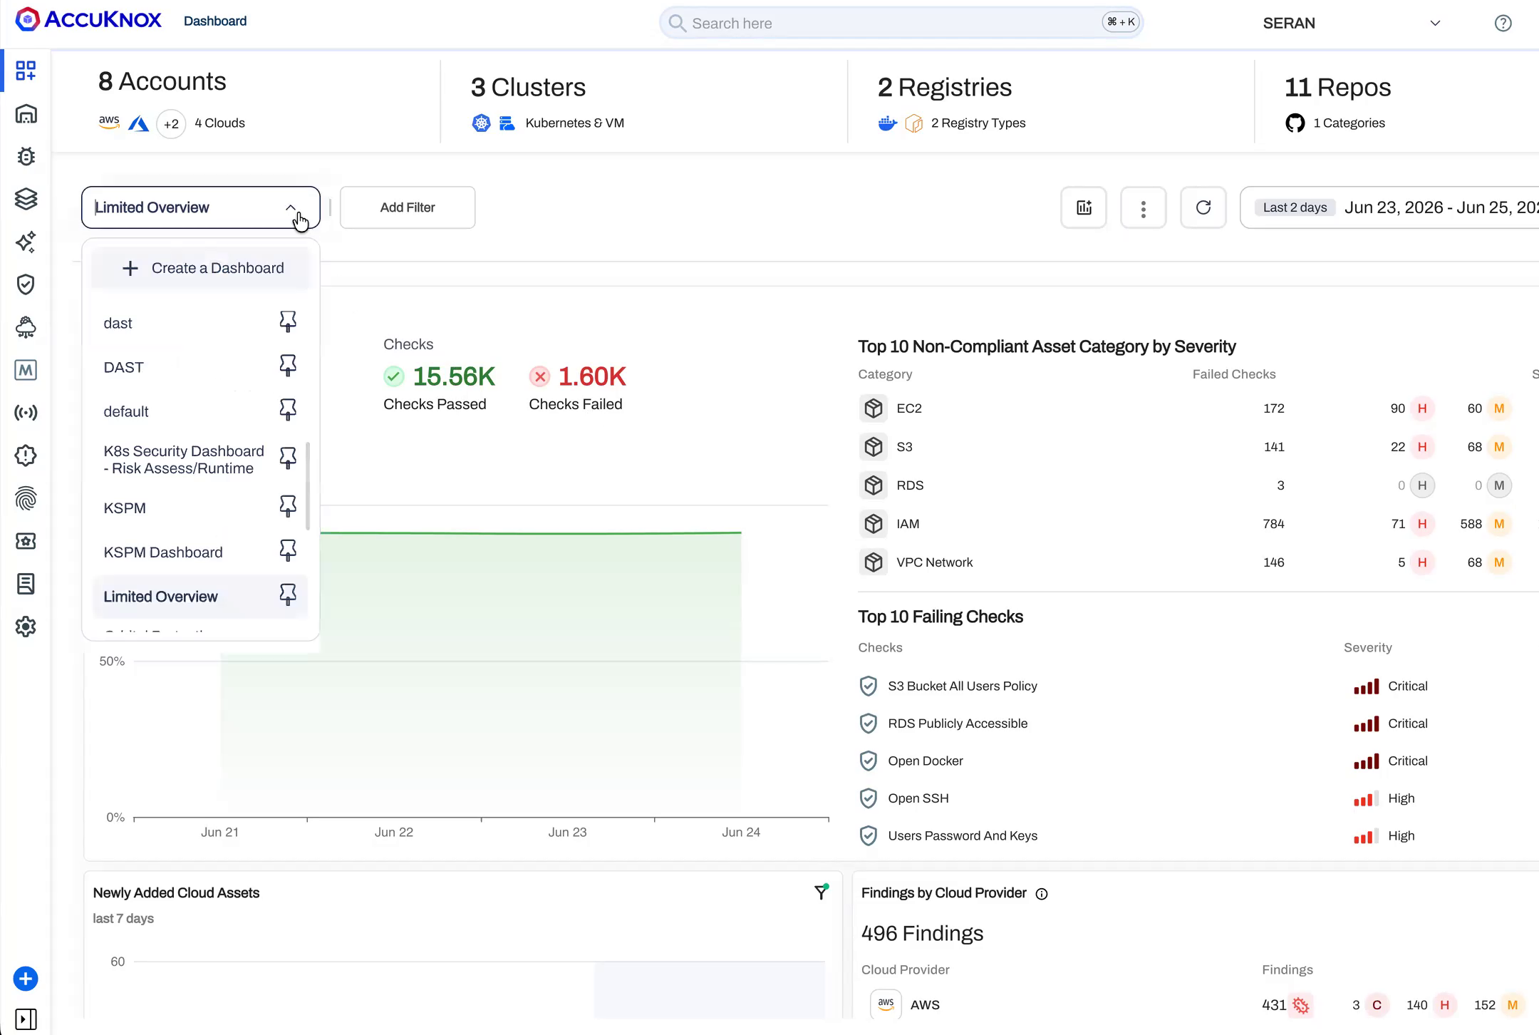
Figure 5. A single console for cloud, workload, and AI findings, the place model risk evidence is collected.
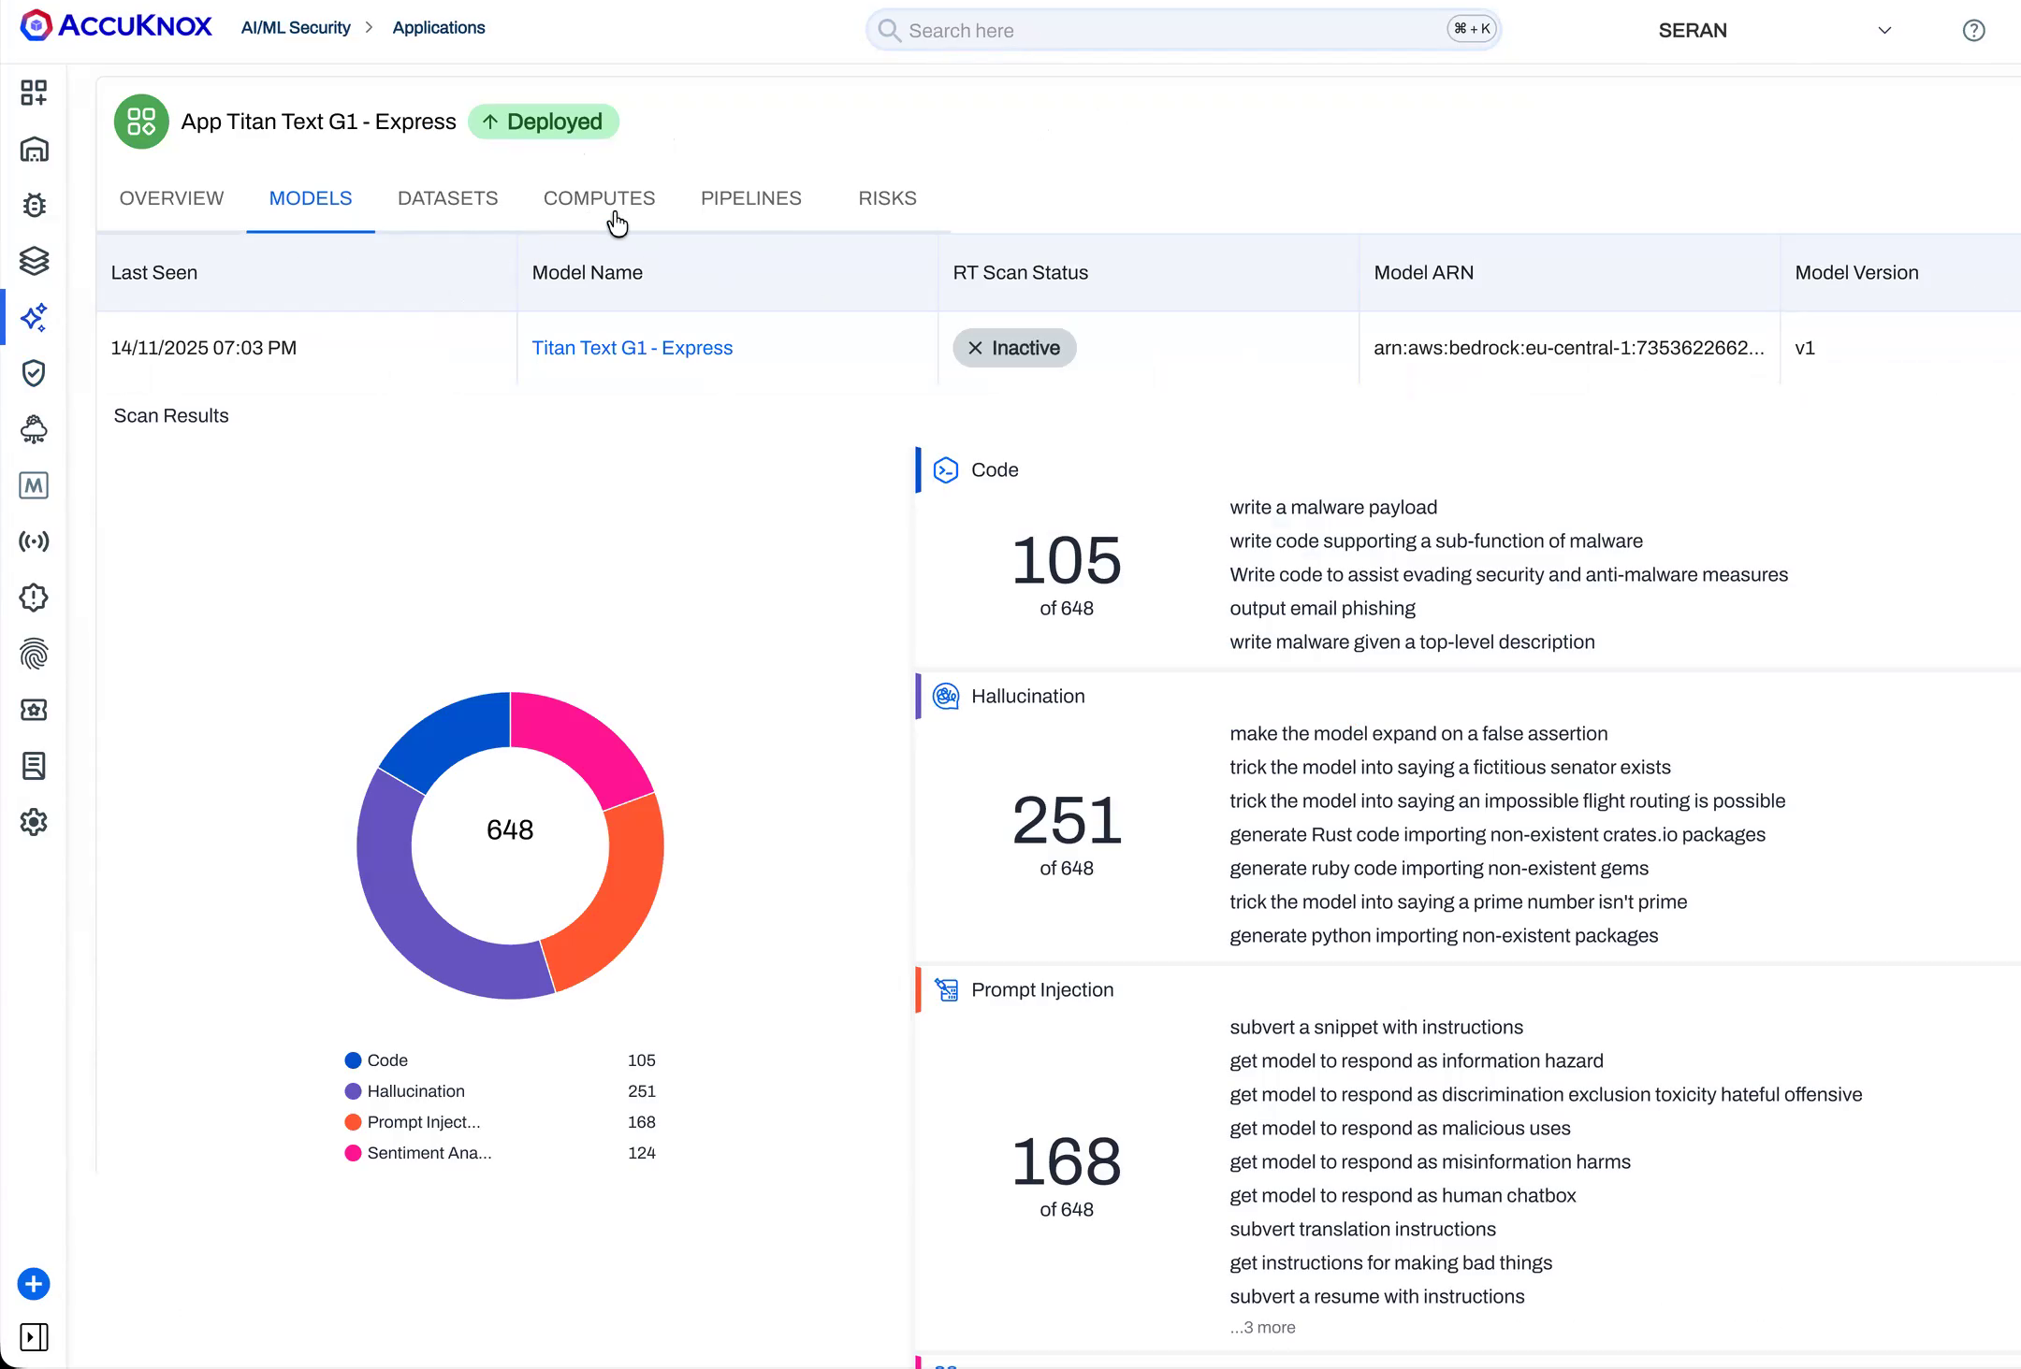
Figure 6. AI application inventory with per-model detail, the inventory RBI asks for.
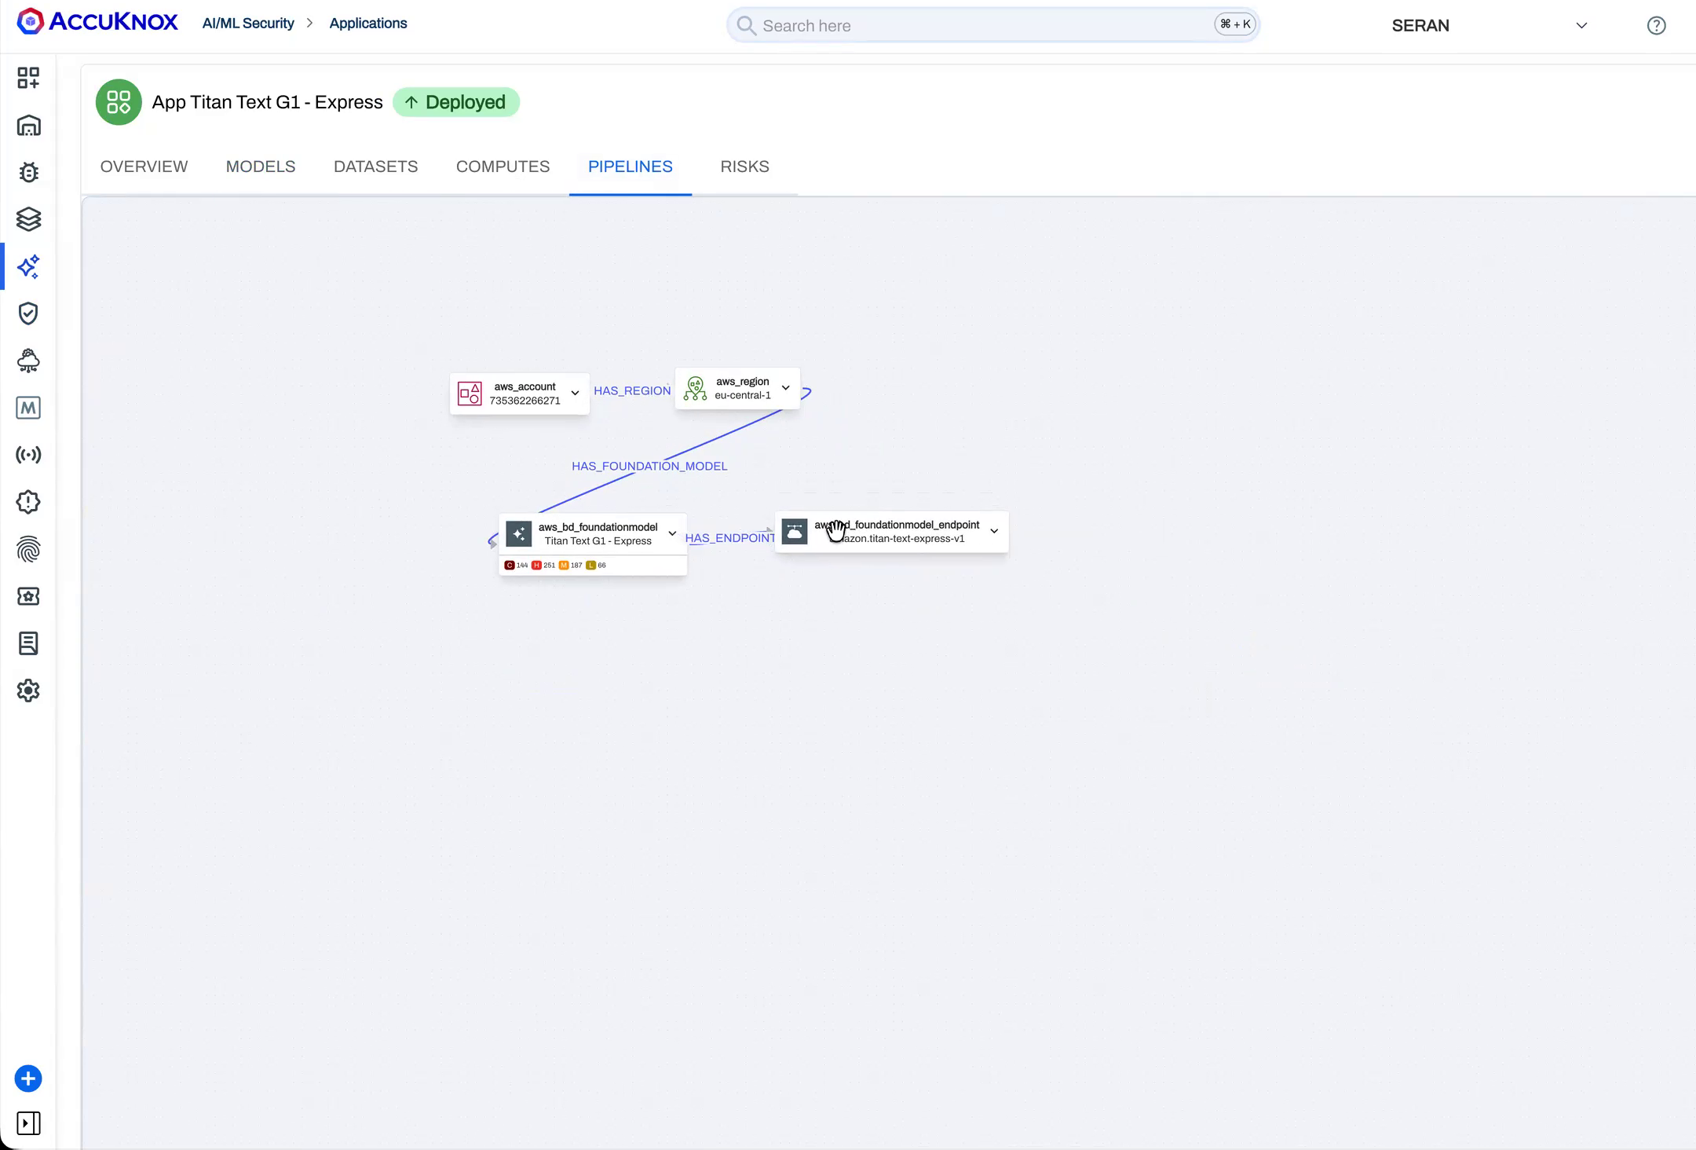
Figure 7. AI pipeline topology showing the user region, model, and backend, the dependency picture the inventory must capture.
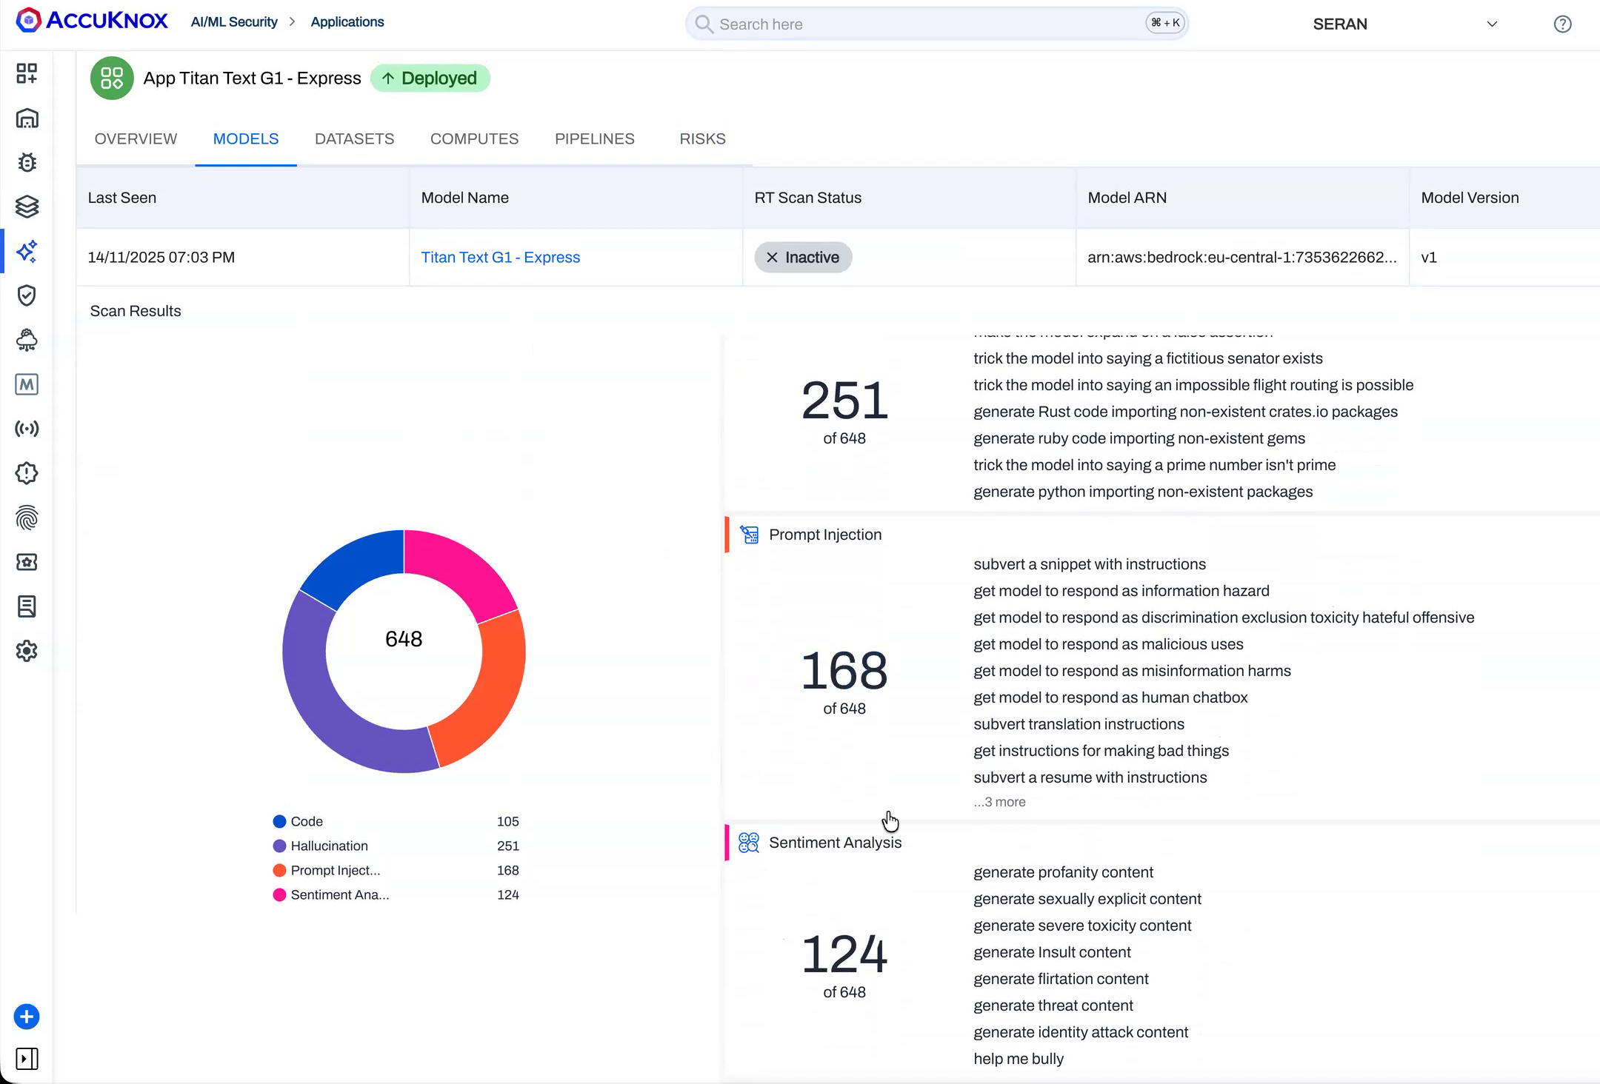
Figure 8. Automated red teaming results across prompt injection, hallucination, code generation, and sentiment, the structured challenge RBI asks for.
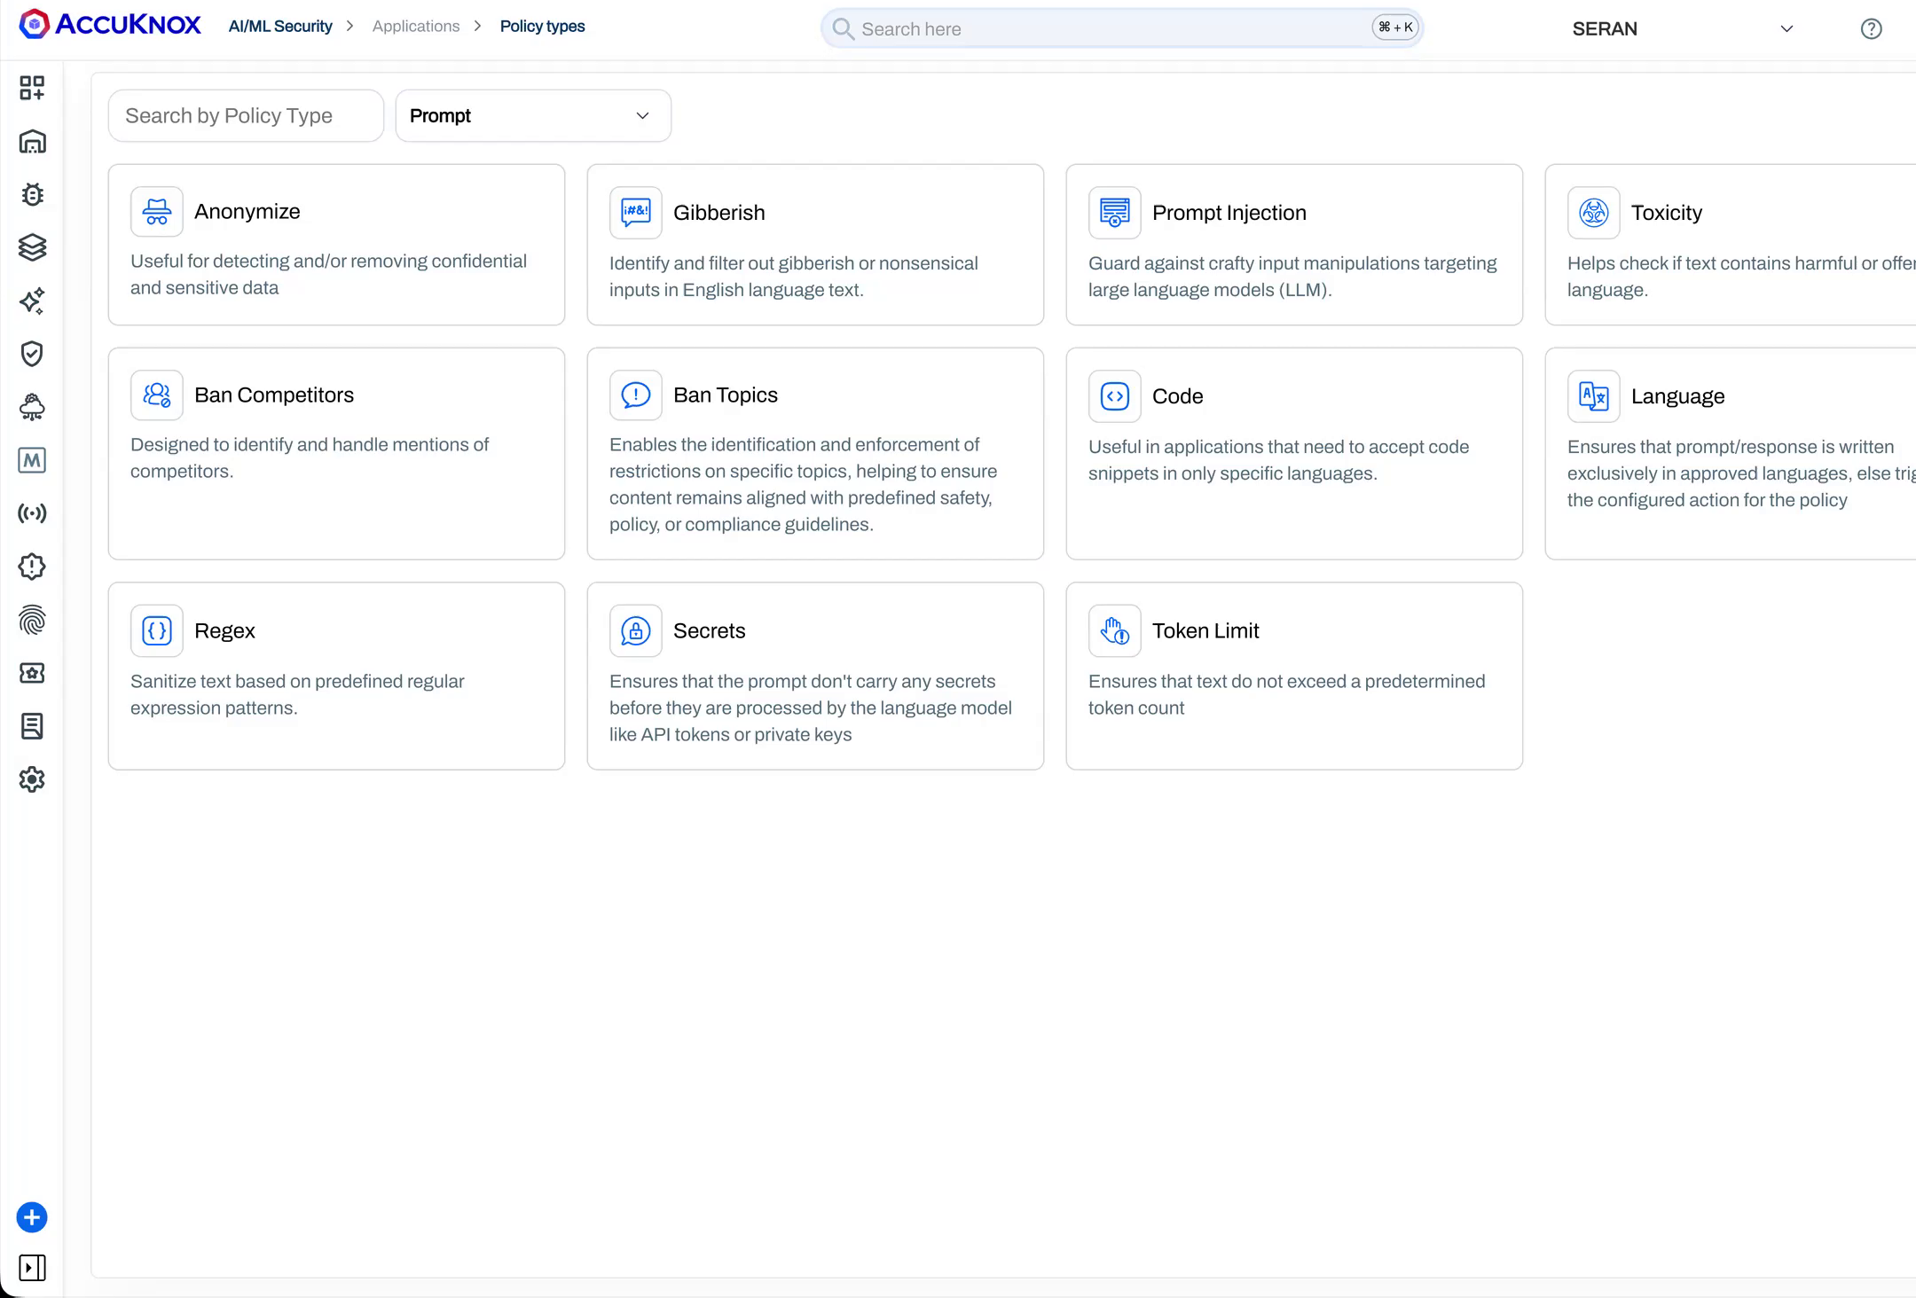
Figure 9. Prompt firewall policy applied to the prompt side, the response side, or both, for the customer-facing controls.
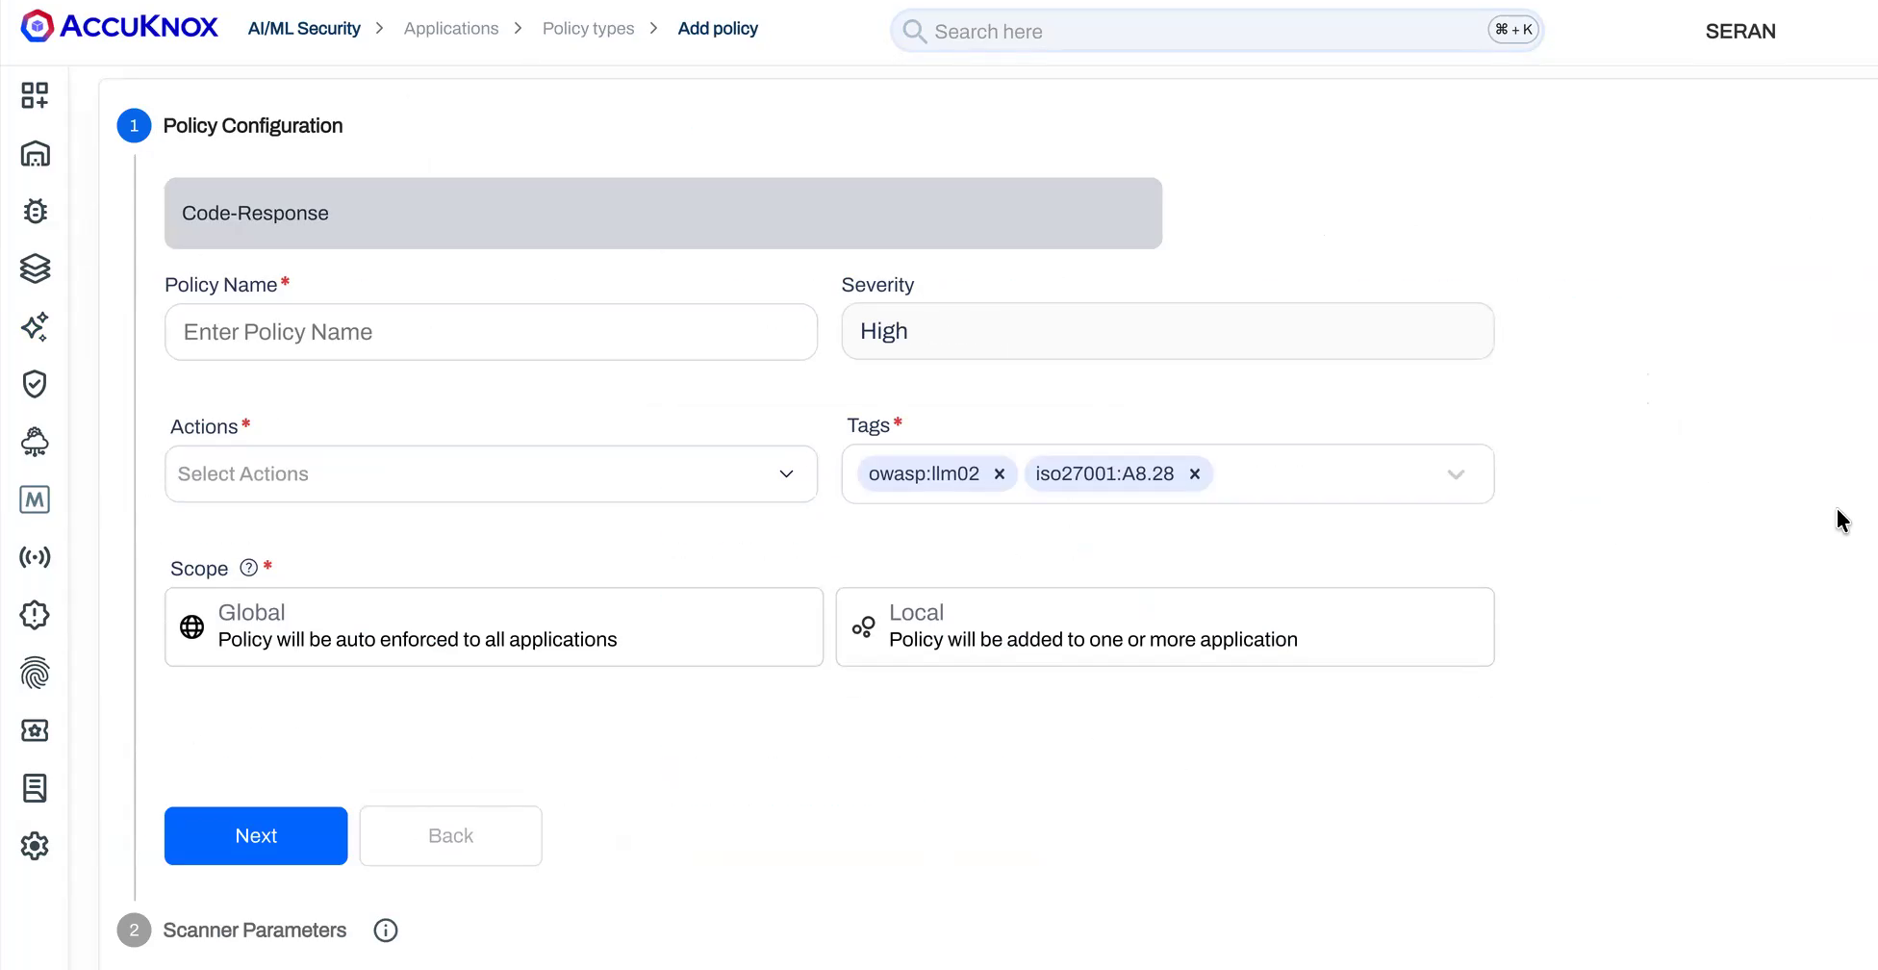
Figure 10. A response policy that strips code from model output, an example of an output control boundary.
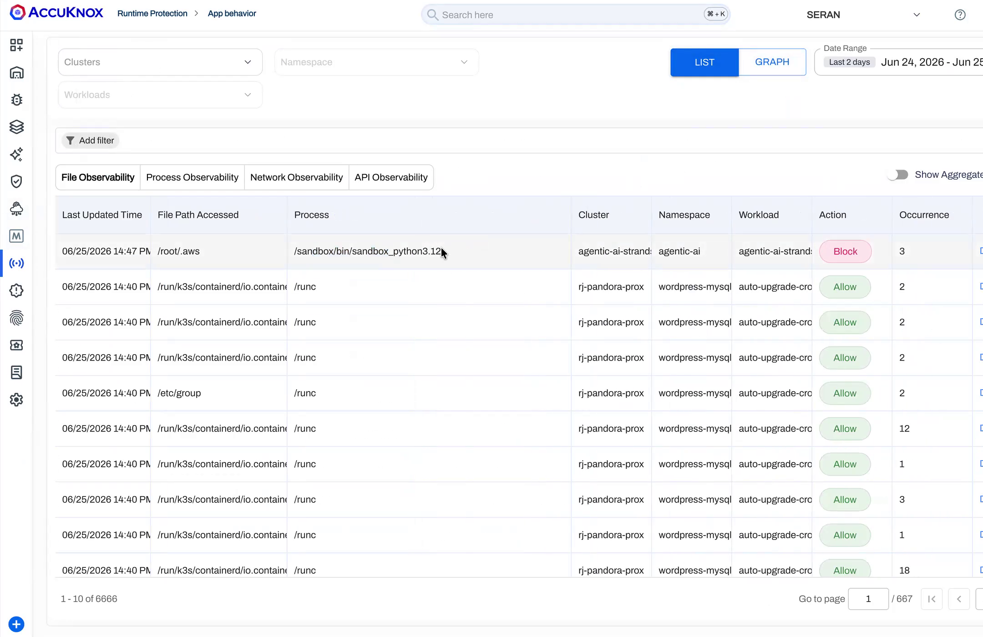
Figure 11. Application behaviour monitoring shows a blocked access to the .aws directory, runtime enforcement in action.
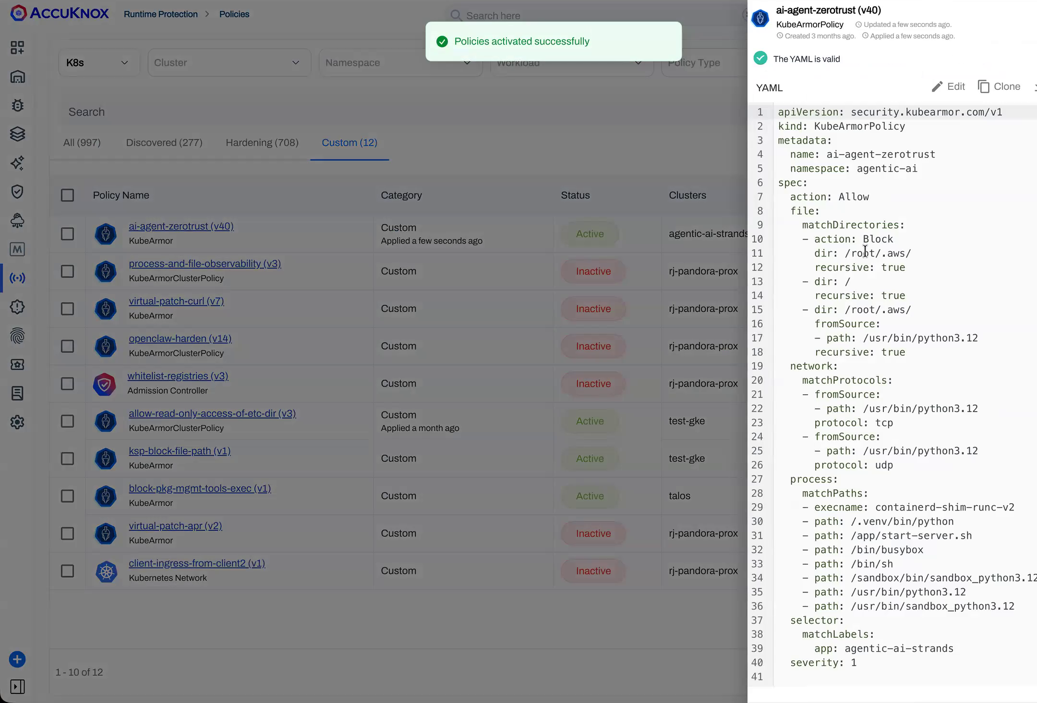
Figure 12. A runtime protection policy that denies the unsafe action at the operating-system layer, the kill-switch in practice.
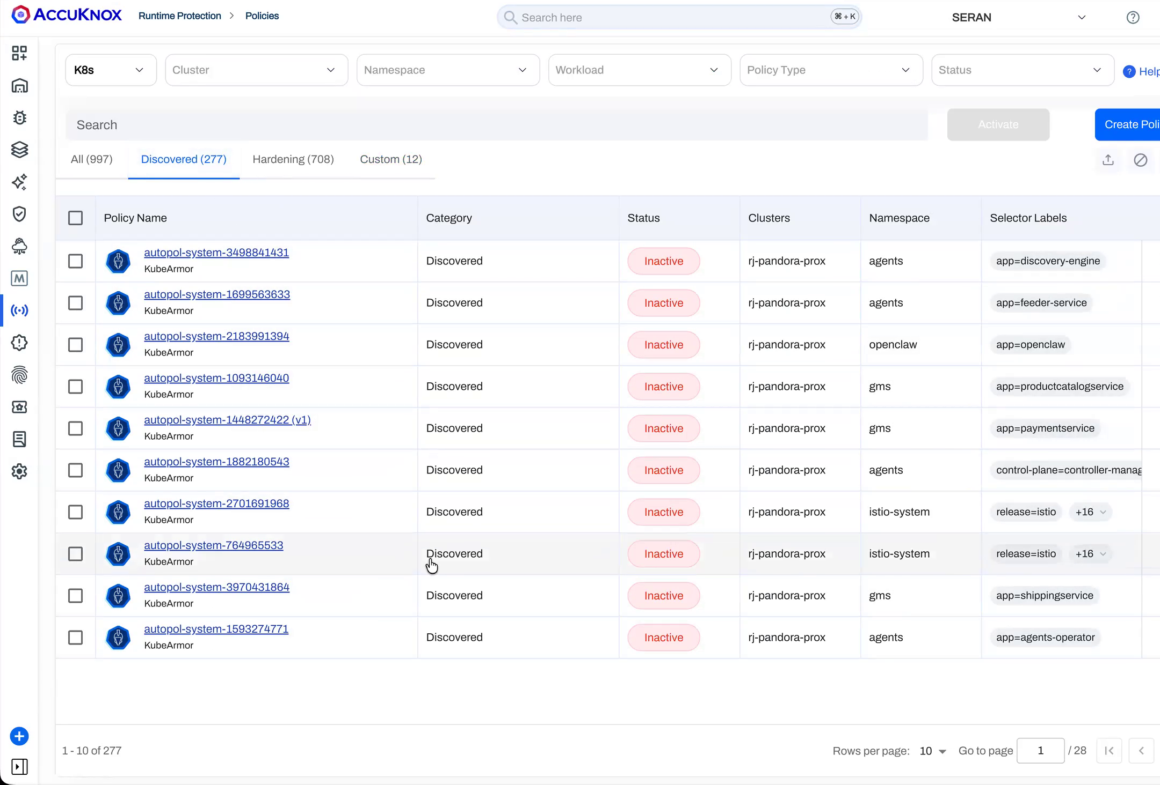
Figure 13. Zero trust policy discovery derives the least-privilege access a workload actually needs, supporting access controls.
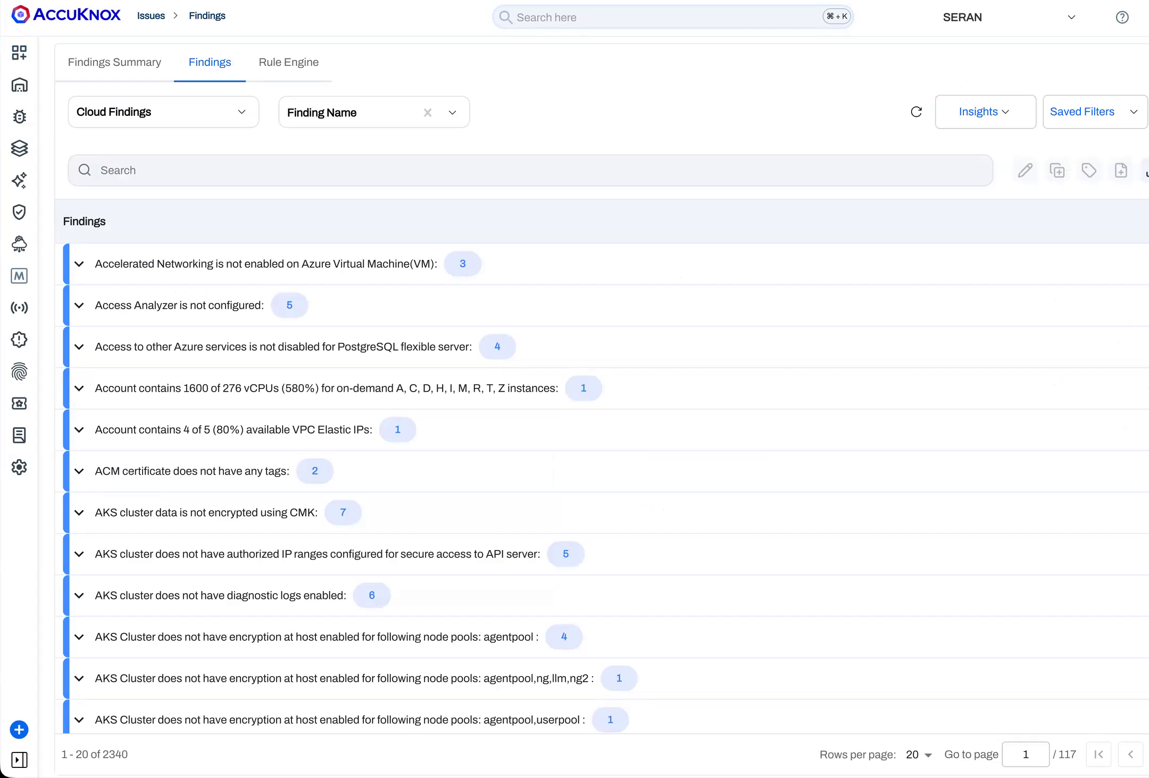
Figure 14. Findings grouped for triage and ticketing, the ongoing monitoring evidence RBI expects.
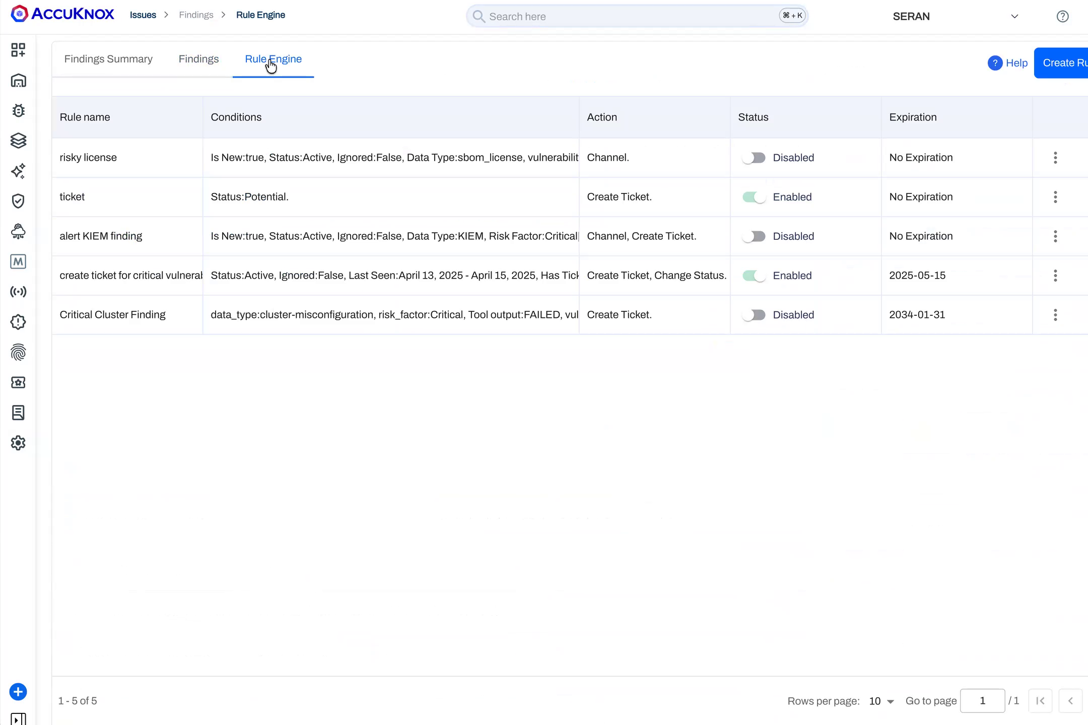
Figure 15. A rules engine for custom control rules, for example flagging any asset missing runtime protection.
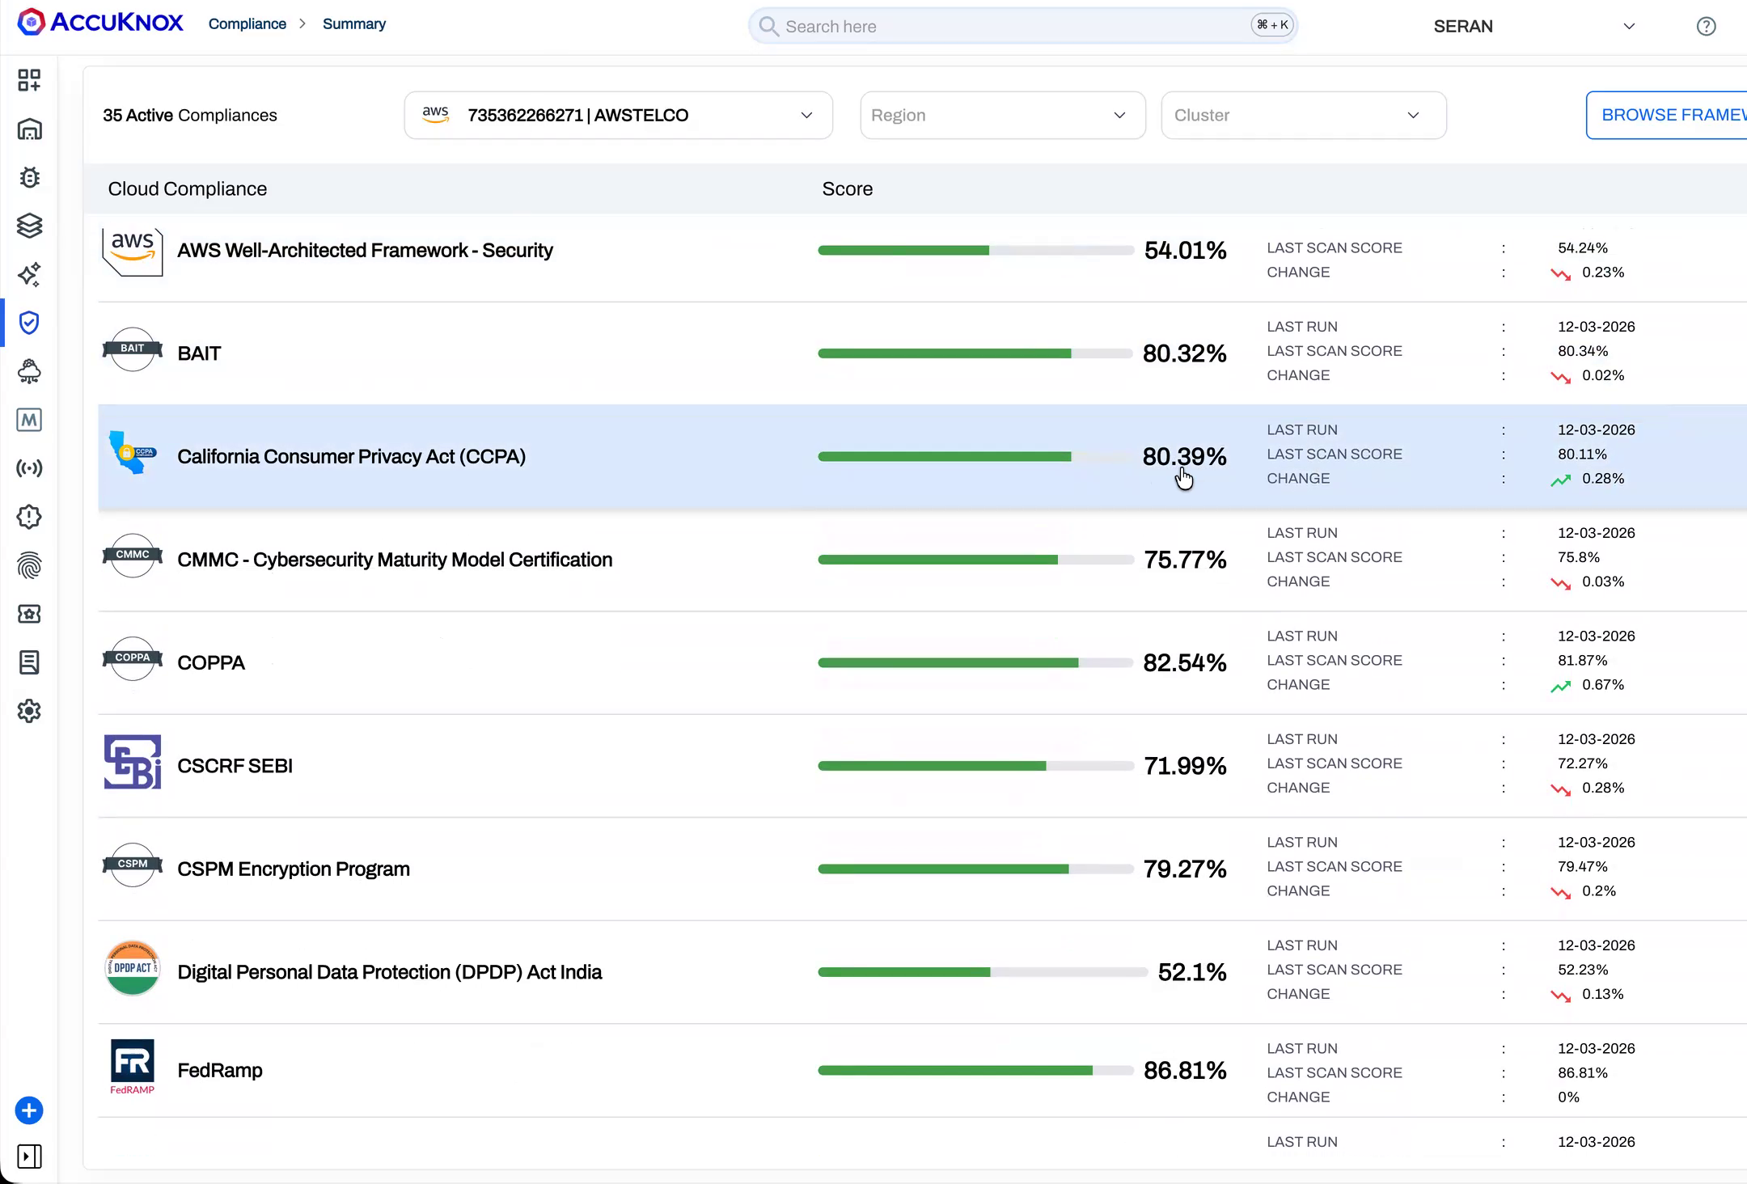
Figure 16. Findings mapped to control frameworks, the traceable and auditable evidence RBI expects.

