PLATFORM COMPARISON
AccuKnox vs HashiCorp Vault
Secrets management platform comparison
AccuKnox Secrets Manager keeps the Vault API and adds namespaces and runtime hardening.
10  Parameters compared | 3  AccuKnox leads | 7  Parity

PICK ACCUKNOX SECRETS MANAGER TO
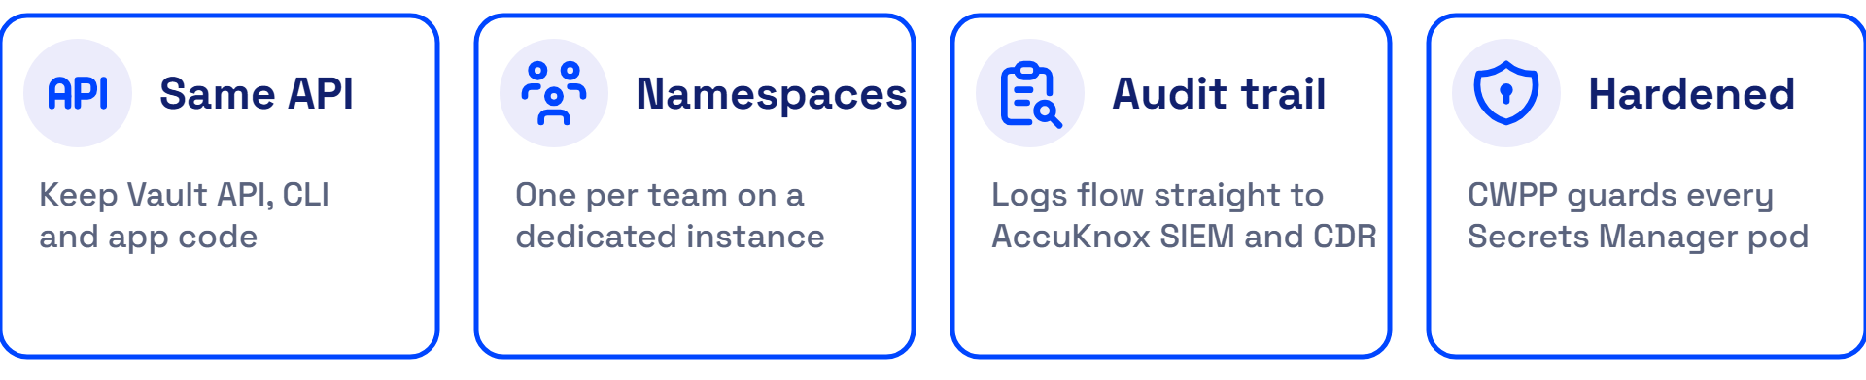
Compare AccuKnox Secrets Manager and HashiCorp Vault across API compatibility, multi-tenancy, audit logging, runtime hardening, compliance reporting, secret engines, authentication, Kubernetes delivery, high availability, and deployment options.

AccuKnox Leads on 3 of 10 Secrets Manager Parameters
Parameter | AccuKnox Secrets Manager | HashiCorp Vault | Result
Vault API compatibility  Keep your code and tooling | API-compatible with HashiCorp Vault. The AccuKnox site states that no major code changes are required to move.  Source: AccuKnox Secrets Management | Overview | The reference API that AccuKnox Secrets Manager matches. | Parity
Multi-tenancy  Isolate every team on a dedicated instance | Each tenant gets a separate namespace with its own permissions, resources and configuration. Shared instances include one namespace. Dedicated instances support several.  Source: AccuKnox Secrets Management | Namespaces need a Vault Enterprise license or an HCP Vault Dedicated cluster. A namespace isolates secret engines, auth methods, policies, entities and tokens.  Source: Vault namespaces | AccuKnox leads
Audit logging and SIEM  Audit trail feeds your SIEM directly | Every request is logged, allowed or denied. Dedicated instances integrate directly with AccuKnox SIEM and CDR.  Source: Overview | AccuKnox Secrets Management | Audit devices record API requests and responses to a file, a syslog server or a socket. Auditing stays off until you enable a device.  Source: Vault audit logging | AccuKnox leads
Runtime hardening of the secrets server  Secrets servers hardened at runtime | AccuKnox CWPP, built on KubeArmor, hardens every Secrets Manager pod at runtime. It limits what processes in the pods can read and run.  Source: Architecture | Vault Enterprise is self-managed, so your team operates and protects the Vault servers.  Source: Vault Enterprise | AccuKnox leads
Compliance reporting  Audit evidence and compliance reports | Real-time audit logs, compliance reporting and a dashboard for secrets health and status. Dedicated instances support custom compliance adherence.  Source: AccuKnox Secrets Management | Vault Enterprise lists multi-level access controls, customizable audit logs, and support for FIPS 140-2 and SOC 2.  Source: Vault Enterprise | Parity
Secret engines  Same core engines, nothing to relearn | KV version 1 and 2, Database, PKI, Transit, SSH and TOTP engines. Dynamic secrets cover AWS, Kubernetes and databases.  Source: Architecture | AccuKnox Secrets Management | Vault Enterprise lists static and dynamic secrets, PKI, key management and data encryption.  Source: Vault Enterprise | Parity
Authentication methods  Sign in with your existing identity provider | Kubernetes service account, AppRole, TLS certificate, OIDC, LDAP, username and password, JWT, Okta and token. LDAP sign-in works fully offline.  Source: Architecture | Air-Gapped Deployment | Vault Enterprise lists Workload Identity Federation with AWS, Azure and Google Cloud to solve secret zero. The AccuKnox docs do not list it.  Source: Vault Enterprise | Parity
Kubernetes delivery  Pods read secrets without code changes | Agent Injector, External Secrets Operator, and a direct SDK for Java, .NET, Python and Node.js. External Secrets Operator syncs secrets into Kubernetes with no app code change.  Source: External Secrets Operator | Connect Applications | Vault Enterprise lists OpenShift OLM, sidecar injection, a CSI provider and Vault Operator.  Source: Vault Enterprise | Parity
High availability and disaster recovery  Three nodes, backups every 15 minutes | Three nodes in high availability mode on all instances. A snapshot agent copies data to S3-compatible storage every 15 minutes by default, so a restore loses at most 15 minutes of changes.  Source: High Availability and Backup | Vault Enterprise lists multi-datacenter deployments, performance replication and disaster recovery.  Source: Vault Enterprise | Parity
Deployment options  Managed, on-prem or air-gapped | Shared or dedicated managed instances in North America, Europe, the Middle East and India. Dedicated instances also deploy on-prem or air-gapped. You can self-install with Helm on Kubernetes 1.30 or later.  Source: AccuKnox Secrets Management | Air-Gapped Deployment | Vault Enterprise is self-managed for hybrid and on-premises estates. HCP Vault Dedicated is the hosted option.  Source: Vault Enterprise | Vault namespaces | Parity

Why Customers Choose AccuKnox Over HashiCorp Vault

Better
Namespaces, SIEM-linked audit logs and runtime hardening ship with Secrets Manager. Vault namespaces need a Vault Enterprise license or an HCP Vault Dedicated cluster, per the Vault namespaces documentation. AccuKnox CWPP hardens each pod, as the Architecture guide describes.

Faster
Migration from Vault takes six steps, and the AccuKnox site states that no major code changes are required. The steps are in the next section. A Helm install brings up three nodes, and the Deployment Guide walks through initializing and unsealing the server.

Cheaper
Managed shared and dedicated instances remove the install, hardening and backup work from your team. Every instance runs in high availability mode, and shared instances take daily backups, per the AccuKnox Secrets Management page. Secrets Manager also installs without an AccuKnox CNAPP subscription. For Vault Enterprise cost, request a quote from the HashiCorp pricing page.

Migrate From Vault to AccuKnox in Six Steps
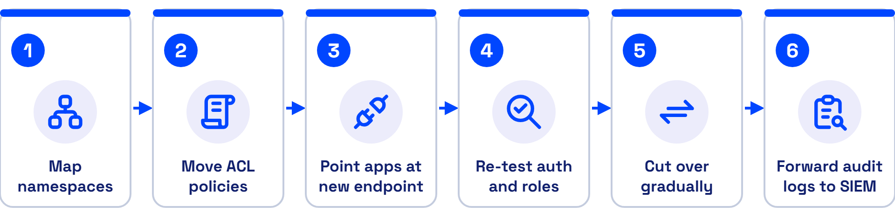
Step | What to do
1 | Map each Vault namespace to an AccuKnox namespace.
2 | Reuse or translate your Vault ACL policies.
3 | Point your applications at the AccuKnox endpoint by updating VAULT_ADDR or the SDK endpoint. The Connect Applications guide shows both methods.
4 | Re-test dynamic secret roles and auth methods such as Kubernetes, AppRole and OIDC.
5 | Cut over gradually, and validate audit logs and backups at each stage. The High Availability and Backup guide covers snapshots.
6 | Forward audit logs to AccuKnox SIEM and CDR.

Every Claim Traces to a Page the Publisher Wrote
Pages read on 26 October 2026. AccuKnox claims link to AccuKnox pages. Vault claims link to HashiCorp pages.
Publisher | Page | Address
AccuKnox | AccuKnox Secrets Management | https://accuknox.com/solutions/secrets-management
AccuKnox | Air-Gapped Deployment | https://help.accuknox.com/secrets-manager/air-gapped/
AccuKnox | Architecture | https://help.accuknox.com/secrets-manager/architecture/
AccuKnox | Connect Applications | https://help.accuknox.com/secrets-manager/connect-applications/
AccuKnox | Deployment Guide | https://help.accuknox.com/secrets-manager/deployment/
AccuKnox | External Secrets Operator | https://help.accuknox.com/secrets-manager/external-secrets/
AccuKnox | High Availability and Backup | https://help.accuknox.com/secrets-manager/high-availability/
AccuKnox | Overview | https://help.accuknox.com/secrets-manager/overview/
HashiCorp | Vault audit logging | https://developer.hashicorp.com/vault/docs/audit
HashiCorp | Vault namespaces | https://developer.hashicorp.com/vault/docs/enterprise/namespaces
HashiCorp | Vault Enterprise | https://www.hashicorp.com/en/products/vault/vault-enterprise
HashiCorp | HashiCorp pricing page | https://www.hashicorp.com/products/vault/pricing?tab=vault-enterprise

See it on your stack
Schedule a demo of AccuKnox Secrets Manager at https://www.accuknox.com/contact-us or write to support@accuknox.com.

