COMPETITIVE ANALYSIS
Security Graph UI & Attack Path Visualization
Across Cloud Security Vendors
Prepared for: AccuKnox Product Strategy
May 2026 | Confidential
12 Vendors Analyzed | 15 Product Screenshots | 4-Phase Roadmap

TL;DR
- Security Graph / Attack Path visualization is now table-stakes for every serious CNAPP. Absence is a fast disqualifier in enterprise RFPs.
- The new battleground is runtime-fed, eBPF-validated graphs showing which paths are actually exploitable in production (Wiz Defend, Sysdig Cloud Attack Graph, Upwind, SentinelOne Storyline).
- Best opportunity for AccuKnox: build a runtime-first Kubernetes Security Graph. Nodes = pods/containers/processes/files/identities. Edges = eBPF-observed syscalls, network flows, ingress/egress. Overlaid with KubeArmor enforcement policy and behavioral-alert heat layer.
- AccuKnox's KubeArmor + eBPF foundation is structurally well-positioned vs. legacy agentless CNAPPs (Wiz, Orca) and posture-focused graphs (Defender, Tenable) that cannot natively show this data.

Executive Summary

Why a Security Graph Is Now Table Stakes
1. Toxic combination prioritization. Wiz proved that mapping cloud assets, identities, vulnerabilities, and network exposure into a graph DB lets you compute the small set of combinations that constitute real breach risk. This collapsed thousands of flat alerts into high-fidelity attack paths. Wiz grew from $1M to $100M ARR in 18 months (Feb 2021 to July 2022).
2. CISO/board communication. Buyers choose graph-driven CNAPPs because the graph is the artifact they show executives. The visual attack path is how security teams communicate risk to the board.
3. Google's $32B acquisition of Wiz (closed March 2026). Google's largest acquisition ever. The graph data model is now the asset Google is building its cloud security stack around. Every CNAPP vendor is responding.

What Best-in-Class Looks Like
- Multi-layer nodes: cloud resources, identities, vulnerabilities, secrets, sensitive data, pods/containers, processes.
- Multi-source edges: API config + cloud audit logs + IAM trust + network flow logs + eBPF runtime syscalls.
- Exploitability scoring: on each path, with choke points highlighted (Microsoft, Tenable, CrowdStrike).
- NL query layer: Wiz AI, Prisma Cloud Copilot, Sysdig Sage, SentinelOne Purple AI.
- Code-to-cloud back-trace: clicking a node opens the offending Terraform/IaC line (Wiz Code, Prisma Cloud).
- Runtime validation: eBPF sensors confirm whether theoretical paths are exploitable now (Wiz Defend, Sysdig, Upwind).

Vendor Overview
The following table summarizes the 12 vendors analyzed, their graph capabilities, K8s/runtime depth, AI layer, and key differentiator.
Vendor | Graph Capabilities | K8s/Runtime | AI Layer | Key Differentiator
Wiz | Neptune graph DB, toxic combos, code-to-cloud trace | Best-in-class agentless + eBPF (2025) | Wiz AI Copilot, Red Agent | Google $32B acquisition validates model
Prisma Cloud | 350+ OOTB attack path policies, Application Graph for CI/CD | CWPP via Compute Defenders; config-heavy | Precision AI Copilot | Broadest integration; RQL complexity criticized
Defender | Cloud Security Graph + Exposure Map, choke points | K8s templates, agentless container posture | Built-in insights, KQL-like | Hybrid cloud+on-prem; Azure-native advantage
Orca | Agentless SideScanning, Discovery Query Builder | Snapshot-based; no runtime agent | Sonar AI | No real-time blocking capability
Sysdig | Real-time Cloud Attack Graph, in-use vulns/perms | Deep K8s runtime via Falco | Sage agentic AI | Best runtime context; graph is cloud-centric
CrowdStrike | Predictive Attack Path via ExPRT.AI + Threat Graph | Falcon sensor DaemonSet; partial pod topology | Charlotte AI | Strong endpoint lineage; less K8s-native
SentinelOne | Storyline + Process Graph + Verified Exploit Paths | Container process-tree (containerd visibility) | Purple AI | Best process-level visibility; time-scrubbing
Lacework | Polygraph ML-based behavioral baseline | Early container-aware hierarchies | Limited | 60-70% alert noise reduction; ML catches novel threats
Tenable | ATT&CK heatmap, Choke Point Priority, Blast Radius | Weak K8s; identity/vuln-centric | Limited | Custom path builder is unique; no runtime
Aqua | Aqua Hub code-to-runtime, Verified Exploit Paths | Strong eBPF via Tracee; drift prevention | Limited | More timeline-centric than graph-centric
Upwind | Topology Graph + Asset Map + Explorer query-to-policy | eBPF sensor; normalized K8s workloads | Limited | Most direct AccuKnox competitor; query-to-policy unique
Illumio | Illumination dependency map + Vulnerability Map | Container workloads; VM/bare-metal core | AI labeling (Guardicore) | Pioneered category (2014); E-W exposure scoring

Vendor Deep Dives

1. Wiz (The Reference Implementation)
Timeline: Security Graph since 2020 founding. Attack Path Analysis launched June 2022 (RSA). Wiz Defend (eBPF) via Gem Security acquisition ($350M, April 2024). eBPF Runtime Sensor live 2025. Google acquired Wiz for $32B (March 2026).
Graph core: Built on Amazon Neptune (hundreds of clusters, 20+ regions). Nodes = every cloud asset, identity, role, vulnerability, secret, sensitive data store, container/pod. Edges = IAM trust, network paths, mount relationships, data flow, runtime process activity.
Key features: Toxic Combinations engine scores chains like 'internet-exposed VM to IAM role to S3 with PII.' Wiz Code traces findings to specific commits. Lens feature (2025) filters graph by viewer role. One-click PR remediation from graph findings.
K8s depth: Maps relationships between nodes, pods, containers, identities, sensitive data, and cloud services. eBPF sensor detects container escapes, privilege escalation, crypto-mining, reverse shells with process-level context on the graph.
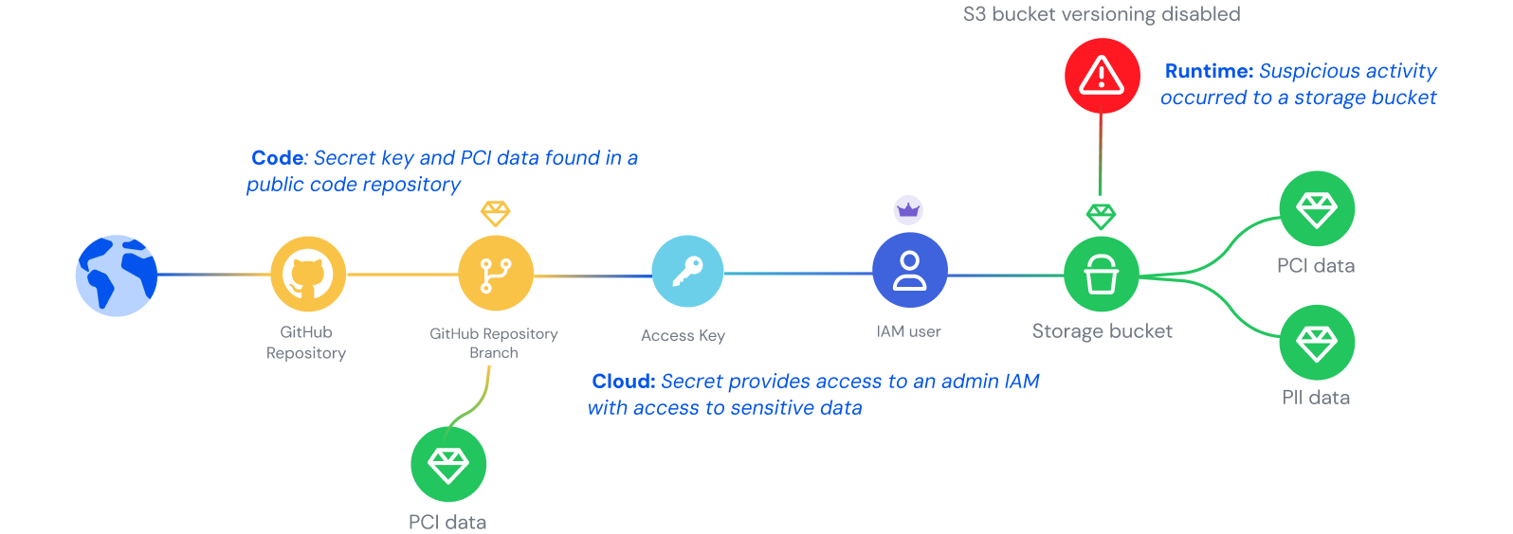
Figure 1: Wiz Security Graph - Code-to-runtime attack path visualization
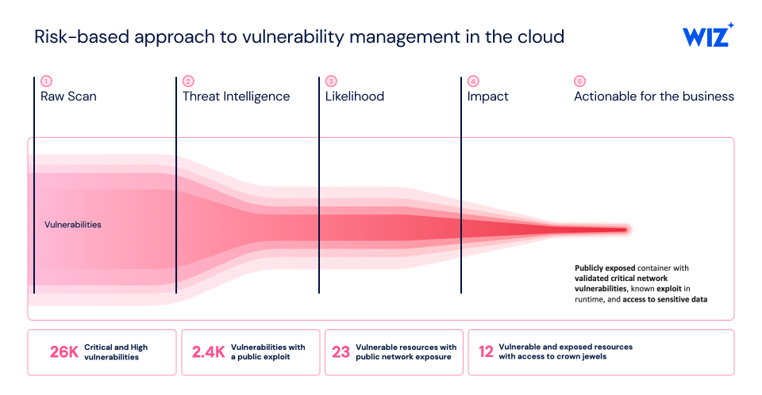
Figure 2: Wiz context-driven risk prioritization with toxic combinations
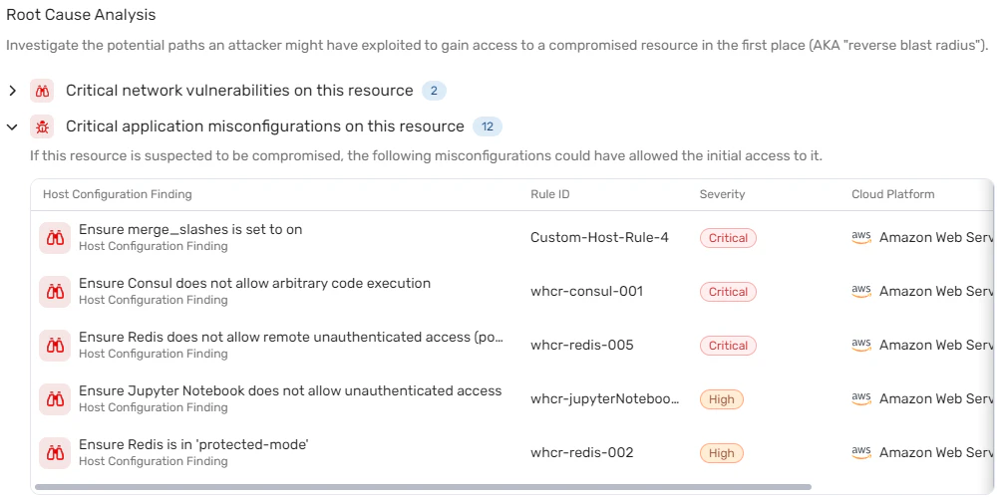
Figure 3: Wiz accelerated incident response with root cause analysis

2. Prisma Cloud (Palo Alto Networks)
Timeline: Attack Path policies ~2022. Application Graph at Black Hat Aug 2023. Darwin UI with dedicated Attack Path Visualization Oct 2023. DSPM integrated Sept 2024.
Graph core: Evidence graph correlates misconfigs, vulns, excessive permissions, public exposure, anomalous activity. 350+ OOTB attack path policies plus custom policy DSL. Application Graph for CI/CD is the first graph-based CI/CD security model. DSPM context lights paths red when they terminate at sensitive data.
K8s depth: Strong K8s coverage via CWPP Compute Defenders, but graph is primarily configuration-driven. Runtime telemetry feeds incidents rather than graph nodes directly.
UX: Prisma Cloud Copilot (Precision AI) for NL queries. Three-tab home: Incidents | Attack Paths | Risks. Saved views and shared dashboards.

3. Microsoft Defender for Cloud
Timeline: Cloud Security Graph + Attack Path Analysis preview at Ignite 2022, GA early 2023. Merged into Security Exposure Management 2024. Container attack-path coverage GA 2024.
Graph core: Proprietary algorithm scans per-tenant graph for validated-reachable entry points. Active reachability scans (network probing) reduce false positives. Enterprise Exposure Map shows choke points. Hybrid graphs span cloud + on-prem. Cloud Security Explorer supports KQL-like queries with K8s templates.
K8s depth: Container-aware with pre-built K8s templates. Paths include 'pod runs vulnerable image to admin RBAC to host mounts to secret access.'
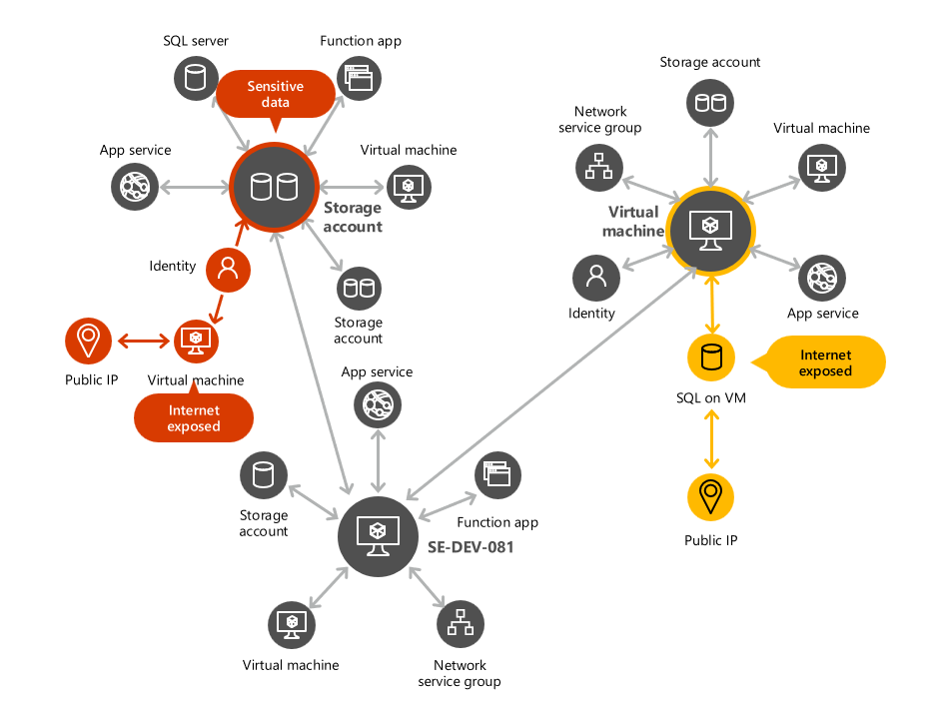
Figure 4: Microsoft Defender Cloud Security Graph with attack path mapping
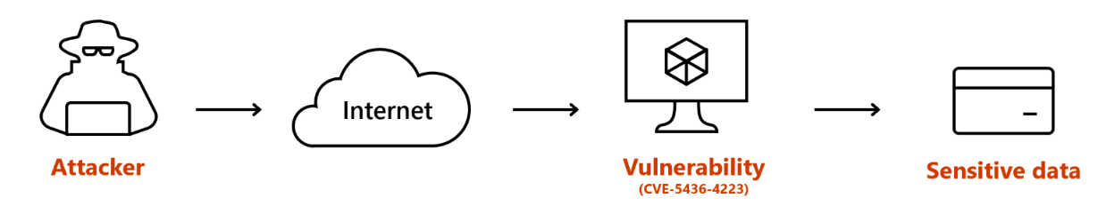
Figure 5: Microsoft Defender attack path from attacker to sensitive data

4. Orca Security
Timeline: SideScanning patented Nov 2022. Attack Path Analysis ~Q1 2022. Interactive graph visualization late 2022 in Discovery Search tab.
Graph core: Agentless SideScanning reads block-storage snapshots to populate the entire graph without agents. Patented attack-path analysis surfaces toxic combinations. Visual graph in Discovery Query Builder. IAM-to-resource permission graph.
K8s depth: Container scan reads network info during scanning phase. Less runtime-deep than agent-based vendors. No real-time blocking capability.
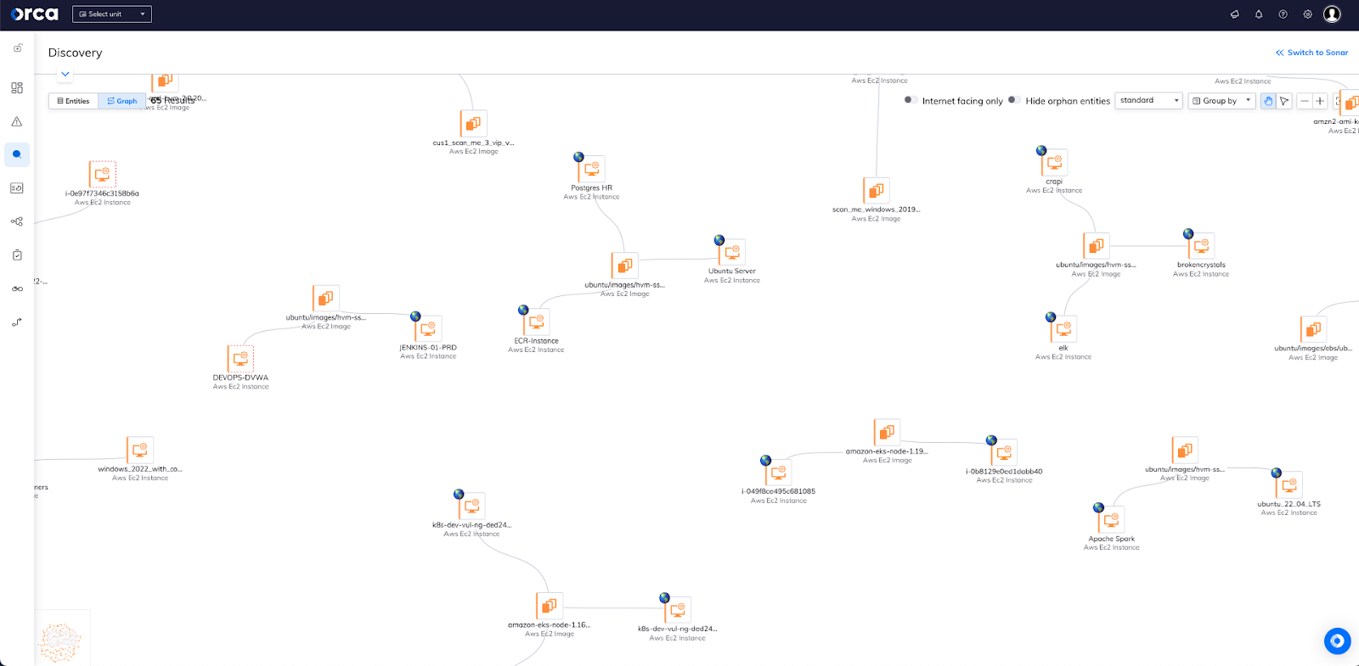
Figure 6: Orca Security graph visualization of interconnected cloud risks
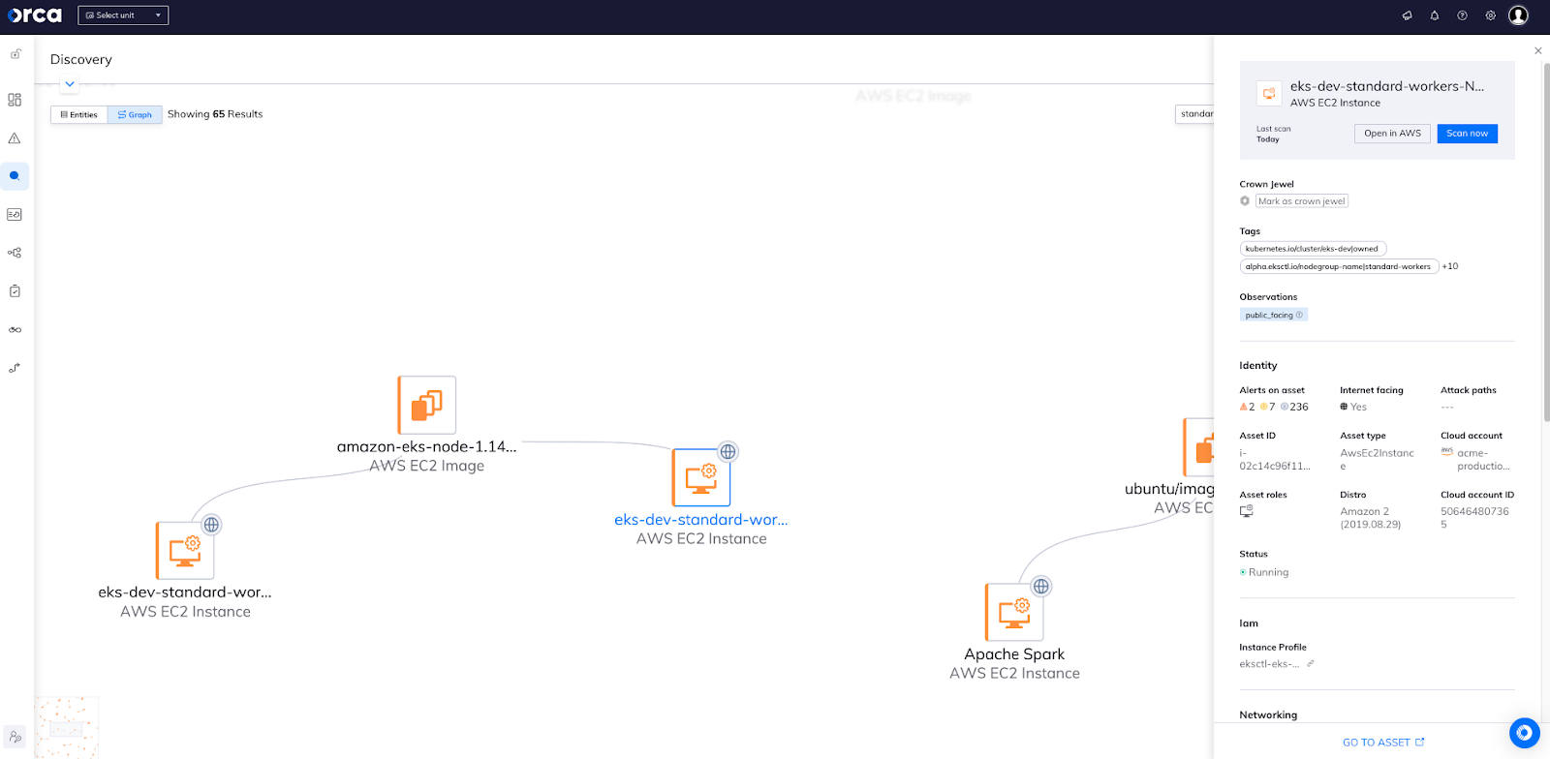
Figure 7: Orca Security discovery graph with asset quick-view

5. Sysdig
Timeline: Risk Spotlight April 2022. Cloud Attack Graph GA Sept 27, 2023. Sysdig Sage (agentic AI) shipped 2024-25.
Graph core: Neural center of Sysdig CNAPP. Correlates assets, users, activity, risk in real time. Powered by Falco runtime telemetry + agentless scanning hybrid. Surfaces in-use vulnerabilities and in-use permissions only. Live detection of lateral movement, container escapes.
K8s depth: Best-in-class runtime context. Each graph node drills into runtime events (file/process/network). Integrates IAM posture with workload runtime events.
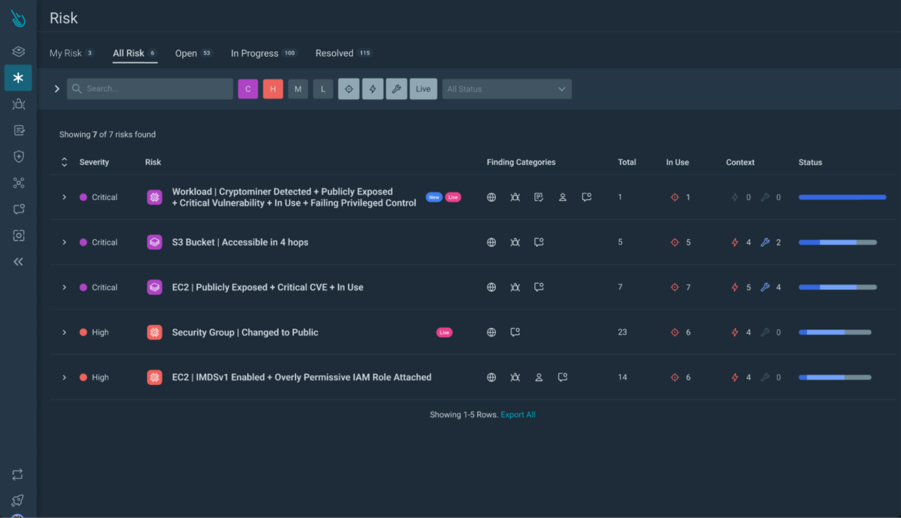
Figure 8: Sysdig real-time Cloud Attack Graph with runtime context
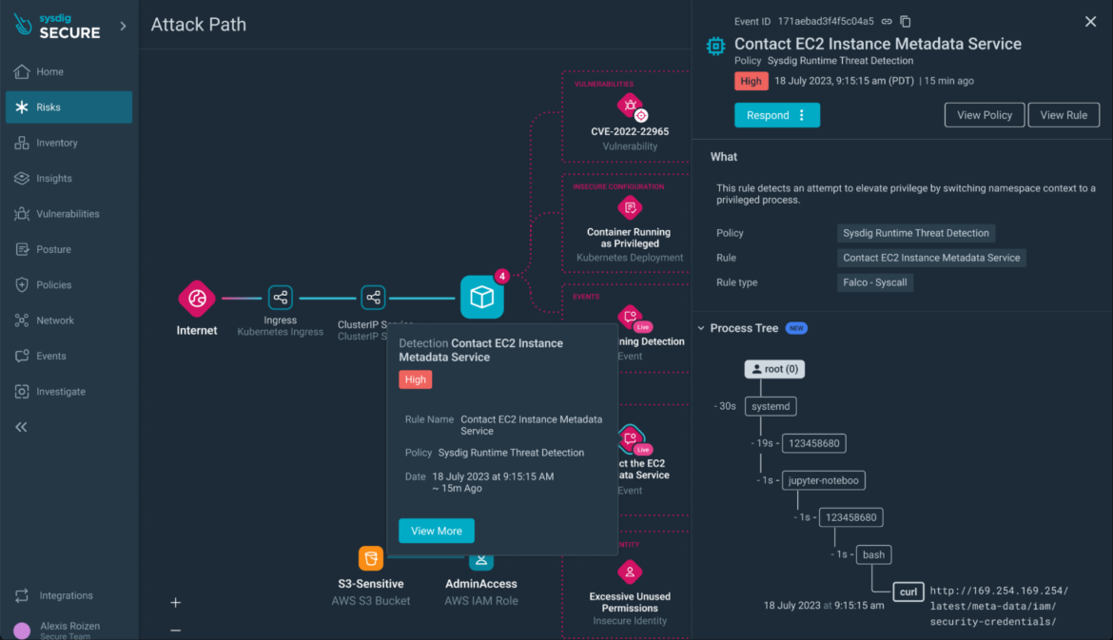
Figure 9: Sysdig attack path detail with lateral movement visualization

6. CrowdStrike Falcon Cloud Security
Timeline: Asset Graph GA 2023. Cloud Attack Path Analysis expanded with AWS-specific paths (EC2, S3, IAM, RDS, containers) in 2024. Predictive Attack Path via ExPRT.AI integrated 2024-25.
Graph core: Unified cross-cloud and on-prem Asset Graph. Predictive Attack Path uses Threat Graph + Predictors of Attack to rank chains by exploit likelihood. Paths terminate at sensitive data resources. One-click containment from the path. Falcon Fusion SOAR ties graph remediation to automated actions.
K8s depth: Strong via Falcon sensor (DaemonSet on K8s nodes). Asset Graph supports container images. Less native pod-to-pod topology focus than runtime-first competitors.
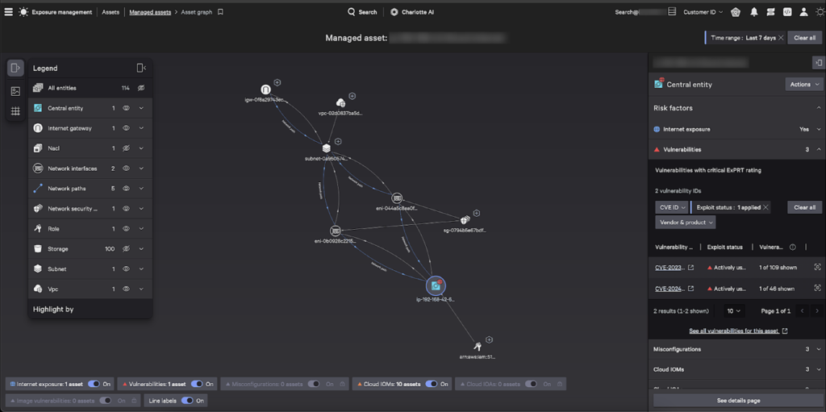
Figure 10: CrowdStrike Falcon Asset Graph with entity relationships
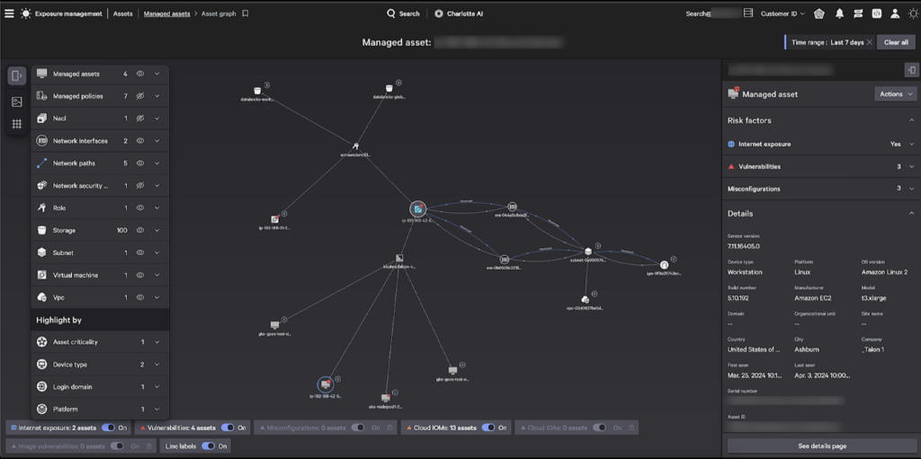
Figure 11: CrowdStrike attack path analysis with risk indicators

7. SentinelOne (Singularity / Purple AI)
Timeline: Storyline patented 2019. Process Graph for XDR launched 2022. Cloud Native Security (PingSafe acquisition) added Verified Exploit Paths 2024. Purple AI agentic 2024-25.
Graph core: Storyline auto-assembles per-process attack narratives (one storyline = one alert). Process Graph shows OS view vs. Storyline view for cross-process correlations. Verified Exploit Paths via Offensive Security Engine performs internal red-teaming.
K8s depth: Process Graph explicitly shows containerd as root with bash child processes flagged red. Best-in-class for container process-tree visibility. Time-scrubbing, MITRE ATT&CK mapping per node, Purple AI NL hunt.
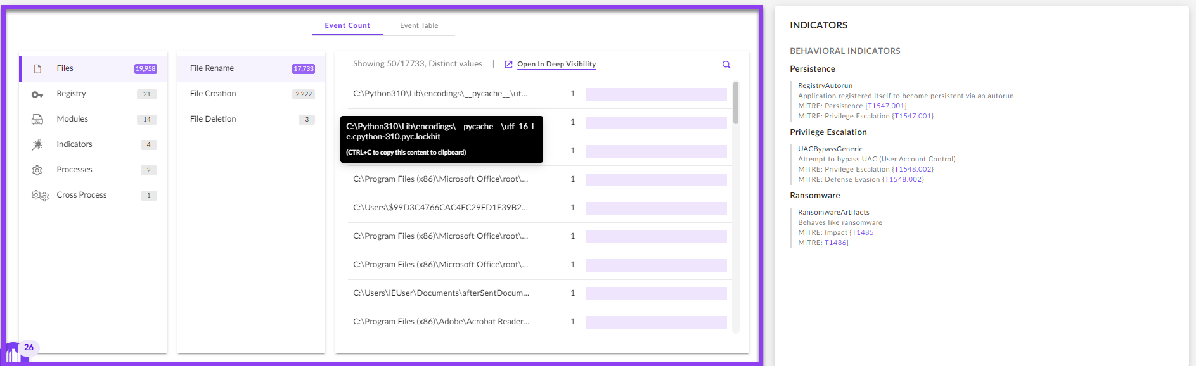
Figure 12: SentinelOne Singularity XDR Process Graph
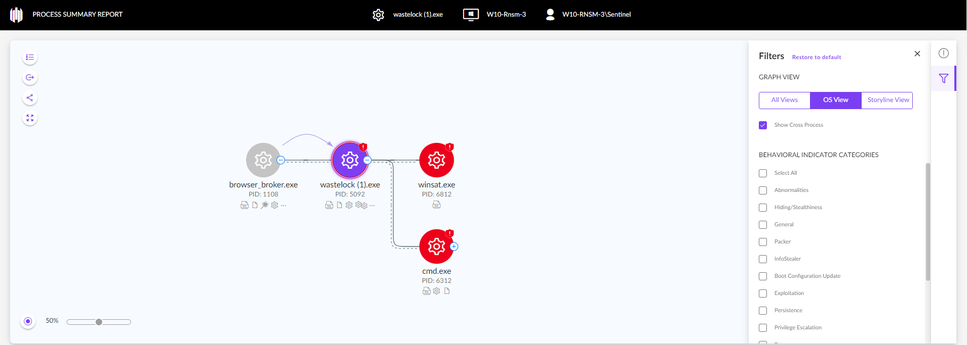
Figure 13: SentinelOne XDR Graph with MITRE ATT&CK mapping

8. Lacework / FortiCNAPP
Core: Polygraph continuously learns behavioral baselines via unsupervised ML on processes, APIs, users, networks. Anomalies surface as graph deviations. Time-series modeling catches volume spikes. One of the earliest container-aware behavioral graphs (processes, containers, pods, machines). Patent US 10,986,114 filed July 2019, granted April 2021. Customers report 60-70% alert noise reduction.

9. Tenable Cloud Security
Core: Pairs vulnerability/identity/cloud data with MITRE ATT&CK mappings. Choke Point Priority metric ranks path intersections. Blast Radius view from any asset. Custom path builder with editable origin/target (rare and praised). K8s coverage is weak; graph is identity- and vuln-centric.

10. Aqua Security
Core: Aqua Hub dynamic graph ties code to image to runtime workload to cloud resource. Verified Exploit Paths simulate external exploitation. Incident timeline maps MITRE techniques against eBPF event chain via Tracee. Strong kernel visibility but more timeline-centric than graph-centric.

11. Upwind Security (Most Direct AccuKnox Competitor)
Timeline: Founded 2022 by ex-Spot.io team. Topology Graph + Inventory 2.0 + Asset Map preview 2024-2025. Azure marketplace launch with Sentinel Graph integration 2025.
Graph core: Runtime Map + Asset Map backed by a graph database overlaying cloud assets, configs, SBOMs, runtime sensor signals. Upwind Explorer query builder where every query is visualizable in the Topology Graph and can be one-clicked into custom posture rules. Live policy validation shows policy effects rippling through the topology.
K8s depth: eBPF sensor. Explicitly normalizes container clusters and K8s workloads. Surfaces process trees, network topology, CI/CD context. Multi-zoom from Orbital View (sensitive data overview) down to container detail.
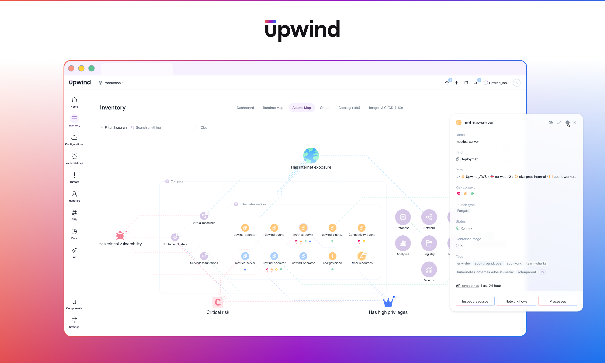
Figure 14: Upwind Asset Map with runtime context and topology
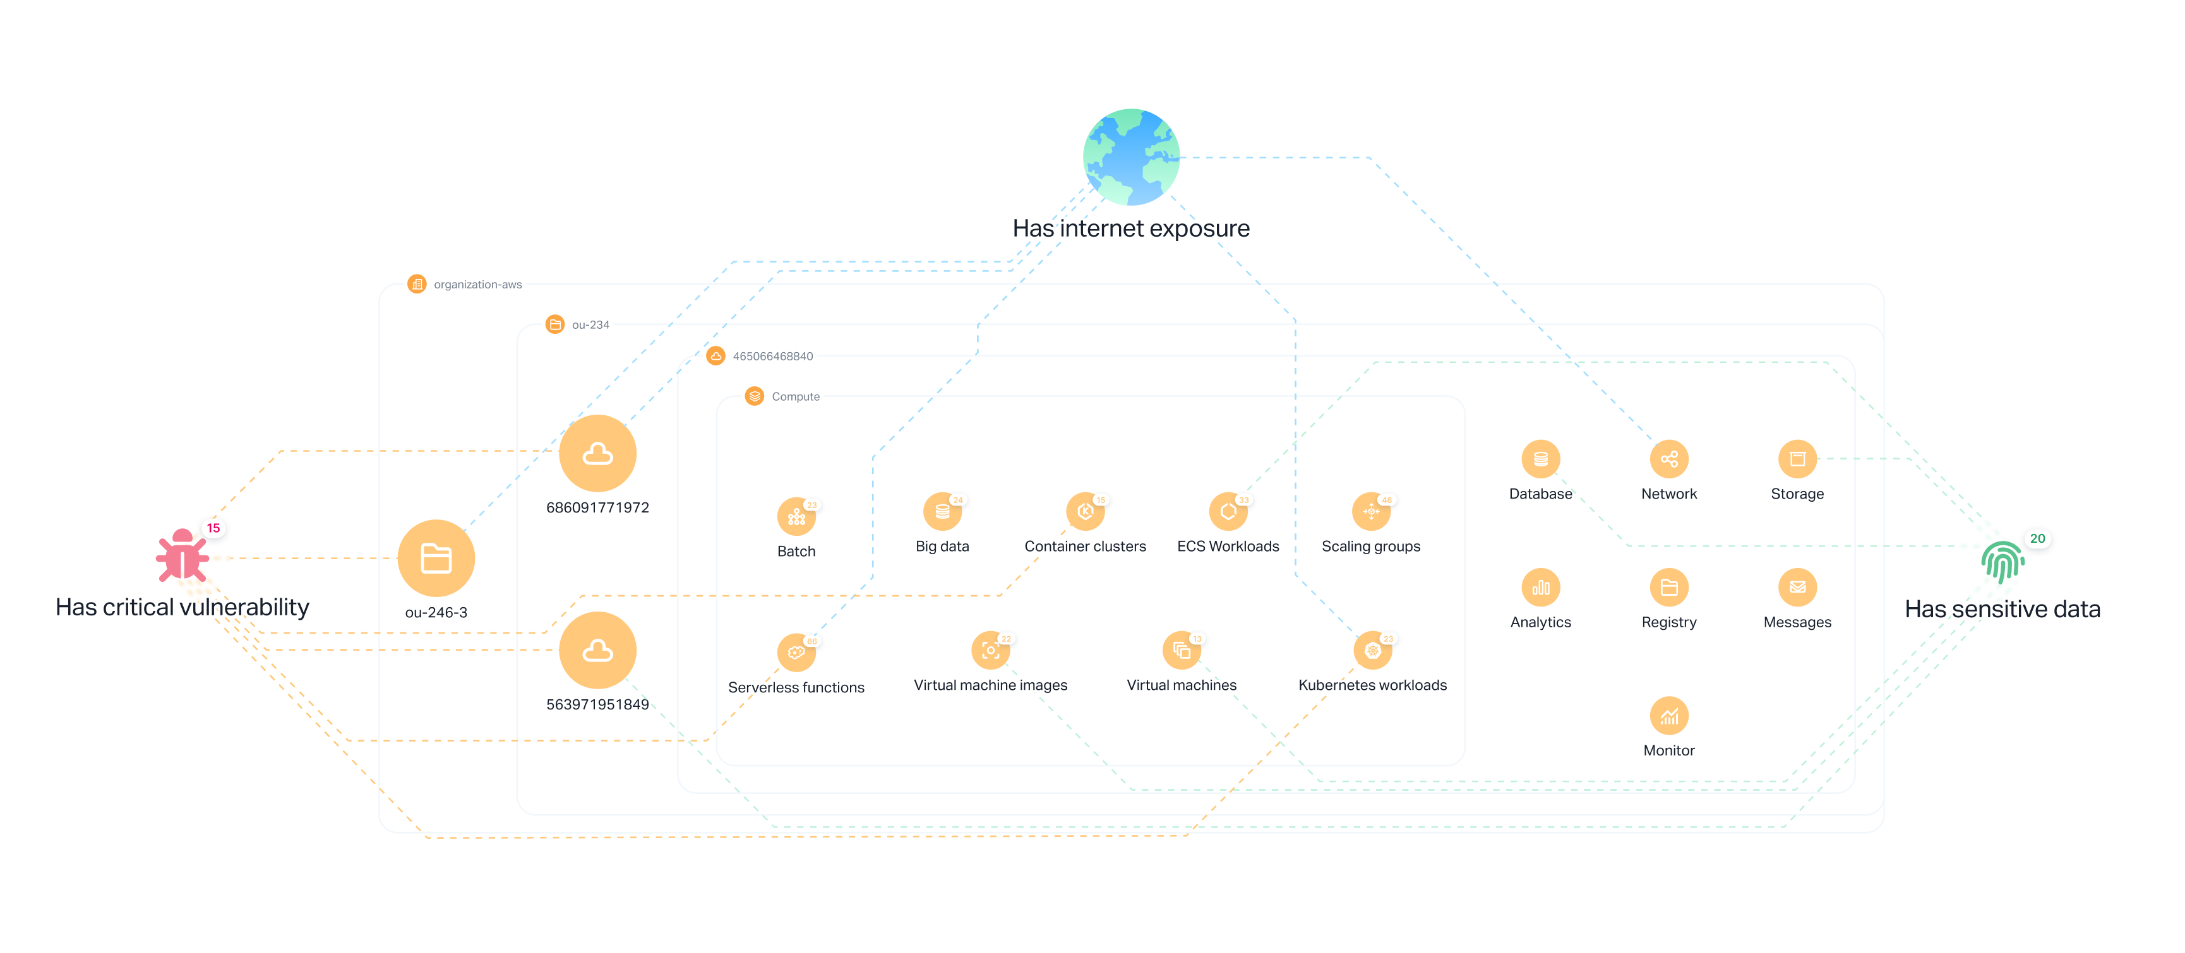
Figure 15: Upwind unified graph database architecture

12. Illumio / Akamai Guardicore
Core: Illumio Illumination (2014) pioneered real-time application dependency mapping. Vulnerability Map overlays vulnerable ports with East-West Exposure Score. Guardicore adds process-level granularity and AI-driven asset labeling. Both support container workloads; core strength is VM/bare-metal east-west traffic.

Feature Comparison Matrix
Condensed comparison across all 12 vendors on key graph and runtime capabilities:
Vendor | Attack Path | K8s Topo | Runtime Alerts | Query Layer | AI Insights | Timeline | eBPF Valid.
Wiz | Best-in-class | Yes | Yes (eBPF) | WQL + AI | Copilot, Red Agent | Yes | Yes
Prisma Cloud | Yes (Darwin) | Partial | Limited | RQL + Copilot | Precision AI | Yes | Limited
Defender | Yes | Yes | Limited | KQL-like | Built-in | Yes | Partial
Orca | Yes | Partial | No agent | Query Builder | Sonar AI | Yes | No
Sysdig | Real-time | Deep | Yes (Falco) | Sage NL | Sage agentic | Yes | Yes
CrowdStrike | Predictive | Partial | Yes | FQL + ExPRT | Charlotte AI | Yes | Yes
SentinelOne | Storyline | Process Graph | Best (procs) | SQL + Purple AI | Purple AI | Yes | Yes
Lacework | Polygraph | Yes | ML baseline | LQL | Limited | Yes | Yes
Tenable | Yes | Weak | No | ATT&CK map | Limited | Yes | No
Aqua | Aqua Hub | Yes | Tracee eBPF | Limited | Limited | Yes | Yes
Upwind | Topology | Normalized | Yes (eBPF) | Explorer | Limited | Yes | Yes
Illumio | Dep. map | Containers | Flow-based | Explorer | AI labeling | Yes | No

Key UX Patterns Across Leaders
The following table summarizes the most common and most praised UX patterns found across the leading security graph implementations:
UX Pattern | Category | Vendors
Node-edge with hover-to-inspect | Universal | All vendors
Three-tab home (Incidents/Paths/Risks) | Navigation | Prisma Cloud, copied by several
Click node -> side drawer context | Detail inspection | Wiz, Sysdig, Defender
Query -> Graph -> Policy round-trip | Workflow | Upwind (standout), Wiz, Sysdig
Choke point / breakpoint highlighting | Prioritization | Microsoft, Tenable, CrowdStrike
Code-to-cloud back-trace | Remediation | Wiz Code, Prisma Application Graph
Natural-language query overlay | Accessibility | Wiz AI, Sage, Purple AI, Copilot
MITRE ATT&CK mapping on nodes | Framework | Aqua, Sysdig, SentinelOne, Tenable
Multi-zoom levels (Orbital View) | Navigation | Upwind (unique)
Time-scrubbing graph backwards | Investigation | SentinelOne Storyline, Sysdig
Most praised in reviews: Users consistently highlight three themes: (1) the graph shows exactly how attacks chain together, (2) alert noise drops dramatically (one path vs. hundreds of alerts), and (3) click-to-fix workflows from graph findings directly into PRs.

Gaps & Opportunities for AccuKnox
AccuKnox's structural advantages (KubeArmor with BPF-LSM enforcement, eBPF observability at the kernel, CNCF Sandbox status) align with market direction but are under-exploited in product UX.

Where the Market Is Weak Today
- No truly first-class K8s-native graph exists that combines pod-to-pod E-W traffic, per-process syscalls, behavioral alerts as heat on cluster topology, and live enforcement policy visualization.
- Agentless CNAPPs (Wiz, Orca) lack deep runtime context. They bolt on eBPF sensors awkwardly post-hoc.
- K8s topology tools (Cilium Hubble, Calico, Datadog NPM) lack security context. They show flows but not toxic combinations.
- Behavioral alerts (Falco, Tracee) live in tables, not on a graph. Sysdig is closest but its graph is still cloud-asset-centric, not pod-process-centric.

AccuKnox's Unique Opportunity
Build a runtime-first Kubernetes Security Graph where:
- Nodes are pods, containers, processes, files, identities
- Edges are eBPF-observed syscalls, network flows, ingress/egress
- KubeArmor enforcement policy is overlaid with allowed/blocked/audit coloring
- Behavioral alerts appear as a heat layer on cluster topology
- Policy simulation shows what would break before enforcement (like Illumio draft mode, but at syscall level)
No other CNAPP can replicate this because they lack an LSM-level enforcement engine.

Recommended Roadmap
Phase | Timeline | Key Deliverables | Trigger
1 | 0-6 months | Graph DB adoption (Neptune/Neo4j), KubeArmor process graph as landing page, basic attack-path view linking runtime to KSPM | >30% lost RFPs cite no graph UI
2 | 6-12 months | Policy overlay on graph (allowed/blocked/audit edges), policy impact simulation ('what breaks if enforced?') | Tier-1 customer asks for security graph
3 | 12-18 months | Runtime-validated attack paths, behavioral anomaly nodes (new outbound IPs, unusual syscalls) | Wiz Defend >25% K8s runtime CDR share
4 | 12-24 months | NL query layer over graph, auto-generated KubeArmor policies from 14-day observed behavior | NL queries in >50% of evaluations

Caveats
- Multiple vendor-published customer quotes (Sysdig, CrowdStrike) excluded because they lack third-party verification.
- Enterprise CNAPP discussion happens behind PeerSpot/Gartner gates, not in public forums. Reddit/HN surfaced little on this topic.
- 'Verified Exploit Paths' naming overlaps between SentinelOne, Aqua, and Wiz. Terminology is converging across vendors.
- Prisma Cloud attack-path feature launch dates are imprecise; Palo Alto markets multiple sub-features under 'Attack Path' that each landed at different times.
- Wiz eBPF sensor (2025) is new; full graph-overlay maturity is unproven. Wiz Red Agent and Upwind AI Agentic Pack are forward-looking marketing claims.
- Lacework's 'Polygraph 2016' origin claim is overstated. USPTO shows foundational patent filed July 2019, granted April 2021. Earliest provisionals date to Nov 2017.

