

Integrating Secret Scanning with AccuKnox in Jenkins
Home › Integrations › CI/CD › Jenkins

This guide adds a Secret scan stage to a Jenkins pipeline using the AccuKnox ASPM Scanner plugin. The scanner walks the full git history of the checked-out repo to find committed secrets and uploads results to AccuKnox.

On this page
1. Prerequisites
2. Step 1: Install the AccuKnox ASPM Plugin
3. Step 2: Configure Jenkins credentials & global settings
4. Step 3: Define the Jenkins Pipeline
5. Pipeline inputs
6. Severity model
7. Without AccuKnox vs With AccuKnox
8. Viewing Results in AccuKnox
9. Conclusion

Prerequisites
- A Jenkins controller (2.387.3 LTS or newer) with at least one build agent.
- An AccuKnox SaaS account with a tenant / label you can upload findings to.
- Network egress from the Jenkins agent to the AccuKnox control plane (or a mirrored scanner image for air-gapped agents — see AIRGAP.md).
- Use a full git clone (no --depth=1) — the secret scanner walks the commit history.

Step 1: Install the AccuKnox ASPM Plugin
See 1-install.docx for the one-time plugin installation steps.

Step 2: Configure Jenkins credentials & global settings
- Store the AccuKnox token as a Jenkins Secret text credential.
- Set the endpoint, label, and token credential on the global config screen.

Step 3: Define the Jenkins Pipeline
// AccuKnox Secret scan — standalone Jenkinsfile.
//
// Clones a repo and scans its git history for committed secrets.
// SECRET_COMMAND must point at a git working tree the scanner can read.
pipeline {
agent any
parameters {
string(name: 'REPO_URL',
defaultValue: 'https://github.com/Vickydew1/Testing.git',
description: 'Git repo to clone and scan.')
string(name: 'SECRET_COMMAND',
defaultValue: 'git file://.',
description: 'Secret scanner command. Default scans the current dir as a git repo.')
string(name: 'SEVERITY_THRESHOLD',
defaultValue: 'HIGH,CRITICAL',
description: 'Comma-separated severities that fail the build.')
booleanParam(name: 'SOFT_FAIL',
defaultValue: true,
description: 'true (default) = run and upload, build stays green; false = fail build on matching severities.')
}
options {
timestamps()
timeout(time: 20, unit: 'MINUTES')
disableConcurrentBuilds()
}
environment {
REPO_URL = "${params.REPO_URL}"
}
stages {
stage('Checkout') {
steps {
sh '''
set -eu
rm -rf repo
git clone "$REPO_URL" repo # full history — secret scan reads it
'''
}
}
stage('Secret') {
steps {
dir('repo') {
accuknoxSecret(secretCommand: params.SECRET_COMMAND,
severityThreshold: params.SEVERITY_THRESHOLD,
softFail: params.SOFT_FAIL)
}
}
}
}
}
Source: tested/jenkinsfile.secret.

Pipeline inputs
Parameter | Description | Required | Default
secretCommand | Passed verbatim to the secret scanner. Default scans the current dir as a git repo. | no | git file://.
severityThreshold | CSV of severities that fail the build. | no | HIGH,CRITICAL
softFail | true = advisory only; false = fail build on matching severities. | no | false

Common knobs (every step accepts these)
Parameter | Default | Notes
endpoint | from global config | Control-plane host (no scheme). Per-step override.
label | from global config | Becomes the label_id on the upload.
credentialsId | from global config | Jenkins credential ID holding the AccuKnox bearer token.
skipUpload | false | Run the scanner but don't upload. Useful for dry runs.
keepResults | true | Keep results JSON on the agent and archive it as a build artifact.
containerMode | false | Run the scanner inside Docker on the agent.
cliPath | auto | Path to a pre-staged accuknox-aspm-scanner binary (air-gapped use).

Severity model
The underlying secret scanner doesn't classify findings by severity, so the plugin counts every secret as a HIGH finding (committed secrets are inherently high-risk). With severityThreshold = 'HIGH,CRITICAL' any detected secret fails the build; set 'CRITICAL' only if you explicitly want to allow them.

Without AccuKnox vs With AccuKnox
Without AccuKnox:
Secret-scan output is left as a JSONL file in the workspace; you have to manually inspect or wire downstream tooling.
With AccuKnox:
Findings are uploaded and grouped by repo / commit / rule, and the AccuKnox console provides remediation guidance and ticketing.
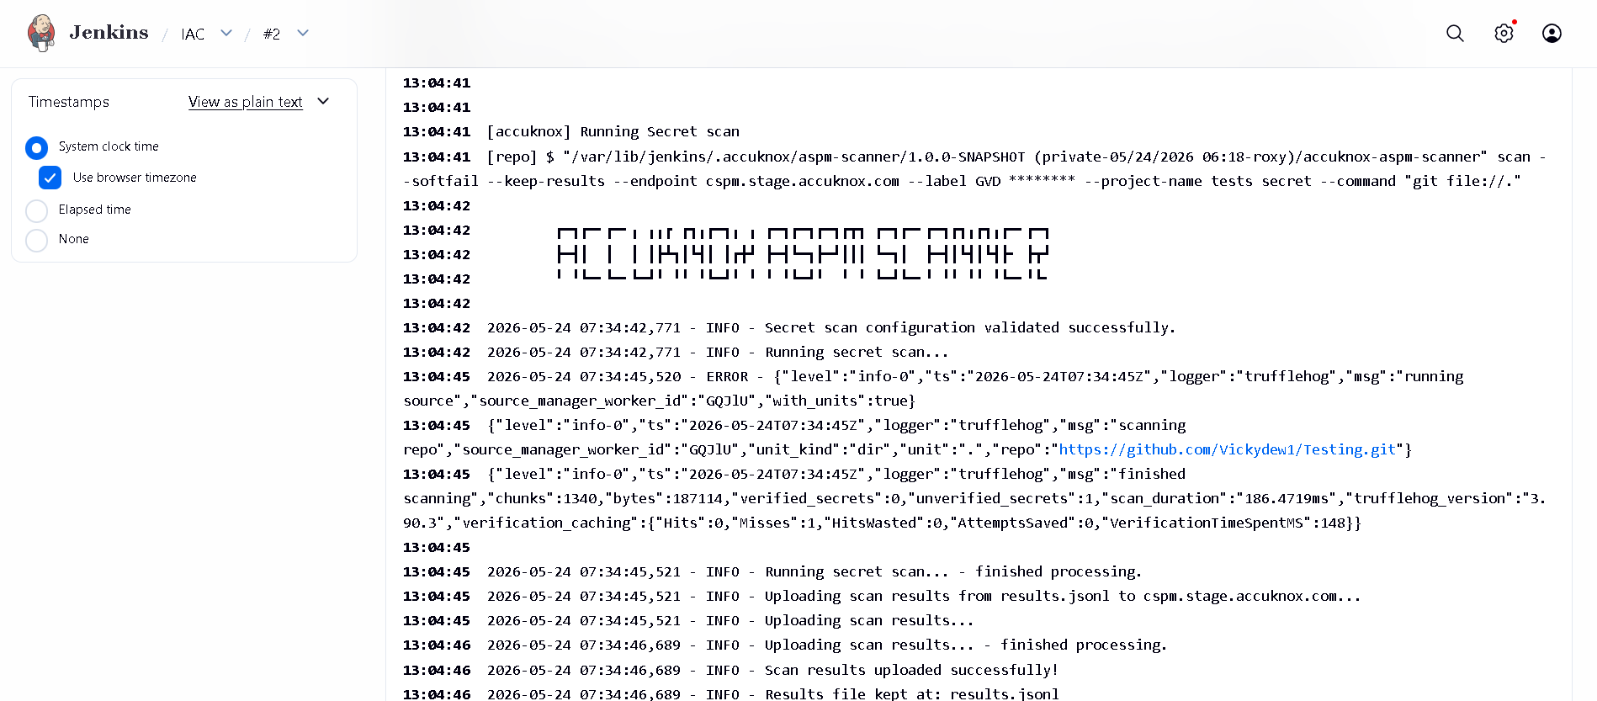
Figure 1 — Secret findings in the AccuKnox console.
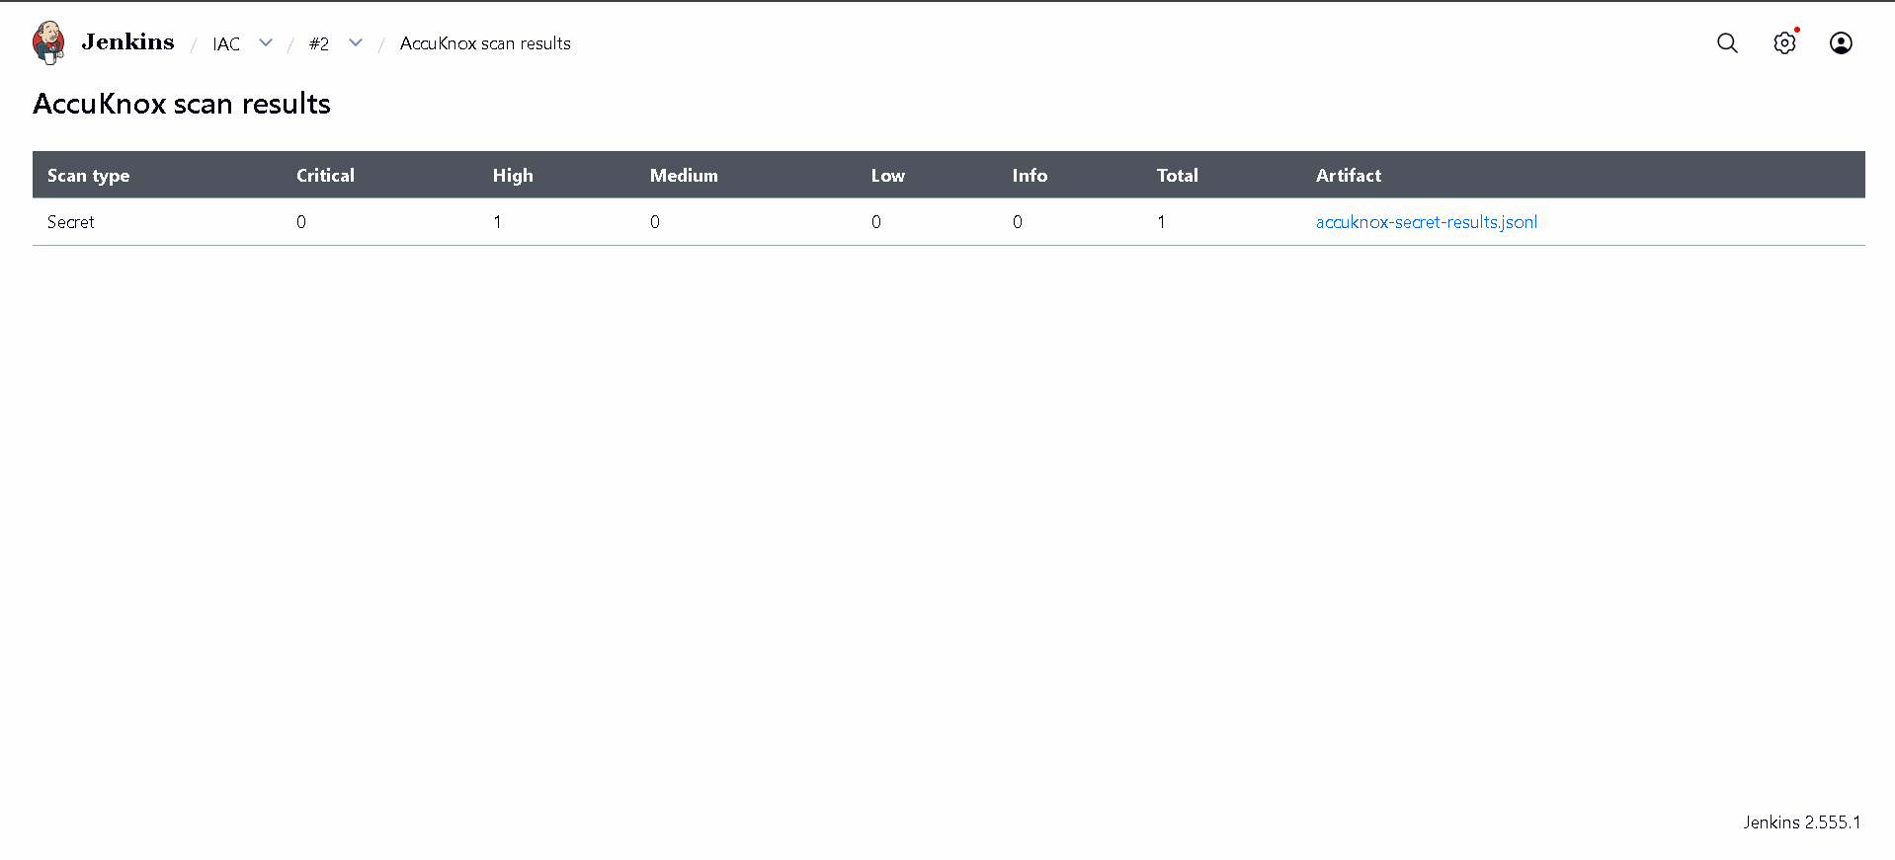
Figure 2 — Drilling into a single secret finding.

Viewing Results in AccuKnox
Once the Jenkins job uploads its report, the findings are available in the AccuKnox SaaS console.
- Log in to the AccuKnox console and switch to the tenant whose label you configured in Jenkins.
- Open Issues → Findings, and filter by the data type that matches the scan (SAST, IaC, Secret, Container, SBOM, SCA).
- Click any finding to inspect the file, line, CWE, and the recommended remediation.
- Use the ASK AI button on a finding for an LLM-generated explanation and patch suggestion.
- Create a ticket directly from the finding to track remediation.
- Re-run the Jenkins job after fixing the issue — the finding flips to Resolved on the next ingest.

Conclusion
Wiring Secret scanning into Jenkins via the AccuKnox ASPM plugin gives you continuous, automated detection of issues on every build, with a single pane of glass in the AccuKnox console for triage, ticketing, and verification. Combine it with the other scan types (SAST, IaC, Secret, Container, SBOM, SCA) to get full-coverage ASPM directly from your pipelines.

