

Integrating Container Image Scanning with AccuKnox in Jenkins
Home › Integrations › CI/CD › Jenkins

This guide adds a Container scan stage to a Jenkins pipeline using the AccuKnox ASPM Scanner plugin. The scanner pulls the image from a registry, runs SCA on it, and uploads findings to AccuKnox.

On this page
1. Prerequisites
2. Step 1: Install the AccuKnox ASPM Plugin
3. Step 2: Configure Jenkins credentials & global settings
4. Step 3: Define the Jenkins Pipeline
5. Pipeline inputs
6. Without AccuKnox vs With AccuKnox
7. Viewing Results in AccuKnox
8. Conclusion

Prerequisites
- A Jenkins controller (2.387.3 LTS or newer) with at least one build agent.
- An AccuKnox SaaS account with a tenant / label you can upload findings to.
- Network egress from the Jenkins agent to the AccuKnox control plane (or a mirrored scanner image for air-gapped agents — see AIRGAP.md).
- Registry credentials configured on the Jenkins agent if you scan a private image.
- Docker available on the agent if you set containerMode: true.

Step 1: Install the AccuKnox ASPM Plugin
See 1-install.docx for the one-time plugin installation steps.

Step 2: Configure Jenkins credentials & global settings
- Store the AccuKnox token as a Jenkins Secret text credential.
- Set the endpoint, label, and token credential on the global config.

Step 3: Define the Jenkins Pipeline
pipeline {
agent any
parameters {
string(
name: 'IMAGE_NAME',
defaultValue: 'testing-app:latest',
description: 'Docker image name to build and scan'
)
string(
name: 'SEVERITY_THRESHOLD',
defaultValue: 'HIGH,CRITICAL',
description: 'Comma-separated severities that fail the build'
)
booleanParam(
name: 'SOFT_FAIL',
defaultValue: true,
description: 'true = build stays green; false = fail build on findings'
)
}
options {
timestamps()
timeout(time: 30, unit: 'MINUTES')
disableConcurrentBuilds()
}
stages {
stage('Checkout') {
steps {
sh '''
set -eu
rm -rf repo
git clone --depth=1 https://github.com/Vickydew1/Testing.git repo
'''
}
}
stage('Build Docker Image') {
steps {
dir('repo') {
sh '''
docker build -t testing-app .
'''
}
}
}
stage('Container Scan') {
steps {
accuknoxContainer(
image: params.IMAGE_NAME,
severityThreshold: params.SEVERITY_THRESHOLD,
softFail: params.SOFT_FAIL
)
}
}
}
}
Source: tested/jenkinsfile.container.

Pipeline inputs
Parameter | Description | Required | Default
image | Image reference, e.g. nginx:1.27.1 or registry.local/app:1.0. | yes | —
severityThreshold | CSV of severities that fail the build. | no | HIGH,CRITICAL
softFail | true = advisory only; false = fail build on matching severities. | no | false
containerMode | Run the scanner inside Docker on the agent. | no | false
scanImage | Air-gapped: mirrored scanner image to use. | no | (unset)

Common knobs (every step accepts these)
Parameter | Default | Notes
endpoint | from global config | Control-plane host (no scheme). Per-step override.
label | from global config | Becomes the label_id on the upload.
credentialsId | from global config | Jenkins credential ID holding the AccuKnox bearer token.
skipUpload | false | Run the scanner but don't upload. Useful for dry runs.
keepResults | true | Keep results JSON on the agent and archive it as a build artifact.
containerMode | false | Run the scanner inside Docker on the agent.
cliPath | auto | Path to a pre-staged accuknox-aspm-scanner binary (air-gapped use).

Without AccuKnox vs With AccuKnox
Without AccuKnox:
The container scanner produces a long JSON report; gating is left as an exercise for the pipeline author.
With AccuKnox:
The plugin uploads results, applies severity gating, and exposes per-image findings in the AccuKnox console with package / CVE context and remediation links.
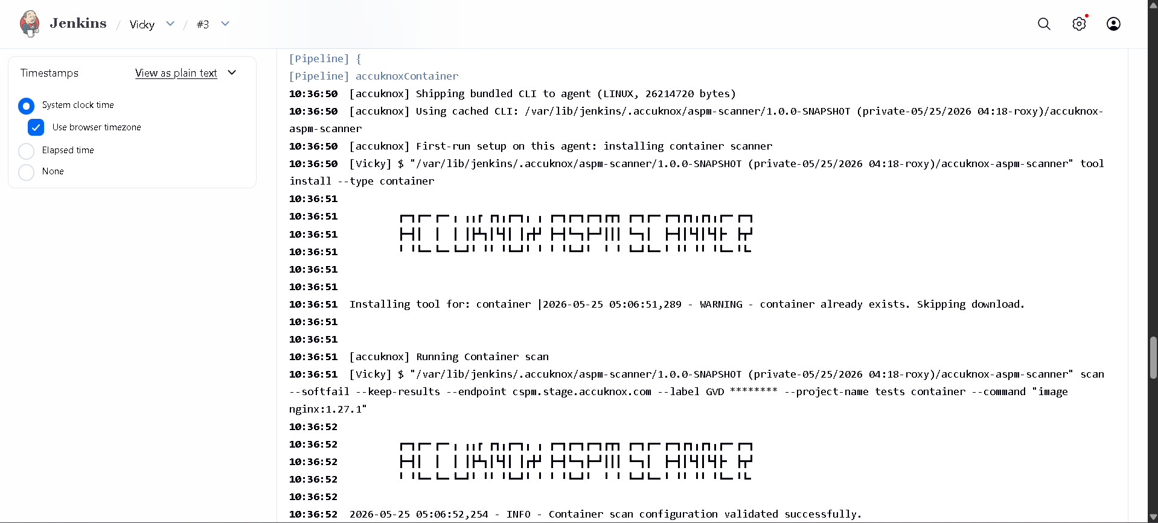
Figure 1 — Container findings in the AccuKnox console.

Viewing Results in AccuKnox
Once the Jenkins job uploads its report, the findings are available in the AccuKnox SaaS console.
- Log in to the AccuKnox console and switch to the tenant whose label you configured in Jenkins.
- Open Issues → Findings, and filter by the data type that matches the scan (SAST, IaC, Secret, Container, SBOM, SCA).
- Click any finding to inspect the file, line, CWE, and the recommended remediation.
- Use the ASK AI button on a finding for an LLM-generated explanation and patch suggestion.
- Create a ticket directly from the finding to track remediation.
- Re-run the Jenkins job after fixing the issue — the finding flips to Resolved on the next ingest.

Conclusion
Wiring Container scanning into Jenkins via the AccuKnox ASPM plugin gives you continuous, automated detection of issues on every build, with a single pane of glass in the AccuKnox console for triage, ticketing, and verification. Combine it with the other scan types (SAST, IaC, Secret, Container, SBOM, SCA) to get full-coverage ASPM directly from your pipelines.

