

Generating Container SBOMs with AccuKnox in Jenkins
Home › Integrations › CI/CD › Jenkins

This guide adds an SBOM (Software Bill of Materials) stage to a Jenkins pipeline using the AccuKnox ASPM Scanner plugin. A CycloneDX SBOM is generated for a container image and uploaded to AccuKnox under a named project.

On this page
1. Prerequisites
2. Step 1: Install the AccuKnox ASPM Plugin
3. Step 2: Configure Jenkins & pre-create the SBOM project
4. Step 3: Define the Jenkins Pipeline
5. Pipeline inputs
6. Without AccuKnox vs With AccuKnox
7. Viewing Results in AccuKnox
8. Conclusion

Prerequisites
- A Jenkins controller (2.387.3 LTS or newer) with at least one build agent.
- An AccuKnox SaaS account with a tenant / label you can upload findings to.
- Network egress from the Jenkins agent to the AccuKnox control plane (or a mirrored scanner image for air-gapped agents — see AIRGAP.md).
- An AccuKnox project pre-created with classifier 'container' — the SBOM upload fails otherwise.

Step 1: Install the AccuKnox ASPM Plugin
See 1-install.docx for the one-time plugin installation steps.

Step 2: Configure Jenkins & pre-create the SBOM project
- Store the AccuKnox token as a Jenkins Secret text credential.
- Set the endpoint, label, and token credential on the global config.
- On the AccuKnox console, go to Projects → Add Project and create the project name you plan to pass as projectName, with classifier 'container'.

Step 3: Define the Jenkins Pipeline
// AccuKnox SBOM generation — standalone Jenkinsfile.
//
// Generates a CycloneDX SBOM for a container image and uploads it to AccuKnox.
// PROJECT_NAME is what the SBOM is attached to in the AccuKnox UI.
pipeline {
agent any
parameters {
string(name: 'IMAGE',
defaultValue: 'nginx:1.27.1',
description: 'Container image to generate SBOM for.')
string(name: 'PROJECT_NAME',
defaultValue: 'jenkins-sbom-demo',
description: 'Project name to associate the SBOM with on AccuKnox.')
booleanParam(name: 'SOFT_FAIL',
defaultValue: true,
description: 'SBOM has no per-finding severity; SOFT_FAIL=true is the sensible default.')
booleanParam(name: 'CONTAINER_MODE',
defaultValue: false,
description: 'Run the scanner inside Docker (requires Docker on the agent).')
}
options {
timestamps()
timeout(time: 20, unit: 'MINUTES')
disableConcurrentBuilds()
}
stages {
stage('SBOM') {
steps {
accuknoxSbom(image: params.IMAGE,
projectName: params.PROJECT_NAME,
softFail: params.SOFT_FAIL,
containerMode: params.CONTAINER_MODE)
}
}
}
}
Source: tested/jenkinsfile.sbom.

Pipeline inputs
Parameter | Description | Required | Default
image | Container image reference. | yes | —
projectName | AccuKnox project (classifier 'container') to attach the SBOM to. | yes (or via global) | (global default)
softFail | SBOM has no per-finding severity; true is the sensible default. | no | true
containerMode | Run the scanner inside Docker on the agent. | no | false
scanImage | Air-gapped: mirrored scanner image to use. | no | (unset)

Common knobs (every step accepts these)
Parameter | Default | Notes
endpoint | from global config | Control-plane host (no scheme). Per-step override.
label | from global config | Becomes the label_id on the upload.
credentialsId | from global config | Jenkins credential ID holding the AccuKnox bearer token.
skipUpload | false | Run the scanner but don't upload. Useful for dry runs.
keepResults | true | Keep results JSON on the agent and archive it as a build artifact.
containerMode | false | Run the scanner inside Docker on the agent.
cliPath | auto | Path to a pre-staged accuknox-aspm-scanner binary (air-gapped use).

Without AccuKnox vs With AccuKnox
Without AccuKnox:
An SBOM JSON file is left on the agent. Asset inventory and vulnerability matching are someone else's problem.
With AccuKnox:
The CycloneDX SBOM is shipped to AccuKnox and attached to the named project, where it powers asset inventory, supply-chain queries, and the runtime correlation views.
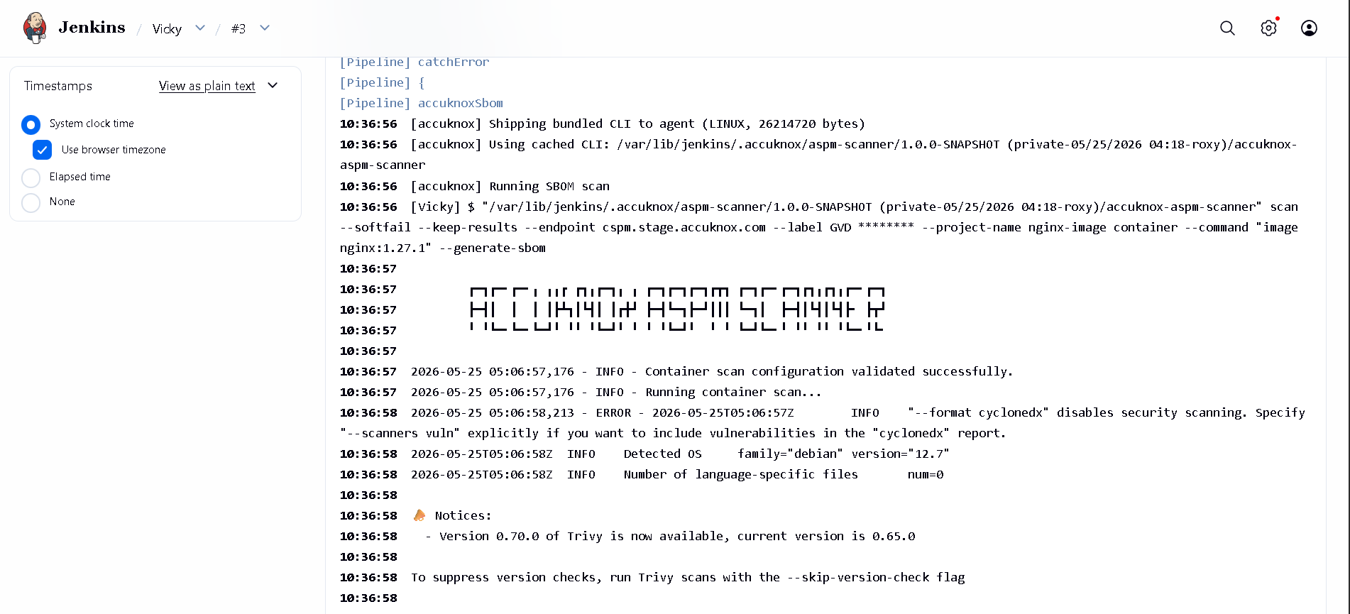
Figure 1 — SBOM attached to a project on AccuKnox.

Viewing Results in AccuKnox
Once the Jenkins job uploads its report, the findings are available in the AccuKnox SaaS console.
- Log in to the AccuKnox console and switch to the tenant whose label you configured in Jenkins.
- Open Issues → Findings, and filter by the data type that matches the scan (SAST, IaC, Secret, Container, SBOM, SCA).
- Click any finding to inspect the file, line, CWE, and the recommended remediation.
- Use the ASK AI button on a finding for an LLM-generated explanation and patch suggestion.
- Create a ticket directly from the finding to track remediation.
- Re-run the Jenkins job after fixing the issue — the finding flips to Resolved on the next ingest.

Conclusion
Wiring SBOM generation into Jenkins via the AccuKnox ASPM plugin gives you continuous, automated detection of issues on every build, with a single pane of glass in the AccuKnox console for triage, ticketing, and verification. Combine it with the other scan types (SAST, IaC, Secret, Container, SBOM, SCA) to get full-coverage ASPM directly from your pipelines.

