

Integrating Multi-Artifact (SCA) Scanning with AccuKnox in Jenkins
Home › Integrations › CI/CD › Jenkins

This guide adds a multi-artifact SCA stage to a Jenkins pipeline. Every file matching a glob (jars, binaries, archives, package lockfiles) is scanned individually for known CVEs and uploaded to AccuKnox under /api/v1/artifact/.

On this page
1. Prerequisites
2. Step 1: Install the AccuKnox ASPM Plugin
3. Step 2: Configure Jenkins credentials & global settings
4. Step 3: Define the Jenkins Pipeline
5. Pipeline inputs
6. Without AccuKnox vs With AccuKnox
7. Viewing Results in AccuKnox
8. Conclusion

Prerequisites
- A Jenkins controller (2.387.3 LTS or newer) with at least one build agent.
- An AccuKnox SaaS account with a tenant / label you can upload findings to.
- Network egress from the Jenkins agent to the AccuKnox control plane (or a mirrored scanner image for air-gapped agents — see AIRGAP.md).
- Build artifacts (jars, wheels, archives, etc.) available in the Jenkins workspace by the time the stage runs.

Step 1: Install the AccuKnox ASPM Plugin
See 1-install.docx for the one-time plugin installation steps.

Step 2: Configure Jenkins credentials & global settings
- Store the AccuKnox token as a Jenkins Secret text credential.
- Set the endpoint, label, and token credential on the global config.

Step 3: Define the Jenkins Pipeline
// AccuKnox Artifact scan — standalone Jenkinsfile.
//
// For each file matching FILES, runs a CVE scan and uploads the report
// to AccuKnox /api/v1/artifact/. Use for fat-jars, binaries, archives.
//
// Air-gapped agents: see AIRGAP.md.
pipeline {
agent any
parameters {
string(name: 'REPO_URL',
defaultValue: 'https://github.com/Vickydew1/Testing.git',
description: 'Repo that contains the binaries to scan.')
string(name: 'FILES',
defaultValue: '**/*.py*',
description: 'Glob pattern (Ant-style) for the artifacts to scan. e.g. repo/build/**/*.jar')
string(name: 'SEVERITY_THRESHOLD',
defaultValue: 'CRITICAL',
description: 'Comma-separated severities that fail the build.')
booleanParam(name: 'SOFT_FAIL',
defaultValue: true,
description: 'true (default) = run and upload, build stays green; false = fail build on matching severities.')
}
options {
timestamps()
timeout(time: 30, unit: 'MINUTES')
disableConcurrentBuilds()
}
environment {
REPO_URL = "${params.REPO_URL}"
}
stages {
stage('Checkout') {
steps {
sh '''
set -eu
rm -rf repo
git clone --depth=1 "$REPO_URL" repo
'''
}
}
stage('Artifact scan') {
steps {
accuknoxArtifact(files: params.FILES,
severityThreshold: params.SEVERITY_THRESHOLD,
softFail: params.SOFT_FAIL)
}
}
}
}
Source: tested/jenkinsfile.arti.

Pipeline inputs
Parameter | Description | Required | Default
files | Ant-style glob, e.g. build/**/*.jar. Each match is scanned individually. | yes | —
severityThreshold | CSV of severities that fail the build. | no | HIGH,CRITICAL
softFail | true = advisory only; false = fail build on matching severities. | no | true
scannerPath | Path to a pre-installed file-scanning binary (air-gapped). | no | (auto-discover)

Common knobs (every step accepts these)
Parameter | Default | Notes
endpoint | from global config | Control-plane host (no scheme). Per-step override.
label | from global config | Becomes the label_id on the upload.
credentialsId | from global config | Jenkins credential ID holding the AccuKnox bearer token.
skipUpload | false | Run the scanner but don't upload. Useful for dry runs.
keepResults | true | Keep results JSON on the agent and archive it as a build artifact.
containerMode | false | Run the scanner inside Docker on the agent.
cliPath | auto | Path to a pre-staged accuknox-aspm-scanner binary (air-gapped use).

Without AccuKnox vs With AccuKnox
Without AccuKnox:
Scan results land as per-artifact JSON files in the workspace; you must aggregate and review them by hand.
With AccuKnox:
Each artifact is uploaded under /api/v1/artifact/ and grouped in the AccuKnox console, where CVE / package context is enriched and tickets can be opened directly from a finding.
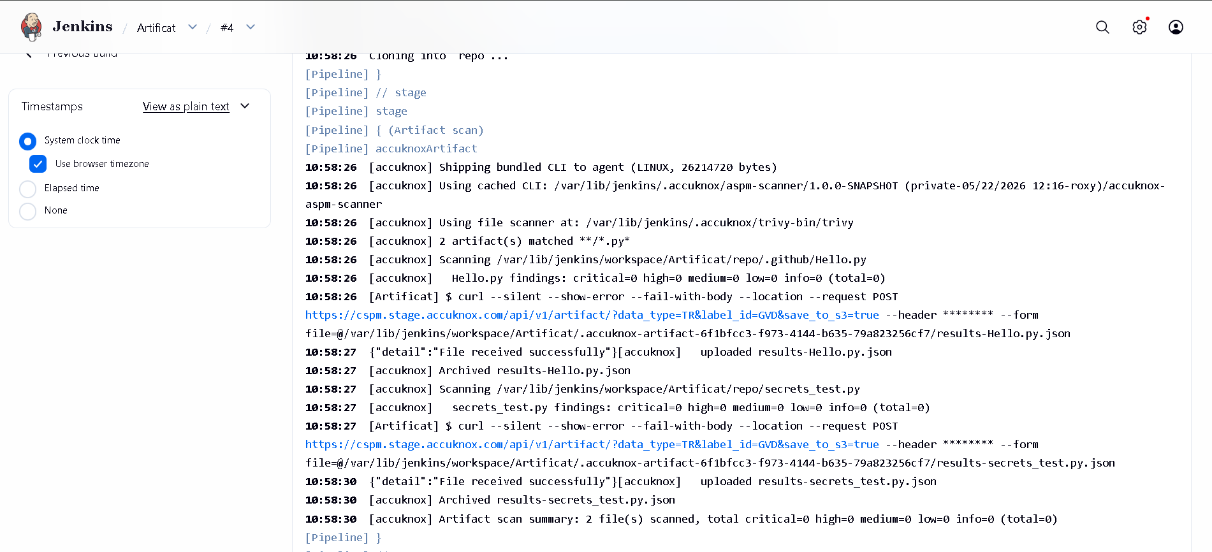
Figure 1 — Multi-artifact SCA findings on AccuKnox.

Viewing Results in AccuKnox
Once the Jenkins job uploads its report, the findings are available in the AccuKnox SaaS console.
- Log in to the AccuKnox console and switch to the tenant whose label you configured in Jenkins.
- Open Issues → Findings, and filter by the data type that matches the scan (SAST, IaC, Secret, Container, SBOM, SCA).
- Click any finding to inspect the file, line, CWE, and the recommended remediation.
- Use the ASK AI button on a finding for an LLM-generated explanation and patch suggestion.
- Create a ticket directly from the finding to track remediation.
- Re-run the Jenkins job after fixing the issue — the finding flips to Resolved on the next ingest.

Conclusion
Wiring multi-artifact (SCA) scanning into Jenkins via the AccuKnox ASPM plugin gives you continuous, automated detection of issues on every build, with a single pane of glass in the AccuKnox console for triage, ticketing, and verification. Combine it with the other scan types (SAST, IaC, Secret, Container, SBOM, SCA) to get full-coverage ASPM directly from your pipelines.

