AccuKnox Differentiated Offering

Cloud Security

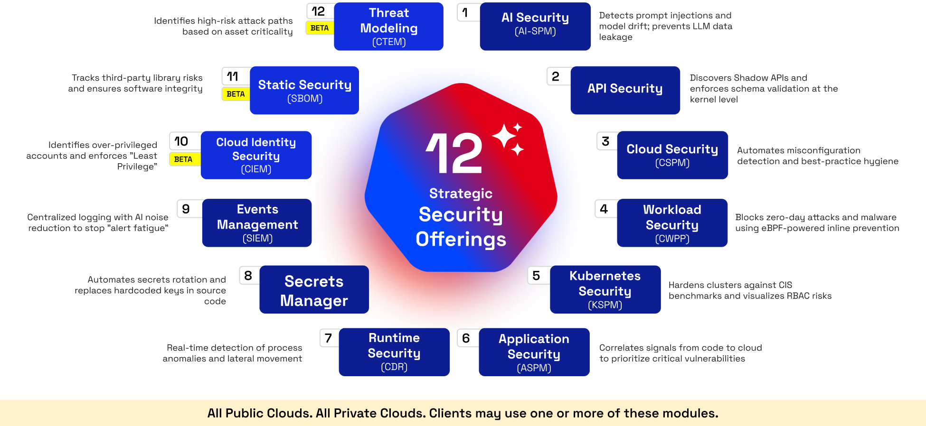
AccuKnox Unified CNAPP: CSPM, CWPP, KSPM, ASPM, CDR, AI Security in one platform

1. Cloud Security Posture Management (CSPM)
AccuKnox CSPM continuously monitors multi-cloud environments (AWS, Azure, GCP) to detect misconfigurations, enforce compliance, and reduce your cloud attack surface. It uses agentless technology for 360-degree visibility across all cloud assets.
Capability | Details
Misconfiguration Detection | Continuous scanning of EC2, S3, IAM, RDS, GKE and more. Flags deviations from CIS, NIST, PCI-DSS, SOC 2, HIPAA, and GDPR benchmarks.
Multi-Cloud Visibility | Unified dashboard across AWS, Azure, GCP, and Kubernetes. Asset inventory, compliance mapping, and risk scoring from a single pane.
Compliance Mapping | 33+ compliance frameworks mapped out of the box: CIS, NIST CSF, PCI-DSS, SOC 2, HIPAA, GDPR, CMMC, FISMA, MITRE, STIG. Audit-ready reports in seconds.
Auto-Remediation | Policy-as-code guardrails (YAML/JSON). Correlated findings with severity scoring, auto-patch, ticketing, and remediation playbooks.
Zero Trust + K8s Depth | Least-privilege IAM enforcement with behavioral insights. Deep Kubernetes visibility across EKS, AKS, GKE, OpenShift, and Talos clusters.
Docs: CSPM Onboarding Guide | CSPM Use Cases | Platform Page

2. Cloud Detection and Response (CDR), including AI-DR
AccuKnox CDR continuously monitors cloud environments to detect, analyze, and respond to threats in real-time. It supports AWS, Azure, and GCP with automated remediation workflows.
Metric | AccuKnox CDR | Traditional Solutions
Response Time | < 30 seconds | Hours to Days
False Positive Rate | 5% | 60%+
Detection Rate | 99.9% | 85%
Setup Time | Minutes | Weeks
CDR follows a 5-step workflow: Detect (ingest cloud logs and threat intelligence), Analyze (discover malicious activity or baseline drift), Alert (integrated notification), Investigate (multi-cloud forensics), and Remediate (automated workflows with recommendations).
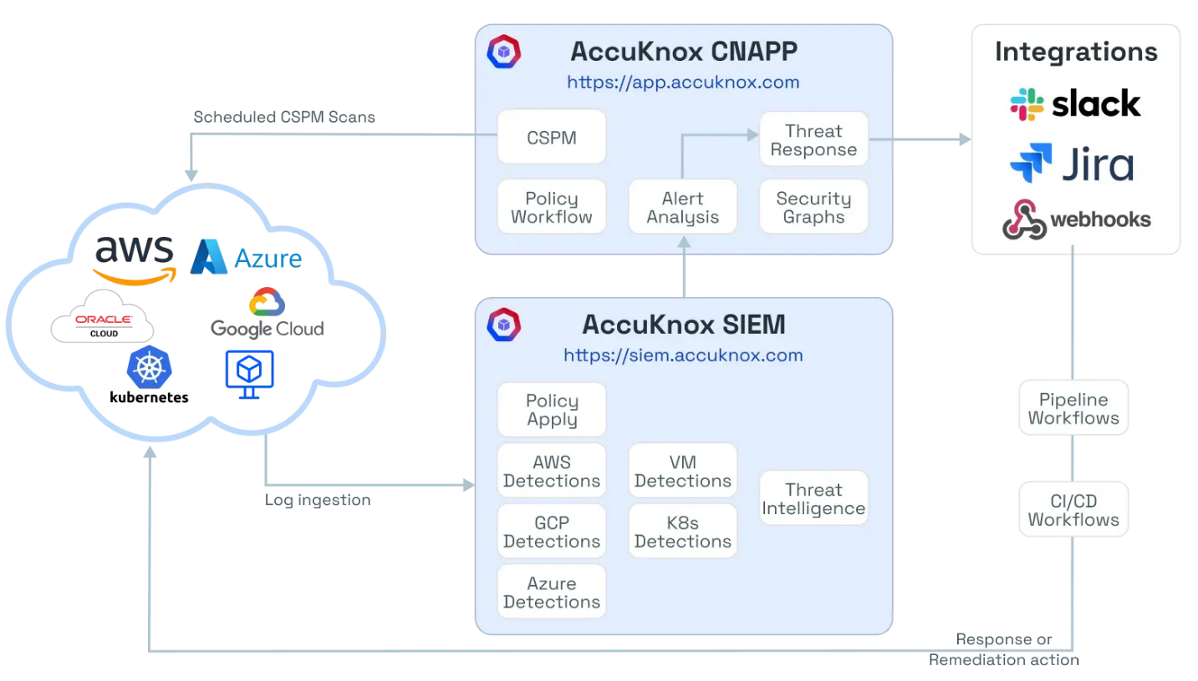
AccuKnox CDR Architecture: Multi-cloud event collection, SIEM-based detection, automated remediation

AI Detection and Response (AI-DR)
AI-DR extends CDR to AI/ML workloads. It monitors AI control-plane activity across SageMaker, Bedrock, Azure ML, and OpenAI, detecting unauthorized model customizations, insecure notebook configurations, and irreversible resource deletions. Key capabilities include policy-based detection for AI operations, automated remediation via GitHub Actions, and governance audit trails for every AI configuration change.
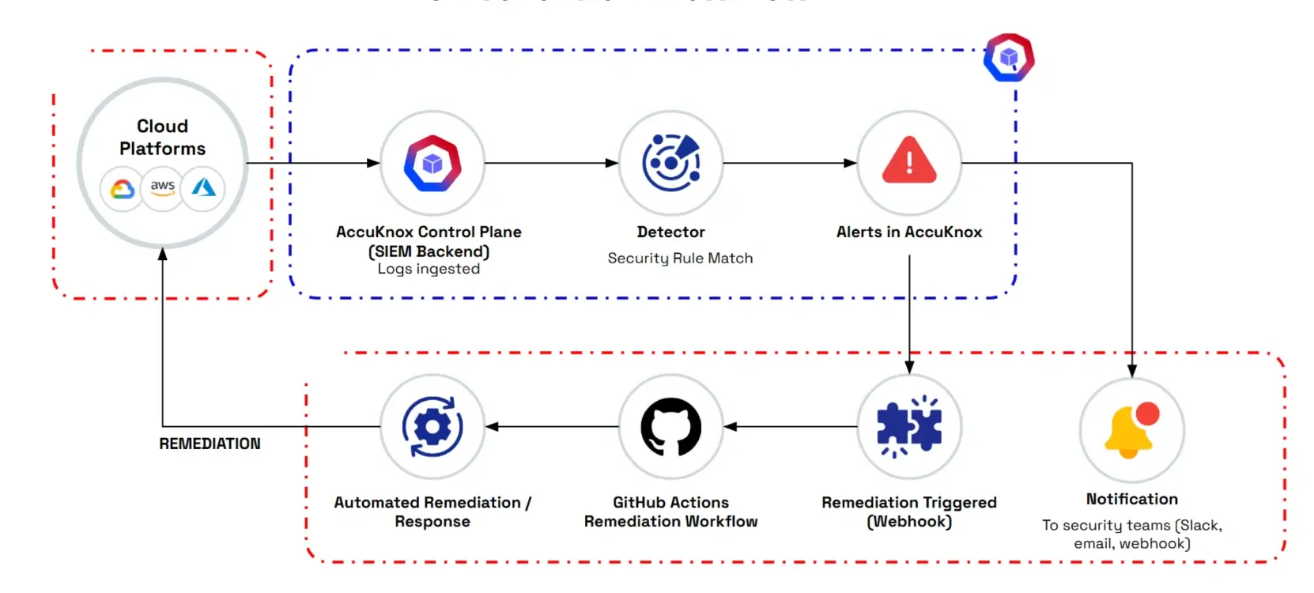
AI-DR Real-Time Threat Detection and Prevention Workflow
Docs: CDR Onboarding (AWS) | CDR Use Cases | AI-DR Use Cases | AI-DR Platform Page

3. AI Security (AI-SPM)
AccuKnox delivers a full-spectrum AI security platform covering posture management, runtime defense, red teaming, and compliance. It protects AI models, agents, datasets, and pipelines across multi-cloud environments with both SaaS and on-prem deployment options.
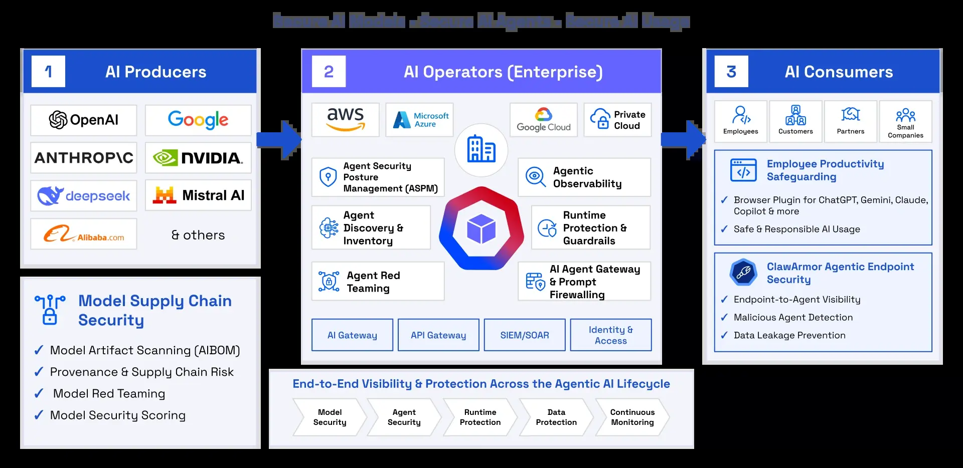
AccuKnox Agentic AI Security Platform: Inventory, Red Teaming, Prompt Firewall, Sandboxing, Compliance
Module | What It Does
Prompt Firewall | Real-time blocking of prompt injections, jailbreaks, PII leaks, and toxic outputs. 10+ policy types: anonymization, toxicity, competitor mentions, code filtering, secrets detection.
AI Red Teaming | Automated adversarial testing for code injection, hallucination, prompt leakage, bias, toxicity. Per-model risk scoring across four attack categories.
Agent Sandboxing | KubeArmor runtime sandboxing for AI agents: process, filesystem, credential, and network isolation at K8s workload level via zero-trust YAML policies.
Shadow AI Discovery | Discovers unmanaged AI agents, gateways, inference engines, SDKs, and MCP servers. Full asset inventory with lineage mapping across Azure AI Foundry, Copilot Studio, and AWS Bedrock.
AI Compliance | 12 active frameworks: OWASP Top 10 for LLMs, MITRE ATLAS, NIST 800-171, HIPAA, ISO 27001, SOC 2, PCI, RBI CSF, HITRUST CSF, GDPR, ISO 27017, NIST SP 800-53.
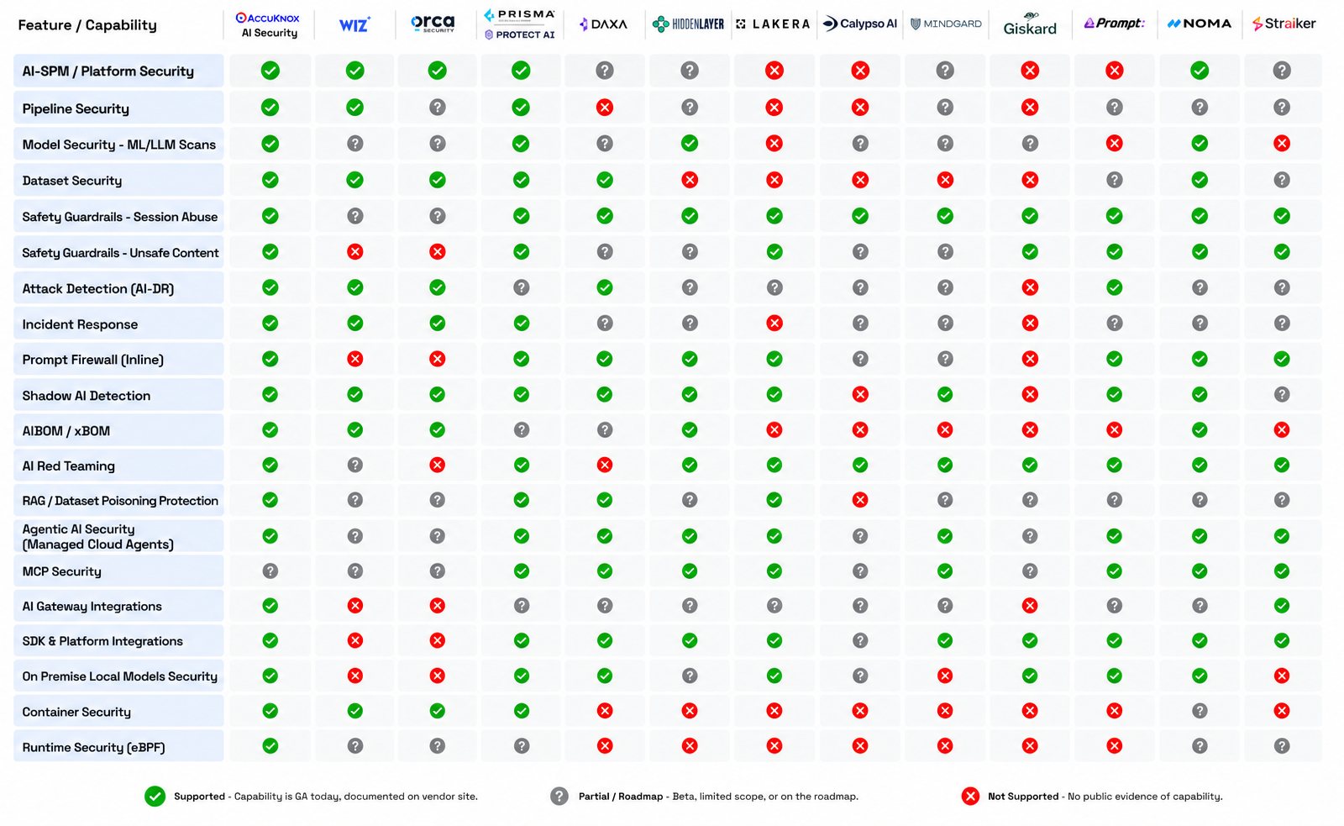
AccuKnox AI Security Competitive Stack Ranking
Docs: AI/ML Security Overview | Prompt Firewall | AI Security Platform Page

4. Data Security Posture Management (DSPM) Roadmap
AccuKnox DSPM is an AI-powered solution to discover, classify, and protect sensitive data across public, private, and hybrid clouds. It deploys agentlessly in 15 minutes with 99.8% classification accuracy across 50+ sensitive data types.
85%  of orgs don’t know where sensitive data lives | 73%  breached from misconfigured storage | 92%  struggle with manual classification | $10.22M  avg. cost of a data breach (2025)
DSPM Workflow: Onboarding (one-click cloud integration) → Discovery (agentless scan of all data stores) → Classification (ML-based, 50+ types, GDPR/HIPAA/PCI mapping) → Access Review (permission mapping, over-privilege detection) → Monitoring (real-time risk dashboards) → Remediation (automated workflows with ITSM integration).
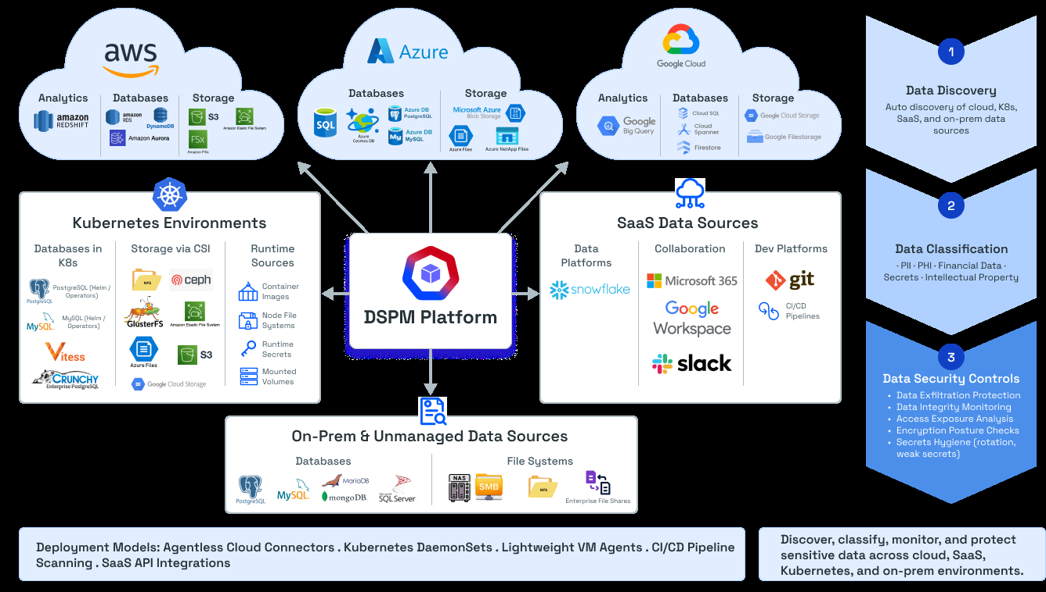
DSPM Integration Ecosystem: SIEM, ticketing, cloud storage, databases, and VMs
Reference: DSPM Platform Page

5. Differentiation and Unique Value Proposition
AccuKnox stands apart from legacy CNAPP vendors with capabilities that most competitors cannot match:
Capability | AccuKnox | Typical Competitors
CNCF Open Source foundation (KubeArmor) | ✓ | ✗
Inline mitigation (detect + block, not detect-only) | ✓ | ✗
On-premises and air-gapped deployment parity | ✓ | ✗
Full AI Security stack (AISPM, Red Team, Prompt FW, Sandbox) | ✓ | Partial
eBPF + LSM kernel-level runtime enforcement | ✓ | ✗
5G, Edge, and IoT security | ✓ | ✗
Auto-discovery of application behavior + drift detection | ✓ | ✗
33+ compliance frameworks (vs. 8-15 typical) | ✓ | Partial
Network micro-segmentation + topology monitoring | ✓ | ✗
AccuKnox is incubated out of SRI International (Stanford Research Institute), holds 10+ Zero Trust security patents, is backed by $15M in seed funding from National Grid Partners, Dolby Family Ventures, and Dreamit Ventures, and has won the #1 AI Security Startup award at BSides Bangalore 2025. Trusted by US DoD, Alice Blue, Pure Storage, Sonesta, and more.
More: Full Differentiators | CNAPP Platform | Compliance Matrix | Runtime Security | Kubernetes Security

Ready to see AccuKnox in action? Schedule a Demo

