**Installation of “facematch” engine for PHP**

**1. The structure of install folder**

**1) “facematch” folder**

This is web contents of php.

User have to copy this folder to php document root folder like /var/www/html

**2) “packages” folder**

rpm dependencies by used extension library

- opencv

- leptonica

**3) “extension” folder**

This is php extension library.

There is one file named “libphp-facematch.so”

**2. The Method of Installation**

**1) System requires**

System : CentOS 7, php5.6.34

**2) Install dependency rpms**

- Open the Terminal on centos7

If you are working on server, run terminal program directly.

If you are a client, you have to use putty.exe to run terminal

- install leptonica and opencv3.4.2

#rpm –ivh leptonica-1.75.3-1.el7.centos.x86_64.rpm

#rpm –ivh opencv-core-3.4.2-10.el7.centos.x86_64.rpm

#rpm –ivh opencv-3.4.2-10.el7.centos.x86_64.rpm

if there are dependencies error in install

then use this command

#yum install leptonica-1.75.3-1.el7.centos.x86_64.rpm

#yum install opencv-core-3.4.2-10.el7.centos.x86_64.rpm

#yum install opencv-3.4.2-10.el7.centos.x86_64.rpm

**3) Installation of php extension library**

There are 2 ways to install php extension library.

phpinfo(); find php.ini now using

**Method1.**

- copy php extension file to php mudole folder

#cp libphp-facematch.so /usr/lib64/php/modules

- edit php.ini file (red part have to be added)

… … … … …

;;;;;;;;;;;;;;;;;;;;;;

; Dynamic Extensions ;

;;;;;;;;;;;;;;;;;;;;;;

**extension=libphp-facematch.so**

… … … … …

- restart the httpd service

#service httpd restart

**Method2.**

- copy php extension file to any folder (ex : /root/extension)

#cp libphp-facematch.so /root/extension

- edit php.ini file (red part have to be added)

… … … … …

;;;;;;;;;;;;;;;;;;;;;;

; Dynamic Extensions ;

;;;;;;;;;;;;;;;;;;;;;;

**extension=/root/extension/libphp-facematch.so**

… … … … …

- restart the httpd service

#service httpd restart

3) restart httpd service

#service httpd restart

**3. Installation of PHP contents**

Copy “facematch” folder to php document root folder

ex:

#cp –r facematch /var/www/html

**4. Run**

Input the url in google chrome.

ex:

<http://localhost/facematch>

**Picture 4. The screen of running**

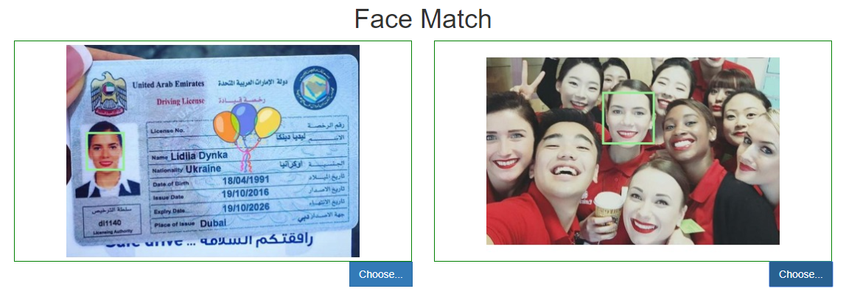

Enjoy!!!