Digital Ocean Notes
About – Open Source Initiative
How to incorporate open source An introduction to innersource,
Open Source Guides | Learn how to launch and grow your project.
GitHub Skills
To have a website:
1. Get a computer.
2. Have public IP address. Connect to internet
3. Get a domain (optional).
4.Setting up computer to respond
Droplet
Digital Ocean removes 2 first steps, by creating a droplet.
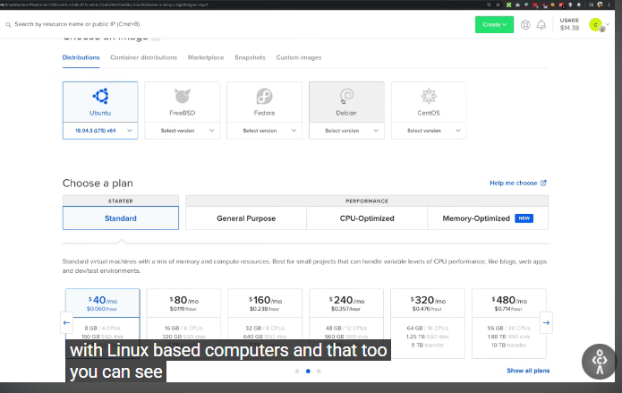
Most popular ones Ubuntu. Choose a plan:
DigitalOcean allows you to have powerful or not powerful computer, it takes its supercomputer to give you 2 cores for example. Standard, performs well on its own, you share the CPU with others. General purpose, is it completely yours, example, for multithreading. CPU-optimized performance, for every CPU you have 2GB of RAM, compared to general purpose $GB of RAM for every CPU. Memory-Optimized is that you have more RAM per CPU, example if you work mostly with data. We’re going to stick with standard, because it’s cheap. Datacenter region, where you want your computer to be hosted, if your site is not local, I would always go for US, I’ve felt that they’re superior.
Additional options, IPv6 is not needed if you start out, unless there’s reasons for performance and application use. User data allows you to do bunch of things before you launch the droplet, yaml file, but complicated.
Authentication, choose the way to go into user. SSH is more secure. Create key by writing ssh key-gen. git-bash. cd ~/.ssh/.
Hostname is something visible to you.
Tags allows you to tag droplets.
I don’t recommend enabling backup. You want backup in the database, so you’re fine. You can set up a simple script.
Create the droplet.
SSH into the machine with the IP address
Terminal. ssh -i ./dokey root@<IP_address>. free -h. df -h/. See size of the disk. apt-get install nginx, it’s ready to respond to people accessing the website. See the IP on the website.
SSH
Graphs section. You can get more metrics when you opt for more details. If you have monitoring then you don’t have to do it. You just need to copy this script:
curl -sSL https://repos.insights.digitalocean.com/install.sh -o /tmp/install.sh | sudo bash
Once that happens, take a look at crafts, you’ll have more graphs.
apt-get install stress.
stress –cpu 1 – -timeout 30
we’re burning the CPU at 100%. It should change the graph in CPU usage, it spikes almost 100. 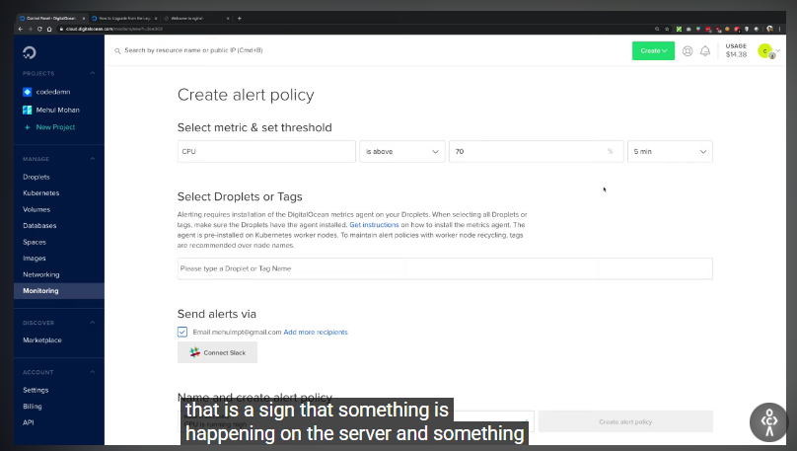
You can create your own alert policy, free. CPU is above 70.
Firewall
Networking, create a firewall. Name it. Customize rules, how the traffic reaches instance, restrict network layer, that is before even response reaches the server. You can do it in the dashboard as well. You should never touch your firewall, unless.. Most of internet consists of TCP and UDP. UDP is like TCP, but much more relaxed. Idea is you only want to allow TCP. HTTP and HTTPS. In custom you can adjust the port. Inbound rules means rule for inbound requests. curl google.com. Outbound rules leave it like this. Removing All IPv4 and IPv6 in inbound rules makes the website load endlessly.
VPC
Virtual Private Cloud, new thing. VPC is allowing you to communicate droplets between them. Private network allows you to do that. Public network would result in a bandwidth and you would have to reach out to computer that’s sitting next to you. Create a private IP, which allow you to communicate droplets among themselves. Creating a VPC in Networking section. Select the region, your VPC is going to be a bunch of droplets sitting together physically. Generate an IP range for me, to not mess with customization. Create VPC Network. Add resources to really have the power of droplets, but for the most part you don’t want to get into security.
apt update && apt install nginx
curl localhost:80
ifconfig | grep 10
curl <private_IP>
You can remove droplet using a snapshot.
ssh root@<IP_address> -i ./dokey
apt update && install nginx
curl localhost :80
Snapshots make on demand copy of droplets, all your sower, all your install configurations. DigitalOcean allows you to communicate with it through API. You can use snapshot as backup.
Create a Snapshot
curl localhost:80
Touch secret.txt
Service status nginx
cat secret.txt
Take the snapshot. You can’t download the snapshot yet. From snapshots you can create droplets. Create your droplets, choose snapshots, choose a droplet. You can’t choose the configuration lower, reason is data is not stored in sequential manner.
Spaces
AWS s3, s3 is most popular option to store online, simple storage service. DigitalOcean used infrastructure and s3 API from s3 itself, that allows people using s3 to swiftly use Ocean.
Block Storage and Object Storage
block storage is more like regular SSD, folders inside folders, that’s file system, it’s good for humans interacting hard storage. Object storage is a service, it allows you to store chunks of file without file system, OS can’t extract that, there are ways to fix that, but there will be performance issues, it’s actually going to give you URL, maybe you want streaming site.
Creating First Space
Create a space. Configurate CDN, it allows end users to fetch their resources faster, because the trip is faster, cached object, it saves a bunch of ms. File listing, it makes the objects on your space available as a list through URL, just like FTP. Choose unique name globally, 250GB per month.
Uploading File on Spaces
Upload file, private. This file is available on the internet.
XML File
S3 is standard for working with block storages, at least in the cloud. You want to disable file listing most of the time for it to not be accessed by other people.
Private Files in Spaces
Upload private files for members to not upload the file URL on the internet. File link when expires can no longer view that part. Right click, then open in the new tab to open the private file. TO share this you would use API or URL.
Domain Name Checker
Troubleshoot
The php artisan migrate --force command is used in Laravel to run database migrations in a production environment without requiring confirmation. By default, Laravel prompts for confirmation when running migrations in production to prevent accidental data loss. The --force flag bypasses this prompt, allowing migrations to execute without manual intervention.

