HTML
HTML stands for HyperText Markup Language. It uses markup to describe the structure of web pages. The structure is built up by elements, and they are represented by tags!
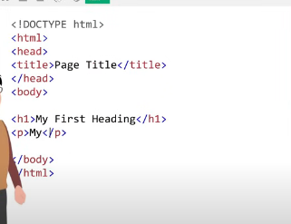
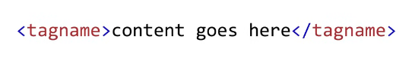this is a tag
HTML Editor
when you're learning HTML you should start with a simple text editor like Notepad on PCs or Text edit on Macs.
Write or copy the following HTML code into Notepad:
<!DOCTYPE html>
<html>
<body>
<h1>My First Heading</h1>
<p>My first paragraph.</p>
</body>
</html>
Name the file "index.html" and set the encoding to utf-8 which is the preferred encoding for all HTML files.
HTML files can have .html or just .htm as file extension.
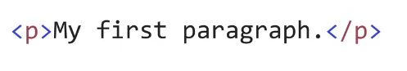This defines a paragraph element.
<br> defines a line break in a paragraph.
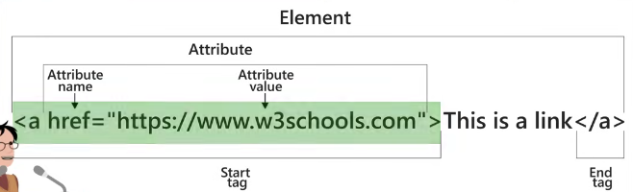

HTML Images
HTML images are defined with the <img> tag.
The source file (src), alternative text (alt), width, and height are provided as attributes:

Example
<img src="w3schools.jpg" alt="W3Schools.com" width="104" height="142">

The style Attribute
The style attribute is used to add styles to an element, such as color, font, size, and more.

Example
<p style="color:red;">This is a red paragraph.</p>

The lang Attribute
You should always include the lang attribute inside the <html> tag, to declare the language of the Web page. This is meant to assist search engines and browsers.
The following example specifies English as the language:
<!DOCTYPE html>
<html lang="en">
<body>
...
</body>
</html>

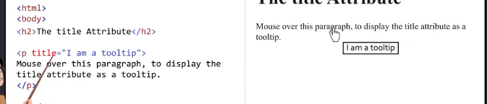

HTML Headings
HTML headings are defined with the <h1> to <h6> tags.
<h1> defines the most important heading. <h6> defines the least important heading.

Example
<h1>Heading 1</h1>
<h2>Heading 2</h2>
<h3>Heading 3</h3>
<h4>Heading 4</h4>
<h5>Heading 5</h5>
<h6>Heading 6</h6>
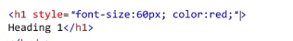change font size and color

HTML Paragraphs
The HTML <p> element defines a paragraph.

The HTML Style Attribute
Setting the style of an HTML element, can be done with the style attribute.
The HTML style attribute has the following syntax:
<tagname style="property:value;">

Background Color
The CSS background-color property defines the background color for an HTML element.

Example
Set the background color for a page to powderblue:
<body style="background-color:powderblue;">
<h1>This is a heading</h1>
<p>This is a paragraph.</p>
</body>

Fonts
The CSS font-family property defines the font to be used for an HTML element:

Example
<h1 style="font-family:verdana;">This is a heading</h1>
<p style="font-family:courier;">This is a paragraph.</p>

Text Alignment
The CSS text-align property defines the horizontal text alignment for an HTML element:

Example
<h1 style="text-align:center;">Centered Heading</h1>
<p style="text-align:center;">Centered paragraph.</p>
HTML Special Elements
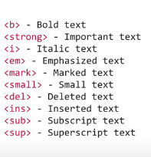
B defines bold text
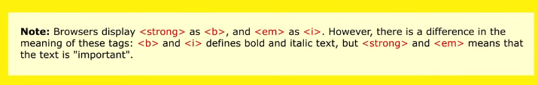

HTML <blockquote> for Quotations
The HTML <blockquote> element defines a section that is quoted from another source.
Browsers usually indent <blockquote> elements.

Example
<p>Here is a quote from WWF's website:</p>
<blockquote cite="http://www.worldwildlife.org/who/index.html">
For 60 years, WWF has worked to help people and nature thrive. As the world's leading conservation organization, WWF works in nearly 100 countries. At every level, we collaborate with people around the world to develop and deliver innovative solutions that protect communities, wildlife, and the places in which they live.
</blockquote>

HTML <q> for Short Quotations
The HTML <q> tag defines a short quotation.
Browsers normally insert quotation marks around the quotation.

Example
<p>WWF's goal is to: <q>Build a future where people live in harmony with nature.</q></p>

HTML <abbr> for Abbreviations
<p>The <abbr title="World Health Organization">WHO</abbr> was founded in 1948.</p>
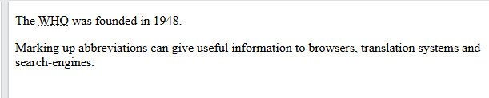

HTML <address> for Contact Information
The HTML <address> tag defines the contact information for the author/owner of a document or an article.
The contact information can be an email address, URL, physical address, phone number, social media handle, etc.
The text in the <address> element usually renders in italic, and browsers will always add a line break before and after the <address> element.

Example
<address>
Written by John Doe.<br>
Visit us at:<br>
Example.com<br>
Box 564, Disneyland<br>
USA
</address>

HTML <cite> for Work Title
The HTML <cite> tag defines the title of a creative work (e.g. a book, a poem, a song, a movie, a painting, a sculpture, etc.).
Note: A person's name is not the title of a work.
The text in the <cite> element usually renders in italic.

Example
<p><cite>The Scream</cite> by Edvard Munch. Painted in 1893.</p>

HTML <bdo> for Bi-Directional Override
BDO stands for Bi-Directional Override.
The HTML <bdo> tag is used to override the current text direction:

Example
<bdo dir="rtl">This text will be written from right to left</bdo>
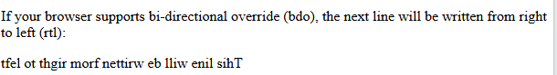
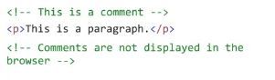
HTML Colors
RGB stands for Red Green and Blue. Each parameter red, green,
and blue defines the intensity of the color between zero and 255. To get black, all color parameters must be set to zero. Alternatively to get white all color parameters must be set to 255.
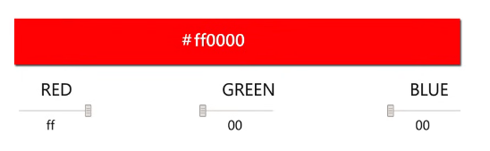
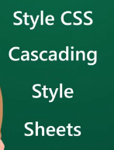
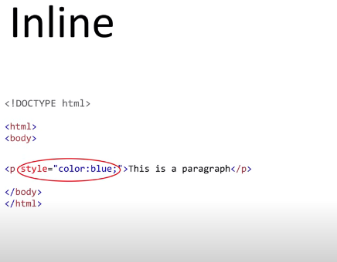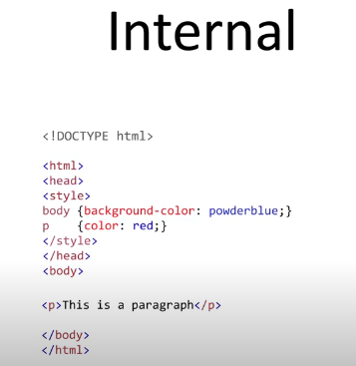
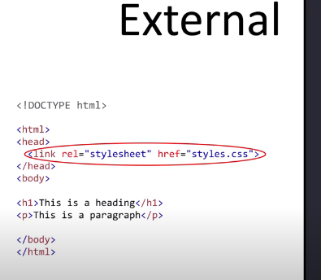

HTML Links - The target Attribute
By default, the linked page will be displayed in the current browser window. To change this, you must specify another target for the link.
The target attribute specifies where to open the linked document.
The target attribute can have one of the following values:
- _self - Default. Opens the document in the same window/tab as it was clicked
- _blank - Opens the document in a new window or tab
- _parent - Opens the document in the parent frame
- _top - Opens the document in the full body of the window

Example
Use target="_blank" to open the linked document in a new browser window or tab:
<a href="https://www.w3schools.com/" target="_blank">Visit W3Schools!</a>

Absolute URLs vs. Relative URLs
Both examples above are using an absolute URL (a full web address) in the href attribute.
A local link (a link to a page within the same website) is specified with a relative URL (without the "https://www" part):

HTML Links - Use an Image as a Link
To use an image as a link, just put the <img> tag inside the <a> tag:

Example
<a href="default.asp">
<img src="smiley.gif" alt="HTML tutorial" style="width:42px;height:42px;">
</a>

Link to an Email Address
Use mailto: inside the href attribute to create a link that opens the user's email program (to let them send a new email):

Example
<a href="mailto:someone@example.com">Send email</a>

Chapter Summary
- Use the <a> element to define a link
- Use the href attribute to define the link address
- Use the target attribute to define where to open the linked document
- Use the <img> element (inside <a>) to use an image as a link
- Use the mailto: scheme inside the href attribute to create a link that opens the user's email program
- Image Floating
- Use the CSS float property to let the image float to the right or to the left of a text:
- Example
- <p><img src="smiley.gif" alt="Smiley face" style="float:right;width:42px;height:42px;">
The image will float to the right of the text.</p>
<p><img src="smiley.gif" alt="Smiley face" style="float:left;width:42px;height:42px;">
The image will float to the left of the text.</p>
- HTML Image Tags
Tag | Description
<img> | Defines an image
<map> | Defines an image map
<area> | Defines a clickable area inside an image map
<picture> | Defines a container for multiple image resources
For more: HTML Images

The Title Element
The <title> element adds a title to your page:

Example
<!DOCTYPE html>
<html>
<head>
<title>HTML Tutorial</title>
</head>
<body>
The content of the document......
</body>
</html>

Define an HTML Table
A table in HTML consists of table cells inside rows and columns.

Example
A simple HTML table:
<table>
<tr>
<th>Company</th>
<th>Contact</th>
<th>Country</th>
</tr>
<tr>
<td>Alfreds Futterkiste</td>
<td>Maria Anders</td>
<td>Germany</td>
</tr>
<tr>
<td>Centro comercial Moctezuma</td>
<td>Francisco Chang</td>
<td>Mexico</td>
</tr>
</table>

Table Rows
Each table row starts with a <tr> and ends with a </tr> tag.
tr stands for table row.

Example
<table>
<tr>
<td>Emil</td>
<td>Tobias</td>
<td>Linus</td>
</tr>
<tr>
<td>16</td>
<td>14</td>
<td>10</td>
</tr>
</table>

Table Headers
Sometimes you want your cells to be table header cells. In those cases use the <th> tag instead of the <td> tag:
th stands for table header.

Example
Let the first row be table header cells:
<table>
<tr>
<th>Person 1</th>
<th>Person 2</th>
<th>Person 3</th>
</tr>
<tr>
<td>Emil</td>
<td>Tobias</td>
<td>Linus</td>
</tr>
<tr>
<td>16</td>
<td>14</td>
<td>10</td>
</tr>
</table>

HTML Table Tags
Tag | Description
<table> | Defines a table
<th> | Defines a header cell in a table
<tr> | Defines a row in a table
<td> | Defines a cell in a table
<caption> | Defines a table caption
<colgroup> | Specifies a group of one or more columns in a table for formatting
<col> | Specifies column properties for each column within a <colgroup> element
<thead> | Groups the header content in a table
<tbody> | Groups the body content in a table
<tfoot> | Groups the footer content in a table
For more HTML Tables

Ordered HTML List
An ordered list starts with the <ol> tag. Each list item starts with the <li> tag.
The list items will be marked with numbers by default:

Example
<ol>
<li>Coffee</li>
<li>Tea</li>
<li>Milk</li>
</ol>
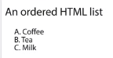

Unordered HTML List
An unordered list starts with the <ul> tag. Each list item starts with the <li> tag.
The list items will be marked with bullets (small black circles) by default:

Example
<ul>
<li>Coffee</li>
<li>Tea</li>
<li>Milk</li>
</ul>
