Linux Commands

Echo Command in Linux
The most straightforward usage of the echo command is to display a text or string on the terminal. echo "Hello, World!"
Options Available
The echo command has several options that modify its behavior:
- -e: Enables the interpretation of backslash escapes.
- -n: Omits the trailing newline.
- -E: Disables the interpretation of escape characters (default).

Escape Characters
When using the -e option, you can include various escape characters to format the output:
- \n: Adds a newline.
- \t: Adds a horizontal tab.
- \r: Carriage return.
- \b: Backspace.
- \a: Alert (bell).
- \v: Vertical tab.
- \c: Suppresses any further output.

The nc Command in Linux
- ¹²³
- The nc (Netcat) command is a powerful and versatile networking tool available on Linux, macOS, Windows, and BSD. It is often referred to as the "Swiss Army knife" of networking tools due to its wide range of functionalities, including debugging and monitoring network connections, port scanning, data transfer, and more

Netcat Syntax
- The most basic syntax of the Netcat utility takes the following form:
- nc [options] host port

- By default, nc attempts to start a TCP connection to the specified host and port. To establish a UDP connection, use the -u option:
nc -u host port
Port Scanning
Netcat can scan for open ports on a target host. For example, to scan ports 20-80 on a host:
nc -z -v 10.10.8.8 20-80
The -z option tells nc to scan for open ports without sending any data, and the -v option provides verbose output

10. Create a chat server
On the server side run
# nc -l 1234
On the client side run
# nc example.com 1234
This command will create a chat server that allows users to communicate via a TCP connection. The server listens for incoming connections on port 1234, while clients connect to the server using the remote host’s IP address or domain name. Once connected, users can type messages that are sent over the connection.
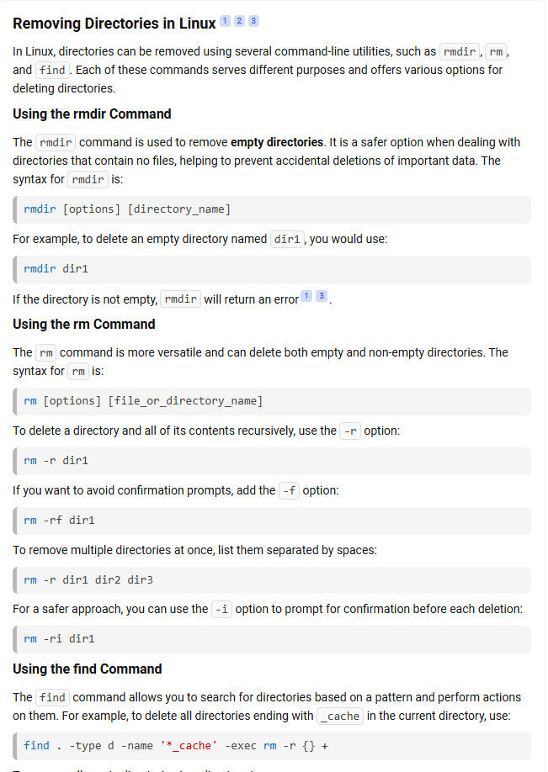

1. Search for a Pattern in Files Within a Directory
grep "pattern" /path/to/directory/*
This searches for "pattern" in all files within the specified directory.

2. Recursive Search in All Files and Subdirectories
grep -r "pattern" /path/to/directory
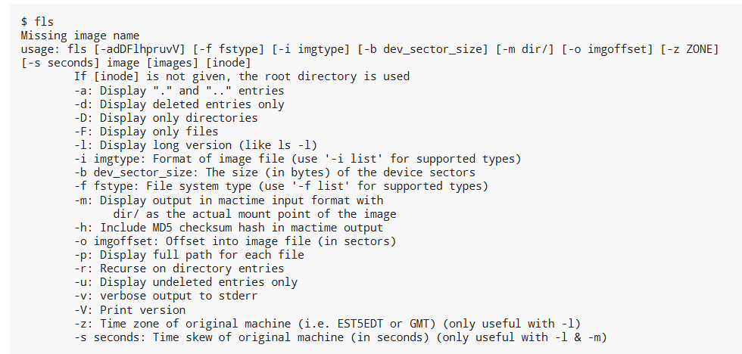
The wget command is a powerful and widely used utility for non-interactive downloading of files from the web. It supports HTTP, HTTPS, and FTP protocols and is often used in scripts or for downloading large files.

Basic Syntax:
Copy the codewget [options] [URL]

Common Use Cases:
- Download a Single File:
- Copy the codewget https://example.com/file.zip
This downloads file.zip to the current directory.
- Download and Save with a Custom Name:
- Copy the codewget -O custom_name.zip https://example.com/file.zip
Saves the file as custom_name.zip.
- Resume a Partially Downloaded File:
- Copy the codewget -c https://example.com/largefile.zip
The -c option resumes an interrupted download.
- Download Files in the Background:
- Copy the codewget -b https://example.com/largefile.zip
Runs the download in the background and logs progress to wget-log.
- Download an Entire Website:
- Copy the codewget --mirror --convert-links --adjust-extension --page-requisites --no-parent https://example.com
This mirrors the website for offline use.
- Limit Download Speed:
- Copy the codewget --limit-rate=200k https://example.com/file.zip
Limits the download speed to 200 KB/s.
- Download Files from a List:
- Copy the codewget -i filelist.txt
Downloads all URLs listed in filelist.txt.
- Set User-Agent:
- Copy the codewget --user-agent="Mozilla/5.0" https://example.com
Sets a custom User-Agent header.
- Authenticate with Username and Password:
- Copy the codewget --user=username --password=password https://example.com/protectedfile.zip
- Skip SSL Certificate Verification:
- Copy the codewget --no-check-certificate https://example.com
Useful for self-signed certificates (use cautiously).

Helpful Options:
- -q: Quiet mode (no output).
- -v: Verbose mode (default).
- -r: Recursive download.
- -np: No parent directory traversal.
- --timeout=SECONDS: Set a timeout for the connection.

