Public Satisfaction with AI in High-Risk and Low-Risk Decision Contexts: An Ordinal Analysis of Demographic and Contextual Effects
Ashik Chandra Das, Qazi Novera Tansue Nasa
Bielefeld University of Applied Science and Arts, Germany.
University of Potsdam, Germany
Abstract:
Introduction:
Artificial intelligence (AI) has rapidly become part of everyday institutional decision-making. AI systems are now used to assist medical diagnosis, evaluate credit applications, detect financial risk, personalize learning, and support educational assessment. As these systems become more common, AI is no longer viewed only as a technical tool, but increasingly as a decision-support mechanism that can influence important outcomes in people’s lives. Because of this growing role, understanding how the public evaluates and responds to AI has become an important research issue in technology governance and social acceptance studies (Aysolmaz et al., 2023; Starke et al., 2022).
Although AI promises efficiency, speed, and data-driven accuracy, public reactions toward AI-based decisions remain mixed. People do not automatically accept algorithmic systems simply because they are technologically advanced. Instead, they often evaluate AI according to whether it appears fair, accountable, transparent, and trustworthy. Previous studies show that public acceptance of algorithmic decision-making is strongly shaped by perceptions of fairness and social risk, especially when automated systems are involved in decisions with personal consequences (Starke et al., 2022; Wang et al., 2020). Therefore, technical capability alone is not sufficient for successful AI adoption; public satisfaction with AI has become equally important.
A growing body of literature further suggests that public satisfaction with AI is not the same across all areas of use. Individuals often respond more positively to AI in routine or low-consequence situations, but they become more cautious when AI is involved in decisions that can affect health, finances, or social opportunities. Brauner et al. (2023) describe this as a difference in the perceived criticality of AI applications, arguing that people judge AI differently depending on the seriousness of the possible consequences if the system fails. Similarly, recent cross-context trust studies report that citizens show varying levels of trust and benevolence judgments toward AI across sectors such as healthcare, education, and other social domains (Brauner et al., 2023; Novozhilova et al., 2024). This means that AI should not be studied as one general technology, because public satisfaction may depend heavily on where the technology is used.
Healthcare, banking, and education provide an especially useful comparison for examining this issue. In healthcare, AI recommendations may affect diagnosis quality, treatment selection, and patient safety, making this a highly consequential setting. Public opinion studies consistently show that people remain hesitant about allowing AI to make or dominate medical decisions, even when they recognize its possible efficiency benefits (Longoni et al., 2019; Rojahn et al., 2023). Banking also represents a high-risk context because algorithmic decisions can determine loan approval, fraud suspicion, or financial eligibility, which directly influence economic security. In such contexts, concerns about fairness, opacity, and the inability to challenge machine judgments become more visible (Aysolmaz et al., 2023). By contrast, educational AI systems such as tutoring support, grading assistance, and learning recommendations are often viewed as relatively lower risk because their outcomes are usually more reversible and can be corrected by human intervention. These three sectors therefore create a meaningful continuum between high-criticality and lower-criticality AI decision environments.
In addition to contextual differences, public satisfaction with AI may also be influenced by demographic characteristics. Among these, age has been frequently discussed in technology acceptance literature. Older adults often report greater skepticism toward automated systems because they tend to have lower digital familiarity and stronger preference for human judgment in important decisions. Younger individuals, on the other hand, are generally more accustomed to interacting with intelligent technologies and may therefore be more open to AI-assisted decision making (Brauner et al., 2025).
Educational attainment may create a different form of influence. Individuals with higher education often have greater access to technological knowledge, stronger information literacy, and more confidence in understanding how digital systems operate. This may reduce uncertainty and increase confidence in algorithmic systems. Research on AI trust has shown that technological familiarity and knowledge-based competence are positively associated with favorable judgments toward AI capabilities in multiple social domains (Novozhilova et al., 2024; Van de Walle et al., 2024). Thus, education may serve as an important predictor of how comfortable people feel with AI-supported decisions.
Despite the increasing number of studies on AI trust and algorithmic fairness, three important gaps remain. First, many studies focus on public attitudes toward AI within a single sector and do not directly compare high-criticality and low-criticality decision contexts. Second, demographic characteristics are often included only as background controls rather than as central explanatory variables. Third, limited empirical work examines whether demographic influences such as age and education become stronger or weaker depending on the seriousness of the AI decision environment. In other words, it is still unclear whether public satisfaction with AI is shaped primarily by who the users are, where AI is used, or by the interaction between these two conditions.
To address these gaps, the present study investigates public satisfaction with AI across three socially important domains: healthcare, banking, and education. These domains represent different levels of perceived decision criticality and allow a comparison between high-risk and low-risk AI applications. The study also examines whether age and educational attainment influence public satisfaction with AI and whether these demographic effects vary across contexts.
Accordingly, this study addresses the following research questions:
RQ1: How does public satisfaction with AI vary across decision contexts characterized by different levels of perceived criticality?
RQ2: To what extent do age and educational attainment influence public satisfaction with AI?
RQ3: Do the effects of age and education on AI satisfaction differ across high-risk and low-risk decision contexts?
Based on the above literature, the study proposes the following hypotheses:
H1a: Public satisfaction with AI is lower in high-criticality decision contexts than in low-criticality decision contexts.
H1b: Among the selected domains, public satisfaction with AI is lowest in healthcare, followed by banking, and highest in education.
H2a: Age is negatively associated with public satisfaction with AI.
H2b: Educational attainment is positively associated with public satisfaction with AI.
H3a: The negative effect of age on public satisfaction with AI is stronger in high-criticality decision contexts than in low-criticality decision contexts.
H3b: The positive effect of educational attainment on public satisfaction with AI differs across decision contexts and is stronger in high-criticality contexts.
Methodologically, this study applies an ordinal analytical approach because satisfaction with AI is measured through ordered levels of agreement rather than continuous numerical scores. This method enables a more precise estimation of how demographic and contextual variables influence increasing or decreasing levels of public satisfaction. By combining contextual comparison with demographic interaction effects, the study contributes to the broader literature on responsible AI adoption and highlights that public acceptance of AI depends not only on technological performance but also on decision seriousness and user background.
The remainder of this paper is organized as follows. Section 2 reviews the relevant literature on AI satisfaction, perceived decision criticality, and demographic influences, and further develops the theoretical logic behind the hypotheses. Section 3 presents research methodology, including data collection, variable measurement, and the ordinal regression model. Section 4 reports empirical findings. Section 5 discusses the results in relation to prior studies and practical implications. Finally, Section 6 concludes the paper with limitations and directions for future research.

Result and Discussion:
The first image
RQ1
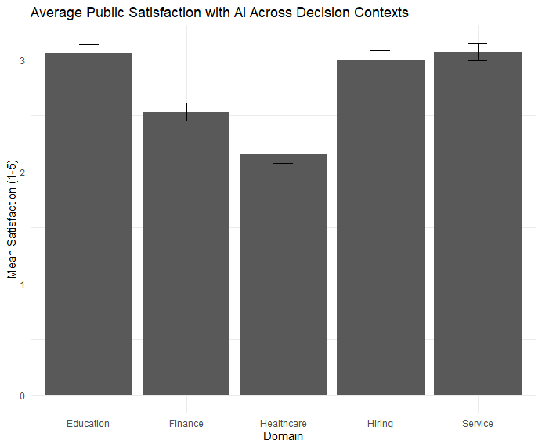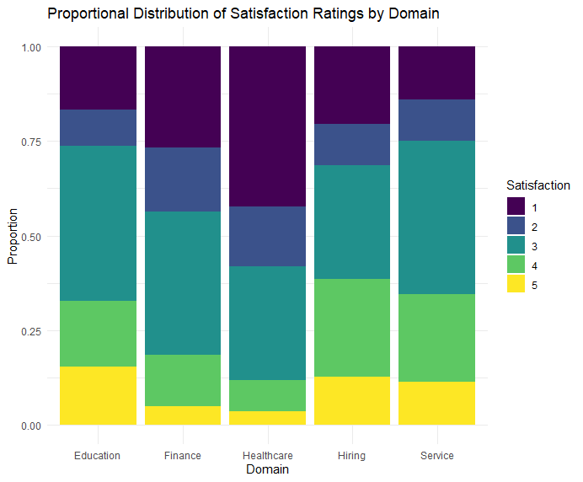
Figure 1: (a) Average Public Satisfaction with AI in Decision Contexts, (b) Proportional Distribution of Satisfaction Ratings by Domain

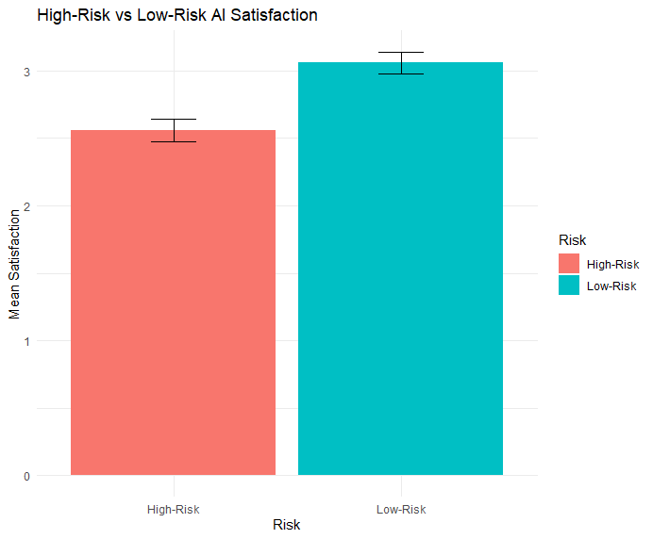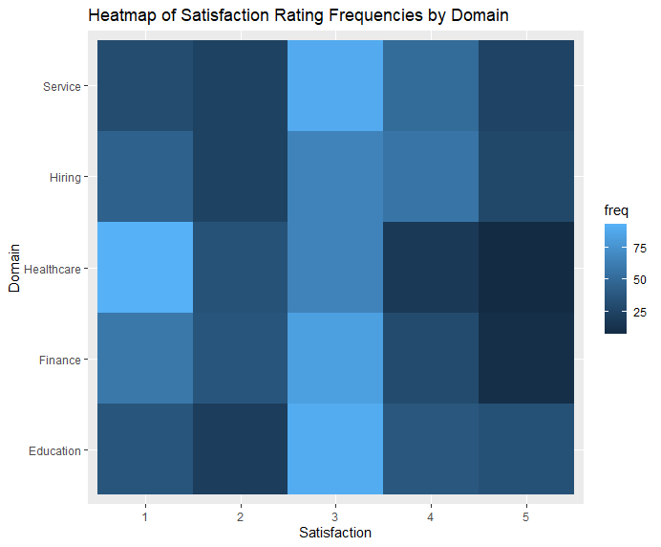

Figure 2: (a) High Risk vs Low Risk Satisfaction, (b) Satisfaction Rating Frequencies by Domain

Model Based:
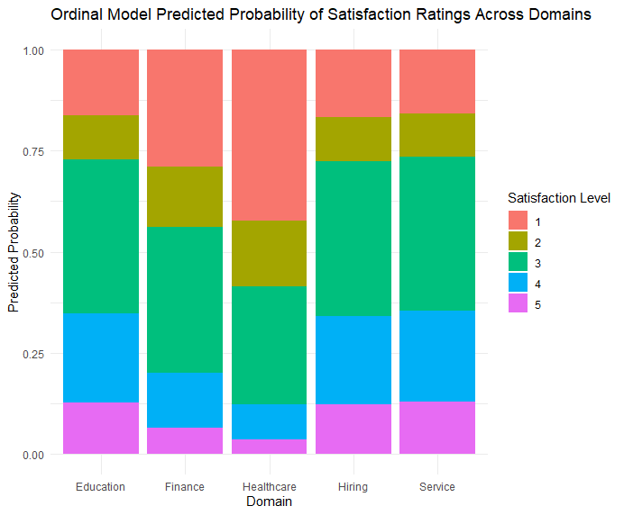
Figure 3: Ordinal Model Predicted Probability of Satisfaction Ratings Across Domains

RQ2:
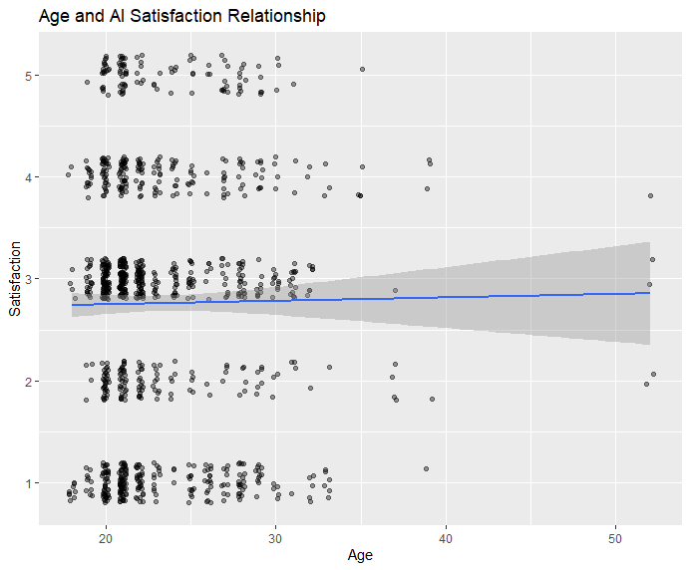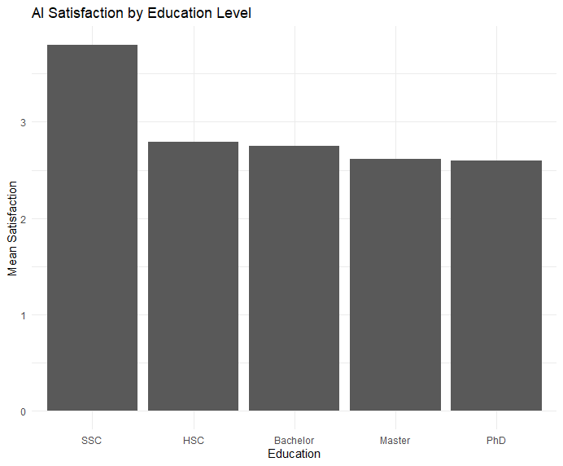
Figure 4: (a) Age and AI satisfaction Relationship (b) AI satisfaction by Education Level
Model:
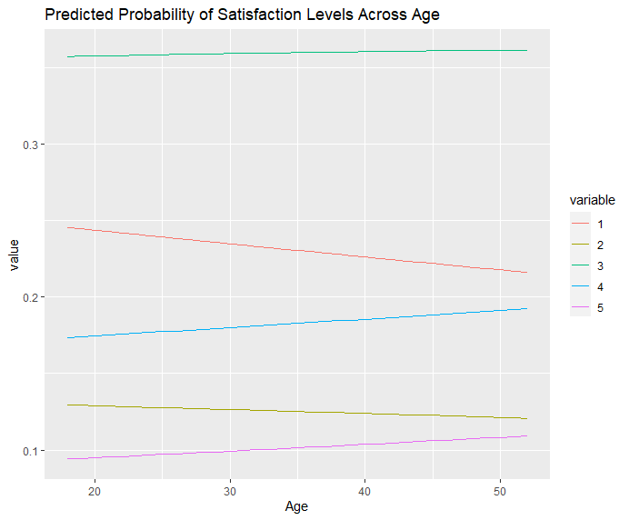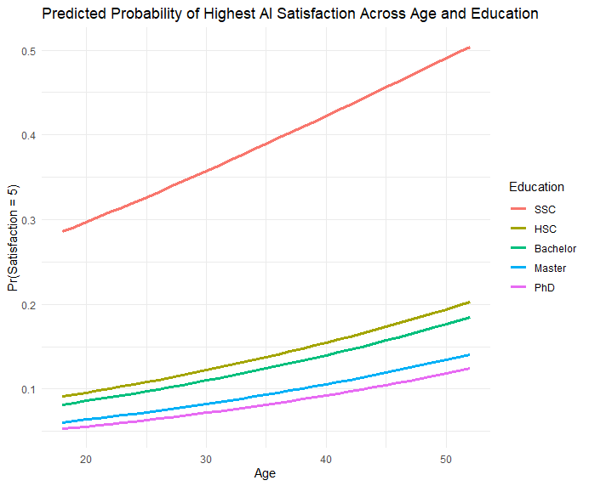
Figure 5: (a) Predicted Probability of Satisfaction Levels Across Age (b) Predicted Probability of highest AI Satisfaction Across Age and Education

RQ3:
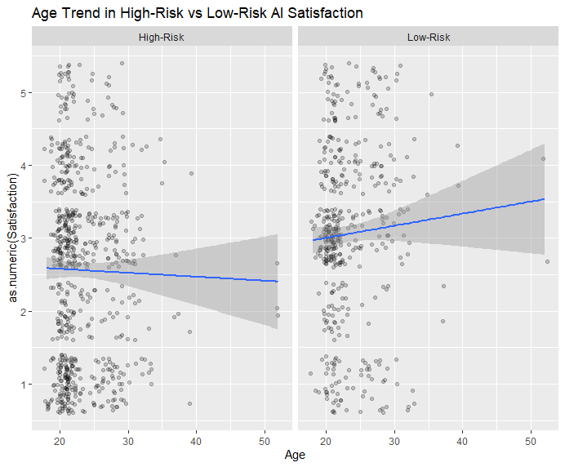
Figure 6: Age Trend in High Risk vs Low Risk AI Satisfaction

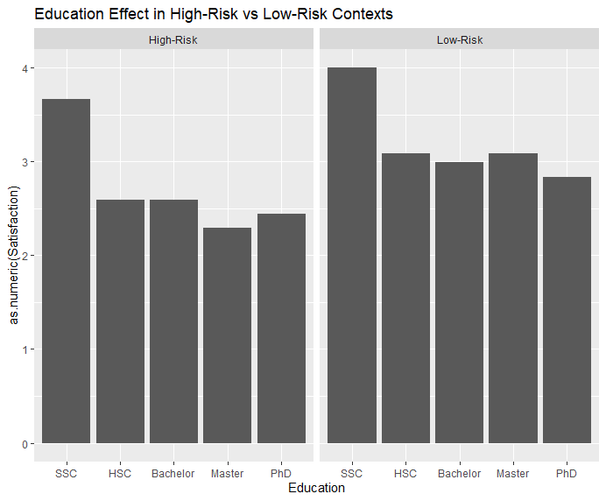
Figure 7: Education Effect in High Risk vs Low Risk Context

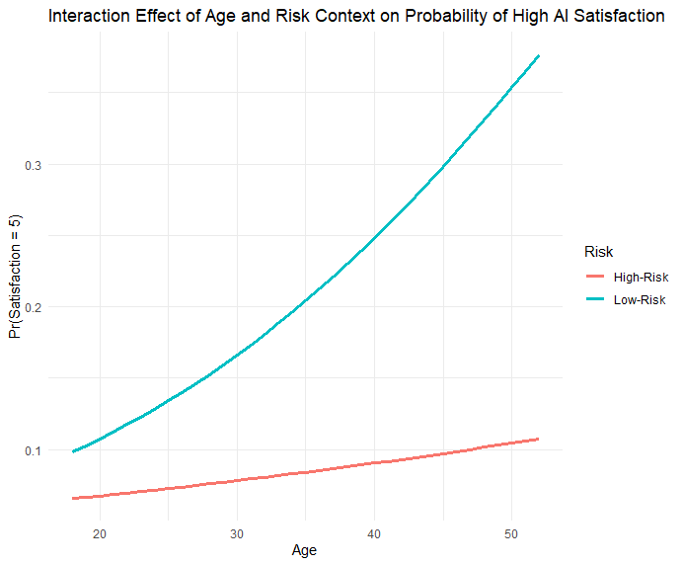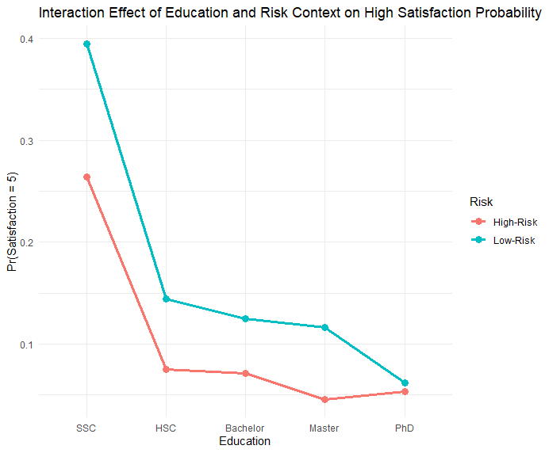
Figure 8: Interaction Effect of (a) Age (b) Education and Risk Context on Probability of High AI Satisfaction.

References:
Aysolmaz, B., Muller, R. E., & Meacham, D. (2023). The public perceptions of algorithmic decision-making systems: Results from a large-scale survey. Telematics and Informatics, 79, 101954. https://doi.org/10.1016/j.tele.2023.101954
Brauner, P., Hick, A., Philipsen, R., & Ziefle, M. (2023). What does the public think about artificial intelligence? A criticality map to understand bias in the public perception of AI. Frontiers in Computer Science, 5, 1113903. https://doi.org/10.3389/fcomp.2023.1113903
Brauner, P., Glawe, F., Liehner, G. L., Vervier, L., & Ziefle, M. (2025). Mapping public perception of artificial intelligence: Expectations, risk–benefit tradeoffs, and value as determinants for societal acceptance. Technological Forecasting and Social Change, 220, 124304. https://doi.org/10.1016/j.techfore.2025.124304
Longoni, C., Bonezzi, A., & Morewedge, C. K. (2019). Resistance to medical artificial intelligence. Journal of Consumer Research, 46(4), 629–650. https://doi.org/10.1093/jcr/ucz013
Novozhilova, E., Mays, K., Paik, S., & Katz, J. E. (2024). More capable, less benevolent: Trust perceptions of AI systems across societal contexts. Machine Learning and Knowledge Extraction, 6(1), 342–366. https://doi.org/10.3390/make6010017
Rojahn, J., Palu, A., Skiena, S., & Jones, J. J. (2023). American public opinion on artificial intelligence in healthcare. PLOS ONE, 18(11), e0294028. https://doi.org/10.1371/journal.pone.0294028
Starke, C., Baleis, J., Keller, B., & Marcinkowski, F. (2022). Fairness perceptions of algorithmic decision-making: A systematic review of the empirical literature. Big Data & Society, 9(2), 1–23. https://doi.org/10.1177/20539517221115189
Van de Walle, B., Steyvers, M., & Van Oost, P. (2024). Factors influencing trust in algorithmic decision-making: An indirect scenario-based experiment. Frontiers in Artificial Intelligence, 7, 1465605. https://doi.org/10.3389/frai.2024.1465605
Wang, R., Harper, F. M., & Zhu, H. (2020). Factors influencing perceived fairness in algorithmic decision-making: Algorithm outcomes, development procedures, and individual differences. Proceedings of the 2020 CHI Conference on Human Factors in Computing Systems, 1–15.

