

Weather FORCAST   
Assignment REPORT

**rUPAL SINGH**

**A00268800**

# **Introduction**

This is a ‘Weather Forecast Web Application’ developed as a part of my assessment at Athlone IT in the subject Client-Side Technologies. The purpose is to use the API from openweathermaps.org using an ajax request, to get the XML format and parse the data received and display it on the browser in an easy to comprehend manner. Once the user enters the name of the city of his choice, he/she could view its weather conditions at that instance and for the next 5 intervals of 3 hours, displayed over the period of 15 hours. The user will also be able to toggle through, to see the graph of the different temperature i.e. min temperature and maximum temperature.

I’ve used Vanilla / Pure JavaScript to implement my requests and displayed it over the browser using HTML scripting along with making it slightly visually appealing using CSS styling.

# **Web Page**

This is the landing page of my website when you run Main.html. The user will be required to type in the name city they want to check the weather forecast for.



After the user enters the name of the city, the ajax request will be sent to open weather map along with the name of city. Weather data will be fetched in the form of XML file which will be parsed to show the details in a following way.

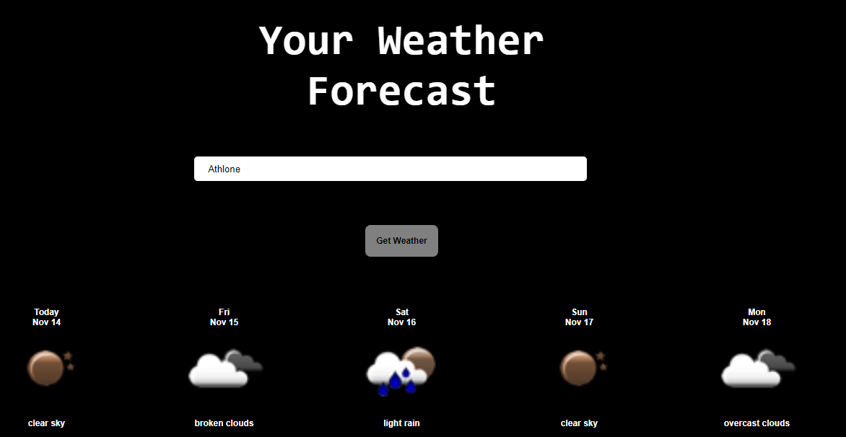

In the above picture is the forecast for Athlone I’ve used another API from openweathermap.org to fetch the icon pack and displayed the weather icon accordingly.

Here, following data is displayed:

* Current Date
* Time Interval for the data
* Wind Speed
* Wind Direction
* Current Temperature
* Climate condition through a picture.

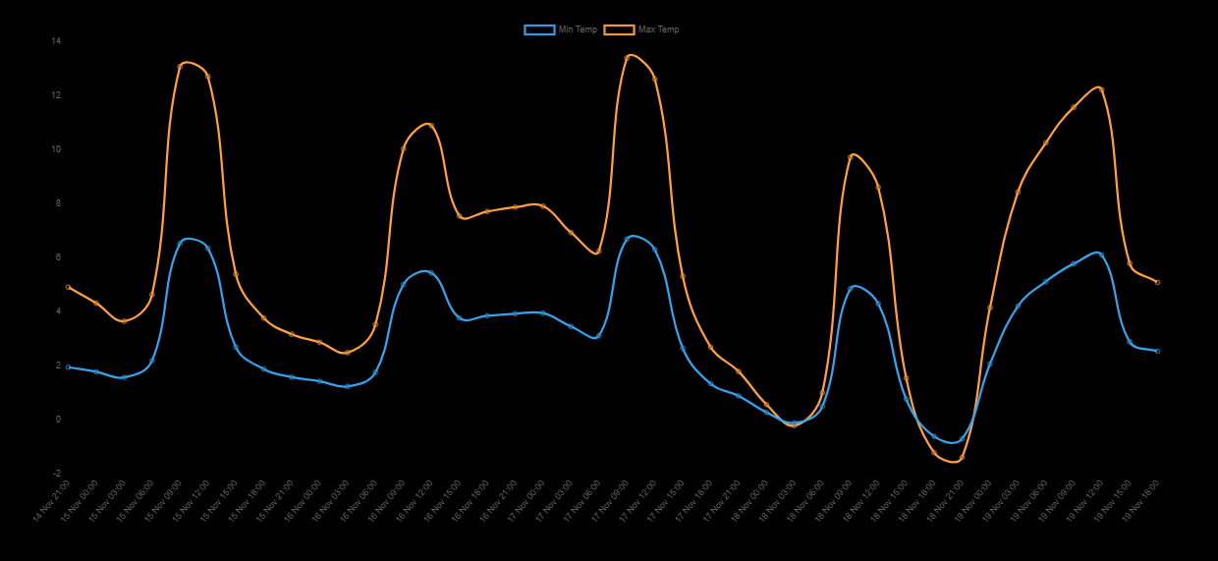

The graphs are created with the help of **Charts.js** library. Bar graph to show the minimum and the maximum temperature of the five intervals and the line graph to show the variation in humidity and pressure.

# **CONCLUSION**

This assignment was a good learning curve that showed me the implementation of AJAX and DOM scripting as well as using online API’s in a live scenario . It helped me to further increase my knowledge of HTML, CSS and JavaScript and was good practice in using pure Javascript without the use of our preferred libraries.