Fall 2017

ECS171 HW1

Gabriel Yin

999885129

**Problem 1**

The dataset (392 samples) can be divided into three sets so that low has 130 elements, medium has 131 elements and high has 131 elements. Threshold for low

to medium is 18.6 and from medium to high is 26.8.

**Problem 2**

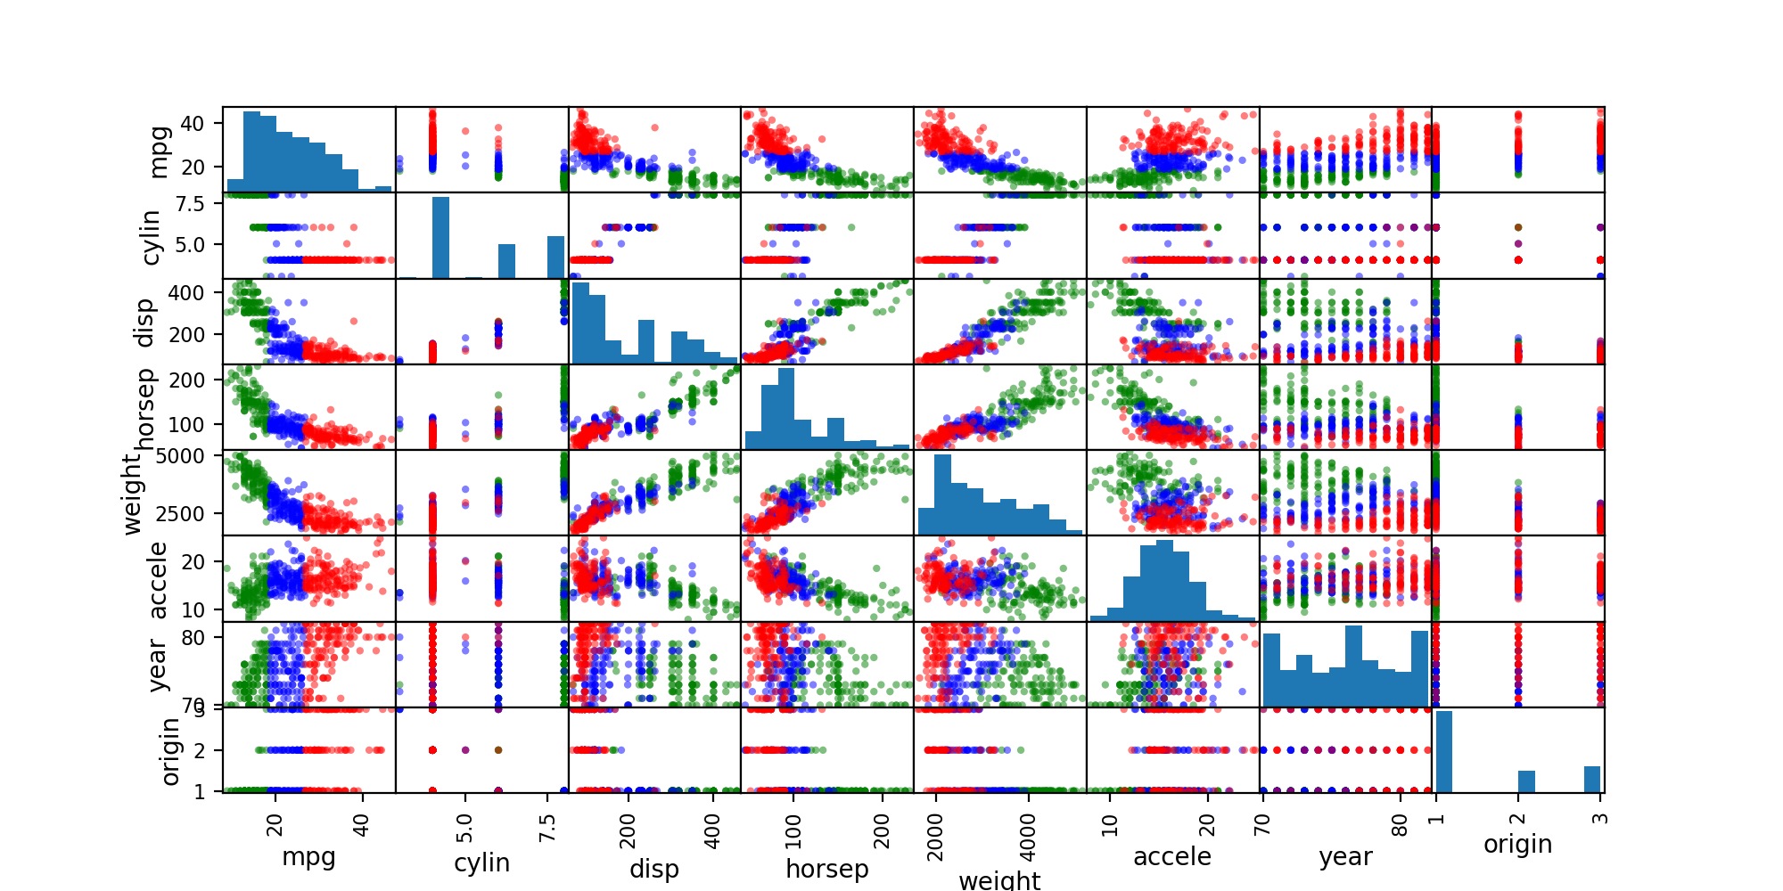

From the chart above, we can see that displacement and horsepower and weight and accelerations and year are the informative ones. Among them, horsepower is the most informative one.

**Problem 3**

Please see function OLS.

**Problem 4**

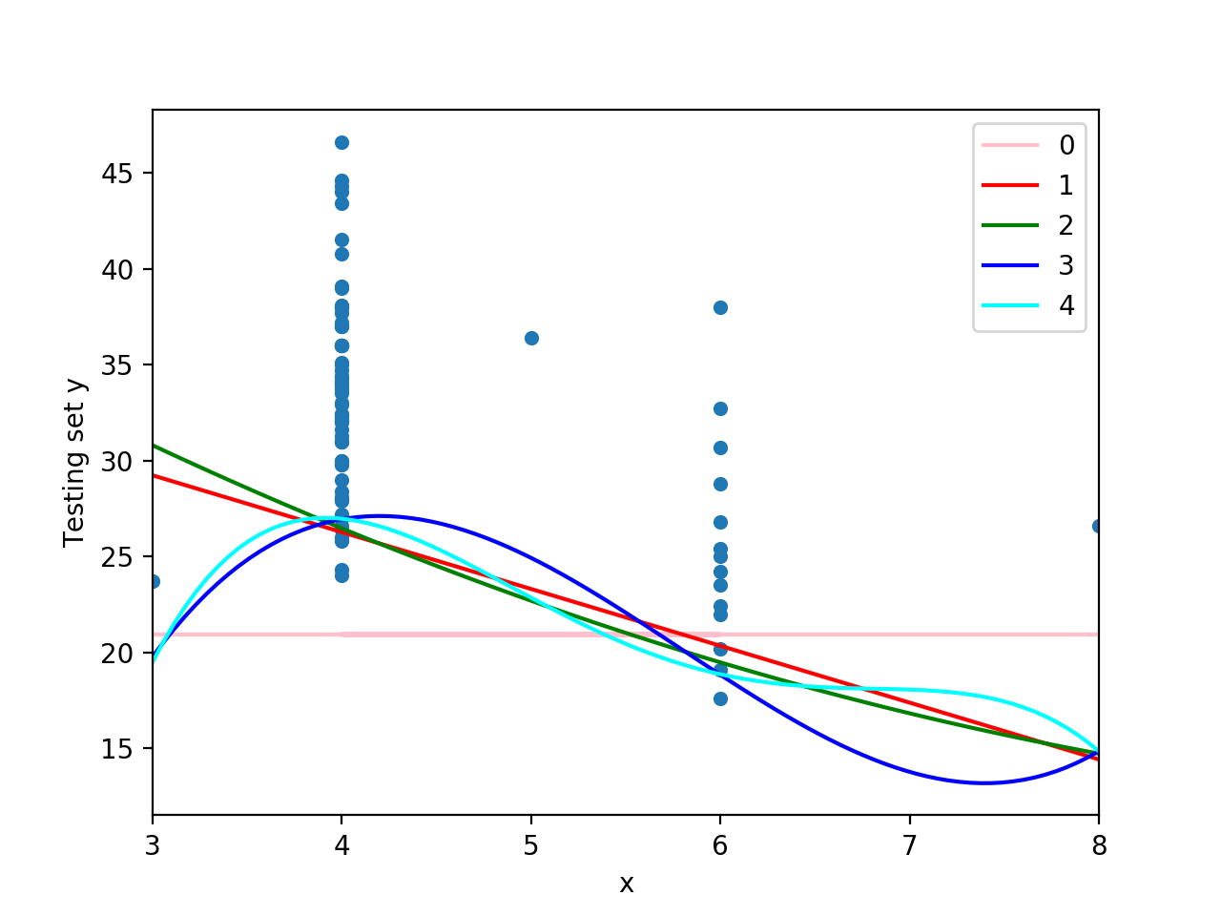

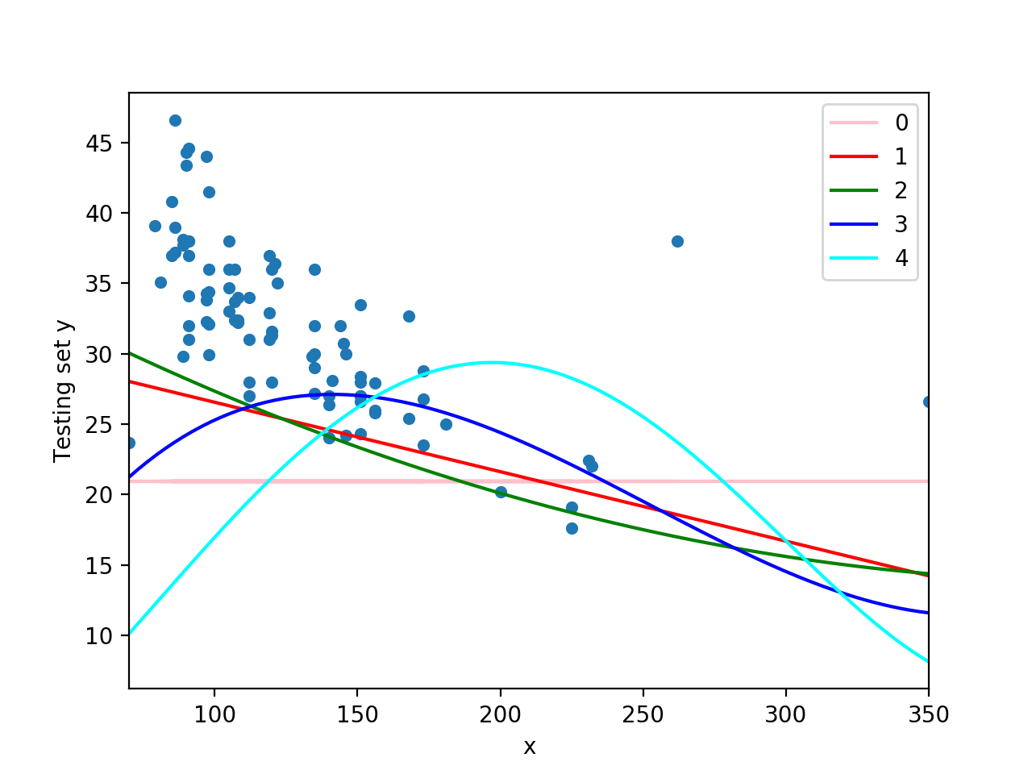

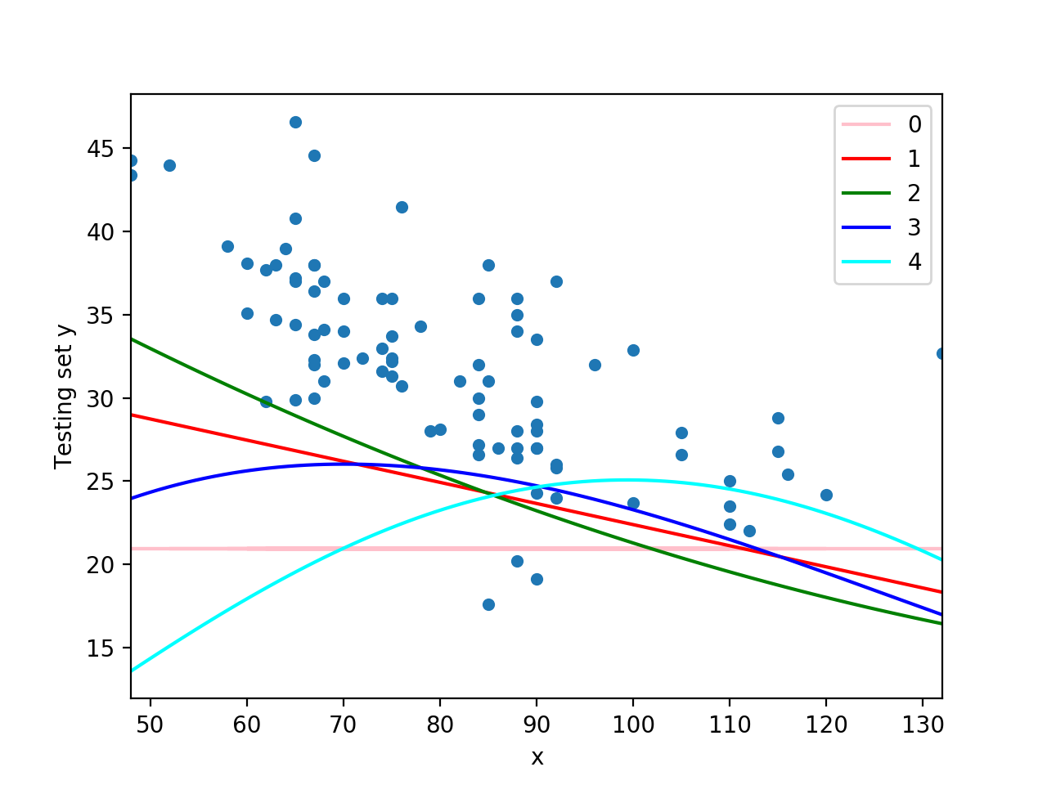

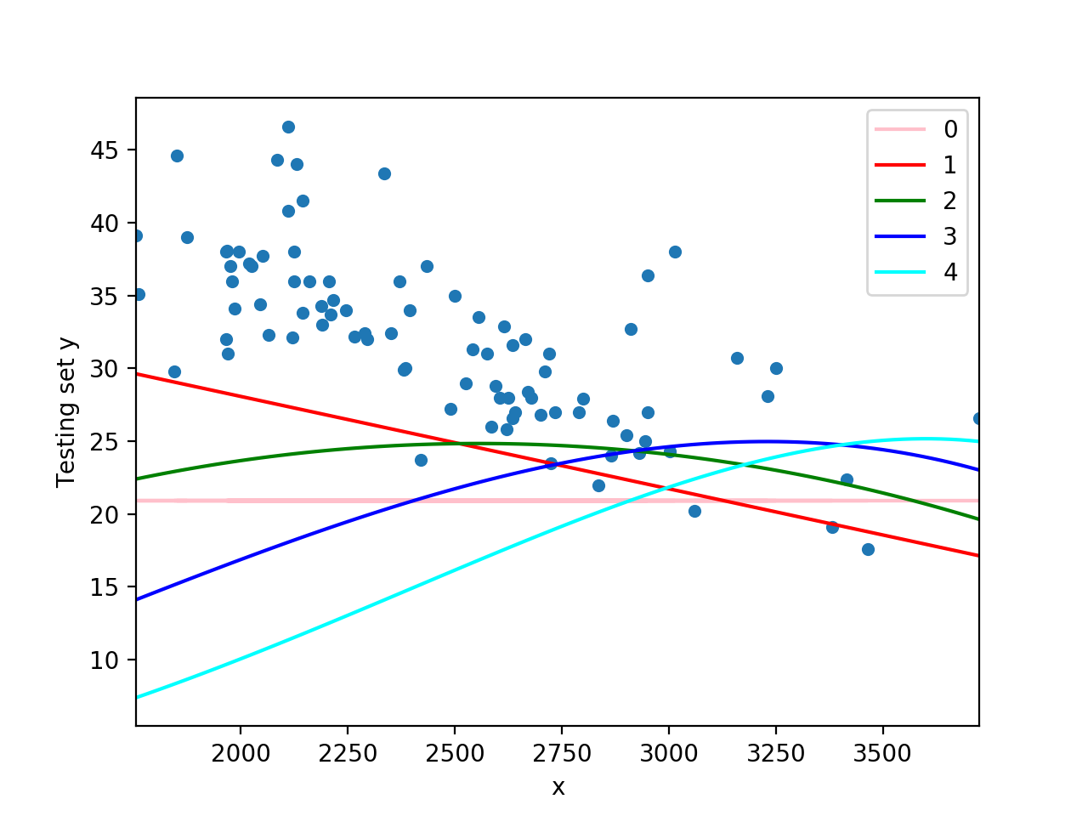

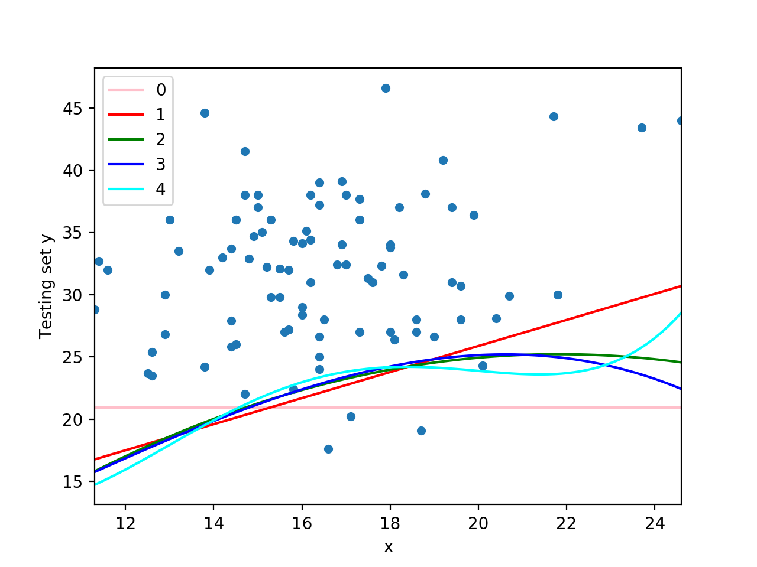

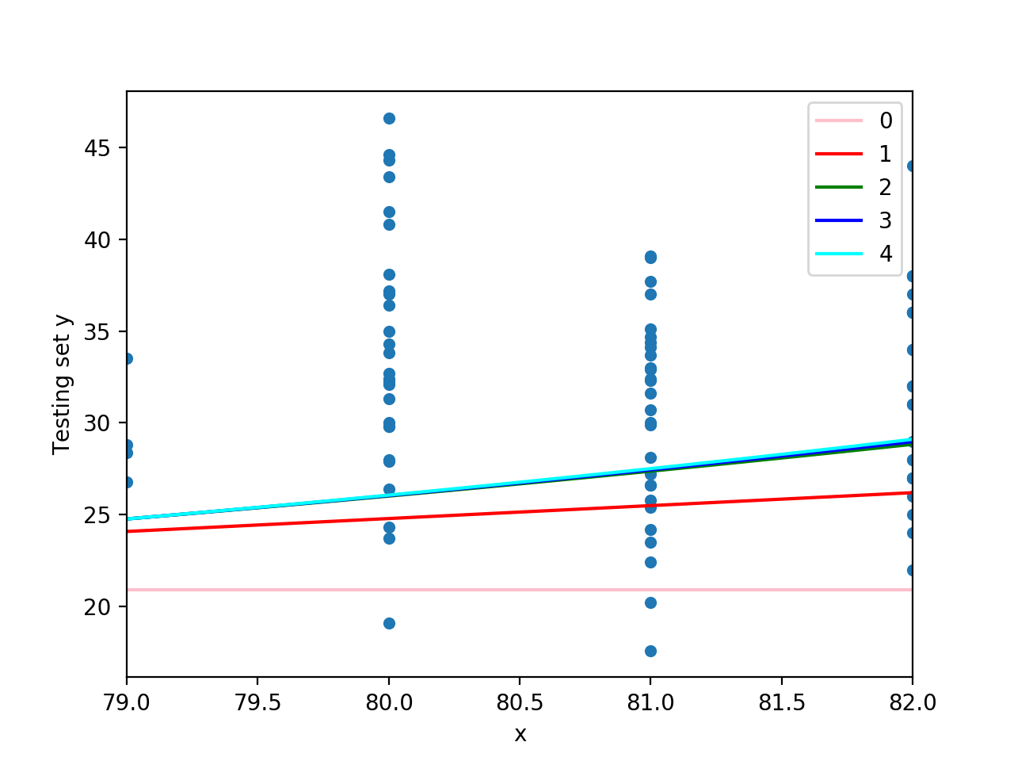

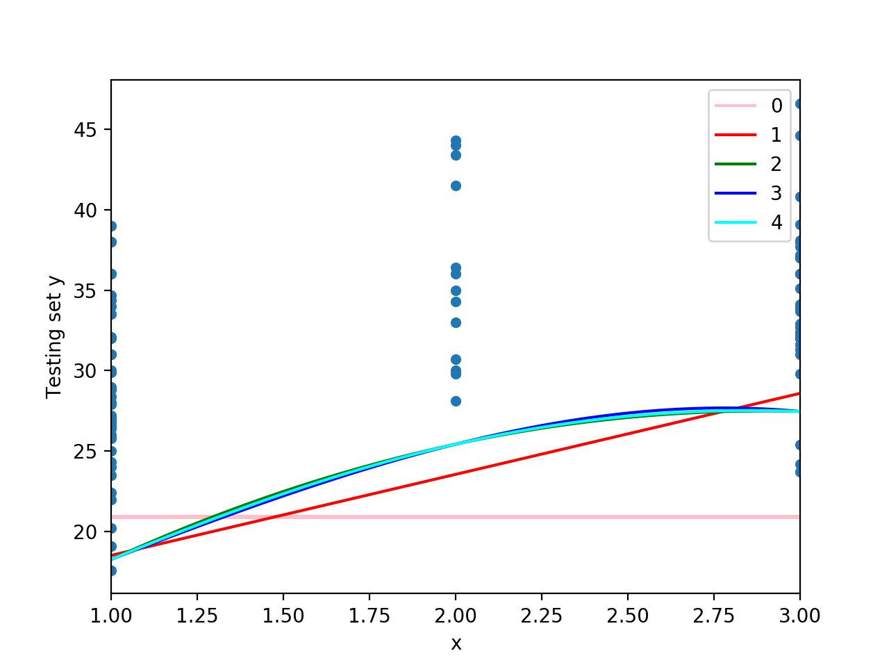

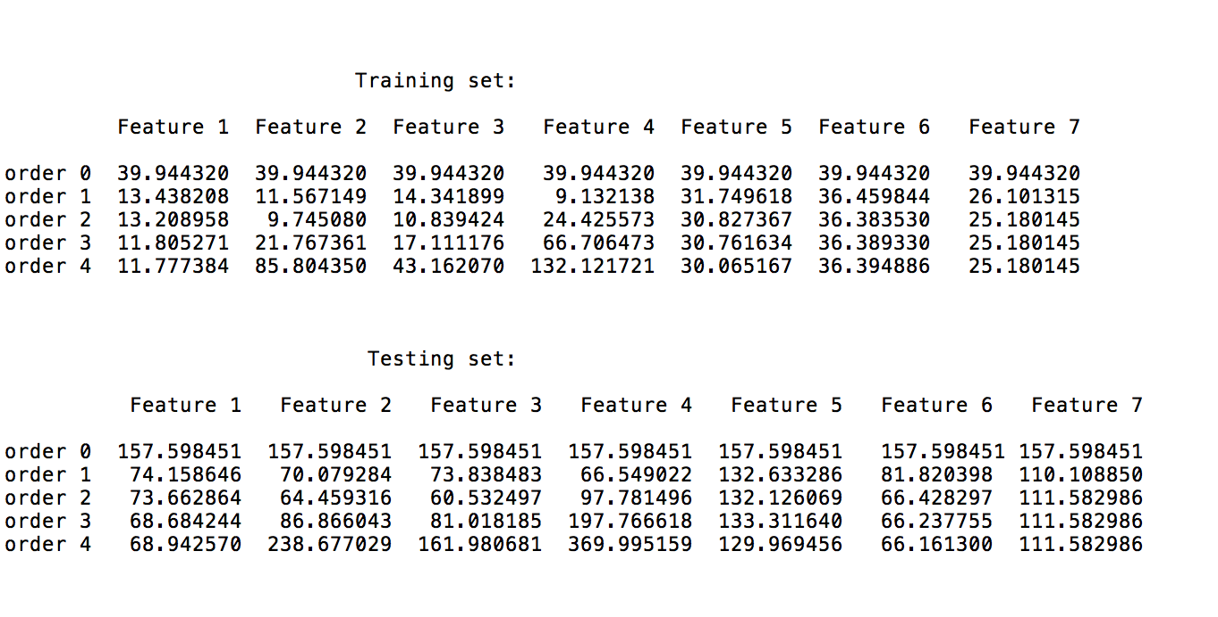

From the MSE table above, we can see that 2nd order is the best and the horsepower feature is the most informative one.

**Problem 5**

Training MSE Testing MSE

Order 0: 39.944320 157.598451

Order 1: 7.126725 33.358956

Order 2: 4.906403 28.345249

**Problem 6**

Training Precision: 85.333%

Testing Precision: 64.130%

**Problem 7**

It will fall into the low category.

**Problem 8**

This car has a MPG of 0 since it has no engine and cow does not consume gasoline.