# Introduction

The purpose of this document is to describe how to use this Lucky Draw Program.

Lucky Draw Program is a web application based requirement of HRA department.  
Detail Requirement as below:

* System supports extracting multiple winning at the same time, maximum 10 winners for once drawn.
* Each candidate can ONLY be a lucky dog one time.
* System support import candidates name list flexibly.
* System records the association between the winners and the prizes.
* System keeps the last winners on the screen. (new requirement)
* .
* .

# Usage

## Usage – HR

For HR department will focus on prepare candidates name list, include English Name, Chinese Name, Department.

### Open Chrome or Firefox or IE(>=9) as browser.

Input below information:

<http://zhangtt-2-w7:8090/admin/>

Username: hr

Password: 123456

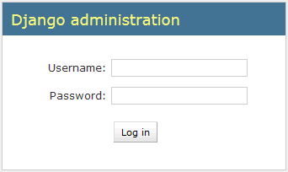

### After login, the screen should be as below:

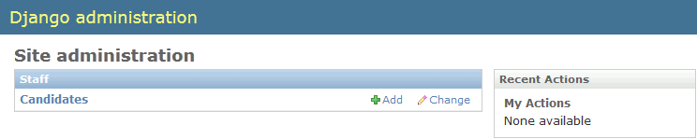

### After clicked “Add” action, the screen should be as below,

System supports two ways to add candidates:

1. **Single Add**. English Name and Department are required. Consider some staff without Chinese Name.
2. **Batch Upload**, here attached excel template as example.

|  |  |  |
| --- | --- | --- |
| **English Name** | **Chinese Name** | **Team** |
| AAAAAA (\*) | 红红红 | Team1 |
| BBBBBB | 橙橙橙 | Team2 |
| CCCCCC (\*) | 黄黄黄 | Team3 |
| DDDDDD (\*) | 绿绿绿 | Team4 |
| EEEEEEE (\*) | 蓝蓝蓝 | Team5 |

<NameList_LuckyDraw.xlsx>

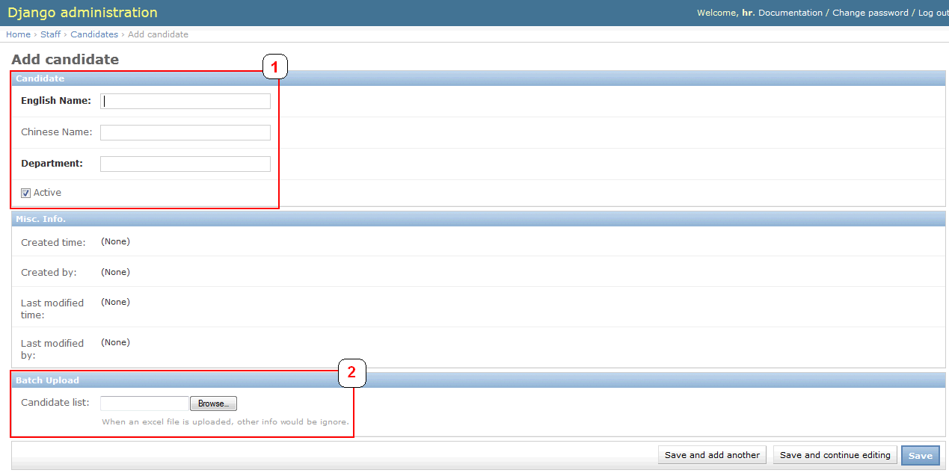

### After clicked “Save” button, the screen should be as below,

System supports below functions:

1. **Search Candidates**.   
   Support English Name, Chinese Name and Department as search criteria. Such as: search “UCD”

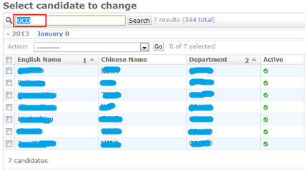

1. **Modify / Delete / Deactivate / Activate Candidates**.
   * Select candidate’s English name could modify related information. 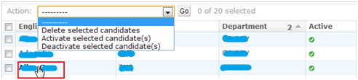
   * Pick up checkbox in front of candidate, select “Delete selected candidates” and click “Go” button, system will show as below: 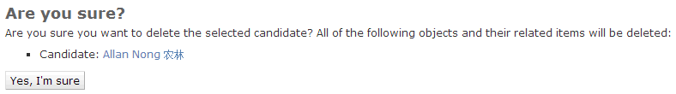
   * Deactivate and Activate candidates, pick up checkbox in front of candidate, select “Deactivate selected candidate(s)” and click “Go” button. This candidate will be deactivate.  
     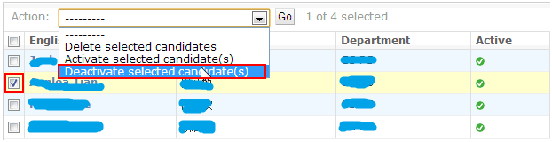 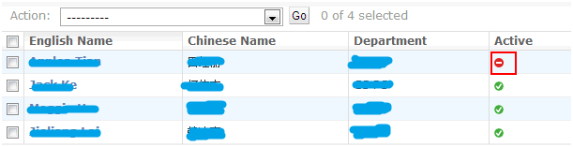

## Usage – Operator

For the operations staff of lucky draw will focus on how many winners should be extract on time, and how to start and stop.

### Start and Stop program.

System supports two ways to start program:

1. **By Mouse**. Click “START” and “STOP” button  
    
2. **By Keyboard**, either “Enter” or “Space” key can trigger.

## Installation

### Download and Install python 2.7.3

Go to: <http://www.python.org/>

According to your PC (32bit or 64bit)

Click the installer to install python as shown below:

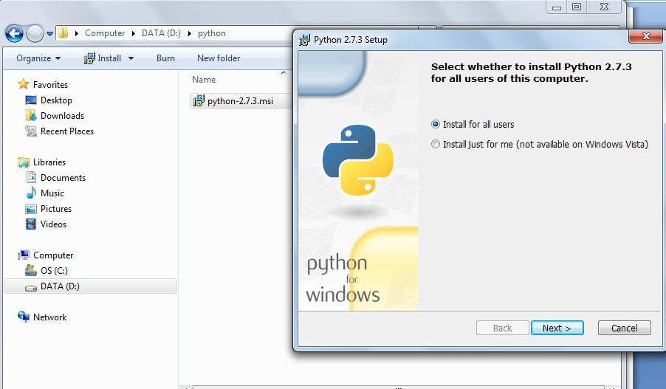

Next and next and next till it gets done

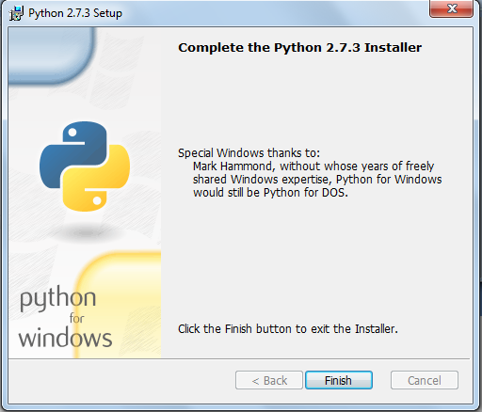

Set the environmental variable according to your installation directory

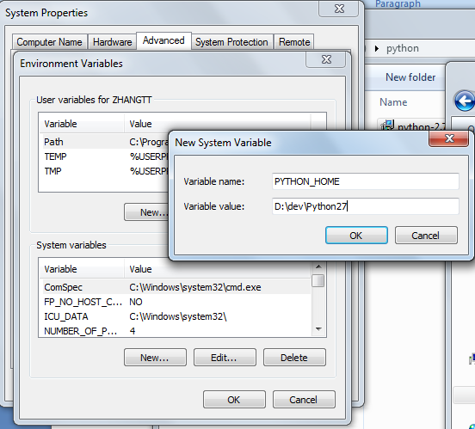

Add below string to existing variable PATH

%PYTHON\_HOME%;%PYTHON\_HOME%\Scripts;

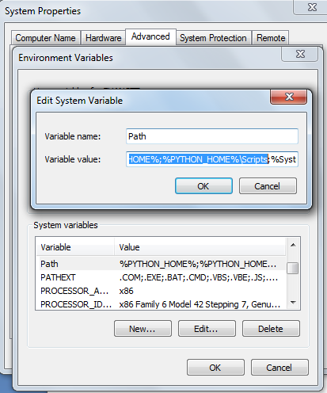

Verification: open cmd

Type python –V

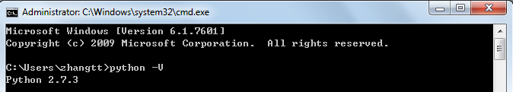

Open link <http://peak.telecommunity.com/dist/ez_setup.py>

Copy all content within to a file named ez\_setup.py in local directory

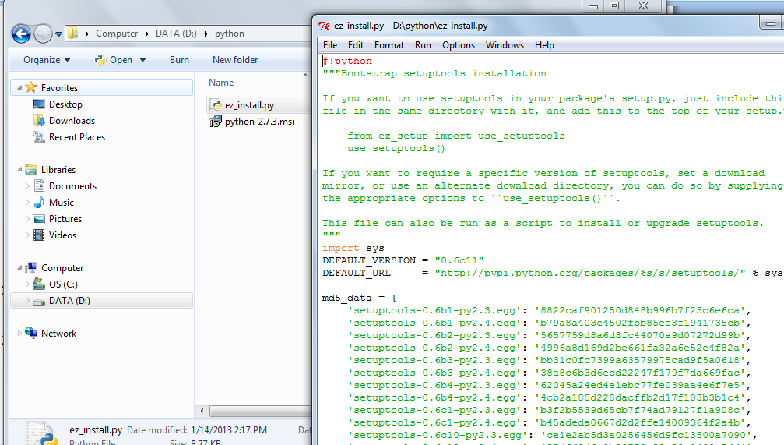

**Install python package**

**Type below command lines in a row, one by one**

python ez\_setup.py

easy\_install pip

pip install django or (easy\_install django)

pip install xlrd or (easy\_install xlrd)

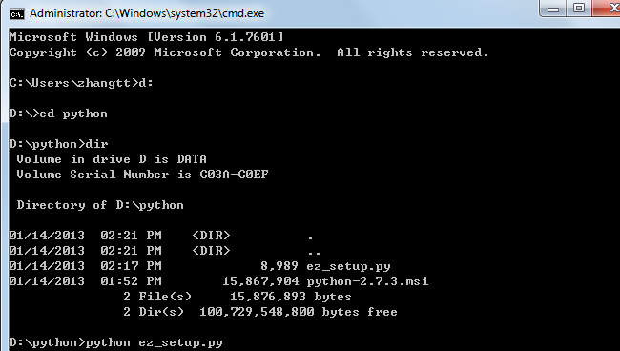

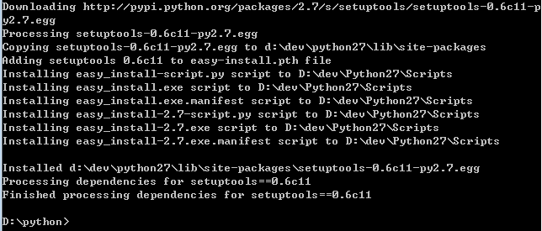

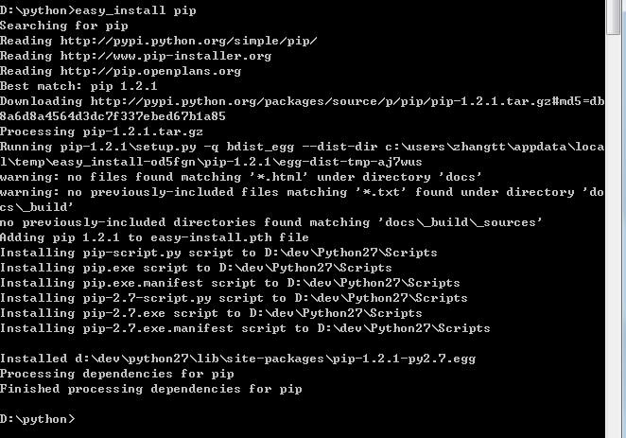



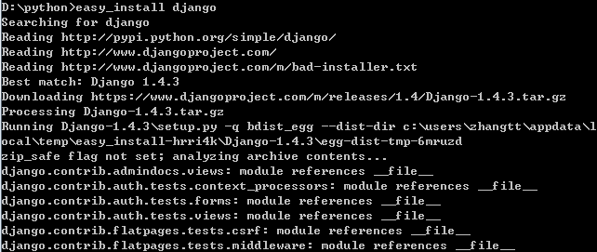

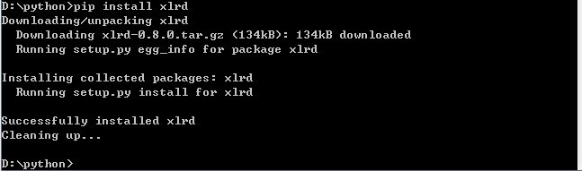

Firefox setup

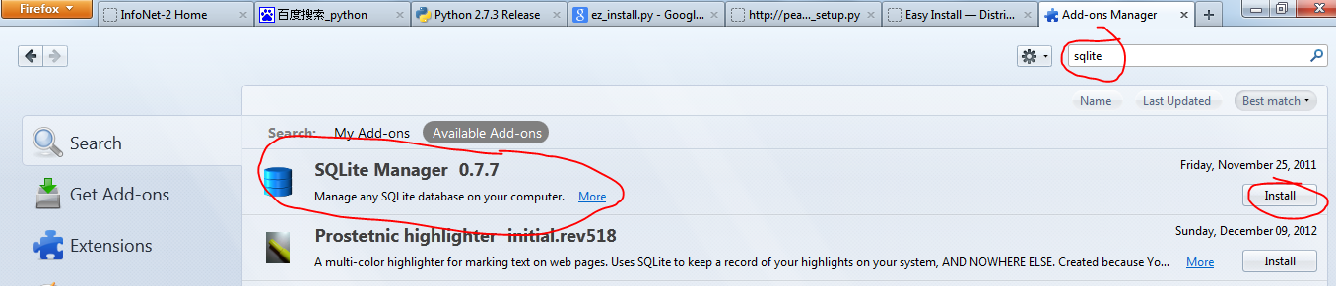

Restart firefox

Open link <https://github.com/ace-han/slot-machine>, download the program src

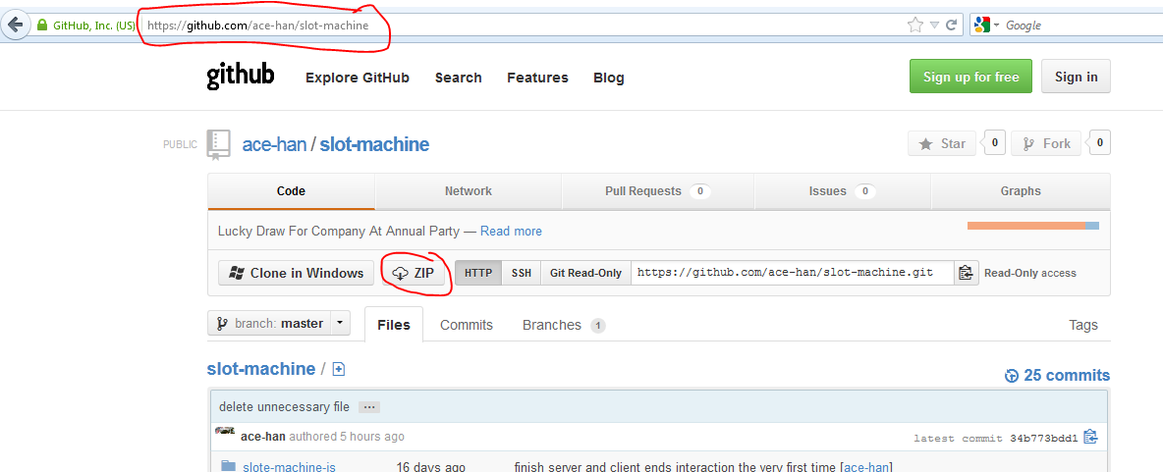

Unzip it to anywhere like

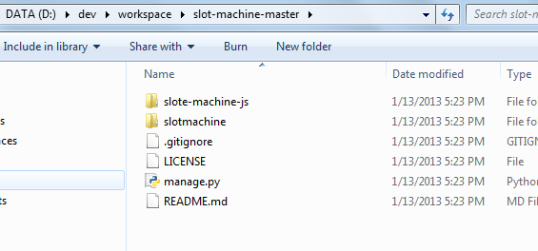

install git bash

nav to D:\dev\workspace\github

init:

git clone <https://github.com/ace-han/slot-machine.git>

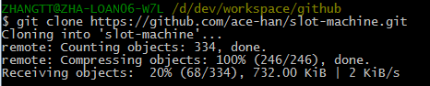

cd /d/dev/workspace/github/

D:\dev\workspace\github\ slot-machine

update:

git pull

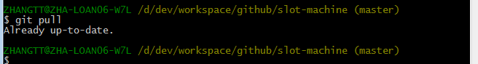

Run the program:

1. cd to the program directory

e.g.: cd /d d:\dev\workspace\github\slot-machine

1. cmd format python manage.py runserver <host><:port>

e.g.: python manage.py runserver zha-loan06-w7l:8090

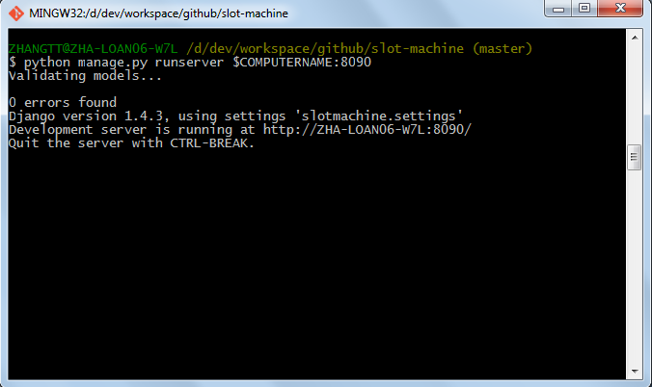

* 1. Running Snapshot

