Documentation
Sonoff replacement firmware

Table of contents:
- Initial configuration
  - Hotspot and Login Information
  - API Key
  - Configure your WiFi
  - Validate
- Behavior and features
  - Reset the configuration
  - Modes, settings and default values
  - Connection loss
- HTTP API
  - Available methods and usage
  - Example
1. Initial configuration
After powering on the device for the first time, if no valid configuration was found or the last configuration was deleted it will automatically go into config mode.
1.1 Hotspot and Login Information
After config mode has started the device will open a WiFi Hotspot named “SmartHome Switch” followed by the MAC address of the controller.
You can connect to the WiFi using the password “espconfig”. Make sure to use DHCP.
Once logged in (with pc, laptop or smartphone) you may turn off mobile network and other network adapters to ensure no problems with failover functionality of the device you are using to connect.
Now you can open your browser and navigate to http://10.10.10.10/ to get to the configuration page.
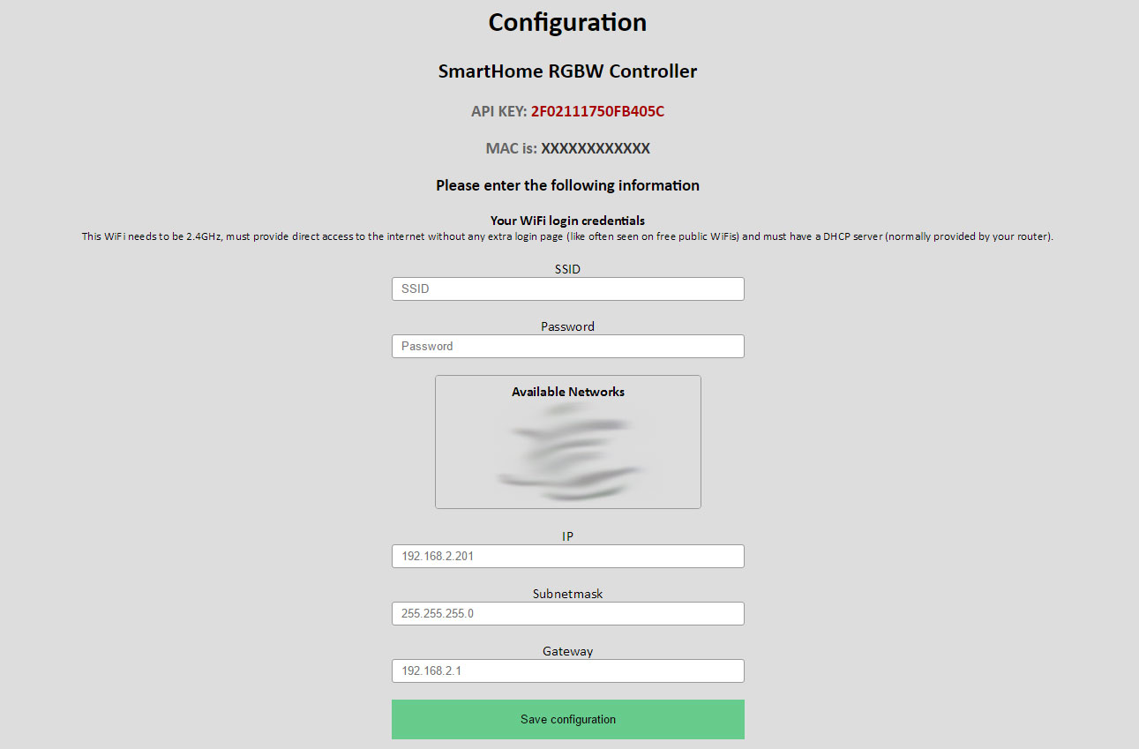
1.2 API Key
You will see your controller specific API Key at the top of the page.
MAKE SURE TO SAVE IT, YOU NEED IT TO USE THE API!
1.3 Configure your WiFi
As you can see in the screenshot above, there are some fields you need to fill out.
- Your SSID
- Your Password
- A static IP address which matches your Network (i.e. 192.168.0.200)
- The Gateway (Usually your Router) (i.e. 192.168.0.1)
- Your subnet mask (i.e. 255.255.255.0)
After you filled everything, make sure to double check you entries. Then click on the “Save” button below the form.
The Controller will now try to connect to your WiFi. If there is a problem the controller will open the configuration WiFi again. In that case start over from point 1.1.
If everything goes fine and the configuration WiFi does not show up again you can connect to your normal WiFi again.
Make sure to revert any changes to interfaces and mobile networks on your phone if you made any.
1.4 Validate
If you have successfully connected to your WiFi again you can validate that the controller works by opening your browser and navigating to the IP you set during the configuration process earlier.
(i.e. 192.168.0.200)
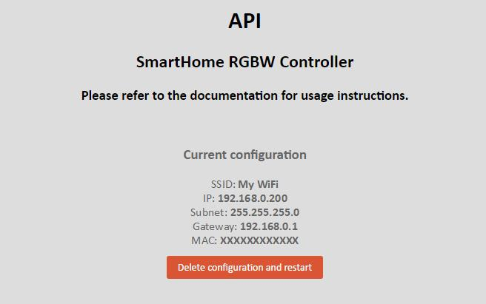
If you tee a page like the one in the picture below you successfully connected the controller and you are ready to use it!
2. Behavior and features
2.1 Reset the configuration
As you saw in the last picture there is a reset button on the http index page of the controller. If you click it, the configuration will be deleted and the configuration WiFi will be opened again.
However if you can’t access the website due to IP miss-configuration you can always turn off your WiFi AP/Router and reboot the controller. Once it recognizes that the WiFi which is saved is not reachable it will automatically start configuration mode again. You can edit your settings like described in step 1.1.
2.2 Modes, settings and default values
The Firmware has 2 options
- Off (power=0) [default]
- On (power=1)
All changes will be saved to the EEPROM and will be restored after reboot.
More about that in section 3.
2.3 Connection loss
If your WiFi router has a failure and the WiFi network is not available the controller continuously tries to reconnect to the network which is saved on it until you reboot the controller. (then it will start configuration mode due to unavailability of the saved network after 10 minutes.)
However, if you do not restart the controller it will automatically reconnect to you WiFi once it’s available again.

3. HTTP API

3.1 Available methods and usage
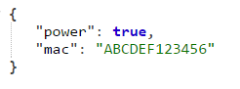
GET method:
This gets the current state of the controller in JSON format.
You can call it via the following URL: “http://<ip>/get”.
There is no API Key required.
The result will look like this:

SET method:
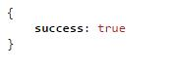
This sets the variables described in 2.2.
You can call it via the following URL: “http://<ip>/set”.
API Key is required. (key parameter, see example in 3.2)
The result will look like this:

3.2 Example
http://192.168.0.200/set?key=2F0211175F5B405C&power=1
Turns Power on.
http://192.168.0.200/set?key=2F0211175F5B405C&power=0
Turns Power off.

