A2 Praktikum Rechner – Gegenstellenrechner

ISDN

Arbeitsrechner - ISDN

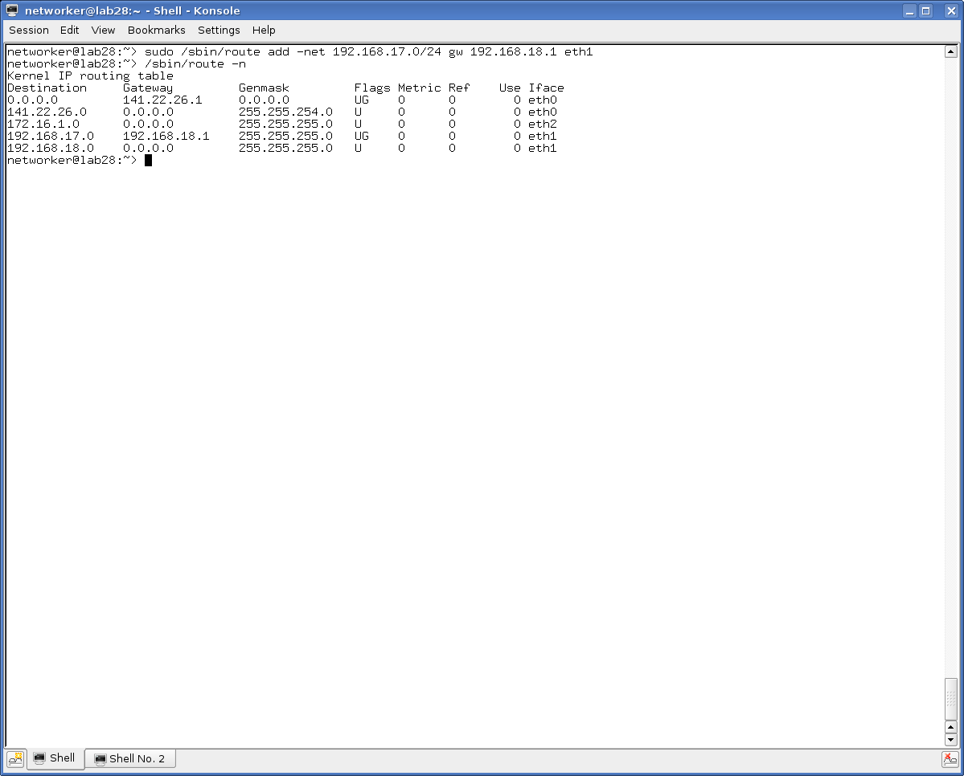

Gegenstelle – ISDN

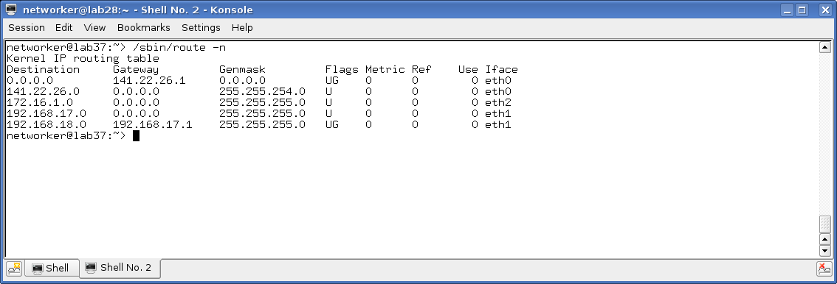

ARP

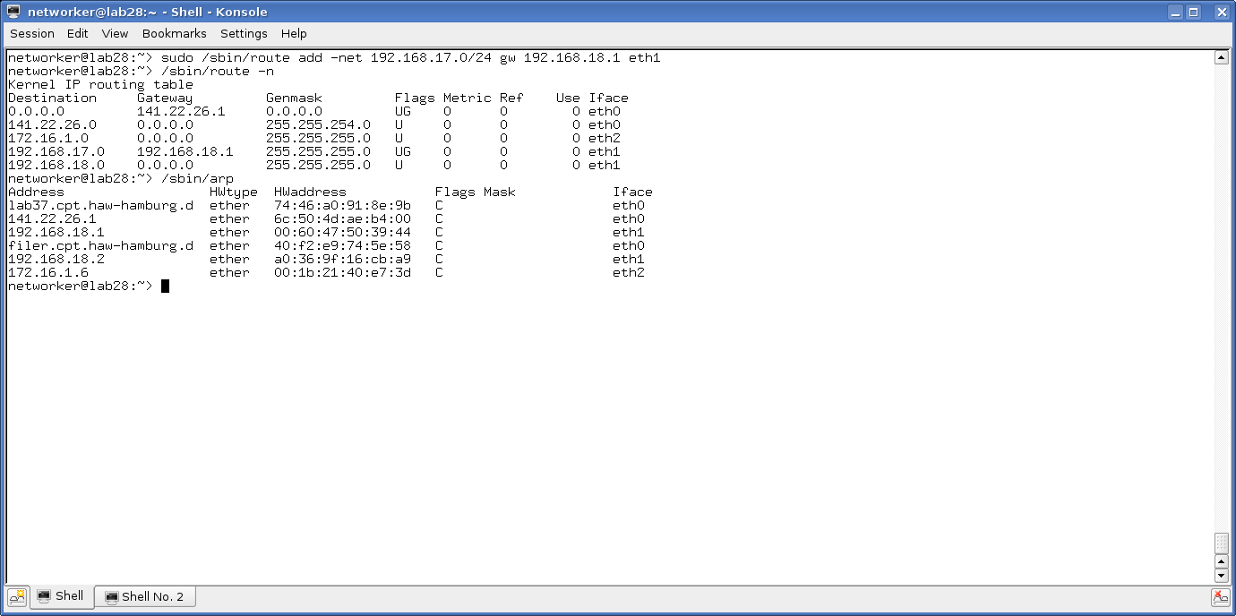

traceroute

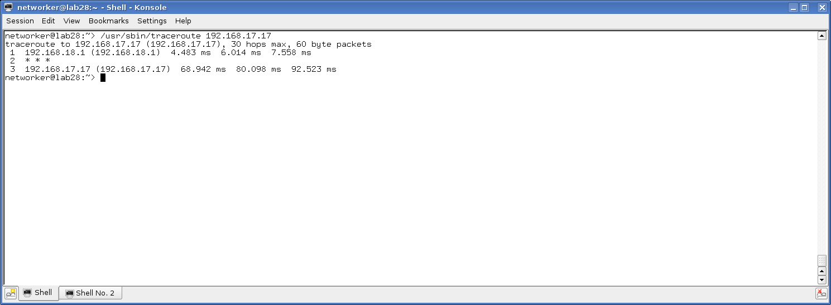

ping -R

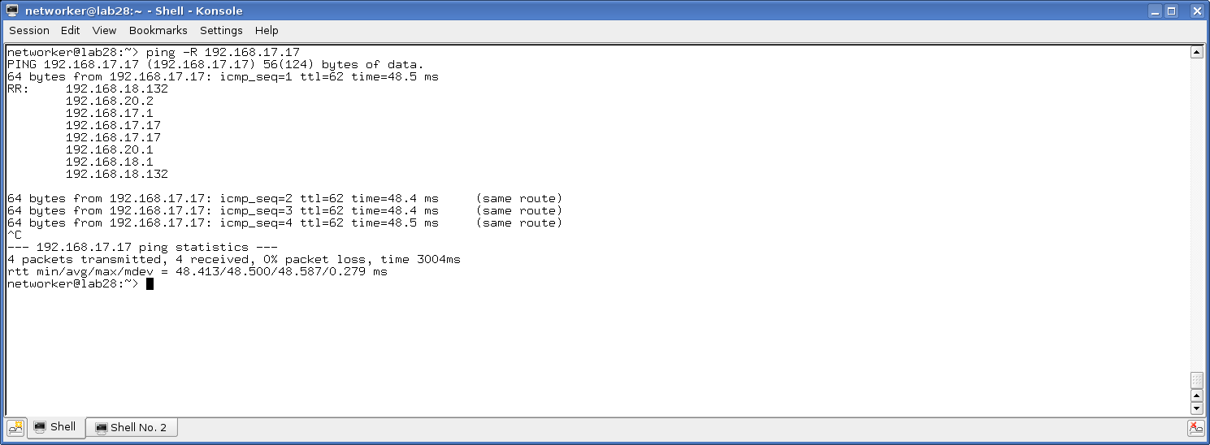

netperf

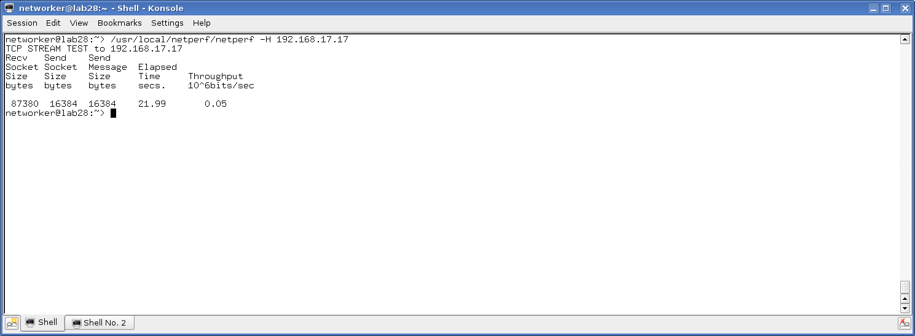

Knotenrechner

Arbeitsrechner

networker@lab28:~> sudo /sbin/route add -net 192.168.17.0/24 gw 192.168.18.2 eth1

networker@lab28:~> /sbin/route -n

Kernel IP routing table

Destination Gateway Genmask Flags Metric Ref Use Iface

0.0.0.0 141.22.26.1 0.0.0.0 UG 0 0 0 eth0

141.22.26.0 0.0.0.0 255.255.254.0 U 0 0 0 eth0

172.16.1.0 0.0.0.0 255.255.255.0 U 0 0 0 eth2

192.168.17.0 192.168.18.2 255.255.255.0 UG 0 0 0 eth1

192.168.18.0 0.0.0.0 255.255.255.0 U 0 0 0 eth1

networker@lab28:~>

Gegenstelle:

networker@lab37:~> sudo /sbin/route add -net 192.168.18.0/24 gw 192.168.17.2 eth1

networker@lab37:~> /sbin/route -n

Kernel IP routing table

Destination Gateway Genmask Flags Metric Ref Use Iface

0.0.0.0 141.22.26.1 0.0.0.0 UG 0 0 0 eth0

141.22.26.0 0.0.0.0 255.255.254.0 U 0 0 0 eth0

172.16.1.0 0.0.0.0 255.255.255.0 U 0 0 0 eth2

192.168.17.0 0.0.0.0 255.255.255.0 U 0 0 0 eth1

192.168.18.0 192.168.17.2 255.255.255.0 UG 0 0 0 eth1

networker@lab37:~>

ARP

networker@lab28:~> /sbin/arp

Address HWtype HWaddress Flags Mask Iface

lab37.cpt.haw-hamburg.d ether 74:46:a0:91:8e:9b C eth0

141.22.26.1 ether 6c:50:4d:ae:b4:00 C eth0

192.168.18.1 ether 00:60:47:50:39:44 C eth1

filer.cpt.haw-hamburg.d ether 40:f2:e9:74:5e:58 C eth0

192.168.18.2 ether a0:36:9f:16:cb:a9 C eth1

172.16.1.6 ether 00:1b:21:40:e7:3d C eth2

networker@lab28:~>

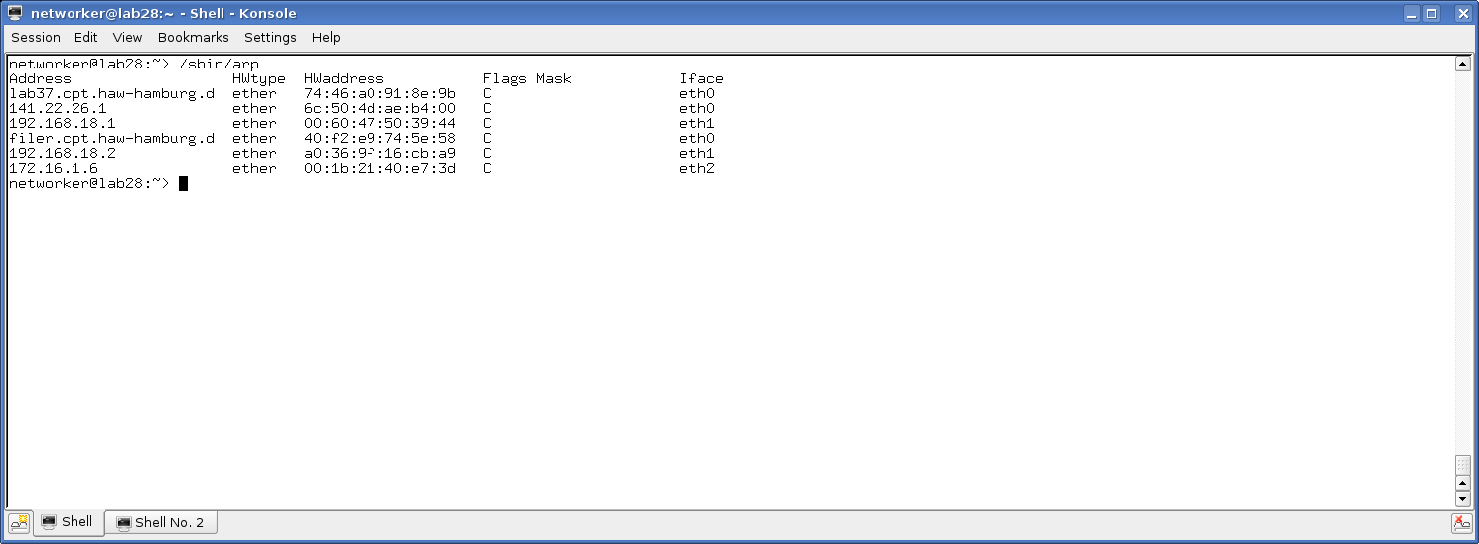

Traceroute

networker@lab28:~> /usr/sbin/traceroute 192.168.17.17

traceroute to 192.168.17.17 (192.168.17.17), 30 hops max, 60 byte packets

1 192.168.18.2 (192.168.18.2) 0.172 ms 0.161 ms 0.157 ms

2 192.168.17.17 (192.168.17.17) 0.410 ms 0.406 ms 0.493 ms

networker@lab28:~>

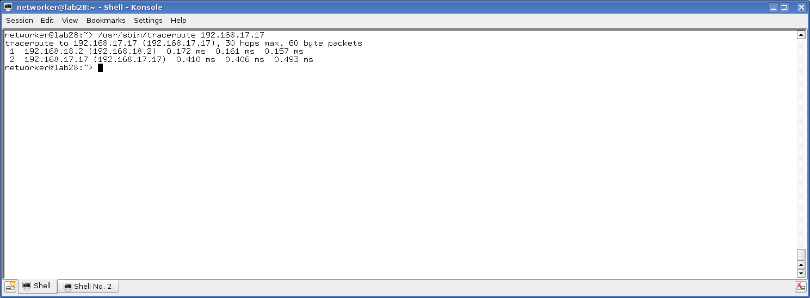

ping -R

networker@lab28:~> ping -R 192.168.17.17

PING 192.168.17.17 (192.168.17.17) 56(124) bytes of data.

64 bytes from 192.168.17.17: icmp_seq=1 ttl=63 time=0.350 ms

RR: 192.168.18.132

192.168.17.2

192.168.17.17

192.168.17.17

192.168.18.2

192.168.18.132

64 bytes from 192.168.17.17: icmp_seq=2 ttl=63 time=0.351 ms (same route)

64 bytes from 192.168.17.17: icmp_seq=3 ttl=63 time=0.334 ms (same route)

64 bytes from 192.168.17.17: icmp_seq=4 ttl=63 time=0.298 ms (same route)

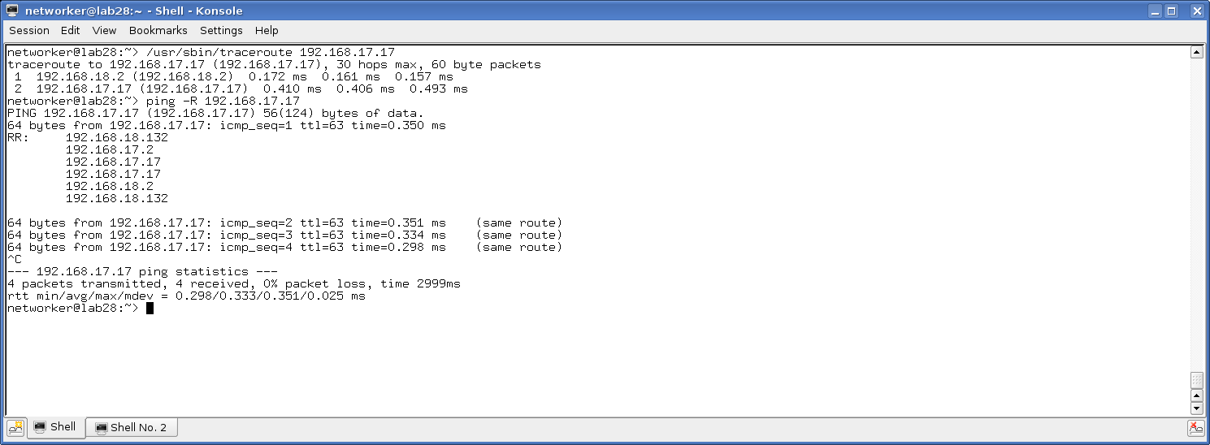

Aufgabe 2

networker@lab28:~> sudo /sbin/ifconfig eth1 add 192.168.18.132 netmask 255.255.255.255

networker@lab28:~> ping 192.168.17.12

PING 192.168.17.12 (192.168.17.12) 56(84) bytes of data.

From 188.1.231.165 icmp_seq=7 Destination Host Unreachable

From 188.1.231.165 icmp_seq=21 Destination Host Unreachable

From 188.1.231.165 icmp_seq=27 Destination Host Unreachable

^C

--- 192.168.17.12 ping statistics ---

34 packets transmitted, 0 received, +3 errors, 100% packet loss, time 33002ms

[networker@lab28](mailto:networker@lab28):~>

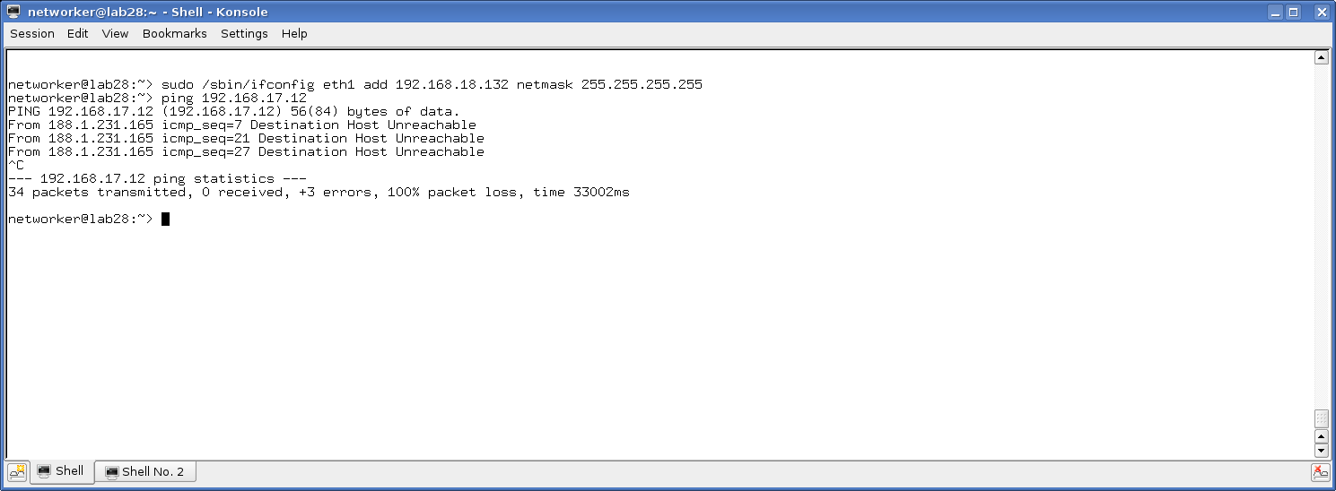

networker@lab28:~> sudo /sbin/route add 192.168.18.2 eth1

Host Route 18.2 ist über eth1 anzusprechen

networker@lab28:~> sudo /sbin/route add -net 192.168.17.0/24 gw 192.168.18.2 eth1

networker@lab28:~> /sbin/route -n

Kernel IP routing table

Destination Gateway Genmask Flags Metric Ref Use Iface

0.0.0.0 141.22.26.1 0.0.0.0 UG 0 0 0 eth0

141.22.26.0 0.0.0.0 255.255.254.0 U 0 0 0 eth0

172.16.1.0 0.0.0.0 255.255.255.0 U 0 0 0 eth2

192.168.17.0 192.168.18.2 255.255.255.0 UG 0 0 0 eth1

192.168.18.2 0.0.0.0 255.255.255.255 UH 0 0 0 eth1

networker@lab28:~> ping 192.168.18.2

PING 192.168.18.2 (192.168.18.2) 56(84) bytes of data.

64 bytes from 192.168.18.2: icmp_seq=1 ttl=64 time=0.277 ms

64 bytes from 192.168.18.2: icmp_seq=2 ttl=64 time=0.207 ms

64 bytes from 192.168.18.2: icmp_seq=3 ttl=64 time=0.153 ms

64 bytes from 192.168.18.2: icmp_seq=4 ttl=64 time=0.158 ms

64 bytes from 192.168.18.2: icmp_seq=5 ttl=64 time=0.156 ms

64 bytes from 192.168.18.2: icmp_seq=6 ttl=64 time=0.131 ms

^C

--- 192.168.18.2 ping statistics ---

6 packets transmitted, 6 received, 0% packet loss, time 4999ms

rtt min/avg/max/mdev = 0.131/0.180/0.277/0.050 ms

networker@lab28:~>

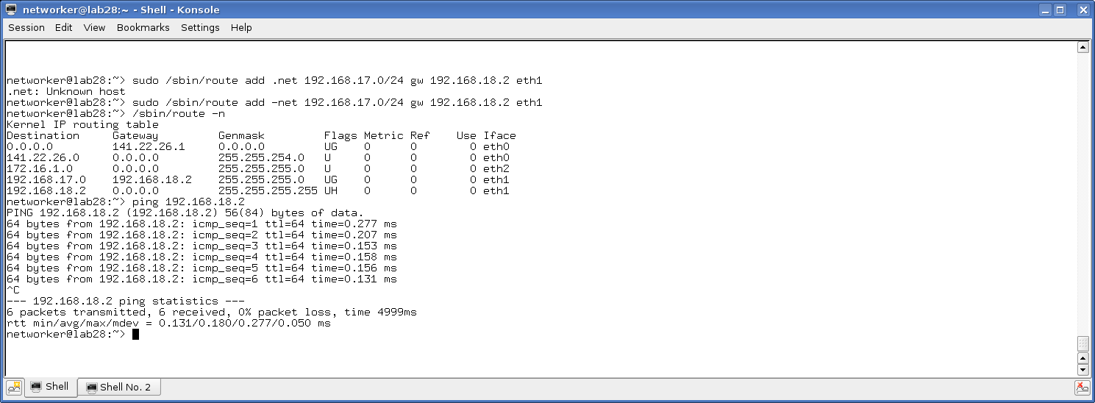

networker@lab28:~> ping -Rc1 192.168.18.2

PING 192.168.18.2 (192.168.18.2) 56(124) bytes of data.

64 bytes from 192.168.18.2: icmp_seq=1 ttl=64 time=0.139 ms

RR: 192.168.18.132

192.168.18.2

192.168.18.2

192.168.18.132

--- 192.168.18.2 ping statistics ---

1 packets transmitted, 1 received, 0% packet loss, time 0ms

rtt min/avg/max/mdev = 0.139/0.139/0.139/0.000 ms

networker@lab28:~>

