A2 Praktikum Rechner – Gegenstellenrechner

ISDN

Arbeitsrechner - ISDN
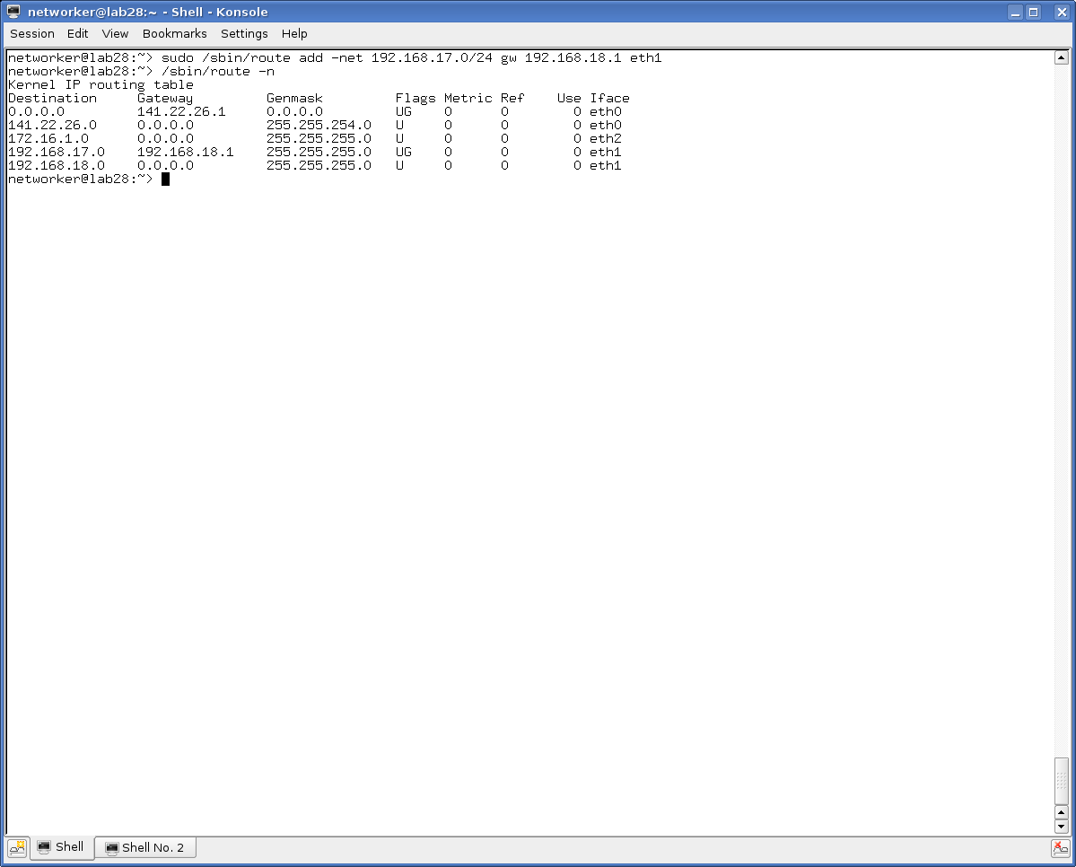

Gegenstelle – ISDN
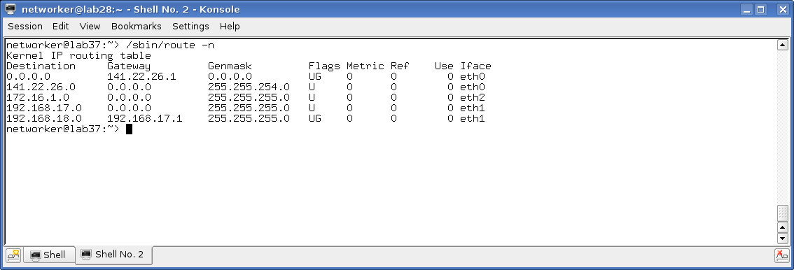

ARP
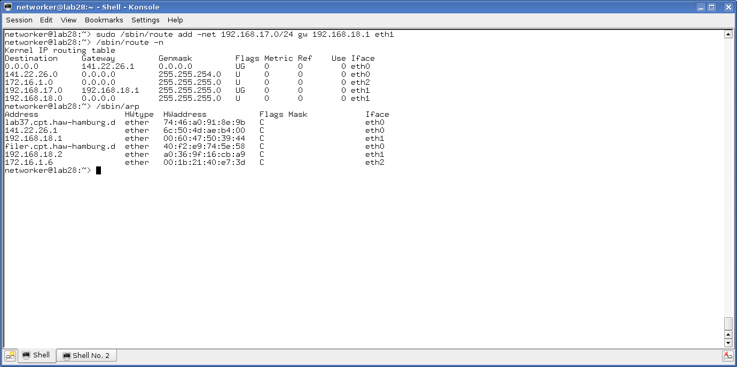
traceroute
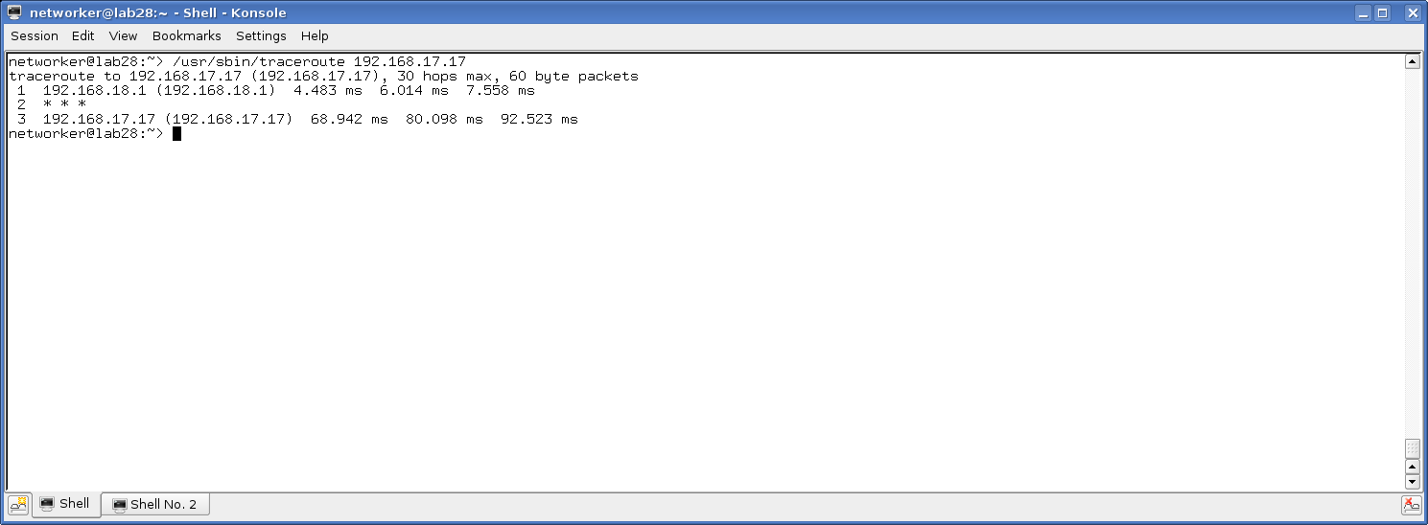
ping -R
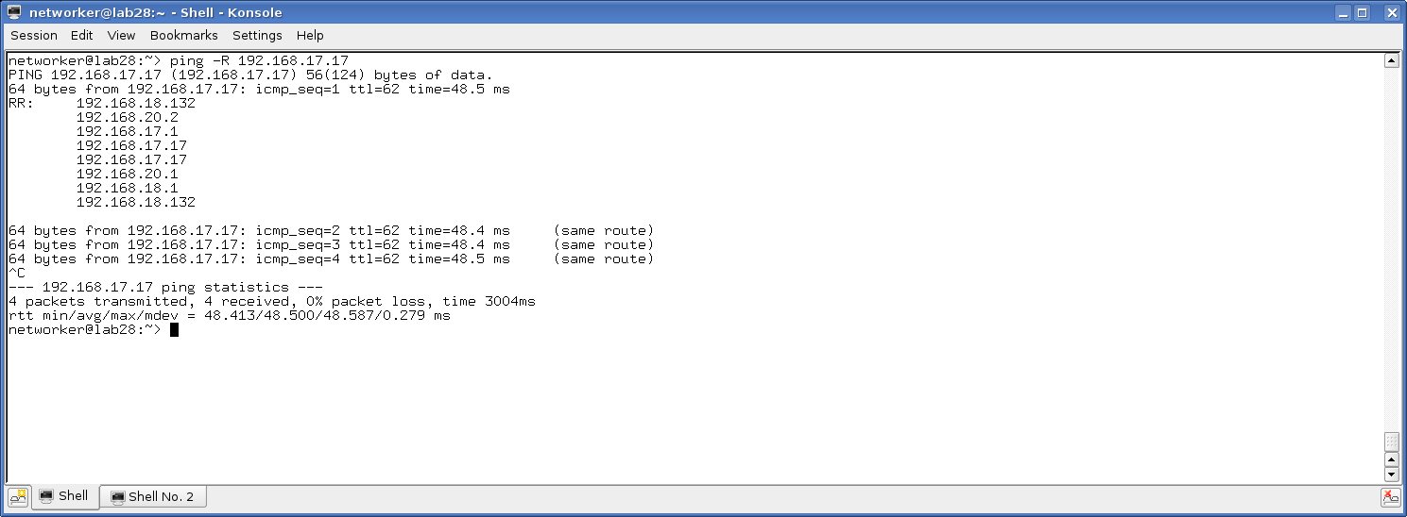

netperf
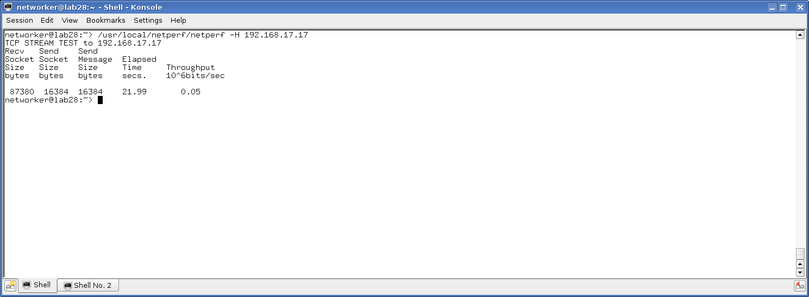

Knotenrechner

Arbeitsrechner

networker@lab28:~> sudo /sbin/route add -net 192.168.17.0/24 gw 192.168.18.2 eth1
networker@lab28:~> /sbin/route -n
Kernel IP routing table
Destination Gateway Genmask Flags Metric Ref Use Iface
0.0.0.0 141.22.26.1 0.0.0.0 UG 0 0 0 eth0
141.22.26.0 0.0.0.0 255.255.254.0 U 0 0 0 eth0
172.16.1.0 0.0.0.0 255.255.255.0 U 0 0 0 eth2
192.168.17.0 192.168.18.2 255.255.255.0 UG 0 0 0 eth1
192.168.18.0 0.0.0.0 255.255.255.0 U 0 0 0 eth1
networker@lab28:~>

Gegenstelle:
networker@lab37:~> sudo /sbin/route add -net 192.168.18.0/24 gw 192.168.17.2 eth1
networker@lab37:~> /sbin/route -n
Kernel IP routing table
Destination Gateway Genmask Flags Metric Ref Use Iface
0.0.0.0 141.22.26.1 0.0.0.0 UG 0 0 0 eth0
141.22.26.0 0.0.0.0 255.255.254.0 U 0 0 0 eth0
172.16.1.0 0.0.0.0 255.255.255.0 U 0 0 0 eth2
192.168.17.0 0.0.0.0 255.255.255.0 U 0 0 0 eth1
192.168.18.0 192.168.17.2 255.255.255.0 UG 0 0 0 eth1
networker@lab37:~>

ARP
networker@lab28:~> /sbin/arp
Address HWtype HWaddress Flags Mask Iface
lab37.cpt.haw-hamburg.d ether 74:46:a0:91:8e:9b C eth0
141.22.26.1 ether 6c:50:4d:ae:b4:00 C eth0
192.168.18.1 ether 00:60:47:50:39:44 C eth1
filer.cpt.haw-hamburg.d ether 40:f2:e9:74:5e:58 C eth0
192.168.18.2 ether a0:36:9f:16:cb:a9 C eth1
172.16.1.6 ether 00:1b:21:40:e7:3d C eth2
networker@lab28:~>

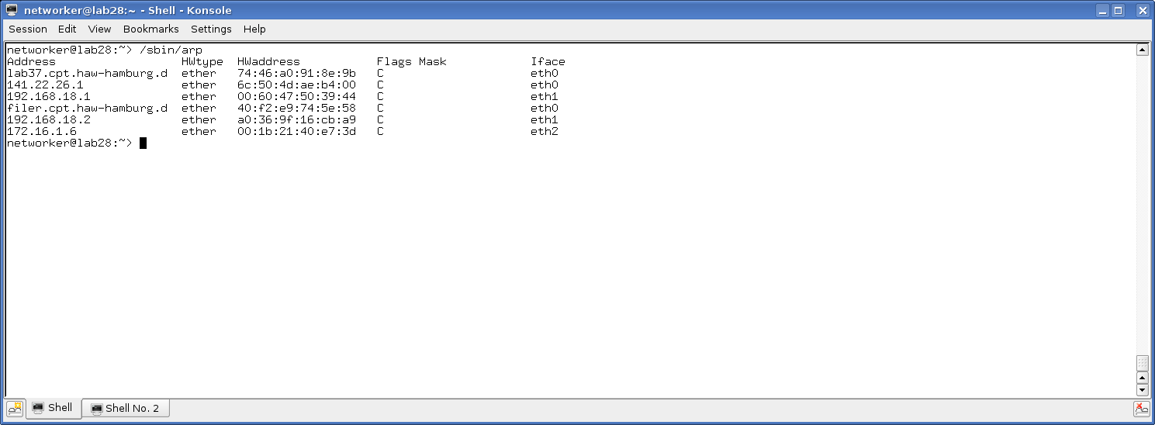

Traceroute

networker@lab28:~> /usr/sbin/traceroute 192.168.17.17
traceroute to 192.168.17.17 (192.168.17.17), 30 hops max, 60 byte packets
1 192.168.18.2 (192.168.18.2) 0.172 ms 0.161 ms 0.157 ms
2 192.168.17.17 (192.168.17.17) 0.410 ms 0.406 ms 0.493 ms
networker@lab28:~>

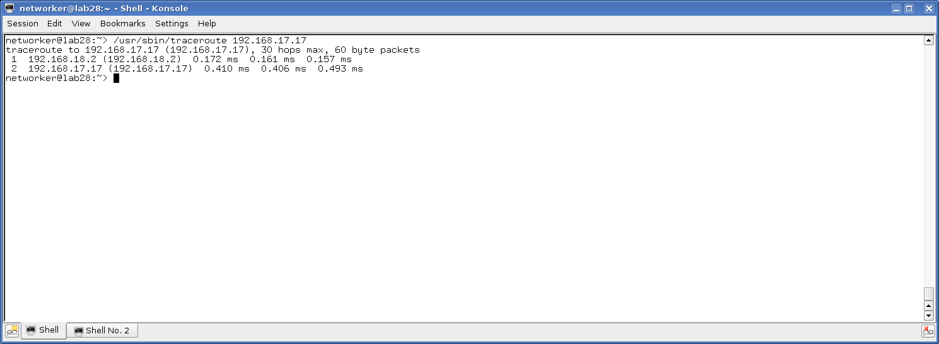

ping -R
networker@lab28:~> ping -R 192.168.17.17
PING 192.168.17.17 (192.168.17.17) 56(124) bytes of data.
64 bytes from 192.168.17.17: icmp_seq=1 ttl=63 time=0.350 ms
RR: 192.168.18.132
192.168.17.2
192.168.17.17
192.168.17.17
192.168.18.2
192.168.18.132

64 bytes from 192.168.17.17: icmp_seq=2 ttl=63 time=0.351 ms (same route)
64 bytes from 192.168.17.17: icmp_seq=3 ttl=63 time=0.334 ms (same route)
64 bytes from 192.168.17.17: icmp_seq=4 ttl=63 time=0.298 ms (same route)

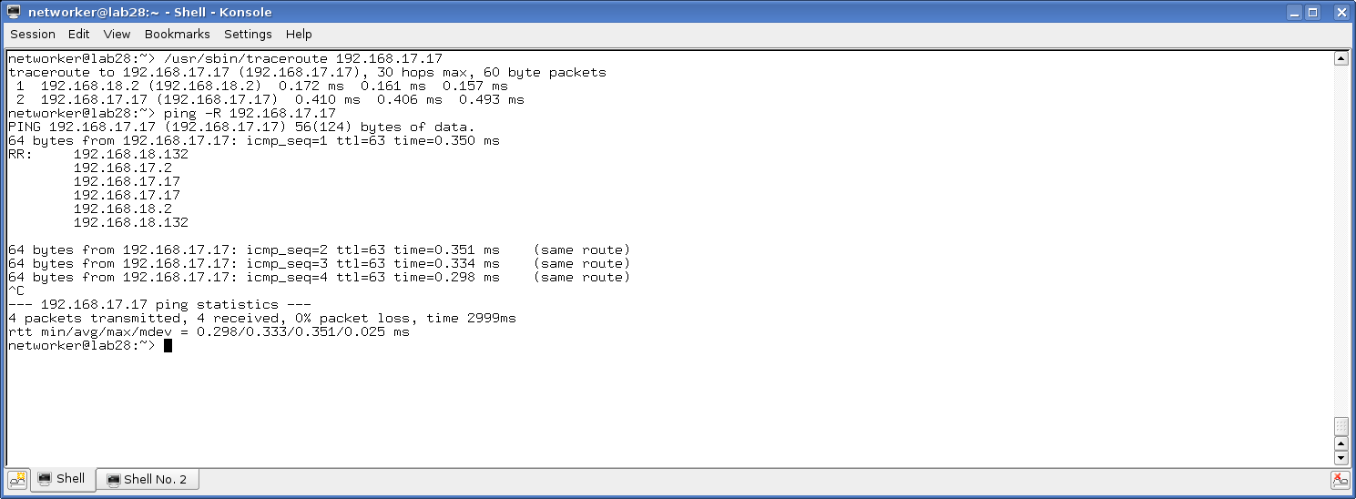

Aufgabe 2

networker@lab28:~> sudo /sbin/ifconfig eth1 add 192.168.18.132 netmask 255.255.255.255
networker@lab28:~> ping 192.168.17.12
PING 192.168.17.12 (192.168.17.12) 56(84) bytes of data.
From 188.1.231.165 icmp_seq=7 Destination Host Unreachable
From 188.1.231.165 icmp_seq=21 Destination Host Unreachable
From 188.1.231.165 icmp_seq=27 Destination Host Unreachable
^C
--- 192.168.17.12 ping statistics ---
34 packets transmitted, 0 received, +3 errors, 100% packet loss, time 33002ms

networker@lab28:~>

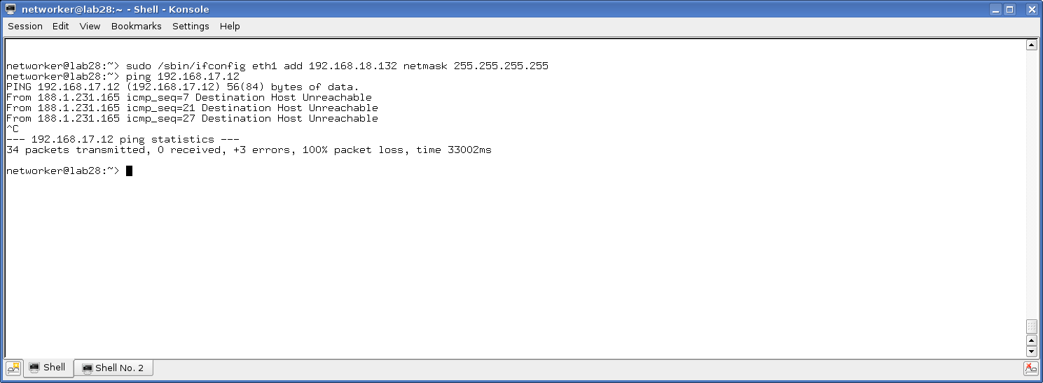

networker@lab28:~> sudo /sbin/route add 192.168.18.2 eth1

Host Route 18.2 ist über eth1 anzusprechen
networker@lab28:~> sudo /sbin/route add -net 192.168.17.0/24 gw 192.168.18.2 eth1
networker@lab28:~> /sbin/route -n
Kernel IP routing table
Destination Gateway Genmask Flags Metric Ref Use Iface
0.0.0.0 141.22.26.1 0.0.0.0 UG 0 0 0 eth0
141.22.26.0 0.0.0.0 255.255.254.0 U 0 0 0 eth0
172.16.1.0 0.0.0.0 255.255.255.0 U 0 0 0 eth2
192.168.17.0 192.168.18.2 255.255.255.0 UG 0 0 0 eth1
192.168.18.2 0.0.0.0 255.255.255.255 UH 0 0 0 eth1
networker@lab28:~> ping 192.168.18.2
PING 192.168.18.2 (192.168.18.2) 56(84) bytes of data.
64 bytes from 192.168.18.2: icmp_seq=1 ttl=64 time=0.277 ms
64 bytes from 192.168.18.2: icmp_seq=2 ttl=64 time=0.207 ms
64 bytes from 192.168.18.2: icmp_seq=3 ttl=64 time=0.153 ms
64 bytes from 192.168.18.2: icmp_seq=4 ttl=64 time=0.158 ms
64 bytes from 192.168.18.2: icmp_seq=5 ttl=64 time=0.156 ms
64 bytes from 192.168.18.2: icmp_seq=6 ttl=64 time=0.131 ms
^C
--- 192.168.18.2 ping statistics ---
6 packets transmitted, 6 received, 0% packet loss, time 4999ms
rtt min/avg/max/mdev = 0.131/0.180/0.277/0.050 ms
networker@lab28:~>

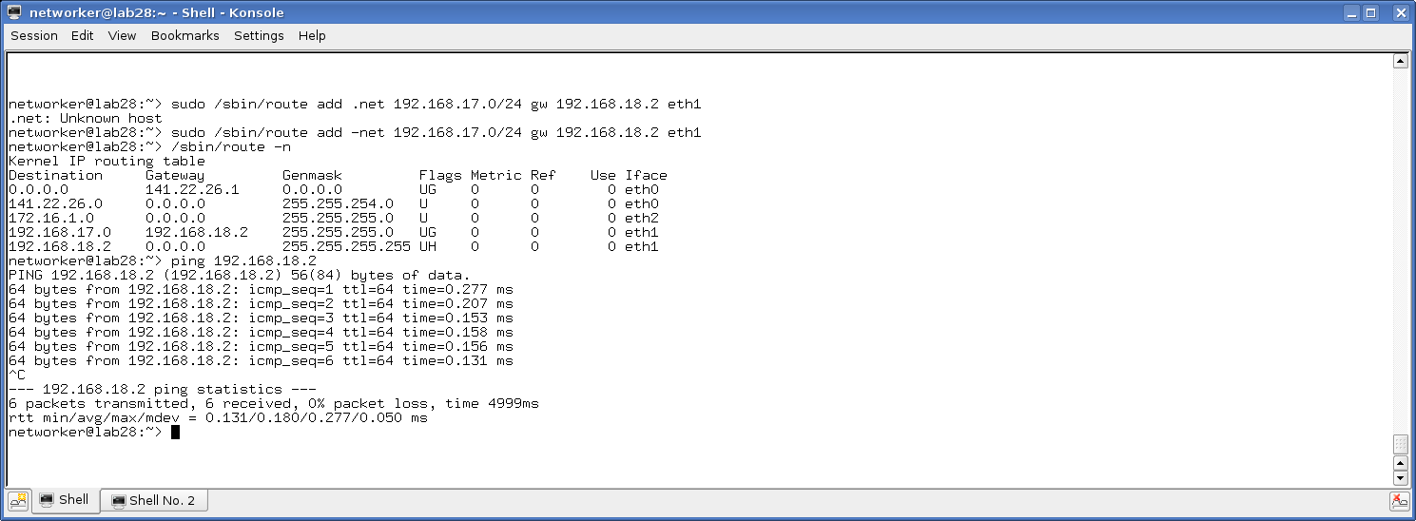

networker@lab28:~> ping -Rc1 192.168.18.2
PING 192.168.18.2 (192.168.18.2) 56(124) bytes of data.
64 bytes from 192.168.18.2: icmp_seq=1 ttl=64 time=0.139 ms
RR: 192.168.18.132
192.168.18.2
192.168.18.2
192.168.18.132

--- 192.168.18.2 ping statistics ---
1 packets transmitted, 1 received, 0% packet loss, time 0ms
rtt min/avg/max/mdev = 0.139/0.139/0.139/0.000 ms
networker@lab28:~>

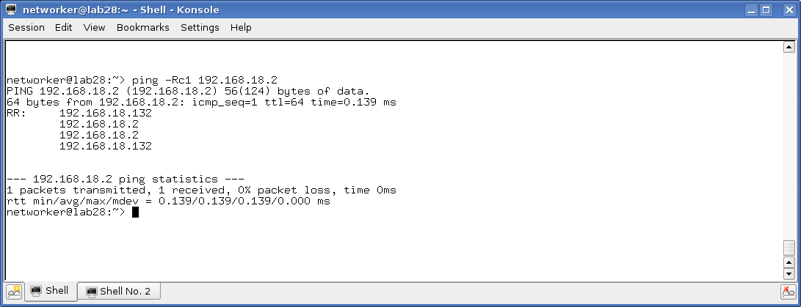

Aufgabe 2 NEU AUF LAB25
etworker@lab25:~> /sbin/route -n
Kernel IP routing table
Destination Gateway Genmask Flags Metric Ref Use Iface
0.0.0.0 141.22.26.1 0.0.0.0 UG 0 0 0 eth0
141.22.26.0 0.0.0.0 255.255.254.0 U 0 0 0 eth0
172.16.1.0 0.0.0.0 255.255.255.0 U 0 0 0 eth2
192.168.18.0 0.0.0.0 255.255.255.0 U 0 0 0 eth1
networker@lab25:~> sudo /sbin/route add -net 192.168.17.0/24 gw 192.168.18.2 eth1
networker's password:
networker@lab25:~> ping 192.168.17.11
PING 192.168.17.11 (192.168.17.11) 56(84) bytes of data.
64 bytes from 192.168.17.11: icmp_seq=1 ttl=63 time=0.256 ms
64 bytes from 192.168.17.11: icmp_seq=2 ttl=63 time=0.336 ms
64 bytes from 192.168.17.11: icmp_seq=3 ttl=63 time=0.150 ms
64 bytes from 192.168.17.11: icmp_seq=4 ttl=63 time=0.187 ms
64 bytes from 192.168.17.11: icmp_seq=5 ttl=63 time=0.283 ms
64 bytes from 192.168.17.11: icmp_seq=6 ttl=63 time=0.324 ms
^C
--- 192.168.17.11 ping statistics ---
6 packets transmitted, 6 received, 0% packet loss, time 4999ms
rtt min/avg/max/mdev = 0.150/0.256/0.336/0.068 ms
networker@lab25:~> sudo /sbin/ifconfig eth1 add 192.168.18.132 netmask 255.255.25
5.255
networker@lab25:~> ping 192.168.17.12
PING 192.168.17.12 (192.168.17.12) 56(84) bytes of data.
From 192.168.18.2 icmp_seq=1 Destination Host Unreachable
From 192.168.18.2 icmp_seq=2 Destination Host Unreachable
From 192.168.18.2 icmp_seq=3 Destination Host Unreachable
From 192.168.18.2 icmp_seq=4 Destination Host Unreachable
From 192.168.18.2 icmp_seq=5 Destination Host Unreachable
From 192.168.18.2 icmp_seq=6 Destination Host Unreachable
From 192.168.18.2 icmp_seq=7 Destination Host Unreachable
From 192.168.18.2 icmp_seq=8 Destination Host Unreachable
^C
--- 192.168.17.12 ping statistics ---
11 packets transmitted, 0 received, +8 errors, 100% packet loss, time 10002ms
pipe 4
networker@lab25:~>
networker@lab25:~>
networker@lab25:~>
networker@lab25:~> /sbin/route -n
Kernel IP routing table
Destination Gateway Genmask Flags Metric Ref Use Iface
0.0.0.0 141.22.26.1 0.0.0.0 UG 0 0 0 eth0
141.22.26.0 0.0.0.0 255.255.254.0 U 0 0 0 eth0
172.16.1.0 0.0.0.0 255.255.255.0 U 0 0 0 eth2
192.168.17.0 192.168.18.2 255.255.255.0 UG 0 0 0 eth1
192.168.18.0 0.0.0.0 255.255.255.0 U 0 0 0 eth1
networker@lab25:~> sudo /sbin/route add 192.168.18.2 eth1
networker@lab25:~> /sbin/route -n
Kernel IP routing table
Destination Gateway Genmask Flags Metric Ref Use Iface
0.0.0.0 141.22.26.1 0.0.0.0 UG 0 0 0 eth0
141.22.26.0 0.0.0.0 255.255.254.0 U 0 0 0 eth0
172.16.1.0 0.0.0.0 255.255.255.0 U 0 0 0 eth2
192.168.17.0 192.168.18.2 255.255.255.0 UG 0 0 0 eth1
192.168.18.0 0.0.0.0 255.255.255.0 U 0 0 0 eth1
192.168.18.2 0.0.0.0 255.255.255.255 UH 0 0 0 eth1
networker@lab25:~> sudo /sbin/route add -net 192.168.17.0/24 gw 192.168.18.2 eth1
SIOCADDRT: File exists
networker@lab25:~> sudo /sbin/route add -net 192.168.17.0/24 gw 192.168.18.2 eth1
SIOCADDRT: File exists
networker@lab25:~> /sbin/route -n
Kernel IP routing table
Destination Gateway Genmask Flags Metric Ref Use Iface
0.0.0.0 141.22.26.1 0.0.0.0 UG 0 0 0 eth0
141.22.26.0 0.0.0.0 255.255.254.0 U 0 0 0 eth0
172.16.1.0 0.0.0.0 255.255.255.0 U 0 0 0 eth2
192.168.17.0 192.168.18.2 255.255.255.0 UG 0 0 0 eth1
192.168.18.0 0.0.0.0 255.255.255.0 U 0 0 0 eth1
192.168.18.2 0.0.0.0 255.255.255.255 UH 0 0 0 eth1
networker@lab25:~> ping 192.168.18.2
PING 192.168.18.2 (192.168.18.2) 56(84) bytes of data.
64 bytes from 192.168.18.2: icmp_seq=1 ttl=64 time=0.133 ms
64 bytes from 192.168.18.2: icmp_seq=2 ttl=64 time=0.141 ms
64 bytes from 192.168.18.2: icmp_seq=3 ttl=64 time=0.120 ms
64 bytes from 192.168.18.2: icmp_seq=4 ttl=64 time=0.156 ms
64 bytes from 192.168.18.2: icmp_seq=5 ttl=64 time=0.123 ms
64 bytes from 192.168.18.2: icmp_seq=6 ttl=64 time=0.128 ms
64 bytes from 192.168.18.2: icmp_seq=7 ttl=64 time=0.171 ms
^C
--- 192.168.18.2 ping statistics ---
7 packets transmitted, 7 received, 0% packet loss, time 5999ms
rtt min/avg/max/mdev = 0.120/0.138/0.171/0.023 ms
networker@lab25:~>
networker@lab25:~>
networker@lab25:~>
networker@lab25:~>
networker@lab25:~>
networker@lab25:~> sudo /sbin/route eth1 192.168.18.131 netmask 255.255.255.255
networker's password:
Usage: route [-nNvee] [-FC] [<AF>] List kernel routing tables
route [-v] [-FC] {add|del|flush} ... Modify routing table for AF.

route {-h|--help} [<AF>] Detailed usage syntax for specified AF.
route {-V|--version} Display version/author and exit.

-v, --verbose be verbose
-n, --numeric don't resolve names
-e, --extend display other/more information
-F, --fib display Forwarding Information Base (default)
-C, --cache display routing cache instead of FIB

<AF>=Use '-A <af>' or '--<af>'; default: inet
List of possible address families (which support routing):
inet (DARPA Internet) inet6 (IPv6) ax25 (AMPR AX.25)
netrom (AMPR NET/ROM) ipx (Novell IPX) ddp (Appletalk DDP)
x25 (CCITT X.25)
networker@lab25:~> sudo /sbin/route add eth1 192.168.18.131 netmask 255.255.255.255
eth1: Unknown host
networker@lab25:~> sudo /sbin/ifconfig eth1 192.168.18.131 netmask 255.255.255.255
networker@lab25:~> /sbin/route -n
Kernel IP routing table
Destination Gateway Genmask Flags Metric Ref Use Iface
0.0.0.0 141.22.26.1 0.0.0.0 UG 0 0 0 eth0
141.22.26.0 0.0.0.0 255.255.254.0 U 0 0 0 eth0
172.16.1.0 0.0.0.0 255.255.255.0 U 0 0 0 eth2
192.168.17.0 192.168.18.2 255.255.255.0 UG 0 0 0 eth1
192.168.18.0 0.0.0.0 255.255.255.0 U 0 0 0 eth1
192.168.18.2 0.0.0.0 255.255.255.255 UH 0 0 0 eth1
networker@lab25:~> sudo /sbin/rozte add 192.168.18.2
sudo: /sbin/rozte: command not found
networker@lab25:~> sudo /sbin/route add 192.168.18.2
SIOCADDRT: No such device
networker@lab25:~> sudo /sbin/route add 192.168.18.2 eth1
SIOCADDRT: File exists
networker@lab25:~> sudo /sbin/route/ add -net 192.168.18.0/24 gw 192.168.18.2
sudo: /sbin/route/: command not found
networker@lab25:~> sudo /sbin/route add -net 192.168.18.0/24 gw 192.168.18.2 eth1
networker@lab25:~> /sbin/route -n
Kernel IP routing table
Destination Gateway Genmask Flags Metric Ref Use Iface
0.0.0.0 141.22.26.1 0.0.0.0 UG 0 0 0 eth0
141.22.26.0 0.0.0.0 255.255.254.0 U 0 0 0 eth0
172.16.1.0 0.0.0.0 255.255.255.0 U 0 0 0 eth2
192.168.17.0 192.168.18.2 255.255.255.0 UG 0 0 0 eth1
192.168.18.0 192.168.18.2 255.255.255.0 UG 0 0 0 eth1
192.168.18.0 0.0.0.0 255.255.255.0 U 0 0 0 eth1
192.168.18.2 0.0.0.0 255.255.255.255 UH 0 0 0 eth1
networker@lab25:~> ping 192.168.18.2
PING 192.168.18.2 (192.168.18.2) 56(84) bytes of data.
64 bytes from 192.168.18.2: icmp_seq=1 ttl=64 time=0.267 ms
64 bytes from 192.168.18.2: icmp_seq=2 ttl=64 time=0.130 ms
64 bytes from 192.168.18.2: icmp_seq=3 ttl=64 time=0.170 ms
64 bytes from 192.168.18.2: icmp_seq=4 ttl=64 time=0.149 ms
64 bytes from 192.168.18.2: icmp_seq=5 ttl=64 time=0.121 ms
64 bytes from 192.168.18.2: icmp_seq=6 ttl=64 time=0.128 ms
^C
--- 192.168.18.2 ping statistics ---
6 packets transmitted, 6 received, 0% packet loss, time 4999ms
rtt min/avg/max/mdev = 0.121/0.160/0.267/0.052 ms
networker@lab25:~> ^C
networker@lab25:~> ^C
networker@lab25:~>

networker@lab25:~> sudo /sbin/route delete -net 192.168.17.0/24 gw 192.168.18.2 eth1
networker@lab25:~> /sbin/route -n
Kernel IP routing table
Destination Gateway Genmask Flags Metric Ref Use Iface
0.0.0.0 141.22.26.1 0.0.0.0 UG 0 0 0 eth0
141.22.26.0 0.0.0.0 255.255.254.0 U 0 0 0 eth0
172.16.1.0 0.0.0.0 255.255.255.0 U 0 0 0 eth2
192.168.18.0 192.168.18.2 255.255.255.0 UG 0 0 0 eth1
192.168.18.0 0.0.0.0 255.255.255.0 U 0 0 0 eth1
192.168.18.2 0.0.0.0 255.255.255.255 UH 0 0 0 eth1
networker@lab25:~> ^C
networker@lab25:~>

networker@lab25:~> ping 192.168.18.4
PING 192.168.18.4 (192.168.18.4) 56(84) bytes of data.
From 192.168.18.2: icmp_seq=1 Redirect Host(New nexthop: 192.168.18.4)
64 bytes from 192.168.18.4: icmp_seq=2 ttl=255 time=0.548 ms
64 bytes from 192.168.18.4: icmp_seq=3 ttl=255 time=0.556 ms
64 bytes from 192.168.18.4: icmp_seq=4 ttl=255 time=0.587 ms
64 bytes from 192.168.18.4: icmp_seq=5 ttl=255 time=0.535 ms
64 bytes from 192.168.18.4: icmp_seq=6 ttl=255 time=0.543 ms
64 bytes from 192.168.18.4: icmp_seq=7 ttl=255 time=0.551 ms
^C
--- 192.168.18.4 ping statistics ---
7 packets transmitted, 6 received, 14% packet loss, time 5999ms
rtt min/avg/max/mdev = 0.535/0.553/0.587/0.025 ms

networker@lab25:~> ping 192.168.17.11
PING 192.168.17.11 (192.168.17.11) 56(84) bytes of data.
From 188.1.231.165 icmp_seq=5 Destination Host Unreachable
From 188.1.231.165 icmp_seq=11 Destination Host Unreachable
From 188.1.231.165 icmp_seq=16 Destination Host Unreachable
^C
--- 192.168.17.11 ping statistics ---
23 packets transmitted, 0 received, +3 errors, 100% packet loss, time 21999ms

FERTIG

