RNP A2

networker@lab28:~> sudo /sbin/route -n
Kernel IP routing table
Destination Gateway Genmask Flags Metric Ref Use Iface
0.0.0.0 141.22.26.1 0.0.0.0 UG 0 0 0 eth0
141.22.26.0 0.0.0.0 255.255.254.0 U 0 0 0 eth0
172.16.1.0 0.0.0.0 255.255.255.0 U 0 0 0 eth2
192.168.18.0 0.0.0.0 255.255.255.0 U 0 0 0 eth1

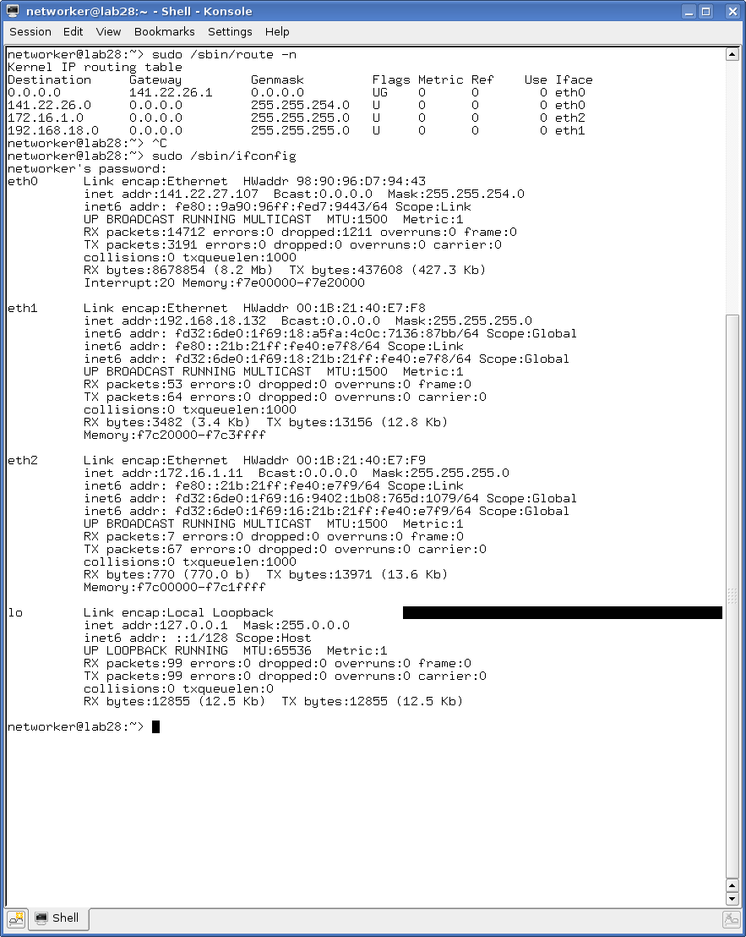

Kommando
networker@lab28:~> sudo /sbin/route add -net 192.168.17.0/24 gw 192.168.18.2 eth1

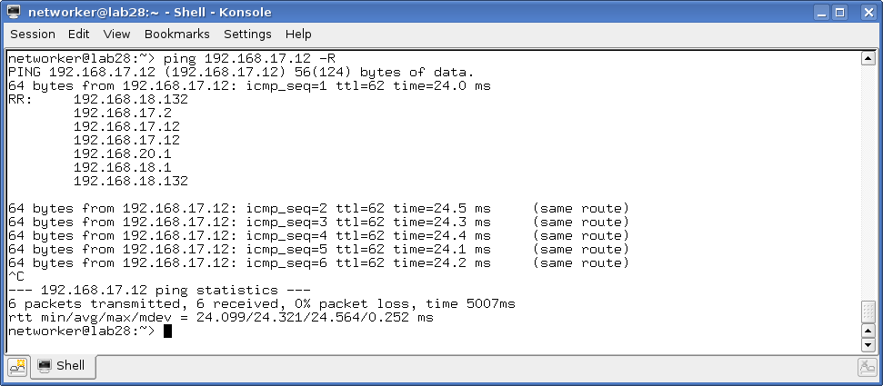

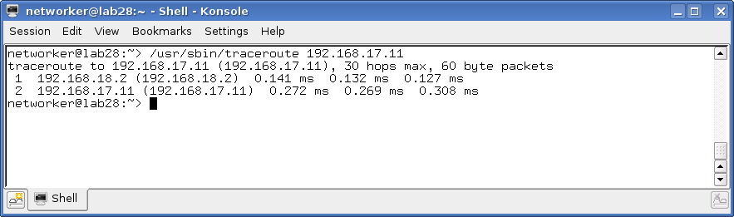
networker@lab28:~> /usr/sbin/traceroute 192.168.17.11
traceroute to 192.168.17.11 (192.168.17.11), 30 hops max, 60 byte packets
1 192.168.18.2 (192.168.18.2) 0.138 ms 0.119 ms 0.080 ms
2 192.168.17.11 (192.168.17.11) 0.245 ms 0.233 ms 0.214 ms

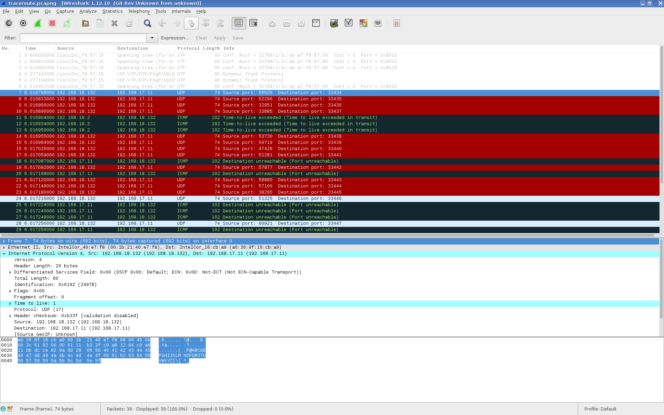

networker@lab28:~> ping -c 10 192.168.17.11
PING 192.168.17.11 (192.168.17.11) 56(84) bytes of data.
64 bytes from 192.168.17.11: icmp_seq=1 ttl=63 time=0.342 ms
64 bytes from 192.168.17.11: icmp_seq=2 ttl=63 time=0.252 ms
64 bytes from 192.168.17.11: icmp_seq=3 ttl=63 time=0.280 ms
64 bytes from 192.168.17.11: icmp_seq=4 ttl=63 time=0.342 ms
64 bytes from 192.168.17.11: icmp_seq=5 ttl=63 time=0.334 ms
64 bytes from 192.168.17.11: icmp_seq=6 ttl=63 time=0.298 ms
64 bytes from 192.168.17.11: icmp_seq=7 ttl=63 time=0.331 ms
64 bytes from 192.168.17.11: icmp_seq=8 ttl=63 time=0.344 ms
64 bytes from 192.168.17.11: icmp_seq=9 ttl=63 time=0.334 ms
64 bytes from 192.168.17.11: icmp_seq=10 ttl=63 time=0.366 ms

--- 192.168.17.11 ping statistics ---
10 packets transmitted, 10 received, 0% packet loss, time 9000ms
rtt min/avg/max/mdev = 0.252/0.322/0.366/0.035 ms
networker@lab28:~>

