工99-1
輸入 :
1000010000010010000000000000000000000000

輸出 :
Compressed Data : 0 100 101 10 11001
Compressed Rate : 45%
工99-2
輸入 :
56

輸出 :
N = 56
M = 68

輸入 :
99

輸出 :
N = 99
M = 15
工99-3
輸入 :
3 6 9 1.5 2 4 8 5.51

輸出 :
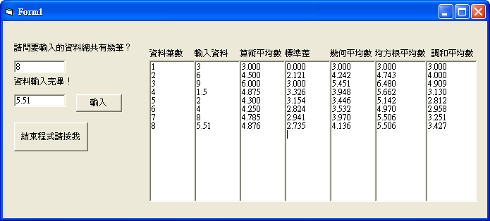
工99-5
輸入檔 :
For the past six years, Guo Chi-mei has struggled to get out of bed on his own. The 40-year-old suffered(2) a stroke in 2006 and can only take a few unaided steps to his wheelchair before his blood pressure rises to a dangerous level.
Last year the government ruled that the stroke was because of overwork but his company is legally challenging the decision.

輸入尋找字串 : company
輸出 : 315
輸入尋找字串 : in
輸出 : 118

