Shape To Shape
Following are the steps to perform shape to shape morphing i.e. transformation of one shape into another using shape tween.

STEP 1:
First open a flash file ( .fla )

File → New → Flash Document

STEP 2:
Goto to tool box and click on the Oval Tool. If tool box is not visible go to

Windows → Tools Or Press Ctrl + F2
and then select Oval Tool.

STEP 3:
Now draw a circle or a oval using the tool, on frame 1.

STEP 4:
Select Frame 40 on same layer and add a blank keyframe by going to

Insert → Timeline → Keyframe, Or By Pressing F7

Or Select Frame Frame, And Right-Click And Choose Insert Blank Keyframe

STEP 5:
On the stage now draw a square or rectangle by using Rectangle Tool in frame 40.
You should now have a keyframe in frame 1 with a circle and a keyframe in frame 40 with a rectangle.

STEP 6:
Now select any frame between the two key frame and create shape tween by

Right Click The Frame → Create Shape Tween

STEP 7:
Goto frame 1 and click on the circle and hold Ctrl and hit letter B twice, this breaks apart your text. Now do the same for the square on frame 40.

To Break Apart Symbols → Select Symbol → Press Ctrl+B+B

Or Right-Click → Break Apart

STEP 8:
Now goto frame 1 again and selct the circle and go down to properties tab, If it is not visible goto

Windows → Check Properties Or Press Ctrl+F3

STEP 9:
Open the dropdown menu next to Tween and click on Shape.

STEP 10:
Now play the movie by

Control → Play Or Press Ctrl+Enter
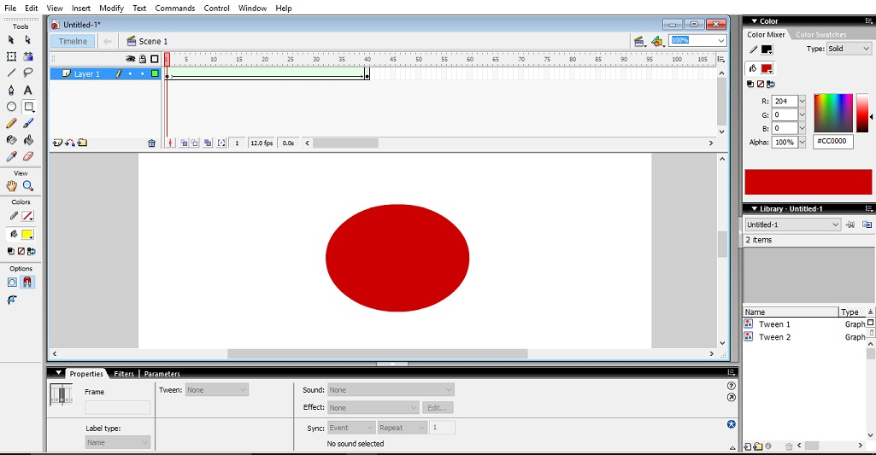

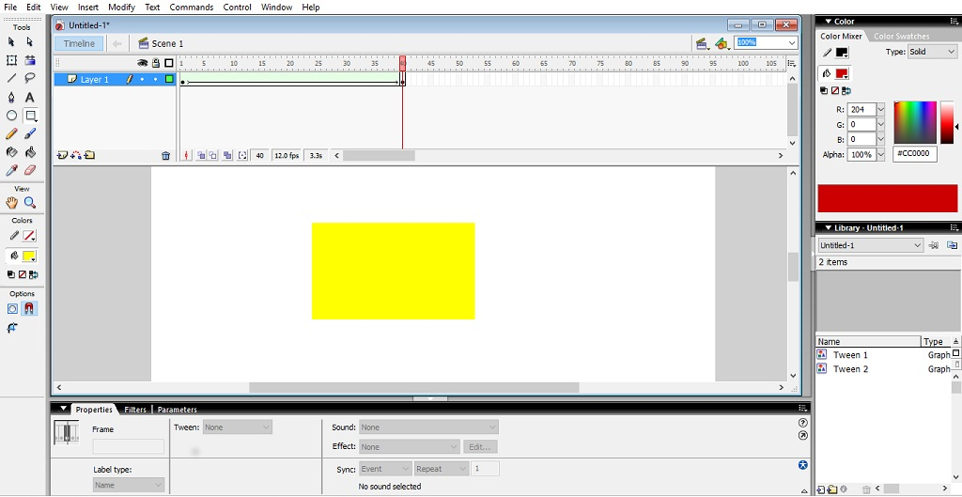

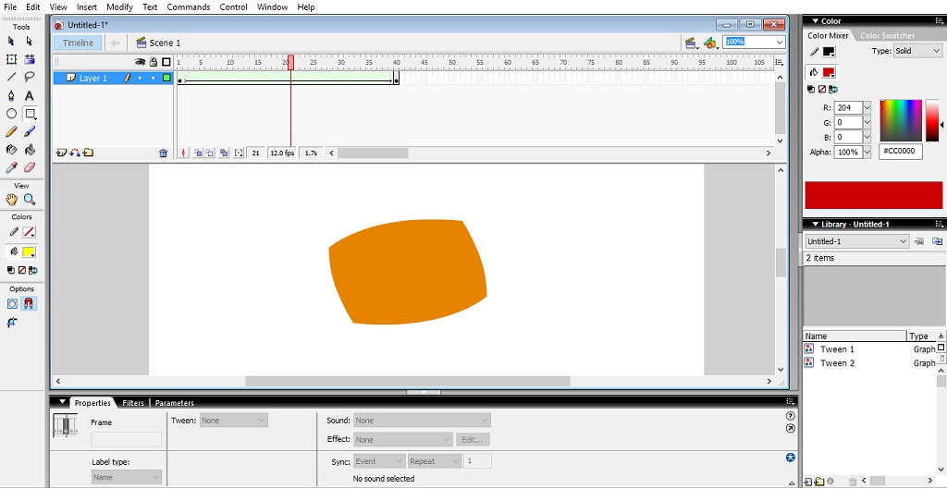

Blinking Eye
Following are the steps for creating a blinking eye.

STEP 1:
First open a flash file ( .fla )

File → New → Flash Document

STEP 2:
In frame 1 , draw an eye using the Brush Tool and the Oval Tool.

STEP 3:
Copy it and flip the copy to make the other eye by selecting the eye and transforming it as follows.

Modify → Transform → Flip Horizontal

STEP 4:
Now select frame 10 and make a closed eye through same method as step 2.

STEP 5:
Now play the movie by
Control → Play Or Press Ctrl+Enter
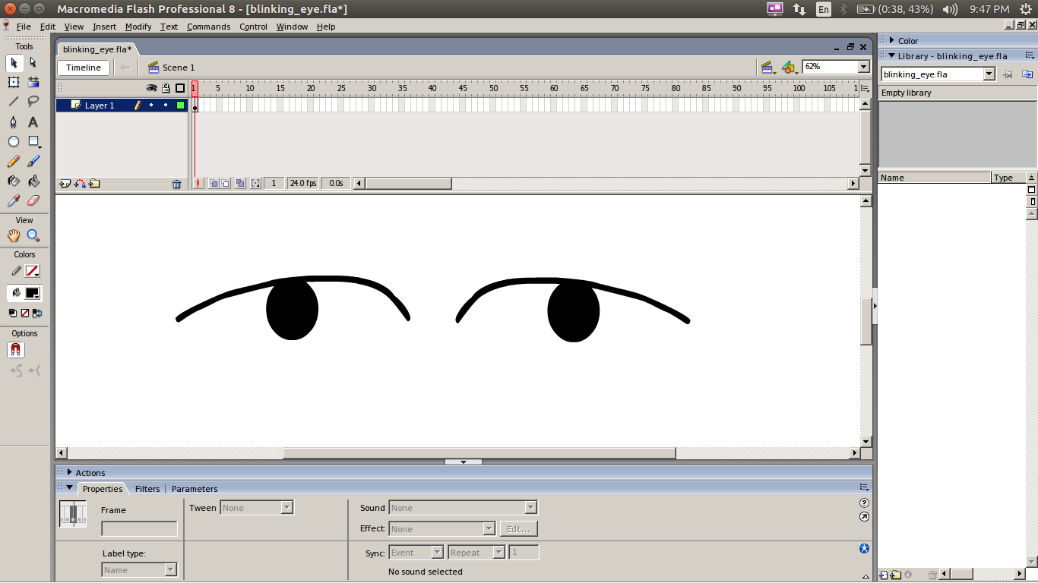
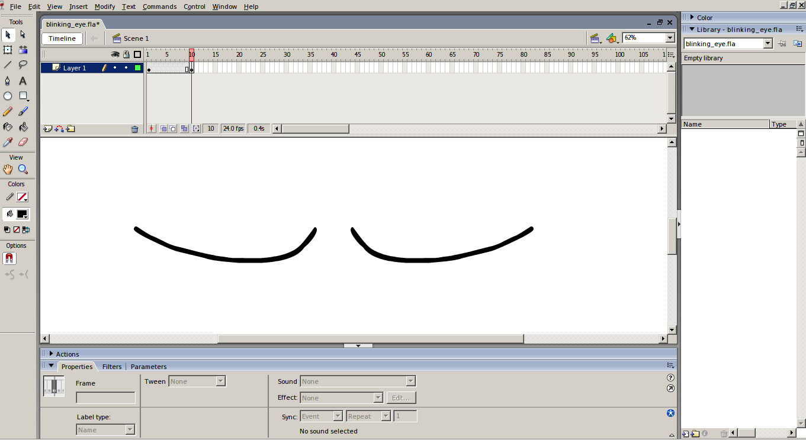

Solar System
Following are the steps for creating a Solar System.

STEP 1:
First open a flash file ( .fla )

File → New → Flash Document

STEP 2:
Make backround of stage black by going to properties and changing the background.

STEP 3:
Rename Layer 1 to Sun as this layer will contain sun. Draw an Oval using the Oval tool
Set the Stroke Color to none and Fill color to any shade of yellow. And center it on the stage.

STEP 4:
Add 100 frames to the Sun layer.

STEP 5:
Create a new layer and name it Orbits.

STEP 6:
Create orbits for the planet using Oval Tool by setting Fill Color to none and Stroke Color to white. Insert a frame at Frame 100 on this layer too. Lock both Orbits and Sun layer to avoid modifying them.

STEP 7:
Create another layer named Planet 1. This layer is used to add a planet and animate it.

STEP 8:
Create a planet using Oval Tool with desired Fill Color and no Stroke Color.

STEP 9:
Make the planet a Symbol by selecting the planet and

Modify → Make Symbol Or Press F8

STEP 10:
Now Motion Tween the planet over the Orbit by inserting key frames at some interval and repositioning the planet accordingly for every key frame and adding Tween to the intermediate frames by

Right Click The Frame → Create Motion Tween

STEP 11:
Now repeat the Step 7 to 10 with naming layers Planet 2, Planet 3 and so on.

STEP 12:
Now hide Orbit Layer.

STEP 13:
Now play the movie by
Control → Play Or Press Ctrl+Enter
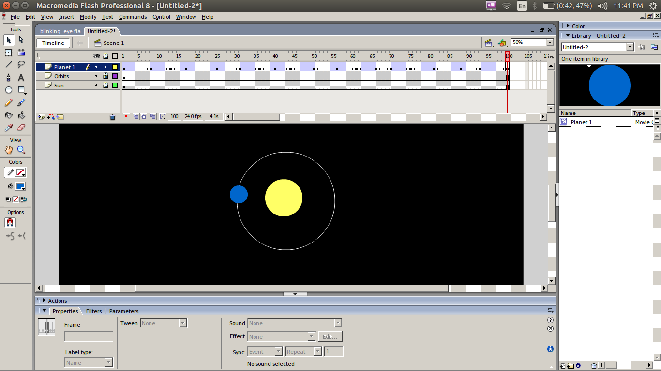

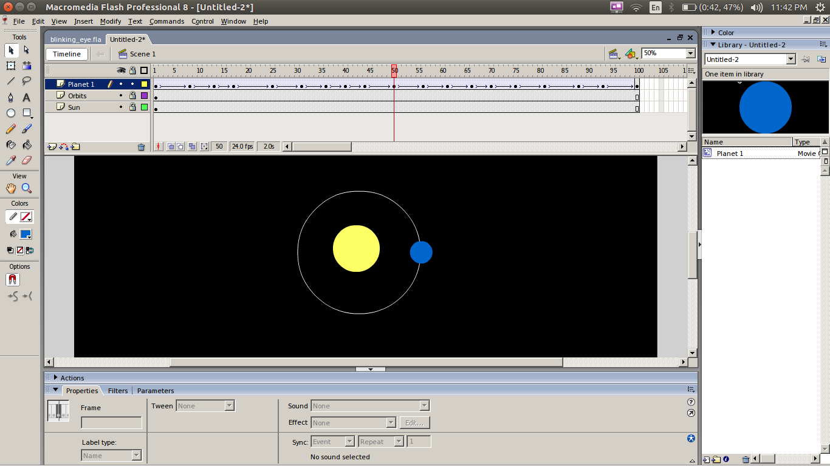
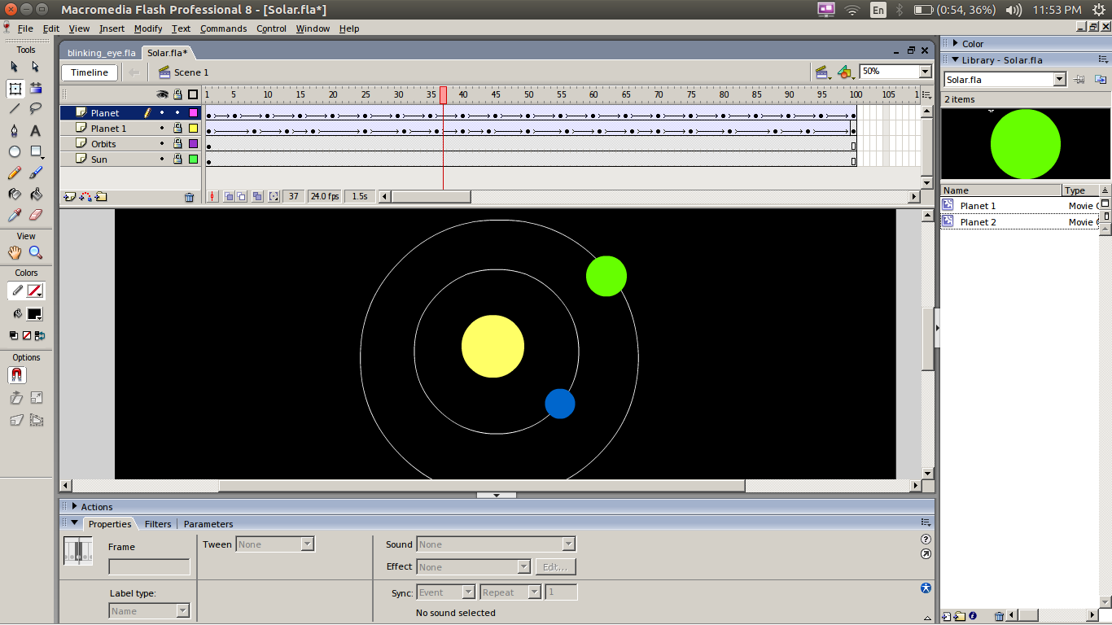

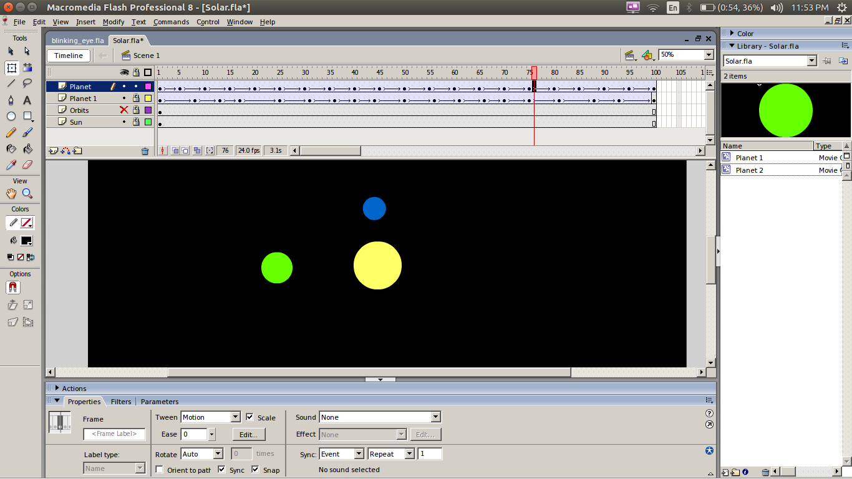

Fading Moon
Following are the steps for creating a moon fading and appearing using Filters.

STEP 1:
First open a flash file ( .fla )
File → New → Flash Document

STEP 2:
Change the background of the stage to Black using the Background option in properties tab.

STEP 3:
Make a white circle using Oval Tool with no stroke ,this is the moon ,convert this circle into a Symbol.
Select The Shape → Press F8

STEP 4:
Select the symbol then navigate to Filter Tab and add Glow property to the moon by pressing the + icon on filters and selecting Glow from drop down menu.

STEP 5:
Adjust the properties of Glow such as strength ,quality ,reach etc. To reach desirable results.

STEP 6:
Add another layer and lock the layer Moon was drawn on.

STEP 7:
Draw an black circle over the moon on the second layer and mate it a symbol.

STEP 8:
Give same filters that are given to moon just change the Glow Color to black.

STEP 9:
Add 50 frames to both layers.
STEP 10:
Now add key frames at regular interval on layer 2 and Motion Tween the black circle so that after every key frame some part of the moon is revealed.

STEP 11:
Now play the movie by
Control → Play Or Press Ctrl+Enter
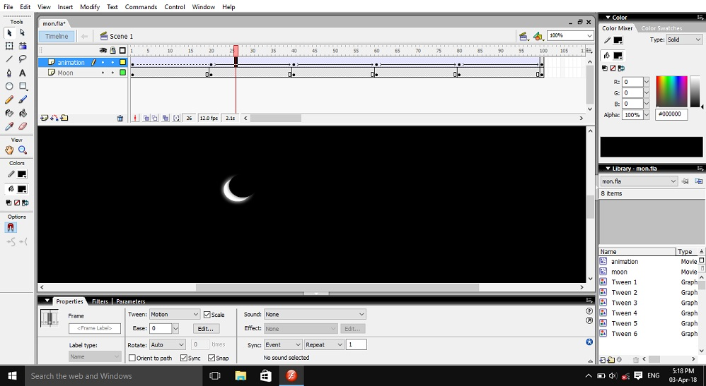
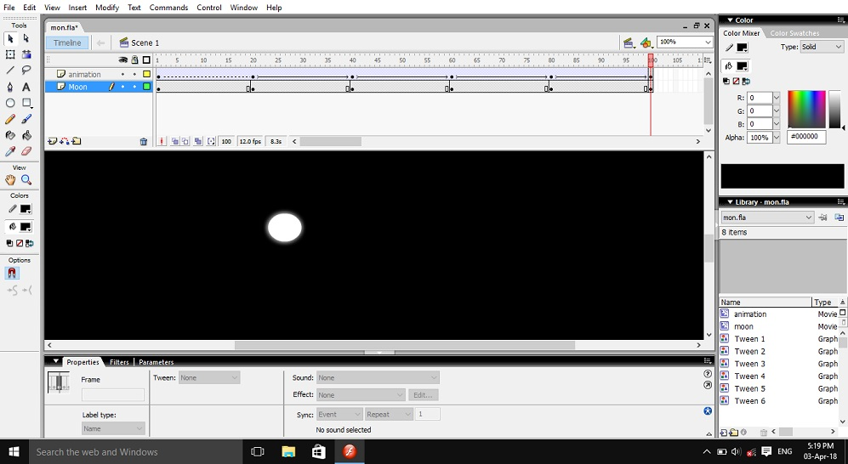
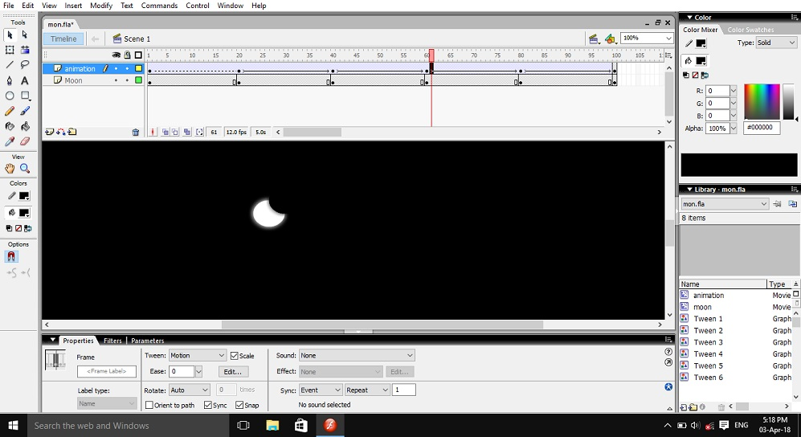
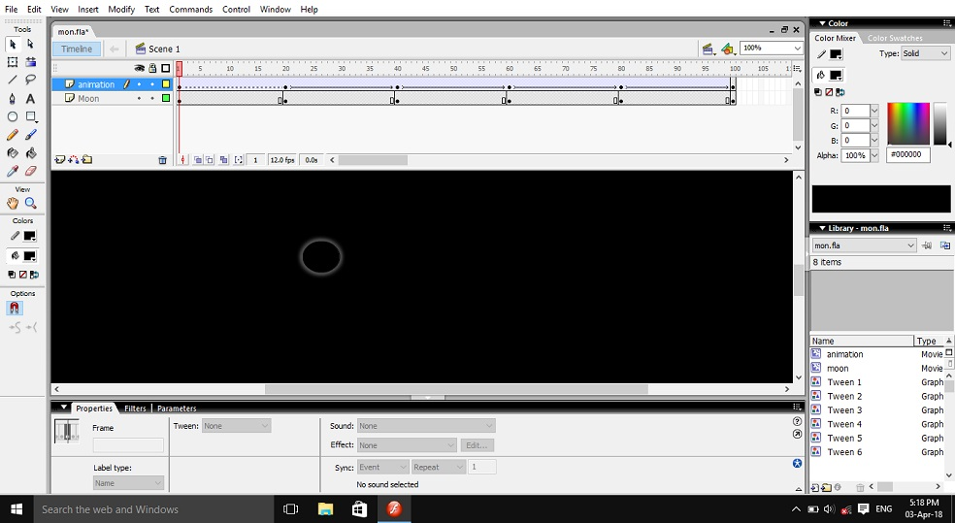

Ball On Steps
Following are the steps for creating animation of a Ball falling on stairs.

STEP 1:
First open a flash file ( .fla )
File → New → Flash Document

STEP 2:
Create steps using Line Tool.

STEP 3:
Create a new layer for the ball.

STEP 4:
On second layer create a ball using Oval Tool and place the ball at top of the stairs.

STEP 5:
Add 100 frames to both layers then add key frames at regular intervals.

STEP 6:
Then Motion Tween the ball’s movement down the stairs.

STEP 7:
Now play the movie by
Control → Play Or Press Ctrl+Enter
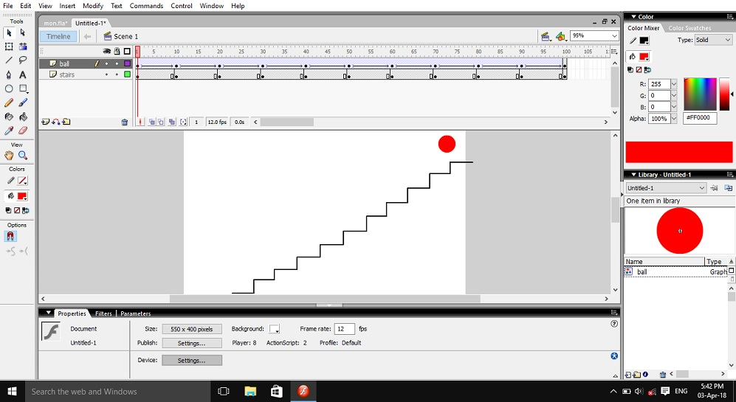
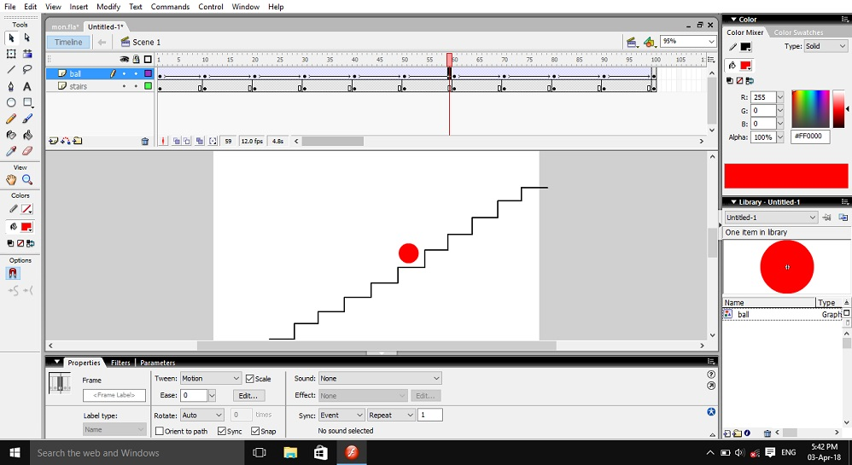

Ringing Bell
Following are the steps for creating animation of a bell ringing.

STEP 1:
First open a flash file ( .fla )
File → New → Flash Document

STEP 2:
Import a picture of a bell or draw a bell. To import
Goto File Tab → Select Import → Select Import To
Library
Then browse to the image and open it.

STEP 3:
Use the method in Step 2 to import the sound file of bell ringing ,the sound file should be in wave format.

STEP 4:
Then drag and drop the image from library onto the stage and position it as you like.

STEP 5:
Then drag and the audio file onto the layer in the timeline that you want to add the sound effects to.

STEP 6:
Add or remove frames to the layer the sound clip is on and adjust the duration of the clip.

STEP 7:
Now play the movie by going to
Control → Play Or Press Ctrl+Enter

Welcome
Following are the steps for creating animation of letters of welcome appearing one by one.

STEP 1:
First open a flash file ( .fla )
File → New → Flash Document

STEP 2:
Create a text box on the stage by selecting the Text Tool from Tools.

STEP 3:
Write ‘W’ in the Text Box and change its color.

STEP 4:
Add a Key Frame to the timeline and select the newly created Key Frame.

STEP 5:
Write the next letter and change the color to a different color again.

STEP 6:
Repeat Step 4 and Step 5 until all the letters iin the word WELCOME are typed out.

STEP 7:
Add frames between the Key Frames to increase the delay between appearance of letters.

STEP 8:
Now play the movie by going to
Control → Play Or Press Ctrl+Enter

Walking Stick-Man
Following are the steps to animate walk of a stick-man.

STEP 1:
First open a flash file ( .fla )
File → New → Flash Document

STEP 2:
Make a Rectangle and Fill it with some color this will be the ground for stickman.

STEP 3:
Create another layer and make a stick-man on it using Line Tool.

STEP 4:
Now convert the stick man into a Symbol
Select The Stick-Man → Press F8

STEP 5:
Now Edit the stick-man by double clicking it.

STEP 6:
Now create the walk cycle of stick-man by inserting Key Frames into the time line and changing the position of the figures arms and legs.

STEP 7:
After creating the walk cycle exit the stick-man symbol by double clicking the stage.

STEP 8:
Place the stick-man on the start point ,in this case left side of the stage.

STEP 9:
And 100 frames and a Key Frame at the end of both layers.

STEP 10:
Place the stick-man at the end point ,in this case it is the right side of the stage.

STEP 11:
Motion tween the stick-man.

STEP 12:
Now play the movie by going to
Control → Play Or Press Ctrl+Enter

Walking Stick-Man
Following are the steps to animate walk of a stick-man.

STEP 1:
First open a flash file ( .fla )
File → New → Flash Document

STEP 2:

