**KPSEAGRADE 6 TERM ONE 2024**

**ASSESSMENT AGRICULTURE AND NUTRITION**

**NAME:………………………………..ASSMT NO:………………**

1. Exposed  plant roots on a bare flat ground  is an indication of
   1. Splash erosion.
   2. sheet erosion.

**B**

* 1. gulley erosion.
  2. rill erosion.

1. All the  following are ways of controlling soil erosion. Which one is not?
   1. Using drip irrigation.

**A**

* 1. Mulching.
  2. Planting cover crops
  3. Building gabions.

1. Below is a small domestic animal reared in Kenya.

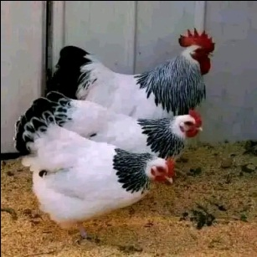

Which of the following are the products  from the animal above?

* 1. Meat and milk.

**B**

* 1. Manure,eggs and meat.
  2. Milk and skin.
  3. 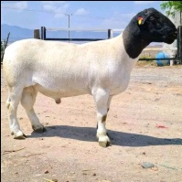Wool and manure.

1. Identify the animal drawn below.
   1. Goat.

**C**

* 1. Dog
  2. Sheep.
  3. Bull.

1. Which of the following shows a pair of tiny seeded crops?
   1. Sugarcane and banana.

**D**

* 1. Onions and tomatoes.
  2. Pumpkin and cucumber.
  3. Sunflower and carrots.

1. Which of the following is not a planting material for creeping crops?
   1. Seeds.
   2. Hoes.
   3. Scissors.
   4. Manure. Burning candle
2. Which of the following is an example of creeping crops?
   1. Cactus.

**C**

* 1. Carrot.
  2. Passion.
  3. Pumpkin.

1. Which of the following is a deterrent of wild animals against farming activities?
   1. Scarecrow.

**A**

* 1. Chicken.
  2. Mongoose.
  3. Bananas.

1. All the following are ways of conserving water in the farm except
   1. Mulching.

**C**

* 1. Shading.
  2. Thinning.
  3. Cover cropping.

1. Kwame came across a bare land with deep  U-shaped channels as shown below.

Which type of soil erosion was this likely  to be?

* 1. Splash erosion.

**D**

* 1. Rill erosion.
  2. Sheet erosion.
  3. Gulley erosion.

**HOMESCIENCE**

1. Which of the following lists consists of accessories only?
   1. Lipstick, eye pencil, deodorants.

**D**

* 1. Deodorants, creams, nailpolish.
  2. Perfumes, headgears, lotion.
  3. Scarves, necklaces, wristbands.

1. A person between 13 and 19 years is
   1. a young man.

**D**

* 1. an underage.
  2. a small lady.
  3. an adolescent.

1. Which of the following diseases is non- communicable?
   1. Tuberculosis.

**C**

* 1. Malaria.
  2. Epilepsy.
  3. Covid-19.

1. Which of the following is not a factor to consider when making a budget?
   1. Taste and preference.

**D**

* 1. Amount of money.
  2. The type of food.
  3. The weather of the day.

1. The following are factors to consider when choosing buttons. Which one is not?
   1. The person you are buying the buttons for
   2. The colour of the garment

**A**

* 1. The size of the button
  2. The number of button holes

1. Which or the following lists consists of a balanced diet?
   1. Rice, meat, chapati.

**C**

* 1. Fish, orange, carrots.
  2. Ugali, eggs, kales.
  3. Chips, sausages, chicken.

1. A sufuria is a cooking equipment that is commonly cleaned using
   1. Charcoal powder.
   2. steelwool.

**B**

* 1. a sand paper.
  2. egg shells.

1. The causes of obesity are listed below. Which one is not?
   1. Excess intake of fat

**C**

* 1. Lack of regular exercises
  2. Maintaining a healthy body weight
  3. Eating junk foods

1. Which of the following foods can be stewed?
   1. Meat

**A**

* 1. Cassava
  2. Yams.
  3. Cabbage.

1. Which of the following may be needed for baking?
   1. Maize flour.
   2. Oven.

**C**

* 1. Onions.
  2. Tomatoes