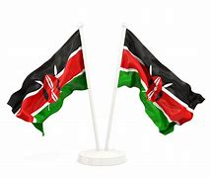

**GRADE SIX TERM ONE 2024**

**ASSESSMENT**

**SCIENCES**

**Read the passage and then answer questions 1 to 4.**

**NAME: ……………………………………………………………. ………………………………….**

**ASSESSMENT NUMBER:………………………………………………………………………………..**

**Science and Technology**

1. Below is a simplified diagram of the circulatory system.  
   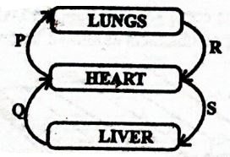  
   Which pair of blood vessels carry blood with carbondioxide?
   1. P, Q
   2. P, S
   3. R, S
   4. P,R
2. The pie chart below shows the composition of gases that make up air.  
   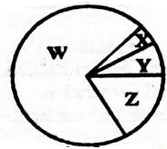  
   Which of the following statements is true about the composition of air represented above?
   1. The gas marked W is used during germination.
   2. Gas X can be used to put out fire.
   3. The gas labelled Y is used to preserve soft drinks.
   4. Gas Z is used by legumes to make proteins.
3. Which of the following parts of a computer displays the document being typed?
   1. Keyboard.
   2. Monitor.
   3. Printer.
   4. Mouse.
4. The diagram below represents classification of plants.  
   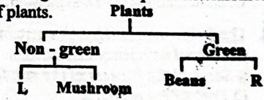  
   Which of the following plants can be used to represent L and R respectively?
   1. Mucor, bracket tree.
   2. Moss, grass.
   3. Cabbage, toadstool.
   4. Moulds, sugarcane.
5. Which of the following statements is true?
   1. A VDU is used to process data.
   2. A mouse has a space bar.
   3. A cursor shows the end of text being worked on.
   4. The monitor is used to produce hard copies.
6. Use the diagram below to answer the following question,  
   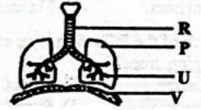  
   Which statement does not match with the parts represented by letters in the diagram above?
   1. P- its volume decreases during exhalation.
   2. U - cleans and warms the air.
   3. R - helps the trachea to stay open.
   4. V - flattens during inhalation.
7. Which of the following small animals are all invertebrates?
   1. Newt, cockroach, spider.
   2. Snail, spider, mite.
   3. Slug, crab, frog.
   4. Centipede, snake, scorpion.
8. Which of the following effects of heat on matter are as a result of increase in temperature?
   1. Melting and expansion.
   2. Condensation and contraction.
   3. Freezing and evaporation.
   4. Evaporation and contraction.
9. Which of the following is not a function of leaves?
   1. Photosynthesis.
   2. Breathing.
   3. Transpiration.
   4. Absorption.
10. The diagram below shows transfer of heat on matter.  
    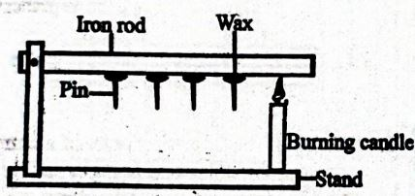  
    The type of heat transfer demonstrated  above is called
    1. convection.
    2. radiation
    3. conduction.
    4. expansion
11. The following are signs of a certain nutritional deficiency disease:
    1. Sores at the corners of the mouth.
    2. Protruding stomach
    3. Swollen body parts.
    4. Brown hair.  
       Which of the following foods can be recommended for a person suffering from the disease?
       1. Beans, tomatoes, cabbages.
       2. Rice, ugali, liver.
       3. Meat, fish, groundnuts.
       4. Chips, sugarcane, bananas.
12. Candle wax is able to float on water because of its
    1. weight.
    2. material.
    3. size.
    4. shape.
13. Crops such as peas, greengrams and are called
    1. cereals.
    2. legumes.
    3. tubers.
    4. vegetables.
14. Below is a chart showing farm animals  and their uses:  
    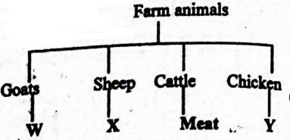   
    Which products are represented by W, X  and Y respectively?
    1. Milk, mutton, eggs. :
    2. Wool, mutton, eggs.
    3. Mutton, meat, mohair.
    4. Hide, eggs, meat.