3a (0.5 pt) Use the web demo to parse the ambiguous sentence I saw  
a man in boxer shorts. You have to uncheck the “Merge phrases”  
checkbox.  
What do you think about the way this sentence was parsed? Is it a  
good parse or not? Why (not)?

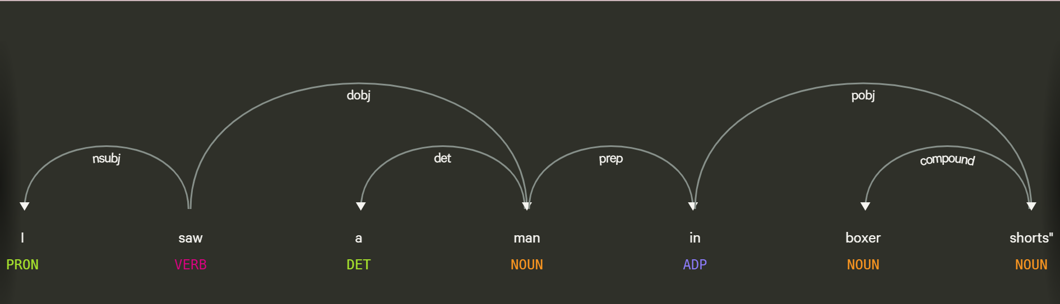

In this I is treated as Pronoun, saw as VERB, a as DET, man as NOUN, in as ADP, boxer as NOUN and shorts as NOUN. In this I is Nominal Subject that serves as the subject of a verb in a sentence, Saw is the main verb, a is the determiner that specifies “man”, man is the direct object of saw that indicates the entity that was seen, “in” is prep that introduces a prepositional phrase, “boxex” is a noun, with the compound of “shorts” which is the object of the preposition “in” that indicates that the man is wearing boxer shorts.

It does appears to be reasonable as it correctly classifies “I” as the subject and “saw” as the verb and identifies “ a man” as the direct object of the verb “saw” that indicates that a man was seen. But it is noted that “In boxer shorts” is not connected with “ saw” but connected with man.So, we think it is a suitable parse but It really depends on the context/Ambiguity because “boxer shorts” is considered as a single unit which is indeed valid but if we are looking for more detailed of “boxer shorts” we might need to divide it.

1 pt) Now, use the web demo to parse the following variations of the

previous sentence. Keep the “merge phrases” checkbox unchecked.

1. I like a man in boxer shorts

2. I shot a man in boxer shorts

3. I shot a man in my boxer shorts

4. men seduce women in boxer shorts

5. women seduce men in boxer shorts

Discuss the differences between the dependency parses SpaCy assigns

to these sentences. Do you think they are good parses? Why (not)?

Can you think of reasons for the different parses?

For the first sentence

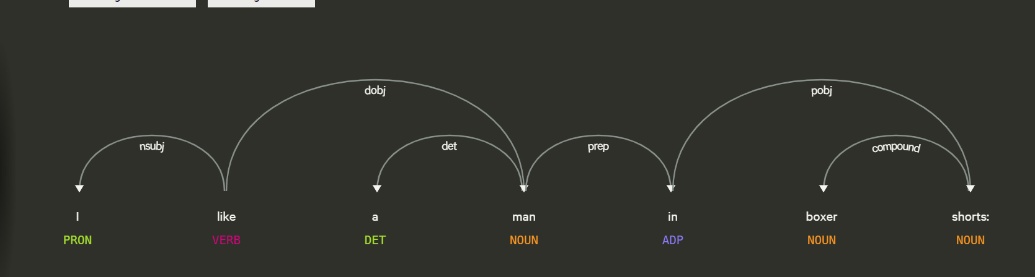

We can see that it acts kindly the same compared to “I saw a man in boxer shorts”.

We think it is a good parse, as “I” is a pronoun which is nominal subject of the verb “like”. “ a” is a determiner which specifies “man”. “man” is the direct object of the verb “like”.”in” is a preposition that connects with “man” to “shorts”. Whereas “shorts” is connected as compound to “boxer” and is the object of the preposition “in”. From this we can say “like” is linked with “man” not with “in boxer shorts”.

For the second sentence

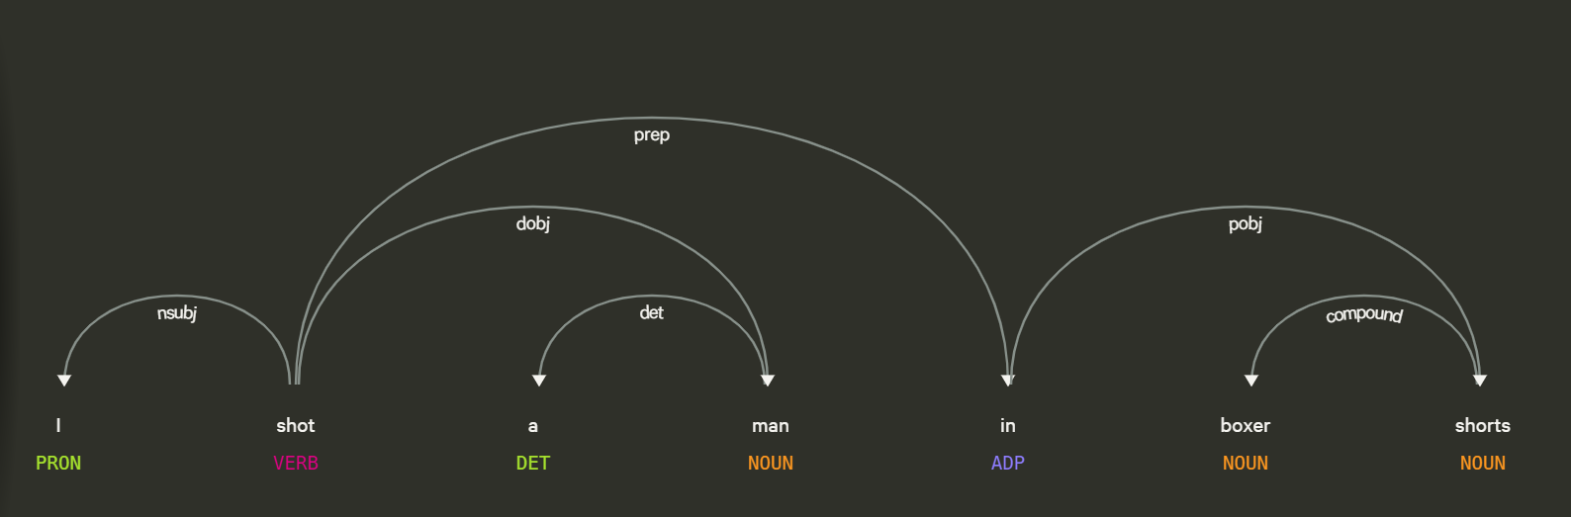

Both the sentences have the main basic structure but the difference linked with verb.Here the phrase “in boxer shorts” is attached to the verb “shot” via the prep that indicates that the verb “shot” is linked to “in boxer shorts” which means that the man who was shot wears “boxer shorts” during the shooting. Whereas in the previous sentence the verb “like” was not linked via prepositional phrase that means that the verb “like” was not direct linked with “in boxer shorts” but with man which simply describes the liking of a man. In conclusion, this indicates that a man was shot in boxer shorts.

For third sentence

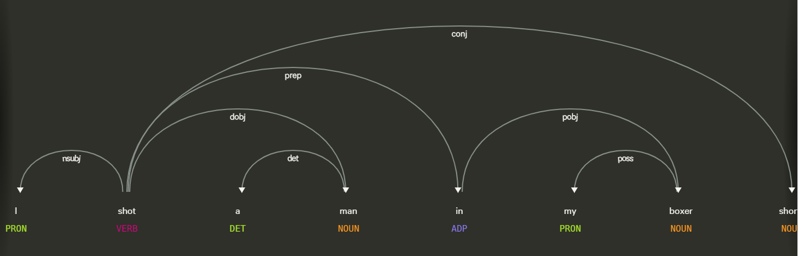

Here “shot” is direct object to “man”, linked with “in” via prepositional phrase and conj with “shorts”. Compared to others there is also no compound between “shorts” and “boxer” and “in” is pobj to “boxer” not with “shorts”.

From this we can interpret as “shot” is direct object of “man” and conj with “shorts” that means both "shot" and "shorts" are linked to the same subject or action in the sentence. Additionally, the relationship between “boxer” and “my” suggests that the focus of the action is shift to the speaker, indicating that it's the speaker who was wearing boxer shorts, not the man who got shot. This shift in focus is indeed different from the previous sentences and can be context-dependent. In this case, the interpretation depends on whether the speaker or the person who got shot is of greater interest in the context of the sentence.

For fourth sentence

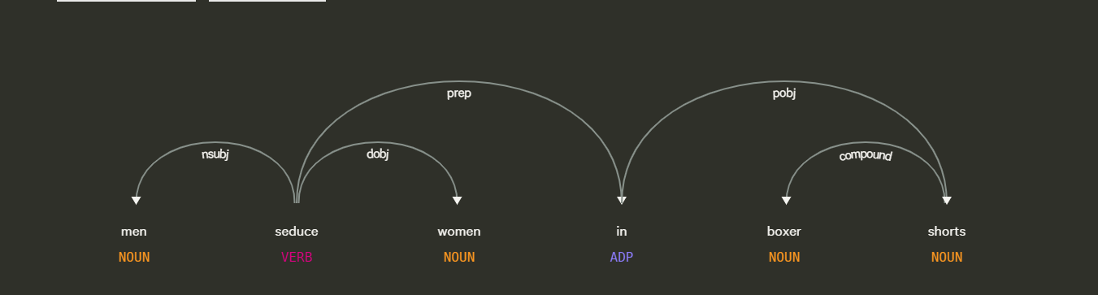

In the sentence, it's evident that "men" serves as the subject ("nsubj") of the verb "seduce," while "women" functions as the direct object ("dobj") of the same verb. Furthermore, the term "shorts" is linked as a compound to "boxer," forming a single unit within the sentence structure. This parse indicates that the men are engaged in seducing women, specifically those who are wearing boxer shorts. However, this parsing does not definitively clarify whether the "boxer shorts" are being worn by the men or the women, introducing a level of ambiguity.The ambiguity arises from the versatile nature of the preposition "in," which can be associated with multiple noun phrases or objects in various contextual situations. In the context of this sentence, "in" could signify that the men are wearing boxer shorts or that the women are wearing them. The preposition "in" itself does not provide sufficient information to distinguish between these interpretations, leading to potential ambiguity in the sentence's meaning.

Ultimately, the sentence's interpretation is depending on the broader context or additional linguistic cues.

For fifth sentence

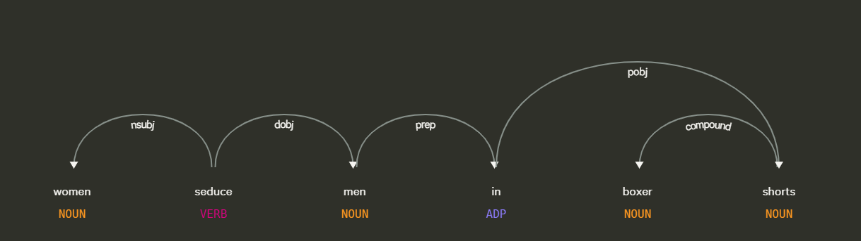

Here “women” is the nsubj of “seduce” and “men” is the direct object of “seduce”. Also “in” is linking with the “men” by prep and pobj with “shorts”. Compared to the previous sentence, this parse has indicated that the men are wearing boxer shorts during the context of seduction.

To put it simply, sentences can have various parses because natural language is complex and full of ambiguity. Words often have multiple meanings, making it necessary for the parser to consider the context. This complexity leads to different interpretations of the same sentence, resulting in distinct parses. For instance, the word "boxer" could mean clothing or an athlete, and the parser's choice depends on the context.