把图片都写入到一个文件中，为此需要在本地构建一个文件索引表，（图片名、图片在文件中的偏移地址，图片大小），把图片作为大文件的记录插入，插入时需要同时维护这个文件索引表，读取图片时也是先查找这个索引表。

报告内容：请在报告中写明你的实现逻辑，和将每张图片单独作为小文件来存储的性能比较，并附上相应的代码段和截图。

**实现**

将本地的文件夹中的每个文件顺序存入hdfs，在本地创建local_index文件，存储该文件夹中每个文件的偏移量。

查找某个文件时只需按照local_index中的偏移量和该文件的长度来定位hdfs系统中的该文件位置，并将其下载。

String root_path="/home/lwx/Documents/hw1/";

String hdfs_fileName = "hw1/g2/Group_file";

String local_fileName = root_path+"local_index";

Configuration conf = new Configuration();

conf.set("fs.defaultFS", "hdfs://Master:9000");

conf.set("fs.hdfs.impl", "org.apache.hadoop.hdfs.DistributedFileSystem");

FileSystem fs = FileSystem.get(conf);

Path hdfs_file_path = new Path(hdfs_fileName);

File local_index_file_obj=new File(local_fileName);

if(!local_index_file_obj.exists())

{

//this hdfs file path not exist

//create index local file

System.out.println("create local index file");

create_local_index_file(local_fileName);

}

//readFileIndex(local);

if(args[0].equalsIgnoreCase("build"))

{

System.out.println("build");

read_dir(args[1]);

// for(int j =0; j<file_num_now;j++)

// System.out.println(f_name[j]);

save_File(fs,hdfs_file_path,local_fileName);

}

else if(args[0].equalsIgnoreCase("query"))

{

readFileIndex(local_fileName);

queryFile(fs,hdfs_file_path,args[1]);

}

fs.close();

**savefile函数：将文件夹上传到hdfs中并在本地创建local_index索引**

public static void save_File(FileSystem fs, Path hdfs_file_path,String local_index) throws IOException{

FSDataOutputStream os =fs.create(hdfs_file_path);

File local_index_obj =new File(local_index);

FileWriter fileWriter = new FileWriter(local_index_obj.getName(),true);

System.out.println("will write index into index file : "+local_index);

System.out.println("file num now: "+file_num_now);

fileWriter.write(file_num_now + "\n");

fileWriter.flush();

/*

byte[] Total_byte = intToByteArray(200);

os.write(Total_byte,0,Total_byte.length);

byte[] now_byte = intToByteArray(0);

os.write(now_byte,4,now_byte.length); */

//int file_off_counter = 0;

for(int i = 0; i<file_num_now; i++)

{

fileWriter.write(file_off[i] + "\n");

fileWriter.write(file_len[i] + "\n");

fileWriter.write(f_name[i] + "\n");

}

fileWriter.close();

byte[] buffer = new byte[4096];

for(int i = 0; i<file_num_now; i++)

{

//byte[] buffer = new byte[4096];

File f = new File(directory_path + f_name[i]);

int t;

//System.out.println(i+" len="+file_len[i]);

InputStream in = new FileInputStream(f);

for(int j = 0; j < file_len[i]; j+=4096)

{

if(j + 4096 <= file_len[i])

t = 4096;

else

t = file_len[i] -j;

//System.out.println(j+"j t"+t);

in.read( buffer, 0, t);

os.write(buffer, 0, t);

//file_off_counter += t;

}

in.close();

}

System.out.println("Save file in hdfs:"+hdfs_file_path.getName());

os.close();

}

**query_file函数：按照local_index获取hdfs中的某个文件**

public static void queryFile(FileSystem fs, Path hdfs_file_path, String name) throws IOException

{

int i = 0;

for(; i < file_num_now; i++)

{

if(f_name[i].equals(name))

break;

}

if(i==file_num_now)

{

System.out.println(name+" doesn't exist");

return;

}

FSDataInputStream in = fs.open(hdfs_file_path);

FileOutputStream out = new FileOutputStream(new File("fetched_"+name));

BufferedReader d = new BufferedReader(new InputStreamReader(in));

byte[] tmpb = new byte[4096];

int t;

in.seek(file_off[i]);

for(int j = 0; j<file_len[i]; j+=4096)

{

if(j + 4096 <= file_len[i])

t = 4096;

else

t = file_len[i] -j;

in.read(tmpb, 0, t);

out.write(tmpb,0,t);

}

out.close();

d.close();

in.close();

}

**截图**

上传文件夹到hdfs中

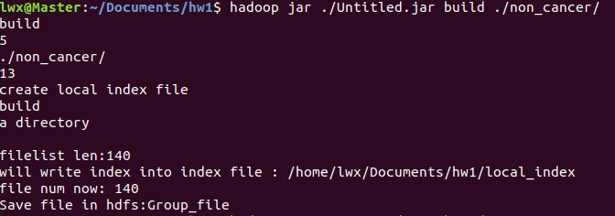

查找某个文件并下载到本地

