**Cariboo Lake Results Draft**

Section 2: Spatial Trends in Surficial Sediment

November 9, 2020

Revision 1

**Spatial Trends** **in Surficial Sediment**

Twenty surficial sediment cores ranging from 6-12 cm thick were analyzed for grain size, laminae thickness, and organic content. These samples were collected following a longitudinal transect down Cariboo Lake and indicate how sediment flux varies with distance from the Cariboo River delta (Fig. 4, *n* = 20). Proximal to the Cariboo River delta (< 500 m) the structure of the surficial sediments exhibits massive layering, erosive contacts and the fraction of sand grains in these samples is greater than 60 % (Fig. 5). A sand bed with a thickness of 1 cm is observed in the bulk sample closest to the Cariboo River delta (Fig. 6 - A). The D50 grain size follows a steep decline from 89.9 μm 300 m from the delta to 31.3 μm 550 m from the Cariboo River delta (Fig. 7). The decrease in grain size generally continues further down-lake besides samples retrieved near river deltas. A small increase in D50 is observed proximal to the Pine Creek delta from a low of 21.5 μm at 1.1 km, up to 28.2 μm 1.83 km from the main Cariboo River delta (Fig. 7). At distances greater than 2 km from the Cariboo River delta the fraction of silt grained sediments remains over 80 %, aside from core E16 which is near the Frank Creek delta (Fig. 5). Proximal to the Frank Creek delta the D50 grain size nearly doubles in size from 7.92 μm at 6.4 km to 15.1 μm at 7.35 km from the Cariboo River delta. In main Cariboo River sub-basin, the most well-preserved core was taken 5.24 km from the Cariboo River delta in the deepest part of the sub-basin at a depth of 40 m and shows rhythmically laminated sediments (Fig 6, b). In the Keithley Creek basin the D50 grain size has an average of 15.9 μm (*n* = 3) and the composition of sediment 4.0% clay, 85.8% silt, and 10.2% sand (Fig 5, Fig 6 - C).

Sediment cores E9-E15 and E18-E20, retrieved from areas in Cariboo Lake that are distal from river deltas, and have a high fraction of silt and clay sediment, exhibit a sequence of fine-grained dark layers followed by coarse-grained light layers (Fig. 6). The thickness of sediment laminae within these surface cores demonstrate a gradual decreasing trend with distance down-lake from the Cariboo River delta (Fig. 7). Maximum varve thickness has an average of 4.7 mm (*n* = 6) in the Cariboo River basin and 7.9 mm (*n* = 3) in the Keithley Creek basin. In the Cariboo River basin, maximum varve thickness decreases by 0.62 mm/km and by 2.17 mm/km in the Keithley Creek basin with distance down-lake (Fig. 7). This decrease in laminae thickness with distance from the delta is attributed to the Cariboo River being the main source of sediment into Cariboo Lake as sediment flux typically declines with distance from the primary sediment source. The decline in thickness is steeper in the Keithley Creek Basin likely due to additional local inputs of coarser grained sediment coming from the Keithley Creek tributary which are not transported as far as suspended sediments.

Trends in percent organic content of surficial sediment cores where not found to exhibit systematic patterns with distance down-lake (Fig.9). However, higher %LOI values were observed close to the main Cariboo River delta, likely due to the relatively low levels of erosion and high levels of allochthonous organic matter entering the lake. The lowest %LOI values were observed in the Keithley Creek basin which suggest higher levels of erosion in this basin.

The results from particle size, laminae thickness, and percent organics suggest that sediment delivered from the main Cariboo River is the primary source of sediment to Cariboo Lake. Massive layering of sediment and coarse-grained particle sizes are limited to areas proximal to Pine Creek, Frank Creek and Keithley Creek deltas where turbidity currents are active. Outside of these areas, where turbidity currents and bedload transport processes are reduced, the sediment in Cariboo Lake is largely comprised of rhythmically laminated silt and clay sediments likely transported primarily through suspended sediment currents from the main Cariboo River. In the Keithley Creek basin grain size and laminae structures are larger in size than those observed in the main Cariboo River basin suggesting sediment inputs from the Keithley Creek are significant (Fig. 6, C).

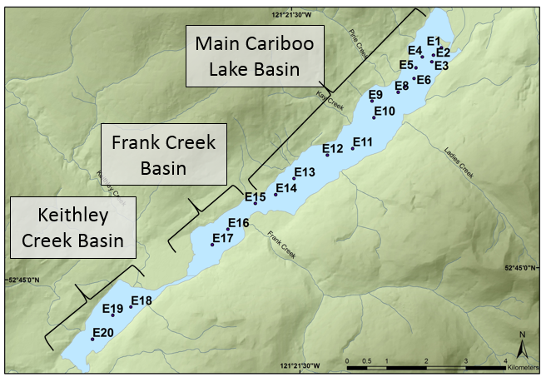

**Figure 4:** Ekman bulk sample locations. Sub-basins denoted by text boxes.

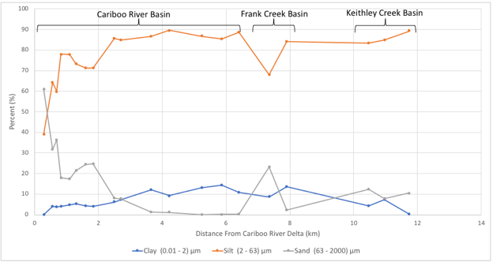

**Figure 5:** Ekman bulk sample percent composition of clay, silt, and sand sized particles versus distance from Cariboo River delta.

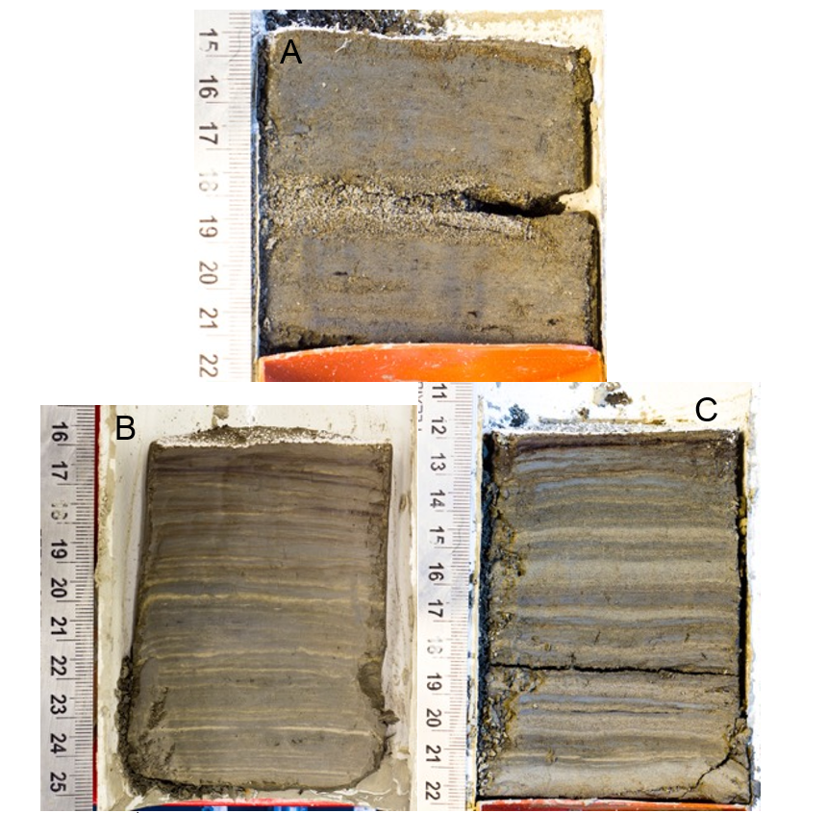

**Figure 6:** Selected surficial Ekman sediment core photographs. A (E1) is proximal to the Cariboo River delta. B (E13) was retrieved from the second deepest basin in the lake in the Cariboo River basin. C (E18) was retrieved from the Keithley Creek basin.

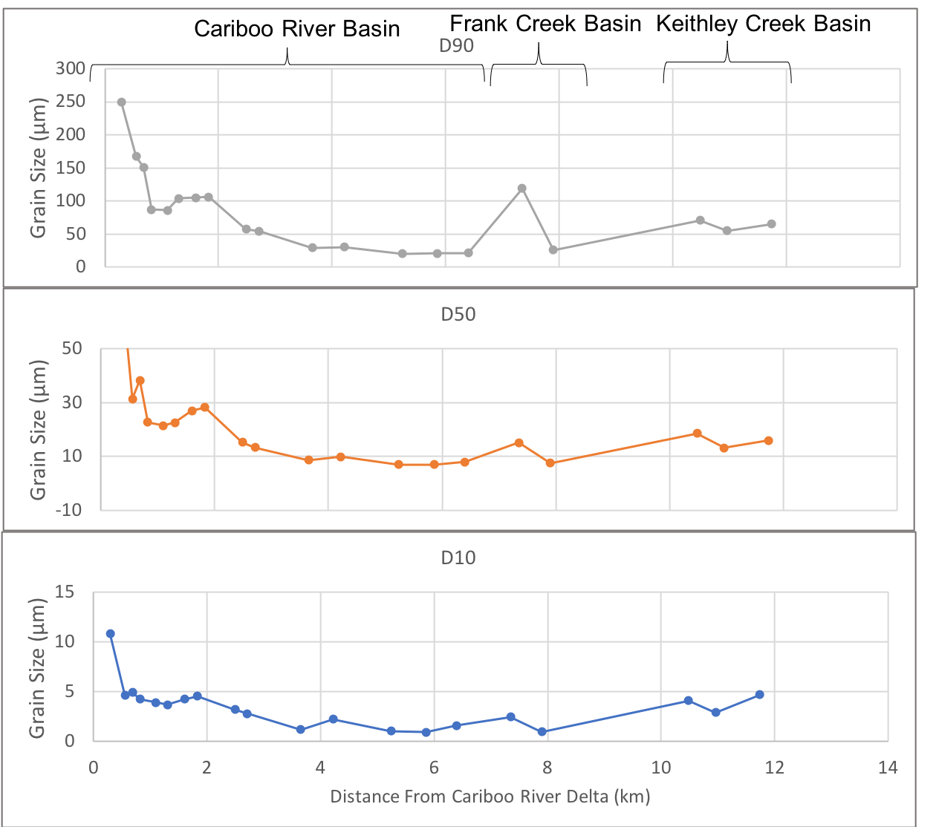

**Figure 7:** Ekman bulk sample grain size diameter versus distance from the Cariboo River delta. (A) D90, (B) D50, (C) D10.

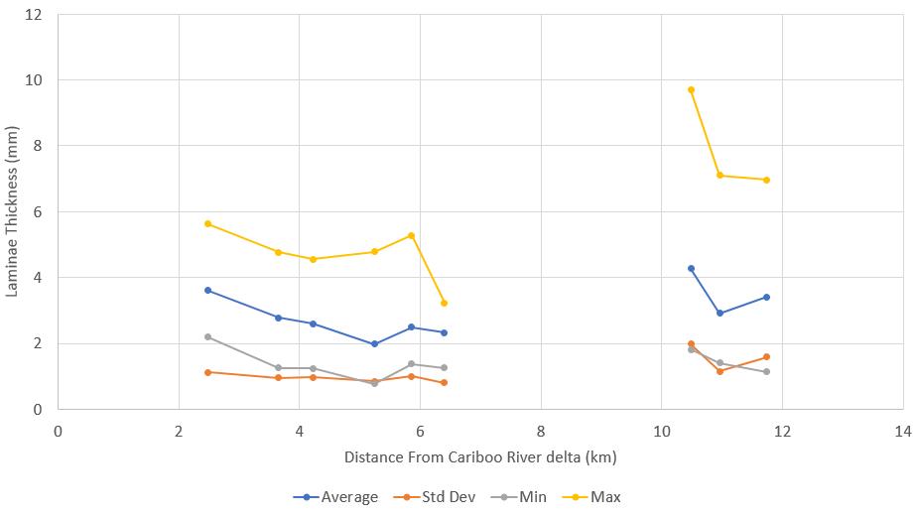

Keithley Creek Basin

Cariboo River Basin

**Figure 8:** Laminae Statistics calculated on surficial Ekman cores E9-15 and E18-E20.

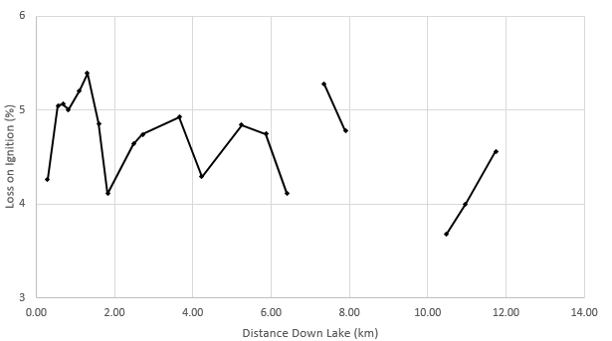

Keithley Creek

Basin

Frank Creek Basin

Cariboo River Basin

**Figure 9:** Ekman bulk sample percent loss on ignition versus distance from the Cariboo River delta.